T3 Cancer of the Esophagus and GE Junction

## 1 Anatomy

Food moves from the throat

esophagus

stomach

small bowel (jejunum)

We’ll start with reviewing some anatomy about how the body digests food.

Food moves from the throat to the esophagus, and from there to the stomach.

From the stomach, food moved through a valve called the pylorus into the small intestines

## 2 Types of Esophageal Cancer

There are two common types of esophageal cancer

* Adenocarcinoma
* Squamous Cell Carcinoma

In many ways, these two different types of esophageal cancer behave in similar fashion.

We will see later that the treatment **can** be different depending upon whether the cancer is adenocarcinoma or squamous cell carcinoma.

## 3 Cancer Staging

Staging refers to the tests to determine

* How large is the tumor?
* Has there been spread to lymph nodes?
* Has it spread to other parts of the body?

**Treatment options depend upon the cancer stage**

## 4 Cancer Staging

* **T** = Tumor - Depth of growth into the wall
* **N** = Nodes - Spread to the lymph nodes
* **M** = Metastasis - Spread to liver, lungs, or bone

## 5 Early Stage Cancers

Early-stage cancers are those that are small and have not grown very far into the wall

Cancers start on the very inside layer called the mucosa

## 6 Locally-advanced Cancers

Over time, cancers can grow into the muscular wall

Locally-advanced cancers are those that have grown through the wall

## 7 Lymph Nodes

In some cases, cancer cells can break off from the main tumor and spread to lymph nodes

If the lymph nodes contain enough cancer cells, they can be seen on CT scans or PET scans

## 8 T Stage

Cancers are categorized based upon the thickness of the tumor, known as the T stage

T1 tumors are early stage, and T4 tumors more advanced

## 9 N Stage

Cancers are categorized by whether there is spread to the nodes.

* **N0** cancers have not spread to the nodes
* **N1** cancers have spread to the nodes.

## 10 M Stage

Some cancers spread to other parts of the body

* **M0** cancers have not spread to other parts of the body
* **M1** cancers have spread lungs, liver, or bone

## 11 PET scan

Similar to CT scan

Tracer shows ‘hot spots’

* Cancer
* Inflammation or infection
* Normal organs (heart, kidneys)

In some cases, the PET scan is not performed until a CT scans b=has been done.

## 12 Endoscopic Ultrasound

* Similar to upper endoscopy (EGD)
* Ultrasound in scope
* Evaluates T stage

Endoscopic ultrasound is most helpful in early stage cancers.

## 13 Laparoscopy

* Some stomach cancers can spread inside the abdomen
* Areas of spread can be very small (grain of rice)
* Laparoscopy can detect spread inside the abdomen

Not all patients with gastric cancer need a laparoscopy.

## 14 Laparoscopy

* General anesthetic
* Several 1/4” incisions
* Telescope examines the abdomen
* Biopsies can be performed.

## 15 Treatment Plan

Superficial (T1): Endoscopic Therapy

Localized (T1b/T2): Surgery (esophagectomy)

Locally-advanced (T3M0): ChemoRadiation Surgery

Metastatic (M1): Chemotherapy

This table summarizes four different treatment categories:

* Superficial cancers are T1 and can be treated by endoscopic therapy without the need for surgery
* Localized cancers are T1b or T2 and are frequently treated by surgery alone without the need for chemotherapy or radiation
* Locally-advanced cancers are T3 or N1 and are usually treated with some combination of chemotherapy and radiation prior to surgery
* Metastatic cancers are M1 and are treated primary by chemotherapy.

## 16 Locally-advanced cancers

Patients with locally-advanced esophageal cancer often have localized spread of cancer cells in the surrounding area

## 17 Locally-advanced cancers

If locally-advanced cancers are treated with surgery alone…

## 18 Locally-advanced cancers

If locally-advanced cancers are treated with surgery alone…

There is a risk that cancer cells can be left behind

## 19 Preoperative Therapy

It is helpful to start with therapy *before* surgery that will shrink the cancer.

## 20 Preoperative Therapy

It is helpful to start with therapy *before* surgery that will shrink the cancer.

## 21 Preoperative Therapy

It is helpful to start with therapy *before* surgery that will shrink the cancer.

## 22 Surgery after Preoperative Therapy

When surgery is then performed…

## 23 Preoperative Therapy

When surgery is then performed…

The risk of cancer recurrence is minimized

## 24 Preoperative Therapy

When surgery is then performed…

The risk of cancer recurrence is minimized

## 25 Chemotherapy + Radiation CROSS Trial

363 patients with esophageal cancer studied

Patients were treated in two groups:

**Surgery Alone**

vs

**Chemo + Radiation** Surgery

## 26 Chemotherapy + Radiation CROSS Trial

363 patients with esophageal cancer studied

Chemotherapy + radiation together over 6 wks

**Surgery Alone**

vs

**Chemo + Radiation**Surgery Longer Survival

The results were quite dramatic: The group that was treated with all three therapies, chemotherapy and radiation and surgery, lived on average twice a long as patients who had surgery alone.

## 27 Chemo + Radiation CROSS Trial

Typical schedule for chemotherapy + radiation:

* Chemotherapy once per week for six weeks
* Radiation five days per week for six weeks (28)
* PET scan (or CT) 4 weeks after the end of radiation
* Surgery 8 weeks after the end of radiation

## 28 Chemo + Radiation - Side Effects

Kills cancer cells in the esophagus and lymph nodes

Can also irritate the lining of the esophagus.

Swallowing can be difficult the last 2 weeks.

Feeding tube may be needed for hydration/nutrition.

## 29 Adenocarcinoma Treatment Options

For patients with *adenocarcinoma* an alternative to chemotherapy + radiation is “Sandwich” chemotherapy

## 30 Locally-advanced Adenocarcinoma

“Sandwich” chemotherapy before + after surgery:

Chemo (8 wks) Surgery Chemo (8 wks)

Two different drug combinations:

* FLOT (more effective)
* FOLFOX (better tolerated)

## 31 “Sandwich” Chemotherapy Drugs

**FLOT**

* 5-FU
* Leucovorion
* Oxaliplatin
* Taxotere

**FOLFOX**

* 5-FU
* Leucovorin
* Oxaliplatin

## 32 FLOT Treatment Plan

* FLOT Chemo every 2 weeks x 4 (=8 weeks total)
* Surgery (4-6 weeks later)
* FLOT Chemo every 2 weeks x 4 (=8 weeks total)

## 33 Immunotherapy

Immunotherapy is a form of cancer treatment that stimulates your immune system to fight cancer.

Some cancer cells will turn off immune cells using a protein called PD-L1. Immunotherapy can counteract this “off signal” and gives immune cells a “turn on signal” so that they fight cancer.

Darvalumab is an immunotherapy drug that fights cancers by counteracting PD-L1

## 34 Matterhorn Trial

The Matterhorn clinical trial compared two types of treatment:

FLOT x 4 doses -> Surgery -> FLOT x 4 doses

FLOT + Durvalumab -> Surgery -> FLOT + Durvalumab -> Durvalumab

Better survival with addition of durvalumab

## 35 FLOT± Durvalumab

**FLOT**

* FLOT Chemo every 2 weeks x 4 (=8 weeks total)
* Surgery (4-6 weeks later)
* FLOT Chemo every 2 weeks x 4 (=8 weeks total)

**FLOT + Durvalumab**

* FLOT Chemo every 2 weeks x 4 (=8 weeks total)
  + Durvalumab 2 doses
* Surgery (4-6 weeks later)
* FLOT Chemo every 2 weeks x 4 (=8 weeks total)
* Durvalumab 2 doses
* Durvalumab 10 doses every month

## 36 Matterhorn Trial

The Matterhorn clinical trial compared two types of treatment:

FLOT x 4 doses -> Surgery -> FLOT x 4 doses

FLOT + Durvalumab -> Surgery -> FLOT + Durvalumab -> Durvalumab

Better survival with addition of durvalumab

**Treatment with durvalumab depends upon approval from insurance company**

## 37 Adenocarcinoma Treatment Options

**Chemo + Radiation**

* Chemo+Radiation (6 wks)
* Surgery

**Chemotherapy**

* Chemotherapy (8 wks)
* Surgery
* Chemotherapy (8 wks)

## 38 Adenocarcinoma Treatment Options

**CROSS Chemo + Radiation**

* Longer track record
* Better tolerated
* Port usually placed
* Eating worse better
* May need feeding tube

**FLOT Chemotherapy**

* More effective
* More side effects
* Port always required
* Eating gets slowly better
* Feeding tube less likely

## 39 Chemotherapy Administration

Most chemotherapy is administered by vein.

Several options exist to administer chemotherapy:

* Intravenous catheter in peripheral veins
* Peripheral Intravenous Central Catheter (PICC)
* Central Venous port

## 40 Intravenous Catheter in Peripheral Vein (“IV”)

* IV catheter placed in vein of hand or arm
* Allows administration of chemo and fluids
* Placed for each dose
* Removed that day
* Not suitable for FLOT chemo

A peripheral IV catheter involves placing a small tube into the veins, which is then used to give fluids or chemotherapy

A new catheter is placed for each dose of chemotherapy

FLOT chemotherapy requires a home infusion pump, got which a peripheral IV won’t work

## 41 PICC Lines

* Placed in Radiology
* Stay in place during all of treatment
* Needs to be kept clean and dry
* Suitable for FLOT chemotherapy

A PICC line is placed in Radiology and stays in place during the treatment course Special care is needed at home to keep the catheter and it’s dressing clean and dry

## 42 Central Venous Port

* Implantable device makes chemo easier
* May shower in 24 hrs
* No special care at home
* OK for FLOT chemo
* Allows for blood draws

A central venous port is an implantable device that makes the administration of chemotherapy easier.

Once it is in place, it requires no special care at home

With a port, you can shower, bathe, and swim without restriction

A central venous port is suitable for FLOT chemotherapy

A port can be used for blood draws for blood tests as well.

## 43 Central Venous Port

* Implanted under skin
* Neck incision (1/4”)
* Incision below the collarbone
* Sutures dissolve
* “Superglue” on incisions

A port is placed underneath the skin and usually below the right collarbone.

Two incisions are made for placement: a quarter-inch incision over the neck, and a one-inch incision below the collarbone.

Sutures are under the skin and dissolve on their own

Surgical “Super Glue” covers the incisions and flakes off after a week or so

## 44 Central Venous Port

When it is time for chemotherapy, a needle is inserted through the skin into the port

When it comes time for chemotherapy, the nurses can easily access the port with a needle that goes through the skin into the port, rather than placing an intravenous needle in a vein. The drugs can then be administered directly into the bloodstream. If blood needs to be drawn for tests, this can also be done through the port.

## 45 Restaging

CT (or PET) scan performed after preoperative therapy

* Surgery performed after restaging
* Timing depends upon recovery from therapy

## 46 Primary Care Practitioner (PCP)

Critical to coordinate care between specialists.

We will update your PCP after each visit

PCP Referral Line (844) 235-6998

## 47 My Atrium Patient Portal

* Critical to good communication with your care team
* Available for desktop or laptop or phone
* Sign up at my.atriumhealth.org

## 48 Exercise

* Reduces risk of complications from treatment
* Goal is 30min/day of vigorous exercise 6 days/wk
  + Working hard enough that you can’t converse
  + Start slowly and build up
  + Every day counts! (Aim for daily activity)

## 49 Smoking Cessation

* Smoking makes cancer treatment more difficult
  + Increases risk of complications after surgery
* Options for help with smoking cessation:
  + NC Quit Line 1-800-QUIT-NOW (1-800-784-8669)
  + American Lung Assn www.freedomfromsmoking.org
  + Smoking Cessation Counseling (Metro Charlotte)

## 50 Protein Needs

## 51 Feeding Tubes

There are two types of feeding tubes:

* Jejunostomy tubes are placed in the small intestine
* Gastrostomy tubes are placed in the stomach

Your dietitian and physician will help you decide which tube is best for your situation

## 52 Gastrostomy Tube

Feeding Gastrostomy

* Feeding with a syringe several times per day.
* Tube can be hidden underneath clothing
* Tube does not interfere with eating by mouth
* Removed easily in the office when no longer needed

## 53 Gastrostomy Tube Methods

PEG: Tube placed by endoscopy

Laparoscopic: Tube placed surgically by laparoscopy

Preferred method depends upon whether esophagectomy is planned

## 54 Gastrostomy Tube

* Outpatient Placement (go home the same day)
* Central venous port can be placed at the same time (if needed)

## 55 Jejunostomy Tube

## 56 Jejunostomy Typical Regimen

* Jejunostomy tube feeds for 16 hours (6pm-10am)
  + Men: 75mL/hour x 16 hours = 5 cartons
  + Women: 60mL/hour x 16 hours = 4 cartons
* Water 240ml (8oz) via syringe 4x/day

Hospital nurses will teach use of the feeding tube

## 57 Jejunostomy Feeds with Diabetes

Jejunostomy feedings elevate blood sugars

* Insulin may be required along with feeds

Typical Pattern for tube feeds

* Feeds run via pump from 6pm to 10am
* Insulin at 6pm (70/30 insulin)
* Insulin at Midnight (70/30 insulin)
* No insulin if tube feedings are not run

## 58 Jejunostomy Video

## 59 Surgery for Esophageal Cancer

Surgery for esophageal cancer is performed for:

* Superficial Tumors (T1) not removed by endoscopy
* Localized Tumors (T2 N0 M0)
* Locally Advanced (T3 M0) after preop therapy

## 60 Goals of Surgery

* Remove tumor from esophagus
* Remove surrounding lymph nodes
* Create a new esophagus

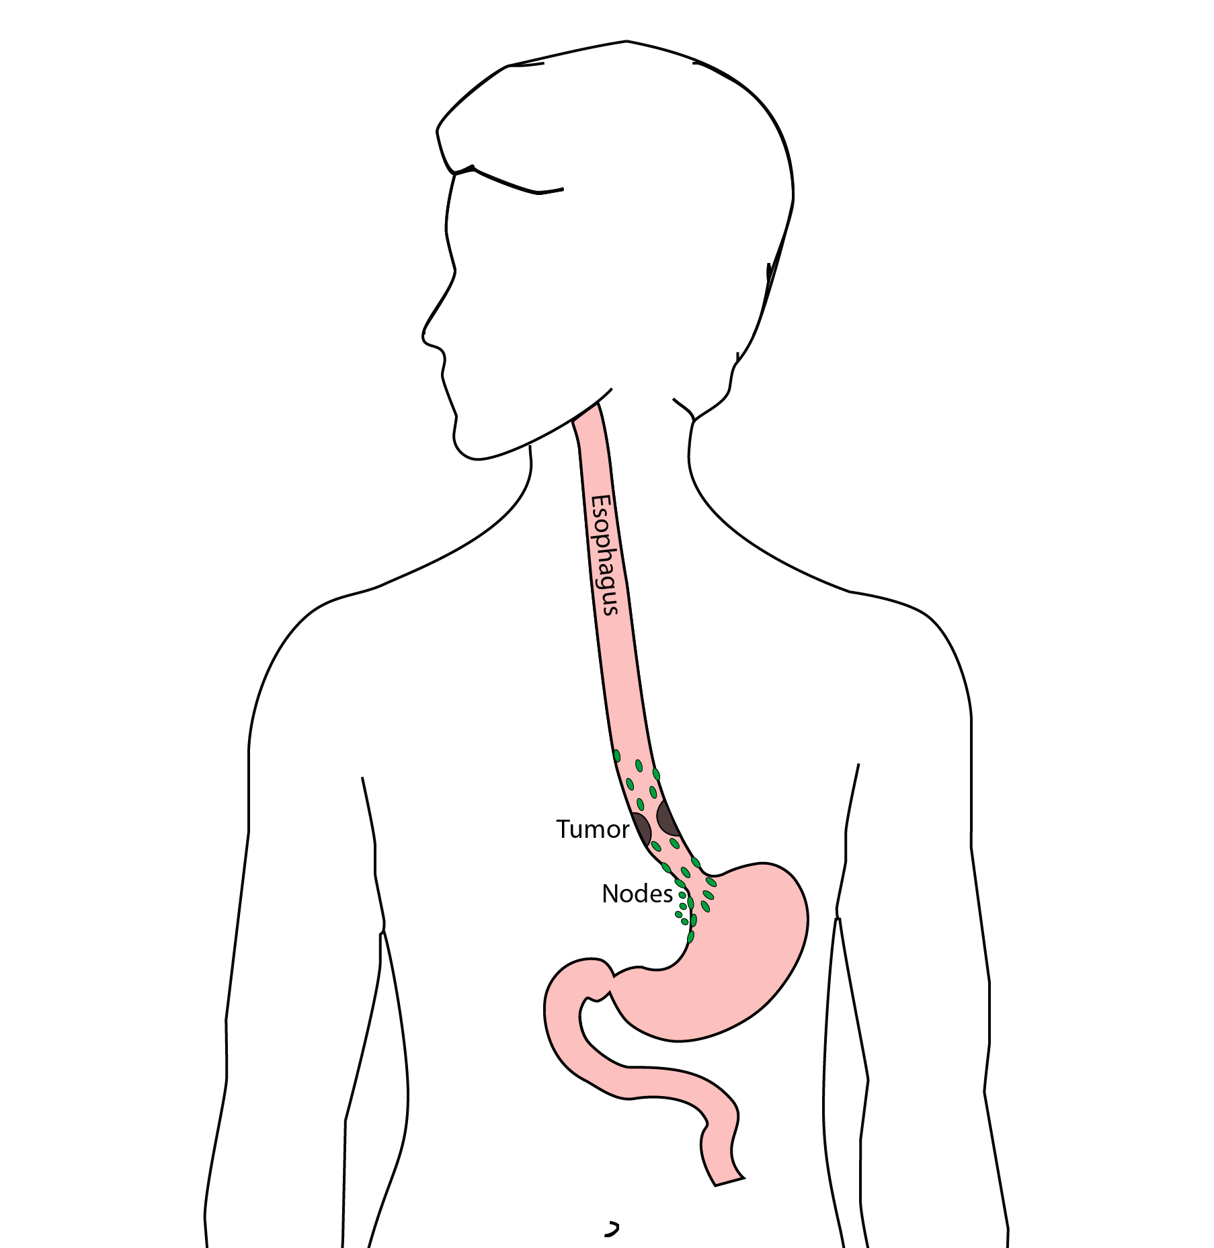

## 61 Ivor Lewis (Transthoracic) Esophagectomy

* Removes tumor and lower 1/3 esophagus
* Removes surrounding lymph nodes
* GI tract reconstructed

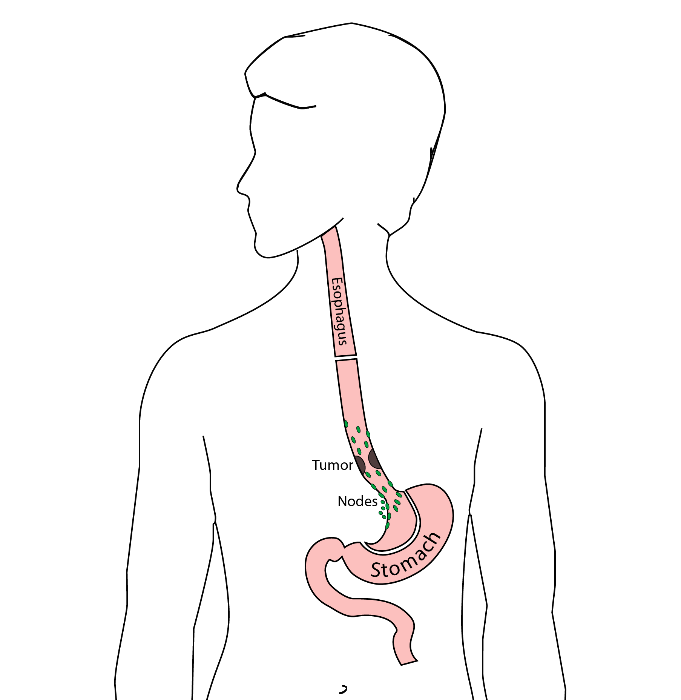

## 62 Reconstruction

New esophagus is created from the stomach in the abdomen by fashioning it into a tube.

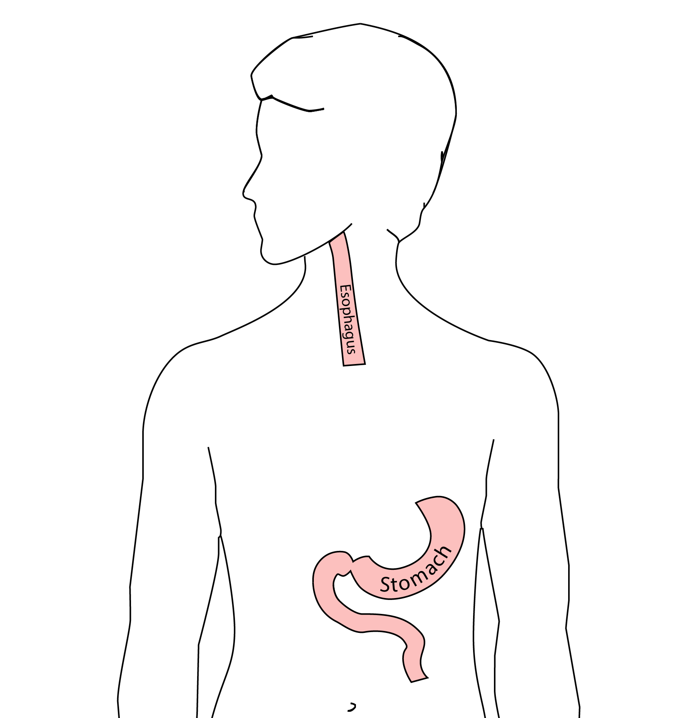

## 63 Ivor Lewis esophagectomy

The new esophagus is now brought up into the chest. A connection is made between the esophagus and the stomach, called an *anastomosis*.

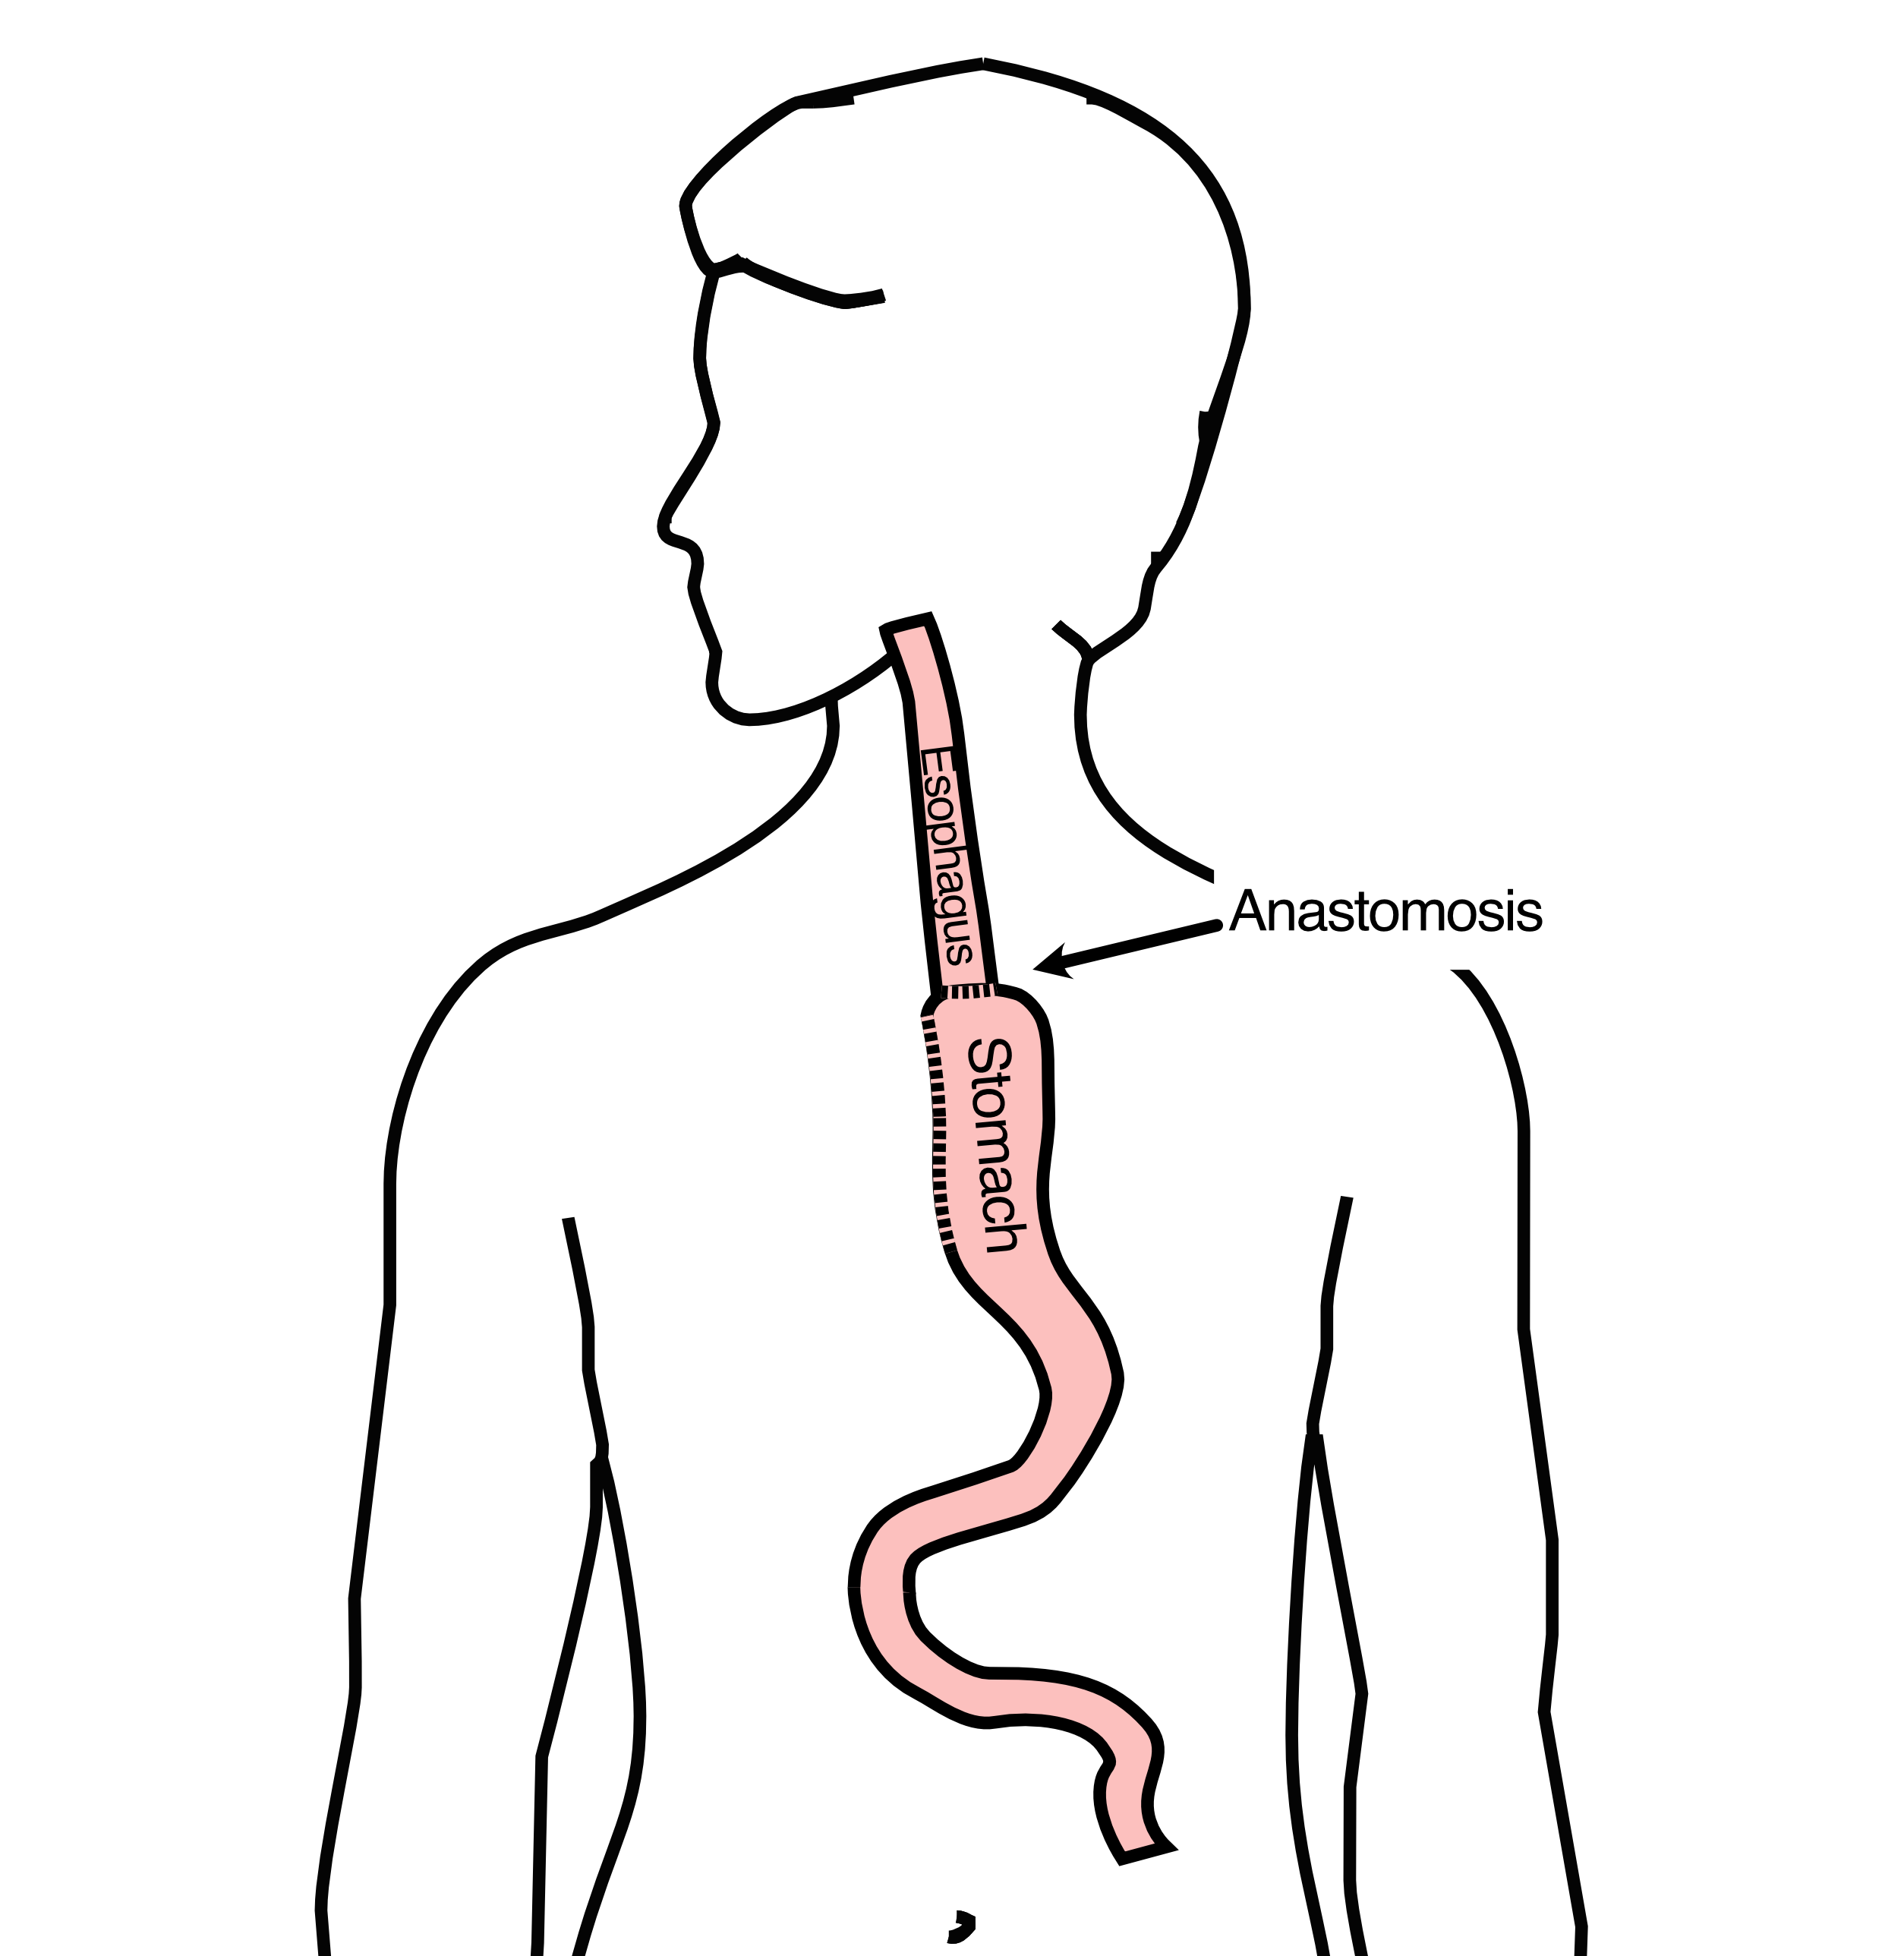

## 64 Minimally-invasive Ivor Lewis

* Small incisions abdomen and chest
* Surgical telescope and instruments
* Smaller incisions faster recovery and less discomfort

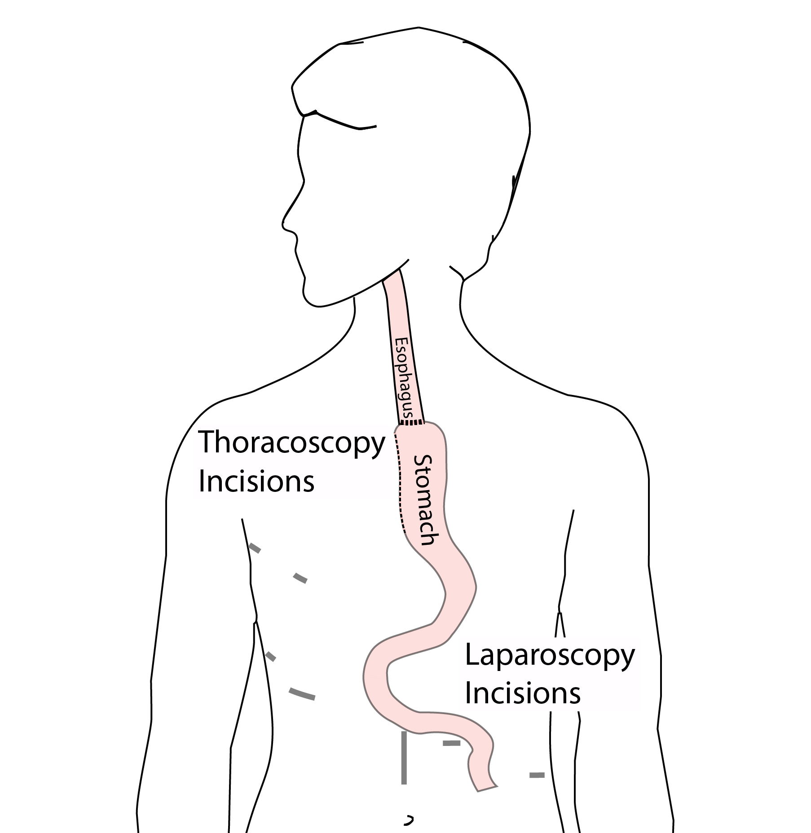

## 65 Open Ivor Lewis

Mininally-invasive approach feasible in 95% of cases

In some cases, an open approach is still necessary.

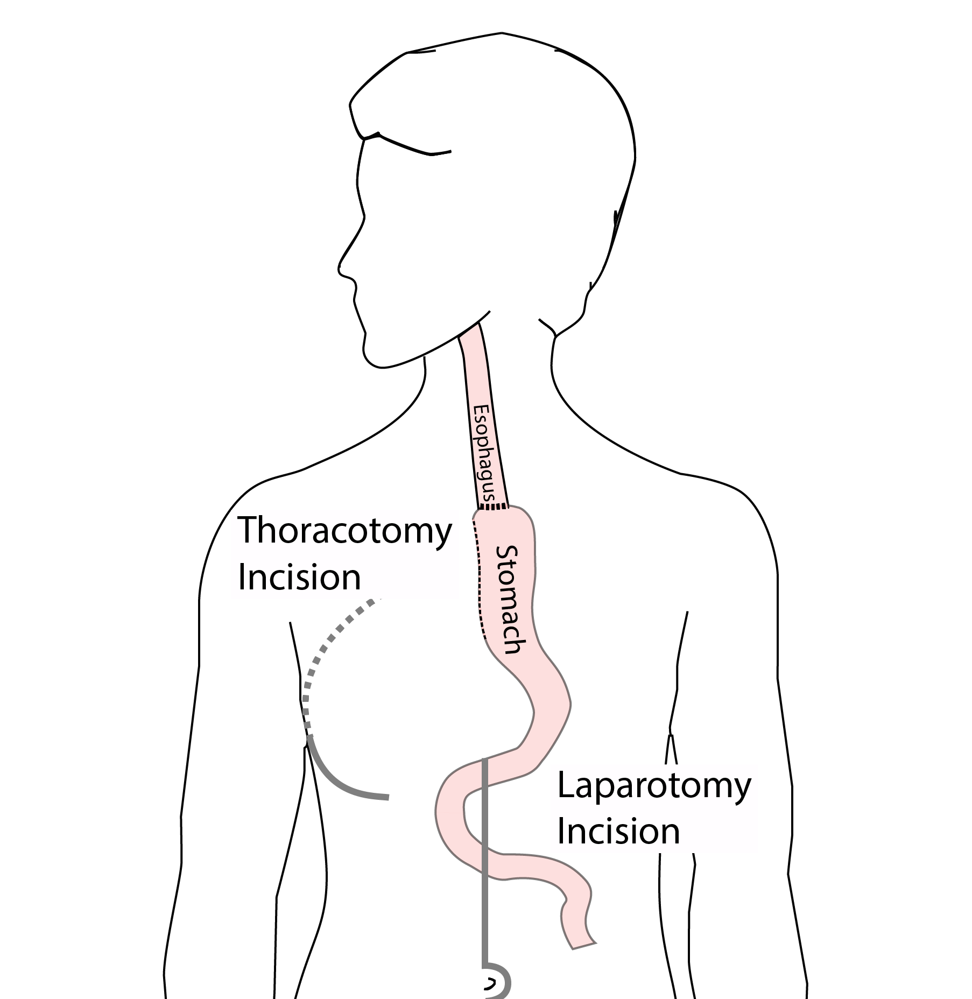

## 66 Total Esophagectomy

For patients with tumors in the upper esophagus, we need to remove more of the esophagus

We need to remove the whole esophagus, including the portion in the neck

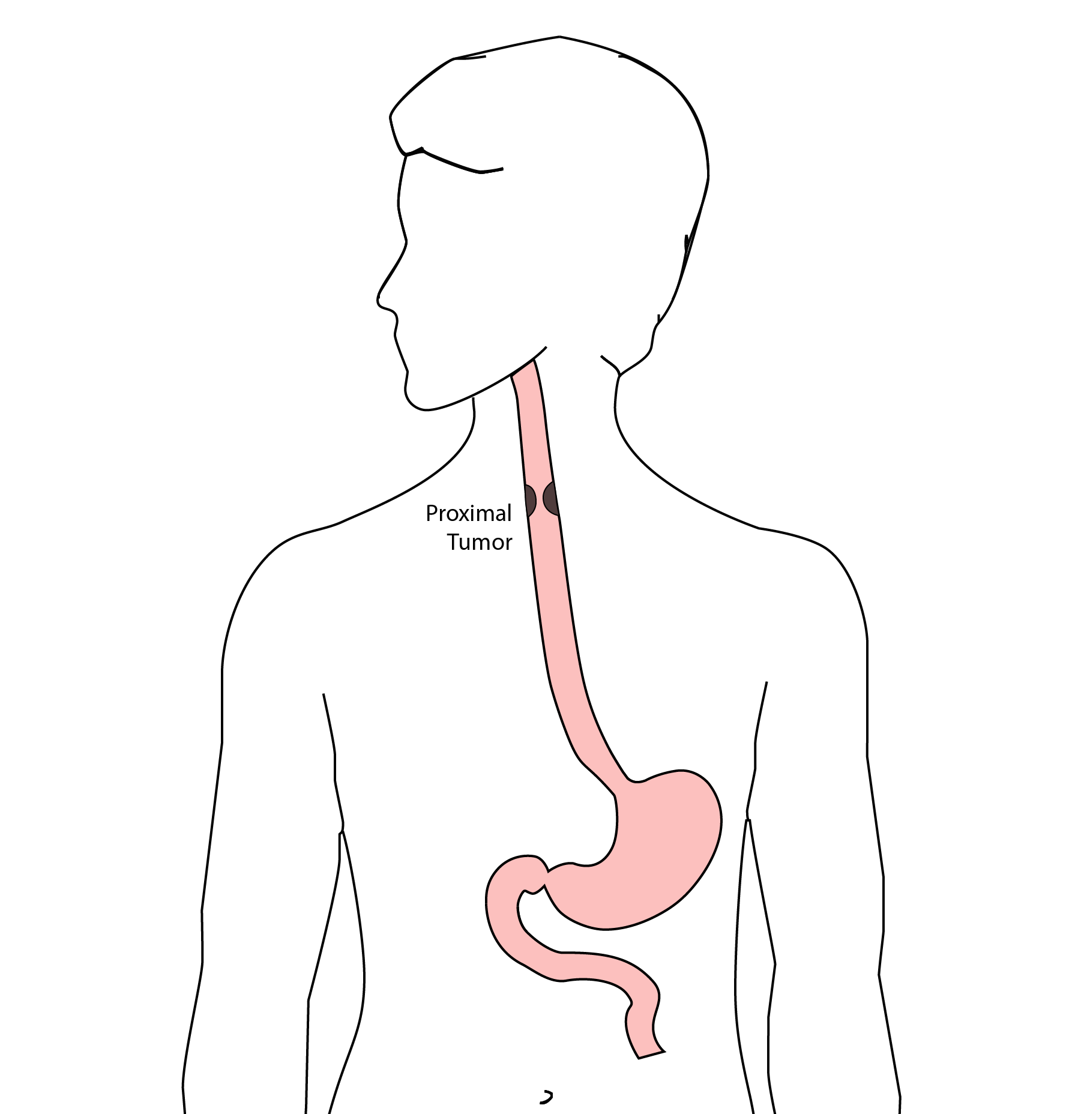

## 67 McKeown Esophagectomy

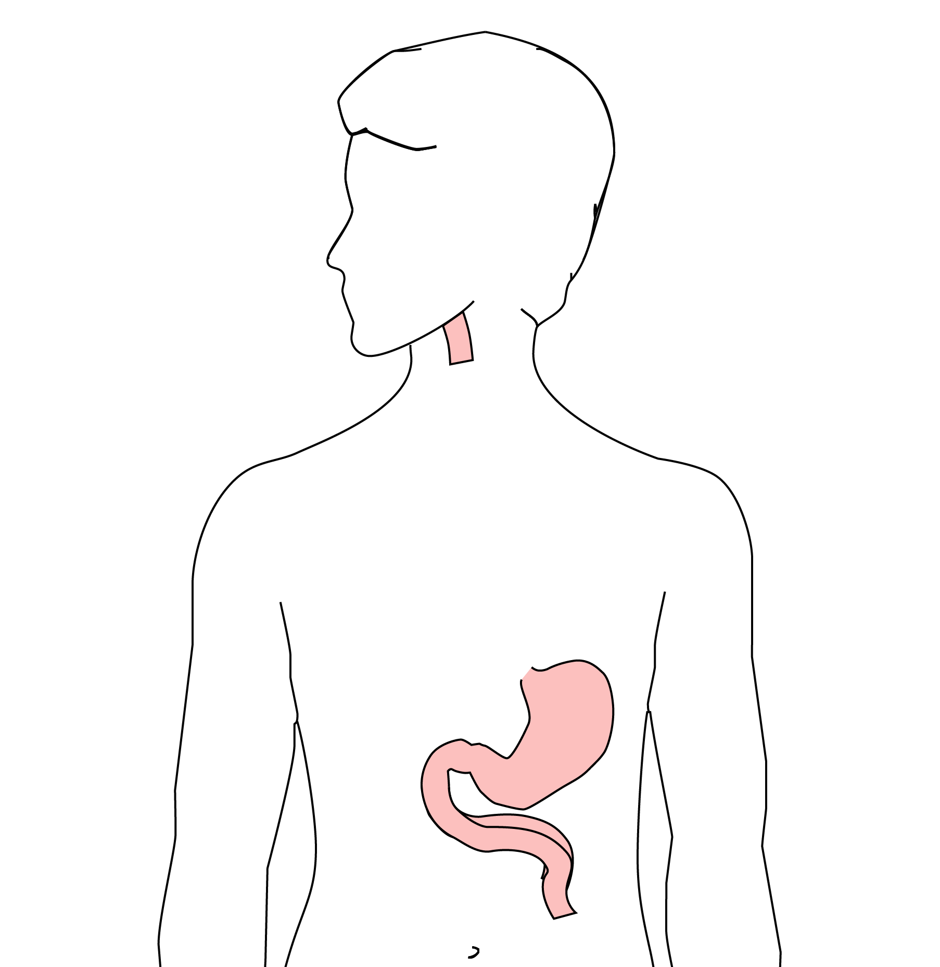 All of esophagus removed

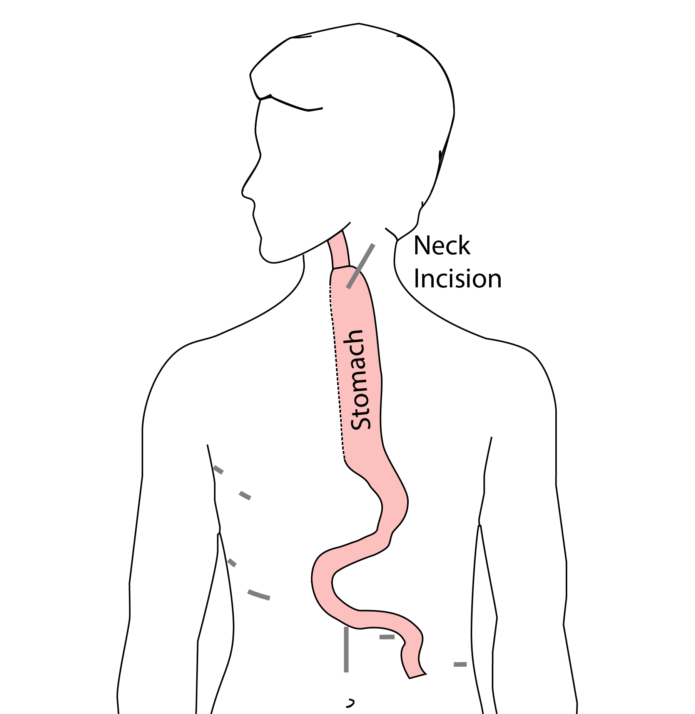 Connection made in the neck

## 68 Colon Interposition

If the stomach is not suitable to make a new esophagus, the colon can be used to replace the esophagus

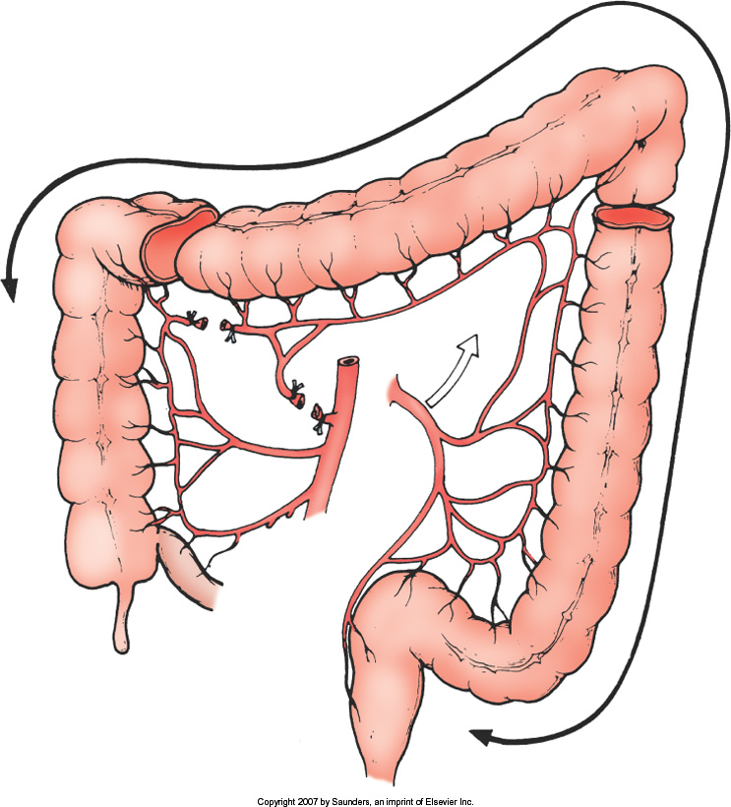

## 69 Colon Interposition

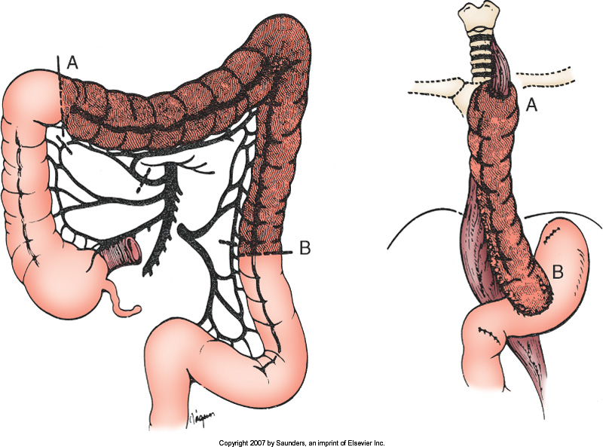

## 70 Risks of Esophagectomy

Esophagectomy is a complex operation, with a real risk of complications.

Two significant complications:

* Anastomotic leak
* Pneumonia

## 71 Anastomotic Leak

The anastomosis is surgical connection between the esophagus and the stomach.



## 72 Anastomotic Leak

If healing doesn’t occur:

* Leakage of fluid from the esophagus
* Infection in the space between the lungs
* Requires additional time in the hospital

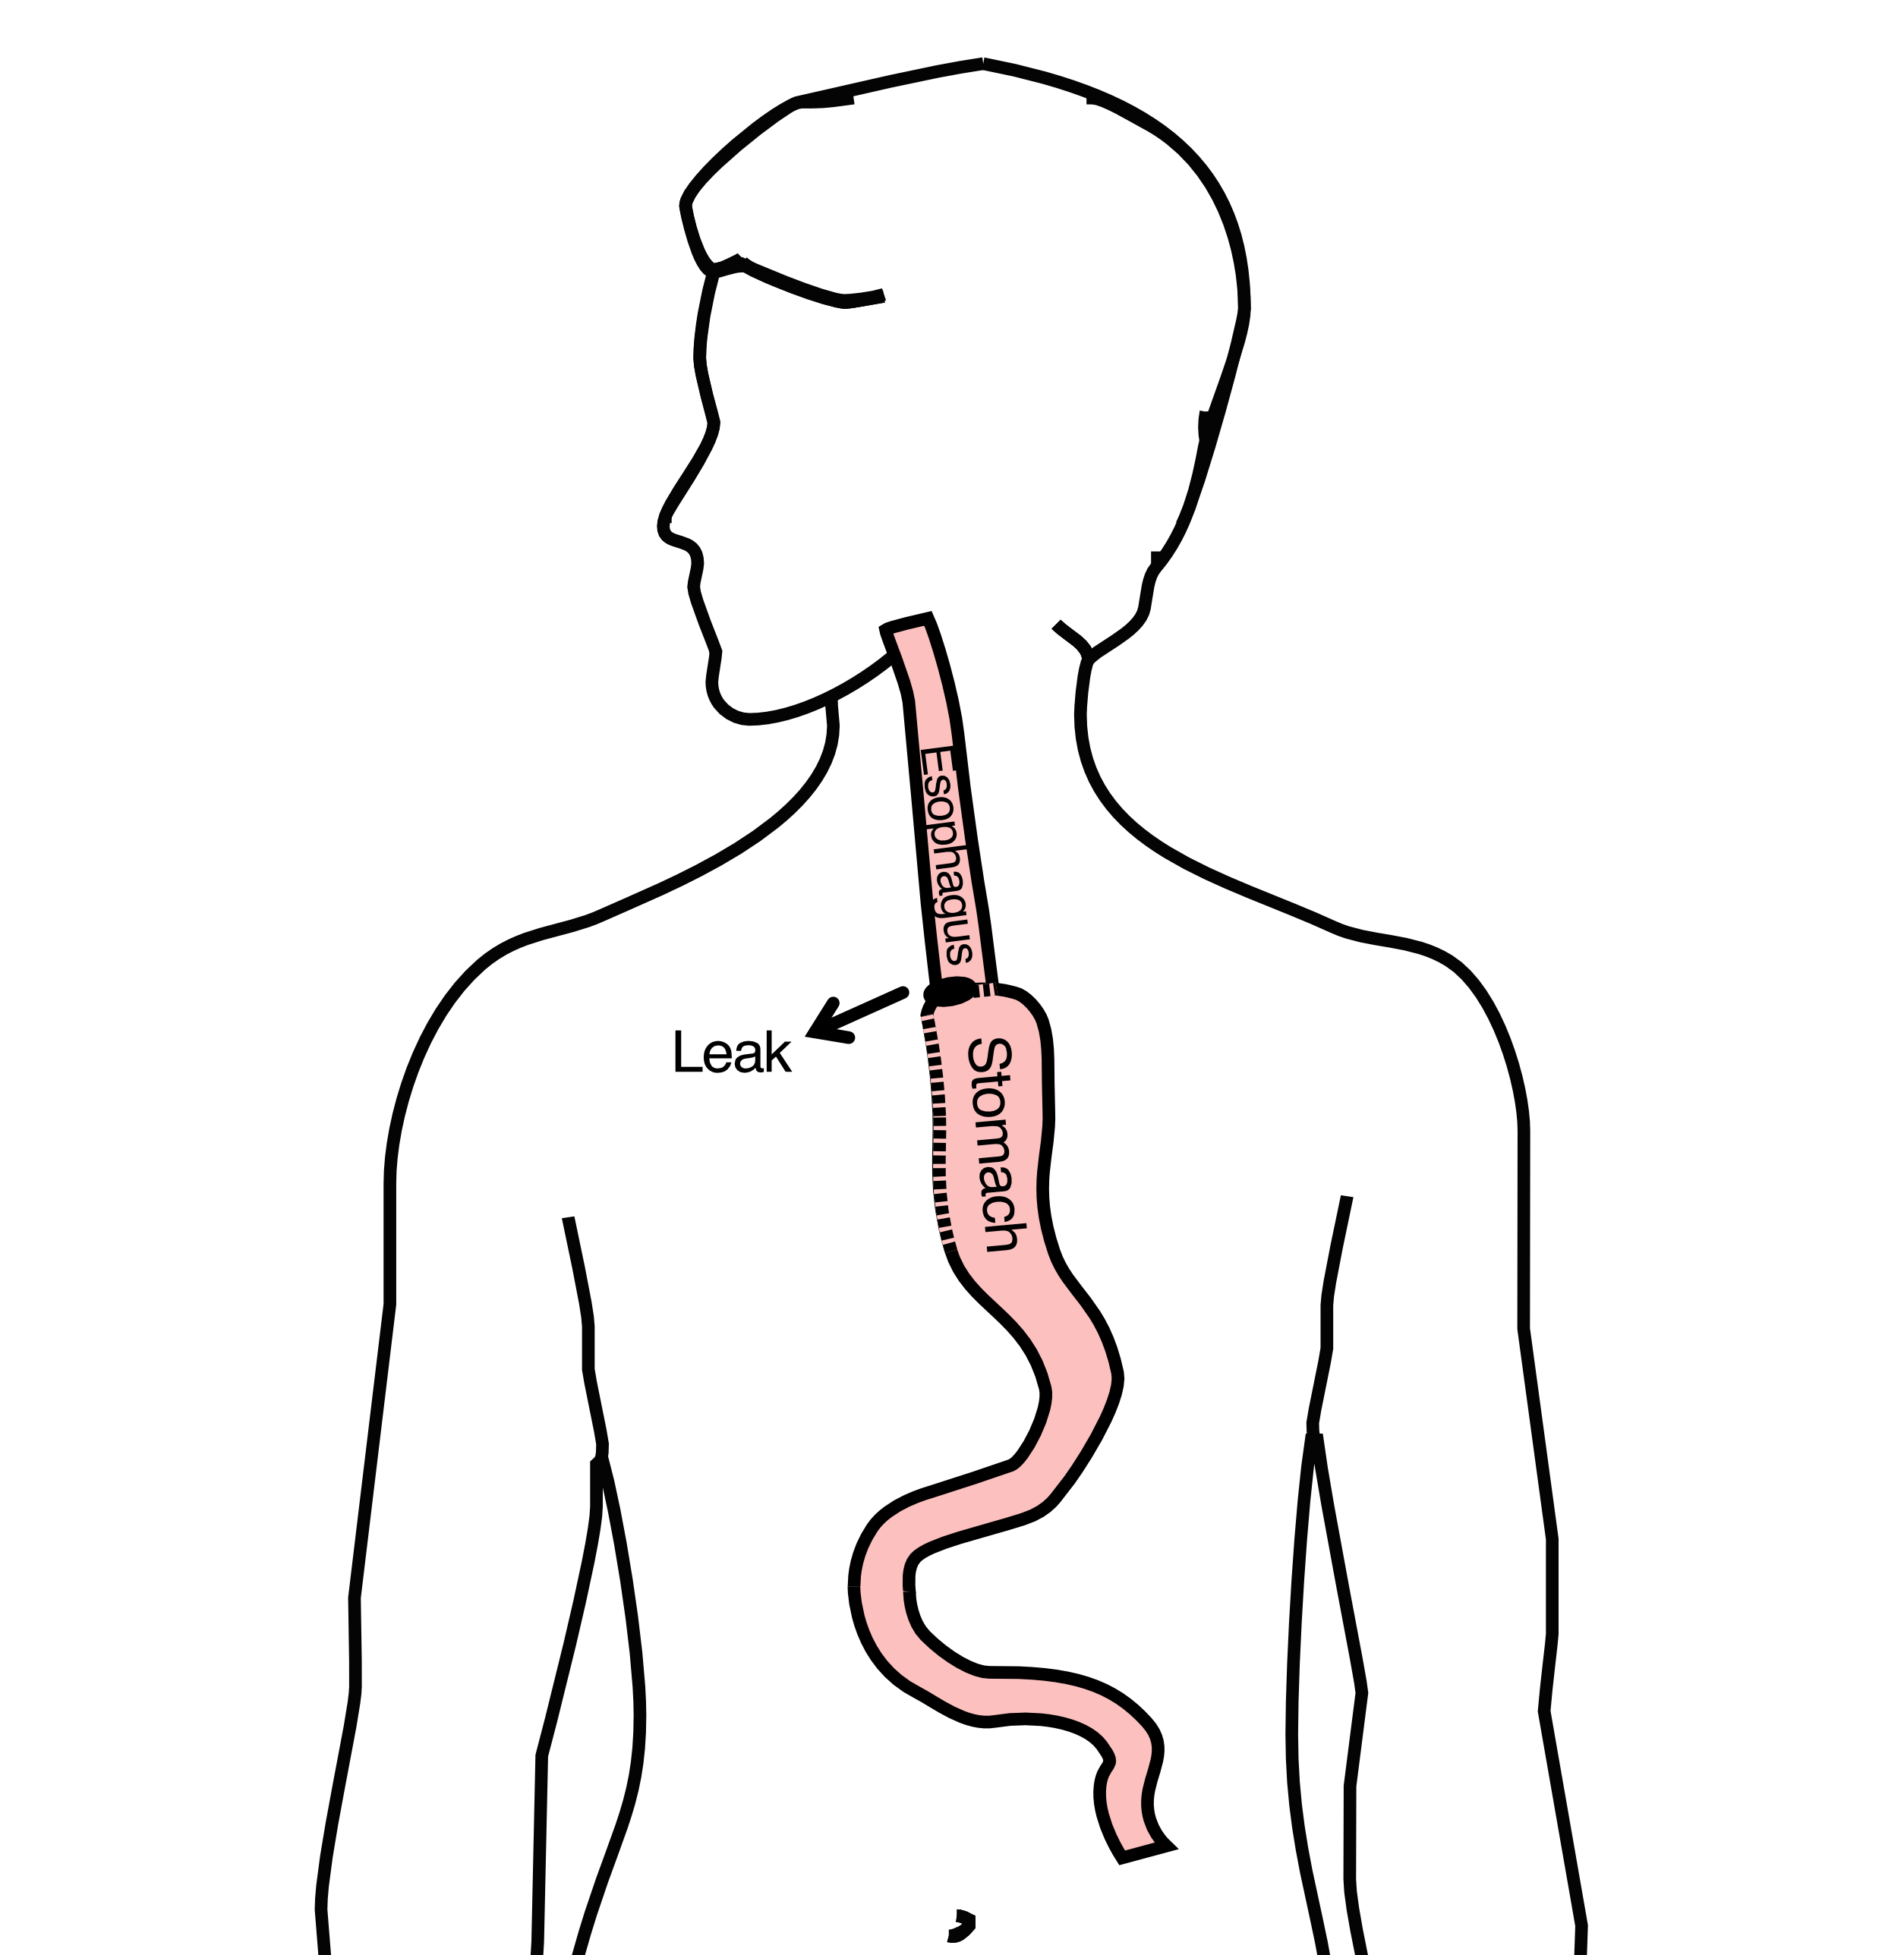

## 73 Anastomotic Leak

If leak occurs:

* Some leaks will seal
* Stent may be required to help healing
* Occasionally additional surgey is required



## 74 Anastomotic Leak

Risk of leak depends on:

* Type of operation performed
* Nutritional status of patient
* Experience of the surgeon



## 75 Pneumonia

* Occurs in 10-15% of patients after esophagectomy.
* Requires treatment with antibiotics
* Requires a longer hospitalization.

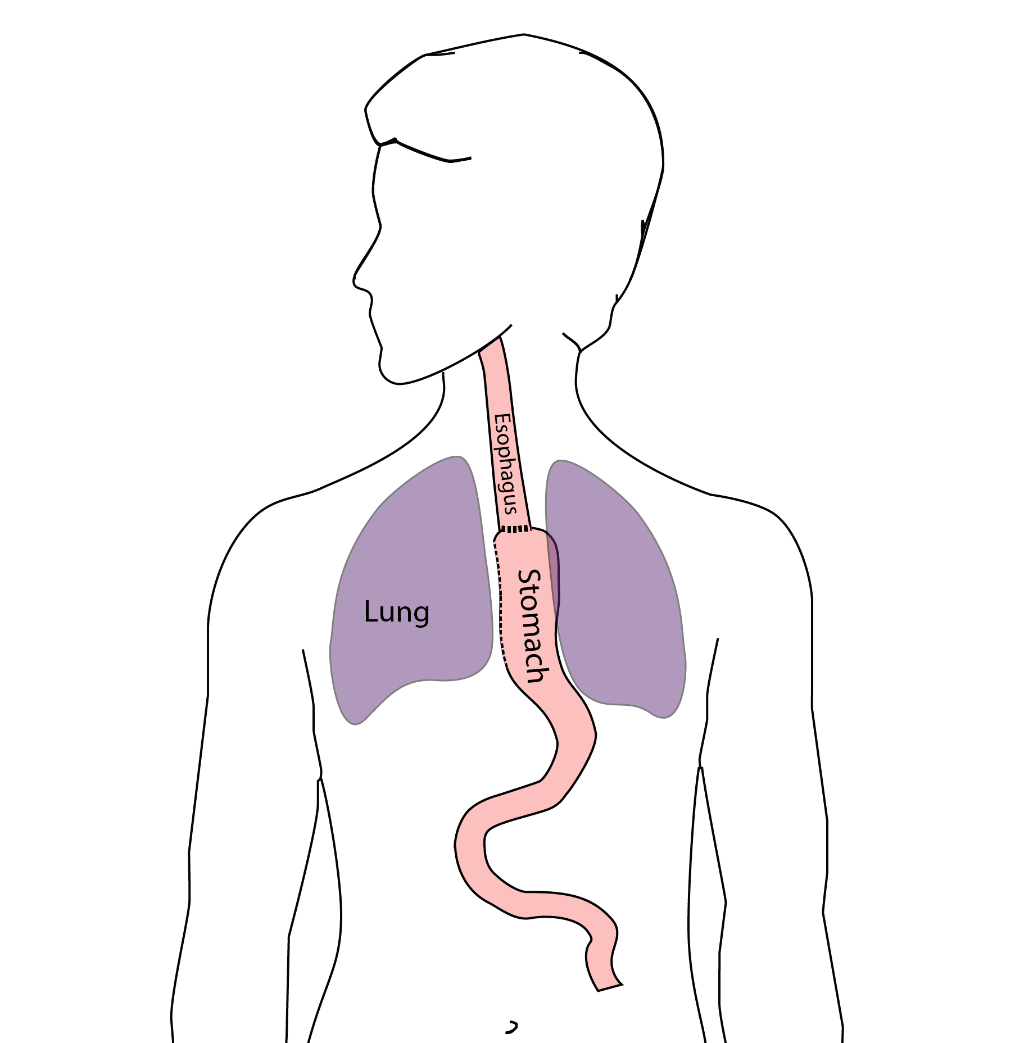

## 76 Preventing Pneumonia

Several ways to help prevent pneumonia:

* Deep breathing
* Coughing
* Walking

After surgery, this means:

* Sitting in a chair most of the day
* Walking in the halls as soon as possible

## 77 Minimally-invasive Esophagectomy

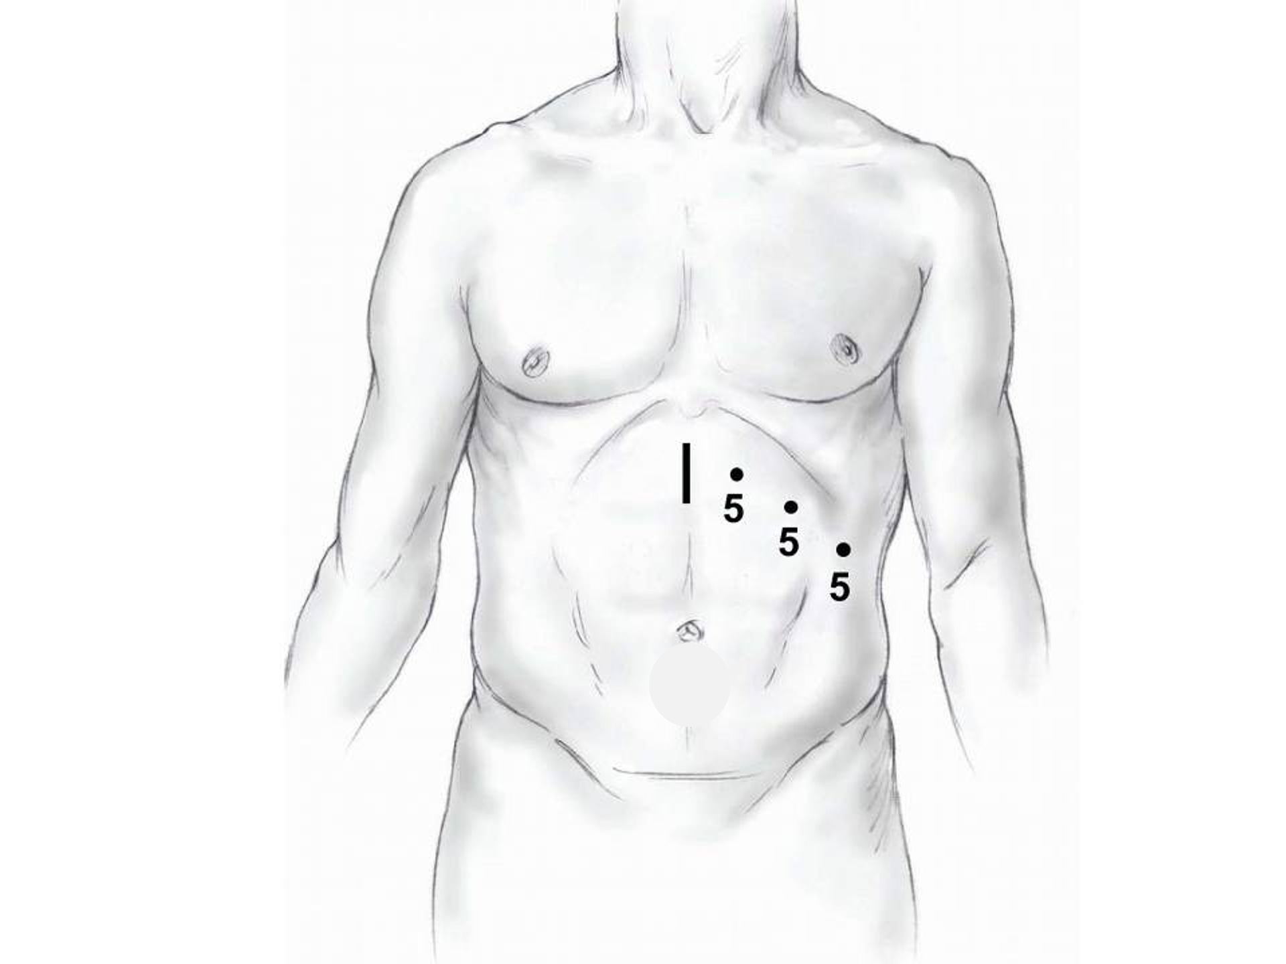

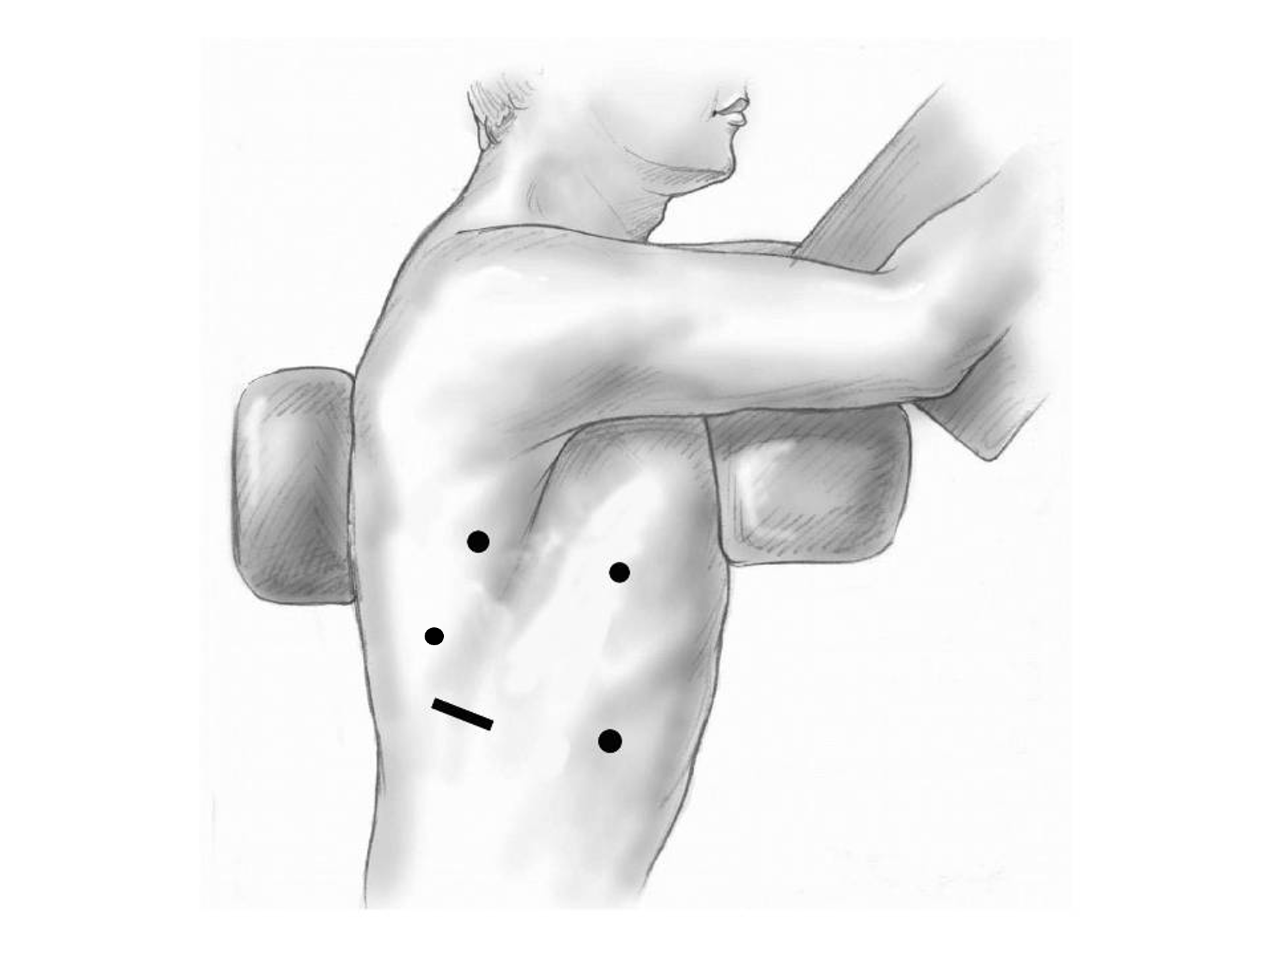

## 78 Risks of Surgery

Risks related to anesthesia

* Heart attack (5%)
* Irregular heart rhythm (15%)
* Pneumonia (10%)
* Blood clots in legs (<5%)
* Pulmonary embolism (2%)

## 79 Risks of Surgery

Risks related to Surgery

* Anastomotic leak (5%)
* Stricture at anastomosis (15%)
* Death within 90 days of surgery
  + Low risk patients = 2%
  + Intermediate risk = 10%
  + High risk = 30%

## 80 Risks of Surgery

Risks of Death within 90 Days of Surgery

|  | Age <75 | Age >75 |
| --- | --- | --- |
| Normal Muscle (75%) | 2% | 10% |
| Low Muscle (25%) | 10% | 30% |

## 81 Day Prior to Surgery

* Clear liquids for 24 hours prior to surgery
* Check with Pre-op nurse regarding medicines day prior to surgery
* No tube feedings the night before surgery

## 82 Day of Surgery

* Arrive at 5am – nothing to eat or drink after midnight.
* Medicines OK w/ a sip of water
* sip of black coffee but **no cream**.
* Surgery will be cancelled if you have cream/milk
* Waiting room for family and friends on 5th floor

## 83 Epidural Catheter for Pain Control

* Remains in place for 2-5 days
* Dosage can be adjusted as needed
* Can make it more difficult to urinate
* May require foley catheter in bladder
* Foley catheter removed after epidural removed

## 84 Intensive Care Unit (ICU) (2-4 days)

* Surgical ICU on 11th floor
* NG tube in nose to drain stomach and esophagus
* Catheter in bladder
* Chest tube right chest
* Abdominal drains (usually 2)
* Feeding jejunostomy (usually stays in 8 wks)

## 85 Intensive Care Unit (ICU)

* Bladder catheter removed → check that bladder empties properly
* Chest tube removed (day 2-4) → follow-up x-ray
* Fluid emptied from drains every few hours
* Start tube feedings by feeding
* Feeding jejunostomy (stays in 8 weeks)

## 86 Ward - 6Tower

* Jejunostomy feeds started
* Up in a chair most of the day
* Walking in the halls
  + Start with assistance
  + Improves lung function
  + Prevents loss of muscle strength

## 87 Jejunostomy Feeds

Jejunostomy tube feeds

* Start continuous (24 hours)
* Convert to night-time only (16 hours)

Water administered through feeding tube

* Usually 8oz 4 times/day
* Important to prevent dehydration

## 88 Jejunostomy Tube

## 89 Jejunostomy Typical Regimen

* Jejunostomy tube feeds for 16 hours (6pm-10am)
  + Men: 75mL/hour x 16 hours = 5 cartons
  + Women: 60mL/hour x 16 hours = 4 cartons
* Water 240ml (8oz) via syringe 4x/day

Hospital nurses will teach use of the feeding tube

## 90 Jejunostomy Feeds with Diabetes

Jejunostomy feedings elevate blood sugars

* Insulin may be required along with feeds

Typical Pattern for tube feeds

* Feeds run via pump from 6pm to 10am
* Insulin at 6pm (70/30 insulin)
* Insulin at Midnight (70/30 insulin)
* No insulin if tube feedings are not run

## 91 Jejunostomy Video

## 92 Activity after Surgery

* Up in chair most of the day
* Walking with help from nurse/Physical Therapist
* Goals:
  + Improve lung function
  + Prevent muscle loss

## 93 Nasogastric (NG) Tube

Tube passed through nose into stomach

* Drains fluid from stomach
* Prevents vomiting

Upper GI X-ray on 2nd or 3rd day after surgery

* If stomach empties well NG tube removed
* Otherwise, X-ray repeated 2-3 days later

## 94 Swallowing Evaluation

Once NG tube has been removed:

Modified barium swallow in radiology

* Drink a white chalky liquid (barium)
* Look for proper swallowing function
* 70% of patients liquids started by mouth

## 95 Oral Intake at Home

Most are taking protein shakes when they go home

Protein shakes are started after tolerating water

* 2 oz per hour to start
* 4 oz per hour if 2oz are tolerated well

## 96 Discharge

Goal: ready to leave day #6/7 after surgery

* Night-time tube feedings (6pm to 10am)
* Nutrition by mouth (70% of patients)
  + 1 oz of water per hour by mouth OR
  + Protein shakes 4oz every 2 hours
* Water through tube 8oz four times per day
* Home care nursing (feeding tube teaching)
* Home infusion (tube feeding supplies)

## 97 Nutrition after Surgery

At discharge home:

* Protein shakes 4oz every 2 hrs
* Tube feeds 4-5 cans at night (6pm-10am)

10-12 Days: Increase protein shakes

* Tube feeds 3-4 cans at night

Three weeks: Post-esophagectomy Diet

8-12 weeks: Remove feeding tube (in office)

## 98 Transition from Tube Feeds Eating

Dietitian will calculate daily protein goal

* Typically 60-75 grams protein/day
* Each carton of tube feeding has 15 grams
  + 75 grams protein = 5 cartons/night
* More intake by mouth tube feeds reduced

Spread out protein during the day (20gm/meal)

* Three meals + 2-3 high-protein snacks

## 99 Post-esophagectomy Diet

* Soft Consistency
* High Protein
* Avoid sugary liquids (can cause ‘dumping’)
* Avoid raw vegetables (and salads)
* Eating
  + Small, frequent meals
  + Sit up for 30-45 minutes after eating
  + Avoid eating within 2 hours of bedtime

## 100 Medicines at Home - Pain

Acetaminophen (Tylenol) 1000mg 4x/day

Gabapentin 300mg 3 times/day

Oxycodone

* As needed in addition to Tylenol/gabapentin
* Will begin reducing dose at first postop visit
* Can usually discontinue by 4 weeks
* NO DRIVING WHILE ON OXYCODONE

## 101 Non-steroidals Anti Inflammatory (NSAID)

Non-steroidal anti-inflammatories (Celebrex)

* 200 mg every 12 hours starting at 2 weeks

NO GOODY POWDERS OR BCs

* (Can cause permanent scarring at the surgery site)

## 102 Acid Blockers = Proton Pump Inhibitors

Examples include ompeprazole and pantoprazole

* Will stay on for at 1-2 years to prevent acid reflux
* Important in preventing scarring at anastomosis (new connection between esophagus and stomach)
* To administer through feeding tube, open capsule and resuspend beads in 60mL (2oz) of water

## 103 Medicines at Home

Reglan – Helps stomach empty

* Will plan to stop after six weeks
* 0.1% risk of tardive dyskinesia (nervous tic)

Remeron – Helps improve appetite

* Can cause vivid dreams
* Used for several weeks after surgery
* Will stop within first three months of surgery

## 104 Metoprolol = Beta Blockers

* Slows heart rate and lowers blood pressure
* Used to prevent rapid heart rate
* Patients not taking a beta blocker prior to surgery wean after after surgery
* Patients taking a beta blockerprior to surgery return to prior dose and drug after surgery

## 105 Sleeping at Home

Reflux can occur the first few weeks/months after surgery

This improves over the first few months

A wedge pillow can be helpful for sleep

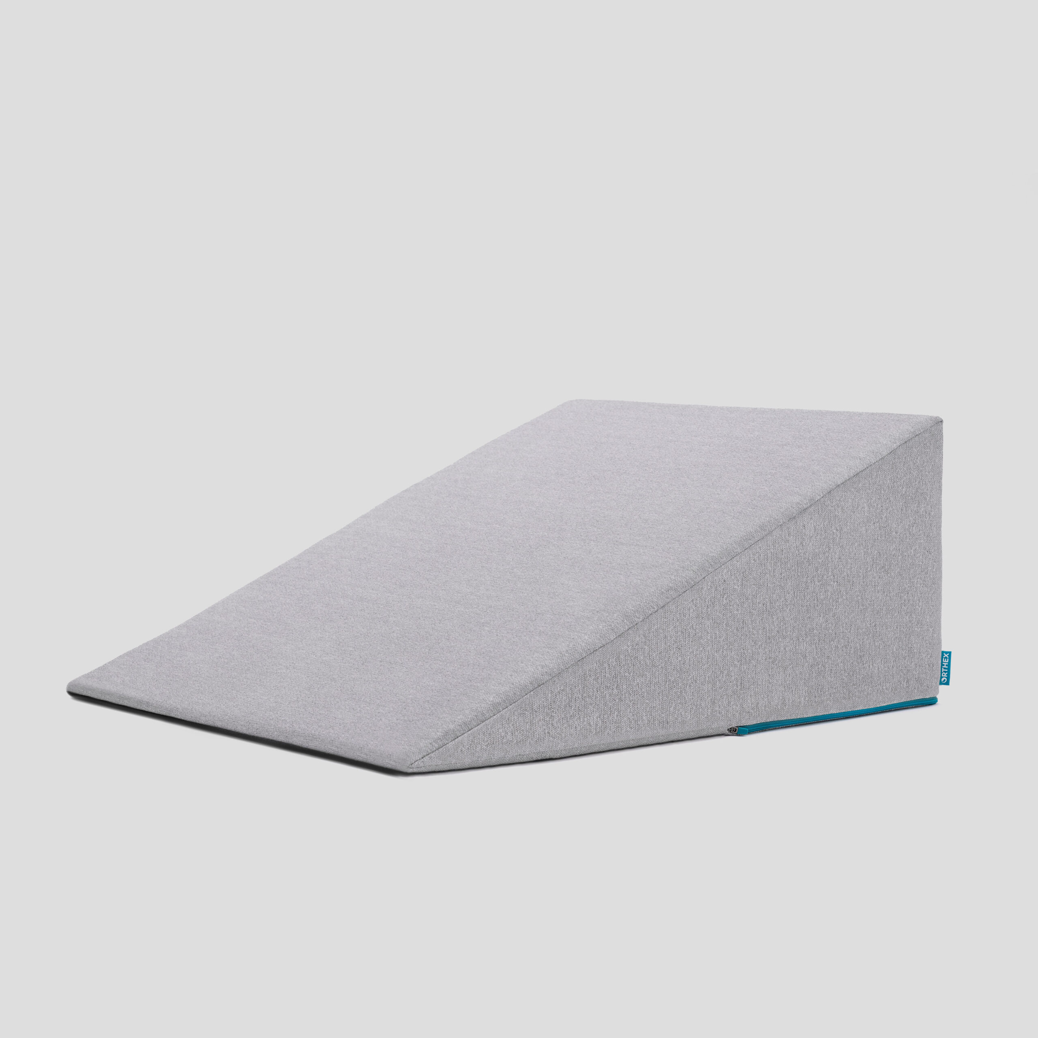

## 106 Postoperative Visit at 7-10 Days

Check surgical site

* Remove staples (if needed)

Adjust medicines as needed

* Insulin (for diabetic patients on insulin)
* Reduce beta blocker medicines

Advance diet

Reduce tube feeds

## 107 After surgery

Wean off medicines added after surgery

* Pain medicines
* Beta-blockers
* Reglan and Remeron

Continue acid blockers for at least 1 year

## 108 Jejunostomy Removal

Jejunostomy tube is removed in the office once you can take in enough nutrients by mouth

Removal usually around 8 weeks after surgery

May take 30 minutes and some local anesthetic to loosen up the tube for removal.

## 109 Nutritional Monitoring after Surgery

You may have difficulty absorbing some nutrients:

* Iron
* Vitamin B12
* Vitamin D

## 110 Nutritional Monitoring after Surgery

About 3 months after the jejunostomy tube is removed, we will check blood levels:

* Iron (ferritin)
* Vitamin B12
* Vitamin D

## 111 Nutritional Replacements after Surgery

Vitamin or iron replacements can be ordered by:

* Primary Care Provider (PCP)
* Medical Oncologist
* Surgeon

If levels are low

* Replacement
* Repeat testing in 3-6 months

## 112 Team Members - Physicians

Primary Care Provider

Gastroenterologist

Medical Oncologist (chemotherapy)

Radiation Oncologist (radiation)

Surgeons

* Jonathan Salo
* Jeffrey Hagen
* Michael Roach

## 113 Team Members - Support Staff

Dietitian - Liz Koch

Nurses - Brandon Galloway - Kit Sluder - Sarah Ezell - Rebecca Wicks

Navigator - Laura Swift