Surgery of the Esophagus

## 1 Surgery for Esophageal Cancer

Surgery for esophageal cancer is performed in several situations:

* Superficial Tumors (T1) not completely removed by endoscopy
* Localized Tumors (T2N0)
* Locally Advanced (T3) after preoperative therapy.

## 2 Goals of Surgery

* Remove tumor from esophagus
* Remove surrounding lymph nodes
* Create a new esophagus

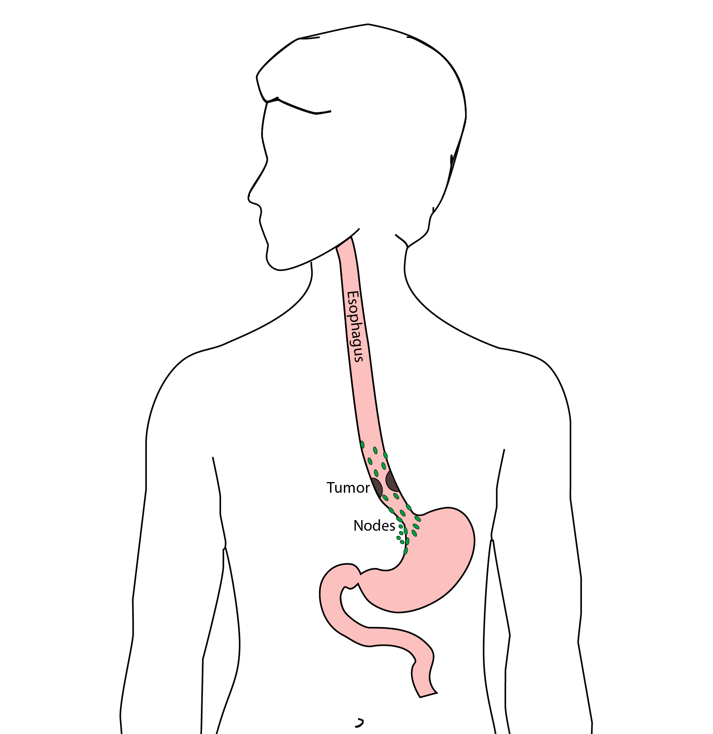

## 3 Ivor Lewis (Transthoracic) Esophagectomy

* Removes tumor
* Removes lower 1/3 of esophagus
* Removes surrounding lymph nodes
* Reconstruction of GI tract

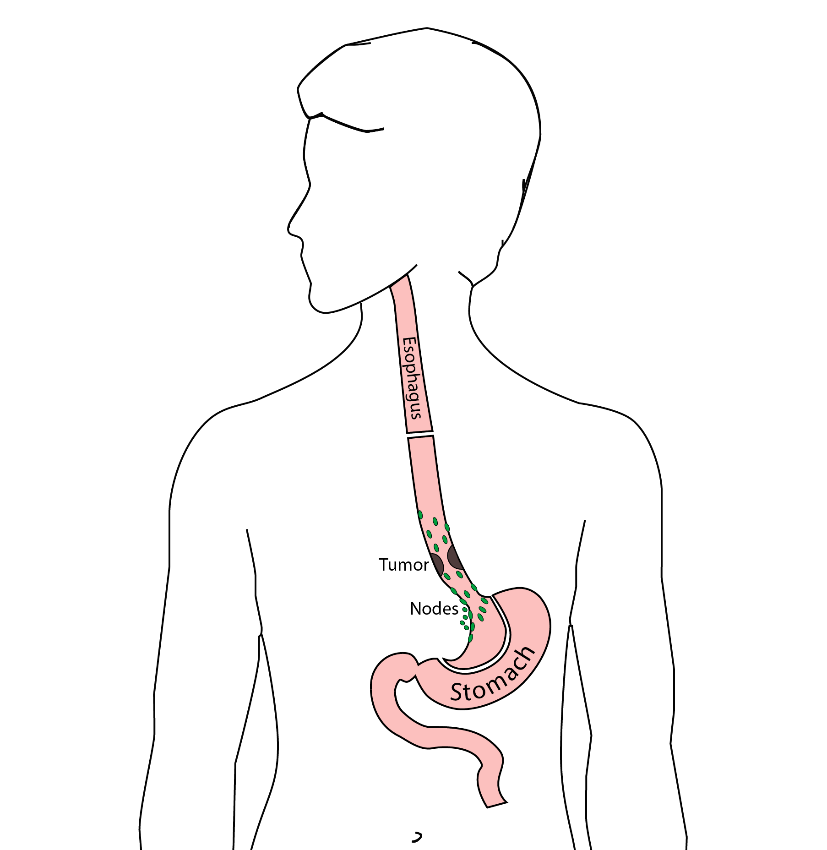

## 4 Reconstruction

A new esophagus is created from the stomach in the abdomen by fashioning it into a tube.

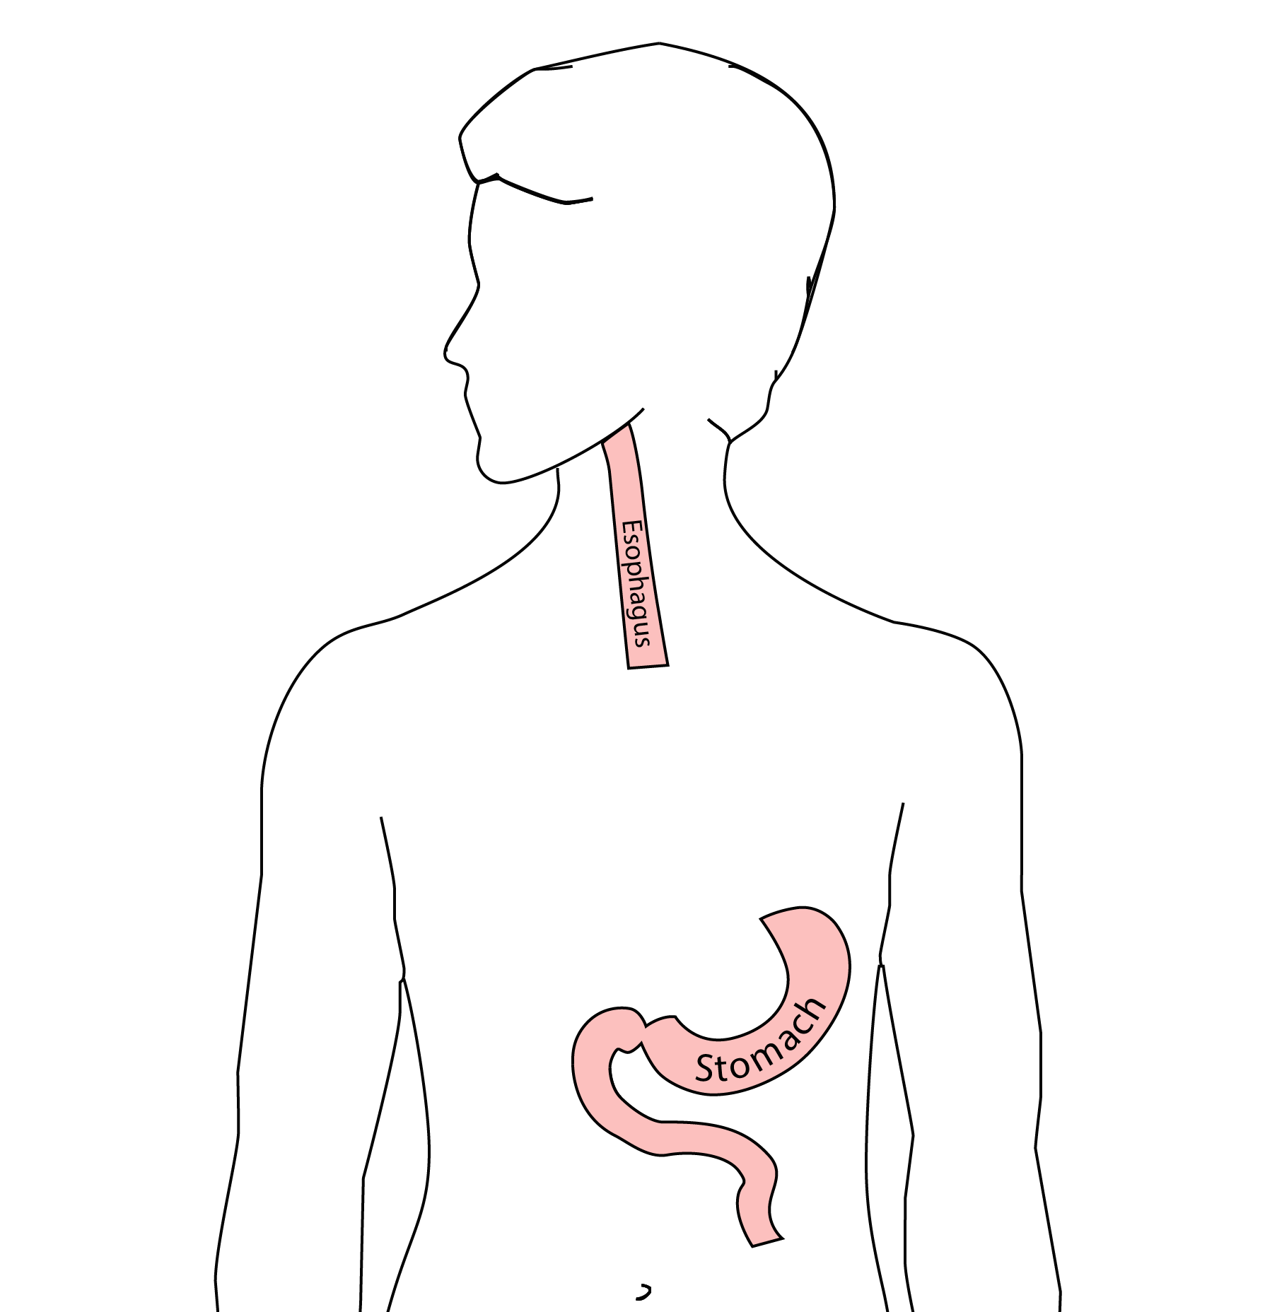

## 5 Ivor Lewis esophagectomy

The new esophagus is now brought up into the chest. A new connection is made between the esophagus and the stomach, called an *anastomosis*.

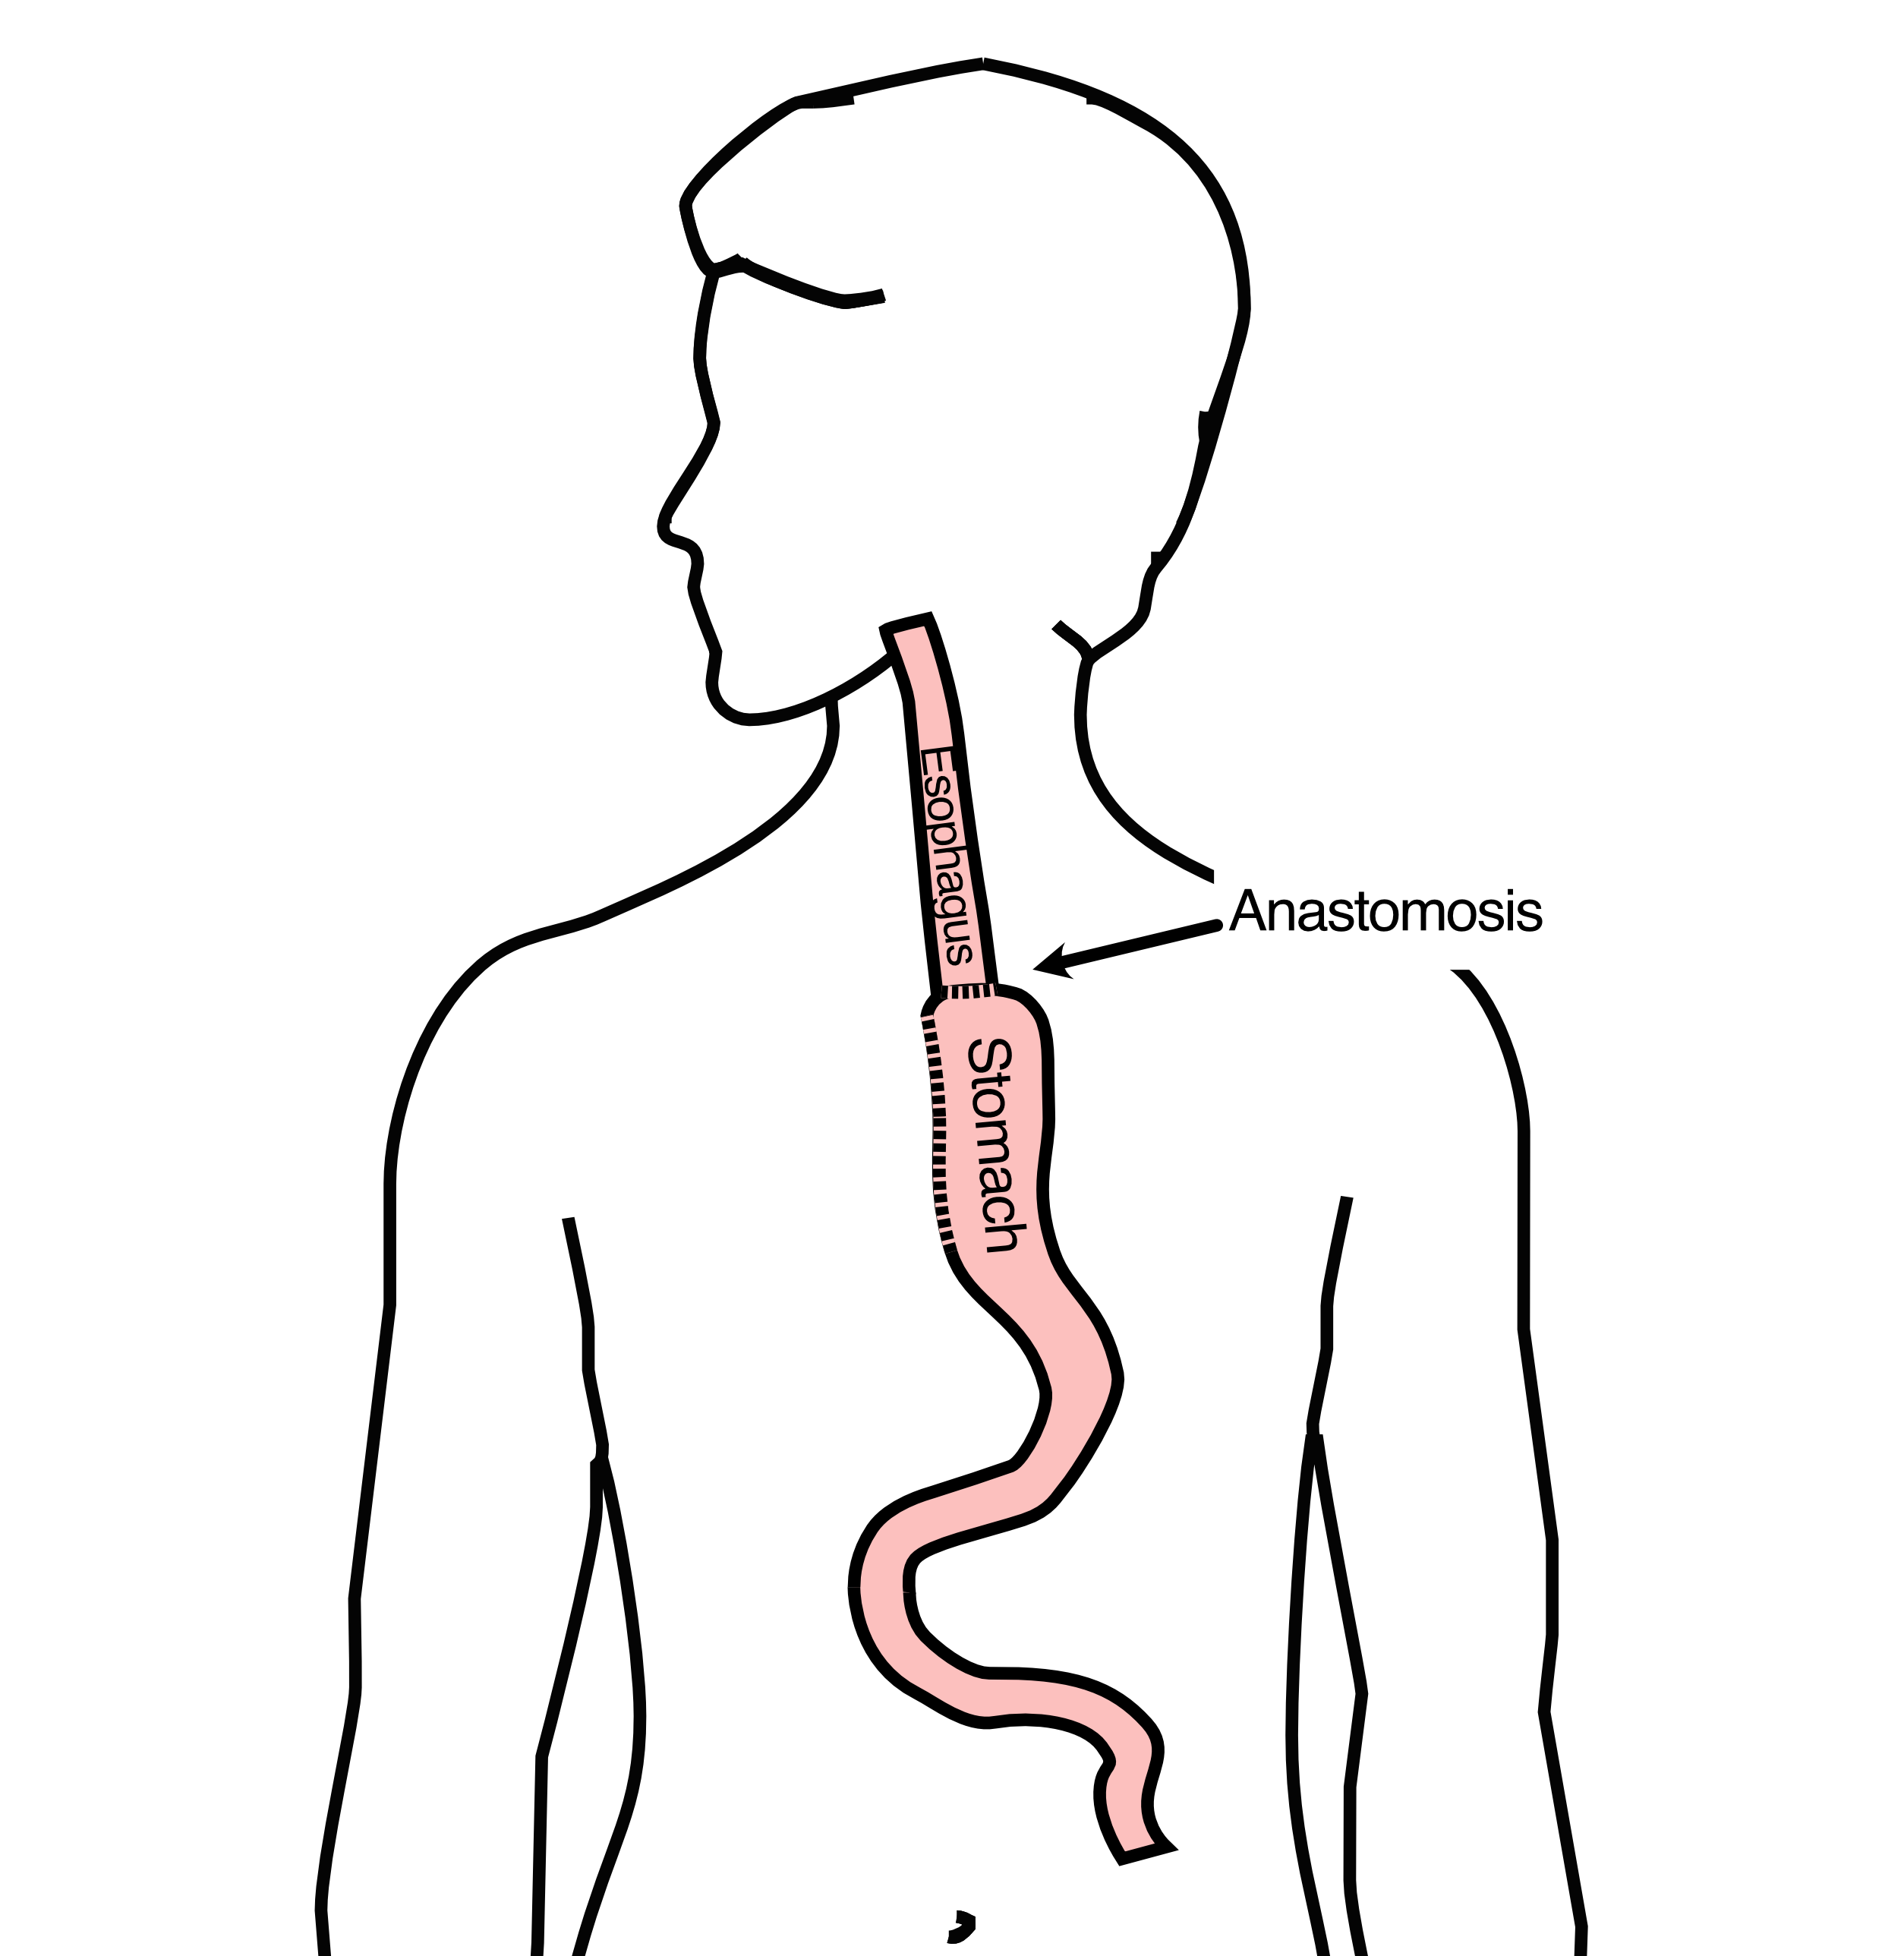

## 6 Minimally-invasive Ivor Lewis

* Small incisions abdomen and chest
* Surgical telescope and instruments
* Smaller incisions faster recovery and less discomfort

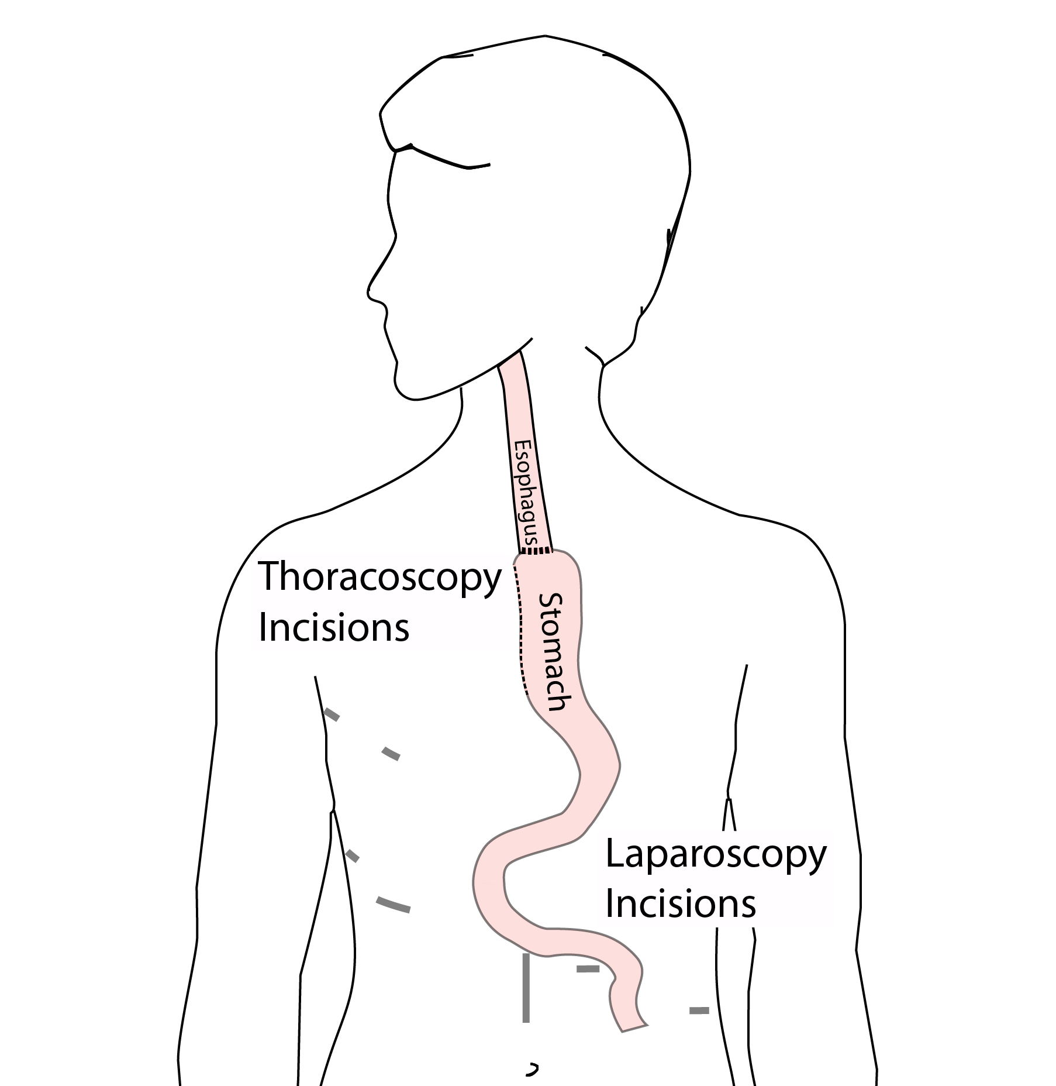

## 7 Minimally-invasive Ivor Lewis

We have found this is the best option for most of our patients. In some cases, an open approach is still necessary.



## 8 Open Ivor Lewis

In some cases, an open approach is still necessary.

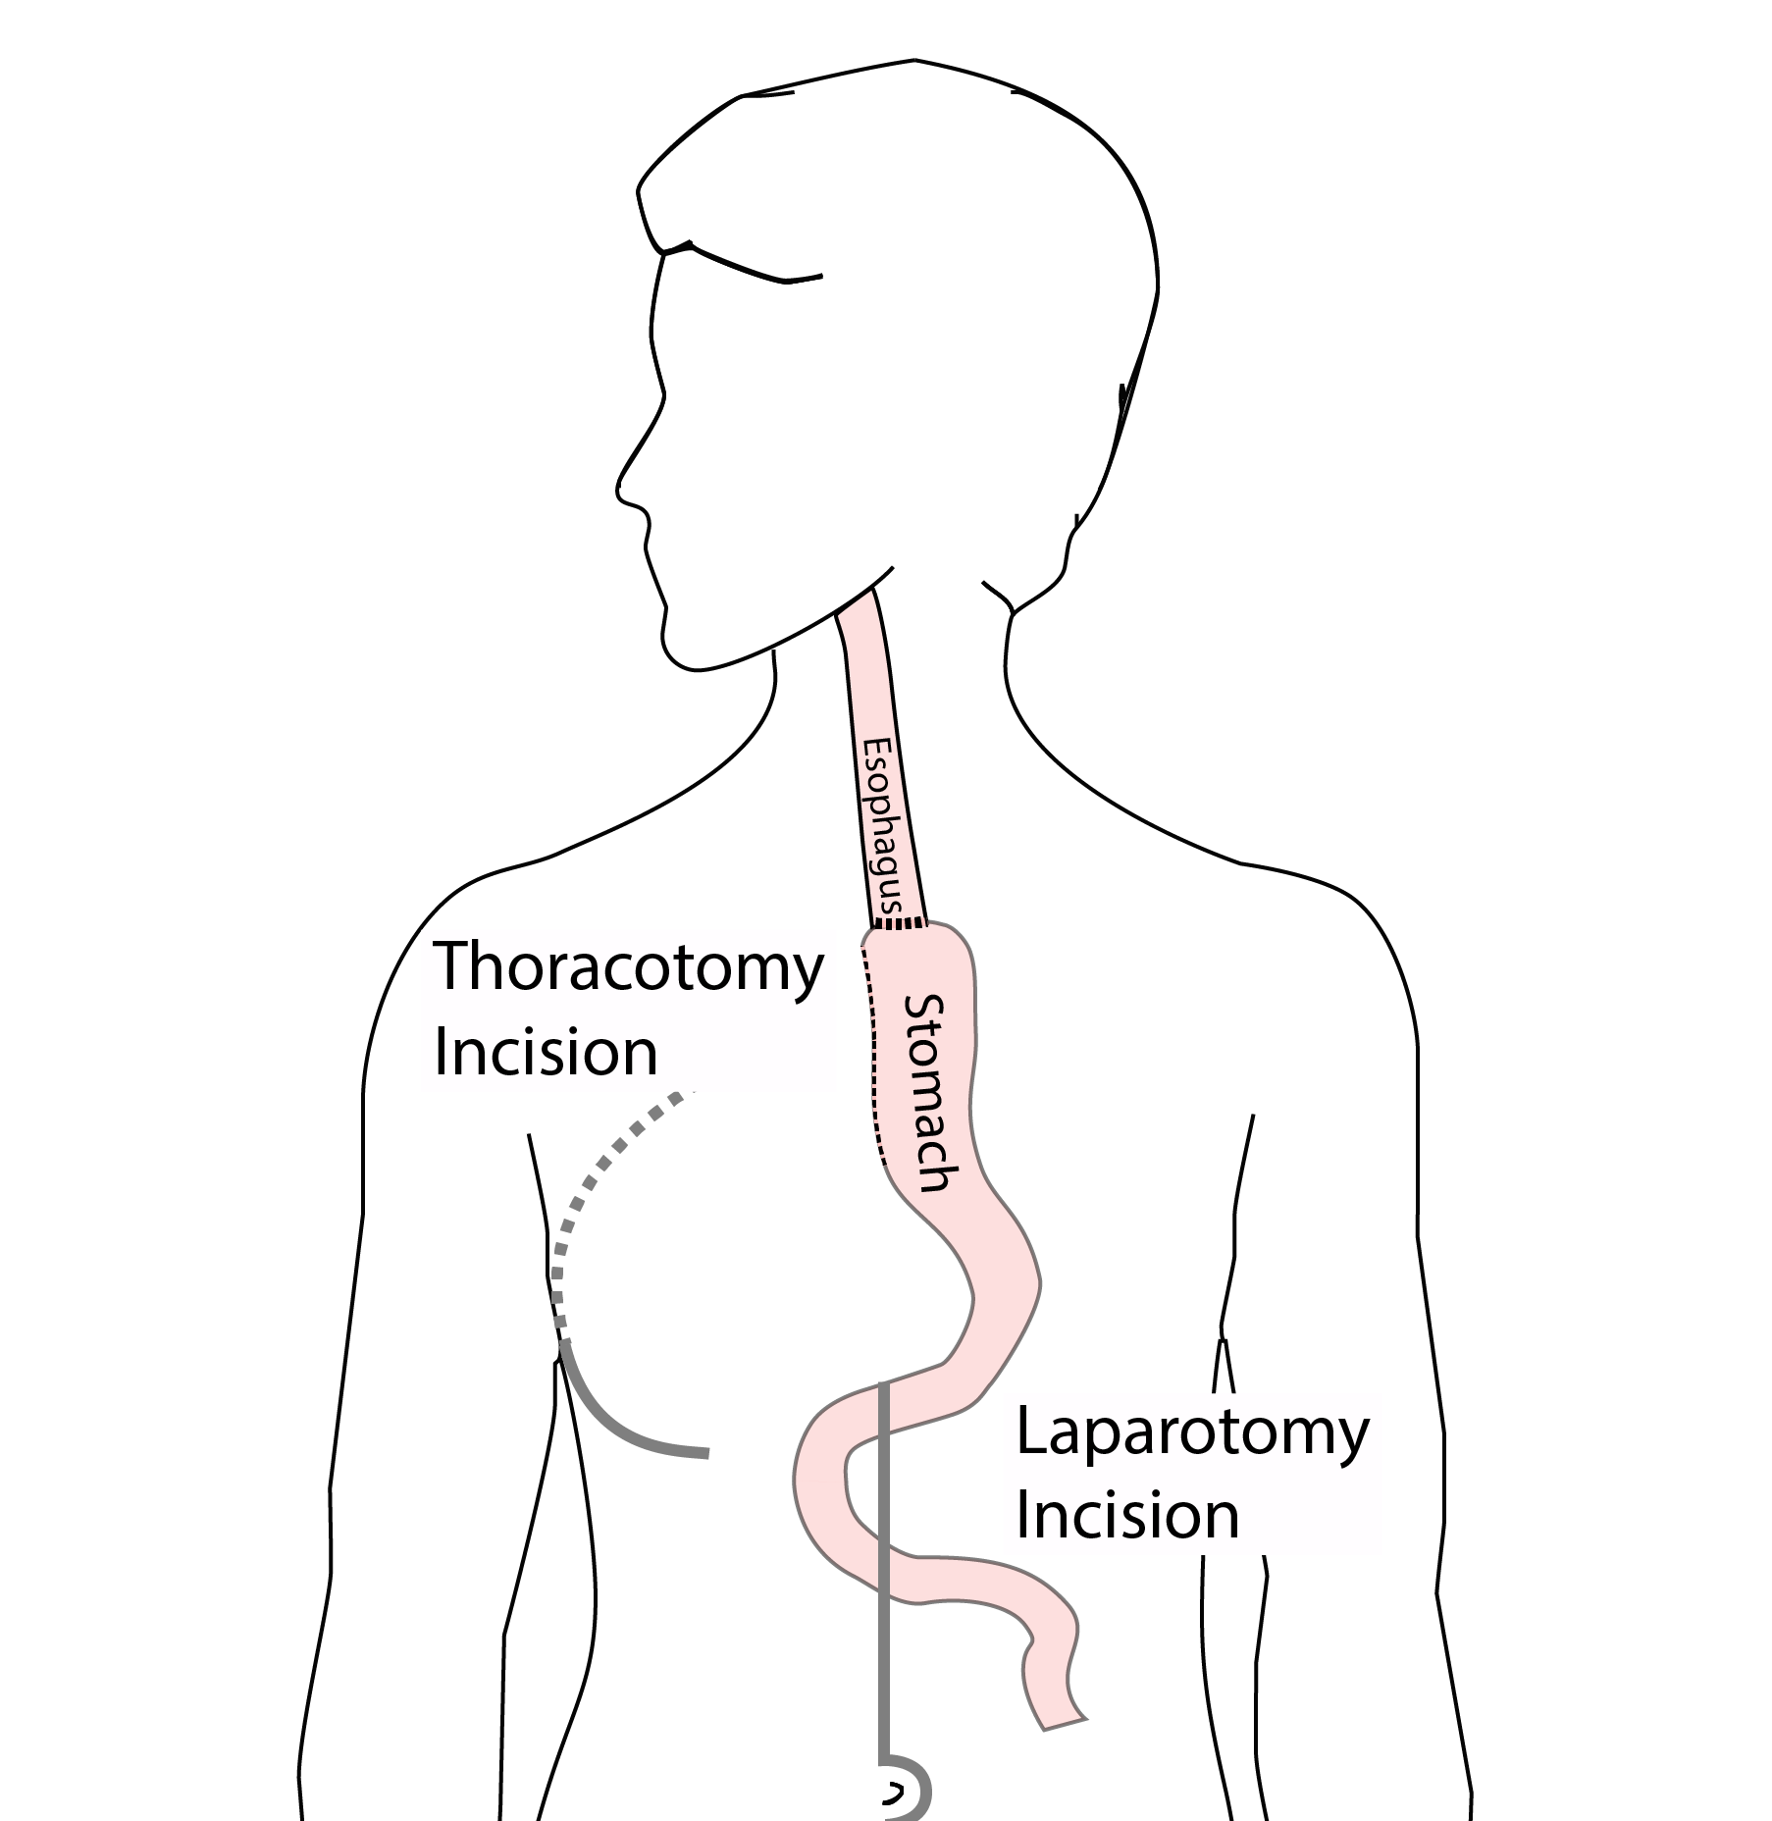

## 9 Total Esophagectomy

For patients with tumors in the upper esophagus, we need to remove more of the esophagus

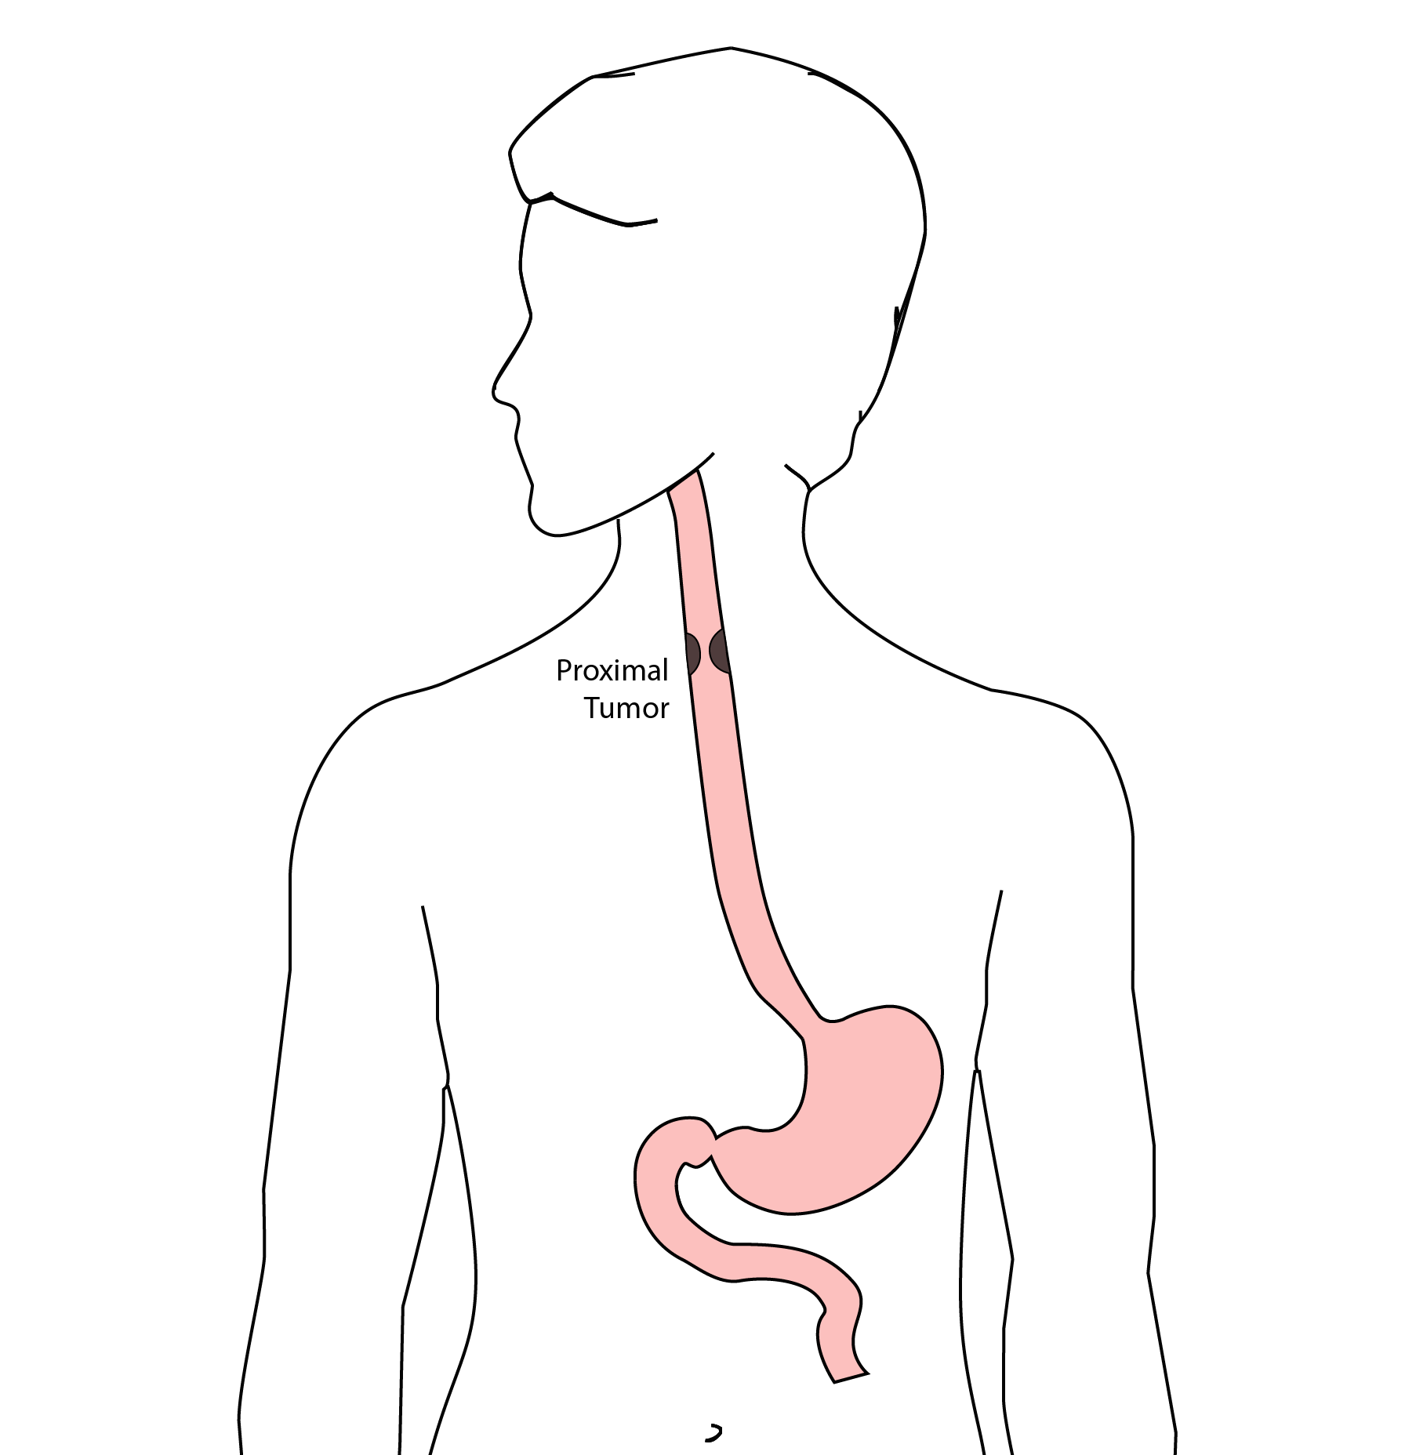

## 10 Total Esophagectomy

For those patients, we need to remove the whole esophagus, including the portion in the neck.

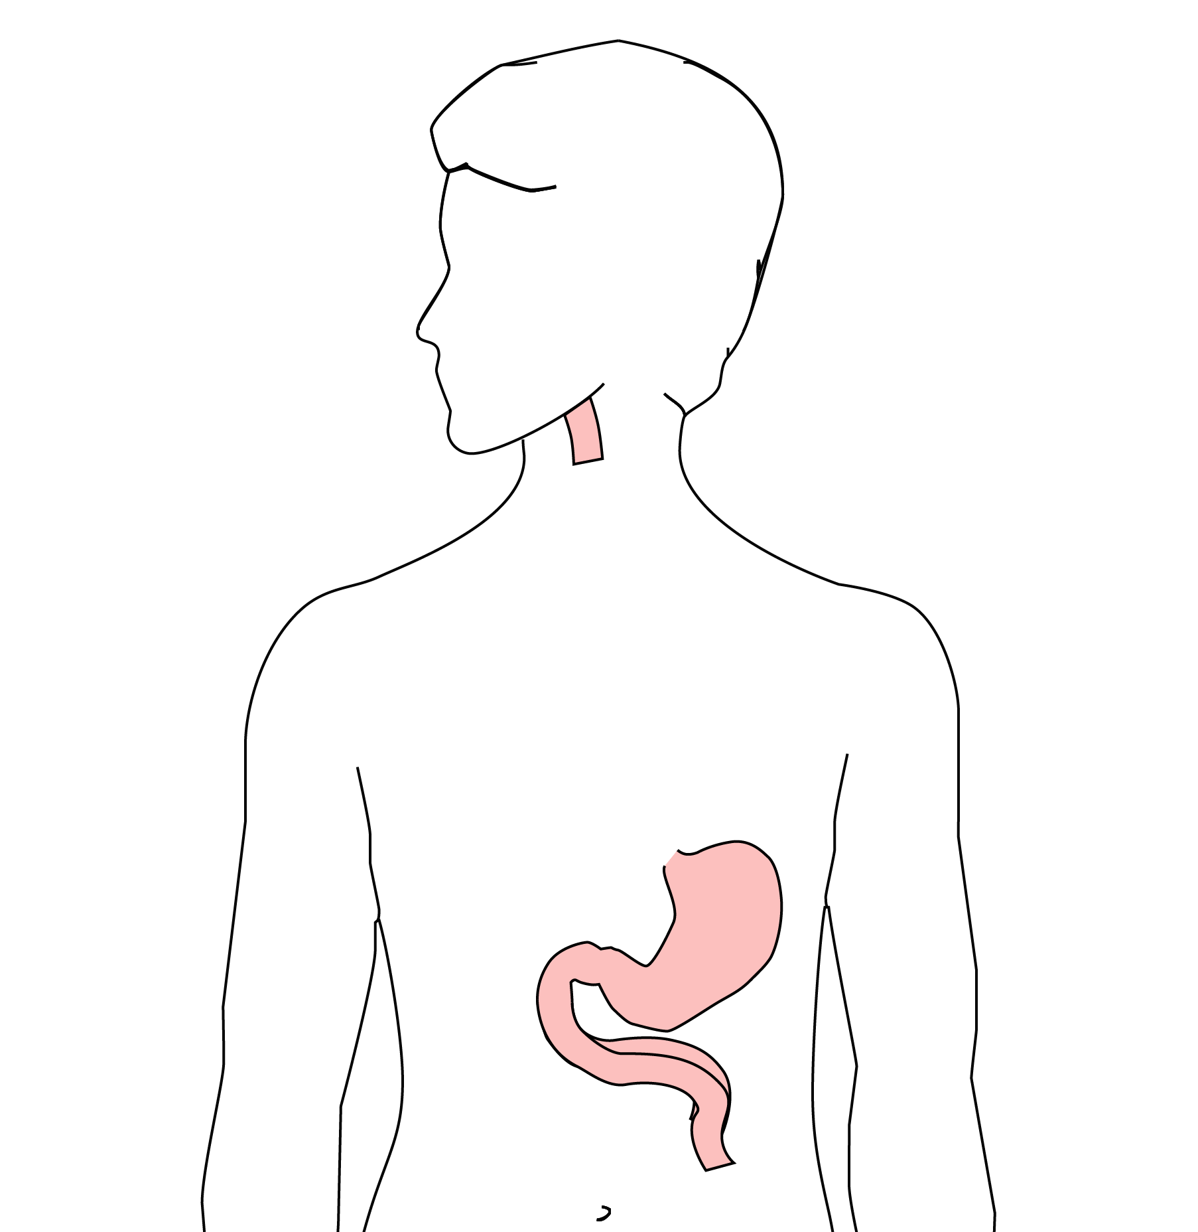

## 11 Minimally-invasive McKeown Esophagectomy

In this case, a connection between the esophagus and the stomach is made in the neck.

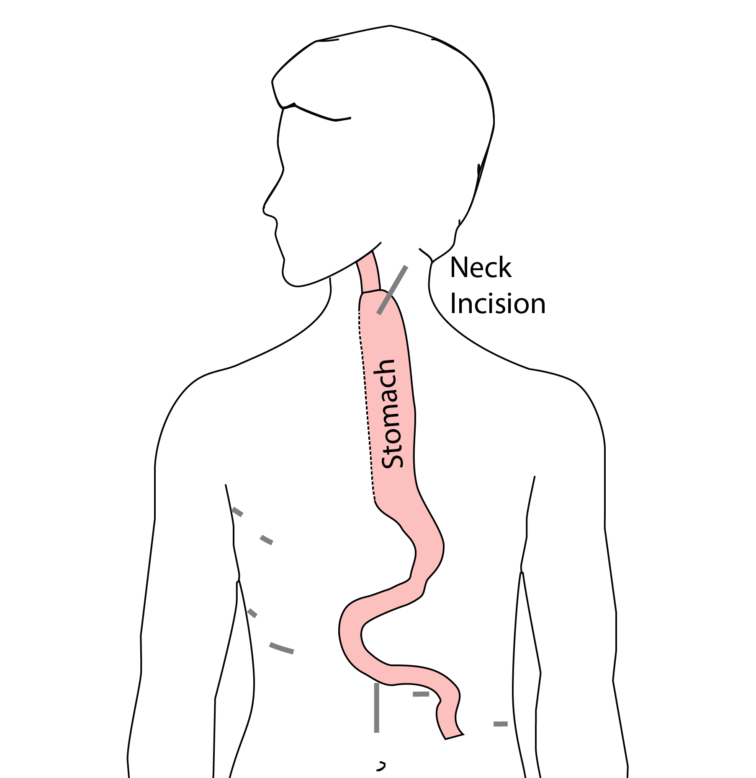

## 12 Colon Interposition

If the stomach is not suitable to make a new esophagus, the colon can be used to replace the esophagus

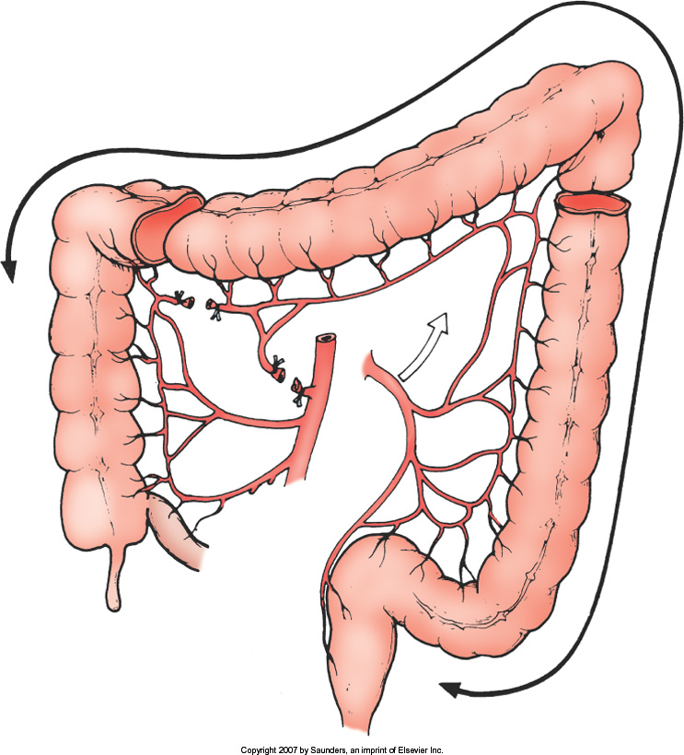

## 13 Colon Interposition

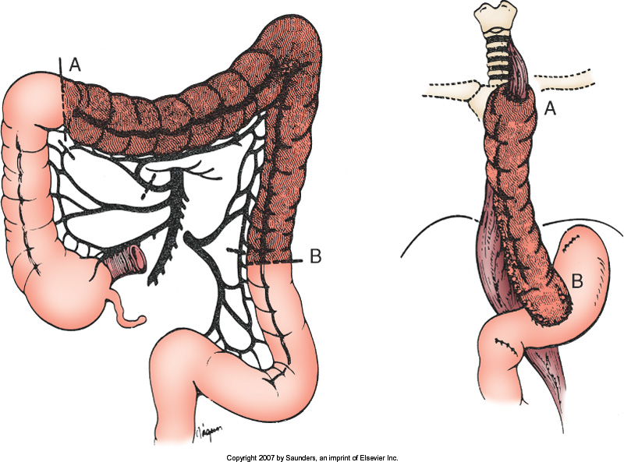

## 14 Risks of Surgery

An esophagectomy is a substantial operation, and in some cases there can be postoperative complications. We’re going to talk about two of these complications and what you can do to reduce your risk of complications:

* Anastomotic leak
* Pneumonia

## 15 Anastomotic Leak

The anastomosis is surgical connection between the esophagus and the stomach.



## 16 Anastomotic Leak

If anastomosis does not heal properly:

* Leakage of fluid from the esophagus
* Infection in the space between the lungs
* Requires additional time in the hospital

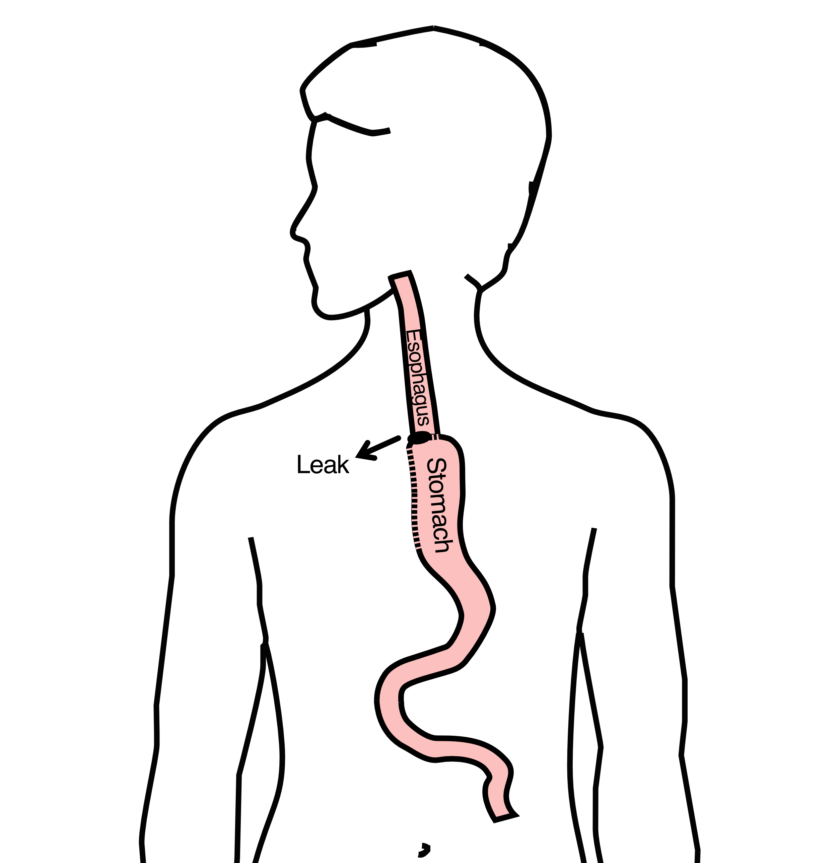

## 17 Anastomotic Leak

If an anastomotic leak does occur:

* Some leaks will seal on their own
* A stent may be required to help healing
* Occasionally additional surgey is required



## 18 Anastomotic Leak

Risk of a leak depends upon:

* Type of operation performed
* Overall nutritional status of patient
* Experience of the surgeon



## 19 Pneumonia

Pneumonia can occurs in about 10-15% of patients after esophagectomy.

Pneumonia requires treatment with antibiotics and frequently requires a longer hospitalization.

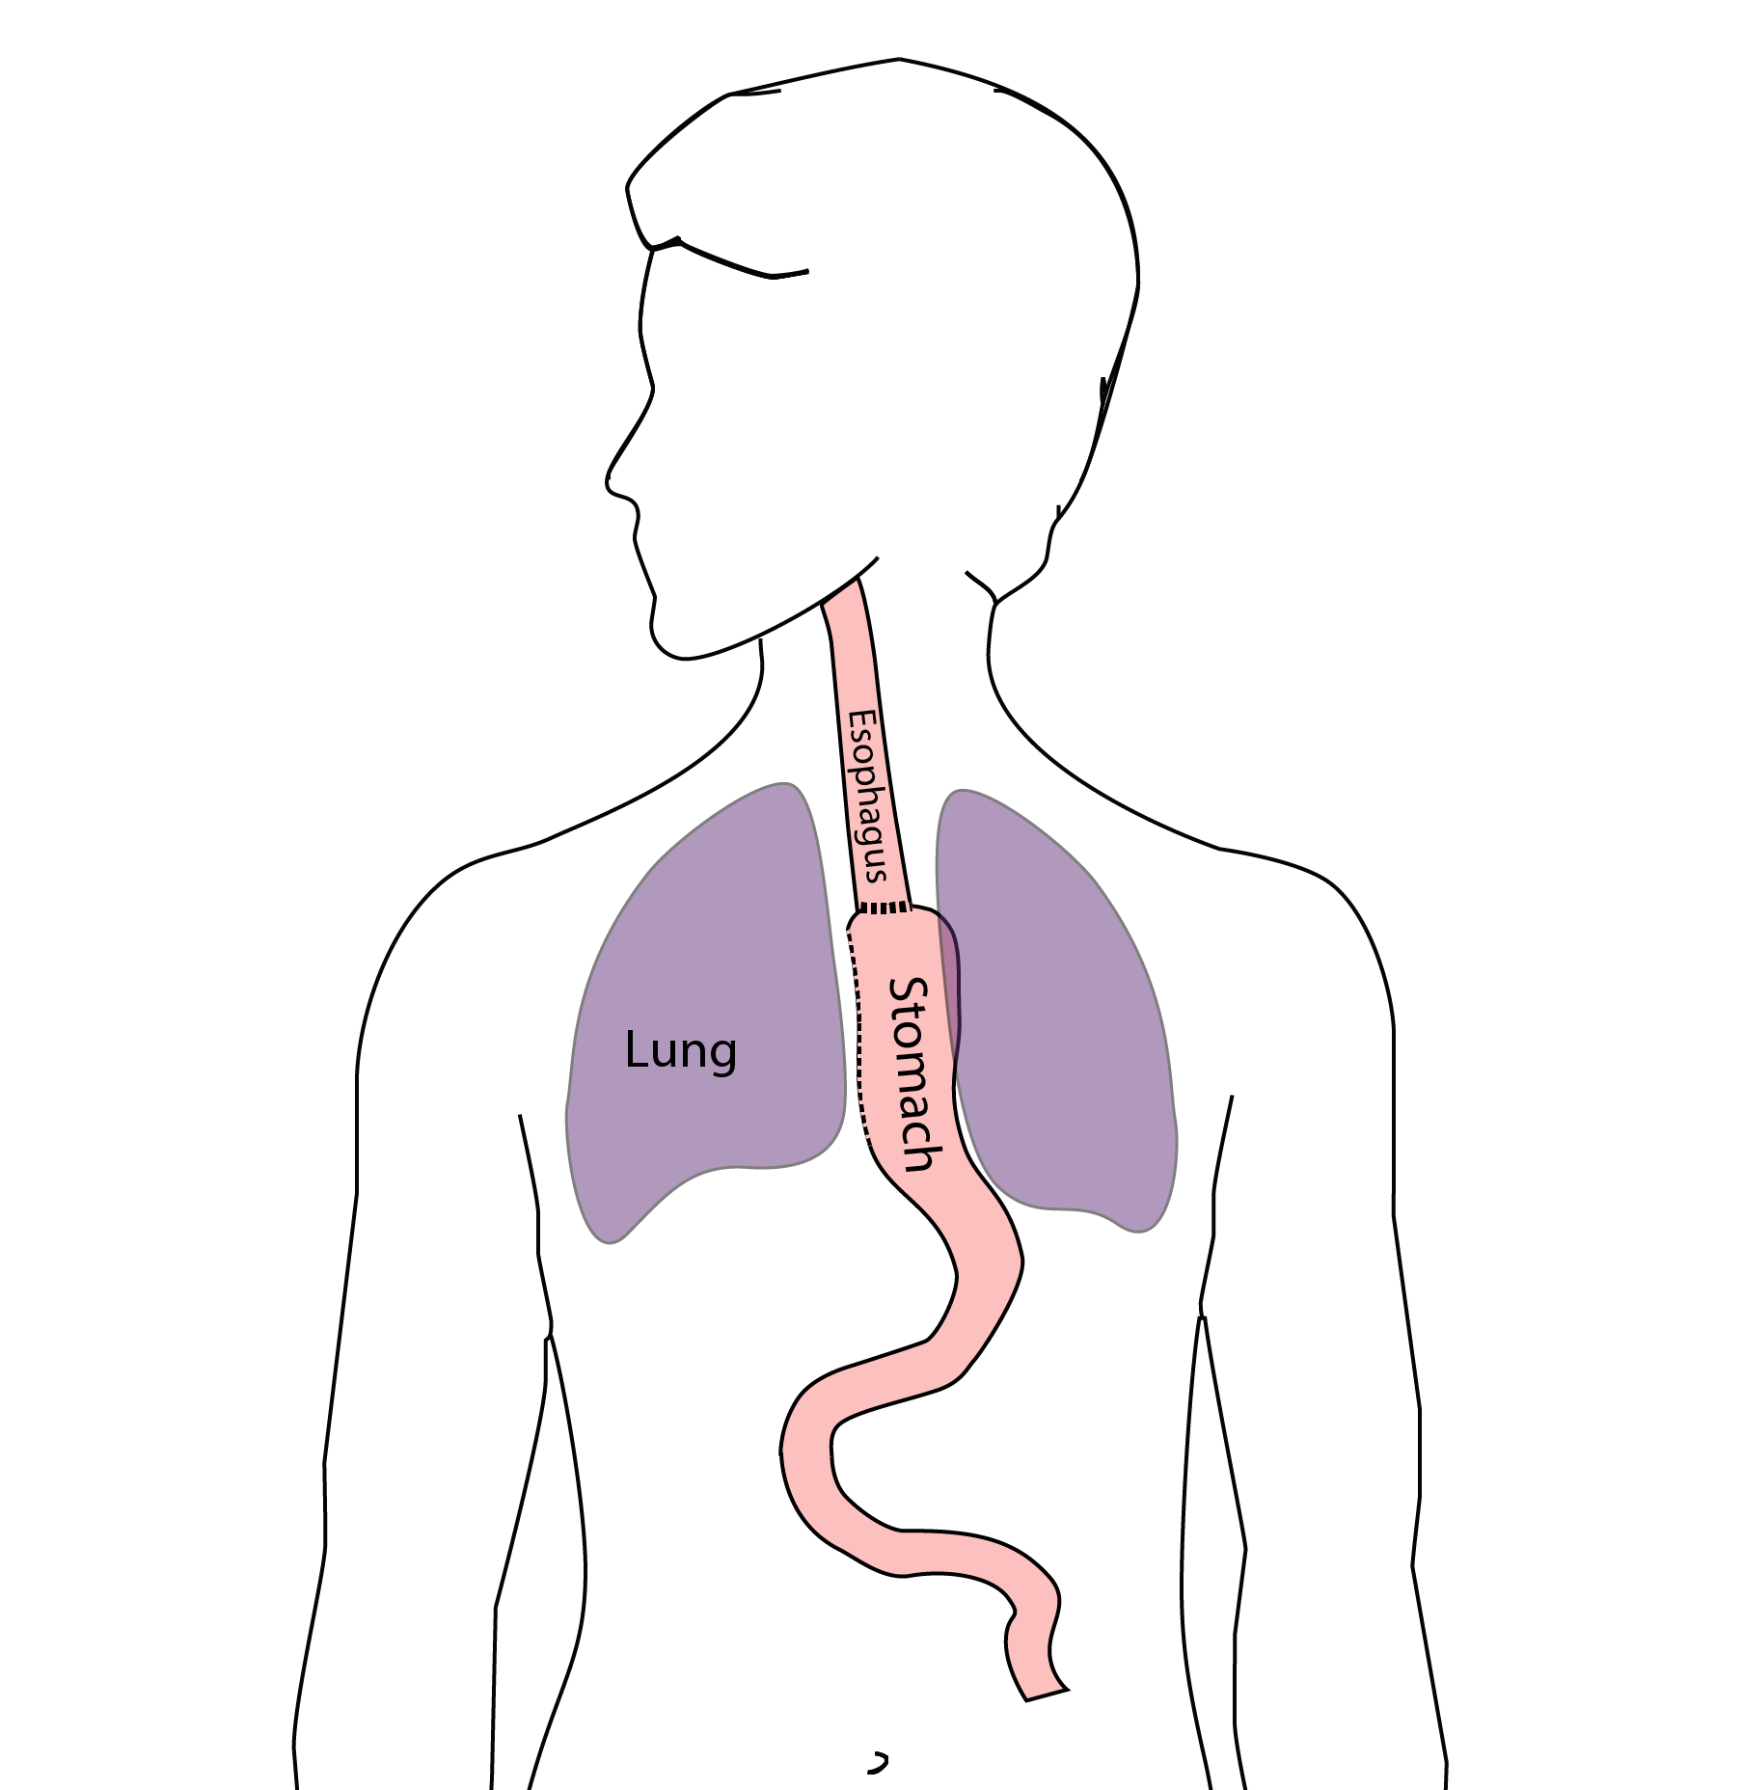

## 20 Preventing Pneumonia

Several ways to help prevent pneumonia after surgery:

* Deep breathing
* Coughing
* Walking

After surgery, this means:

* Sitting in a chair most of the day
* Walking in the halls as soon as possible

## 21 Minimally-invasive Esophagectomy

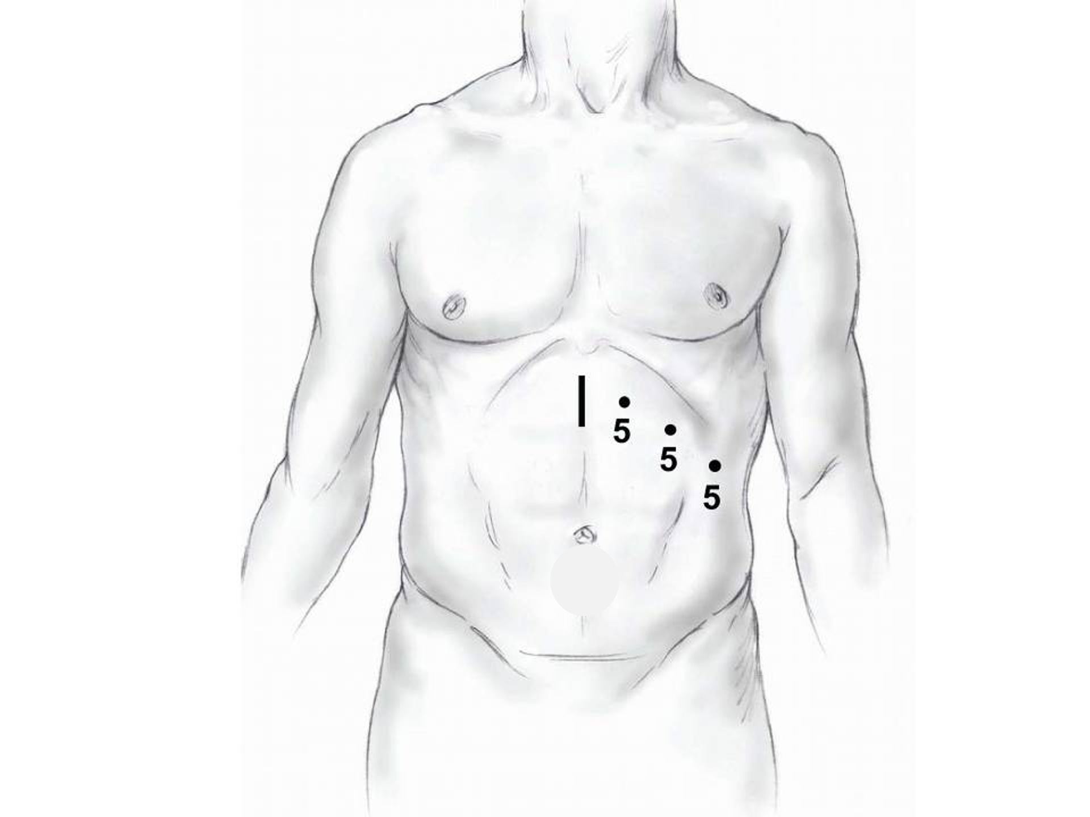

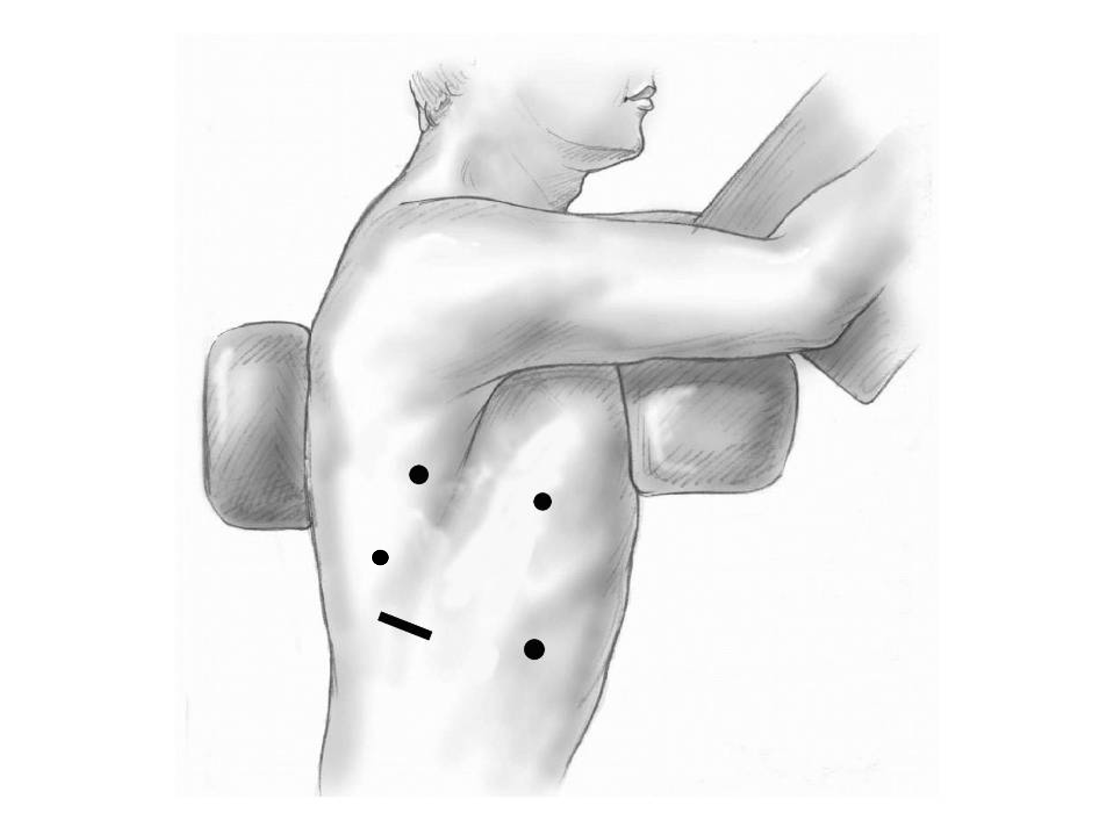

## 22 Risks of Surgery

Risks related to anesthesia

* Heart attack (5%)
* Irregular heart rhythm (15%)
* Pneumonia (10%)
* Blood clots in legs (<5%)
* Pulmonary embolism (2%)

## 23 Risks of Surgery

Risks related to Surgery

* Anastomotic leak (5%)
* Stricture at anastomosis (15%)
* Death within 90 days of surgery
  + Low risk patients = 2%
  + Intermediate risk = 10%
  + High risk = 30%

## 24 Risks of Surgery

Risks of Death within 90 Days of Surgery

|  | Age <75 | Age >75 |
| --- | --- | --- |
| Normal Muscle (75%) | 2% | 10% |
| Low Muscle (25%) | 10% | 30% |

## 25 Preparing for Cancer Treatment

* Primary Care Physician
* MyAtrium Portal
* Exercise
* Smoking Cessation

## 26 Primary Care Practitioner (PCP)

A PCP is critical to coordinate care between specialists.

We will update your PCP after each visit

Call our referral line at (844) 235-6998 if you need a PCP

## 27 My Atrium Patient Portal

* Critical to good communication with your care team
* Available for desktop or laptop or phone
* Sign up at my.atriumhealth.org

## 28 Exercise

* Reduces risk of complications from treatment
* Goal is 30min/day of vigorous exercise 6 days/week
  + Working hard enough that you can’t converse
  + Start slowly and build up
  + Every day counts! (Aim for some activity every day)

## 29 Smoking Cessation

* Smoking makes cancer treatment more difficult
  + Increases risk of complications after surgery
* Options for help with smoking cessation:
  + NC Quit Line 1-800-QUIT-NOW (1-800-784-8669)
  + American Lung Assn www.freddomfromsmoking.org
  + Smoking Cessation Counseling (Metro Charlotte)

## 30 Day Prior to Surgery

* Clear liquids for 24 hours prior to surgery
* Check with Pre-op nurse regarding medicines day prior to surgery
* No tube feedings the night before surgery

## 31 Day of Surgery

* Arrive at 5am – nothing to eat or drink after midnight.
* Medicines w/ a sip of water (or black coffee) but **no cream**.
* Surgery will be cancelled if you have cream/milk
* Waiting room for family and friends on 5th floor
* Post-operative care in STICU (11th floor)

## 32 Epidural Catheter for Pain Control

* Remains in place for 2-5 days
* Dosage can be adjusted as needed
* Can make it more difficult to urinate
* May require foley catheter in bladder
* Foley catheter removed after epidural removed

## 33 ICU Stay (2-4 days)

* NG tube in nose to drain stomach and esophagus
* Catheter in bladder
* Chest tube right chest
* Abdominal drains (usually 2)
* Feeding jejunostomy (usually stays in 8 wks)

## 34 ICU

* Bladder catheter removed → check that bladder empties properly
* Chest tube removed (day 2-4) → follow-up chest x-ray
* Fluid emptied from drains every few hours
* Start tube feedings by feeding
* Feeding jejunostomy (stays in 8 weeks)

## 35 Ward - 6Tower

* Jejunostomy feeds started
* Up in a chair most of the day
* Walking in the halls
  + Start with assistance
  + Improves lung function
  + Prevents loss of muscle strength

## 36 Jejunostomy Feeds

Jejunostomy tube feeds

* Start continuous (24 hours)
* Convert to night-time only (16 hours)

Water administered through feeding tube

* Usually 8oz 4 times/day
* Important to prevent dehydration

## 37 Feeding Jejunostomy - Typical Regimen

* Jejunostomy tube feeds for 16 hours (6pm to 10am)
  + Men: 75mL/hour x 16 hours = 5 cartons
  + Women: 60mL/hour x 16 hours = 4 cartons
* Water 240ml (8oz) via syringe 4x/day

Hospital nurses will teach use of the feeding tube pump

## 38 Jejunostomy Feeds with Diabetes

Jejunostomy feedings elevate blood sugars

* Insulin may be required along with feeds

Typical Pattern for tube feeds

* Feeds run via pump from 6pm to 10am
* Insulin at 6pm (70/30 insulin)
* Insulin at Midnight (70/30 insulin)
* No insulin if tube feedings are not run

## 39 Feeding Jejunostomy

Video shows how to set up and run the jejunostomy tube pump



## 40 Activity

* Up in chair most of the day
* Walking with help from nurse/Physical Therapist
* Goals:
  + Improve lung function
  + Prevent muscle loss

## 41 Nasogastric (NG) Tube

Tube passed through nose into stomach

* Drains fluid from stomach
* Prevents vomiting

Upper GI X-ray on 2nd or 3rd day after surgery

* If stomach empties well NG tube removed
* Otherwise, X-ray repeated 2-3 days later

## 42 Swallowing Evaluation

Once NG tube has been removed:

Modified barium swallow in radiology

* Drink a white chalky liquid (barium)
* Look for proper swallowing function
* 70% of patients liquids started by mouth

## 43 Protein Shakes

Most are taking protein shakes when they go home

Protein shakes are started after tolerating water

* 2 oz per hour to start
* 4 oz per hour if 2oz are tolerated well

## 44 Discharge

Goal: ready to leave day #6/7 after surgery

* Night-time tube feedings (6pm to 10am)
* Nutrition by mouth (70% of patients)
  + 1 oz of water per hour by mouth OR
  + Protein shakes 4oz every 2 hours
* Water through tube 8oz four times per day
* Home care nursing (feeding tube teaching)
* Home infusion (tube feeding supplies)

## 45 Nutrition after Surgery

At discharge home:

* Protein shakes 4oz every 2 hrs
* Tube feeds 4-5 cans at night (6pm-10am)

10-12 Days: Increase protein shakes

* Tube feeds 3-4 cans at night

Three weeks: Post-esophagectomy Diet

8-12 weeks: Remove feeding tube (in office)

## 46 Transition from Tube Feeds Eating

Dietitian will calculate daily protein goal

* Typically 60-75 grams protein/day
* Each carton of tube feeding has 15 grams
  + 75 grams protein = 5 cartons/night
* As intake by mouth increases, tube feeds are reduced

Spread out protein during the day (20gm/meal)

* Three meals + 2-3 high-protein snacks

## 47 Post-esophagectomy Diet

* Soft Consistency
* High Protein
* Avoid sugary liquids (can cause ‘dumping’)
* Avoid raw vegetables (and salads)
* Eating
  + Small, frequent meals
  + Sit up for 30-45 minutes after eating
  + Avoid eating within 2 hours of bedtime

## 48 Medicines at Home - Pain

Acetaminophen (Tylenol) 4000mg/day (1000mg 4x/day)

Gabapentin 300mg 3 times/day (works best if taken daily)

Oxycodone

* Take as needed in addition to Tylenol and gabapentin
* Will begin reducing dosage at first postoperative visit
* Most patients can discontinue by 4 weeks after surgery
* NO DRIVING WHILE ON OXYCODONE

## 49 Non-steroidals Anti Inflammatory (NSAID)

Non-steroidal anti-inflammatories (Celebrex)

* 200 mg every 12 hours starting 2 weeks after surgery

NO GOODY POWDERS OR BCs

* (Can cause permanent scarring at the surgery site)

## 50 Acid Blockers

Acid blocker = Proton Pump Inhibitors (Omeprazole, Nexium,etc)

* Will stay on for at 1-2 years to prevent acid reflux
* Important in preventing scarring at anastomosis (new connection between esophagus and stomach)
* To administer through feeding tube, open capsule and resuspend beads in 60mL (2oz) of water

## 51 Medicines at Home

Reglan – Helps stomach empty

* Will plan to stop after six weeks
* 0.1% risk of tardive dyskinesia (nervous tic)

Remeron – Helps improve appetite

* Can cause vivid dreams
* Used for several weeks after surgery
* Will stop within first three months of surgery

## 52 Metoprolol = Beta Blockers

* Slows heart rate and lowers blood pressure
* Used to prevent rapid heart rate
* Patients not taking a beta blocker prior to surgery wean after after surgery
* Patients taking a beta blockerprior to surgery return to prior dose and drug after surgery

## 53 Sleeping

Reflux can occur the first few weeks/months after surgery

This improves over the first few months

A wedge pillow can be helpful for sleep

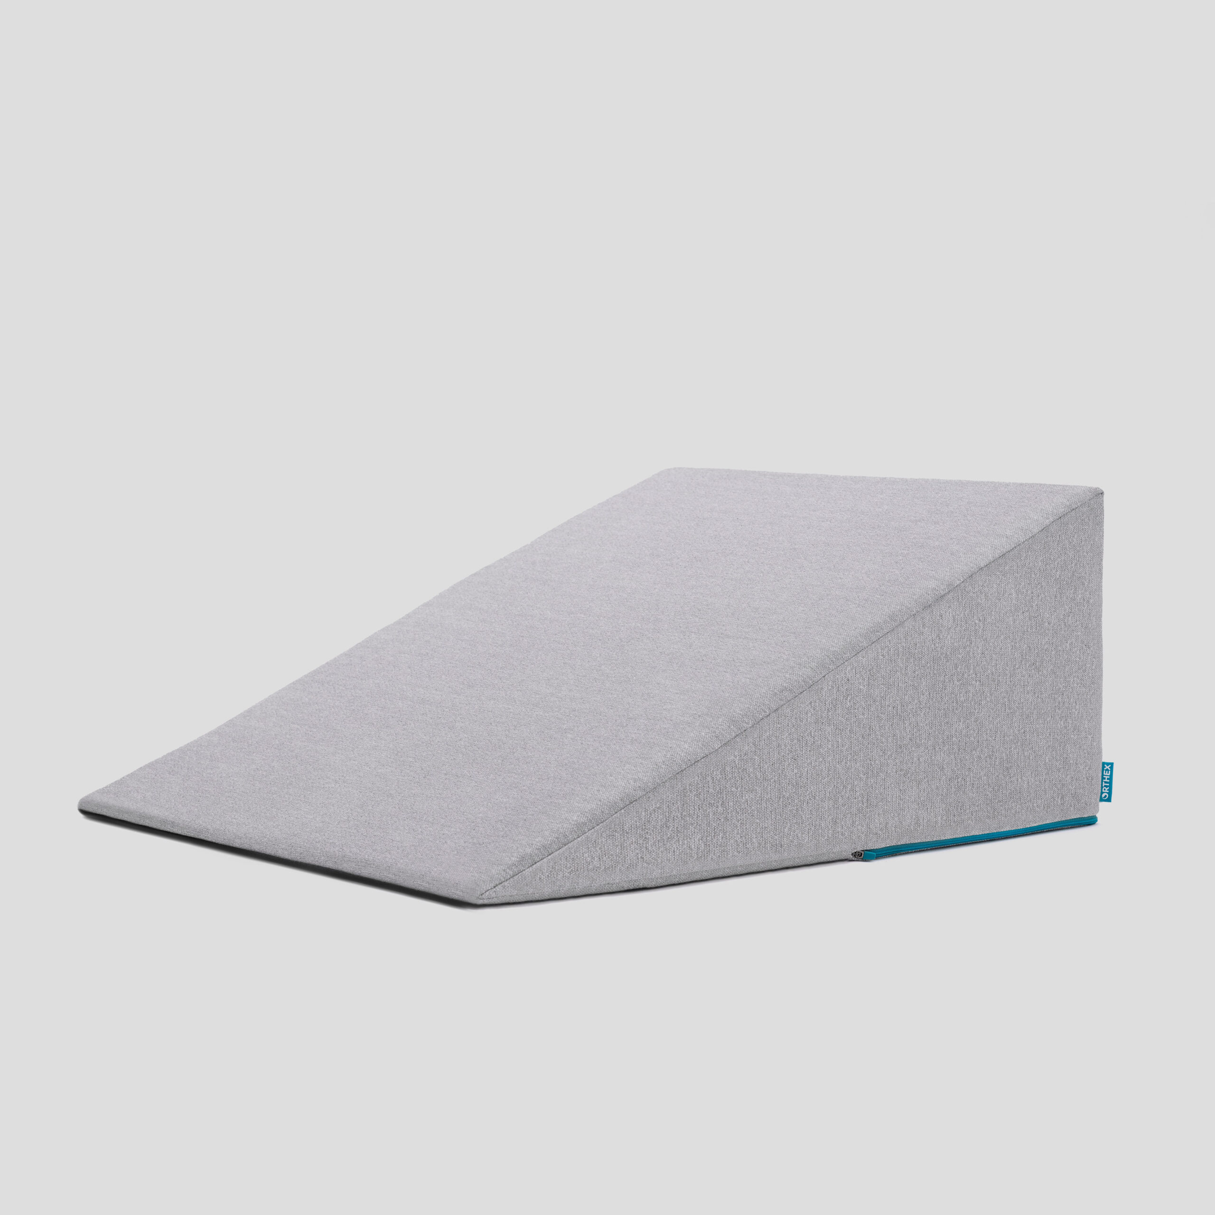

## 54 Postoperative Visit

Check surgical site

* Remove staples (if needed)

Adjust medicines as needed

* Insulin (for diabetic patients on insulin)
* Reduce beta blocker medicines

Advance diet

Reduce tube feeds

## 55 After surgery

Wean off medicines added after surgery

* Pain medicines
* Beta-blockers
* Reglan and Remeron

Continue acid blockers for at least 1 year

## 56 Jejunostomy Removal (8 weeks after surgery)

Jejunostomy tube is removed in the office once you can take in enough nutrients by mouth

May take 30 minutes and some local anesthetic to loosen up the tube for removal.

## 57 Nutritional Monitoring after Surgery

You may have some difficulty absorbing some nutrients:

* Iron
* Vitamin B12
* Vitamin D

## 58 Nutritional Monitoring after Surgery

About 3 months after the jejunostomy tube is removed, we will check blood levels:

* Iron (ferritin)
* Vitamin B12
* Vitamin D.

## 59 Nutritional Replacements after Surgery

Vitamin or iron replacements can be ordered by your primary care physician, medical oncologist, or surgeon

If levels are low, repeat testing in several months may be needed.

## 60 Team Members - Physicians

Primary Care Provider

Gastroenterologist

Medical Oncologist (chemotherapy)

Radiation Oncologist (radiation)

Surgeons

* Jonathan Salo
* Jeffrey Hagen
* Michael Roach

## 61 Team Members - Support Staff

Dietitian - Liz Koch

Nurses - Brandon Galloway & Kit Sluder & Rebecca Wicks

Schedulers - Stacey Singleton & Tony Bethea

Navigator - Laura Swift