Engineering Permit Management System
(EPMS)
Systems Analysis and Design Documentation

Prepared by: Jay Carlou
Local Government Unit - Engineering / Permit Systems Development
Draft for Presentation - July 29, 2026

1. Introduction / Background
The Engineering Permit Management System (EPMS) is a web-based application built to digitize and streamline the processing of building-related permits within a Local Government Unit (LGU) Engineering Office. Historically, permit applications - such as Building, Occupancy, Fencing, Demolition, Signage, and Annual Inspection permits - were processed manually across separate offices (Planning, Engineering, and Treasury), relying on paper forms, physical routing, and manually computed fee assessments. This created delays, inconsistent fee computation, limited visibility into application status for both staff and applicants, and difficulty producing accurate reports for management.
EPMS centralizes all six permit types into one system covering the full life cycle of an application: intake (walk-in or online self-service), zoning and engineering assessment, billing, payment collection, permit generation, and release - with role-based access control, an audit trail, and printable official forms for every stage.

2. Objectives
General Objective
To design and develop an integrated Engineering Permit Management System that automates the end-to-end processing of building and related permits, from online or walk-in application through fee assessment, billing, payment, and permit release.
Specific Objectives
- Provide a self-service online portal so applicants can submit, track, and manage their own permit applications without visiting the office in person.
- Automate fee computation for all six permit types based on official, configurable fee schedules.
- Enforce role-based workflows so each stage (zoning, engineering assessment, billing, collection, permit generation, release) is handled only by the appropriate office.
- Generate accurate, print-ready official forms and permit certificates for every permit type.
- Maintain a complete audit trail of who did what and when, for accountability and compliance.
- Provide management with real-time reports on applications, revenue, and processing turnaround time.

3. Scope and Limitations
Scope
- Covers all six permit types: Building Permit (BP), Occupancy Permit (OP), Fencing Permit (FP), Demolition Permit (DP), Signage Permit (SGP), and Annual Inspection (AI).
- Covers both the staff-facing back office (Planning, Engineering, Treasury, Administration) and the client-facing online applicant portal.
- Covers the complete workflow: application intake, assessment, billing, collection, permit generation, and release, including reversal/revert actions for correcting staff errors.
- Covers reporting: permit reports, revenue reports, collection reports, and audit logs.
Limitations
- Online payment is recorded as a payment method/reference within Collections; the system does not integrate with a live third-party payment gateway.
- The system is a single-LGU deployment (one epms_db database) and does not currently support multi-branch or multi-city consolidation.
- Document uploads are limited to PDF, JPG, and PNG (max 10 MB each) for online applications.
- This documentation reflects the system as of this draft and will be finalized before the presentation.

4. System Overview
EPMS replaces the manual, paper-based permit process with a single system of record. An applicant may either apply online through the client portal or have an application encoded by walk-in staff (the system distinguishes the two via a "source" flag: online vs. walk-in, so management can monitor channel usage). From there, the application is routed through the appropriate assessment stages, billed automatically against configured fee schedules, paid at the Treasury, and finally released as an official, system-generated PDF permit or certificate.
The system is built on PHP 8.2+ and Laravel 12, using MariaDB for data storage, Blade/Tailwind/Alpine.js for the interface, DomPDF for all official print outputs, and the Spatie packages for role-based permissions and audit logging.

5. System Users / Stakeholders
Role | Responsibility in EPMS
Client (Online Applicant) | Submits applications online, uploads requirements, tracks status, edits and resubmits returned applications, downloads approved permits.
Planning Staff / Officer | Performs Zoning Assessment for Building Permit applications (the only permit type with a zoning stage).
Engineering Staff | Reviews and approves/rejects online applications submitted for review; performs day-to-day application handling.
Engineering Officer | Finalizes Engineering Assessment (fees), generates and releases permits/certificates, performs revert/reversal actions.
Treasury Staff / Officer | Records payments (Official Receipts) against billed applications; can void receipts.
Administrator | Manages users, fee schedules, and general system settings.
Super-Admin | Full system access, including audit log visibility and role management.

6. System Architecture
EPMS follows a layered architecture on top of the Laravel framework. Controllers stay thin and delegate business logic to a dedicated Service Layer, Actions, and DTOs, keeping the codebase maintainable as more permit types were added over time. The Data Access Layer uses Laravel's Eloquent ORM across 31 models, backed by a single MariaDB database with soft deletes enabled on every transaction table for data recoverability.
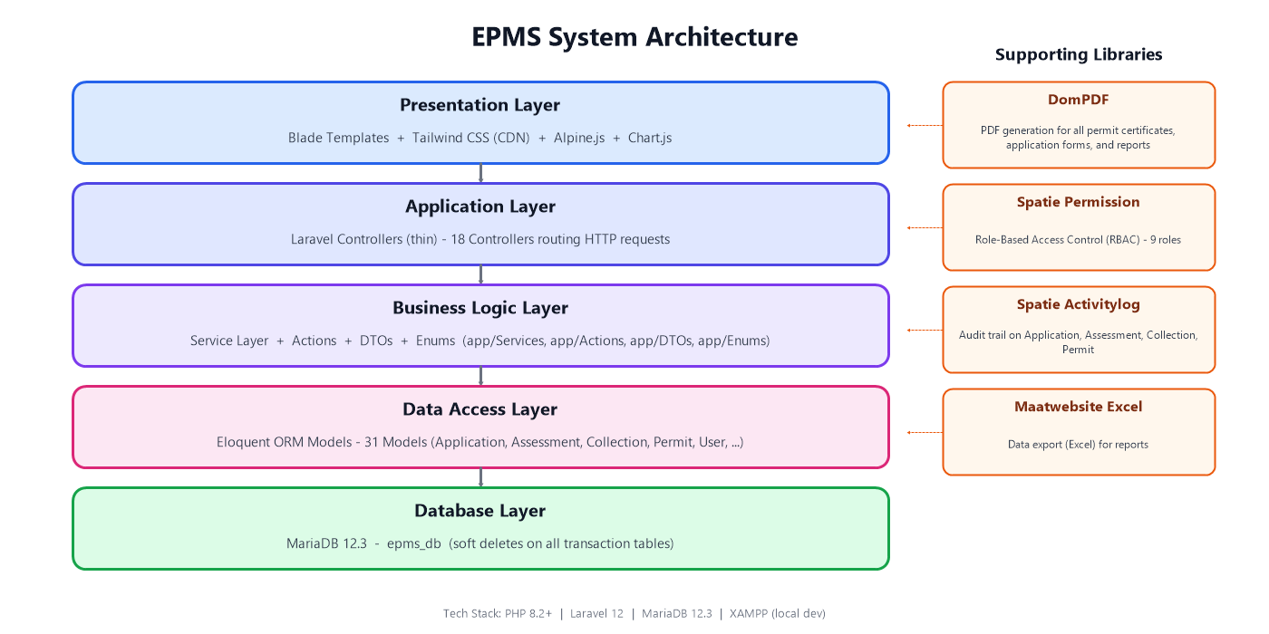
Figure 1. EPMS Layered System Architecture

7. Use Case Diagram
The diagram below summarizes the major actors and the actions each can perform within the system boundary.
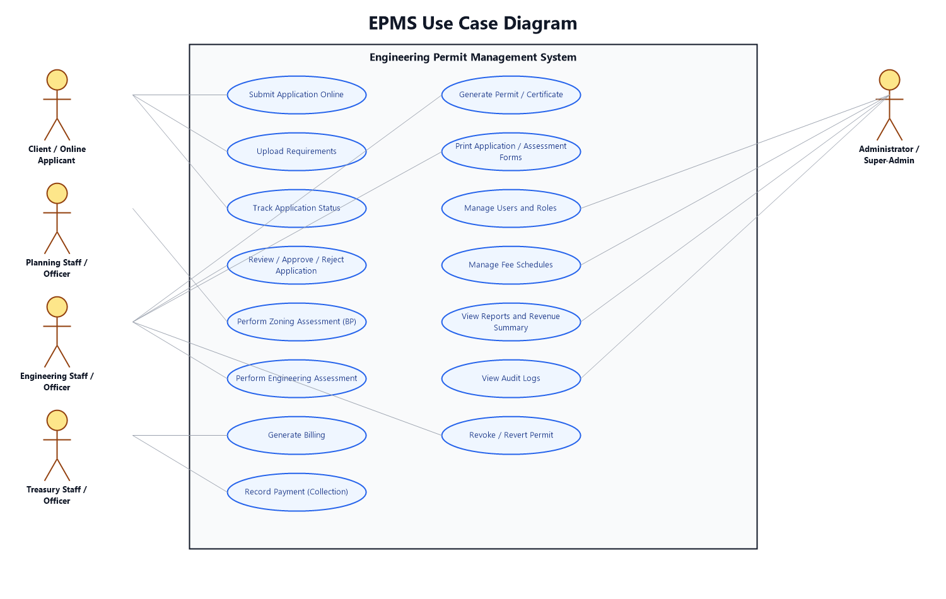
Figure 2. EPMS Use Case Diagram

Use Case Descriptions (Selected)
Use Case | Actor | Precondition | Main Flow | Postcondition
Submit Application Online | Client | Client has a verified account | Client selects permit type, fills out the form, uploads requirements, and submits. | Application status becomes pending_approval.
Review / Approve / Reject Application | Engineering Staff | An application is pending_approval | Staff opens the review queue, inspects the application, approves it (routes to the normal workflow) or disapproves it with remarks. | Status becomes submitted (approved) or returned (disapproved).
Perform Engineering Assessment | Engineering Officer | Application has reached the assessment stage | Officer adds/reviews fee items per category and finalizes the assessment. | Status becomes engineering_assessed; billing is auto-generated.
Record Payment | Treasury Staff | Application status is billed | Staff records the Official Receipt number, amount, and payment method. | Status becomes paid.
Generate Permit / Certificate | Engineering Officer | Application status is paid | Officer triggers permit generation; the system produces a numbered, print-ready PDF. | Status becomes permit_generated (then released after manual release).

8. Data Flow Diagrams
Context Diagram (Level 0)
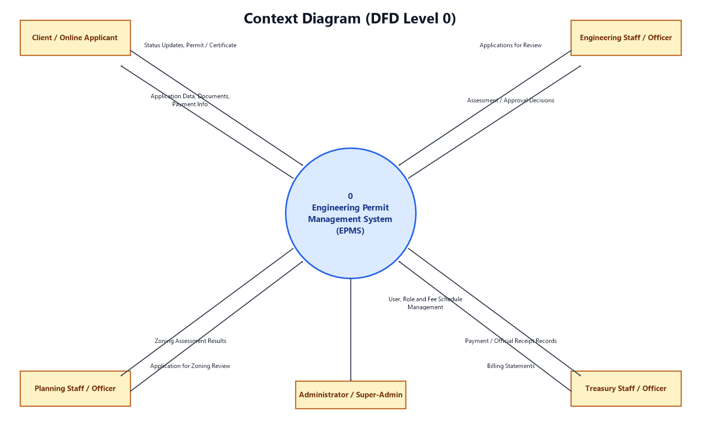
Figure 3. Context Diagram (DFD Level 0)
Level 1 Data Flow Diagram
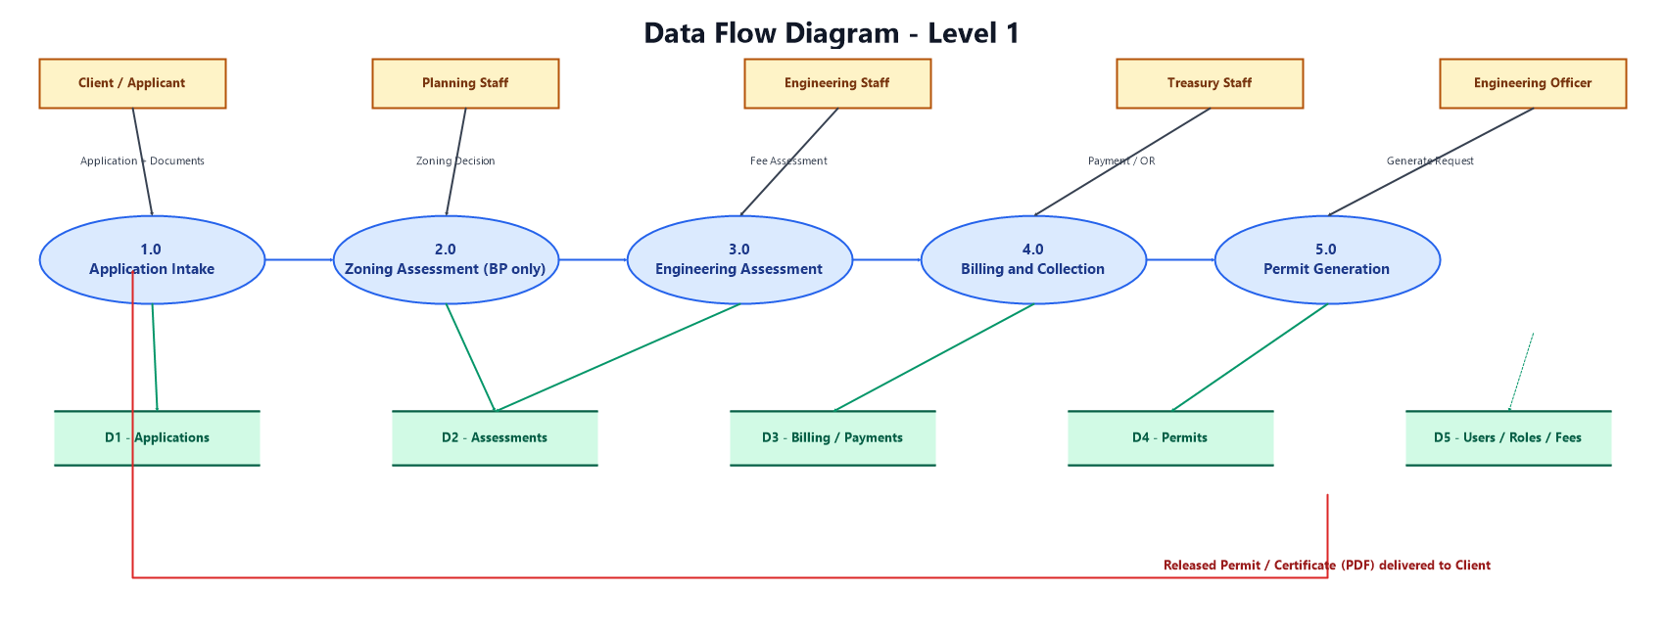
Figure 4. Level 1 Data Flow Diagram

9. Entity Relationship Diagram
The diagram below is simplified for readability - it shows the core entities and their relationships rather than every column. The Application entity represents the six parallel permit-type tables (Application, OccupancyApplication, FencingApplication, DemolitionApplication, SignageApplication, AnnualInspectionApplication), which all share the same relationship shape to Assessment, Billing, Collection, and Permit.
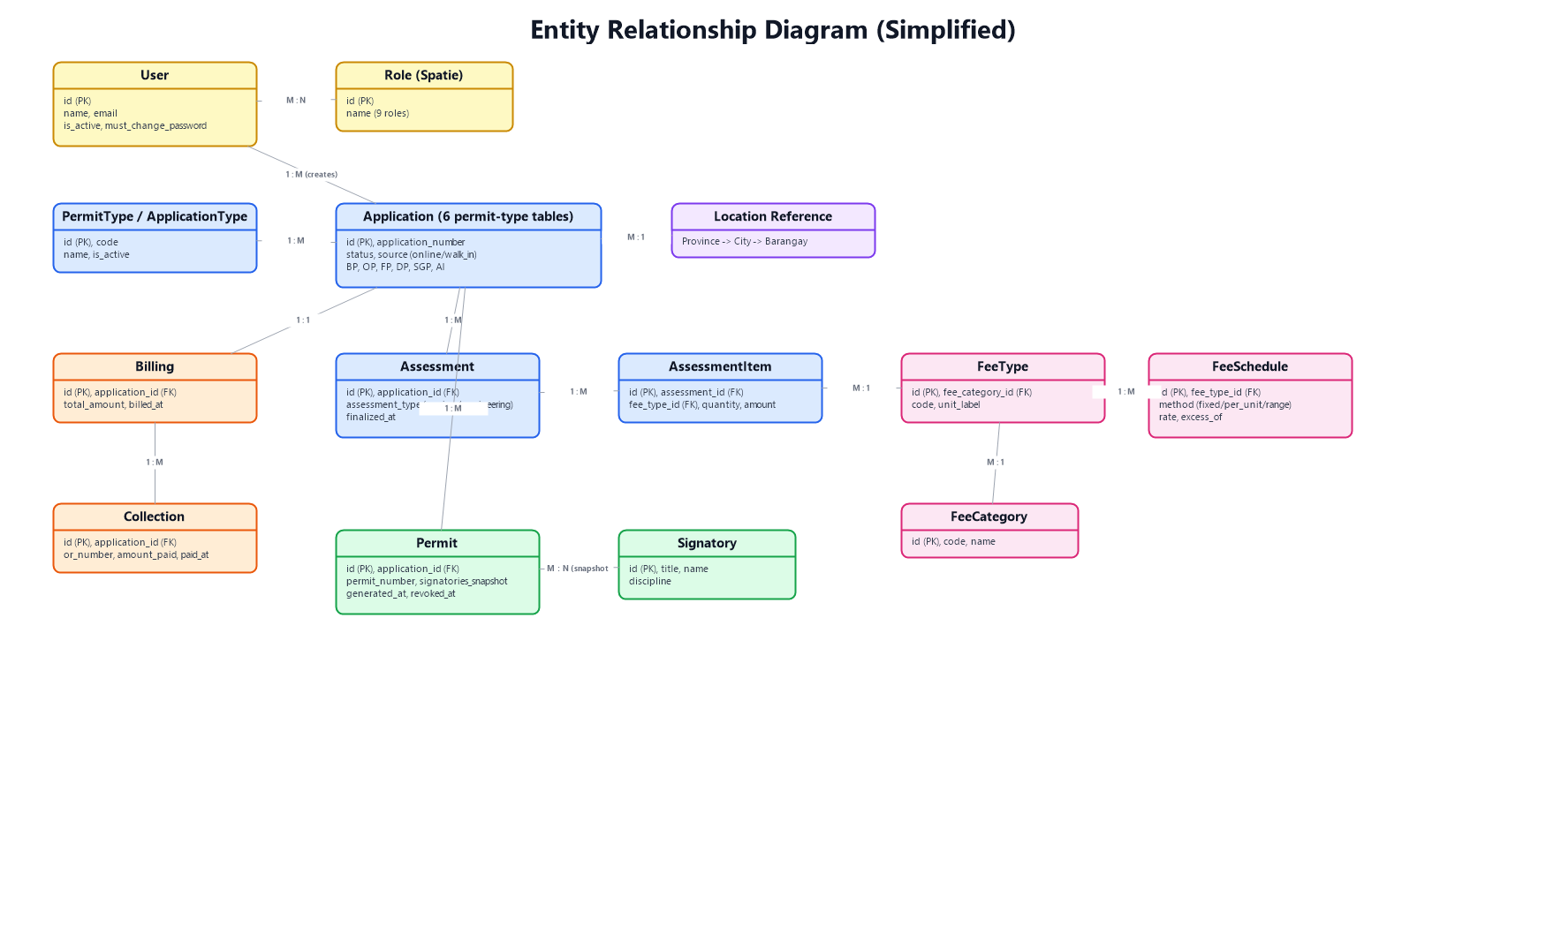
Figure 5. Entity Relationship Diagram (Simplified)

Data Dictionary (Core Entities)
Entity | Key Fields | Purpose
User | id, name, email, is_active, must_change_password | System account for both staff and client portal users.
Application (x6 tables) | id, application_number, status, source (online/walk_in) | One permit application record per type (BP/OP/FP/DP/SGP/AI).
Assessment / AssessmentItem | assessment_type, fee_type_id, quantity, amount | Line-item fee assessment (zoning or engineering) for an application.
FeeCategory / FeeType / FeeSchedule | code, method (fixed/per_unit/range_based), rate | Configurable, official fee rate schedules used to compute assessments.
Billing / Collection | total_amount, or_number, amount_paid, paid_at | Billing statement and recorded Treasury payment for an application.
Permit | permit_number, signatories_snapshot, generated_at, revoked_at | The final generated certificate/permit PDF record, with signatories locked at generation time.

10. System Workflows
Building Permit (BP) follows a longer 9-state workflow because it is the only permit type with a Zoning Assessment stage (handled by Planning). All other permit types - Occupancy, Fencing, Demolition, Signage, and Annual Inspection - share a shorter, identical 7-state shape.

10.1 Building Permit Workflow
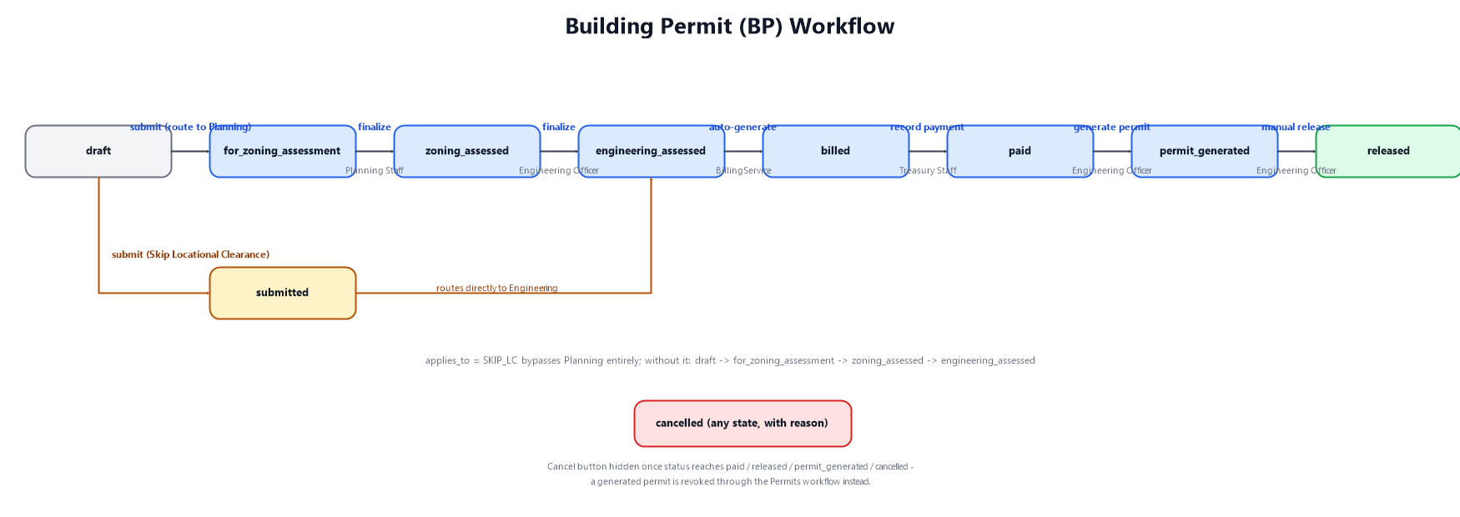
Figure 6. Building Permit (BP) Workflow

10.2 Shared Workflow (OP / FP / DP / SGP / AI) + Online Submission Loop
The diagram below also shows the online submission and review loop that applies to all six permit types when submitted through the client portal, and the Annual Inspection multi-certificate generation behavior, which is the one workflow exception at the permit-generation step.
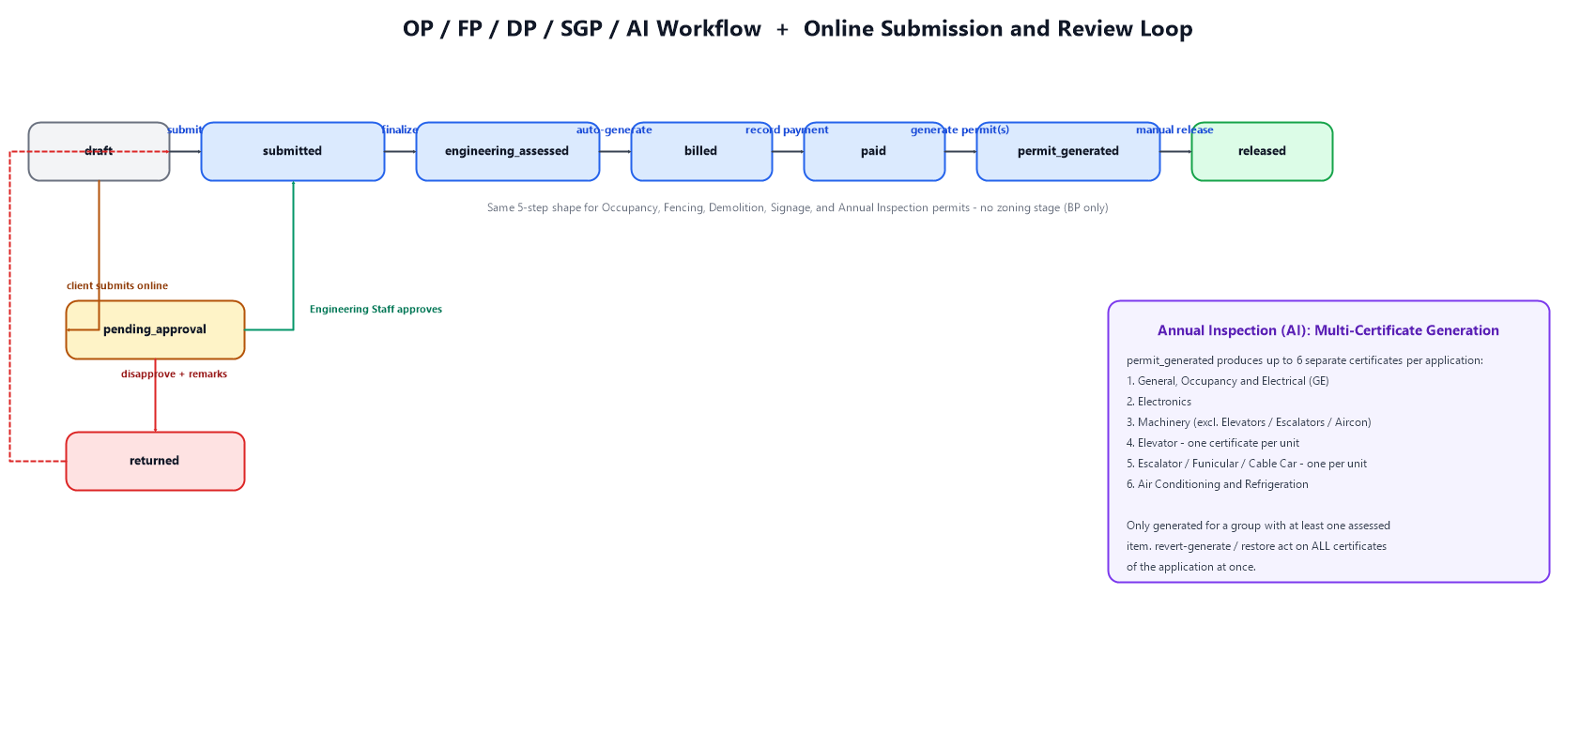
Figure 7. Shared Workflow, Online Review Loop, and AI Multi-Certificate Generation

11. Technology Stack
Layer / Concern | Technology
Backend Framework | PHP 8.2+, Laravel 12
Frontend | Blade Templates, Tailwind CSS, Alpine.js, Chart.js
Database | MariaDB 12.3 (epms_db)
PDF Generation | barryvdh/laravel-dompdf
Role-Based Access Control | spatie/laravel-permission
Audit Logging | spatie/laravel-activitylog
Data Export | maatwebsite/excel
Local Development | XAMPP on Windows (artisan serve, port 8100)

12. Conclusion and Future Enhancements
EPMS consolidates what was previously a fragmented, paper-based, multi-office process into a single system that gives applicants self-service visibility and gives LGU staff a consistent, auditable, role-gated workflow for every permit type it supports. Recommended next steps for a production rollout include: a formal payment gateway integration for true online payments, SMS/email notifications for status changes, and a mobile-friendly or native mobile client for the applicant portal.
This document is a draft prepared for presentation purposes and will be refined based on feedback.

