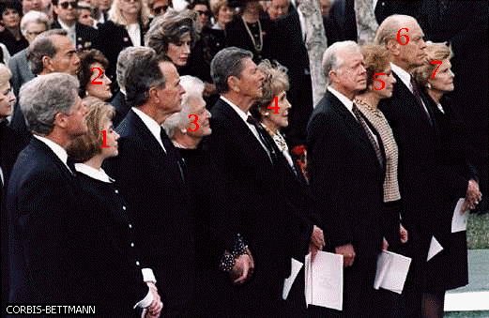For use with the American Figures category round in Round Two

For use with Tossup Eight of Round Three

|3x²-18| < 9

For use with part one of the bonus attached to Tossup Thirteen of the Quarterfinals

y=sin⁻¹ (cos (sin⁻¹ 0))

For use with part two of the bonus attached to Tossup Thirteen of the Quarterfinals

y=cos⁻¹ (sin (tan 2π))

For use with part three of the bonus attached to Tossup Thirteen of the Quarterfinals

y=(cot π/6)(tan 3π/4)

For use with the Mathematics tossup in the Replacements and Tiebreakers packet

{ | 2x-y=25  12y+3x=51

