Final Proposal

For our final project in CIS 308 we are wanting to make a Gameboy Color game using GBDK. We saw the option on the final project description and the idea sounded interesting, so we looked into it and start experimenting. Neither of us have ever used GBDK nor attempted making a game in c, which makes us want to attempt this even more. We think it would be interesting to learn how to make a Gameboy Color game, which is why we decided to go with this prompt. Right now, we have come up with a concept for a game and we have even started on it. Our game will be like a flappy bird type game but a little different, we will have a character that looks like he is running towards randomly generated obstacles which the player will have to jump over, double jump over, and slide under. Every obstacle the player passes without colliding will earn the player a point. We also have an idea to create a leaderboard for the game that will keep track of the players scores until the program ends. The libraries we have selected to use so far is as follows: stdio.h, stdlib.h, rand.h, gb/gb.h, gb/drawing.h. These are the libraries we have found that will help us complete our task.

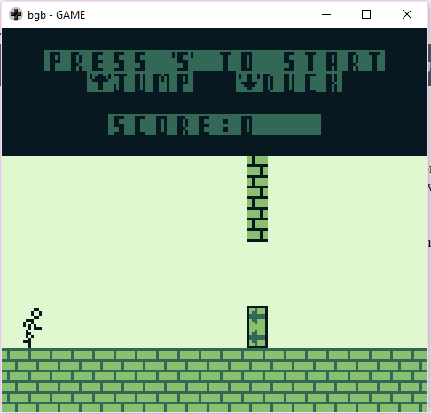**Screenshot of game so far:**

**Note:**

All sprites & tiles are created by us as well.