GRID PROPERTY VENTURES

Business Site Analysis (BSA)
How It Works — A Plain-Language Guide
A visual, non-technical walkthrough of what BSA does,
how a broker uses it, and why its answers can be trusted.
Prepared for leadership and investors
August 2026 · BSA Agency

The Short Version
Business Site Analysis (BSA) helps a real-estate broker answer one deceptively hard question: “Is this a good location for a new branch?” Today that answer depends on a broker’s experience, scattered spreadsheets, and a lot of legwork. BSA gathers the real-world data around a candidate site — nearby competitors, population, foot traffic, lease rates, malls, roads — measures it, and hands the broker a clear, plain-language verdict backed by real numbers, all in one shareable report.
Crucially, BSA is built to sharpen the broker’s judgment, not replace it. The broker still walks the site, reads the room, and closes the deal. BSA simply gives them a faster, evidence-backed head start — and gives their client a professional report to stand behind the recommendation.
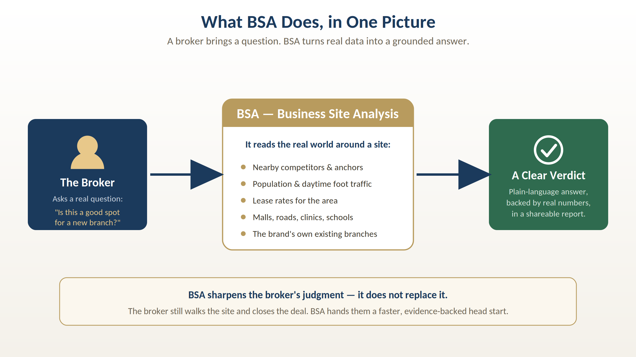
Figure 1 — What BSA does, at a glance: a question in, a grounded answer out.
The one idea to remember
BSA turns the messy, real world around a location into a decision-ready answer — quickly, consistently, and with every number honestly labeled for how certain it is.

How a Broker Actually Uses It
From the broker’s seat, BSA is a guided five-step flow. There is no code to write and no database to understand — just a form, a map, and a report at the end. Here is the whole journey.
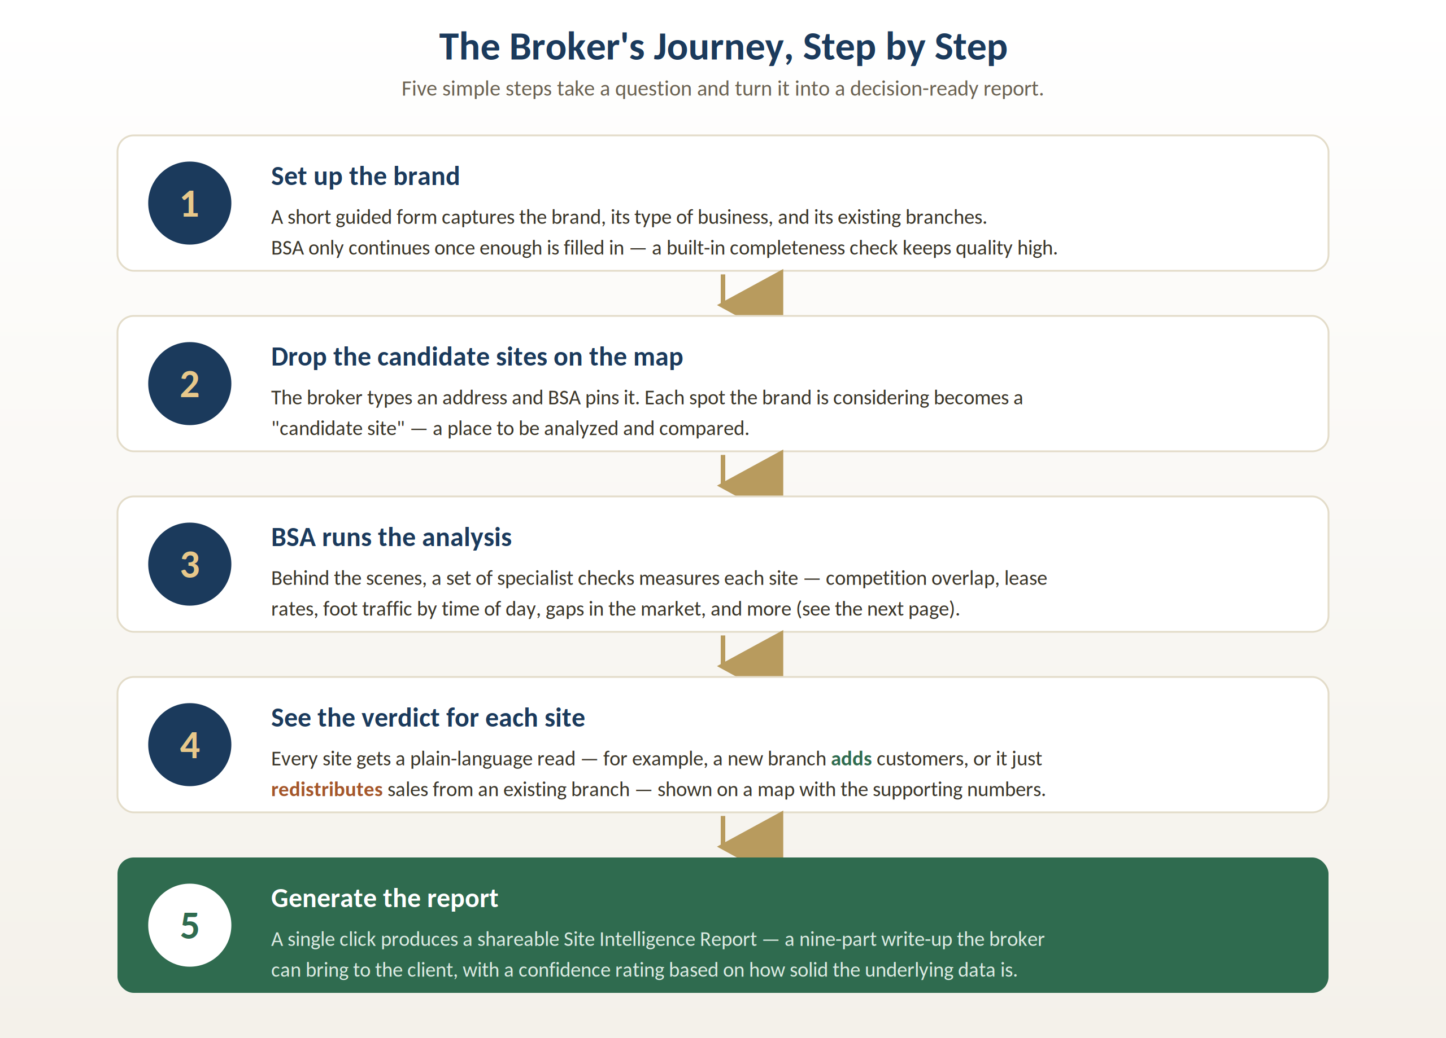
Figure 2 — The broker’s journey, from setup to a finished report.

Walking through the five steps
Step 1 — Set up the brand. A short guided form captures the brand, what kind of business it is, and where its existing branches are. BSA won’t move forward until enough detail is filled in — a built-in completeness check keeps the quality of every analysis high.
Step 2 — Drop the candidate sites on the map. The broker types an address and BSA pins it automatically. Each location the brand is weighing becomes a “candidate site” to be analyzed and compared against the others.
Step 3 — BSA runs the analysis. Behind the scenes, a set of specialist checks measures each site — competition, lease rates, foot traffic by time of day, market gaps, and more. This is where the heavy lifting happens, and it happens in seconds, not days.
Step 4 — See the verdict for each site. Every site gets a plain-language read shown on a map with its supporting numbers. For example, a proposed branch might add genuinely new customers, or it might mostly redistribute sales away from a branch the brand already owns nearby.
Step 5 — Generate the report. One click produces a shareable Site Intelligence Report — a nine-part write-up the broker can bring straight to the client. The report even carries a confidence rating based on how solid the underlying data was.

What BSA Looks At
When BSA “runs the analysis,” it is really running a panel of specialist checks against each site — each answering one focused question. Not every check applies to every business, so BSA automatically switches on the ones that matter for the brand at hand (a café and a pharmacy get different checks).
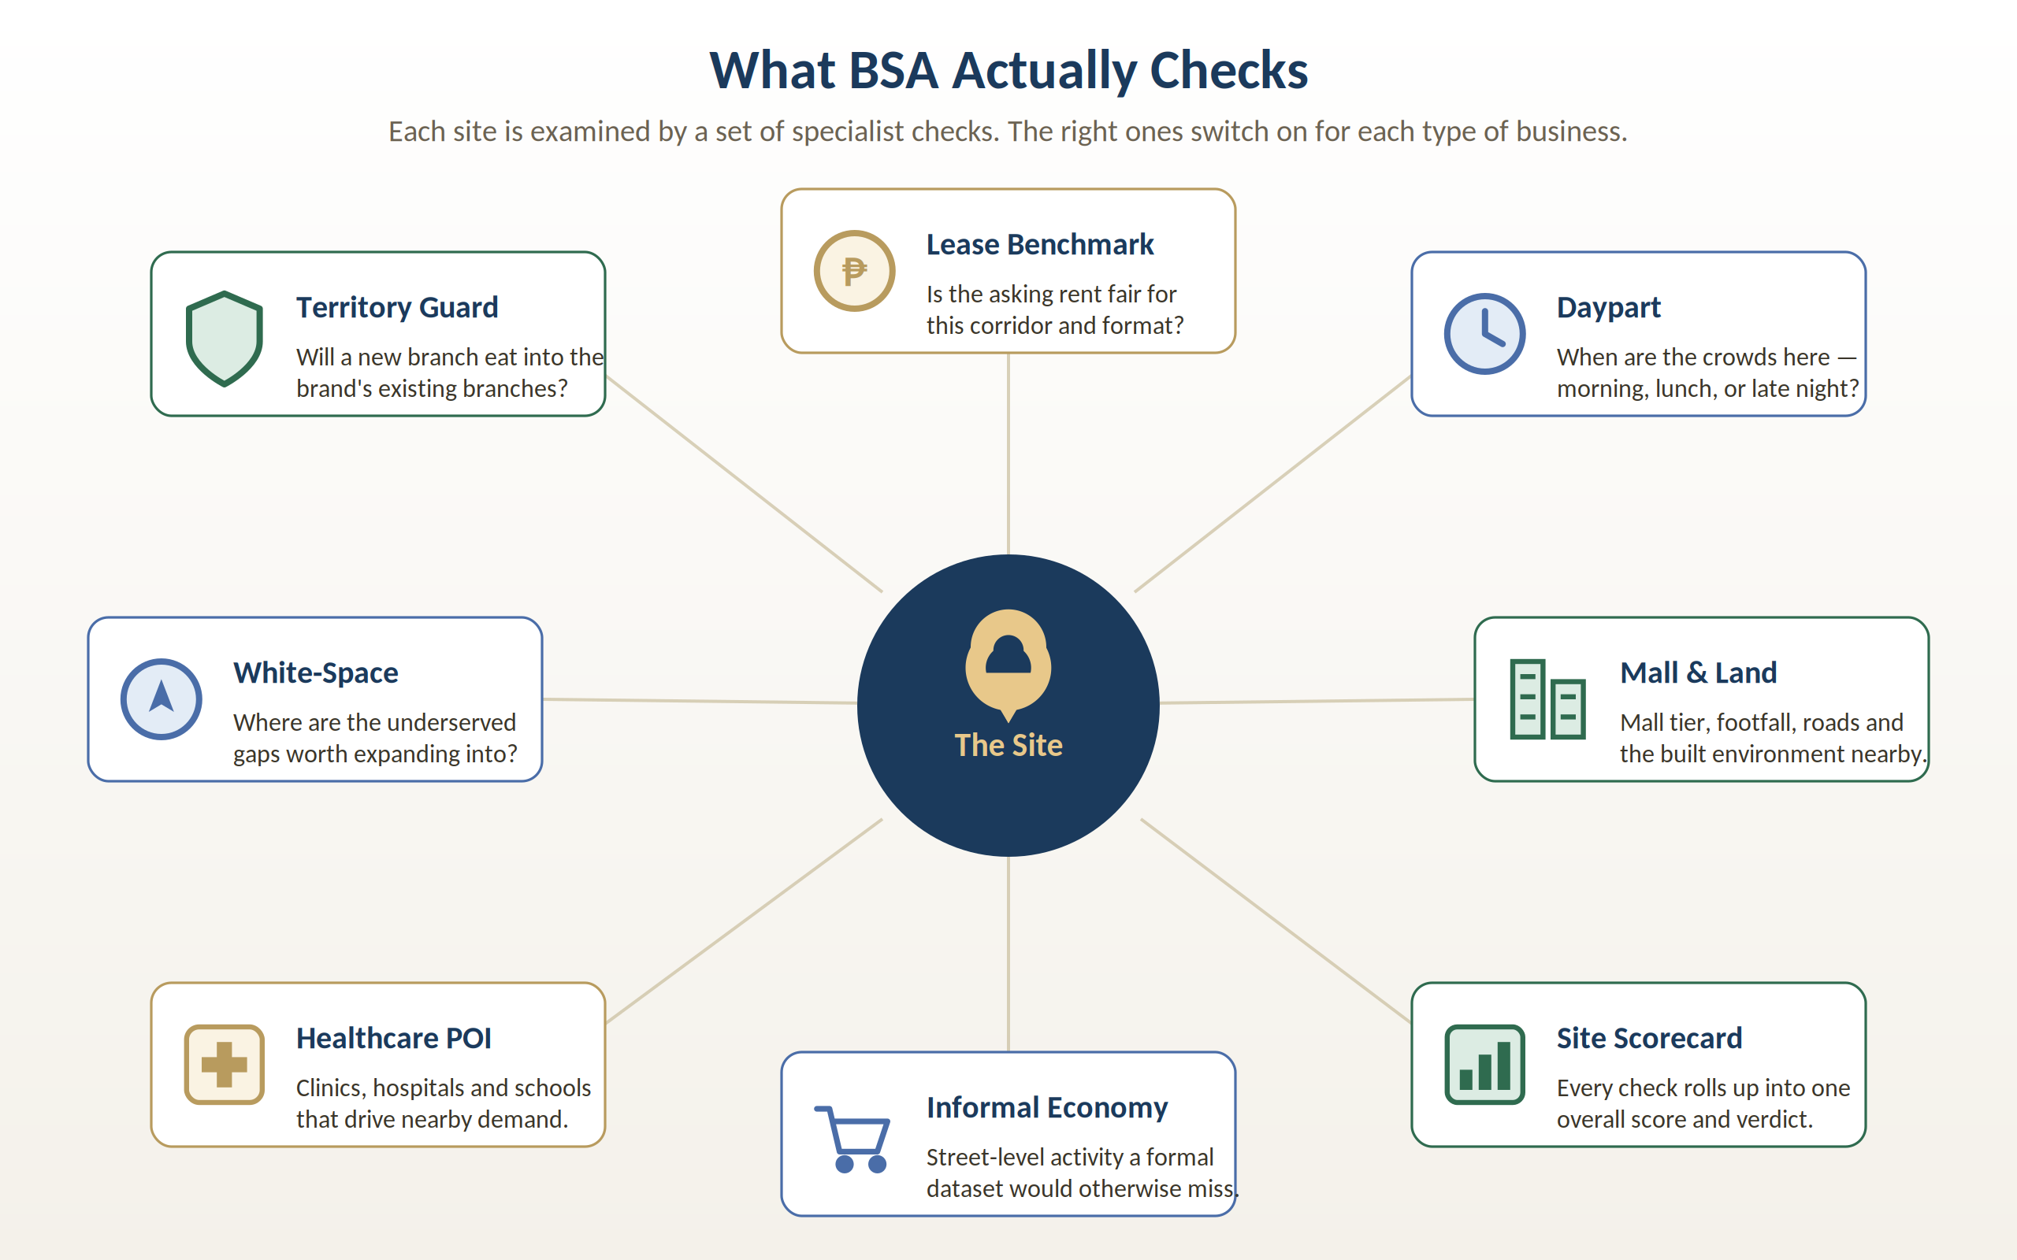
Figure 3 — The specialist checks that surround each site. The right ones activate per business type.
The most-used check, Territory Guard, deserves a special mention because it captures a risk brokers care about most: opening a new branch so close to an existing one that it simply cannibalizes its own sales. BSA measures how much the trade areas overlap and states plainly whether the new site adds, is mixed, or mostly redistributes existing business.

Why BSA’s Numbers Can Be Trusted
A location report is only as good as the trust behind its numbers. BSA’s answer to that is a feature we call the Truth Layer. Every single figure BSA presents carries one of three honesty tags, so a reader can instantly tell a hard fact from an educated guess.
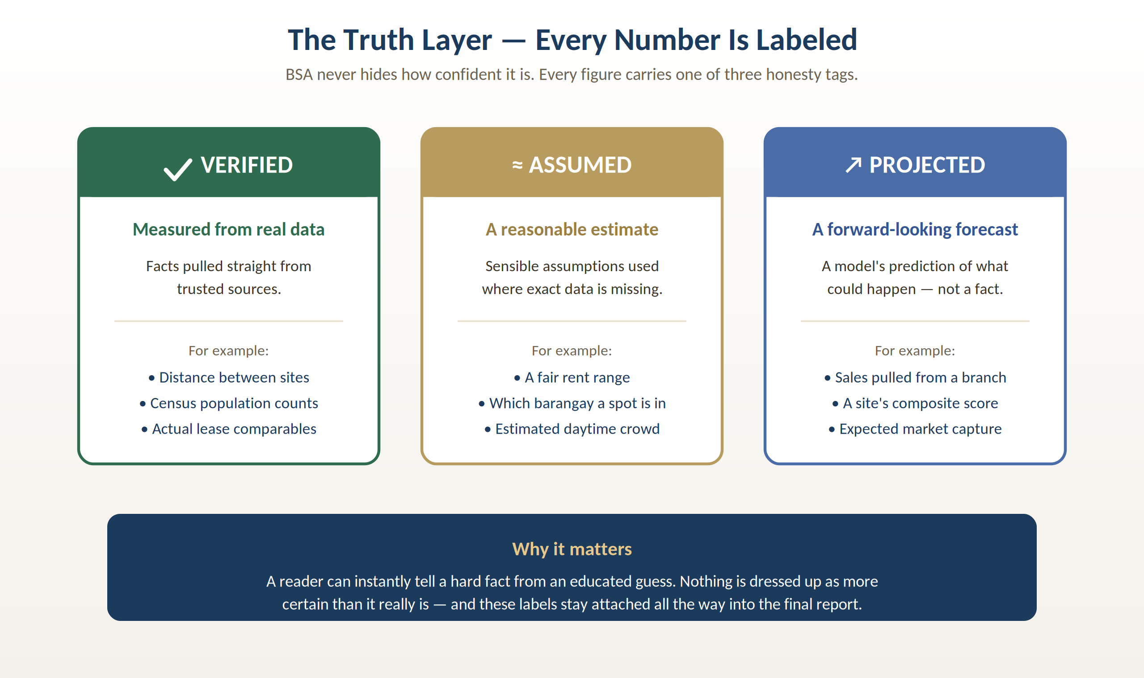
Figure 4 — Every number BSA shows is tagged Verified, Assumed, or Projected.
- Verified — measured from real, trusted data (for example, the true distance between two sites, or an official census population).
- Assumed — a sensible estimate used where exact data isn’t available (for example, a fair rent range for an area).
- Projected — a forward-looking forecast of what could happen, clearly marked as a prediction rather than a fact.
These labels are not cosmetic. They are attached to the data from the moment it enters the system and stay attached all the way into the final report — nothing is ever dressed up as more certain than it really is. When a site simply doesn’t have enough data behind it, BSA says so rather than inventing a confident-sounding answer.
The honest-by-design principle
BSA would rather tell a broker “we don’t have enough data here” than fabricate a number. That honesty is what makes the report safe to put in front of a paying client.

How BSA Uses AI — Safely
BSA does use artificial intelligence — but in a deliberately constrained way that avoids the usual risk of AI “making things up.” The rule is simple: the AI writes the words, but it is never allowed to invent the numbers.
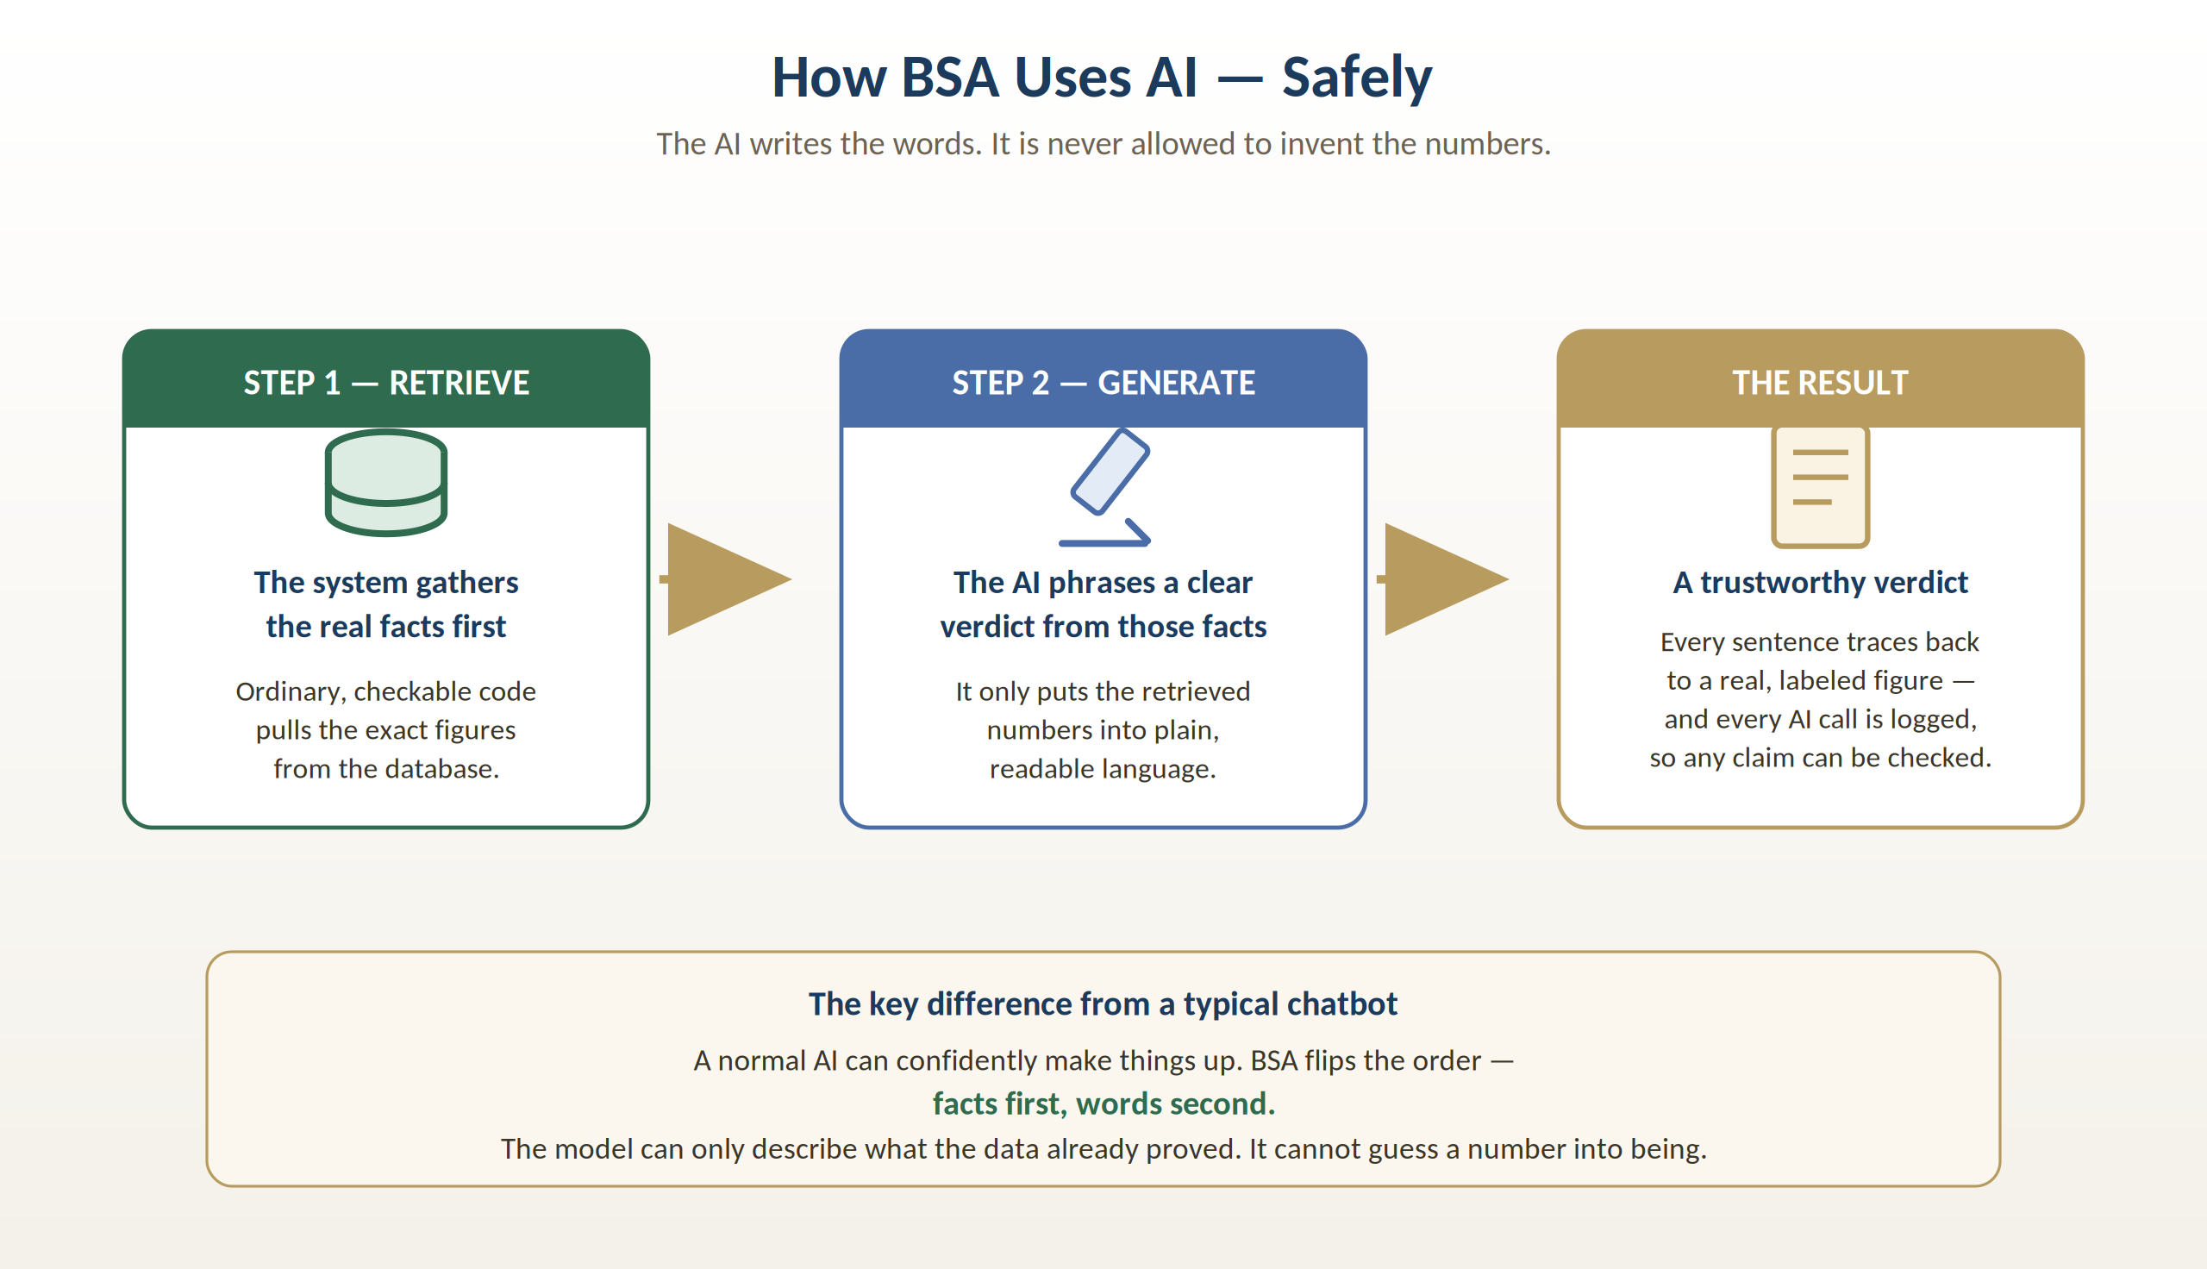
Figure 5 — Facts first, words second: how BSA keeps its AI grounded.
It works in two steps. First, ordinary, checkable software pulls the exact figures from the database — no AI involved. Second, the AI takes only those already-established facts and phrases them into a clear, readable verdict. Because the facts are locked in before the AI ever speaks, the model can only describe what the data already proved. It cannot guess a number into being.
This is the opposite of a typical chatbot, which generates confident-sounding text first and may get the facts wrong. On top of that, every AI-written sentence traces back to a specific figure, and every AI request is logged — so any claim in a report can be checked after the fact. It’s AI you can audit.

The Bottom Line
BSA takes a decision that today rests largely on a single broker’s instinct and turns it into a fast, consistent, evidence-backed process — without ever pretending to be more certain than the data allows, and without taking the broker out of the driver’s seat.
For the broker, it means walking into a client meeting with a professional report and a defensible recommendation in minutes rather than days.
For the client, it means a location decision backed by real data with its confidence clearly stated — not a hunch.
For Grid, it means a repeatable, trustworthy product that scales the expertise of its best brokers across every deal.
In one line
BSA turns the real world around a location into a decision-ready, honestly-labeled answer — and hands it to the broker as a head start, not a replacement.
This guide is a plain-language companion to the technical documentation prepared for Grid’s development team. Every figure BSA produces carries its Truth-Layer classification, in keeping with the standard described on page 5.

