Part 1:

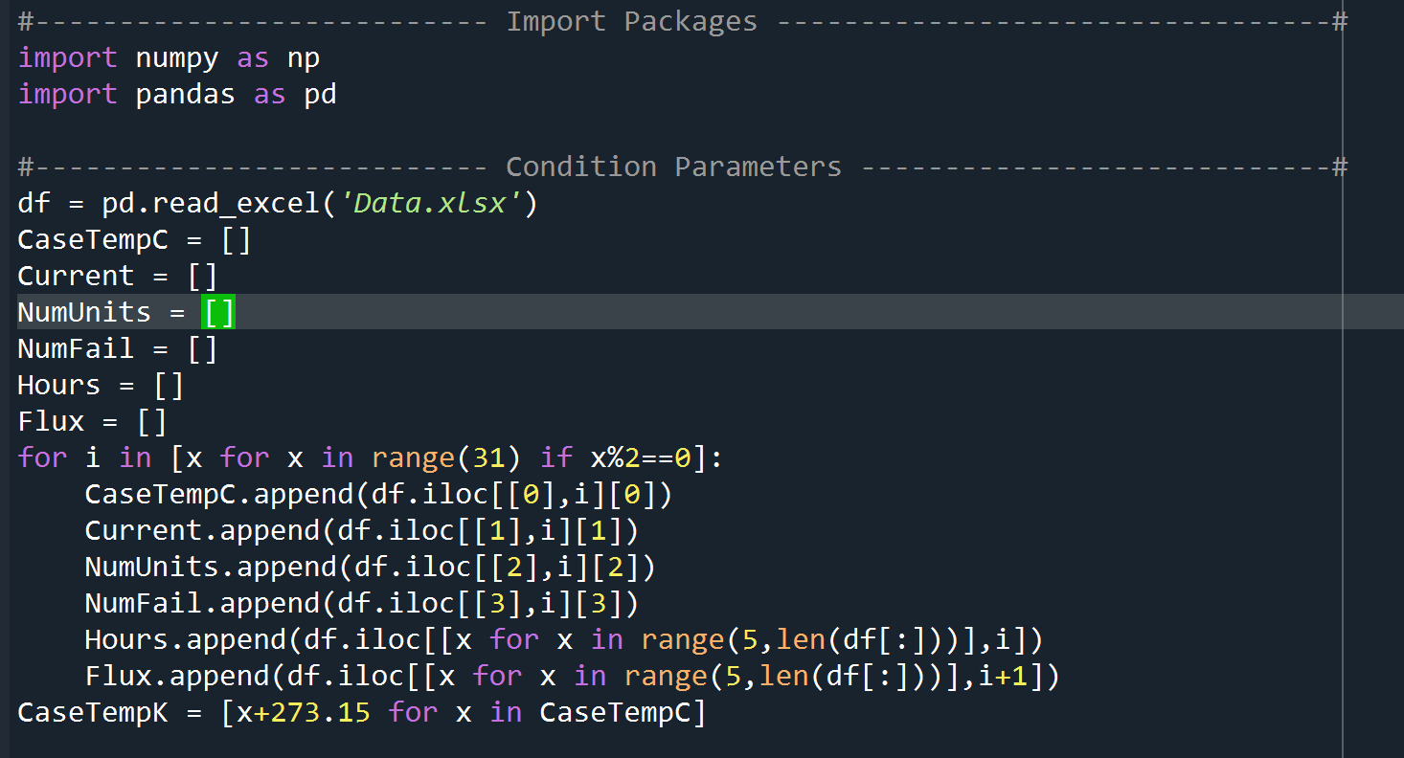

The data frame is read from the “Data.xlsx” I share in the email. It’s like this below. It is a 19x32 matrix.

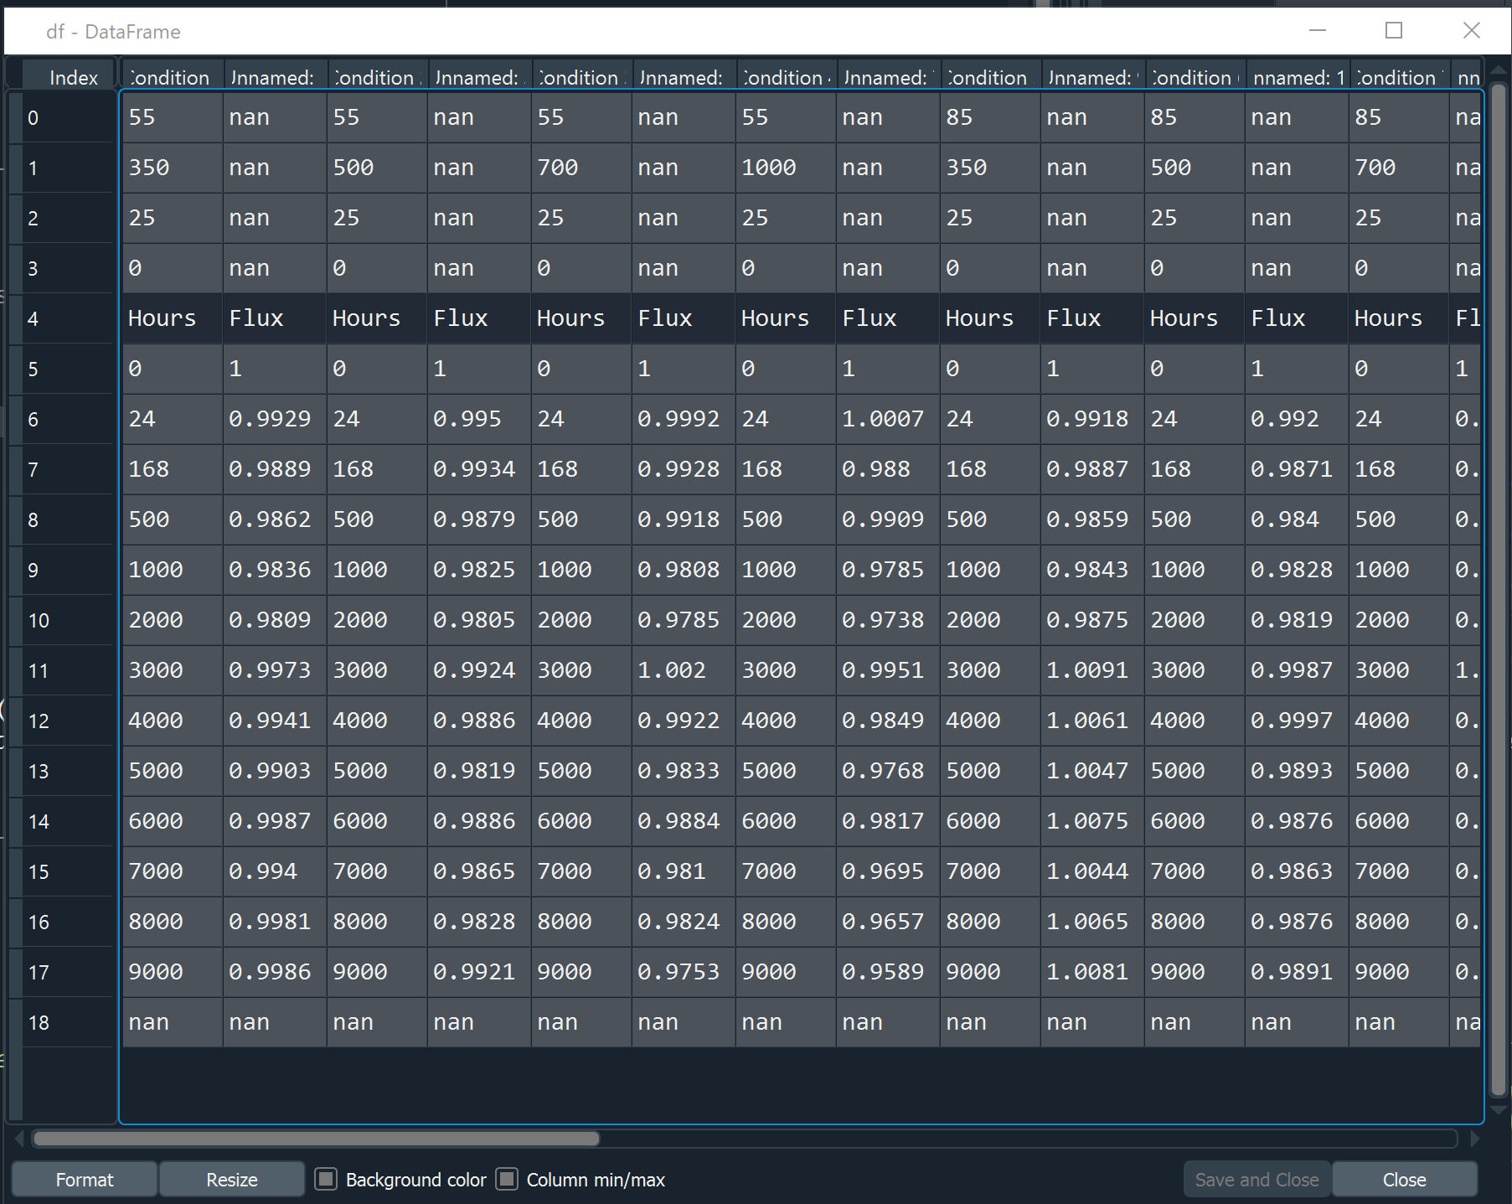

For all the 16 conditions, CaseTempC, Current, NumUnits, NumFail lists are created to store data from Row 0 through Row 3.

CaseTempK converts temperature from Celsius to Kelvin.

“Hours” and “Flux” are two matrices to store Hours and Flux data in each condition.

Part 2:

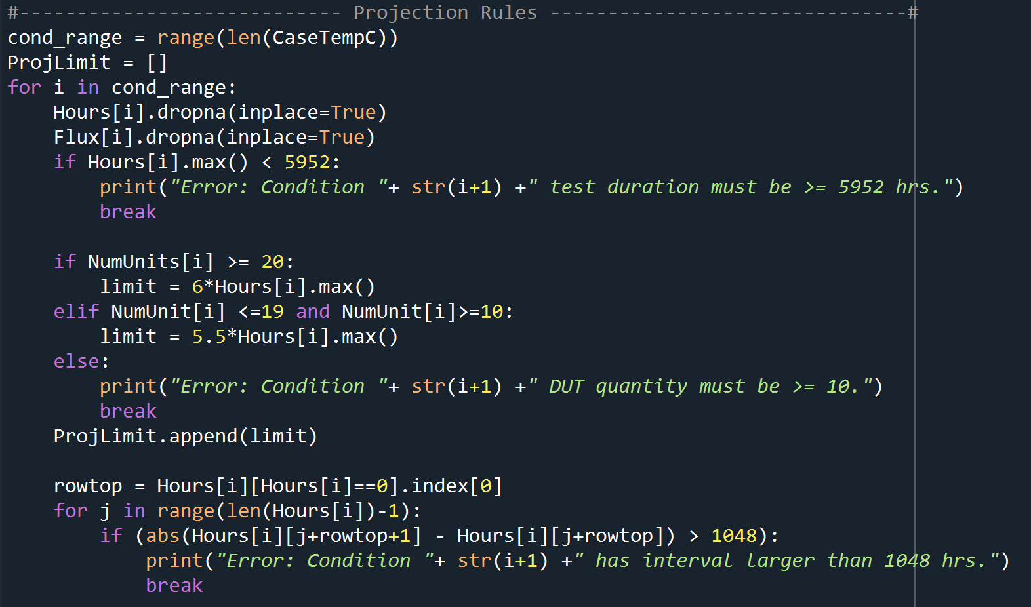

Input: Hours and Flux data from each condition (NaN dropped)

Output: Projection limits for each condition. A “ProjLimit” list is created to store them. See Eric’s slide page 7.

Part 3:

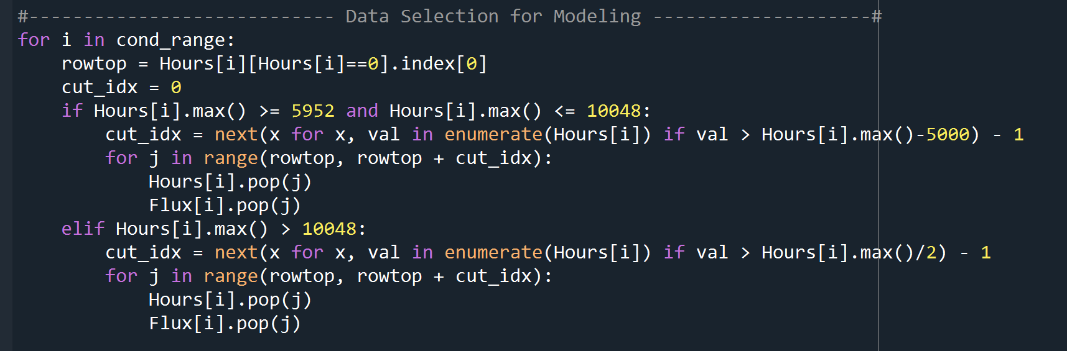

Input: “Hours” and “Flux” matrices for the 16 conditions.

Output: Truncated “Hours” and “Flux” matrices for the 16 conditions, only with usable data (see Eric’s slide page 10).

Part 4:

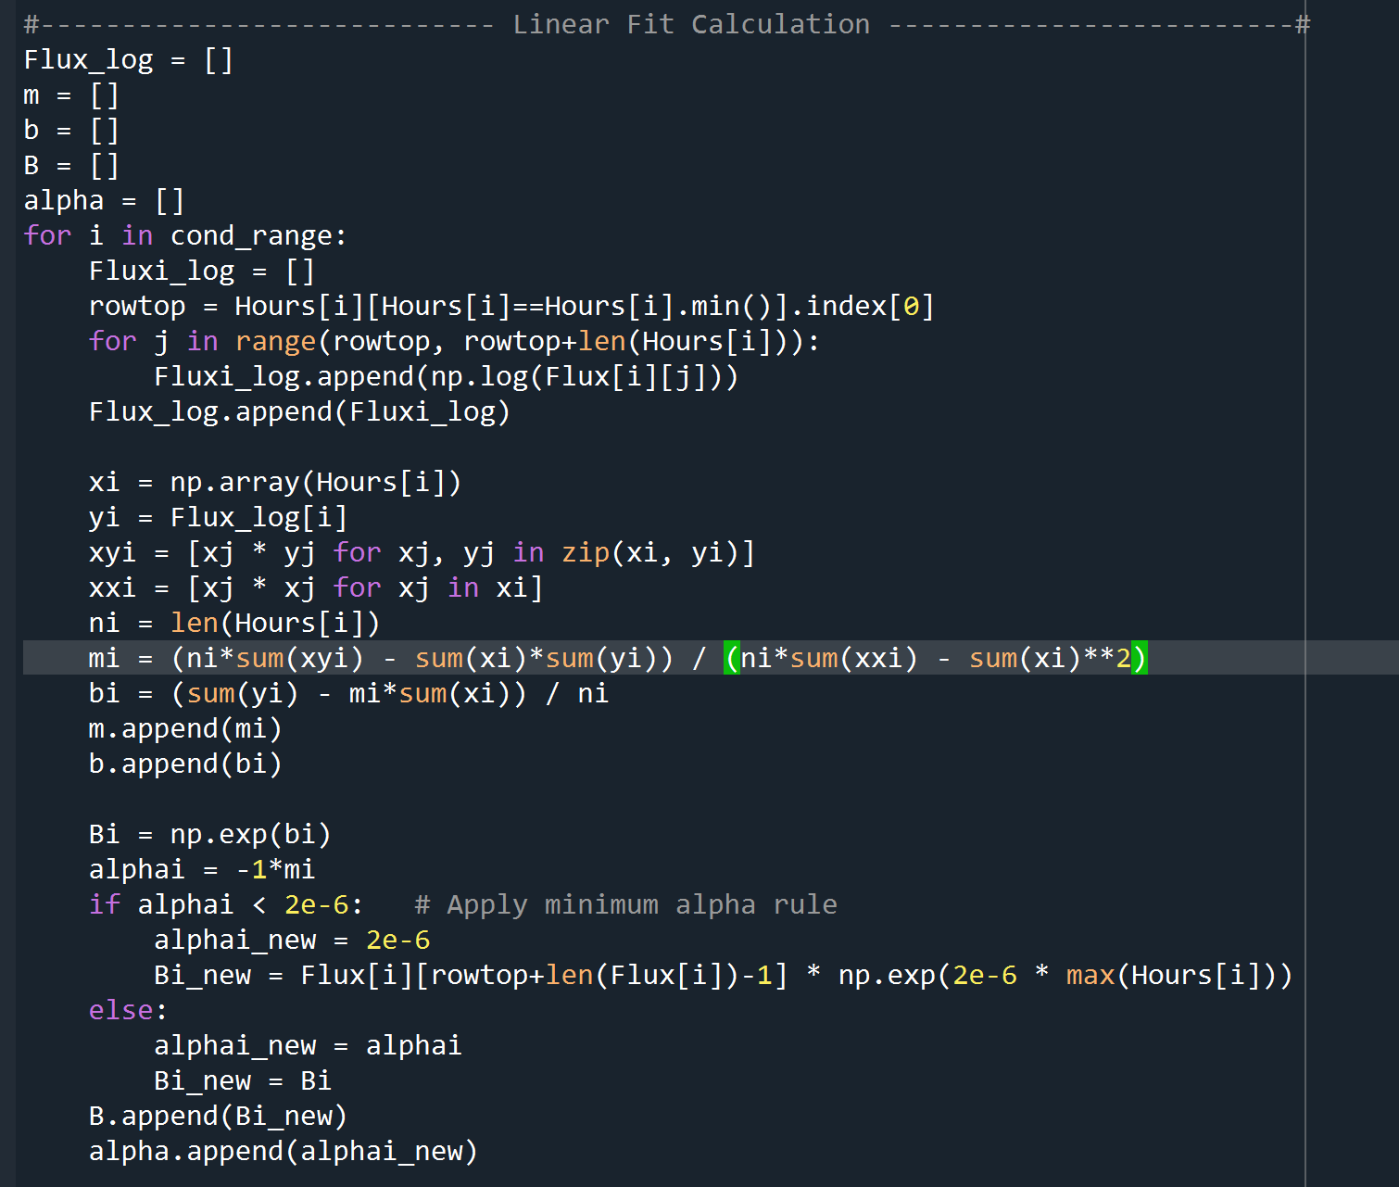

Input: Truncated “Hours” and “Flux” matrices.

Output: “alpha” and “B” lists derived from linear fit. You can also output “m”, “b” and “Flux_log” lists from linear fit. See Eric’s slides page 11-19.

Note: Minimum alpha rule should be used in this step.

Part 5:

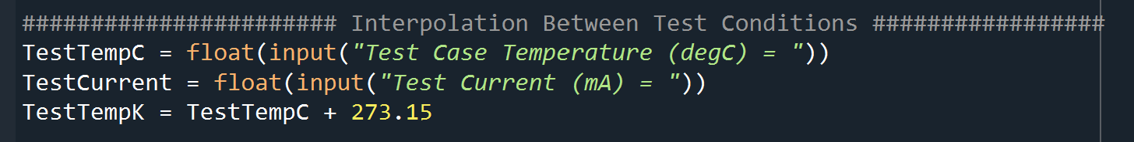

Input: User input “TestTempC” in Celsius and “TestCurrent” in mA.

TestTempK converts temperature from Celsius to Kelvin.

Still working on this part, not output yet.