HOW TO USE THE POST-PROCESSING SCRIPT

The post-processing script is a code developed in parallel of the top noise toolbox. The objective is to export and process the outputs results obtained from the simulations.
A large part of the rolling noise comes from vibrations generated by the contact between the wheel and the rail. One of the main objectives of the script is to calculate the contact forces required to estimate the railway noise.
Before starting, please check if you have the required python libraries indicate in the requirements.txt file. If not, you must install them to continue.

Once launched, the following interface will appear:

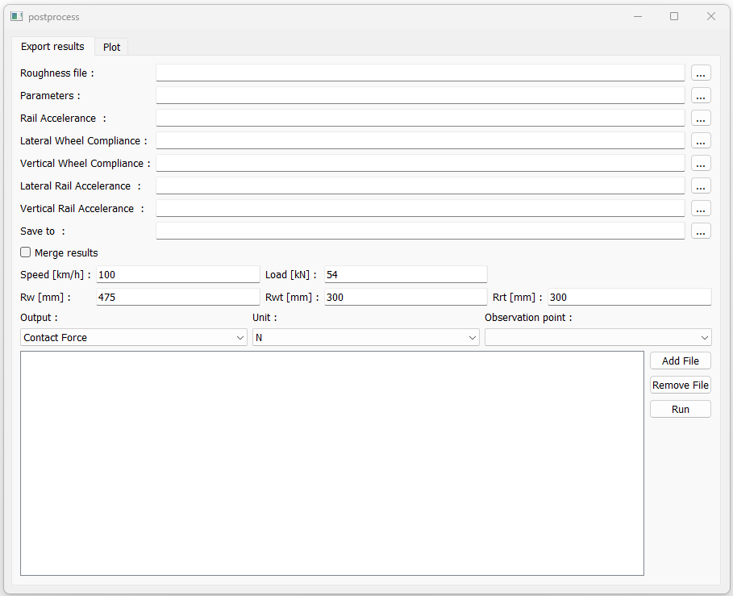

The first tab (Export results) is the interface for exporting and process the inputs coming from the rail track modelling toolbox.
Form description:
- Roughness file: The file containing the roughness of the rail/wheel interface can be selected here. This file is not mandatory. If no file is specified, the results will be express per unit of m
- Parameters: In this input you are supposed to add the .json file of your simulations. This file will be used to get all the parameter from the studied case, as material parameters, groups of nodes...
- Rail accelerance: The file refers to the study simulation. It is the generated FRF.txt file containing the rail accelerance [g/N]. The file is not mandatory for generating contact forces. However, it is useful if you want to export the acceleration and mobility data in (.csv) format and plot them directly from the script. By default, the path corresponds to the FRF.txt file generated by the parameters.json file.
- Lateral/Vertical Wheel Compliance: input the wheel point compliance [m/N] as a (.txt) file
- Lateral/Vertical Rail Mobility: Input the vertical/lateral accelerance of the rail [g/N] as a (.txt) file
- Save to: Directory where results are saved. By default, the outputs directory specified in the parameters.json file is used.

The checkbox Merge Results is useful for concatenate all the results after running the postprocessing script.

After filling in the input and output files, it is necessary to enter the model parameters.
For it to work, it is necessary to enter the train speed [km/h], the wheel load [N] and the geometric parameters of the track [mm].

Run a calculation:
Finaly, the observation point used *
Then the unit
First select, the data to compute

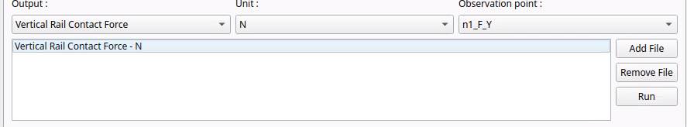

* The algorithm extracts the FRF (Frequency Response Function) generated with the Railtrack Modelling Toolbox and entered in the form. These FRFs need an application point (where the load is applied) and an observation point (where the wanted physical value is measured). Normally, there is only one application point, which is directly taken by default from the .json file. But for observation, the choice is given with all the points found.

For adding the task to the list, you can click on Add File or remove it with Remove File. You can add several tasks in to the list.
The user can select which output to compute from the files. Here are all the possibilities:
- Contact Force: This option computes the norm of the contact force between the rail and the wheel.
- Vertical Rail Contact Force: This option computes the vertical contact force
- Lateral Rail Contact Force This option computes the lateral contact force
- Rail Accelerance: Exports the rail accelerance at the given point. However, to use this option, you must correctly fill in the ‘Rail Accelerance’ field in the form. The exported data corresponds to the values indicated for this case study.
- Rail Mobility: Computes and exports the rail mobility at the given point. However, just like rail accelerance, to use this option, you must correctly fill in the ‘Rail Accelerance’ field in the form
When you finished you can run the script by clicking on Run, the data will be saved into the save directory.

Plot the results
An interface is provided to display the results in the Plot tab.
The purpose of this interface is to graphically represent the values obtained and to compare several scenarios with each other.
A title can be added to the comparison using the ‘Title’ field.

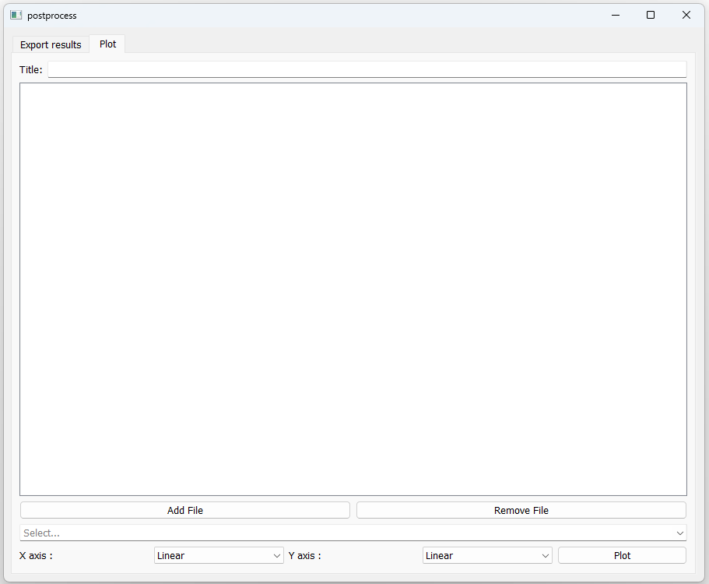
You can add a calculation result to the list by clicking Add File.
And you can remove it with Remove File

It is possible to specify which scale to use for plotting graphs.
There are 2 choices for the x and y axis: Linear and Logarithmic
The plotting interface is a tool that helps you to visualise the results. The way this script was developed is that it identifies the physical quantities enclosed in “[ ]” in the headers of the .csv files. The algorithm then, groups these quantities and displays them in different graphs. The legends used are the headers found in the .csv files. It should be noted that the scales do not apply to phases expressed in rad.

The algorithm analyses and merges the data entered. It is possible to delete certain data by going to ‘select...’.

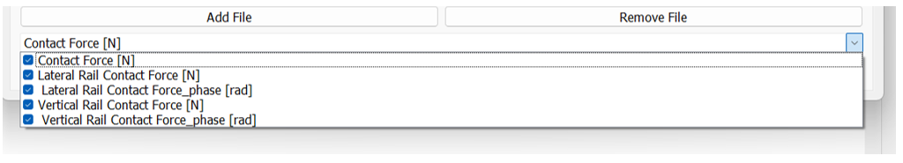

By default, all quantities found are selected. You can deselect any data you do not want to display. Finally, you can display the graphs by clicking on “plot”.

