The impulse model
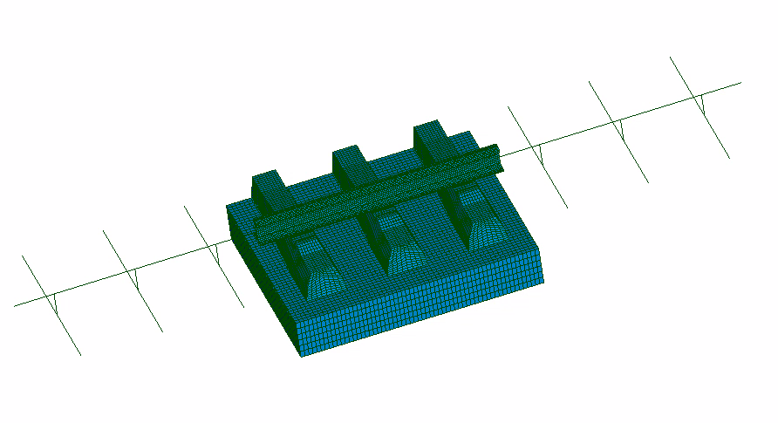
The impulse model provided in the TopNoise toolbox is a parametric model designed to analyse stresses in the ballast when a train passes over it. The section of track modelled is parameterised. This allows the geometry or material properties of elements such as the rail, pads, sleepers or USP (if present) to be modified.
The section of track under investigation is modelled using 3D, beam and discrete elements. This approach was adopted to accurately capture stresses in the ballast whilst minimising computation time. A specific 3D zone is identified at the centre of the track where the force is applied, whilst beam and discrete elements are used at its ends to maintain the stiffness and load transfer effects of the rails.
The number of 3D sleepers and beam elements is left to the user’s choice.
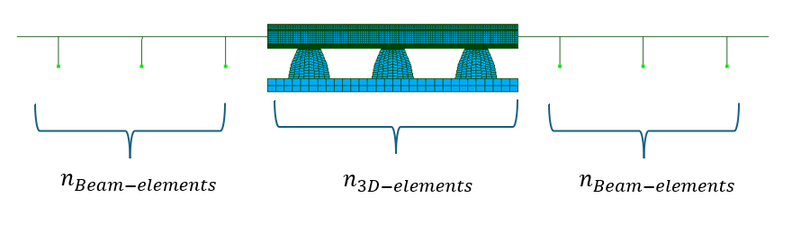
Figure 1 Elements used in the mesh

Depending on the types of elements used, the material behaviour implemented differs. The following table summarises the material behaviour considered depending on the modelling method.
Tableau 1: Material behaviour depending on the element type
 | 3D elements | Beams and discrete elements
Rail | Elastic properties | Elastic properties
Pads | Viscoelastic properties. Generalised Maxwell model defined in a Prony series | Equivalent stiffness at low frequency + Rayleigh damping
Sleepers | Orthotropic elastic + Rayleigh damping | Orthotropic elastic + Rayleigh damping
Ballast | Elastic + Rayleigh damping | Equivalent stiffness at low frequency + Rayleigh damping
USP | Elastic + Rayleigh damping | Equivalent stiffness at low frequency + Rayleigh damping

It is worth noting in particular the implementation of viscoelastic behaviour for the pads to account for relaxation effects. These have been modelled using a generalised Maxwell law defined in the Prosny series. However, this feature is only available for 3D elements.
Mechanical load
The passage of a train induces rail bending, which spreads the applied load across a characteristic length. The following load model is proposed to account for this phenomenon realistically:
$$F\left(t\right)=Fφ(v\left(t-t_{a}\right))$$
where:
- $φ\left(x\right)$ is an influence function centred at $x=0$ and defined over a characteristic length $l$,
- $F$ is the load per wheel (total axel load / 2),
- $v$ is the train speed.
- $t_{a}$ denotes the time at which the axle reaches the considered position
The influence function $φ$ is chosen as a half-sinusoidal shape and is defined as:

$φ\left(x\right)= \left\{\begin{aligned}\sin\left(\frac{πx}{l}\right) if \left|x\right|≤l \\ 0 otherwise\end{aligned}\right.$ and so, the loading function $F\left(t\right)= \left\{\begin{aligned}F. \sin\left(\frac{πvt}{2 l}\right) if \left|vt\right|≤l \\ 0 otherwise\end{aligned}\right.$

The characteristic length under consideration here refers to the distance between the rails. The load is applied at the node defined in JSON file
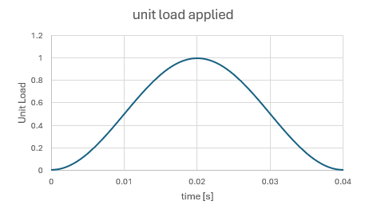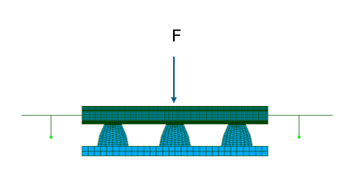
Figure 2: Shape of the mechanical load

Using the impulse module
To use the impulse model, a JSON file is required. This file contains all the parameters to be implemented.

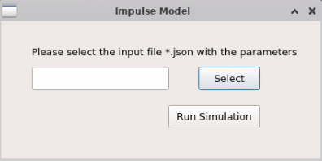
Figure 3: GUI of the impulse model

The calculation takes place in two stages.
First, to generate the mesh, the user must enter the geometric values to define the track.
Next, once the mesh has been defined, the programme runs the simulation (static or non-linear dynamic) to calculate the stresses exerted on the ballast.
Once again, to do this, the user must correctly enter the material data required to run the calculation.

Description of the JSON configuration file
All the parameters used in the .json file are described below.
Global parameters
takeUsp: Indicates if there is USPs in the model
Load: Load per wheel [N]. Don't forget the direction of the load ([ - ] or [ + ])
Load_Grp : Load application point
speed: Train speed [km/h]
timestep: Time step used for the load description [s]
timeline : list of time steps for which the simulation is evaluated [s]
alpha_htt : The time integration method is the HILBER-HUGHES-TAYLOR method (HHT or α-method), with a given negative value for α. The larger |α| is, the greater the numerical damping provided by the calculation.
nCPUs : Number of CPUs used for the simulation
memlim : Maximum amount of RAM used
run_simulation: Whether or not to run the simulation. by disabling It is possible to generate the mesh only.
debug: Keep the debug terminal open after the simulation
Static: Enable quasi-static simulation. In some cases, it may be beneficial to enable this option, particularly to reduce computation time. When this option is enabled, dynamic effects are ignored and the system is assumed to evolve in a quasi-static manner.
A_slp: This value indicates the half- area of the sleeper in contact with the ballast [mm²]
simu_folder: Folder where the result files are saved
mesh: Path linked to the mesh used for the simulation. If the ‘Creat_geom’ option is enabled, the generated mesh is saved at this location.
reptrav: Path of the temporary working directory where the calculation files are stored. Once the simulation is complete, these files are normally deleted
pads: Link to the JSON file that defines the pads material data. The file's parameters are defined in the section ‘Pads material definition’
sleeper: Link to the JSON file that defines the sleeper material data. The file's parameters are defined in the section ‘Sleeper material definition’
ballast: Link to the JSON file that defines the ballast material data. The file's parameters are defined in the section ‘Ballast material definition’
rail: Link to the JSON file that defines the rail material data. The file's parameters are defined in the section ‘Rail material definition’
usp: Link to the JSON file that defines the usp material data. The file's parameters are defined in the section ‘Usp material definition’

Geometry definition
Creat_geom : By disabling this option, the mesh will not be generated. Be careful, if this option and the run_simulation option are enabled, please check if there is a mesh linked to the mesh option.
tiltAngle_rad: Rotation angle of the rail about the longitudinal axis [rad]
halfDistBtwnRails: Z-position of the rail, on the sleeper [mm]
USPthickness: Usp thickness [mm]
padYOffset: Translation of the pad along the vertical axis. For the pad to rest on the sleeper, it must be moved a distance equal to the height of the sleeper [mm]
USP_mesh: Path linked to the mesh of the usp
Save_mesh: Location where the mesh is saved
Ballast_l: Length of the ballast [mm] (must be greater than the length of the half-sleeper)
Ballast_h: Height of the ballast [mm]
Element_per_edge_h : Number of elements used for the height of the ballast
Element_size_L: Sized of elements used for the length of the ballast

Rail:
Rail_mesh: Path linked to the reference mesh for the rail
Element_size : To create a rail section of the correct length, the reference rail mesh is extruded at its ends. This parameter indicated the longitudinal size of the rail elements added.
Rail_portion: Length of the rail section on the reference mesh [mm]

Sleepers:
nbr_sleepers_3D: Number of 3D sleepers used for the model
nbr_sleepers: Total number of sleepers (3D and beams) of the model
L_Sleeper_z: Half length of the sleeper [mm]
slpSpacing : Distance between 2 sleepers [mm]
L_beamSleeper : Half the length of the sleeper [mm]
Sleeper3D_mesh: Path linked to the reference mesh for the sleeper

Pads:
Lx: Characteristic length of the pad along the X-axis. Used in the simulation to calculate the mass and the damping matrices
Lz: Characteristic length of the pad along the Z-axis. Used in the simulation to calculate the mass and the damping matrices
Height: Pads thickness [mm]
Pad_mesh: Path linked to the mesh of the pads

Pads material definition
A viscoelastic behaviour is used to model the pads. To account for the relaxation effects of the pads, a generalised Maxwell’s law defined in Prosny series is used. 5 Prosny terms are implemented. If a simplified model is to be used, with n terms (where n < 5), the missing terms must be set to ‘0’.
Name: Material Name
E : Young modulus [MPa]
nu : Poisson coefficient [/]
rho: Density [kg/ton]
K : Bulk modulus [MPa], A list of 5 terms needs to be filled in.
G: Shear modulus [MPa], A list of 5 terms needs to be filled in.
Tau: Characteristic relaxation time [s], A list of 4 terms needs to be filled in.
DIS_Ky: Stiffness term used in the y-direction [N/mm]. The specified term is used for beam elements in the model. It is recommended to use the static stiffness or the stiffness at a frequency close to the rail’s excitation frequency.
DIS_Kx: Stiffness term used in the x-direction [N/mm]. The specified term is used for beam elements in the model.
DIS_Kz: Stiffness term used in the z-direction [N/mm]. The specified term is used for beam elements in the model.
DIS_Kry: Stiffness rotation term about the y axis [N/mm]. The specified term is used for beam elements in the model.
DIS_Krx: Stiffness rotation term about the x axis [N/mm]. The specified term is used for beam elements in the model.
DIS_Krz: Stiffness rotation term about the z axis [N/mm]. The specified term is used for beam elements in the model.
alpha: Proportionality factor α for Rayleigh damping used in the damping equation [C] = α[M] + β[K]
beta: Proportionality factor β for Rayleigh damping used in the damping equation [C] = α[M] + β[K]

Sleeper material definition
Name: Material Name
E_L: Longitudinal Young modulus [MPa]
E_T: Transversal Young modulus [MPa]
E_N: Transversal Young modulus [MPa]
nu: Poisson coefficient, same for all direction [/]
rho: Density [kg/ton]
alpha: Proportionality factor α for Rayleigh damping used in the damping equation [C] = α[M] + β[K]
beta: Proportionality factor β for Rayleigh damping used in the damping equation [C] = α[M] + β[K]

In the simplified part of the model, the sleeper section is divided in two. The sleeper is cut where the rail is laid. The parameters described below are identical but apply to two different sections. If the cross-section of the beam is constant, you can duplicate the geometric values. The order of the section is organised by their position relative to the centre of the track. Therefore, sec1 is the section closest to the centre of the trac and sec2 is the furthest.
A: Area of the beam section [mm²]
IY: Principal moment of inertia relative to GY [mm⁴]
IZ: Principal moment of inertia relative to GZ [mm⁴]
AY: Shear coefficient in the GY direction [mm²]
AZ: Shear coefficient in the GZ direction [mm²]
JX: Torsional stiffness [mm⁴]

Ballast material definition
Name: Material Name
E: Young modulus [MPa]
nu: Poisson coefficient [/]
rho: Density [kg/ton]
alpha: Proportionality factor α for Rayleigh damping used in the damping equation [C] = α[M] + β[K]
beta: Proportionality factor β for Rayleigh damping used in the damping equation [C] = α[M] + β[K]

Rail material definition
Name: Material Name
E: Young modulus [MPa]
nu: Poisson coefficient [/]
rho: Density [kg/ton]
alpha: Proportionality factor α for Rayleigh damping used in the damping equation [C] = α[M] + β[K]
beta: Proportionality factor β for Rayleigh damping used in the damping equation [C] = α[M] + β[K]
In the simplified part of the model, the rail is modelled using beam elements. The data bellows shows geometric values of the cross-sections used.
A: Area of the beam section [mm²]
IY: Principal moment of inertia relative to GY [mm⁴]
IZ: Principal moment of inertia relative to GZ [mm⁴]
AY: Shear coefficient in the GY direction [mm²]
AZ: Shear coefficient in the GZ direction [mm²]
JX: Torsional stiffness [mm⁴]

Usp material definition
Name: Material Name
E : Young modulus [MPa]
nu : Poisson coefficient [/]
rho: Density [kg/ton]
alpha: Proportionality factor α for Rayleigh damping used in the damping equation [C] = α[M] + β[K]
beta: Proportionality factor β for Rayleigh damping used in the damping equation [C] = α[M] + β[K]

Clamp material definition
Name: Material Name
kx: Stiffness term used in the x-direction,
ky: Stiffness term used in the y-direction,
kz: Stiffness term used in the z-direction,
ampx: Damping term used in the x-direction,
ampy: Damping term used in the y-direction,
ampz: Damping term used in the z-direction,

