TeensyDist user manual

TeensyDist is a DIY / open source distortion / amp modeling pedal that feature up to customisable cascaded distortion stages, pre and post eq and impulse response filters for tone shaping as well as a dynamic compressor and noise gate.

The present document aims at describring the parameters used to model the different parts of a amp or drive pedal and to give recommended starting points to develop your own tones.

Hardware interface

The hardware buttons and pots of TeensyDist pedal are described in the picture below:

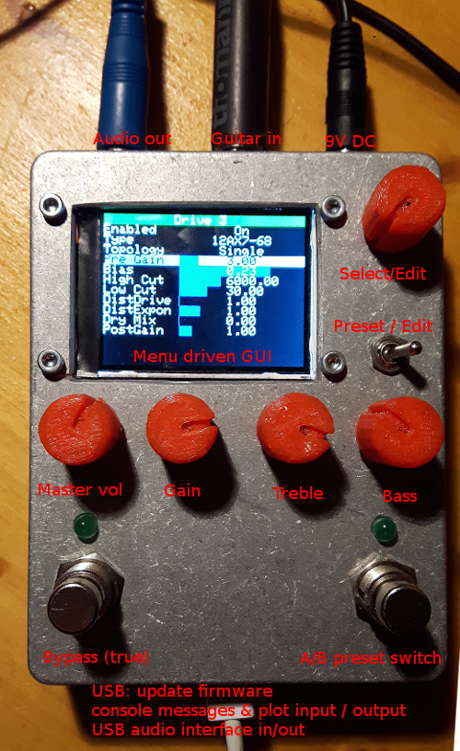

9V DC barrel plug (negative center, Boss style power supply): is used to supply voltage to the preamp buffer stage and optionnally to supply the Teensy microcontroller through a 5V linear voltage regulator.

Guitar In (High impedance input): 6.35 mono Jack input to plug your instrument. This input has a high impedance and feeds the input buffer of your choice.

Audio out (low impedance output): 6.35mm mono Jack output for the processed audio signal. Low impedance, instrument to line level output.

Usb connection: to connect the Teensy microcontroller to a PC for firmware update, debugging and for optionnal USB audio in-out connectivity. Optionnally can supply the microcontroller if you don’t want to add a 5V linear regular to power the Teensy from 9V DC

Select/Edit encoder & push button:
- use it for parameter edition: rotate to change selection (highlighted), press to enter edit mode, turn to change value, press again to validate input.
- to change the active menu: select the menu title, press once, turn until the desired menu is shown, press again to validate.

Preset / Edit switch: toggles between deep editing mode and preset only. When under preset mode, only the preset menu is accessible and a small subset of parameters can be edited. In deep editing mode, all menus and options are accessible.

Master Volume knob: controls the overall output volume level (software gain at the end of the signal processing chain). For more radical change of output level (adjustement of to instrument or line output level), you can also change the hardware output level in the 1st menu.

Gain knob: this control is mapped to the preamp gain of the first distortion stage. If the 1st distortion stage is active, this know will control the overall amount of distortion generated.

Treble knob: this potentiometer is mapped to the post-distortion high cut frequency control. The further on the left, the more it cuts high frequency (less treble). When fully on the right, it let nearly all high frequencies pass to the output.

Bass knob: this potentiometer is mapped to the post-distortion low cut frequency control. The further on the left, the more it lets low frequency pass to the output (more bass). When fully on the left, it let nearly all low frequencies pass to the output. When set on the right it cut low bass to create a tighter sound.

A/B preset switch: when pressed once, it switches between the A and B preset on the current Bank/preset slot. When pressed twice within 0.5s, it cycles through the presets in the current bank. Each bank is composed of 4 dual-presets (A & B).

Bypass: True bypass switch. It redirects the input to the output without signal processing.

Signal processing and distortion modeling

TeensyDist distortion modeling replicates the typical sound alteration process found in most guitar effects and amplifiers.

In a nutshell, the input signal gets filtered before distortion to control the character of the distortion (tight or fat, bright, midfocused, scooped or dark). The signal passes then through a dynamic compressor and noise gate to control the dynamics (response to attack and sustain) of the signal. Then the signal is fed into a cascade of up to 4 non-linear gain stages that will introduce different types of distortion. Each stage is composed of a pre-distortion gain that controls the amount of distortion that will be generated, followed by a nonlinear static transfer function (waveshaper) that can represent the typical response of a tube or solid stage component, or be based on a mathematical model. The waveshaper output is then filtered to remove DC component (can be tuned to control the “squishiness” of the distortion) and a high cut filter to control how much “fizz and treble” is passed to next stage.

The waveshaping function can be chosen to represent harder or smoother clipping functions to control how much harmonic content is generated. Asymmetric (even harmonics) or symmetric (odd harmonics) clipping can be achieved by tuning the input bias to the waveshaper. Each stage can also be configured as a single ended component or as a push pull pair (more symmetric, fuller, response).

Finally, at the end of the 4th distortion stage, the final volume is controlled by a variable gain (Master volume) and the signal is post filtered to shape its final frequency content (equalizer).

The signal processing flow is described in the following diagram:

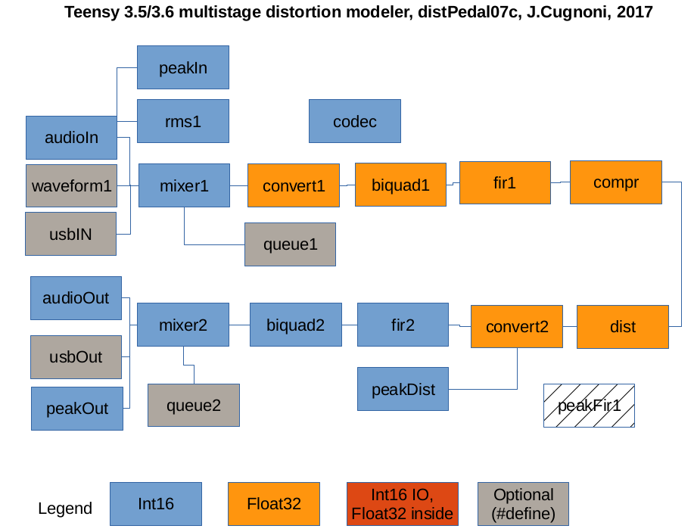

Menu interface

TeensyDist is using a menu driven GUI for parameter editing and preset managements. The 4 potentiometer on the pedal are actually shortcuts to menu parameters Master volume, Pre gain of Drive 1 stage, Post High cut and Post Low cut equalizer settings.

In the following, each menu is presented with the meaning and function of each parameter.
Levels and compressor menu

This menu contains all the parameters affecting the overall input/output volumes and the parameters of the compressor & noise gate.

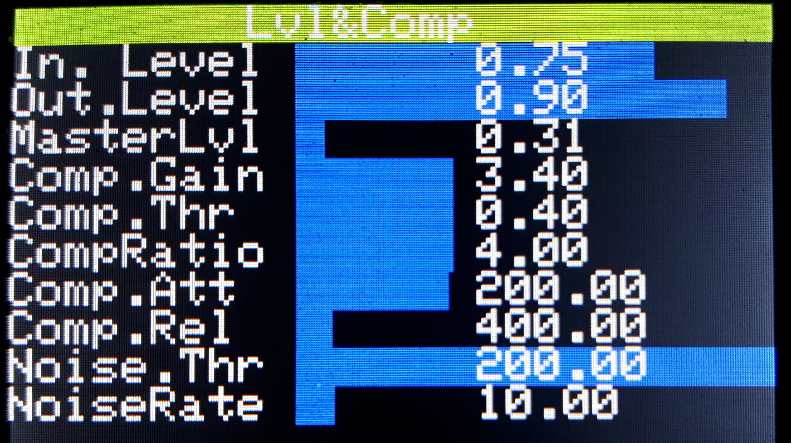
In.Level:
Input level sensitivity of the analog-digital converter; lower values are less sensitive. For low output pickups, set it to about 0.8. For higher output pickups or when using overdrive in front, reduce it to about 0.7 to avoid clipping at the input. If you here a hard clipping on strong notes or chords, try to lower it to avoid input clipping.

Out.Level:
Output signal level. Set to 1.0 for full range output (3.3V peak to peak) this corresponds approximatelly to a line level signal. For a more conventionnal instrument level, set it to about 0.9

MasterLvl:
Software master volume controls the final gain adjustment at the end of the signal processing chain. This parameter is tied to the master volume potentiometer. Use it to adjust the overall output level without affecting distortion. If you here a strong clipping, try to lower it.

Comp.Gain, Comp. Thr, CompRatio, Comp.Att, Comp.Rel:
Dynamic compressor parameters (before distortion). Comp.Gain controls the maximum amount of gain that the compressor can apply to the signal. The gain level will increase low volume notes until it reaches the compression threshold (more gain = more sustain).
Comp.Thr is the compression threshold level and sets at which volume dynamic compression starts. CompRatio sets the compression ratio, I.e how much the volume is compressed above the threshold. Comp.Att and Comp.Rel set the characteristic response time (ms) in attack (limiter effect) and release (sustaining effect).
To mimic the soft compression of a tube rectifier for example, set gain: 2.5, ratio: 2.5 , threshold: 0.45, attack: 200 ms, release: 400 ms. For a hard compression, try gain: 5, threshold: 0.5 to 0.7, ratio: 4 to 5, attack: 20 ms, release: 50 ms. For a hard limiter effect: gain: 1, threshold: 0.9 (or lower), ratio: 10, attack: 1, release 10.

NoiseThr, NoiseRate:
Input noise gate parameters: NoiseThr sets the threshold below which the noise gate cuts the input sound. Adjust according to your guitar pickup level and noise level. NoiseRate sets the response time of the noisegate ie how much time it will take to close or open the gate.

Drive 1 to 4 menus

This menu is used to tune the 4 available drive stages and control the type and feel of the distortion generated by the pedal.

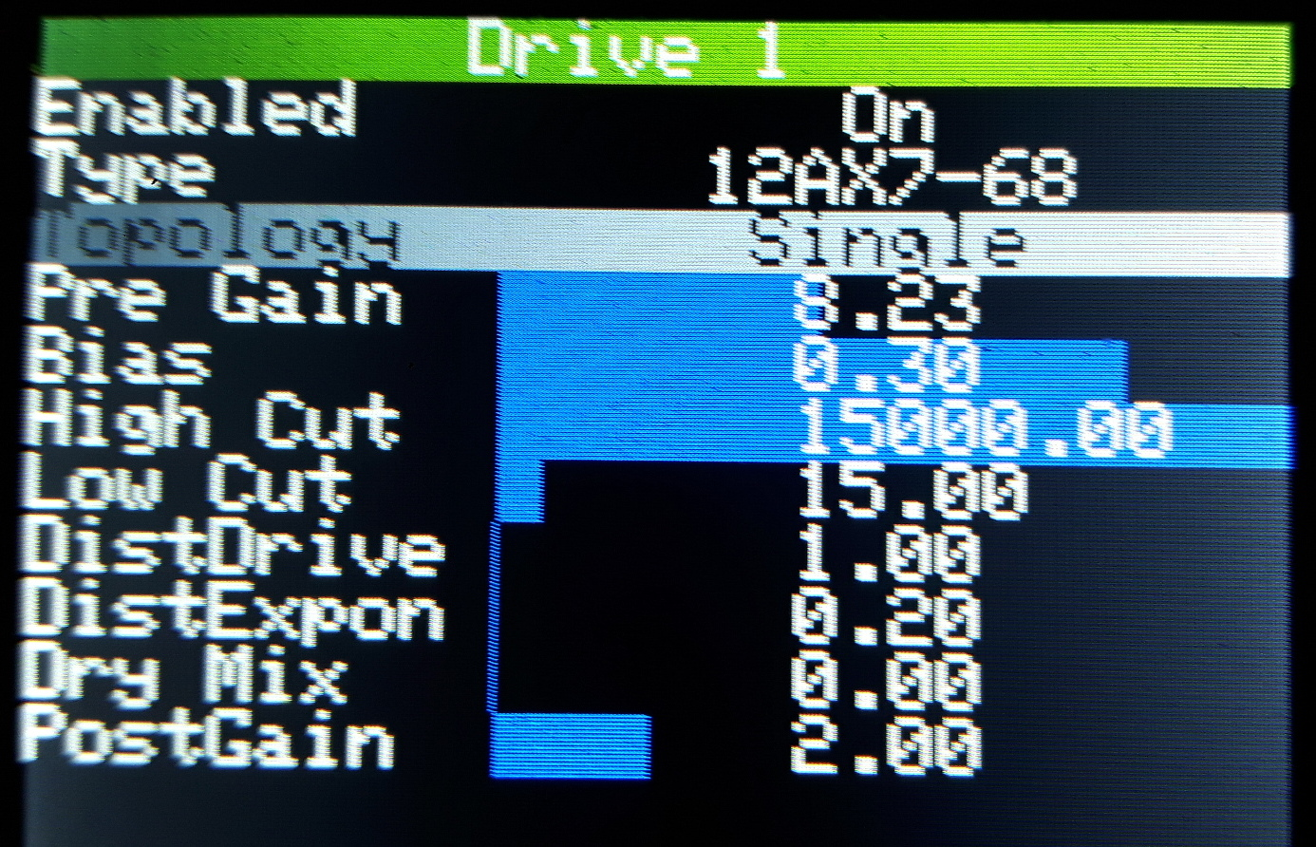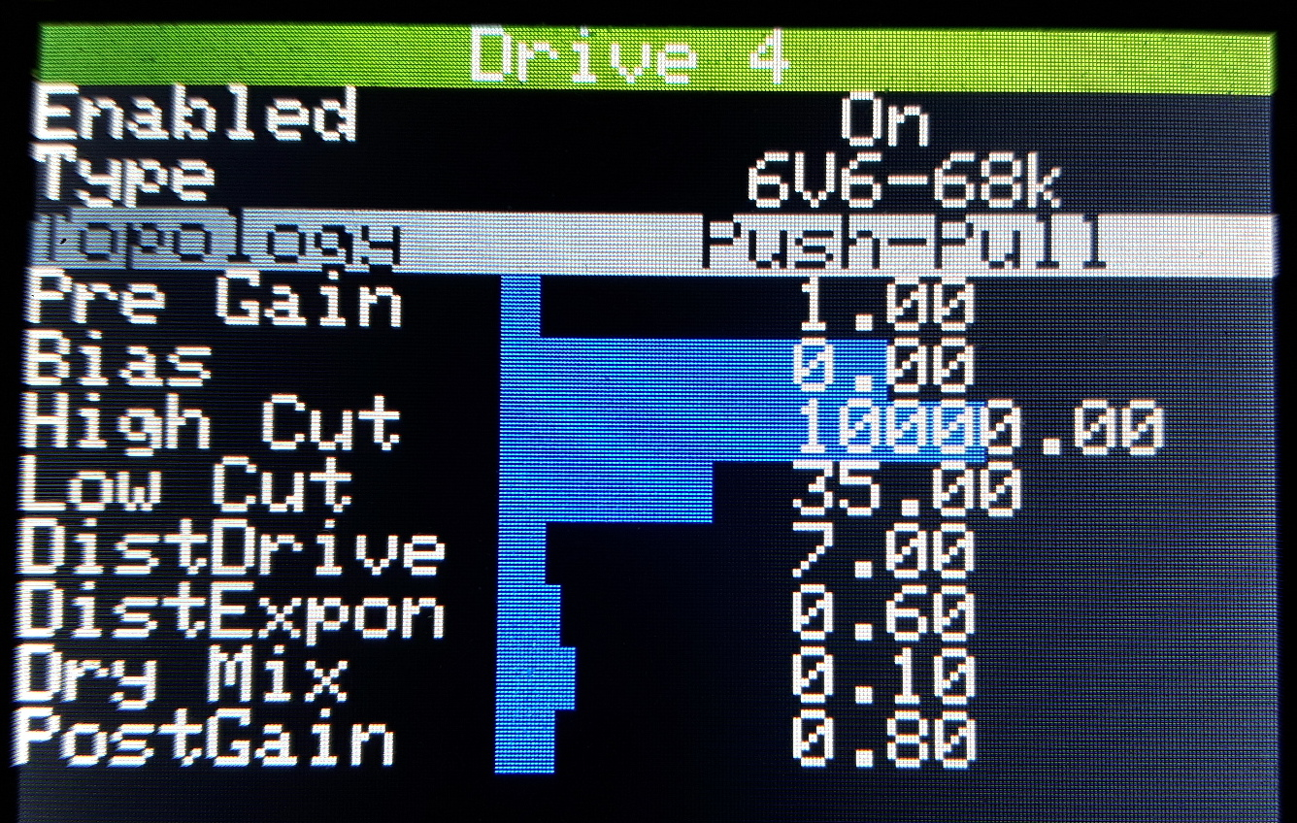

Enabled: On / Off
Enables the current drive stage.

Type: see list at the end of this manual
Sets the type of drive/distortion stage. In technical words, you can select here a wave shaper / transfer function table. There are two types of distortion models: mathematical models such as Cubic, Exponential, Hyp. Tangent, and discrete transfer function tables for tubes and solid state components. Some parameters like DistDrive or DistExpon below only apply to specific mathematical models, while others like Bias apply to all models.

Topology: Single / Push-Pull
Chooses between a single ended (one component) stage or a push-pull configuration (two components with reversed effect). Single ended preserves the full characteristic of the drive, including its assymmetry while push-pull will lead to a more symmetric and linear response (fuller & smoother tone). Select a push-pull configuration to model a push-pull power amp stage or phase inverter in a tube amp. Use single-ended for preamp tube stages.

Pre Gain:
Pre-distortion gain. The more gain is applied before a nonlinear drive stage, the more distortion is generated. This is thus a very important control that will drastically change the amount of distortion generated in that stage. A typical “neutral” values is around 2.0. To generate a high distortion, set it to 5+. For an off-clean, edge of breakup, try values lower than 2 (about 0.75 to 1).

Bias:
Controls the input level DC offset or in other word the central operating point of the drive stage that you model. For mathematical waveshaper, the normal bias (zero operating point) is 0.0. For tubes, the normal bias range is positive, typically between 0.15 to 0.4 (0.25 to 0.3 seem to give the most natural response). Changing the bias out of the normal range introduces more asymmetrical distortion favouring “even” harmonics (harsher , fuzzy tone) while a perfectly “centered” bias will lead to mostly “odd” harmonics (smoother, natural distortion). Altering the bias in a high gain drive might lead to hard signal cut-off due to oversaturation of the drive, such as found is some high gain fuzz pedals.

High cut:
Frequency above which the output signal of that stage will be cut (2nd order filter). This controls how much treble (and harshness) is passed to the next stage. Set to down to 2500 Hz for smoother distortion, and up to about 10’000 Hz for a natural open sounding low gain stage or for a treble booster stage.
Low cut:
Cut frequency of the input DC blocker filter. In a real circuit, this would correspond to the input decoupling cap. A middle ground values of about 30 to 50 Hz is quite common for vintage amps or low gain pedals as it will pass all the important frequencies for a guitar with a natural low-end. If set to high values (about 80Hz), it will tend to tighten the bass and the distortion (more defined, fast and focused distortion). Another effect of this filter is that it introduces a dynamic bias on large volume changes such as when you hit hard on the strings. Lower values like 10-15 Hz will introduce a lot such “dynamic input excursion” voltage and will temporarily modify the distortion on the note attack. This effect is typical of amplifier with large coupling caps such as Fender Tweed amps but can also be used to artificially model a more saggy or lively tone response. This is part of the the so-called “3D sound tube sound” effect. However, very low values might lead to blocking saturation (sound cut-off) if set too low, and might generate a muddy low end.

DistDrive:
Additional gain factor used to modify the distortion curve of the mathematical waveshaper models (Linear, Cubic, etc..). This controls the gain of the distortion model itself while Pregain controls the volume of the input signal. The total linear gain would correspond to the product or Pregain and Distdrive. Use this control to dial in the range of distortion that you want to generate and use PreGain to adjust finely in that range. You will get a similar tone if you double Pregain and divide by two DistDrive.

DistExponent: (for Power and SoftPower models only)
Controls the power exponent that affects the distortion shape and feel. Values close to 1.0 will generate moderate distortion while the further away from that point, the more distortion will be generated. Extreme values will generate distortion resembling that of some fuzz pedals and can be combined with a small amount of bias for more complex distortion.

DryMix: (for hyp.tangent model only at the moment)
Controls the blending ratio of distortion vs dry sound. Can be used to preserve more dynamic response at the note attack in a high gain distortion. Typical values of about 0.2 feels rather natural.

PostGain:
Controls the level of the audio signal passed to the next stage. Adjust this parameter to compensate for the volume boost generated by the drive stage. For example, if you need to increase the pre gain for more distortion , you can choose to compensate the volume boost by reducing the post gain to avoid saturating the next stage. Or on the opposite you can boost (or reduce) the post gain to help saturating (or cleaning up) the next stage if you have already maxed out (minimized) its own pregain.

Note on stacking gain stages: Even though TeensyDist is using 32bit floating arithmetics and his quite robust with respect to large volume boosts, it is a good practice to try to keep the volume more or less uniform at each gain stage to avoid artefacts. To check that point, you can enable/disable each stage to see if it introduces a large volume boost or not. Then adjust the post gain of that drive stage to correct its output volume to be close to unity. This is not an absolute rule so feel free to experiment as well.

Note on tone shaping & filtering: Similarly to real circuits, each gain stage introduces a set of filters, most notably of the treble frequencies. If you find the end result too dark, try to increase the high cut of each stage to higher values. Sometime, only one stage is cutting treble significantly and thus is dominant in the tone shaping. The filtering of the early drive stages tend to control mostly the feel and character of the distortion. The last stages have more effect on the final frequency content (equalization) than on the distortion character and feel itself.

Eq & Impulse menu

This menu contains all parameters affecting the input and output frequency equalization of the pedal, including the pre & post impulse response used to model some typical circuits.

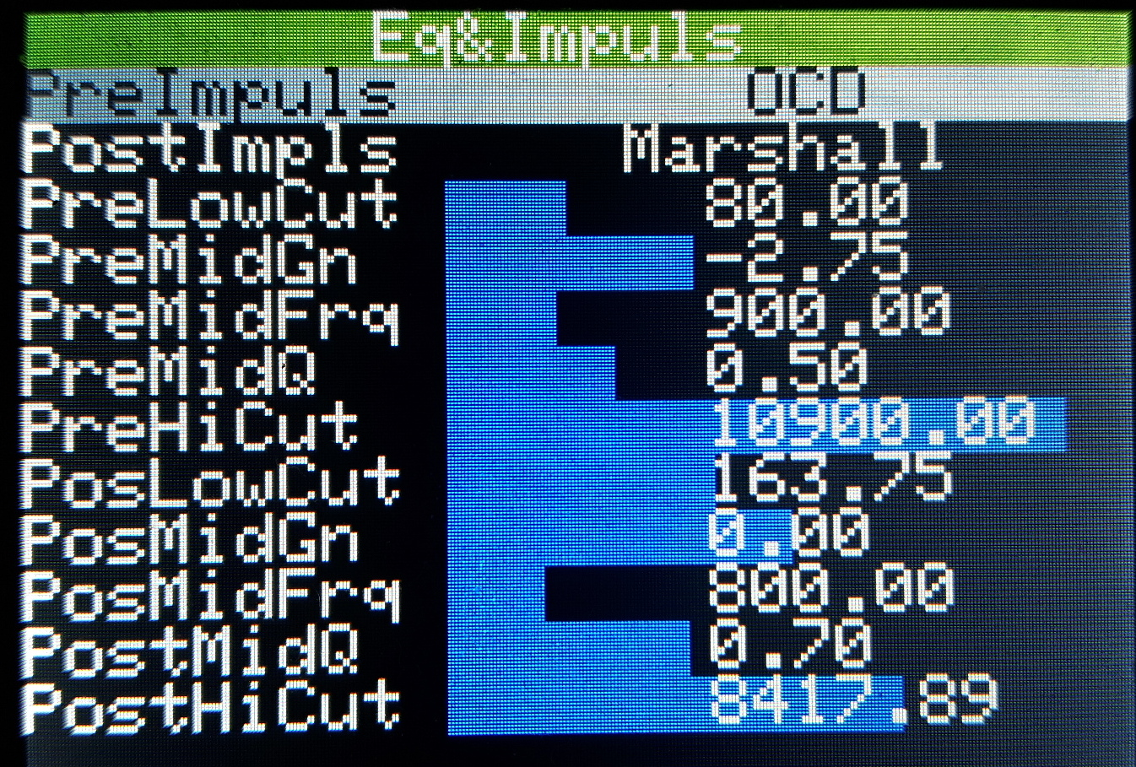

PreImpuls:
Pre distortion impulse response (FIR filter). Choose among the pre-programmed filters to replicate some typical frequency shaping circuits. Pre filter will affect the distortion character (tight, mid-focused, scooped) more than the final frequency content.

PostImpuls:
Post distortion impulse response (FIR filter). Choose among the pre-programmed filters to replicate some typical frequency shaping circuits. Post filter will control the final frequency content but not the distortion character.

PreLowCut, PreMidGn, PreMidFrq, PreMidQ, PreHiCut:
These parameters control the pre distortion tone shaping through a 3 band equalizer consisting in a low frequency cut (PreLowCut), a parametric mid control (PreMid…) and a high frequency cut (PreHighCut). Similarly to PreImpuls, the pre distortion equalization affects significantly the character and feel of distortion. Increase PreLowCut above 80 for a tighter distortion. Adjust PreHighCut to control the fizziness/brittleness of the distortion. Tune the mid parameters to scoop or focus the sound in a given frequency range.
The mid parameters do the following: PreMidGn set the boost/cut of the signal (in dB), PreMidFrq sets the center frequency of the boost/cut, PreMidQ sets the frequency band width affected by the boost/gain. A Q factor of 0.7 corresponds to approx 2 octaves, 1.4 to one octave and 3 to about ½ octave.

PosLowCut, PosMidGn, PosMidFrq, PosMidQ, PosHiCut:
These parameters control the post distortion tone shaping through a 3 band equalizer similar to the pre eq described above. Similarly to PostImpuls, this last eq only controls the final frequency content but does not change the distortion character and feel. PosLowCut and PosHiCut are linked to the Treble and Bass potentiometers. The “neutral” values are typically 100Hz for PosLowCut and 5500 for PosHiCut. Reduce PosHiCut for a “darker” sound, or increase it to 10’000 for more “presence” and treble. Setting PosLowCut to values around 50Hz will add depth and thickness to the sound, while increasing it above 100 will lead to a tighter, more direct sound.

Presets menu

This menu contains all the controls needed to manage presets and reflects the most important settings. When the toggle switch Preset/Edit is set on Preset, the pedal will automatically be switched and be locked to that menu. The current preset ID is displayed in large fonts at the bottom of the screen.

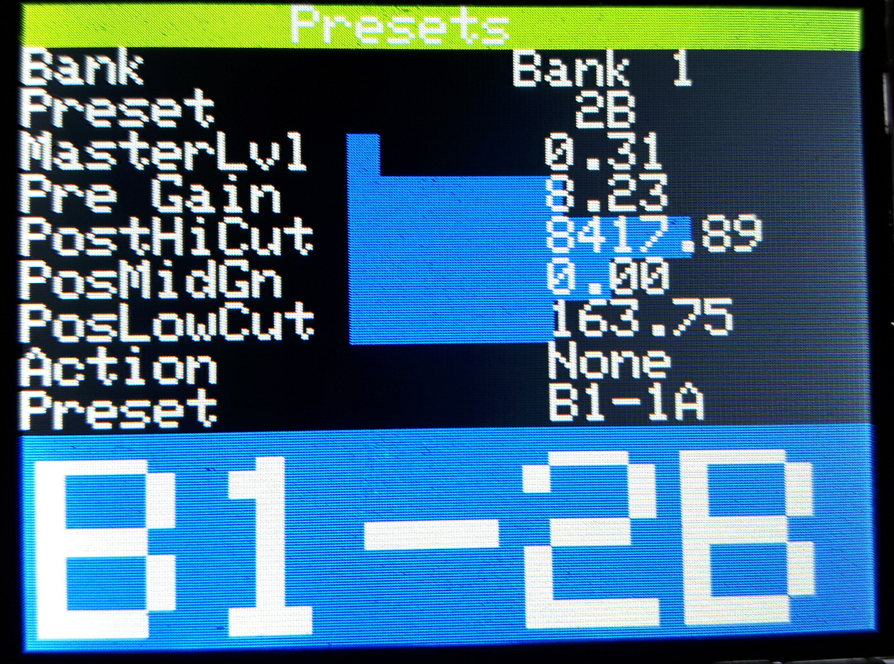

Bank:
Select the current preset bank. There are four banks B1 to B4 each containing four dual presets.

Preset:
Select the active preset in the current bank. Each four preset has two variants A & B that can be switched by pressing the A/B switch. Double pressing the A/B switch will increment the Preset number and cycle through current bank.

MasterLvl, Pre Gain, PostHiCut, PosMidGn, PosLowCut:
These controls reflect the corresponding parameters found in the other menus and can be used to tune the main parameters while in Preset mode.

Action and Preset (below):
The Action menu allows to trigger somes actions to manage the presets. The Preset parameter below specifies the target preset of the action.
None: No action. Choose this one if you entered the selection mode by accident.
Load: Load the parameters of the target preset to current parameter set.
Save: Saves the current settings to the target preset.
Swap: Swaps the active preset (the one displayed in the big display) and the target preset
Copy: Copy the active preset (the one displayed in the big display) to the target preset

Modeling parameters

Wave shaper list and their recommended settings

Here is a list of good starting points for each type of waveshaper. But feel free to adjust to your taste… that’s the whole point of this distortion modeling pedal.

Linear:
Shape parameters: bias
this waveshaper is a simple linear gain until hard saturation. You can use it with a low pre gain and high post gain to get a clean volume boost or represent a solid state power amp. Or you can use a high pre gain and low post gain to model a hard clipping saturation such as opamp or diode. The bias can be adjusted to positive or negative values to create an asymmetric clipping.

Cubic:
Shape parameters: dist gain, bias, (dry mix?)
this piecewise cubic waveshaper represents the smooth breakup of a symmetric tube amp stage (for example a push-pull power amp stage). Set a low pregain (0.5 to 1), a distortion gain of 1 and high post gain to get a clean response with slight breakup at transients or set a high pregain and distortion gain ( ~ 5) and low post gain to model distorting tube power amp stage. Adjust bias slightly to introduce more odd harmonics or push it to get a “lo-fi, fuzzy, amp blowing up” sound.

SoftClip:
Shape parameters: dist gain, bias
This represents a symmetric soft clipping stage which is reminiscent of the sound of low gain pedals such as OD808 or a soft clipping amplifier in a crunch setting. At low gain it only generates a small amount of distortion for a slightly off-clean sound while at high gain it provides a smooth distortion tone. It can also be a good choice for modeling a crunchy softly distorting power amp stage. At the end of the chain, it will smooth out the harshness of aggressive preamp stages. Adjusting bias slightly might lead to some interesting asymmetric clipping tones.

Asymmetric:
Shape parameters: dist gain, bias
This asymmetric waveshaper is meant to represent a cascade of two tube preamp stages that generate an asymmetrical response where the top of the wave is less clipped (more open) than the bottom part. It can also be used to model a cascade of JFET or similar solid state components. Set a low pre gain, unity distortion gain for a clean, edge of breakup preamp. Set a moderate pre gain (2-3), with distortion gain around 6 for crunch tone. For high gain sound, set a high preamp gain (5+) with distortion gain 10+ and tame the volume by lowering the post gain. Adjusting bias might lead to some interesting tones at low gains, but could create a big mess for high gain.

Hyperbolic tangent:
Shape parameters: dist gain, bias, dry mix

