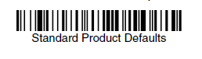

~DEFALT. (~DEFALT.\<FNC3>)

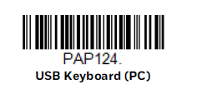

PAP124. (PAP124.\<FNC3>)

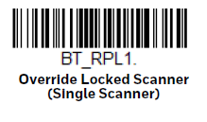

BT_RPL1. (BT_RPL1.\<FNC3>)

**NOTE**: Replace “\<FNC3>” with the FNC3 equivalent character code in your barcode encoder.