Prepare a document and with the following screenshot

− Report View

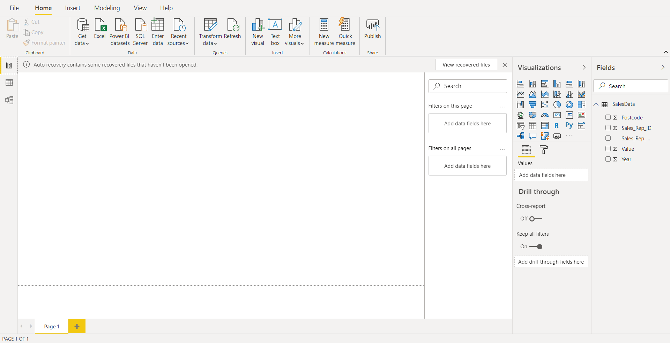

− Data View

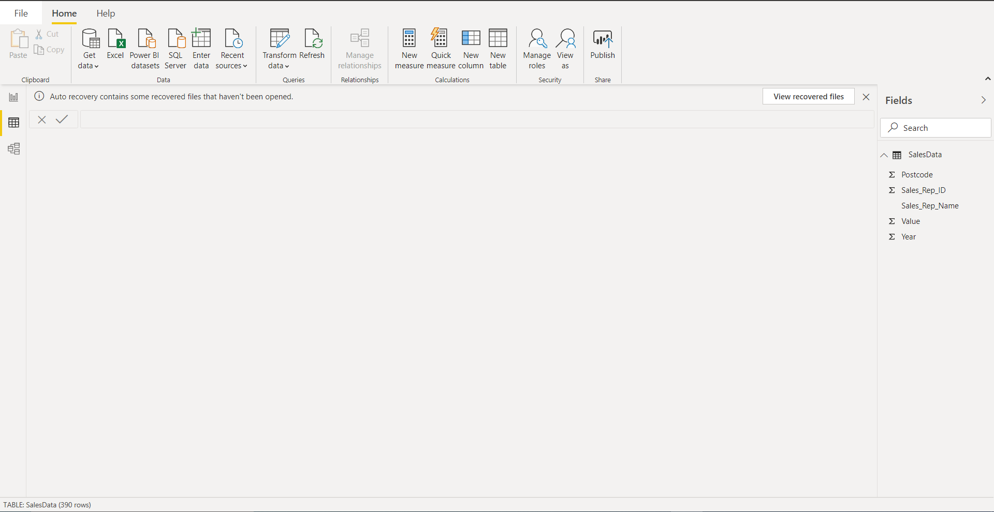

− Model View

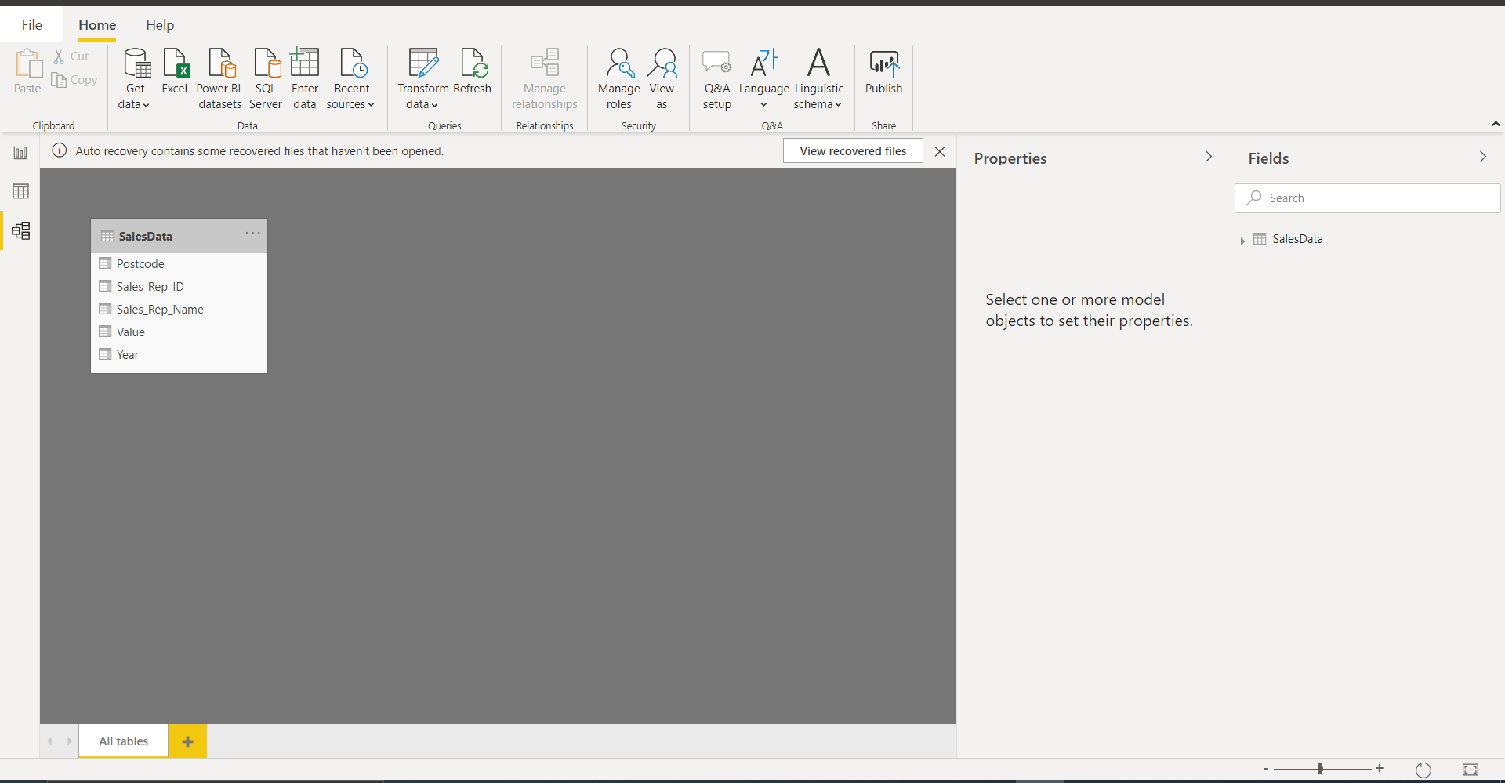

− Power Query Editor

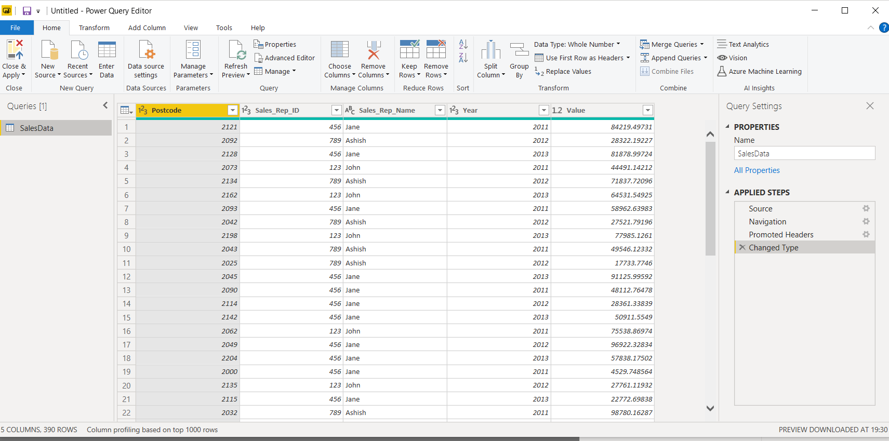

− Advance Editor

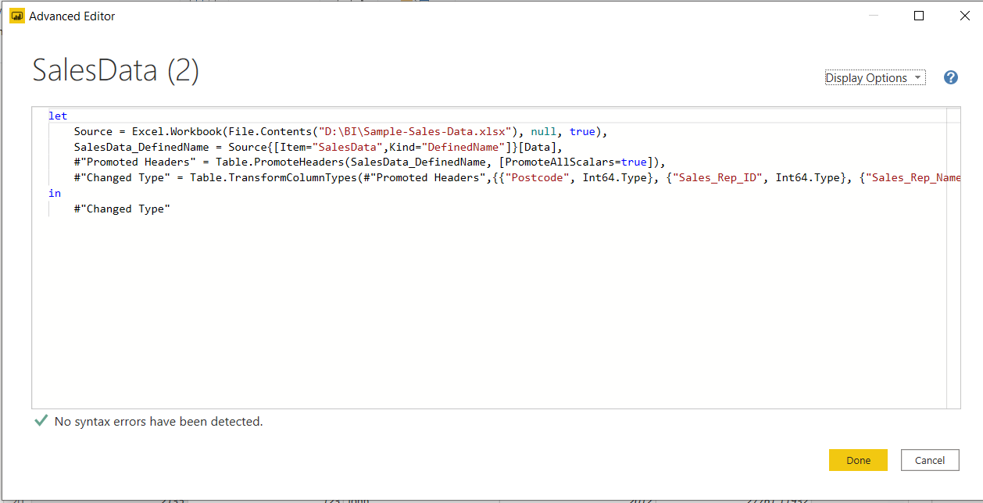

• Prepare a document with details of the following along with their price

− Power BI Desktop

free to any single user

− Power BI Pro

$9.99/user/month

− Power BI Premium

$4,995 a month per dedicated cloud compute and storage resource