**Glossary**

1. Acme Accounting Services - third party organization that is responsible for financial procedures such as recording payments of membership fees and suspending members who's fees are overdue
2. Accounts Payable - a department of the ChocAn data center that handles payment to the providers
3. Card reader - used by the provider to read the member's identification cards in order to determine if a member is active, inactive, or suspended
4. ChocAn Data Center - a central location to obtain information about the ChocAn members, providers, and anything else related to ChocAn
5. Chocoholics Anonymous - also known as ChocAn, an organization who helps people who are addicted to chocolate
6. Electronic Funds Transfer - also known as EFT, an automated process used to transfer funds between ChocAn and a provider
7. Member - a person who obtains a service from a provider and pays a fee to ChocAn
8. Member identification card - a card given to a member that has all of the information associated with that specific member that is used by the provider at the time of service
9. Member number - a specific 9 digit number to identify a member
10. Member report - a weekly report sent to the member in an email with a list of services that have been provided to the specific member
11. Member status - a status to identify a member as either active, inactive, or suspended
12. Provider - a person who provides a service to a customer, namely a dietician, internist, or an exercise expert
13. Provider directory - a directory of six digit codes organized alphabetically that correspond to a specific service and fee that could be provided; can be requested at anytime during the week and is delivered via email
14. Provider form - a simulated form on a provider terminal that allows the provider to key in all of the information in regards to a service that has been provided to a member
15. Provider number - a specific 9 digit number to identify a provider
16. Provider report - a summary report given to a provider which includes the number of consultations and the total fee that the provider has accumulated for the week to be paid by ChocAn; sent via email
17. Provider terminal - the specific terminal that is associated with each different provider to ChocAn members; it is used to communicate with the ChocAn data center
18. Service code - the six digit number that corresponds to a specific service that was provided by a provider to a ChocAn member
19. Special report - a report that has been requested by a ChocAn manager that details the services that have been provided during that week; can be requested at anytime during the week
20. Summary report - a report that is provided to the manager of accounts payable that details every provider to be paid by ChocAn and the number of consultations each provider has made with the total fee for each provider for a given week
21. Validation - the process of determining a member's status which could return an invalid number, member suspended, or validated to the provider terminal

**Use Case Diagram**

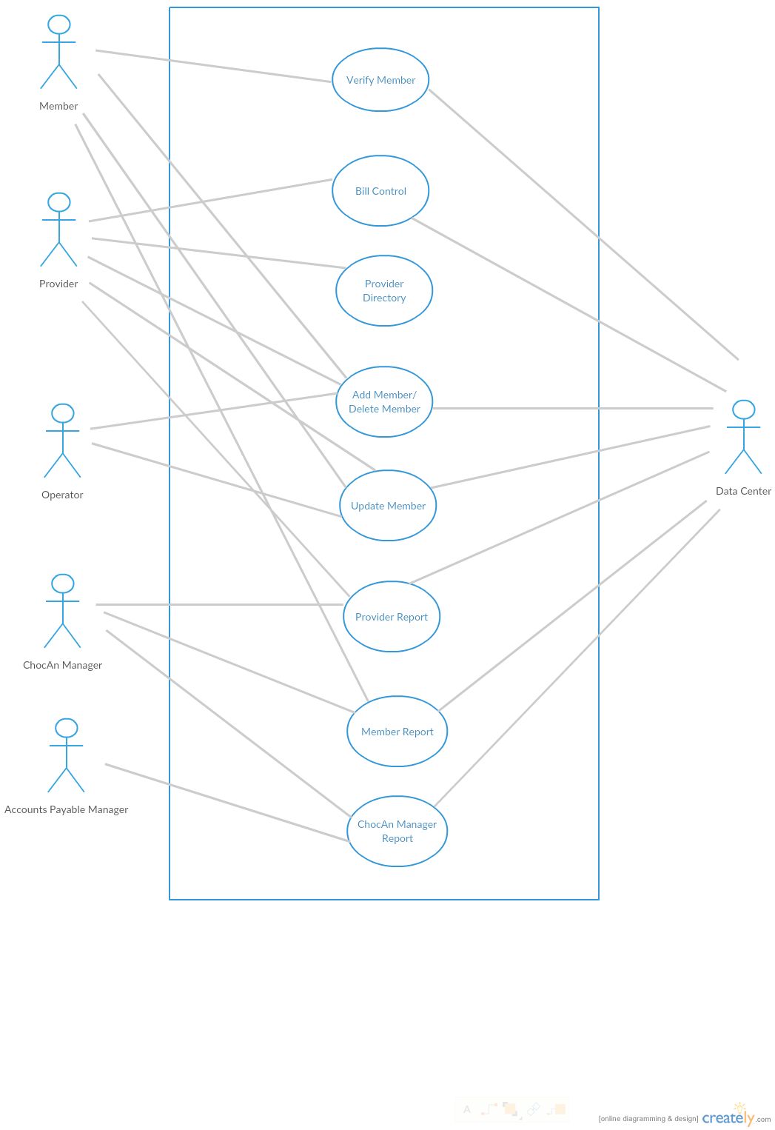

**Version Control LogFile from GitHub Terminal**

jfisher4 - Tue Oct 20 15:03:02 2015 -0400, : upload the log document

Joshua Pinos - Tue Oct 20 13:39:08 2015 -0400, : Added Use Case Diagram. Removed C++ skeleton code and added java code, since GUI usage is prevalent in code.

Joshua Pinos - Mon Oct 19 23:36:17 2015 -0400, : Added skeleton files for code(Mainly for getting folder structure correct in GitHub).

Joshua Pinos - Mon Oct 19 23:33:24 2015 -0400, : Added structure for C++ code, headers files, and Makefile.

Joshua Pinos - Mon Oct 19 16:45:07 2015 -0400, : Added image of UML diagram.

Joshua Cutolo - Mon Oct 19 16:43:09 2015 -0400, : Completed Use Case Diagram using UML diagram.

Joshua Pinos - Mon Oct 19 16:23:57 2015 -0400, : Create visual UML diagram.

Joshua Cutolo - Mon Oct 19 16:19:51 2015 -0400, : Added full skeleton of all datatypes and classes, including physical components as well.

James Fisher - Mon Oct 19 15:53:01 2015 -0400, : Added all class with partial definitions

Joshua Pinos - Mon Oct 19 15:43:05 2015 -0400, : Merge branch 'master' of https://github.com/FSU-CSC-SW/R1.git

Joshua Pinos - Mon Oct 19 15:41:12 2015 -0400, : Added skeleton for UML models

jfisher4 - Mon Oct 19 15:30:58 2015 -0400, : Minor changes

Joshua Pinos - Mon Oct 19 15:28:25 2015 -0400, : Added correct uml diagrams

Joshua Pinos - Mon Oct 19 15:24:05 2015 -0400, : Removed files

jfisher4 - Mon Oct 19 15:08:53 2015 -0400, : Rename Glossary to Glossary.txt

Joshua Pinos - Mon Oct 19 15:01:19 2015 -0400, : !!!TEST!!!-Added ======= under glossary

Joshua Pinos - Mon Oct 19 14:58:51 2015 -0400, : Merge branch 'master' of https://github.com/FSU-CSC-SW/R1.git

Joshua Pinos - Mon Oct 19 14:56:05 2015 -0400, : Update Glossary

jfisher4 - Mon Oct 19 14:54:25 2015 -0400, : Update Glossary

Joshua Pinos - Mon Oct 19 14:53:47 2015 -0400, : Added files

Joshua Pinos - Mon Oct 19 14:53:29 2015 -0400, : Added file

jcutolo - Mon Oct 19 14:50:21 2015 -0400, : Create Glossary

mjinFSU - Tue Oct 6 14:27:54 2015 -0400, : Initial commit

**Time and Percentage Log**

**Task**

1. Create Glossary-

Josh Cutolo- 14 Oct 15 33%

Josh Pinos- 14 Oct 15 33%

James Fisher- 14 Oct 15 33%

2. Create Use Case Diagram-

Josh Cutolo- 19-20 Oct 15 33%

Josh Pinos- 19-20 Oct 15 33%

James Fisher- 19-20 Oct 15 33%

3. Create Version Control Log File , and Time and Percentage Log–

Josh Cutolo- 20 Oct 15 33%

Josh Pinos- 20 Oct 15 33%

James Fisher- 20 Oct 15 33%