Chocoholics Anonymous Use Case Description

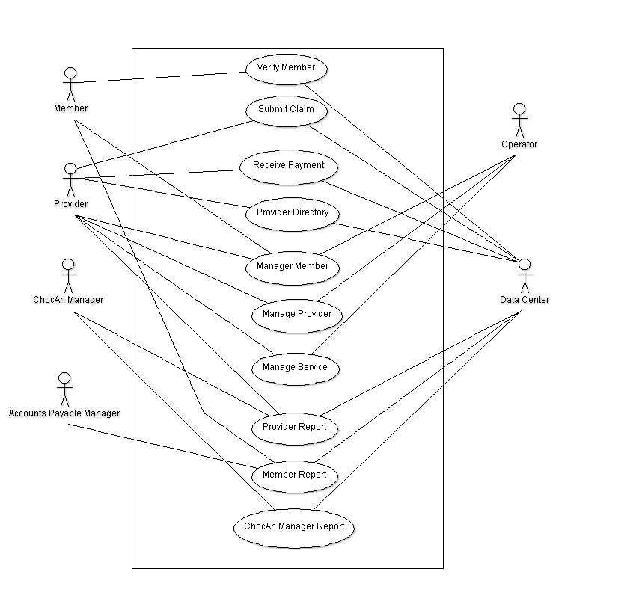

**Use Case 1: Verify Member**

Description: The Verify Member Use Case allows the provider to verify with the data center about the member’s status with Chocoholics Anonymous.

Step 1: The member hands his/her plastic card that is encoded with the member’s name and a nine-digit member number to the provider who slides the card through the card reader on the terminal.

Step 2: The terminal then communicates with the Chocoholics Anonymous Data Center, and the Chocoholics Anonymous Data Center computer verifies the member number.

Step 3: The card reader then displays a message to the provider.

1. If the number is valid, the word Validated appears on the display.
2. If the number is invalid, the reason is displayed.
   1. Invalid Number could be displayed if the member’s number happened to be invalid.
   2. Member Suspended could be displayed and a message displayed along with it if the member hasn’t paid his/her fees for at least a month.

**Use Case 2: Submit Claim**

Description: The Submit Claim Use Case allows the provider to submit his/her claim to the Chocoholics Anonymous Data Center after a service has been provided to a member.

Step 1: The provider begins by swiping the member card through the card reader or he/she can also key in the member number.

Step 2: After the word Validated has appeared on the display, the provider then keys in the date the service was provided using the specific format of MM-DD-YYYY.

Step 3: The provider then uses the Provider Directory to look up the appropriate six-digit service code corresponding to the service he/she provided to the member and keys it in.

Step 4: The software product then displays the name of the service the provider keyed in, in order to ask the provider to verify what he typed in was correct for the specific service he/she gave to the member on that current date and can also enter comments about the service provided.

1. If the provider entered a nonexistent code, an error message is printed.

Step 5: The software product now writes a record of the service to disk the includes the current date and time, the date the service was provided, the provider number, the member number, the service code, and any additional comments the provider made about the service.

**Use Case 3: Receive Payment**

Description: The Receive Payment Use Case allows the provider to receive payment from Chocoholics Anonymous.

Step 1: The software product looks up the fee to be paid for the service that was provided and displays it on the provider’s terminal.

Step 2: The provider has a form on which to enter the current date and time, the date the service was provided, member name and number, service code, and fee to be paid.

Step 3: At the end of the week, the provider totals the fees to verify the amount to be paid to that provider by Chocoholics Anonymous for that specific week.

**Use Case 4: Provider Directory**

Description: The Provider Directory Use Case allows the provider to obtain a Provider Directory.

Step 1: The provider requests the software product for a Provider Directory from the Chocoholics Anonymous Data Center.

Step 2: The alphabetically ordered list of service names and corresponding service codes and fees is then sent to the provider who requested it.

**Use Case 5: Manage Member**

Description: The Manage Member Use Case allows the operator to simply manage new/old members to Chocoholics Anonymous.

Step 1: During the day, the software at the Chocoholics Anonymous Data Center is run in interactive mode.  
Step 2: The operator can then add a new member, delete a member who has resigned, and update member records.

**Use Case 6: Manage Provider**

Description: The Manage Provider Use Case allows the operator to manage new/old providers to Chocoholics Anonymous.

Step 1: During the day, the software at the Chocoholics Anonymous Data Center is run in interactive mode.

Step 2: The operator can then add a new provider, delete a provider who has resigned, and update provider records.

**Use Case 7: Manage Service**

Description: The Manage Service Use Case allows the operator to change, add, and remove the services that providers can offer to the clients.

Step 1: The operator accesses the provider directory list

Step 2: The operator can then add a new service with corresponding service code and delete a service that is no longer provided by any providers associated with Chocoholics Anonymous.

**Use Case 8: Provider Report**

Description: The Provider Report Use Case allows the provider to receive a report from the Chocoholics Anonymous Data Center each week.

Step 1: At midnight on Friday of each week, the main accounting procedure is run at the Data Center. It reads the week’s file of services provided and prints the provider report.

Step 2: The provider receives this report, containing the list of services he/she provided to Chocoholics Anonymous members during that week.

Step 3: The report contains the same information that was entered on the provider’s form, in the order that the data was received by the computer.

Step 4: At the end of the report is a summary including the number of consultations with members and the total fee for that week.

1. The fields that are provided in this report are provider name, provider number, provider street address, provider city, provider state, provider ZIP code, service, total number of consultations with members, total fee for the week.
   1. For each service provided, it also shows the date of the service, the date and time the service was received by the computer, the member name, the member number, the service code, and the fee to be paid.

Step 5: A record consisting of electronic funds transfer data is written to a disk, then banking computers will later ensure that each provider’s bank account is credited with the appropriate amount.

**Use Case 9: Member Report**

Description: The Member Report Use Case allows a member who has received a service from a provider to receive a report from the Chocoholics Anonymous Data Center for each week.

Step 1: At midnight on Friday of each week, the main accounting procedure is run at the Data Center. It reads the week’s file of services provided and prints the member report.

Step 2: The member receives the report, containing the list of services he/she was provided during that week, sorted in order of service date.

1. The fields in this report are member name, member number, member street address, member city, member state, member ZIP code, service.
   1. For each service that was provided, the date of service, the provider name, and the service name are also included in the report.

**Use Case 10: Chocoholics Anonymous Manager Report**

Description: The Chocoholics Anonymous Manager Report Use Case allows the accounts payable manager to have a summary report for each week.

Step 1: At midnight on Friday of each week, the main accounting procedure is run at the Data Center. It reads the week’s file of services provided and prints the Chocoholics Anonymous Manager Report.

Step 2: The report lists every provider to be paid that week, the number of consultations each had, and his/her total fee for the week.

Step 3: The report also totals the number of providers who provided services, the total number of consultations, and the overall fee total.