Tik_Tac_Toe_Game

Your Name: JIMIN CHOI

University of Missouri – Kansas City

Table of Contents
Vision Statement 3
Requirements 4
Product Backlog 5
Sprint #1 6
Review 6
Retrospective 6
Sprint #2 7
Review 7
Retrospective 7
Sprint #3 8
Review 8
Retrospective 8
Sprint #4 9
Review 9
Retrospective 9
Sprint #5 10
Review 10
Retrospective 10
Sprint #6 11
Review 11
Retrospective 11

Vision Statement
Purpose of creating this app is that Clients use their brain more during plying Tic Tac toe Game. I hope their children play this game more because I would like them to improve their analytic skill more because their brain is developing faster in their age. I also make this app since the purpose of becoming them get into social. They may not think it is not necessary to communicate and interact with others. However, becoming social life is a big part of things that they need to learn more in their life. The ide of the game that player will get a straight line of variable first which can be O or X will win. The player can be win, lose, or tie.

Requirements
A discussion of what your application is required to have in functionality. It should identify user roles and goals/actions, and what the key features of the app should be.
Actor | Goal
User | Players 1 or 2.
Player Move | Check the box to O or X that user touch it.
Result | Make method to count the result.

Product Backlog
This will be updated throughout the semester as new PBIs are added, larger items are broken into smaller ones, and completed items removed.

Story ID | Story | Story Points  (in est. hours) | Priority | Status
STORY_1 | Design the background and color for app. | 5hr | 8hr
STORY_2 | Set List or array for the game and set Onclicked function. | 15hr | 20hr
STORY_3 | Create function to draw onclicked and update the winning state | 10hr | 15hr
STORY_4 | Reorganize the app. | 8hr | 14hr

Sprint #1
Goal: I am going to spend a effort to Onclicked Button and Array Button.
Sprint Backlog
Story ID | Story / Task | Estimated  Hours | Actual  Hours
STORY_1 | Creating reset button and Reset Button  The plane may be changed.
Make the button
The plane may be changed
Put some effort to put some picture in my
Project. I meant I try to visualize.
The plane may be changed

Review

[Screenshots, etc go here. This is where you discuss the product, describing what was done this sprint (potentially shippable product increment) and what was planned for the sprint but was not done. ]

Retrospective
[This is where you discuss the process. What went well (and are you planning to do more of that?) What didn’t go so well (and do you have a way to do less of that)? What changes are you planning to make in how you plan & carry out the next sprint?]

Sprint #2

Sprint Backlog
Story ID | Story / Task | Estimated  Hours | Actual  Hours
S2 | Wrote the code for rest button | 30 min | 1 hr
 | Wrote the faction if we click on empty squre | 1hr | 2hr
 | Wrote the code that the first player has “X” and second player will get “Y” | 2hr | 3hr
 | Check the winner function | 4hr | 5hr
 | Set up button array | 4hr | 5hr
 | On click function | 2hr | 3hr

Review

I made a coding all the story 2 function and I believe it will all work. I worked on the button arrays, on click function, wrote the code for the rest button, empty square function, and indicate first player “X” and the second player use “Y”. And I finally have done the winner function.

Retrospective
I had some difficulties at the beginning because of getting familiar a new technology. But I put some effort to learn materials from online for forwarding my project. It took me for long time to finish the array and the winner function. In the next iteration, I am going to work on showing “X” or “Y” on click, update the player points, and resting the board.

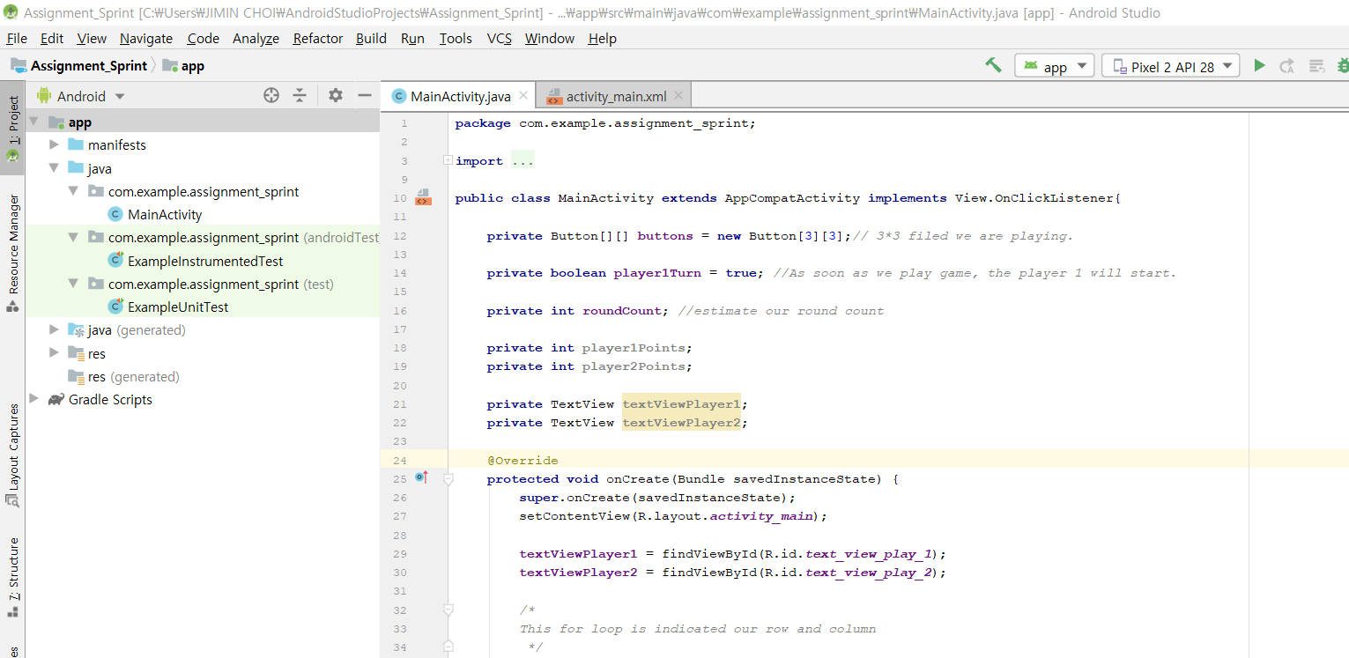

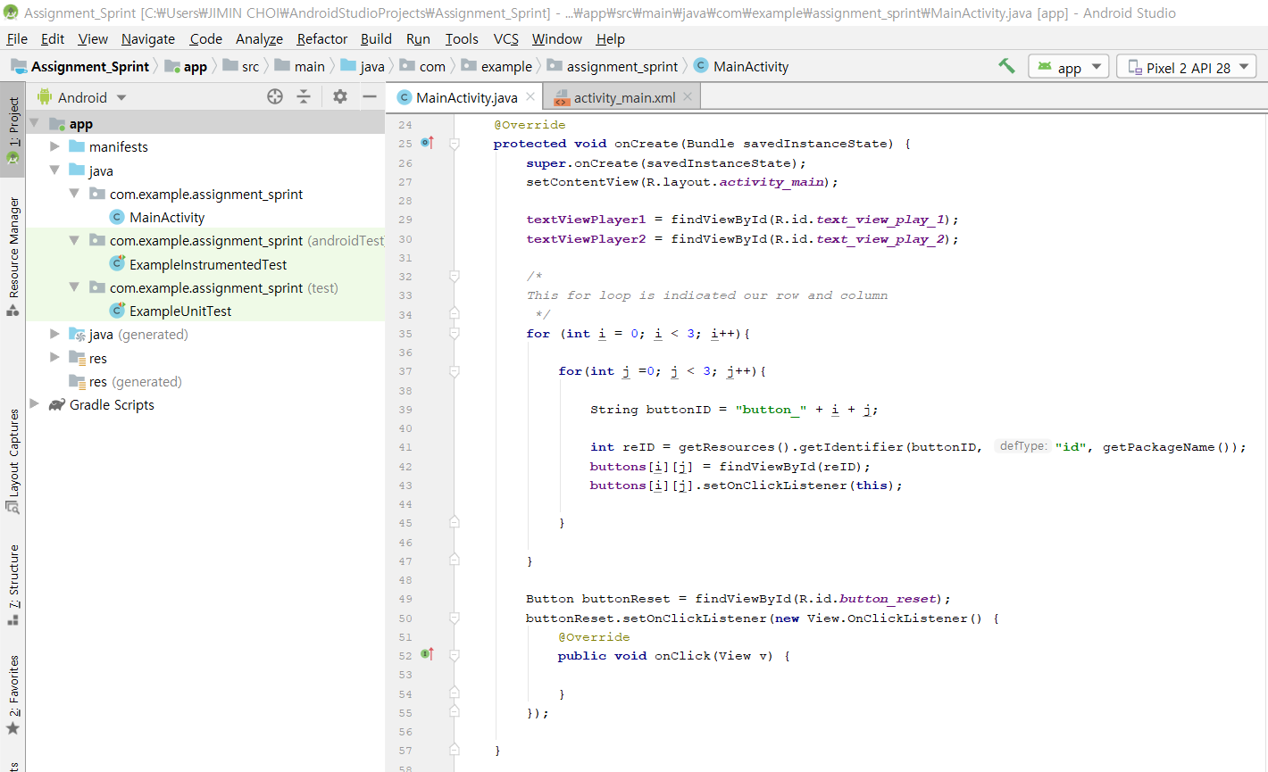

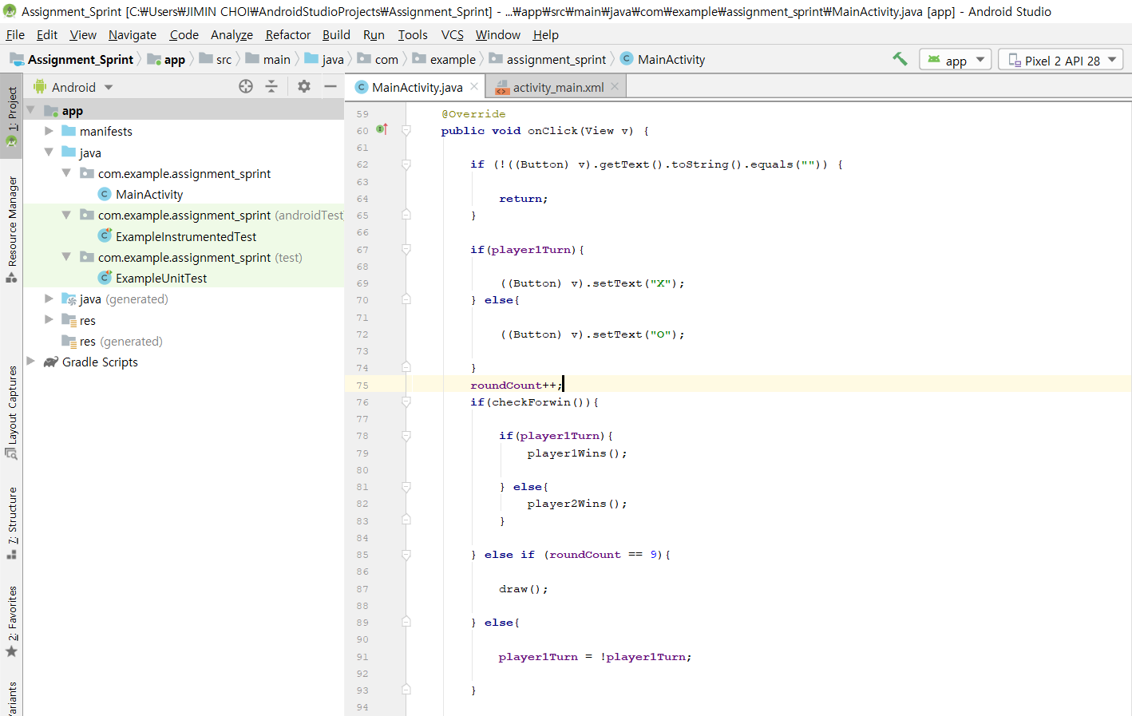

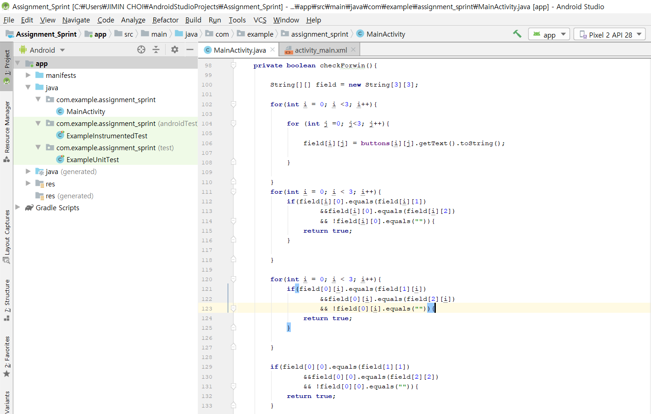
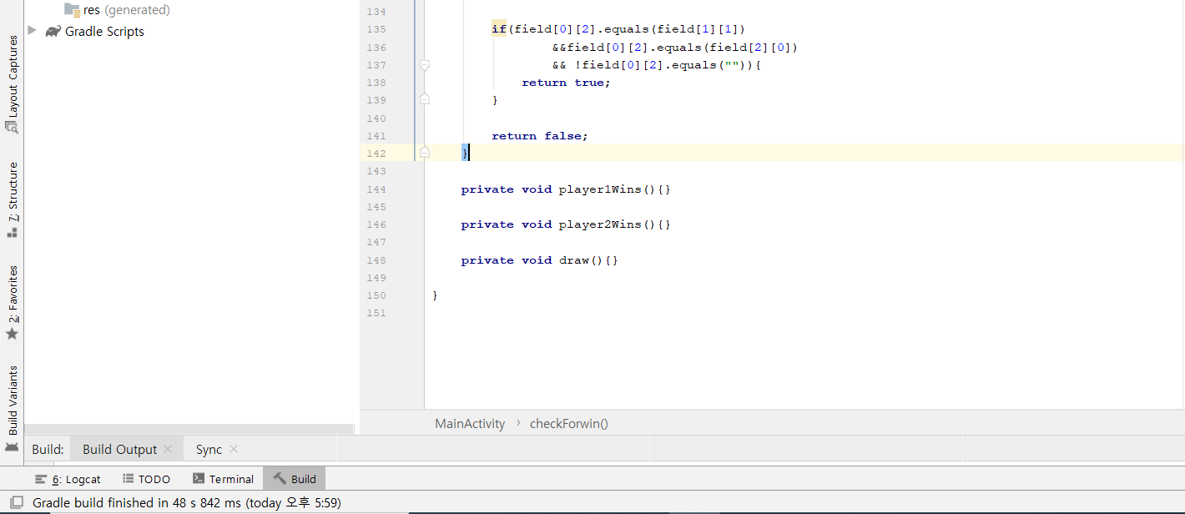

Sprint #3

Sprint Backlog
Story ID | Story / Task | Estimated  Hours | Actual  Hours
S3 | Working on the winner methods for player 1 and 2  I create the method iteration btw the cubes that are next to each other and compare the results. | 4hrs | 8hrs
 | I make the rest methods | 3hrs | 6hrs
 | Put some effort for making the functions that increase the points for the players. | 6hrs | 9hrs
 | Show the draw for X and O on clicks | 8hrs | 16hrs

Review

I finished all the methods that are planed before here. However, I encountered a lot of problems of time managements because of fixing an error and bugs. I had a small mistake when I made a method. I should have typed the private void or int, but I missed the void or int. So I spent so many times found out the mistake.

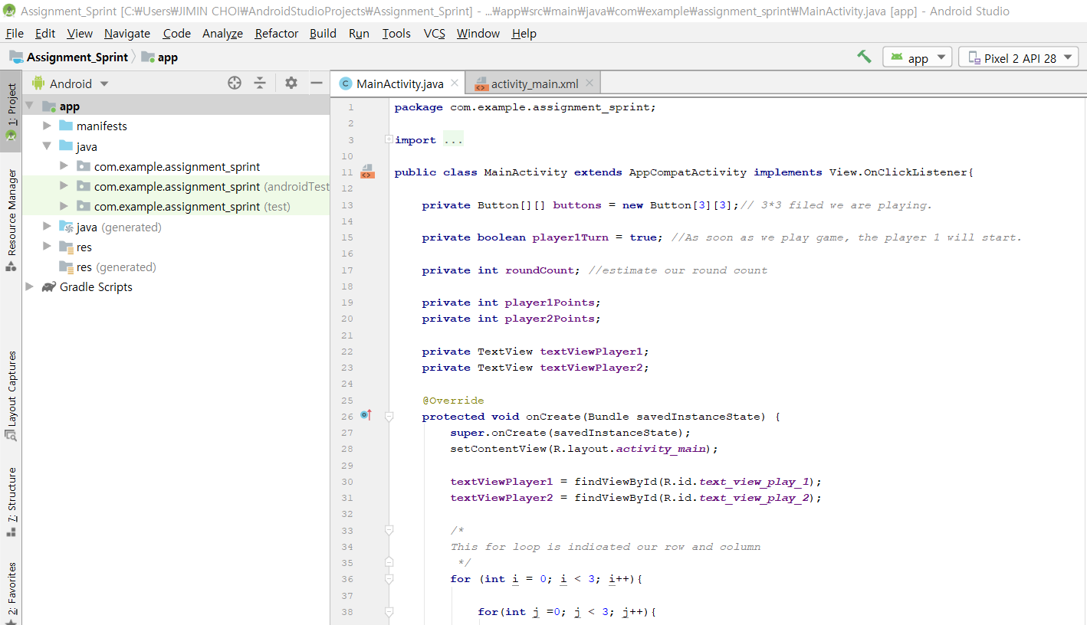

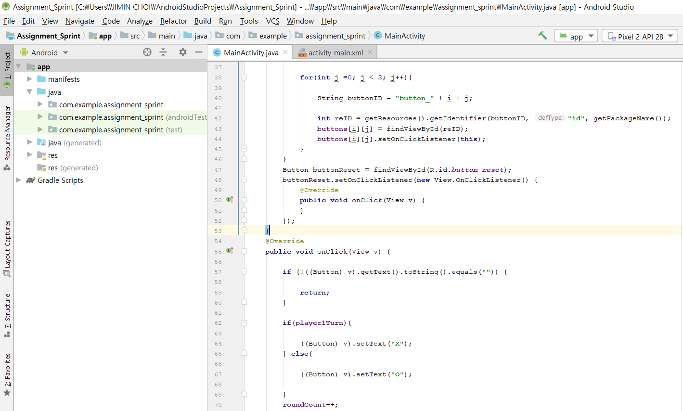

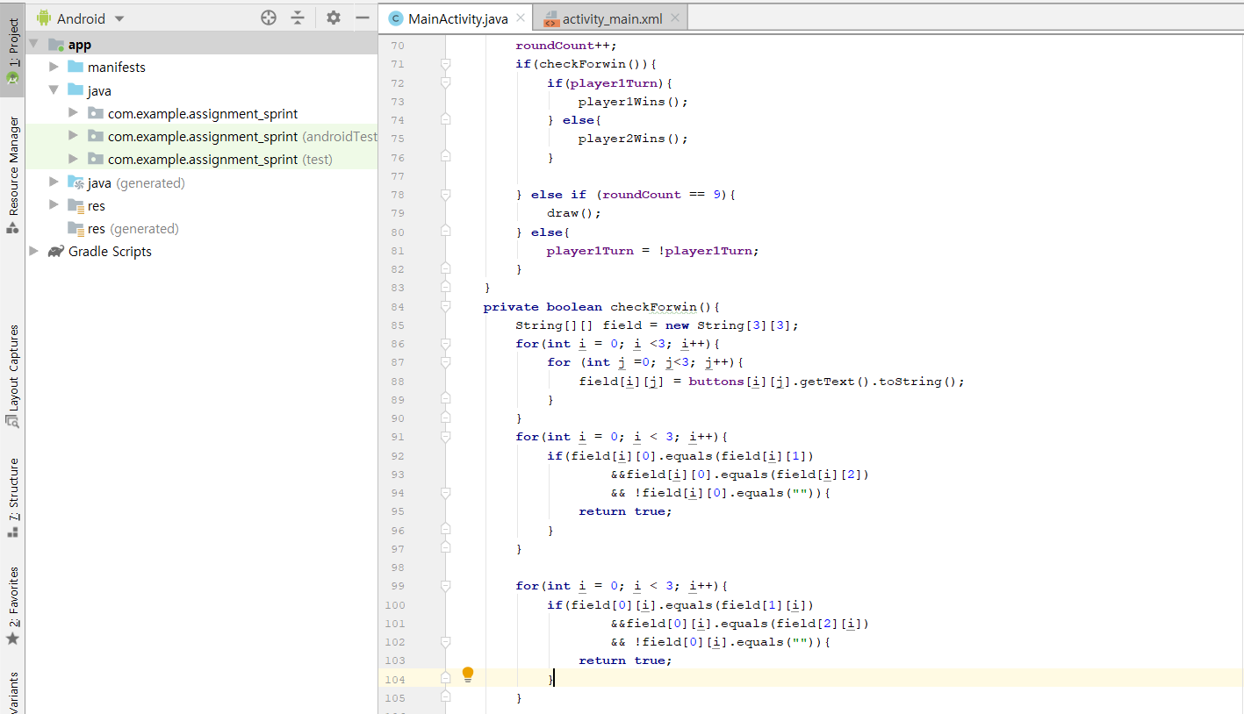

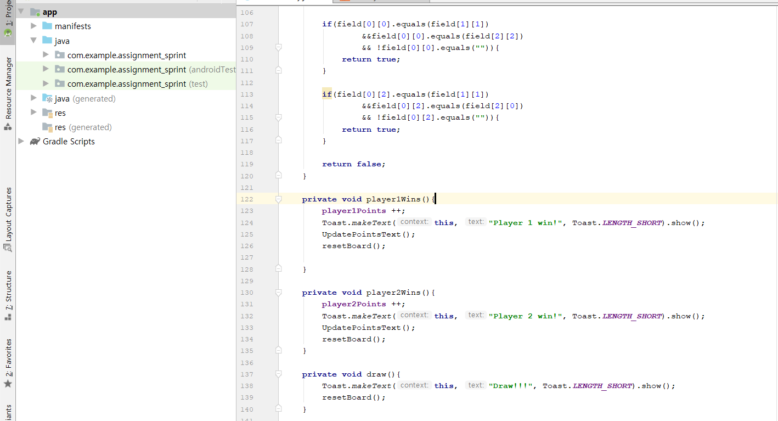

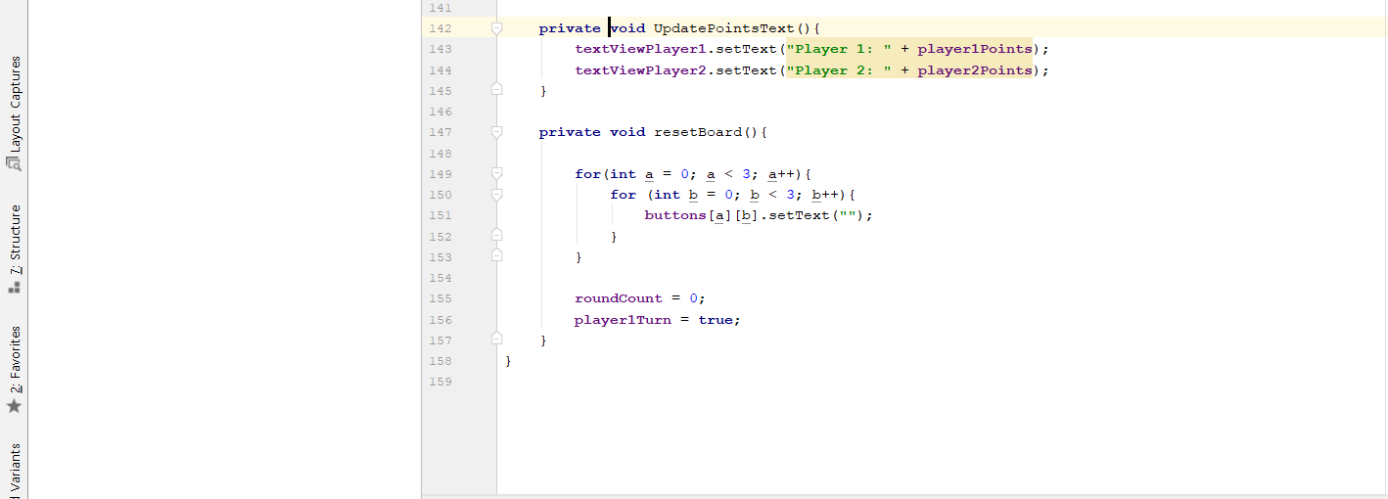

Retrospective

In the next sprint, I will fic methods that I did not finish in the last sprint. I think it will not take long time to fix and will finish my project rather than I had plane.

Sprint #4

Sprint Backlog
Story ID | Story / Task | Estimated  Hours | Actual  Hours
S1 | Fix an error. | 4 | 12
S2 | Change the variable to be more certain. | 3 | 6
S3 | Add exceptions. | 4 | 4
Total |  | 11 | 22

Review
I have worked on correcting the Error that I had before which had taken me forever to figure it out. I changed the variables to create them easy to understand and to process easier in the future iteration. I have also worked on the reset function. Next time, I will finish my iteration 5 and 6.

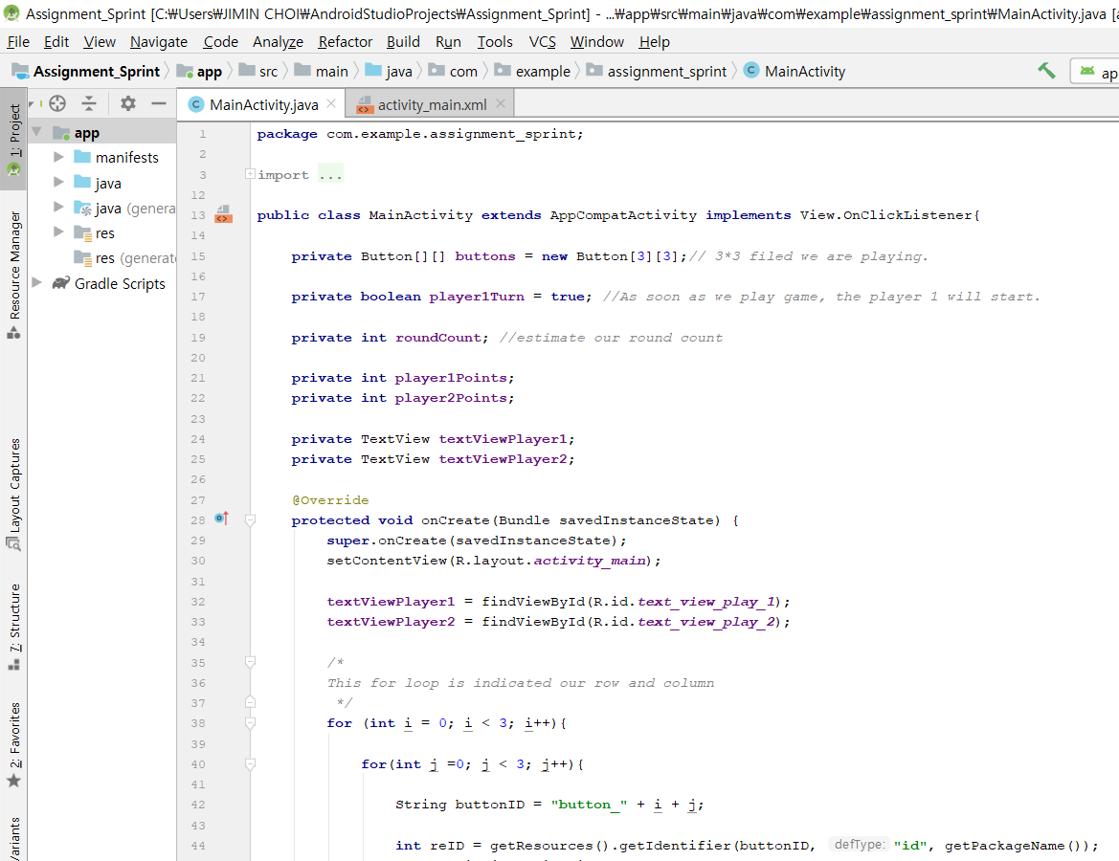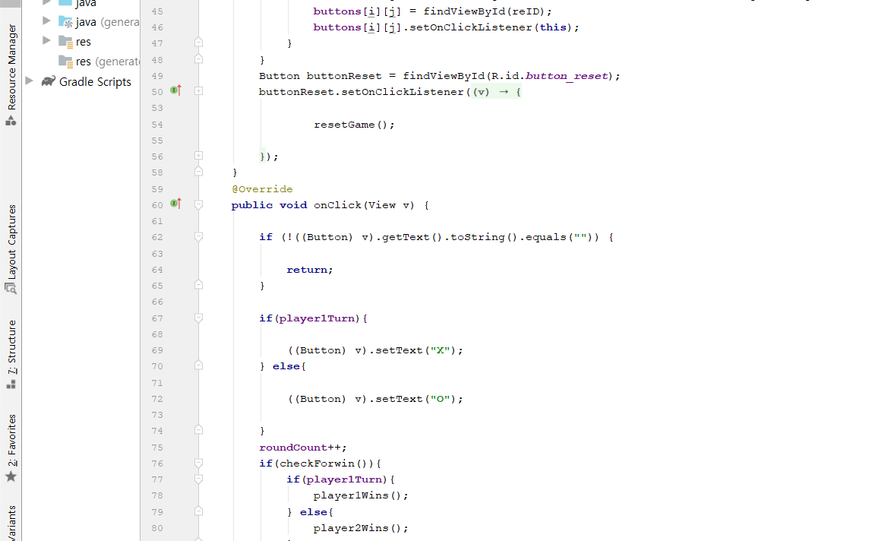
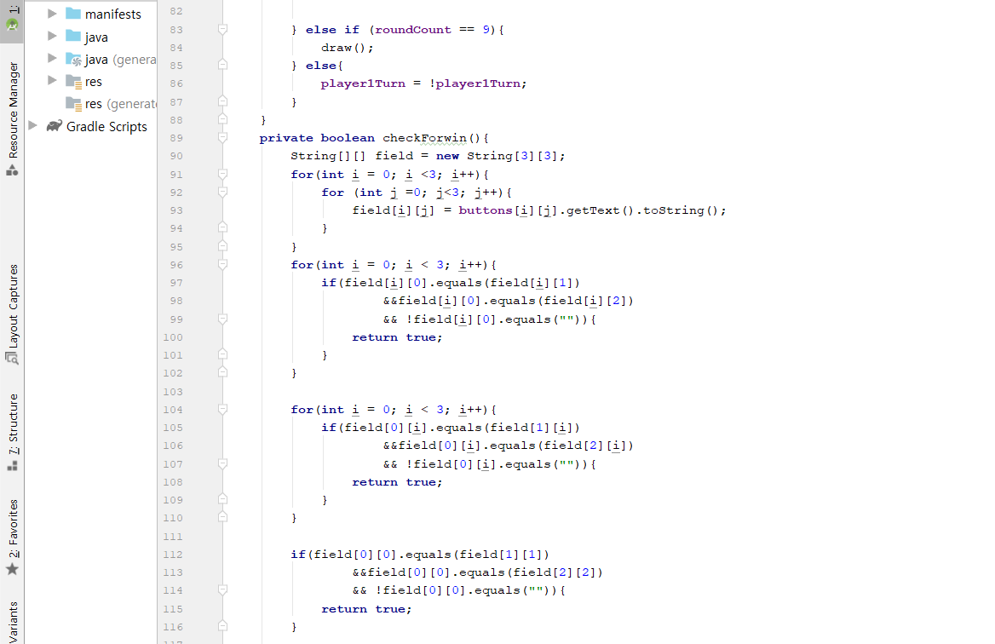
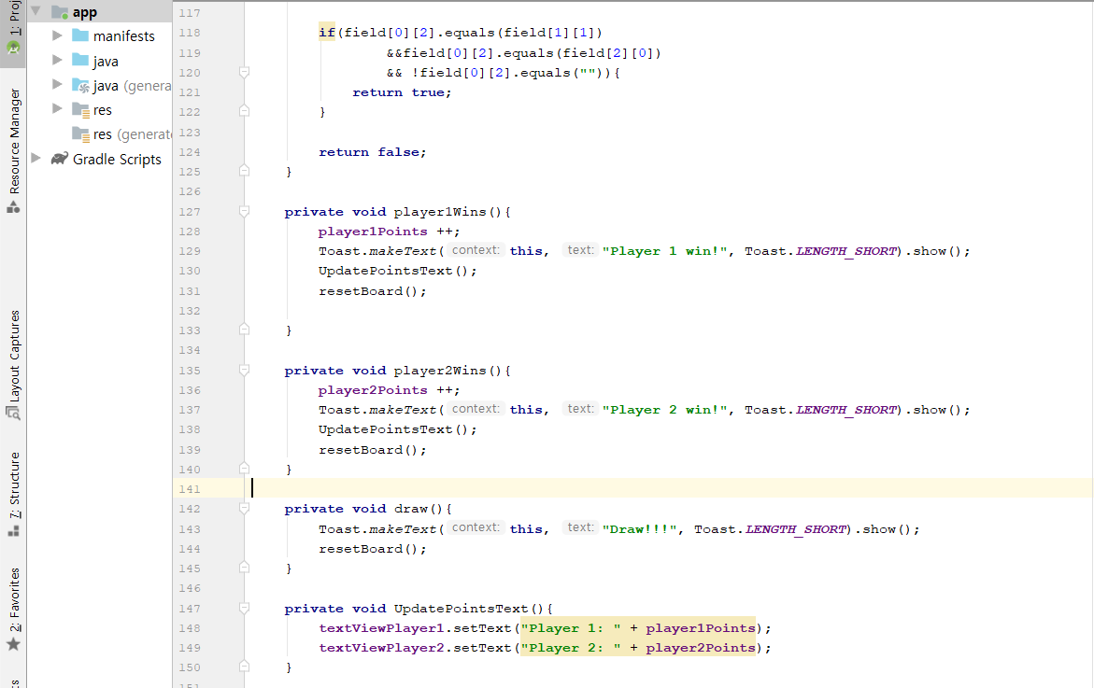

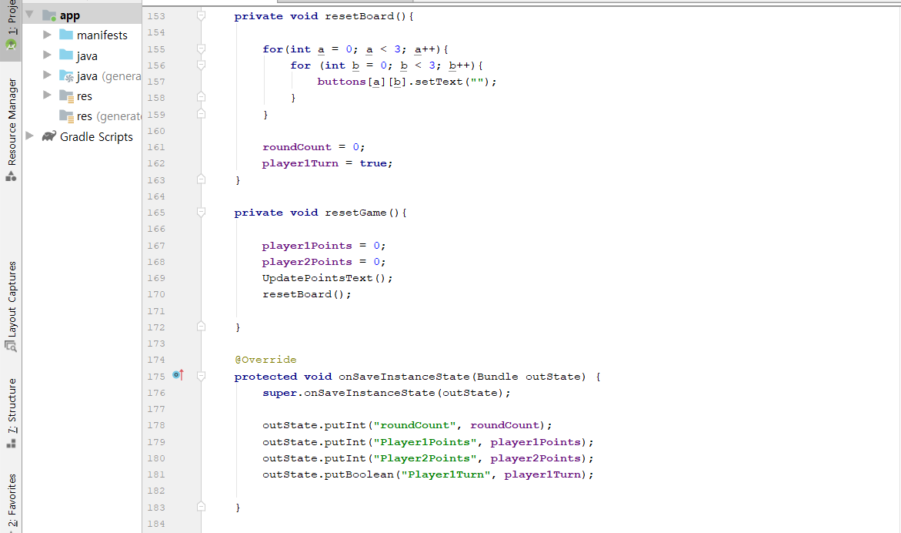
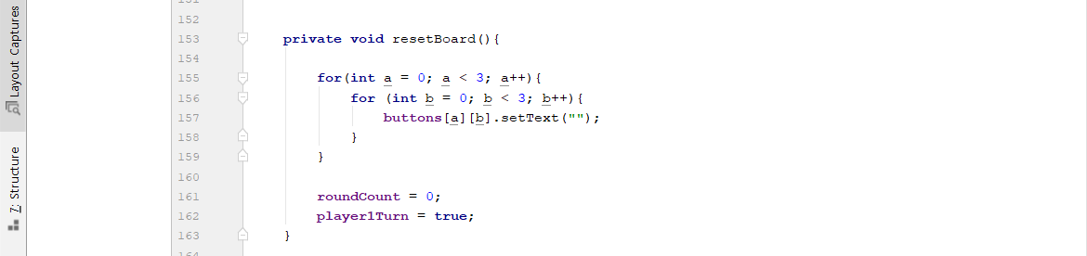

Retrospective
When I start working on this iteration, I thought I can figure out what I did wrong in the code. Thus, I begin to search around for solution, and it took me for ever to find the error. Then I worked on the exception and change and organize variable which make me easier to see the code and error. I also finished reset functions.

Sprint #5

Sprint Backlog
Story ID | Story / Task | Estimated  Hours | Actual  Hours
S1 | Worked for the function that freeze the result when I move the phone to horizontal and vertical | 5 | 10

Review
I have worked to write the code that makes the texts freeze once I flip the Tab that takes me lots of time to find it out. I am doe everything I want to implement in this project.

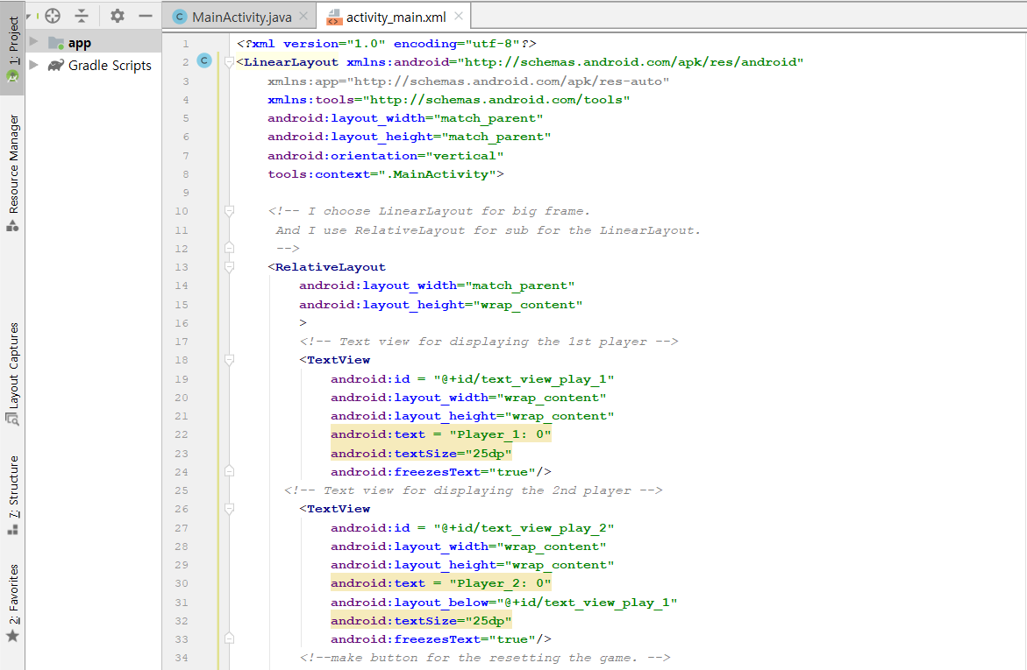
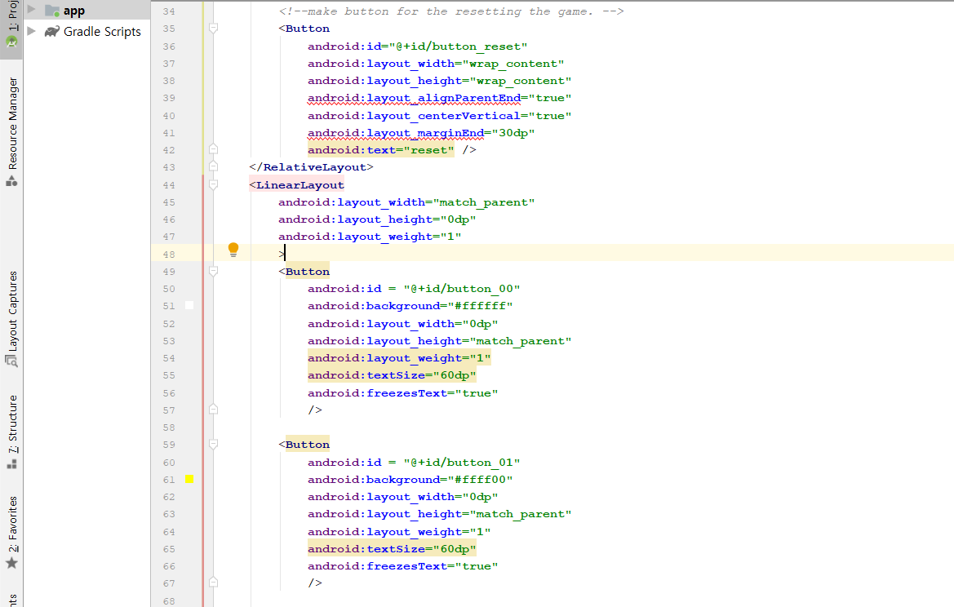

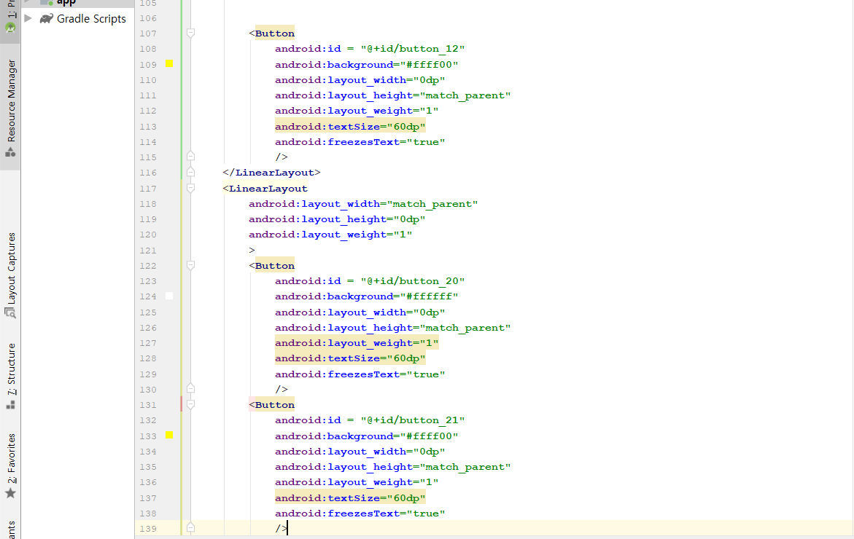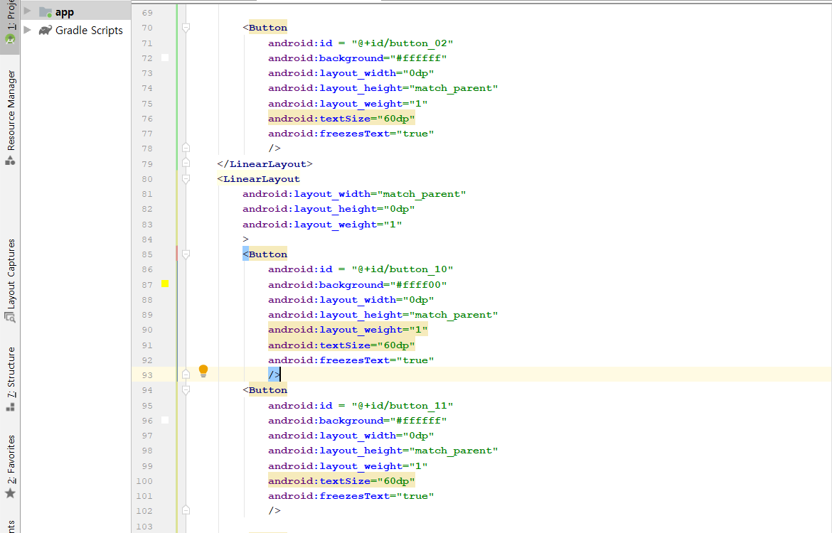

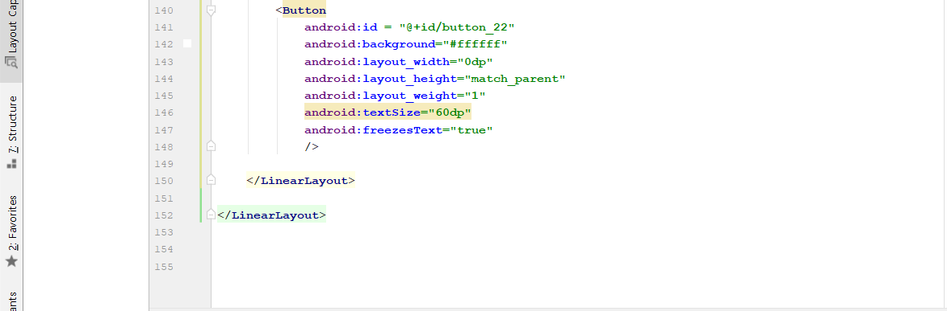

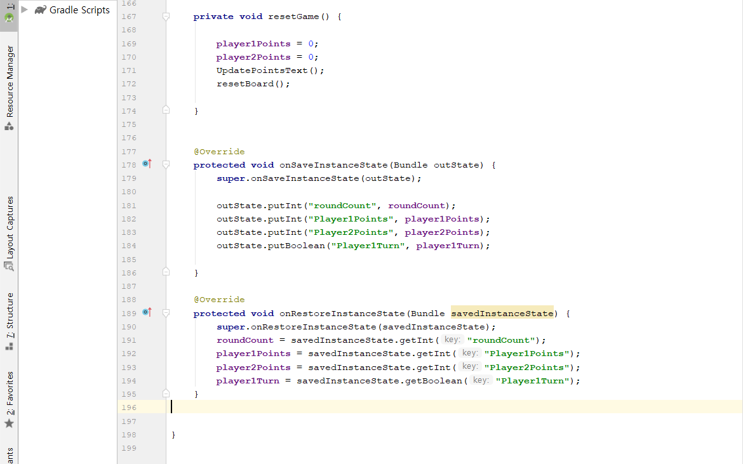

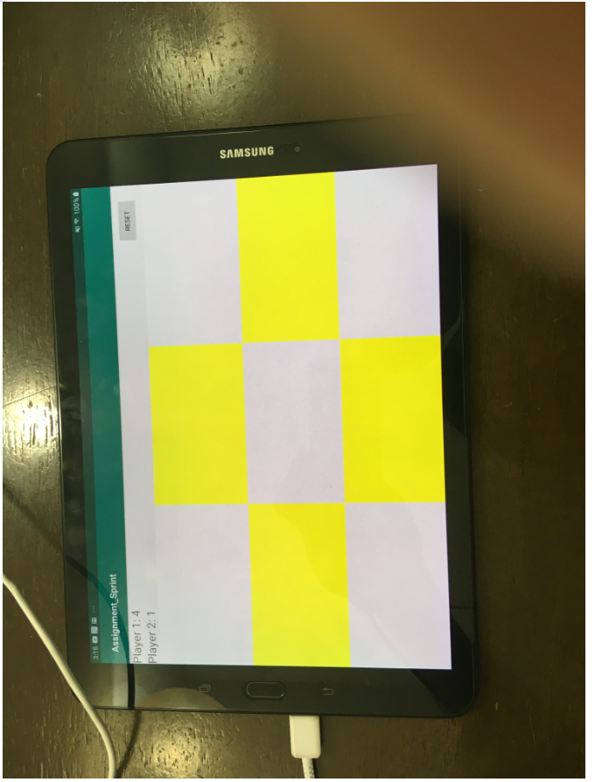

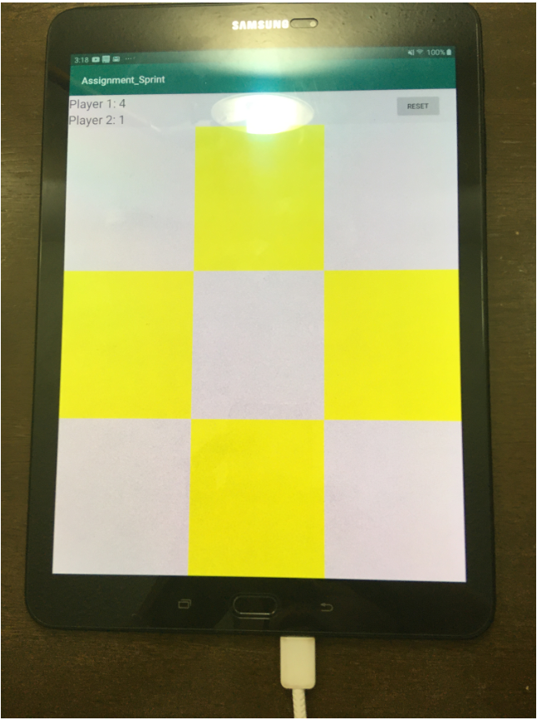

Retrospective
The program work well, but in this time, I have had a difficulty to find out how to do freeze text and it takes lot of time and challenge for me. However, I learn many things while I am figuring out the issues. Next sprint, I will check and organize code.

Sprint #6

Sprint Backlog
Story ID | Story / Task | Estimated  Hours | Actual  Hours

Review

[Screenshots, etc go here. This is where you discuss the product, describing what was done this sprint (potentially shippable product increment) and what was planned for the sprint but was not done. ]

Retrospective
[This is where you discuss the process. What went well (and are you planning to do more of that?) What didn’t go so well (and do you have a way to do less of that)? What changes are you planning to make in how you plan & carry out the next sprint?]

