Juan Carlos Villaseñor-Derbez1*, Caio Faro1, Melaina Wright1, Jael Martínez1, Alvin Suárez2, Stuart Fulton2, Sean Fitzgerald1, Gavin McDonald4, Jorge Torre-Cosio2, Fiorenza Micheli3, Christopher Costello1,4

1 Bren School of Environmental Science and Management, University of California Santa Barbara, Santa Barbara, California, United States

2 Comunidad y Biodiversidad A.C., Calle Isla del Peruano, Guaymas, Sonora, México

3 Hopkins Marine Station, Stanford University, Monterey, California, United States

4 Sustainable Fisheries Group, University of California Santa Barbara, Santa Barbara, California, United States

*Corresponding author

Email: [jvillasenor@bren.ucsb.edu](mailto:jvillasenor@bren.ucsb.edu) (JCVD)

**Abstract**

Marine reserves are often implemented to preserve habitat, recover overfished stocks, and secure livelihoods of coastal communities. As with any other management interventions, we need to better understand their effectiveness and impacts on coastal communities and the environment. To date, the evaluation of the reserves largely relies on analysing ecological data, ignoring socioeconomic and governance dimensions. In absence of a standardized methodology, existing data is analyzed in different ways, hindering the ability to compare results across case studies. We present a framework and tool to evaluate the effectiveness of marine reserves by matching 7 commonly stated management objectives to a set of 9 biophysical, 5 socioeconomic, and 14 governance indicators. We provide guidelines on how to properly colet data that can then be analysied with standardized methods Biophysical indicators are evaluated with causal inference techniques, using a counterfactual approach, to measure the net effect of the reserve on each indicator. Linear regression models are fitted to socioeconomic indicators through time, testing for the differences before and after the implementation of the reserve. Governance indicators are quantitatively analyzed based on literature, identifying common governance structures and their associated effectiveness. To make the framework accessible to fishers and decision makers, and allow replication of results, we developed an open source, web-based Marine Reserve Evaluation App (MAREA). Together, this framework and MAREA represent a major step in marine reserve evaluation that can furhter our understanding and simplify our management of marine reserves.

# Introduction

Overfishing and unsustainable fishing practices are some of the major threats to the conservation of marine ecosystems around the world (Pauly, Watson, and Alder 2005; B. S. Halpern et al. 2008). Marine Protected Areas (MPAs) are frequently proposed as fishery management and conservation tools to help fish stocks rebound (S. Lester and Halpern 2008; S. Lester et al. 2009: Sala et al. (2016)) by limitting or restricting fishing effort and gears. No-take marine reserves (marine reserves hereinafter) are a particular type of MPAs, where all fishing effort and extractive activities are off-limits or highly regulated. The International Union for the Conservation of Nature (2017) categorizes them as Ia (Strict Natural Reserves) or Ib (Wilderness Areas). However, see (Horta e Costa et al. 2016) for a detailed regulation-based classification system.

MPAs have proven to increase biomass (Aburto-Oropeza et al. 2011; S. Lester et al. 2009), enhance resilience of the bounded region (Micheli et al. 2012), and preserve genetic diversity (Munguía-Vega et al. 2015). Compared to partially protected MPAs, marine reserves are known to have even higher levels of biomass, density, richness, and larger organisms (S. Lester and Halpern 2008). Often, these effects are meassured as biological changes in the area through time and lack a control site against which to compare (Betti et al. 2017). This before-after comparison ignores other factors for which one must control (Davies, Mees, and Milner-Gulland 2017), impeding us to talk about causation with complete certainty. While some studies have used control sites, their analyses do not estimate the net effect of the reserve, and often use a control-impact comparison approach (Guidetti et al. 2014; Friedlander et al. 2017; S. Lester et al. 2009; Aburto-Oropeza et al. 2011; A. G. Rodriguez and Fanning 2017). A smaller fraction of studies use measurements of some biological atribute of a reserve and control sites before and after the implementation of the reserves, thus having a before-after-control-impact design (Moland et al. 2013; Soykan and Lewison 2015; S. Lester et al. 2009), allowing them to use causal inference techniques that estimate the net effect of the reserve.

As with any other policy intervention, it is important that we can measure its effect in order to adapt and learn. The diversity of approaches currently used to evaluate the effect of marine reserve often does not answer the simplest question: What is the net effect of the marine reserve? This highlights the need to develop standardized approaches that enable us to truly evaluate the effect of the intervention. Furthermore, while biophysical aspects are important to reserve success, the effectiveness of reserves also depends on the socioeconomic status and governance system of the local fishing community (Basurto, Gelcich, and Ostrom 2013; Basurto and Nenadovic 2012), dimensions often ignored. By excluding these important dimensions. the evaluation provides just a partial picture of the state of the reserve. Currently, only the IUCN framework "How to evaluate your MPA" (R. S. Pomeroy et al. 2005; R. S. Pomeroy, Parks, and Watson 2004) provides a comprehensive list of biophysical, socioeconomic, and governance indicators, and insight into how these indicators may be measured, but does not provide guidelines on how to analyse them. A more recent work by Mascia et al. (2017) integrates these three dimensions and uses causal inference techniques to provide a measure of the effect of implemented an MPA. However, these two certainly novel approaches do not provide a user-friendly tool that enable replicability ans scalability of the analysis.

An increasingly popular way to mace science reproducible, scalable and replicable is through Open science and the development of tools (Lowndes et al. 2017). The Ocean Health Index (B. S. Halpern et al. 2012; B. S. Halpern et al. 2017), for example, has succesfully standardized a way to measure the health and benefits of the oceans. This has been implemented at global scales, but also at country-level (E. R. Selig et al. 2015), and regional scales (B. S. Halpern et al. 2014; C. T. Elfes et al. 2014). Open access tools are not limited to conservation, and have also been developed to evaluate fishery performance indicators (J. L. Anderson et al. 2015), design territorial use rights for fisheries (TURFs; Oyanedel et al. 2017), or to improve decision making in the hydropower industry (Vilela and Reid 2017), just to list a few.

The lack of a comprehensive framework -or the complexity of existing ones, which alienate non-experts- and user-friendly tools to evaluate the effectiveness of marine reserves calls for the development of a new framework and tool. Here, we present a framework to evaluate no-take marine reserves, which incorporates the biological, socioeconomic, and governance dimensions of these conservation areas. We provide a list of commonly stated management objectives, and match them to appropriate indicators that meassure the effectiveness of the management intervention. We include a simple approach to analyze these indicators, building on causal inference techniques (Moland et al. 2013), largely needed to truly understand the effect of management interventions (Burgess et al. 2016; Mascia et al. 2017). We also introduce the Marine Reserve Evaluation App (MAREA), an open source web-based tool that automates the framework described in this paper. To demonstrate the potential of MAREA, we perform an evaluation of marine reserve established by fishers from Isla Natividad, Mexico in 2006.

# Materials and methods

Here, we describe the proposed framework to evaluate the effectiveness of marine reserves (**Fig. 1**). We explain how management objectives were identified and matched to appropriate indicators that allow the evaluation of the reserves, and provide brief guidelines on data collection. Alongside, methodologies to analyze these indicators are presented. Then, we describe the development of MAREA and eplain how this user-friendly open access tool can be used by anyone. Finally, we provide guidelines on how to interpret the results and output generated by MAREA.

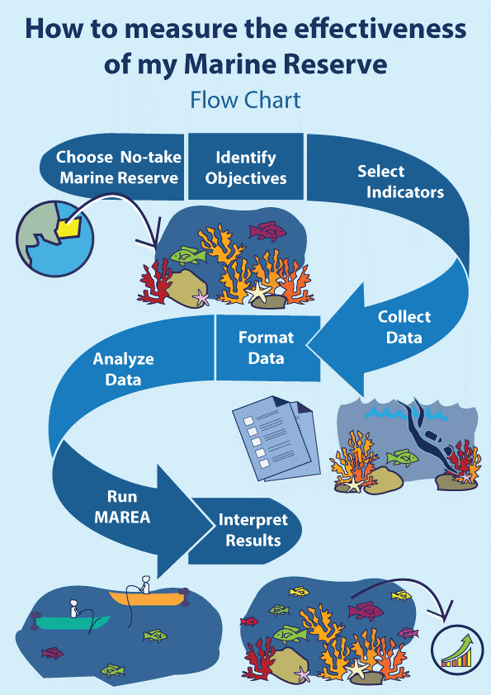

Workflow to evaluate the effectiveness of no-take marine reserves.

## Reserve objectives and indicators

Throughout this work, we will refer to the stated goals for which a reserve was designed as objectives. Given that this work was motivated by the need to provide a framework to evaluate Mexican marine reserves, or focus was on identifying objectives of marine reserves in Mexico. However, we group these objectives into seven major categories, which can be applied to other conservation areas in the world. The list of objectives was gathered through a literature review from the reserves’ stated objectives in official documents such as the Technical Justification Studies (*Estudios Tecnicos Justificativos*), agreements, decrees, and specific legislation (NOM-049-SAG/PESC 2014) associated to these areas. Even though each reserve has its own goals, seven main categories of objectives were identified:

1. Avoid overexploitation
2. Conserve species under a special protection regime
3. Maintain biological process (reproduction, recruitment, growth, feeding)
4. Improve fishery production in nearby waters
5. Preserve biological diversity and the ecosystem
6. Recover overexploited species
7. Recover species of economic interest

Based on these seven objectives, we determined a set of indicators to evaluate the effectiveness. The list of indicators was built through a review of scientific literature, where we identified indicators that were used to measure similar objectives. A first filter eliminated indicators for which baseline data does not exist, or for which data aquisition was expensive or outside of the general scope. The initial list of indicators was reviewed at a workshop with participation of members from Mexican fishery management agencies and non-government organizations. Later, these were also presented to fishers from the Ensenada Fishing Cooperative (*S.C.P.P. Ensenada*), which provided input. Our final list of indicators includes, at least, those identified in review works such as S. Lester et al. (2009) or Woodcock et al. (2017).

Indicators are divided into three main categories: biophysical, socioeconomic, and governance. Biophysical indicators (n = 7) focus on fish and invertebrate communities that are evaluated using underwater ecological surveys performed inside and outside the reserve (see Data section for specific sampling design and methodologies). Socioeconomic indicators (n = 3) reflect the performance of the fishery in terms of catches, income from catches, and availability of alternative livelihoods. Governance indicators (n = 15) describe the governance structures under which the community operates. These indicators may be numeric (*e.g.* Fish biomass) or descriptive (*e.g.* Reasoning for reserve location). Our list includes indicators that respond to the implementation of the reserve (*i.e.* outcome variables) or that might further the understanding of its performance. In that sense, most biophysical and socioeconomic indicators are outcome variables. On the other hand, governance indicators are viewed as explanatory variables that might explain reserve performance. Whenever an indicator is said to also be applied to “Objective species”, it means that the indicator can used for all species (*e.g.* Fish Biomass) and individual species that are either the conservation target of the reserve or are of particular economic or ecological interest (*e.g.* Grouper Biomass). **Table 1** presents the proposed indicators, and **Table 2** shows how objectives are matched with indicators.

## Data and analyses

Biophysical data is collected via underwater ecological surveys as part of a reserve's monitoring program, often carried out by local fishers with guidance of non-government organizations, such as Comunidad y Biodiversidad or Niparajá. Local fishers -trained in scientific diving- perform SCUBA dives to record fish and invertebrate richness and abundances, as well as fish total length. This information is recorded along 30 m transects, with a sampling window of 2 m X 2 m. Between 10 and 24 transects are performed in each site at depths between 1 and 30 m. Ecological surveys are performed yearly in each reserve and its corresponding control site(s), before and after the implementation of the reserve, allowing us to have a before-after-control-impact sampling design. Control sites are areas where habitat is similar to that of the reserve, but with presence of fishing activity.

Having control sites for biophysical data allows us to use counterfactual approaches to evaluate the net effect of the reserve. The hypothesis that the indicators will respond the the implementation of the reserve is tested by analysing spatial and temporal changes in each numeric biophysical indicator (all but B5) using generalized linear models (Moland et al. 2013). To account for variations in the environment and survey conditions, covariates that are gathered during the underwater ecological surveys are included into a model with form:

In this model, $i$, $t$, and $z$ are subindices for transect, time, and zone (control or reserve site), respectively. This model allows us to estimate the change in an indicator ($I$) based on the year ($Y$), a dummy variable that indicates tratment ($Z$; *i.e.* control o reserve), an interaction between a dummy variable that indicates pre- or post-implementation ($P$) and treatment ($Z$), and covariates such as bottom temperature ($T$; in °C), horizontal visibility during the survey ($V$; in m), and depth at which survey was performed ($D$; in m). $ϵ$ represents the error term associated to the equation. Here, years are modeled as factors, using the first year as the reference level. By modelling years as factors, we avoid overimposing a linear structure in the way an indicator changes through time (*i.e.* the change in biomass between 2000 and 2001 does not have to be the same as the change between 2006 an 2007). The treatment and post variables, modeled as dummy variables, are coded as Control = 0 and Reserve = 1; and Pre-implementation = 0 and Post-implementation = 1, respectively.

Socioeconomic data is often collected by fishers or fishery management agencies, which record landings, income, and sometimes prices for each species. In order to control for inflation and changes in buying power, income is adjusted with the countries consumer price index:

Where $I_{t}$ represents the adjusted income for year $t$ as the product between the reported income for that year and the ratio between the consumer price index ($CPI$) in that year to the most recent year's ($T$) CPI. Since no control sites are available, numeric socioeconomic indicators (G1 and G2) are evaluated with a simplified version of *eq. 1*:

While this model does not allow assertion of a causal relation, we can still measure changes in mean landings and income before and after the implementation of the reserve and provide valuable input. For both models (**eq. 1** and **eq. 3**), coefficients are estimated via ordinary least squares, and heteroskedastik-robust standard errors are calculated.

Governance data, however, is not readily available nor systematically collected by the community or any other organizations. In this case, we created a survey specifically designed to collect information needed for the proposed indicators (B5, S3, and G1-G15). The survey is included as supplementary material (**Appendix 1**). To analyze governance information, we performed a literature review of common governance structures and ther relation to effectiveness in managing fisheries or marine reserves. These approach has prooven to succesfuly allow the evaluation of governance structures (Espinosa-Romero et al. 2014). Governance information is not analyzed in a quantitative way, but is presented along with the biophysical and socioeconomic indicators to provide managers and users with a full description of the reserve.

## Marine Reserve Evaluation App (MAREA)

MAREA was developed in R Studio (R Core Team 2017) using the shiny framework (Chang et al. 2017), which provides the tools to build interactive web applications, hosted on an open server. MAREA can be accessed at [turfeffect.shinyapps.io/marea](turfeffect.shinyapps.io/marea/). While the original version was developed in spanish (aimed at Mexico and other Latinamerican countries), all its content can be translated by a translation widget availabe within the environment.

MAREA is designed into a 6-step process, divided in tabs. The first tab provides an introduction to the app and an overview of the evaluation process. Then, the user selects management objectives, which MAREA automatically matches to appropriate indicators, based on **Table 2**. The user can then load the data, using standard *.csv files; sample datasets are provided within MAREA. Once data have been loaded, MAREA identifies all reserves in the data, and lets the user select the reserve to be evaluated. At this point, the user can also specify the year of implementation of the reserve, and indicate objective species that are of particular management interest. Before presenting the results, MAREA provides the user with a section to confirm that all the decisions taken until then are correct. Finally, the user is taken to the results tab, where results can be viewed at a glance or downloaded as a technical report.

The first result is a color-coded scorecard, intended to provide a general overview of the effectiveness of the reserve to a general public. The scorecard provides a global score for the reserve, a general score for each category of indicators, and an individual score for each indicator. The global and category-level scores are determined by the percentage of positive indicators, overall and for each category. For numeric biophysical indicators (all but B5), the color is defined by the sign of the interaction term coefficient ($β_{2}$) in *eq. 1*. For socioeconomic indicators, colors are assigned based on the direction of the slope ($β_{1}$). Red, yellow and green are used for $β_{i}<0$, $β_{i}=0$, and $β_{i}>0$, respectively. The intensity of the color is defined by the significance of coefficient, testing the null hypothesis of no change (*i.e. $H_{0}:β_{i}=0$* ) with a Students t-test. Cutoff values are $p<0.05$ and $p<0.1$. Thus, even in a case where $β_{i}>0$ if the coefficient is not significant (*i.e. $p>0.1$*  ) the indicator will be assigned a yellow color. A legend (**Fig. 2**) is provided within the scorecard to aid in the interpretation of these results. Governance indicators, however, are represented by red or green. The color is defined based on what literature shows to be a positive (green) or negative (red) factor for a reserve. However, due to the nature of some governance indicators, which require the user to provide a narrative, only some indicators are presented in the scorecard (although all are included in the techniical report).

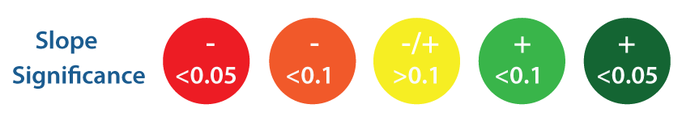

Legend used to interpret the scorecard produced by MAREA. Colors indicate direction of change, and color intensity is given by the statistical significance.

The second output from MAREA is a technical report, intended to communicate information and statystical results in a more formal and technical way. This report also includes a scorecard as a summary of the results, but provides more information for each indicator. For all numeric indicators, the report includes a graph of the value of the indicator, for the reserve and control sites, through time. It also provides a regression table that summarizes the value of all coefficients in the regression and their respective robust standard errors. The summary table also provides information on model fit ($R^{2}$) and significance of the regression.

The scorecard is produced with functions from the Shinydashboard package (Chang and Borges Ribeiro 2017). The technical report is produced by a parameterized Rmarkdown document (Allaire et al. 2017) processed by the knitr package (Xie 2017). Another feature of MAREA is that the user can choose to share the data. Once the technical report is downloaded, information on the reserve, its management objectives, and all uploaded data is saved into a central repository. These data can be accessed at any time by any person interested in aquiring them.

## Case study

We apply the proposed framework and tool to evaluate the effectiveness of one marine reserve from Isla Natividad, in Baja California Sur, Mexico. Isla Natividad is located 8 Km off the Pacific Coast of the Baja Peninsula (**Fig. 3**), where fishers operate under a fishing cooperative (S.C.P.P. Buzos y Pescadores de la Baja California) that promotes co-management of marine resources (B. McCay 2017; B. J. McCay et al. 2014). Additionaly, fishers have Territorial Use Rights for Fisheries (TURFs) that provide them with exclusive access rights to exploit the marine resources in a given perimeter.

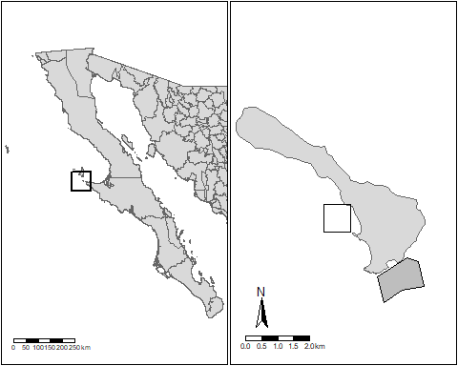

General location of Isla Natividad (left) and map of the island (right). The marine reserve polygon is indicated in gray, and the approximate location of the control site is shown with no fill.

In 2006, the community implemented two marine reserves within their TURF (making them TURF-reserves; Afflerbach et al. 2014). The reserves from Isla Natividad have prooven to be effective in enhancing resilience to climate variations (Micheli et al. 2012) and preserving genetic diversity of highly valuable commercial species, like abalone (Munguía-Vega et al. 2015). These ecological benefits have been translated into economical benefits, enhancing population persistance and supporting abalone fisheries (Rossetto et al. 2015). For the purpose of this evaluation, we will focus on the "La Plana / Las Cuevas" Marine reserve, located in the southern end of the Island (**Fig. 3**) and its corresponding control site "La Dulce / Babencho".

The reserve was implemented to recover species of economic interest -which were overexplotied- in order to enhance fishery production in nearby waters. Fishers were also interested in preserving biological diversity and the ecosystem. Thus, objectives objectives 4-7 were selected. Using **Table 2** to match these objectives with appropriate management indicators, we selected all biophysical, socioeconomic, and governance indicators.

Biophysical data was gathered by fishers from the community. The reserves have been monitored following a standardized ReefCheck protocol (Suman et al. 2010) to collct data on fish and invertebrate communities inside and outside the reserves between 2016 and 2017. A total of 242 and 245 transects were performed in the reserve site for fish and invertebrate surveys, respectively. Similar sampling effort was applied to the control site, with 221 fish and 222 invertebrate transects. Between 12 and 27 transects were performed in each site every year.

Socioeconomic data was obtained from the National Comission for Fisheries and Acuaculture (Comisión Nacional de Pesca y Acuacultura; CONAPESCA). The data contains species-level (9 spp) information on monthly landings and income from 2000 to 2014. Data on landings and income was aggeregated by year, and the yearly Consumer Price Index was included. From the 9 species available, we selected as objective species those that contribute the most (88.27%) to historical income: lobster (*Panulirus interruptus*; 71.76%), red sea urchin (*Strongylocentrotus franciscanus*; 9.33%), snail (*Megastraea undosa*; 3.93%), and sea cucumber (*Parastichopus parvimensis*; 3.23%). Abalone species (*Haliotis fulgens*; 4.52 and *Haliotis corrugata*; 6.16) were excluded because the cooperative decided to implement an informal closure on the species to allow its populations to recover. Eliminating all fishing preasure on these species means that control sites receive (for this species) the same treatment.

For govenance data, we constructed the database based on our knowledge of the area, as well as prototype interviews performed to liders of the fishing cooperative.

# Results and Discussion

The results shown here intend to highlight the relevance and utility of the framework and tool, which automate the analysis and make it replicable. First, we present the scorecard generated by MAREA to provide an overview of the state of the reserve. Then, we provide (mdoified for style) a set of figures generated by MAREA, showing time-series for biophysical and socioeconomic indicators as well as tables containing the magnitude and significance of the $β_{2}$ and $β_{1}$ coefficients. A table with the governance indicators is also provided and discussed.

The scorecard (**Fig. 4**) shows that, overall, the reserve has a good performance achieving a general score of 63.6% of positive indicators. All category-level scores were also high, with values of 66.7%, 60%, and 75% positive indicators for Biophysical, Socioeconomic and Governance, respectively.

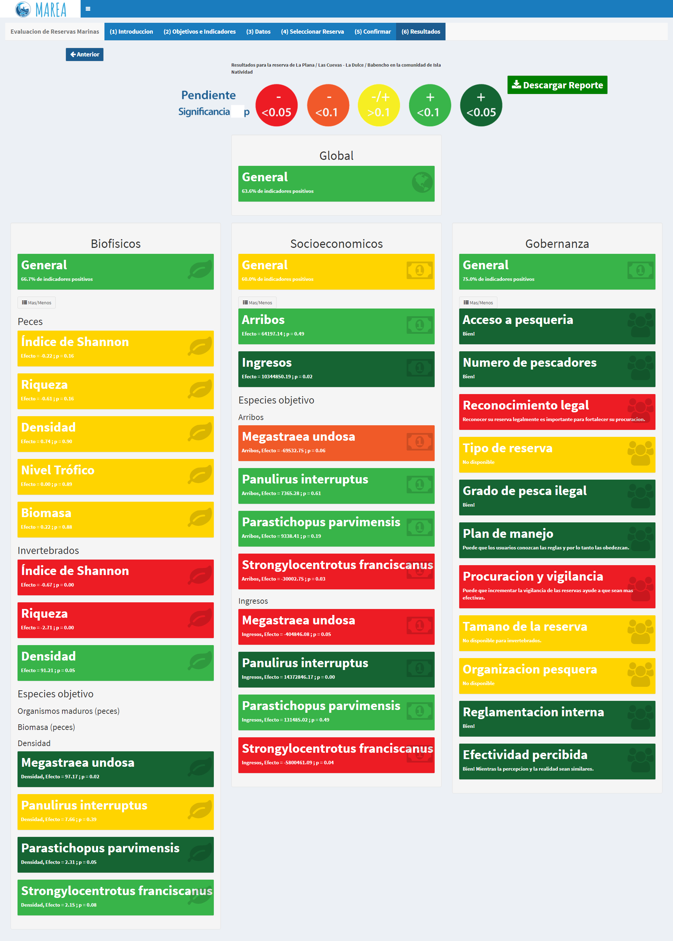

Scorecard for the "La Plana / Las Cuevas" marine reserve in Isla Natividad, Mexico. This scorecard was produced by MAREA.)

Within the biophysical indicators, the greatest effect of the reserve was observed for snail and cucumber densities, with values of $β_{3}=97.17$ (*p* < 0.05) and $β_{3}=2.31$ (*p* < 0.05), respectively. Urchin and lobster densities also increased by $β_{3}=2.15$ and $β_{3}=7.66$ respectively. However, changes in urchin densities were only significant at *p* < 0.1, and not significant for lobster (*p* > 0.1). Shannon's diversity index ($β_{3}=−0.67$) and richness $β_{3}=−2.71$ showed a significant decrease (*p* < 0.05). Fish indicators showed no significant change (*p* > 0.1), with negative trends for Shannon's diversity index and fish species richness and positive trends for density, biomass, and mean trophic level. Changes through time for these indicators are presented in **Figure 5**, and a summary of $β_{3}$ coefficients is provided in **Table 3**.

In the case of socioeconomic indicators, total landings were on average 64.20 tones higher (*p* > 0.1) after the implementation of the reserves. Total income was $10,344.85 (*p* < 0.05) thousands of Mexican Pesos (MXP) higher after the implementation of the reserves. On avergae, lobster and cucumber landings and increased, while urchin and snail landings and income decreased. **Figure 6** presents the changes in this indicators through time, and **Table 4** summarizes this information.

The results identified by our framework and MAREA are consistent to those previously published (*e.g.* Micheli et al. 2012; Rossetto et al. 2015). Invertebrates show increased densities within the reserve, as compared to the control site, providing evidence that the reserve is effectively protecting these species. While we are not able to infer causality from the socioeconomic analysis, we are able to identify important trends. For example, snail and urchin density have significantly increased within the reserve, but their landings and income have decreased. The opposite is observed for lobster and cucumber, which have shown increases in densities, landing, and income. While further information on market behaviour of each species is needed, these results provide insights into the state of the reserve, as well as the associated fisheries.

In terms of governance, it is evident that the community is strongly organized, which is a cause of their success. The first point of success is the existance of a fishing cooeprative that is also affiliated to federation. These polycentric governance structures allow different levels of organization that foster communication and cooperation; federations also provide bargain power with governments (Espinosa-Romero et al. 2014; Finkbeiner and Basurto 2015). Fishers also have good management instruments. Access to the fishing resources they exploit is managed through permits and fishing quotas. Along with a stable number of fishers participating in extractive activities, these limit the total fishing effort effort applied. Additionally, their TURF promotes a sense of stewardship of their resources and incentivizes correct resource management (B. McCay 2017; Finkbeiner and Basurto 2015). Together, these structures enabled a participative, bottom-up process during the reserve design phase; Opinions of all fishing members -and often non-fishers, but community members- were included. Participation of community members in reserve survailance and yearly monitoring indicate commitment and interest, and allow informal communication of results to un-involved community members.

While the reserve has not been legaly recognized (as of this moment), the community has started the process to have the reserve be recognized as a fishery replenishment zone (*Zona de Refugio Pesquer*) under the corresponding Mexican norms (NOM-049-SAG/PESC 2014). Furthermore, the reserve is partially isolated from poaching activity and fishers have internal regulations pertaining the reserves. The low level of illegal fishing by members of the community and outsiders both inside and outside the reserve represents another indication of effectiveness. A summary of governance indicators is provided in **Table 5**.

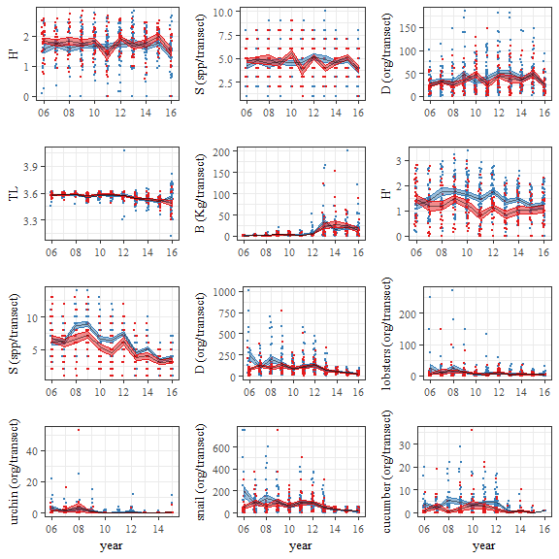

Plots for values of each biophysical indicator (y-axis) through time (x-axis). Red and blue correspond to the reserve and control sites, respectively. Black lines indicate yearly mean values, and ribbons indicate +/- 1 standard error. Dots are horizontally jittered to aid visualization.

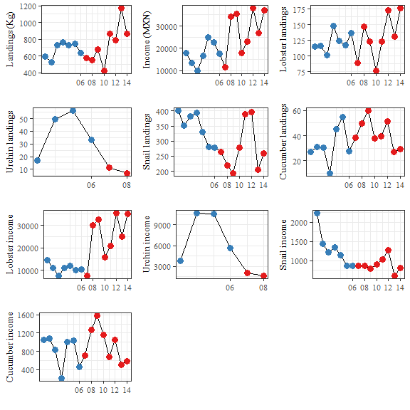

Plots for values of each socioeconomic indicator (y-axis) through time (x-axis). Red and blue correspond to before and after the implementation of the reserve, respectively.

# Conclusions

One of the greatest challenges in management measuring the extent to which objectives have been met. The present framework provides a simple and straightforward way to align management objectives with performance indicators. We aknowledge that these 25 indicators might not fully describe a particular reserve. However, we believe that these provide a starting point to perform the evaluation, and urge decision-makers, managers, and users to include other indicators (*e.g.* larval dispersal or connectivity) that are relevant to their reserve.

The proposed methodologies, specially the way in which biophysical indicators are evaluated, provide valuable information for managers. The analysis isolates the net effect of the reserve, providing a propper measure of reserve effectiveness. We acknowledge there is room for improvement in the way in which socioeconomic and governance data are analized. Despire this, we believe that providing a unifying platform where all can be analyzed and comprehensively presented represents a valuable step towards evidence-based effective management.

Furthermore, MAREA's value is that it provides a free, simple, and replicable way to perform rigurous analysis. The tool can easily be used by fishers, NGO members, and managers in government agencies, providing transparency of the analysis and results. The way in which results are presented allow this information to be interpreted by a wider audience. The scorecard is easily understandable by experts and non-experts, and can be used as an effective tool for communicating the results of yearly evaluations. On the other side, the technical report can serve as a tool for managers and scientists to rapidly communicate information at a more technical level.

While the first release of MAREAis now available, it will continue to be developed and maintained. This will incorporate new features, and enhance current ones, aiming to improve user experience and expand the scope of the analysis. Yet, we believe that this first release represents a major step towards effective management of marine reserves.

# Acknowledgements

The authors wish to thank the fishers from Isla Natividad, who gathered the data used in this study, and the fishers from El Rosario, who helped us validate our survey and framework. Input provided by the participants in the workshop "" was very valuable. We also thank Olivier Deschenes and Andrew Plantinga, who provided valuable input to design the model that evaluates the biophysical indicators.

# References

Aburto-Oropeza, Octavio, Brad Erisman, Grantly R Galland, Ismael Mascareñas-Osorio, Enric Sala, and Exequiel Ezcurra. 2011. “Large Recovery of Fish Biomass in a No-Take Marine Reserve.” *PLoS ONE* 6 (8): e23601. doi:[10.1371/journal.pone.0023601](https://doi.org/10.1371/journal.pone.0023601).

Afflerbach, Jamie C., Sarah E. Lester, Dawn T. Dougherty, and Sarah E. Poon. 2014. “A Global Survey of -Reserves, Territorial Use Rights for Fisheries Coupled with Marine Reserves.” *Global Ecology and Conservation* 2 (December): 97–106. doi:[10.1016/j.gecco.2014.08.001](https://doi.org/10.1016/j.gecco.2014.08.001).

Allaire, JJ, Joe Cheng, Yihui Xie, Jonathan McPherson, Winston Chang, Jeff Allen, Hadley Wickham, Aron Atkins, Rob Hyndman, and Ruben Arslan. 2017. *Rmarkdown: Dynamic Documents for R*. <https://CRAN.R-project.org/package=rmarkdown>.

Anderson, James L, Christopher M Anderson, Jingjie Chu, Jennifer Meredith, Frank Asche, Gil Sylvia, Martin D Smith, et al. 2015. “The Fishery Performance Indicators: A Management Tool for Triple Bottom Line Outcomes.” *PLoS ONE* 10 (5): e0122809. doi:[10.1371/journal.pone.0122809](https://doi.org/10.1371/journal.pone.0122809).

Basurto, Xavier, and Mateja Nenadovic. 2012. “A Systematic Approach to Studying Fisheries Governance.” *Glob Policy* 3 (2): 222–30. doi:[10.1111/j.1758-5899.2011.00094.x](https://doi.org/10.1111/j.1758-5899.2011.00094.x).

Basurto, Xavier, Stefan Gelcich, and Elinor Ostrom. 2013. “The Social–ecological System Framework as a Knowledge Classificatory System for Benthic Small-Scale Fisheries.” *Global Environmental Change* 23 (6): 1366–80. doi:[10.1016/j.gloenvcha.2013.08.001](https://doi.org/10.1016/j.gloenvcha.2013.08.001).

Betti, Federico, Giorgio Bavestrello, Marzia Bo, Valentina Asnaghi, Mariachiara Chiantore, Simone Bava, and Riccardo Cattaneo-Vietti. 2017. “Over 10 Years of Variation in Mediterranean Reef Benthic Communities.” *Marine Ecology* 38 (3): e12439. doi:[10.1111/maec.12439](https://doi.org/10.1111/maec.12439).

Burgess, Matthew G., Michaela Clemence, Grant R. McDermott, Christopher Costello, and Steven D. Gaines. 2016. “Five Rules for Pragmatic Blue Growth.” *Marine Policy*, December. doi:[10.1016/j.marpol.2016.12.005](https://doi.org/10.1016/j.marpol.2016.12.005).

Chang, Winston, and Barbara Borges Ribeiro. 2017. *Shinydashboard: Create Dashboards with ’Shiny’*. <https://CRAN.R-project.org/package=shinydashboard>.

Chang, Winston, Joe Cheng, JJ Allaire, Yihui Xie, and Jonathan McPherson. 2017. *Shiny: Web Application Framework for R*. <https://CRAN.R-project.org/package=shiny>.

Davies, Tim K, Chris C Mees, and E J Milner-Gulland. 2017. “Use of a Counterfactual Approach to Evaluate the Effect of Area Closures on Fishing Location in a Tropical Tuna Fishery.” *PLoS ONE* 12 (3): e0174758. doi:[10.1371/journal.pone.0174758](https://doi.org/10.1371/journal.pone.0174758).

Elfes, Cristiane T, Catherine Longo, Benjamin S Halpern, Darren Hardy, Courtney Scarborough, Benjamin D Best, Tiago Pinheiro, and Guilherme F Dutra. 2014. “A Regional-Scale Ocean Health Index for Brazil.” *PLoS ONE* 9 (4): e92589. doi:[10.1371/journal.pone.0092589](https://doi.org/10.1371/journal.pone.0092589).

Espinosa-Romero, Maria J., Laura F. Rodriguez, Amy Hudson Weaver, Cristina Villanueva-Aznar, and Jorge Torre. 2014. “The Changing Role of Ngos in Mexican Small-Scale Fisheries: From Environmental Conservation to Multi-Scale Governance.” *Marine Policy* 50 (December): 290–99. doi:[10.1016/j.marpol.2014.07.005](https://doi.org/10.1016/j.marpol.2014.07.005).

Finkbeiner, Elena M., and Xavier Basurto. 2015. “Re-Defining Co-Management to Facilitate Small-Scale Fisheries Reform: An Illustration from Northwest Mexico.” *Marine Policy* 51 (January): 433–41. doi:[10.1016/j.marpol.2014.10.010](https://doi.org/10.1016/j.marpol.2014.10.010).

Friedlander, Alan M, Yimnang Golbuu, Enric Ballesteros, Jennifer E Caselle, Marine Gouezo, Dawnette Olsudong, and Enric Sala. 2017. “Size, Age, and Habitat Determine Effectiveness of Palau’s Marine Protected Areas.” *PLoS ONE* 12 (3): e0174787. doi:[10.1371/journal.pone.0174787](https://doi.org/10.1371/journal.pone.0174787).

Guidetti, Paolo, Pasquale Baiata, Enric Ballesteros, Antonio Di Franco, Bernat Hereu, Enrique Macpherson, Fiorenza Micheli, et al. 2014. “Large-Scale Assessment of Mediterranean Marine Protected Areas Effects on Fish Assemblages.” *PLoS ONE* 9 (4): e91841. doi:[10.1371/journal.pone.0091841](https://doi.org/10.1371/journal.pone.0091841).

Halpern, Benjamin S, Melanie Frazier, Jamie Afflerbach, Casey O’Hara, Steven Katona, Julia S Stewart Lowndes, Ning Jiang, Erich Pacheco, Courtney Scarborough, and Johanna Polsenberg. 2017. “Drivers and Implications of Change in Global Ocean Health over the Past Five Years.” *PLoS ONE* 12 (7): e0178267. doi:[10.1371/journal.pone.0178267](https://doi.org/10.1371/journal.pone.0178267).

Halpern, Benjamin S, Catherine Longo, Darren Hardy, Karen L McLeod, Jameal F Samhouri, Steven K Katona, Kristin Kleisner, et al. 2012. “An Index to Assess the Health and Benefits of the Global Ocean.” *Nature* 488 (7413): 615–20. doi:[10.1038/nature11397](https://doi.org/10.1038/nature11397).

Halpern, Benjamin S, Catherine Longo, Courtney Scarborough, Darren Hardy, Benjamin D Best, Scott C Doney, Steven K Katona, Karen L McLeod, Andrew A Rosenberg, and Jameal F Samhouri. 2014. “Assessing the Health of the U.S. West Coast with a Regional-Scale Application of the Ocean Health Index.” *PLoS ONE* 9 (6): e98995. doi:[10.1371/journal.pone.0098995](https://doi.org/10.1371/journal.pone.0098995).

Halpern, Benjamin S, Shaun Walbridge, Kimberly A Selkoe, Carrie V Kappel, Fiorenza Micheli, Caterina D’Agrosa, John F Bruno, et al. 2008. “A Global Map of Human Impact on Marine Ecosystems.” *Science* 319 (5865): 948–52. doi:[10.1126/science.1149345](https://doi.org/10.1126/science.1149345).

Horta e Costa, Bárbara, Joachim Claudet, Gustavo Franco, Karim Erzini, Anthony Caro, and Emanuel J. Gonçalves. 2016. “A Regulation-Based Classification System for Marine Protected Areas (Mpas).” *Marine Policy* 72 (October): 192–98. doi:[10.1016/j.marpol.2016.06.021](https://doi.org/10.1016/j.marpol.2016.06.021).

IUCN. 2017. “Protected Areas Categories.” WEBSITE. *International Union for Conservation of Nature*. <https://www.iucn.org/theme/protected-areas/about/protected-areas-categories>.

Lester, SE, and BS Halpern. 2008. “Biological Responses in Marine No-Take Reserves Versus Partially Protected Areas.” *Mar. Ecol. Prog. Ser.* 367 (September): 49–56. doi:[10.3354/meps07599](https://doi.org/10.3354/meps07599).

Lester, SE, BS Halpern, K Grorud-Colvert, J Lubchenco, BI Ruttenberg, SD Gaines, S Airamé, and RR Warner. 2009. “Biological Effects Within No-Take Marine Reserves: A Global Synthesis.” *Mar. Ecol. Prog. Ser.* 384 (May): 33–46. doi:[10.3354/meps08029](https://doi.org/10.3354/meps08029).

Lowndes, Julia S. Stewart, Benjamin D. Best, Courtney Scarborough, Jamie C. Afflerbach, Melanie R. Frazier, Casey C. O’Hara, Ning Jiang, and Benjamin S. Halpern. 2017. “Our Path to Better Science in Less Time Using Open Data Science Tools.” *Nat. Ecol. Evol.* 1 (6): 0160. doi:[10.1038/s41559-017-0160](https://doi.org/10.1038/s41559-017-0160).

Mascia, Michael B, Helen E Fox, Louise Glew, Gabby N Ahmadia, Arun Agrawal, Megan Barnes, Xavier Basurto, et al. 2017. “A Novel Framework for Analyzing Conservation Impacts: Evaluation, Theory, and Marine Protected Areas.” *Ann N Y Acad Sci* 1399 (1): 93–115. doi:[10.1111/nyas.13428](https://doi.org/10.1111/nyas.13428).

McCay, Bonnie J., Fiorenza Micheli, Germán Ponce-Díaz, Grant Murray, Geoff Shester, Saudiel Ramirez-Sanchez, and Wendy Weisman. 2014. “Cooperatives, Concessions, and Co-Management on the Pacific Coast of Mexico.” *Marine Policy* 44 (February): 49–59. doi:[10.1016/j.marpol.2013.08.001](https://doi.org/10.1016/j.marpol.2013.08.001).

McCay, BonnieJ. 2017. “Territorial Use Rights in Fisheries of the Northern Pacific Coast of Mexico.” *BMS* 93 (1): 69–81. doi:[10.5343/bms.2015.1091](https://doi.org/10.5343/bms.2015.1091).

Micheli, Fiorenza, Andrea Saenz-Arroyo, Ashley Greenley, Leonardo Vazquez, Jose Antonio Espinoza Montes, Marisa Rossetto, and Giulio A De Leo. 2012. “Evidence That Marine Reserves Enhance Resilience to Climatic Impacts.” *PLoS ONE* 7 (7): e40832. doi:[10.1371/journal.pone.0040832](https://doi.org/10.1371/journal.pone.0040832).

Moland, Even, Esben Moland Olsen, Halvor Knutsen, Pauline Garrigou, Sigurd Heiberg Espeland, Alf Ring Kleiven, Carl André, and Jan Atle Knutsen. 2013. “Lobster and Cod Benefit from Small-Scale Northern Marine Protected Areas: Inference from an Empirical Before-After Control-Impact Study.” *Proc Biol Sci* 280 (1754): 20122679. doi:[10.1098/rspb.2012.2679](https://doi.org/10.1098/rspb.2012.2679).

Munguía-Vega, Adrián, Andrea Sáenz-Arroyo, Ashley P. Greenley, Jose Antonio Espinoza-Montes, Stephen R. Palumbi, Marisa Rossetto, and Fiorenza Micheli. 2015. “Marine Reserves Help Preserve Genetic Diversity After Impacts Derived from Climate Variability: Lessons from the Pink Abalone in Baja California.” *Global Ecology and Conservation* 4 (July): 264–76. doi:[10.1016/j.gecco.2015.07.005](https://doi.org/10.1016/j.gecco.2015.07.005).

NOM-049-SAG/PESC. 2014. “NORMA Oficial Mexicana Nom-049-Sag/Pesc-2014, Que Determina El Procedimiento Para Establecer Zonas de Refugio Para Los Recursos Pesqueros En Aguas de Jurisdicción Federal de Los Estados Unidos Mexicanos.” *DOF*.

Oyanedel, Rodrigo, Jennifer Macy Humberstone, Keith Shattenkirk, Salvador Rodriguez Van-Dyck, Kaia Joye Moyer, Sarah Poon, Gavin McDonald, et al. 2017. “A Decision Support Tool for Designing Turf-Reserves.” *BMS* 93 (1): 155–72. doi:[10.5343/bms.2015.1095](https://doi.org/10.5343/bms.2015.1095).

Pauly, Daniel, Reg Watson, and Jackie Alder. 2005. “Global Trends in World Fisheries: Impacts on Marine Ecosystems and Food Security.” *Philos Trans R Soc Lond, B, Biol Sci* 360 (1453): 5–12. doi:[10.1098/rstb.2004.1574](https://doi.org/10.1098/rstb.2004.1574).

Pomeroy, Robert S., John E. Parks, and Lani M. Watson. 2004. *How Is Your Mpa Doing ? A Guidebook of Natural and Social Indicators for Evaluating Marine Protected Areas Management Effectiveness*. IUCN. doi:[10.2305/IUCN.CH.2004.PAPS.1.en](https://doi.org/10.2305/IUCN.CH.2004.PAPS.1.en).

Pomeroy, Robert S., Lani M. Watson, John E. Parks, and Gonzalo A. Cid. 2005. “How Is Your Mpa Doing? A Methodology for Evaluating the Management Effectiveness of Marine Protected Areas.” *Ocean Coast Manag* 48 (7-8): 485–502. doi:[10.1016/j.ocecoaman.2005.05.004](https://doi.org/10.1016/j.ocecoaman.2005.05.004).

R Core Team. 2017. *R: A Language and Environment for Statistical Computing*. Vienna, Austria: R Foundation for Statistical Computing. <https://www.R-project.org/>.

Rodriguez, Alba Garcia, and Lucia M. Fanning. 2017. “Assessing Marine Protected Areas Effectiveness: A Case Study with the Tobago Cays Marine Park.” *OJMS* 07 (03): 379–408. doi:[10.4236/ojms.2017.73027](https://doi.org/10.4236/ojms.2017.73027).

Rossetto, Marisa, Fiorenza Micheli, Andrea Saenz-Arroyo, Jose Antonio Espinoza Montes, Giulio Alessandro De Leo, and Marie-Joëlle Rochet. 2015. “No-Take Marine Reserves Can Enhance Population Persistence and Support the Fishery of Abalone.” *Can. J. Fish. Aquat. Sci.* 72 (10): 1503–17. doi:[10.1139/cjfas-2013-0623](https://doi.org/10.1139/cjfas-2013-0623).

Sala, Enric, Christopher Costello, Jaime De Bourbon Parme, Marco Fiorese, Geoff Heal, Kieran Kelleher, Russell Moffitt, et al. 2016. “Fish Banks: An Economic Model to Scale Marine Conservation.” *Marine Policy* 73 (November): 154–61. doi:[10.1016/j.marpol.2016.07.032](https://doi.org/10.1016/j.marpol.2016.07.032).

Selig, Elizabeth R., Melanie Frazier, Jennifer K. O’Leary, Stacy D. Jupiter, Benjamin S. Halpern, Catherine Longo, Kristin L. Kleisner, Loraini Sivo, and Marla Ranelletti. 2015. “Measuring Indicators of Ocean Health for an Island Nation: The Ocean Health Index for Fiji.” *Ecosystem Services* 16 (December): 403–12. doi:[10.1016/j.ecoser.2014.11.007](https://doi.org/10.1016/j.ecoser.2014.11.007).

Soykan, Candan U, and Rebecca L Lewison. 2015. “Using Community-Level Metrics to Monitor the Effects of Marine Protected Areas on Biodiversity.” *Conserv Biol* 29 (3): 775–83. doi:[10.1111/cobi.12445](https://doi.org/10.1111/cobi.12445).

Suman, Craig S, Andrea Saenz-Arroyo, Cyndi Dawson, and Mary C Luna. 2010. *Manual de Instruccion de Reef Check California: Guia de Instruccion Para El Monitoreo Del Bosque de Sargazo En La Peninsula de Baja California*. Pacific Palisades, CA, USA: Reef Check Foundation.

Vilela, Thais, and John Reid. 2017. “Improving Hydropower Choices via an Online and Open Access Tool.” *PLoS ONE* 12 (6): e0179393. doi:[10.1371/journal.pone.0179393](https://doi.org/10.1371/journal.pone.0179393).

Woodcock, Paul, Bethan C O’Leary, Michel J Kaiser, and Andrew S Pullin. 2017. “Your Evidence or Mine? Systematic Evaluation of Reviews of Marine Protected Area Effectiveness.” *Fish Fish* 18 (4): 668–81. doi:[10.1111/faf.12196](https://doi.org/10.1111/faf.12196).

Xie, Yihui. 2017. *Knitr: A General-Purpose Package for Dynamic Report Generation in R*. <http://yihui.name/knitr/>.