Summary of Chiapas Cofee Leaf Rust and Climate Data Availability

## Available Climate data

This contains daily data for climatic variables collected from weather stations at 2 m above the ground. Data comes from INIFAP's website at [http://clima.inifap.gob.mx/redinifap/](http://clima.inifap.gob.mx/redinifap/est.aspx?est=38213), where one can search by state, station, year, and month. This same portal has station data available for all other states, including Oaxaca, Veracruz, and Guerrero, states that also produce coffee. I have obly searched for the geographic location and last sampling event for each station. The entire climate data still needs to be gathered by copy-pasting directly from the tables displayed in each query for the state of Chiapas and the stations listed under it. There are a total of 28 stations with data that covers some point between 2007 and - (Fig. 1). Within that window, some stations may have gaps of missing data.

## Coffee leaf rust data

Coffee leaf rust data weekly reports from royacafe. The parent directory for all the reports is available at <http://royacafe.lanref.org.mx/ReportesSPEyC_doc/>. The weekly reports include information for coffee leaf rust incidence. The data is reported at municipality level, and no specific coordinates or information about the number of coffee plots is provided by the source. This data set contains information for a total of 55 municipalities, with information from 2014-10-06 to 2016-08-30 (Fig. 2). There are ttwo main clusters of coffee leaf rust information. The first one is located in the southern tip of Chiapas, in the region that borders Guatemala. This region of about 13 Municipalities has 52 sampling events. On the northern part of Chiapas, in the border with Tabasco, there are other 14 municipalities that also have 52 sampling events.

## Recommendations

Based on the observed spatial distribution of data for Chiapas, it might be relevant to perform further analysis in the souternmost region, where coffee leaf rust and climate data overlap (Fig. 3). Further analysis shoud focus on the Municipalities of Villa de Corzo, Comaltitlan, Hixtla, Tapachula, Cacahoatan, Tuxtla Chico, and Metapa. Given the closeness to Guatamala, it might also be relevant to explore data availability from the other side of the border, as it is likely that this is also an important coffee production region.

## Figures

### Climate data availability

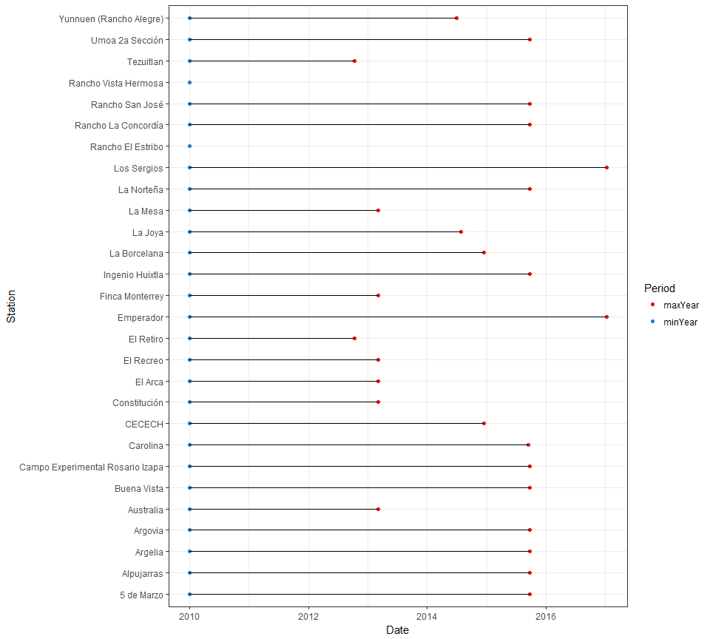

**Figure 1 -** Initial and final times of sampling for each station. These window of meassurements may be interrupted at different points for different stations. Stations Rancho Vista Hermosa and Rancho el Estribo were temporarily unavailable in INIFAP's server.

The information that is available to download is the following:

* *Name*: the name of the station
* *Municipality*: the municipality where the station is
* *Latitud1*: Latitude in decimal degrees
* *Longitude1*: Longitude in decimal degrees
* *Latitude2*: Latitude in DMS format
* *Longitude2*: Latitude in DMS format
* *Date*: Date in dd//mm/yy format (*.csv) and YYYY/mm/dd (*.Rdata)
* *Preci*: Precipitation in mm
* *Tmax*: Maximum daily temperature in °C
* *Tmin*: Minimum daily temperature in °C
* *Tmed*: Mean daily temperature in °C
* *VVMax*: Maximum wind speed in km/h
* *DVVMax*: Direction of the maximum wind speed in azimuth
* *VV*: Mean wind speed in km/h
* *DV*: Mean direction of wind speed in azimuth
* *RadG*: Global radiation in w / m^2
* *HR*: Relative humidity (%)
* *ET*: Reference evapotranspiration (mm)
* *EP*: Potential evapotranspiration (mm)

### Coffee leaf rust data availability

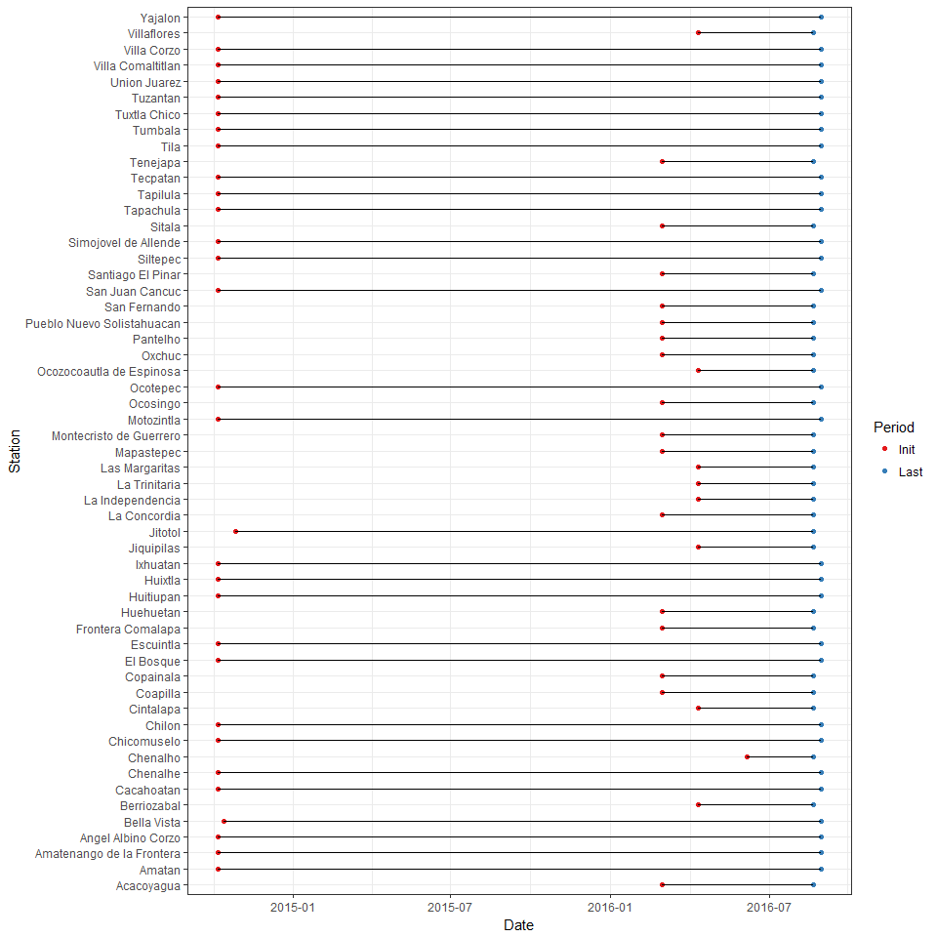

**Figure 2 -** Initial and final times of coffee leaf rust data. These window of meassurements may be interrupted at different points for different stations.

This dataset contains information for:

* *Municipality*: Municipality
* *Initial*: Initial date of sampling for the weekly report as day/month/year
* *Final*: Final date of sampling for the weekly report as day/month/year
* *PS*: Plant severity, expressed as percentage of affected plants
* *PVI*: Plant variability index, expressed as relative variability from regional mean
* *LS*: Leaf severity index, expressed as percentage of affected leaves
* *LVI*: Leaf variability index, expressed as relative variability from regional mean
* *AL*: Number of affected leafs per plant
* *Lechoso*: Number of stage-1 fruits per sampling site
* *Consistente*: Number of stage-2 fruits per sampling site
* *Maduro*: Number of stage-3 (mature) fruits per sampling site

**Note:** While these are called weekly reports, there are not 52 reports per year. Apparently, this makes reference to the fact that the sampling period for each report is often a week.

### Spatial distribution of data

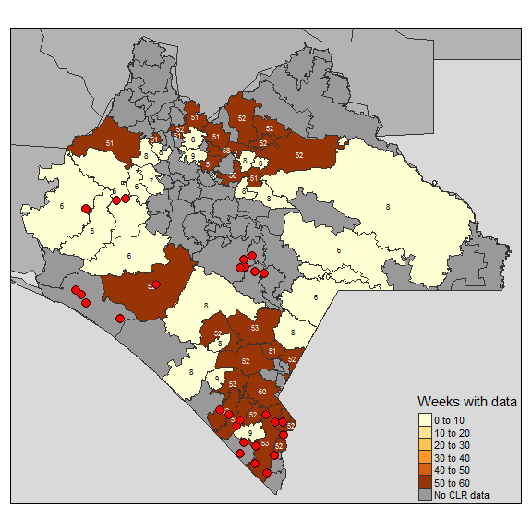

**Figure 3 -** Map of Oaxaca and municipalities. Color of municipalities represent the number of weeks (weekly reports) with available information for each municipality, also shown as text over each municipality. Red dots indicate the locations of weather stations from which data is available from INIFAP's database.