Maps1

Villasenor-Derbez, J.C.

12 de octubre de 2016

## OGR data source with driver: ESRI Shapefile   
## Source: "./Data/Spatial", layer: "states"  
## with 32 features  
## It has 9 fields  
## Integer64 fields read as strings: POP1990 HSE_UNIT90

## Introduction

## Deliverable 1 - Climate data

This contains daily data for climatic variables collected from weather stations at 2 m above the ground. Data comes from INIFAP's [website](http://clima.inifap.gob.mx/redinifap/est.aspx?est=38213), where one can search by state, station, year, and month. This same portal has station data available for all other states, including Chiapas, Veracruz, and Guerrero, states that also produce coffee. Data were obtained by copy-pasting directly from the tables displayed in each query for the state of Oaxaca and every station listed under it. There are a total of 49 stations with data that covers some point between 2007-02-23 and 2016-10-19 (Fig. 1). Within that window, some stations may have gaps of missing data. The compiled database can be downloaded from github in [*.csv format](https://github.com/jcvdav/OaxacaLeafRust/blob/master/Data/inifap_data.csv) or in [*.RData format](https://github.com/jcvdav/OaxacaLeafRust/blob/master/Data/inifap_data.Rdata). This data has the following fields:

* *Name*: the name of the station
* *Municipality*: the municipality where the station is
* *Latitud1*: Latitude in decimal degrees
* *Longitude1*: Longitude in decimal degrees
* *Latitude2*: Latitude in DMS format
* *Longitude2*: Latitude in DMS format
* *Date*: Date in dd//mm/yy format (*.csv) and YYYY/mm/dd (*.Rdata)
* *Preci*: Precipitation in mm
* *Tmax*: Maximum daily temperature in °C
* *Tmin*: Minimum daily temperature in °C
* *Tmed*: Mean daily temperature in °C
* *VVMax*: Maximum wind speed in km/h
* *DVVMax*: Direction of the maximum wind speed in azimuth
* *VV*: Mean wind speed in km/h
* *DV*: Mean direction of wind speed in azimuth
* *RadG*: Global radiation in w / m^2
* *HR*: Relative humidity (%)
* *ET*: Reference evapotranspiration (mm)
* *EP*: Potential evapotranspiration (mm)

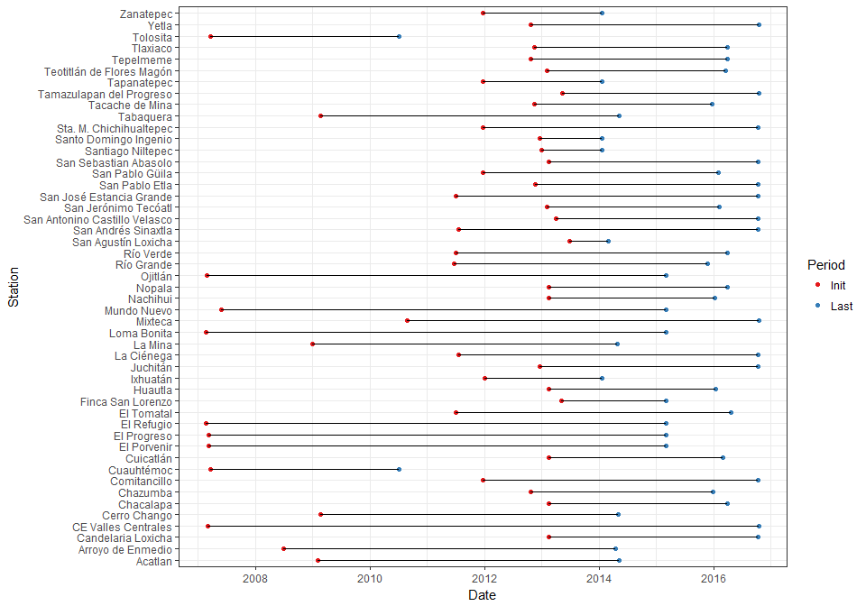

**Figure 1 -** Initial and final times of sampling for each station. These window of meassurements may be interrupted at different points for different stations.

## Deliverable 2 - Coffee leaf rust data

Coffee leaf rust data weekly reports from royacafe. The parent directory for all the reports is available [here](http://royacafe.lanref.org.mx/ReportesSPEyC_doc/). The weekley reports include information for coffee leaf rsut incidence. The data is reported at municipality level, and no specific coordinates or information about the number of coffee plots is provided by the source. This dataset contains information for a total of 13 municipalities, with information from 2015-05-04 to 2016-08-21 (Fig. 2). There are three main clusters of coffee leaf rust information. One of them is located in the Northernmost part of the state. For that region, there are between 1 and 5 weekly reports for each of the 4 municipalities. The second cluster is in the Eastern region of the state, where 3 municipalities have 1 observation each. The third cluster is located in the South of the state. This cluster has 6 municipalities, with between 6 and 28 observations.

This dataset contains information for:

* *Municipality*
* *Initial*
* *Final*
* *PS*
* *PVI*
* *LS*
* *LVI*
* *AL*
* *Lechoso*
* *Consistente*
* *Maduro*

**Note:** While these are called weekly reports, there are not 52 reports per year. Apparently, this makes reference to the fact that the sampling periof for each report is often a week.

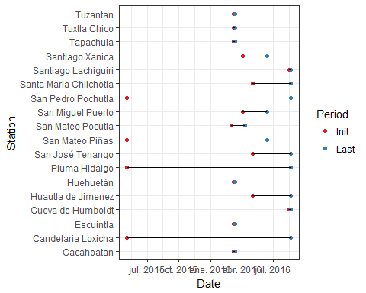

**Figure 2 -** Initial and final times of coffee leaf rust data. These window of meassurements may be interrupted at different points for different stations.

## Spatial distribution of data

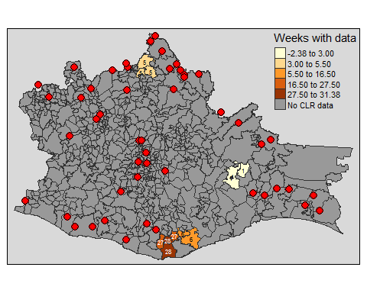

**Figure 3 -** Map of Oaxaca and municipalities. Color of municipalities represent the number of weeks (weekly reports) with available information for each municipality, also shown as text over each municipality. Red dots indicate the locations of weather stations from which data is available from INIFAP's database.

## Other climate data

This data comes from [CLICOM's database](clicom-mex.cicese.mx). The portal allows the suer to download sets of 20 files (stations) at a time, either in *.csv or *.mat formats. This contains daily data for climatic variables. There are a total of 162 stations with data that covers some point between 2000 and 2012. The oldest station has data from as far back as 1922. While this data has a better spatial distribution (Fig. 5), information for recent years is not available.

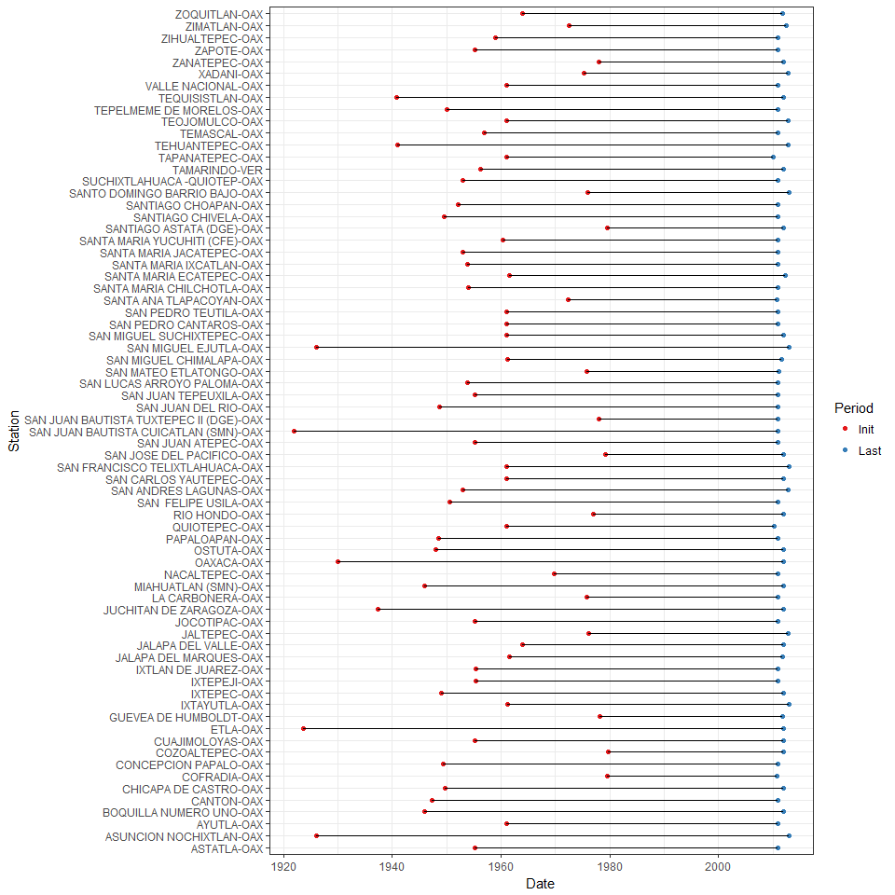

**Figure 4 -** Initial and final times of sampling for each station. This represents a subser of all stations to reduce the size of the graph. This subset represents stations with more than 30 years of data, from 2010 back. These window of meassurements may be interrupted at different points for different stations.

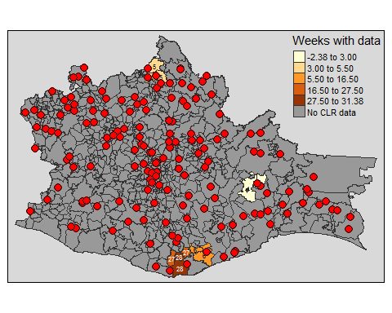

**Figure 5 -** Map of Oaxaca and municipalities. Color of municipalities represent the number of weeks (weekly reports) with available information for each municipality, also shown as text over each municipality. Red dots indicate the locations of weather stations from which data is available up to 2012 from CLICOM's database.