**Size structure of Yellowfin Tuna (Thunnus albacares) is…**

VILLASEÑOR-DERBEZ, J.C.1, GOMEZ-SANCHEZ, M.D.2, DREYFUS-LEON, M.J.3,4

*1Bren School of Environmental Science & Management, University of California Santa Barbara, Santa Barbara CA 93106, USA.*

*2 Instituto de Investigaciones Oceanológicas, Universidad Autónoma de Baja California, Km. 103 Carretera Tijuana-Ensenada, Ensenada CP 22860, Baja California, México*

*3Instituto Nacional de la Pesca, Centro Regional de Investigación Acuícola y Pesquera Ensenada, Carretera Tijuana-Ensenada Km 97.5, Parque Industrial FONDEPORT, El Sauzal de Rodríguez, CP 22760 Ensenada, Baja California, México.*

*4Facultad de Ciencias Marinas, Universidad Autónoma de Baja California, Km. 103 Carretera Tijuana-Ensenada, Ensenada CP 22860, Baja California, México.*

**Corresponding author:** Juan Carlos Villaseñor-Derbez; [juancarlos.villader@gmail.com](mailto:juancarlos.villader@gmail.com); *Laurel Walk 787-C, Goleta, CA, 93117*; (207)-205-8435

**Running title:**

**ABSTRACT**

Each article should include a one-paragraph abstract of not more than 250 words that begins on a separate page and is complete without reference to the text. Key words for indexing should be listed at the end of the abstract.

**Key words:**

**INTRODUCTION**

**MATERIALS AND METHODS**

Datos de atún

Cómo se recopilaron

Cuáles estamos usando (LANATUN)

Series de tiempo

ONI, SOI, MEI, Temp, Chl-A

Imágenes

De dónde vienen (NASA / MODIS Aqua)

Resolución

Variables

Cómo se juntó todo en MatLab y R

Nuestros códigos

Análisis

GLM?

ANCOVA 2 vías (Ano y Mes)

Qué más?

**RESULTS**

Serie de tiempo Talla promedio vs. Año por tipo de lance

Hovmoller tallas

VariableOC vs Tiempo

ONI, SOI, MEI

Algo con

Temp, Chl-A

Hexabinning de talla vs Variable OC (T, Chl-A, ONI, MEI, SOI)

**DISCUSSION AND CONCLUSIONS**

**REFERENCES**

Only full articles which have been published or are 'in press' may be included in the reference list. Papers 'submitted' or 'in prep.' are not permitted. In the text, unpublished studies should be referred to as such or as a personal communication together with an abbreviated address of the source (e. g. R. Swain, Vancouver University, USA, pers. comm.). References should be inserted in parentheses, as follows: (Cushing, 1989; Young et al., 1986). The reference list should be in alphabetical order according to first-named author. Papers with two authors should follow those of the first-named author, arranged in alphabetical order according to the name of the second author. Articles with more than two authors should follow in chronological order. All authors' names and the title of the article must be included. Any web references must include the date of last access.

**Ensure that all references occurring in the text are present in the reference list and that correspondingly there are none that are found solely in the reference list**. Standard abbreviations of journal titles should be used, following the *American National Standard for Abbreviations of Titles of Periodicals*. The following provide examples:

*Periodical:*

Cushing, D.H. (1989) A difference in structure between ecosystis in bly stratified waters and in those that are only weakly stratified. *J. Plankton Res*. **11:** 1-13.

Young, RC., Leis, J.M., and Hausfeld, H.F. (1986) Seasonal and spatial distribution of fish larvae in waters over the North West Continental Shelf of Western Australia. *Mar. Ecol. Prog. Ser*. **31:** 209-222.

*Book:*

Kawasaki, T. (1982) *Pelagic Fish Stocks.* Tokyo: Koseisha-Koseikaku, 327pp. (In Japanese).

*Paper or chapter in book:*

Sissenwine, M.P. (1984) Why do fish populations vary? In: *Exploitation of Marine Communities*. R.M. May (ed.) Berlin: Springer-Verlag, pp. 59-94.

**Note:** When there is one Editor it is abbreviated to ed. but more than one Editor is eds (without stop).

*PhD Thesis:*

O'Toole, K.J. (1977) Investigations into some important fish larvae in the south east Atlantic in relation to the hydrological environment. PhD thesis, Univeristy of Cape Town, 273pp.

*Published report:*

Hunter, J.R. and Alheit, J. (1995) International GLOBEC Small Pelagic Fishes and Climate Change Program. *GLOBEC Rep.* No. **8:** 72pp.

*Unpublished paper or report*

Hansen, B., Kristiansen, A. and Reinert, J. (1990) Cod and haddock in Faroese waters and possible climatic influences on them. *ICES C.M. 1990/G:33*, 23pp.

*Internal report:*

Griffin, D.A. and Lochmann, S.E. (1993) Petrel V cruise 31 to Western Bank, 22 Noviber to 16 December 1992.  Halifax, Nova Scotia: Department of Oceanography, Dalhousie University, OPEN Report 1993/1. 105pp.

Review articles use abbreviated references. Example:

Young, P.C. *et al*. (1986) *Mar. Ecol. Prog. Ser*., **31:** 209-222.

**FIGURES**

Figures should be referred to as e. g. Fig. 2, Fig. 2b, c or Figs 9 and 10 - whether in the main body of the text or in brackets, except at the beginning of sentences where it is in full e. g. Figure 9.

All illustrations and lettering should be capable of 66% to 50% reduction without loss of clarity or legibility. Ensure consistency in fonts, line thickness and style. Very thin lines do not reproduce clearly. Avoid using tints, a coarse stipple reproduces more clearly.

Perform a visual check of images by zooming in to 300%. Suitable images will not become noticeably blurred or pixelated.

Ideally line graphics should be saved in TIFF or EPS format at 600dpi, and halftone figures (colour or greyscale) should be saved as 300dpi TIFF files.

Please address queries concerning the file types for submission to [fog-editorial-office@wiley.com](mailto:fog-editorial-office@wiley.comsdruskat)

In the full-text online edition of the journal, figure legends may be truncated in abbreviated links to the full screen version.  Therefore, the first 100 characters of any legend should inform the reader of key aspects of the figure.

Figure legends should be typed double-spaced on a separate sheet. Authors wishing to include colour plates in a paper should contact the Editor-in-Chief.

C:\Users\JC\Documents\GitHub\atun\Docs\Figs\Fig1.tiff

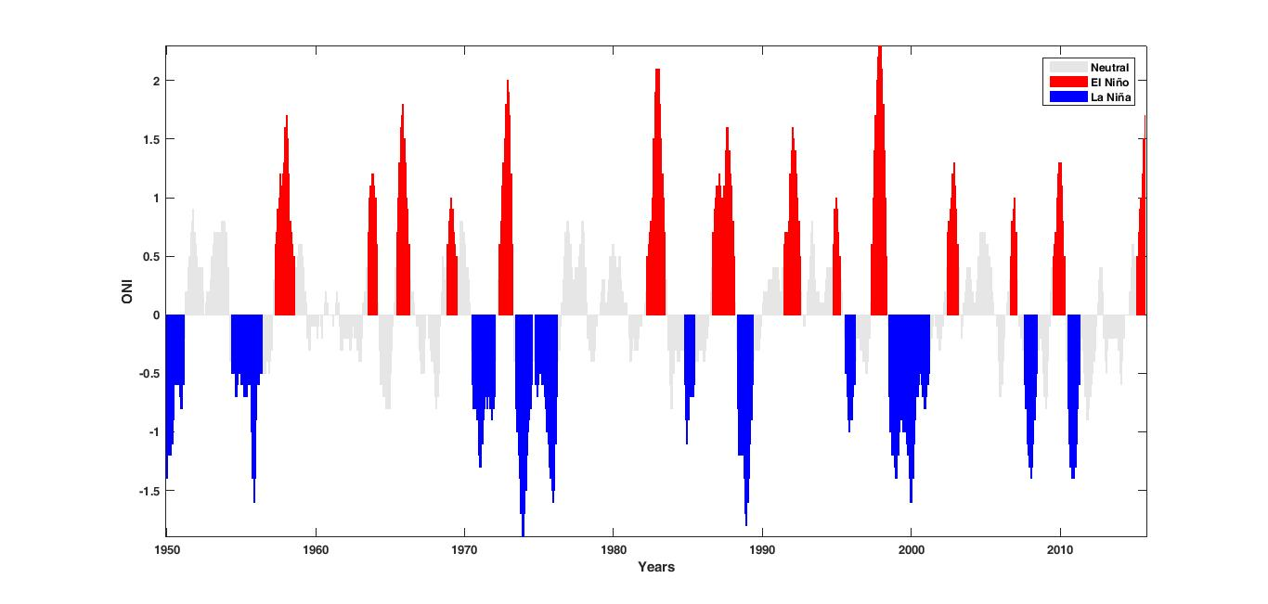

**C:\Users\JC\Documents\GitHub\atun\Docs\Figs\Fig3.tiff**

**C:\Users\JC\Documents\GitHub\atun\Docs\Figs\Fig4.tiff**

**C:\Users\JC\Documents\GitHub\atun\Docs\Figs\Fig5.tiff**

**TABLES**

Tables must be typed double-spaced, without vertical rules, and should not duplicate material in the text or illustrations. All tables should have complete but brief headings, be typed on separate sheets of paper, and be numbered consecutively within the text. Only use horizontal rules to separate the column headers from the main table and at the top and bottom of the table; do not use horizontal rules to separate each line of data. The first letter of text phrases used as column and row headers should be capitalised. The 'Table number' should be in bold but the remainder of the text of the heading is to be in standard weight, e. g. **Table 2.** Correlation coefficients and significance levels.