**Outline**

**Title: Small Scale Fisheries Cooperatives Vulnerability to Climate Change**

**Target journal:**

**Abstract:**

**Introduction:**

Fisheries around the world are facing unprecedented challenges. Climate change is altering oceanographic patterns and shifting the dynamics of many marine ecosystems. This situation threatens global food production and it’s expected to be particularly impactful to coastal communities in developing countries (Allison et al. 2009, Cheung et al. 2010). Often, the livelihoods of these coastal communities rely heavily on small-scale fisheries as a source of food and income, thus, changes in ocean productivity can pose a threat on local food security. Furthermore, these communities often lack the flexibility to respond to changes. Unlike industrial fishing fleets, that can change their area of operation according to the distribution of their target, coastal small-scale fisheries tend to have a reduced range of movement, which can difficult coping with changes in fish distribution (REF).

Despite the limitations of coastal small-scale fisheries to respond to climate change, many of these communities will have the capacity to cope with these changes by developing the appropriate fisheries institutions. One particular form of institution, fishing cooperatives, figure among the most promising. Previous studies have analyzed fishing cooperatives from a commons perspective (Deacon 2012, Ostrom 2015), their role in the development of sustainable and economically efficient fisheries (Makino and Matsuda 2005, Costello and Deacon 2007, Maliao et al. 2009, Author et al. 2010, Deacon et al. 2010) and their conservation benefits (Cinner and Aswani 2007, Gelcich et al. 2008, Ovando et al. 2013). In short, these studies have shown that fishing cooperatives are capable of solving common pool dilemmas, and that their presence can benefit local fisheries by achieving both social (economic efficiency and job security) and conservation goals. However, little is known about how fishing cooperatives will perform under climate change.

The level at which each cooperative will be impacted depends on their vulnerability to climate change. Previous authors have analyzed fisheries vulnerability by separating it into three main components: exposure to change, sensitivity to change and adaptive capacity (Adger 2006, Cinner et al. 2012, 2013, 2015). The exposure to change refers to how strong the impacts of climate change will be in each particular area and it depends on the local oceanographic conditions (Cinner et al. 2013). Sensitivity refers to the capacity of the local community and biota to tolerate those environmental changes, for example, the tolerance of a particular fish species to high temperatures (Cinner et al. 2013). Even under relatively high exposure and sensitivity levels, fishing cooperatives can thrive in new environmental conditions if they have a high adaptive capacity. Adaptive capacity is the faculty to “anticipate and respond to changes, and to minimize, cope with, and recover from the consequences of change”, it particularly looks at the presence of the enabling conditions for communities to cope with environmental changes (Cinner et al. 2015)

Recently a large body of literature has been dedicated to the analysis of the capacity of coastal fishing communities to adapt to climate change (Mcclanahan et al. 2008, Cinner et al. 2012, 2013). These analyses have relied on frameworks that allow integrating the different components of vulnerability to climate change. In particular, Cinner et al. 2013, developed a framework that builds upon the one produced by the Intergovernmental Panel on Climate Change (IPCC) and allows to incorporate a social-ecological perspective into the analysis of fisheries communities’ vulnerability to climate change.

Here we apply the Cinner et al. (2013) framework to assess the vulnerability of fishing cooperatives around the world and identify potential drivers of that vulnerability. We found that…

**Methods:**

We operationalize the socio-ecological vulnerability framework developed by Cinner et al. (2013) to apply it to the database compiled by Ovando et al. (2013) on fishing cooperatives. This database was collected from published case studies using a survey instrument to standardize the collection of information across cases. It provides information on ecological (e.g. Life history parameters of the targeted species), institutional (e.g. Population growth rate, per capita GDP), economic (e.g. Species’ value, market destination), and policy variables (e.g. size limits, subsidies) for 67 cases of cooperatively managed fisheries around the world. It also includes fisheries’ structural variables such as number of vessels and annual landings as well as types of cooperative behaviors for each case study.

The socio-ecological framework defines social-ecological vulnerability as a function of adaptive capacity, sensitivity and ecological vulnerability. This last component is calculated by integrating exposure, ecological sensitivity and ecological recovery potential. We performed a literature review on previous studies assessing vulnerability in fisheries to select indicators for each component (See SI for the list of studies included). We also included indicators that we considered relevant in the context of fishing cooperatives and that have not been considered in previous studies looking at fisheries in general. We then, identified proxies to assess each indicator. **Table 1** and **Table 2** list indicators, proxies, the definition of each proxy, their data sources and their measurement scale for the social and ecological components of the socio-ecological vulnerability score, respectively (See SI for justifications of the selected indicators and proxies).

Data to assess the proxies for social adaptive capacity and social sensitivity was obtained from the database on fishing cooperatives. We focused on changes in SST as the proxy for exposure to climate change since this has been described as the main predictor of species migration (Pinsky et al., 2013). To evaluate changes in SST we use projections on SST anomalies developed by NASA. To compute values for ecological sensitivity we complemented information in the cooperatives database with species-specific vulnerability indexes published by Jones and Cheung (2017) and information on habitat vulnerability from Halpern et al. (2007). Jones and Cheung (2017) used species’ biological and ecological traits to characterize species vulnerability to impacts of climate change, including changes in sea surface temperature. They applied a fuzzy logic approach to account for uncertainty coming from both traits’ values and the link between traits and vulnerability. Halpern et el. (2007) quantified the impacts of anthropogenic stressors, including climate change, on different marine ecosystems by surveying experts around the world. We used their vulnerability scores for changes in sea level, sea temperature, acidification and ozone depletion, built by considering the scale, frequency, functional impact, resistance, recovery time and certainty of each stressor. Finally, to evaluate ecological recovery potential, we used information in the cooperatives database along with the scores for recovery time per ecosystem developed by Halpern et al. 2007. Because a higher recovery time means a lower recovery potential, we transformed the recovery time as follows:

$Proxy of ecosystem^{'}srecovery time=1-\frac{{Recovery time }_{i}}{{Recovery time }_{max}}$

Where *i* represent the different ecosystems and *max* represent the soft benthic ecosystems which is the one with highest recovery time score based on Halpern et al. (2007).

We normalized all the values in each proxy to be between 0 and 1 using the rescale function in R. With the normalized values we computed the mean value across proxies for each indicator and then, for each component across indicators. Finally, we estimated the socio-ecological vulnerability score for each cooperatively managed fishery following the equation below (as proposed in Cinner et al., 2013).

$$V_{socio-ecological}=\left(Exposure+ S_{eco }- Recovery potential\right)+ S_{soc}- AC$$

Where *V* is vulnerability, *S* is sensitivity and *AC* refers to Adaptive Capacity. Due to missing data we could compute socio-ecological vulnerability scores only for XX cases in the cooperatives database. This also excludes freshwater fisheries as they were beyond the scope of our study.

To analyses our data, we looked at the correlation between different indicators and the geographical distribution of socio-ecological vulnerability scores and its components. To explore variance and co-variance among our indicators we run a Principal Component Analysis.

**Results:**

* Exposure levels
* Figure showing the result for each component of the vulnerability measure.
* Map of vulnerability level of all case studies
* PCA

**Discussion:**

* Discussion of our results:
  + Which ones are the most vulnerable cooperatives.
  + Can we identify POTENTIAL drivers. Discuss the results of the PCA analysis.
* How different is our study to pass studies?
* Caveats of our analysis.
  + We lack data on alternative livelihoods. However, based on XX, having a high level of social capital allows for a greater flexibility to respond to environmental changes. Second, we considered those variables that show a diversity of activities as indicators for their capacity to develop.
  + Our sample may not be representative of all cooperatives since Ovando’s database relied on published case studies.
* Implications of our study. How can it inform policy making?

Literature cited

Adger, W. N. 2006. Vulnerability. Global Environmental Change 16:268–281.

Allison, E. H., A. L. Perry, M. C. Badjeck, W. Neil Adger, K. Brown, D. Conway, A. S. Halls, G. M. Pilling, J. D. Reynolds, N. L. Andrew, and N. K. Dulvy. 2009. Vulnerability of national economies to the impacts of climate change on fisheries. Fish and Fisheries 10:173–196.

Author, F., H. Uchida, E. Uchida, J.-S. Lee, J.-G. Ryu, and D.-Y. Kim. 2010. Does Self Management in Fisheries Enhance Profitability? Examination of Korea’s Coastal. Source: Marine Resource Economics.

Cheung, W. W. L., V. W. Y. Lam, J. L. Sarmiento, K. Kearney, R. Watson, D. Zeller, and D. Pauly. 2010. Large-scale redistribution of maximum fisheries catch potential in the global ocean under climate change. Global Change Biology 16:24–35.

Cinner, J. E., and S. Aswani. 2007. Integrating customary management into marine conservation. Biological Conservation 140:201–216.

Cinner, J. E., C. Huchery, E. S. Darling, A. T. Humphries, N. A. J. Graham, C. C. Hicks, N. Marshall, and T. R. McClanahan. 2013. Evaluating social and ecological vulnerability of coral reef fisheries to climate change. PloS one 8.

Cinner, J. E., C. Huchery, C. C. Hicks, T. M. Daw, N. Marshall, A. Wamukota, and E. H. Allison. 2015. Changes in adaptive capacity of Kenyan fishing communities. Nature Climate Change 5:872–876.

Cinner, J. E., T. R. McClanahan, N. A. J. Graham, T. M. Daw, J. Maina, S. M. Stead, A. Wamukota, K. Brown, and O. Bodin. 2012. Vulnerability of coastal communities to key impacts of climate change on coral reef fisheries. Global Environmental Change 22:12–20.

Costello, C., and R. T. Deacon. 2007. The efficiency gains from fully delineating rights in an ITQ fishery. Marine Resource Economics.

Deacon, R. T. 2012. Fishery Management by Harvester Cooperatives. Review of Environmental Economics and Policy 6:258–277.

Deacon, R. T., D. P. Parker, and C. C. Costello. 2010. Overcoming the common pool problem through voluntary cooperation: the rise and fall of a fishery cooperative. National Bureau of Economic Research Working Paper Series No. 16339:1–44.

Gelcich, S., N. Godoy, L. Prado, and J. C. Castilla. 2008. Add-on conservation benefits of marine territorial user rights fishery policies in central Chile. Ecological applications : a publication of the Ecological Society of America 18:273–81.

Makino, M., and H. Matsuda. 2005. Co-management in Japanese coastal fisheries: institutional features and transaction costs. Marine Policy 29:441–450.

Maliao, R. J., R. S. Pomeroy, and R. G. Turingan. 2009. Performance of community-based coastal resource management (CBCRM) programs in the Philippines: A meta-analysis. Marine Policy.

Mcclanahan, T. R., J. E. Cinner, J. Maina, N. A. J. Graham, T. M. Daw, S. M. Stead, and A. Wamukota. 2008. Conservation action in a changing climate. Conservation Letters 1:i–i.

Ostrom, E. 2015. Governing the commons: The evolution of institutions for collective action. Page Governing the Commons: The Evolution of Institutions for Collective Action.

Ovando, D. a., R. T. Deacon, S. E. Lester, C. Costello, T. Van Leuvan, K. McIlwain, C. Kent Strauss, M. Arbuckle, R. Fujita, S. Gelcich, and H. Uchida. 2013. Conservation incentives and collective choices in cooperative fisheries. Marine Policy 37:132–140.

**Figures**

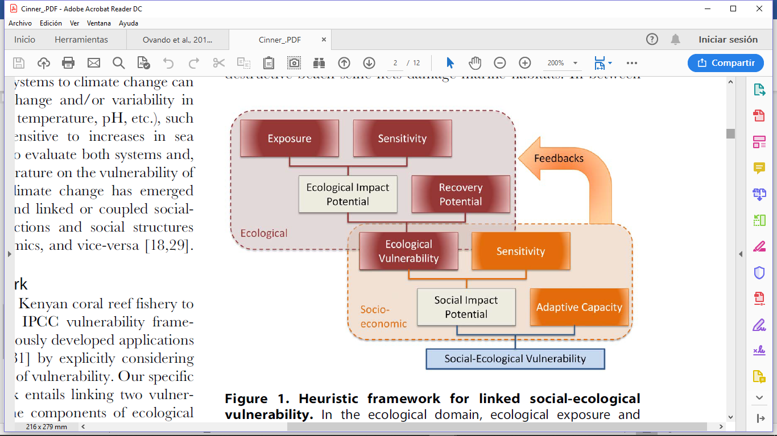

**Figure 1.** Graphical representation of the framework of linked social-ecological vulnerability developed by Cinner et al., 2013.