For this scenario, the best practice I would implement is create the YOLO Microsservice that will consume the WTF service. But for controlling the request and handle any incidence with the WTF service, I will create a WTF Breaker, which has the responsibility of validate the availability of the WTF.

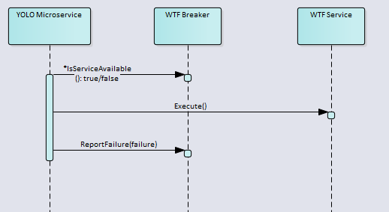

If the service is available, the YOLO Microservice can do the call to WTF Service. Also, if the WTF run in failures, the YOLO Microservice will report that failure to the WTF Breaker.

This pattern is known as Circuit Breaker Pattern, which has a component that act as a switch when exists another component that is likely to fail or be unavailable.

Also this breaker acts as a monitor of the service.