This document’s purpose is to provide instructions on how to deploy an Office 365 lab in Azure IaaS by leveraging Azure Resource Manager templates and PowerShell Desired State Configuration. Additionally, this document will provide a high level explanation on how the deployment works. This document does not go into detail on how to obtain a test tenant or a web certificate. Nor does it provide instruction on how to modify the template file or DSC Resource.

**Lab Deployment Overview**

The lab deployment is made up of two components, a Resource Manager template and a collection of PowerShell Desired State Configuration (DSC) scripts and resources. The template (in JSON format) declaratively defines the lab’s infrastructure. DSC declaratively defines the software and services deployed on the VM. In summary the template file configures everything outside of the VM and DSC configures everything inside the VM. The DSC configuration scripts and resources are stored in a GitHub repository and are downloaded by the VM during provisioning. The Resource Manager template is also stored in GitHub. However, the template file can be stored locally and modified if need be.

The deployment consists of the following servers which are all running Windows Server 2012 R2:

* 1 Domain controller with ADCS
* 1 Exchange 2013 server
* 1 ADFS server
* 1 WAP server
* 1 SQL 2012 server. This is not used but was added as a “better to have it and not need it”
* 1 server that will be used to run AADConnect. This is not domain joined but simply deployed to the lab environment.

**Caveats**

1. The same password must be used for everything, to include the .PFX file.
2. AADConnect must be installed manually.
3. The SSL certificate must be able to be downloaded from a public URL which allows anonymous access
4. The external DNS server IP used on the virtual network will need to be removed after the lab deployment is successful. If it is not remove Exchange will not be able to send mail. The only DNS server configured on the subnet should be the lab’s domain controller.

**Parameters**

* adminUsername
  + Specifies the admin username that will be used on all VMs
* adminPassword
  + Specifies the password that is used for everything i.e. PFX, ADFS service account
* vNetName
  + Specifies the name of the virtual network used in the lab
* DC1virtualMachineName
  + Specifies the name of the first domain controller
* assetLocation
  + Specifies the URL of the GitHub repository where the DSC configurations and resources are downloaded from. For this lab the URL will always be: <https://raw.githubusercontent.com/jcwalker/DscExtensions/master/>
* domainName
  + Specifies the FQDN of the lab’s domain
* ExchangeOrganizationName
  + Specifies the Exchange Organization name. This will be the domain short name. Example if the domain name is contoso.com the Exchange Organization Name will be contoso
* Exchange1Name
  + Specifies the name of the first Exchange server
* Exchange1PublicIPAddressDnsName
  + Specifies the Public DNS name of the Exchange external endpoint.
* CertPath
  + Specifies the local path the SSL certificate will be downloaded to.
* CertUri
  + Specifies the URI the SSL certificate will be downloaded from. I have my cert on my OneDrive. However, I had to use Fiddler to get the proper URL. The link provided in the web interface will not work.
* ExchangeCertThumbprint
  + Specifies the certificate thumbprint for SSL certificate
* ExchangeExternalUrl
  + Specifies the ExternalUrl configured in Exchange
* ExchangeInternalUrl
  + Specifies the InternalUrl configured in Exchange
* ExchangeAutoDDnsName
  + Specifies the Autodiscover DNS name
* SQL1Name
  + Specifies the name of the first SQL box
* Adfs1Name
  + Specifies the name of the first ADFS server
* AdfsFederationServiceName
  + Specifies the display DNS name of the federation service.
* AdfsFederationServiceDisplayName
  + Specifies the display name of the federation fervice. The name that you specify is the organization for which the Federation Service issues tokens.
* AdfsServiceAccountName
  + Specifies the name of the Active Directory account which the ADFS service runs under.
* Wap1Name
  + Specifies the name of the first WAP server
* Dirsync1Name
  + Specifies the name of the first Directory Sync server
* Wap1publicIPAddressNameDnsName
  + Specifies the Public DNS name of the external ADFS proxy endpoint.

**Step by Step Instructions**

1. Install the latest [Azure PowerShell module](https://www.microsoft.com/web/handlers/webpi.ashx/getinstaller/WindowsAzurePowershellGet.3f.3f.3fnew.appids)
2. Launch PowerShell and login to your Azure account (a summary of your account is returned)
   1. 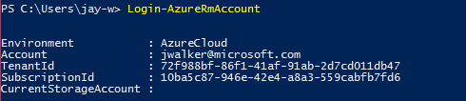
   2. If you have more than one Azure subscription, ensure the subscription you want to use for the deployment is being used in the current context. If not, you can set it to the desired subscription with **Set-AzureRmContext -SubscriptionID** <YourSubscriptionID>
3. Create a resource group that will contain your lab. If you already have a resource group created this step can be skipped.
   1. 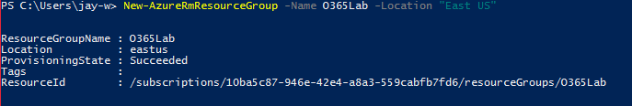
4. Create a new deployment
   1. 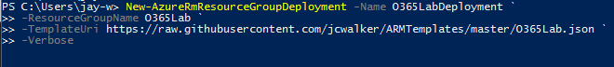
   2. After the New-AzureRmResourceGroupDeployment cmdlet is invoked you will be asked for the argument for each parameter.
      1. 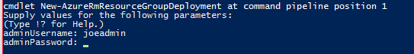
      2. Once the all parameters are specified you will be able to see the progress of the deployment from the verbose output in the PowerShell console or you can watch the progress in the Azure portal
      3. The deployment will report as failed in the PowerShell console but this because extended time it takes to provision an Exchange server. The deployment still continues after it is reported as failed in the console. This can be verified by reviewing “C:\ExchangeSetupLog\ExchangeSetup.log” or the DSC extension logs.
5. Monitoring Progress
   1. To monitor the progress of the deployment in the portal go to Resource groups – Deployments. The resources that are finished will have a green check. The resources in progress will have a blue dot with two arrows representing a circle.
      1. 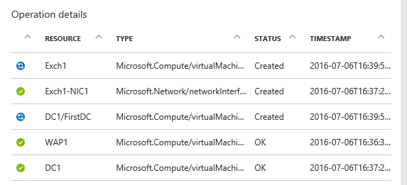
   2. To monitor the progress of the DSC extension per VM use the Get-AzureRmVmDSCExtensionStatus cmdlet
      1. 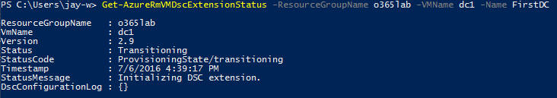
      2. The above example shows the DSC extension is still being initialized/installed. When the DSC configuration is in progress the DscConfigurationLog property will be populated.
      3. 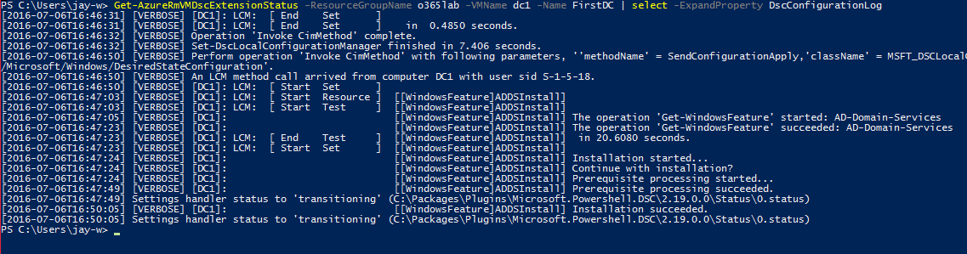

**Post Deployment Tasks**

1. Install and configure AADConnect
2. Remove Public DNS server from virtual network and reboot lab
3. Add lab domain to tenant
4. Federate lab with tenant
5. Create a CNAME in your external DNS to point to ExchangePublicDnsName
6. Create CNAME in your external DNS to point to WapPublicDnsName

**Troubleshooting**

You can verify your parameters are correct in:

***"C:\Packages\Plugins\Microsoft.Powershell.DSC\2.19.0.0\RuntimeSettings\0.settings"***

To view the DSC deployment review the DSC extension logs located in:

***“C:\WindowsAzure\Logs\Plugins\Microsoft.Powershell.DSC\<Version of DSC extension>”***