Supporting Information

Chaoyun Tang,¹⁺ Dipankar Saha,²⁺ Jiacheng Wang,¹ Arvind Chandrasekar,³ Negar Sabouhanian,⁴ Connor L. Witt,² Yulei Wang,¹ Aicheng Chen,⁴ Wei Fan,¹ Chung-Li Dong, ³ Zhu Chen,¹ James J. Watkins,^{2*} and Nianqiang Wu^{1*}

¹ Department of Chemical Engineering, University of Massachusetts, Amherst, MA 01002, United States
²Conte Center for Polymer Research, Department of Polymer Science and Engineering, University of Massachusetts, Amherst, MA 01002, United States
³Department of Physics, Tamkang University, New Taipei City, Taiwan
⁴Department of Chemistry, University of Guelph, Guelph, Canada

*Corresponding author’s email:
nianqiangwu@umass.edu and watkins@umass.edu

+ Equal Contribution

Figure S1. Scheme illustration of thermal pyrolysis instruments and processes.

Figure S2. HAADF-EDX elemental mapping indicates a homogeneous distribution of Mo, carbon, nitrogen, and oxygen atoms throughout the sample. The scale bar for all images is 2 nm.

Figure S3. Scheme illustration of brush polymer template adopted in experiments.

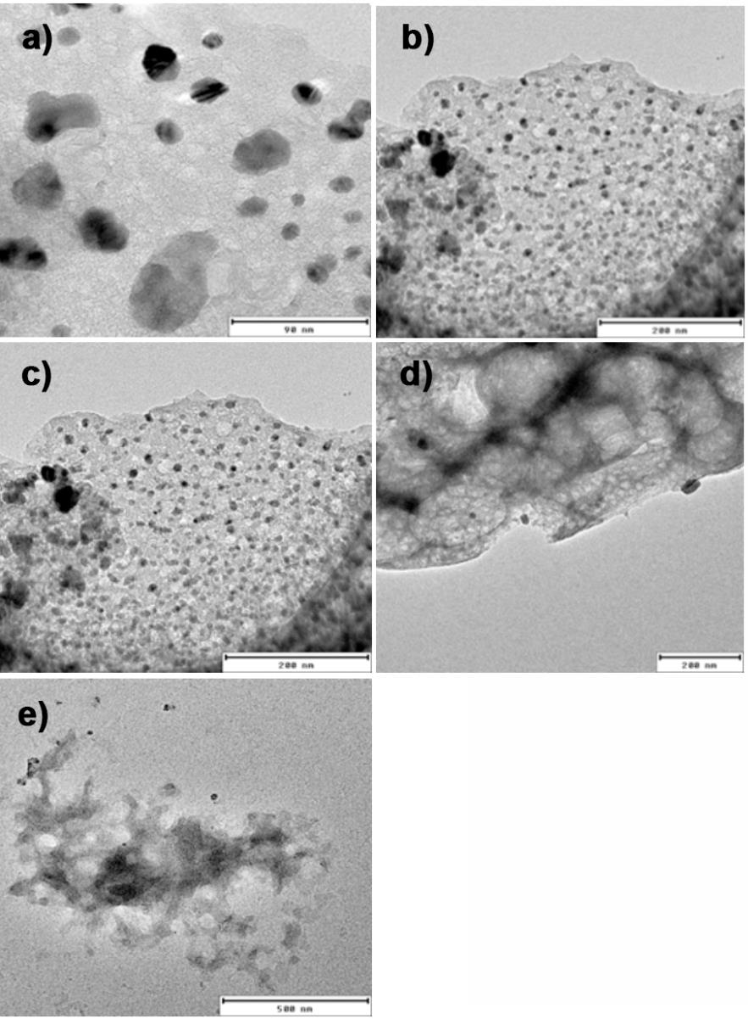
Figure S4. TEM images of as-synthesized samples derived from BBCP with estimated diameters of ) 8 nm, b) 15 nm, c) 21 nm, d) 33 nm, and e) 56 nm.
Figure S5. Statistics pore size distribution of as-synthesized samples derived from BBCP with estimated diameters of a) 8 nm, b) 15 nm, c) 21 nm, d) 33 nm, and e) 56 nm, respectively.
Figure S6. BET absorption/desorption curve of as-synthesized samples with pore size of a) 8 nm, b) 15 nm, c) 21 nm, d) 33 nm, and e) 56 nm.

Figure S7. XRD pattern of as-synthesized Mo/N-C material.

Figure S8. XPS spectra of Mo nanostructure: (a) Mo 3d, (b) O 1s, and (c) N 1s high-resolution spectra showing binding energy peaks for Mo, oxygen, and nitrogen species.
Figure S9. FT EXAFS spectra of 4 and 1 wt. % Mo/C-N, Mo metal powder, MoO₂, MoO₃ and Mo₂C.

Figure S10. Fitting of FT EXAFS spectra of 1 wt. % Mo/C-N.

Sample | Shell Position | N | σ² (Å⁻²) | ∆E₀ (eV) | R (Å) | R-Factor
4 wt. % Mo/C-N | Mo-N | 1.946 | 0.00211 | -7.766 | 1.74896 | 0.0107124
 | Mo-C | 3.892 | 0.00872 | -7.766 | 1.99927
 | Mo-Mo | 5.838 | 0.00991 | -7.766 | 2.97093
1 wt. % Mo/C-N | Mo-N | 1.542 | 0.00062 | -8.019 | 1.75026 | 0.0252494
 | Mo-C | 3.084 | 0.00891 | -8.019 | 1.99616
 | Mo-Mo | 4.626 | 0.00160 | -8.019 | 2.97196
Table S1. Fitting parameters of the Fourier-transformed EXAFS spectrum of Mo.

Figure S11. XPS spectra of as-synthesized 4 wt. % Mo/C-N-21 nanostructure: a) survey spectra and b) high resolution XPS spectra of C 1s.

Figure S12. Linear sweep voltammetry curves of typical 4 wt. % Mo/C-N-21 nanostructure catalyst record in H-type cells in different electrolyte: a) 0.1 M HCl, b) 0.1 M Na₂SO₄ and c) 0.1 M KOH.

Figure S13. Schematic illustration of the gastight electrochemical eNRR system.

Figure S14. Using colorimetric method for detection and quantification of NH₃ in 0.1 M KOH electrolyte after eNRR. a) The UV-Vis absorption spectrum of ${NH}_{4}^{+}$ with different concentrations using indophenol blue method, the characteristic peaks centered at 655 nm correspond to signals of ${NH}_{4}^{+}$. b) The standard curve showing the correlation of ${NH}_{4}^{+}$ concentration with the absorbance peak centered at 655 nm. The error bars represent the standard deviation of over 3 times independent calibrations. c) The UV-Vis absorption spectrum of ${NH}_{4}^{+}$ with different concentrations using Nessler’s reagent method, the characteristic peaks centered at 422 nm correspond to signals of ${NH}_{4}^{+}$. d) The standard curve showing the correlation of ${NH}_{4}^{+}$ concentration with the absorbance peak centered at 422 nm. The error bars represent the standard deviation of over 3 times independent calibrations.
Figure S15. Operando FTIR spectra of 4 wt. % Mo/C-N-21 under N₂ purge at -0.2 V.

Figure S16. a) UV-Vis absorption spectra and b) corresponding calibration curve for the colorimetric N₂H₄ assay in 0.1 M KOH electrolyte.

Figure S17. A comparison of eNRR performance of Reference samples (4 wt. % Mo/C-N-21, loading: 2 mg∙cm⁻²) in different condition: (R) with a potential of -0.2 V vs RHE and N₂ supply. (C1) with a potential of -0.2 V vs RHE and Ar supply. (C2) using blank GDE with a potential of -0.2 V vs RHE and N₂ supply. (C3) with a open circle potential and N₂ supply.

Figure S18. Quantifying the ammonia production of 4 wt. % Mo/C-N-21 operated in a flow cell for 10 hours by NMR with ¹⁵N labelling.

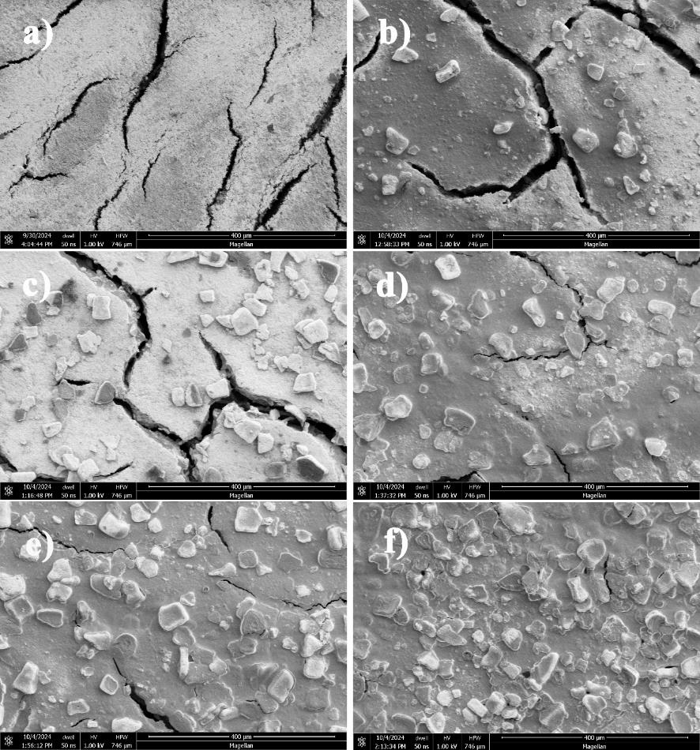
Figure S19. SEM images of as-fabricated GDE with different catalyst loading: a) Blank GDL, b) 0.5 mg∙cm⁻², c) 1 mg∙cm⁻², d) 1.5 mg∙cm⁻², e) 2 mg∙cm⁻², f) 2.5 mg∙cm⁻².

Figure S20. Faradaic efficiencies and NH₃ yield rate of 4 wt. % Mo-PNC-21 in GDE with different catalyst loading.

Figure S21. a) Digital photos of the contact angle of as-fabricated GDE with a catalyst loading of 2 mg∙cm⁻² and with different PTFE loading. b) Summary of applied PTFE loading vs. detected contact angles.

Figure S22. Faradaic efficiencies and NH₃ yield rate of 4 wt. % Mo-PNC-21 in GDE with different PTFE amount.

Figure S23. Nyquist plots of 4 wt. % Mo/N-C-21 recorded in N₂ condition with different applied potentials.

Table S2. Calculated resistance values based on equivalent circle.
Sample | Average Pore Size (nm) | R_{s} (Ω) | R_{ct}/R_{p}(Ω) | R_{ct} (Ω)
4 wt. % Mo-PNC-8 | 8 | 1.8 | 52.2 | 21.8
4 wt. % Mo-PNC-15 | 15 | 1.8 | 52.6 | 22.4
4 wt. % Mo-PNC-21 | 21 | 1.8 | 53.2 | 23.0
4 wt. % Mo-PNC-33 | 33 | 1.8 | 52.8 | 27.6
4 wt. % Mo-PNC-56 | 56 | 1.8 | 52.4 | 30.6

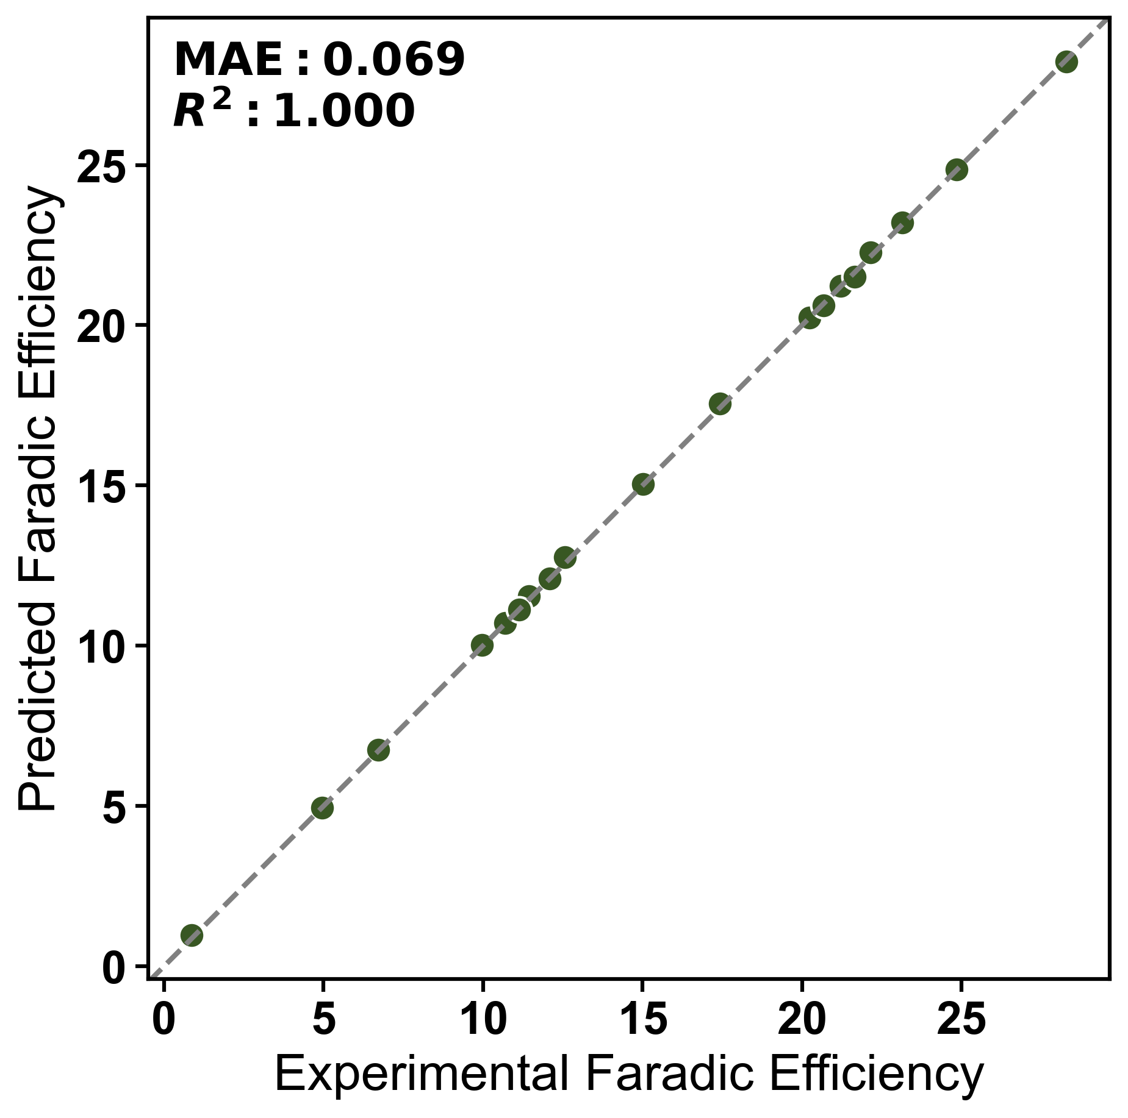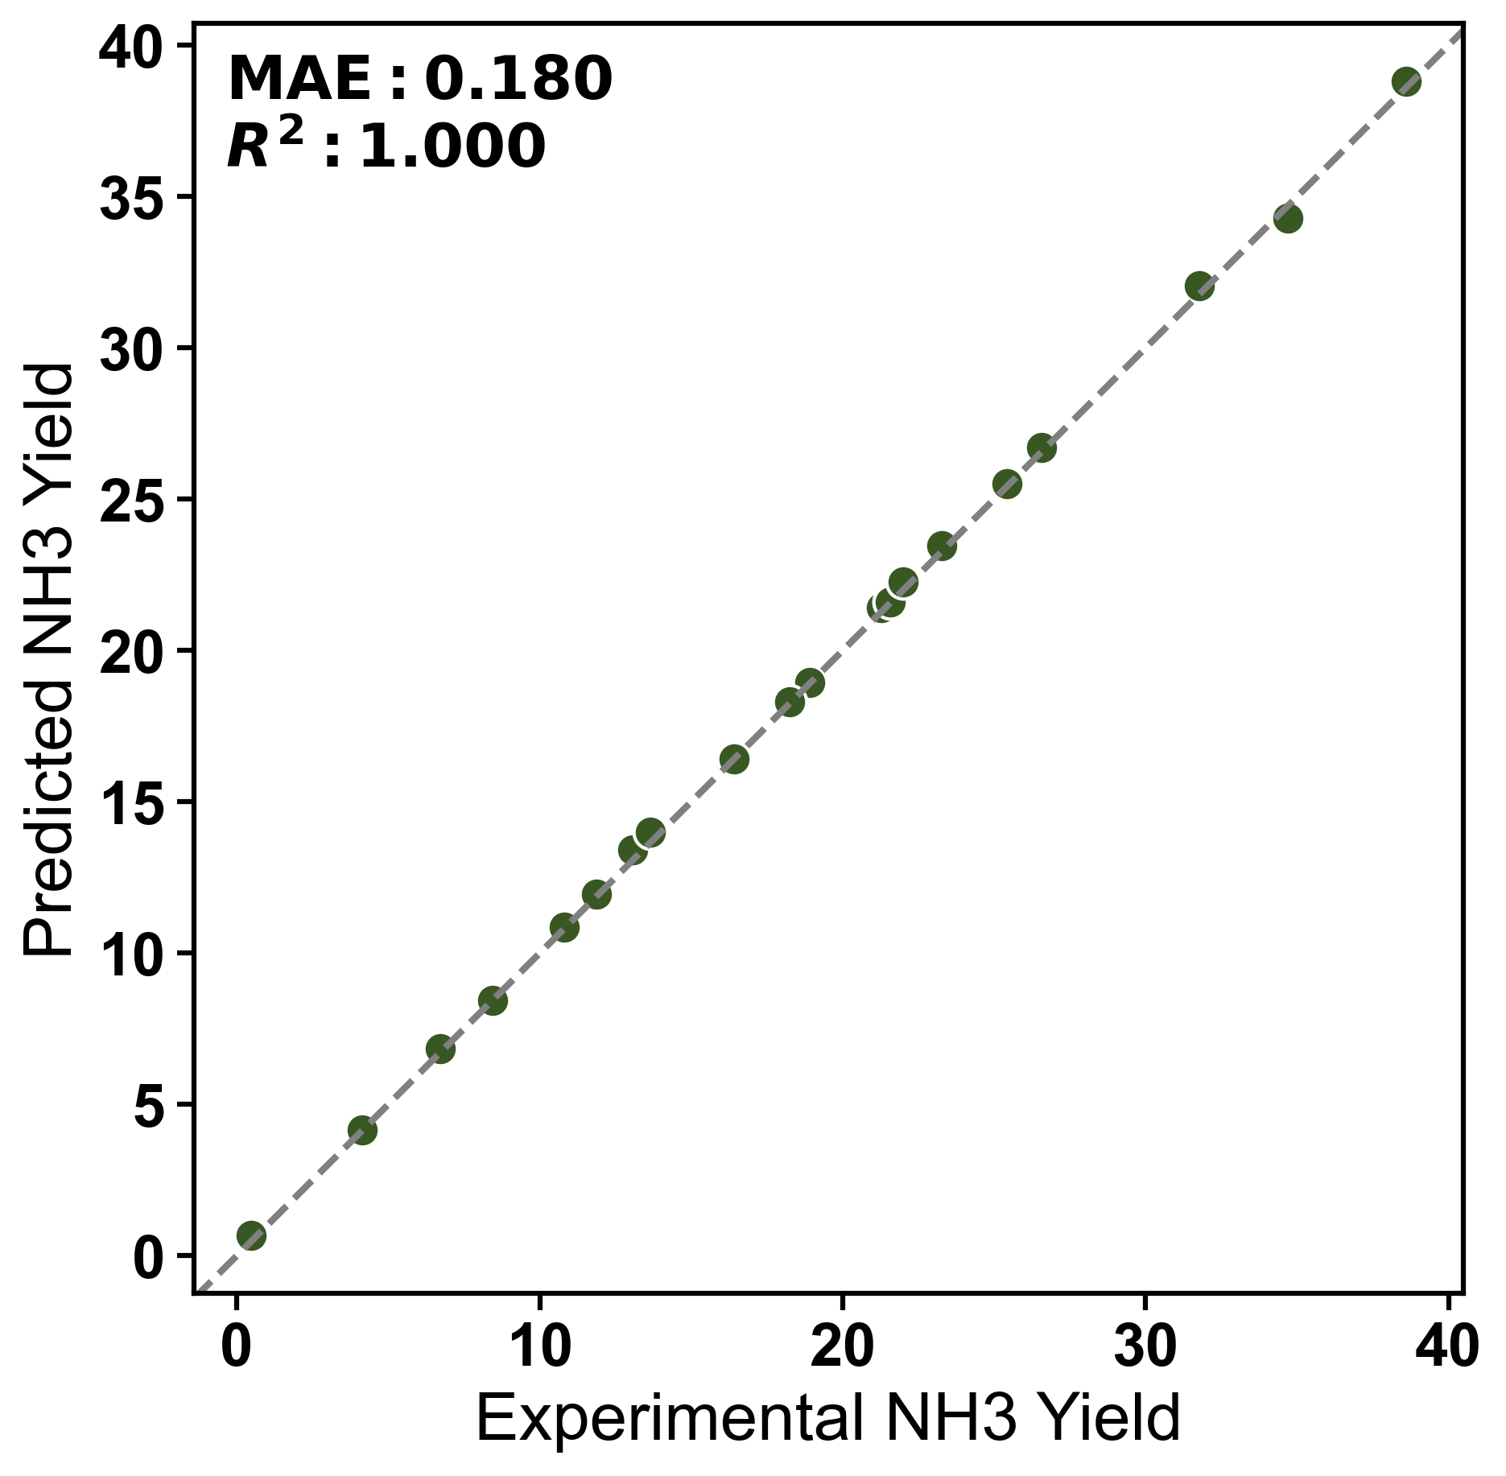
a)
b)
Figure S24. Comparison of experimental values with full-data, in-sample XGBoost fitted values for (a) Faradaic efficiency and (b) NH₃ yield. All 23 observations shown were also used to fit the models; no held-out test set or cross-validation was used. Accordingly, the displayed agreement indicates training-set goodness of fit rather than independently validated predictive performance.
Machine-learning dataset, fitting procedure, and limitations
The complete machine-learning dataset contains 23 experimental records for each target (Table S3). The four inputs are average pore size, PTFE amount, catalyst loading, and Mo content; the targets are Faradaic efficiency and NH₃ yield. The records comprise four one-variable-at-a-time experimental series in which the remaining inputs were held at their nominal baseline values, including repeated measurements at the shared baseline condition.
Two separate XGBoost regressors were fitted, one for each target, using all 23 records. The fixed settings specified in the original analysis were n_estimators = 300, learning_rate = 0.05, max_depth = 6, subsample = 0.8, colsample_bytree = 0.8, and random_state = 42. No hyperparameter optimization or model-selection search was performed. There was no train/test split, k-fold cross-validation, repeated cross-validation, or independent test set; thus, folds and repeats are not applicable, and no additional split seed was used.
R², RMSE, and MAE were calculated from the same full-data predictions used in Figure S24. SHAP values were also calculated on these fitted models for all 23 records. Consequently, the metrics in Table S4 quantify only in-sample goodness of fit, and the SHAP values describe only how the fitted models distribute their predictions over this dataset. Neither analysis provides an independent estimate of generalization or a causal attribution.
Table S3. Complete dataset used for the XGBoost and SHAP analyses.
Data point | Average pore size (nm) | PTFE amount (wt.%) | Catalyst loading (mg cm⁻²) | Mo content (wt.%) | Faradaic efficiency (%) | NH₃ yield (µg h⁻¹ mg⁻¹)
1 | 8 | 7.5 | 2 | 4 | 20.22979 | 21.27624
2 | 15 | 7.5 | 2 | 4 | 17.45711 | 21.559
3 | 21 | 7.5 | 2 | 4 | 21.63927 | 34.68411
4 | 33 | 7.5 | 2 | 4 | 20.66318 | 25.41836
5 | 56 | 7.5 | 2 | 4 | 12.57262 | 13.05852
6 | 21 | 0 | 2 | 4 | 28.27996 | 13.6622
7 | 21 | 2.5 | 2 | 4 | 24.83426 | 16.42642
8 | 21 | 5 | 2 | 4 | 22.15237 | 23.26789
9 | 21 | 7.5 | 2 | 4 | 21.63935 | 34.68414
10 | 21 | 10 | 2 | 4 | 17.41437 | 38.58862
11 | 21 | 7.5 | 0.5 | 4 | 12.0827 | 18.91729
12 | 21 | 7.5 | 1 | 4 | 11.43864 | 18.25319
13 | 21 | 7.5 | 1.5 | 4 | 15.01465 | 22.00271
14 | 21 | 7.5 | 2 | 4 | 21.63909 | 34.68311
15 | 21 | 7.5 | 2.5 | 4 | 23.14743 | 31.76796
16 | 21 | 7.5 | 2 | 0 | 0.86628 | 0.48454
17 | 21 | 7.5 | 2 | 1 | 4.95546 | 4.15184
18 | 21 | 7.5 | 2 | 2 | 6.71713 | 10.81645
19 | 21 | 7.5 | 2 | 3 | 21.20149 | 26.55848
20 | 21 | 7.5 | 2 | 4 | 21.63936 | 34.69575
21 | 21 | 7.5 | 2 | 5 | 9.95775 | 11.88143
22 | 21 | 7.5 | 2 | 6 | 10.6932 | 8.44064
23 | 21 | 7.5 | 2 | 7 | 11.13613 | 6.70618
Note: Data points 3, 9, 14, and 20 are separate experimental measurements at the same nominal inputs (21 nm average pore size, 7.5 wt.% PTFE, 2.0 mg cm⁻² catalyst loading, and 4 wt.% Mo) and were retained as individual records.
Table S4. Full-data, in-sample model-fit metrics for the two targets.
Target | n | Evaluation set | R² | RMSE | MAE
Faradaic efficiency (%) | 23 | Full-data training fit | 1.000 | ≈0.090 | 0.069
NH₃ yield (µg h⁻¹ mg⁻¹) | 23 | Full-data training fit | 1.000 | ≈0.235 | 0.180
The R² and MAE values are those reported for the original fitted-versus-measured comparison; RMSE values were calculated for the same original full-data fitted points and are reported to an appropriate approximate precision. These statistics were calculated on the training data and must not be interpreted as test-set or cross-validation performance.
Limitations. The small sample size (n = 23), four-variable descriptor space, repeated baseline measurements, and one-variable-at-a-time sampling design restrict the combinations represented in the data. In addition, evaluation on the same records used for fitting can produce an optimistic impression of model performance, particularly for a flexible tree-based model. The SHAP rankings may change if the variable ranges, sampling density, or omitted experimental factors change. The present XGBoost and SHAP results should therefore be interpreted as dataset-specific trend identification, not as validated prediction, causal evidence, or universal design principles. Larger, independently sampled datasets and external validation will be required to establish robustness and generality.

Figure S25. I-t curve obtained by 4 wt. % Mo/C-N-21 in optimized GDE condition for 10 hours eNRR experiment at -0.2 V vs. RHE.

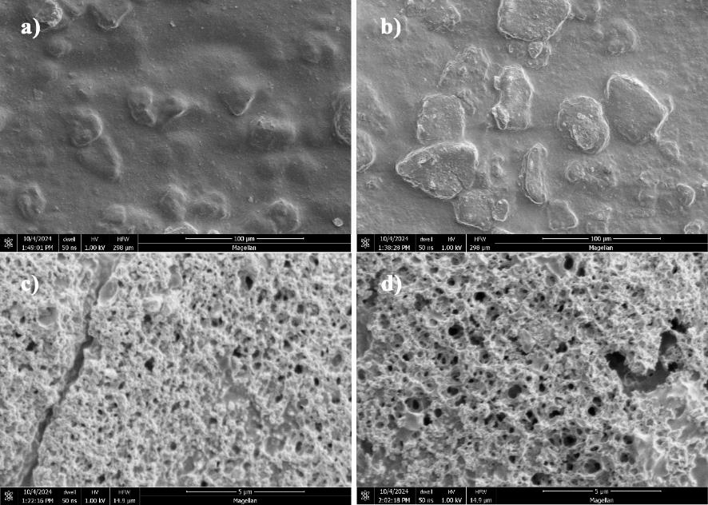
Figure S26. SEM images of 4 wt. % Mo/C-N-21 in optimized GDE condition before (a,c) and after (b,d) 10 hours eNRR at -0.2 V vs. RHE.

Figure S27. XPS analysis of 4 wt. % Mo/C-N-21 in optimized GDE condition after 10 hours eNRR at -0.2 V vs. RHE.

Table S5. Summary of prior studies on electrochemical NH₃ synthesis.
Catalysts | Electrolyte | Potential  (vs. RHE) | NH₃ Yield Rate (μg∙h⁻¹∙mg⁻¹) | FE [%] | References
Mo-PNC | 0.1 M KOH | -0.2 V | 34.7 | 21.6 | This work
VN NPs | 0.05 M H₂SO₄ | -0.1 V | 20.2 | 6 | J. Am. Chem. Soc. 2018, 140, 13387.
Cr₂O₃ | 0.1 M Na₂SO₄ | -0.9 V | 3.04 | 6.78 | ACS Catal. 2018, 8, 8540.
C@CoS@TiO₂ | 0.1 M Na₂SO₄ | -0.55 V | 49.51 | 28.6 | Angew. Chem., Int. Ed. 2019, 58, 18903.
GDY/Co₂N | 0.1 M HCl | -0.2 V | 219.72 | 58.6 | Angew. Chem., Int. Ed. 2020, 59, 13021.
Fe–Ni LDH | 0.1 M Na₂SO₄ | -0.5 V | 10.53 | 23 | Angew. Chem., Int. Ed. 2020, 59, 13623.
Cu/PI-300 | 0.1 M KOH | -0.3 V | 12.4 | 6.56 | Nat. Commun. 2019, 10, 4380.
Cu-TiO₂/CP | 0.5 M LiClO₄ | -0.55 V | 21.31 | 21.99 | Adv. Mater. 2020, 32, 2000299.
Nb₂O₅ nanofiber | 0.1 M HCl | -0.55 V | 43.6 | 9.26 | Nano Energy 2018, 52, 264.
2D W₂N₃ | 0.1 M KOH | -0.2 V | 11.66 | 11.67 | Adv. Mater. 2019, 31, 1902709.
PC/Sb/SbPO₄ | 0.1 M HCl | -0.25 V | 25 | 31 | Angew. Chem., Int. Ed. 2019, 58, 13329.
Sc/NC | 0.1 M HCl | -0.1 V | 20.4 | 11.2 | ACS Nano 2020, 14, 1093.
Y/NC | 0.1 M HCl | -0.1 V | 23.2 | 12.1 | ACS Nano 2020, 14, 1093.
Re₂MnS₆ | 0.1 M Na2SO4 | -0.3 V | 15 | 14 | Nano Lett. 2020, 20, 4960.
Fe-ReS₂ | 0.1 M Na₂SO₄ | -0.2 V | 80.4 | 12.3 | Adv. Funct. Mater. 2020, 30, 1907376.
THH Au NRs | 0.1 M KOH | -0.2 | 1.648 | 4.02 | Adv. Mater. 2017, 29, 1604799.
Vr-ReSe₂@CBC | 0.1 M Na₂SO₄ | -0.25 | 28.3 | 42.5 | Angew. Chem., Int. Ed. 2020, 59, 13320.
Ru SAs/N-C | 0.05 M H₂SO₄ | -0.2 | 120.9 | 29.6 | Adv. Mater. 2018, 30, 1803498.
Ru@ZrO₂/NC | 0.1 M HCl | -0.11 | 3600 | 21 | Chem 2019, 5, 204.
Ru SAs/g-C₃N₄ | 0.05 M NaOH | 0.05 | 23 | 8.3 | Adv. Funct. Mater. 2020, 30, 1905665.
Pd/C | 0.05 M H₂SO₄ | 0.1 | 4.5 | 8.2 | Nat. Commun. 2018, 9, 1795.
PdH_{0.43} | 0.1 M PBS | -0.15 | 20.4 | 43.6 | Angew. Chem., Int. Ed. 2020, 59, 3511.
PdPb nanosponges | 0.1 M HCl | 0.05 | 25.68 | 5.79 | Appl. Catal., B 2020, 265, 118481
Pd_{0.2}Cu_{0.8}/rGO | 0.1 M KOH | -0.2 | 2.8 | 0.6 | Adv. Energy Mater. 2018, 8, 1800124.
PdCu/NC | 0.05 M H₂SO₄ | -0.45 | 69.2 | 24.8 | Angew. Chem., Int. Ed. 2020, 133, 349.
NPG@ZIF-8 | 0.1 M Na₂SO₄ | -0.8 | 28.7 | 44 | Angew. Chem., Int. Ed. 2019, 58, 15362.
AuHNCs | 0.5 M LiClO₄ | -0.4 | 3.9 | 30.2 | Nano Energy 2018, 49, 316.
Au/TiO₂ | 0.1 M HCl | -0.2 | 21.4 | 8.11 | Adv. Mater. 2017, 29, 1606550.
α-Au/CeOx-RGO | 0.1 M HCl | -0.2 | 8.3 | 10.1 | Adv. Mater. 2017, 29, 1700001.
Au₆/Ni | 0.05 M H₂SO₄ | -0.14 | 7.4 | 67.8 | J. Am. Chem. Soc. 2019, 141, 14976.
Au/CoOx | 0.05 M H₂SO₄ | -0.5 | 15.1 | 19 | Angew. Chem., Int. Ed. 2019, 58, 18604.
ISAS-Fe/NC | 0.1 M PBS | -0.4 | 62.9 | 18.6 | Nano Energy 2019, 61, 420.
Fe SA-N-C | 0.1 M KOH | 0 | 7.48 | 56.55 | Nat. Commun. 2019, 10, 341.
Fe-N/C | 0.1 M KOH | -0.2 | 34.83 | 9.28 | ACS Catal. 2019, 9, 336.
FePc/C | 0.1 M Na₂SO₄ | -0.3 | 137.95 | 10.5 | ACS Catal. 2019, 9, 7311.
Mo₃Fe₃C | 0.1 M Li₂SO₄ | -0.05 | 1.23 | 27 | Nano Energy 2020, 68, 10437.
SA-Mo/NPC | 0.1 M KOH | -0.3 | 34 | 14.6 | Angew. Chem., Int. Ed. 2019, 58, 2321.
Mo0/GDY | 0.1 M HCl | -0.1V | 2 | 15.6 | J. Am. Chem. Soc. 2019, 141, 10677.
MoS₂/CC | 0.1 M Na₂SO₄ | -0.5 | 4.96 | 1.17 | Adv. Mater. 2018, 30, 1800191.
DR MoS₂/CPE | 0.1 M Na₂SO₄ | -0.4 | 29.28 | 8.34 | Adv. Energy Mater. 2018, 8, 1801357.
Co-doped MoS_{2-x} | 0.01 M H₂SO₄ | -0.3 | 10.2 | 10 | J. Am. Chem. Soc. 2019, 141, 19269.
Ti₃C₂T_{x} (TO, OH) | 0.1 M HCl | -0.3 | 36.9 | 9.1 | ACS Energy Lett. 2019, 4, 1053.
MXene/TiFeOx-700 | 0.05 M H₂SO₄ | -0.2 | 21.9 | 25.44 | ACS Nano 2020, 14, 9089.
TiO₂/Ti₃C₂T_{x} | 0.1 M HCl | -0.55 | 32.17 | 16.07 | Adv. Energy Mater. 2019, 9, 1803406.
Zr-TiO2 | 0.1 M KOH | -0.45 | 8.9 | 17.3 | Nat. Commun. 2019, 10, 2877.
Bi NS | 0.1 M Na₂SO₄ | -0.8 | 13.23 | 10.46 | ACS Catal. 2019, 9, 2902.
BiNCs with K+ | 0.5 M K₂SO₄ | -0.6 | 884 | 66 | Nat. Catal. 2019, 2, 448.
PEBCD with Li+ | 0.5 M Li₂SO₄ | -0.7 | 2.01 | 2.85 | J. Am. Chem. Soc. 2017, 139, 9771.
PCN-NVx | 0.1 M Na₂SO₄ | -0.2 | 8.09 | 11.59 | Angew. Chem., Int. Ed. 2018, 57, 10246.
NPC | 0.05 M H₂SO₄ | -0.9 | 23.8 | 1.42 | ACS Catal. 2018, 8, 1186.
C-ZIF | 0.1 M KOH | -0.3 | 57.8 | 10.2 | Nano Energy 2018, 48, 217.
CNS | 0.25 M LiClO₄ | -1.19 | 97.18 | 11.56 | Sci. Adv. 2018, 4, e1700336.
BG | 0.05 M H₂SO₄ | -0.5 | 9.8 | 10.8 | Joule 2018, 2, 1610.
B-BCN | 0.05 M Na₂SO₄ | -0.6 | 8.39 | 9.87 | Appl. Catal., B 2021, 283, 119622.
BNS | 0.1 M Na₂SO₄ | -0.8 | 13.22 | 4.04 | ACS Catal. 2019, 9, 4609.
FL-BP NSs | 0.01 M HCl | -0.7 | 31.37 | 5.07 | Angew. Chem., Int. Ed. 2019, 58, 2612.

Figure S28. (a) Plots of Faradaic efficiencies and NH₃ yield rates summarized in Table S5 and recent reports of flow cells.

Figure S29. (a) Current density and Faradaic efficiencies of flow cell with 4 wt. % Mo/N-C-21 GDE under DC voltage. (b) V-I curve and calculated power density, in which scatter line represents the actually power density for ammonia production.

