Jack Cwynar

Lab 2 Testing/Simulation Screenshots

Starting Sim



Unsigned Add Tests (normal, overflow)

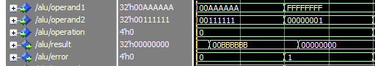

Unsigned Sub Tests (normal, underflow)

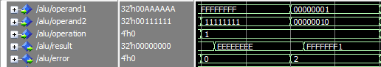

2’s Complement Add (normal, overflow, underflow)

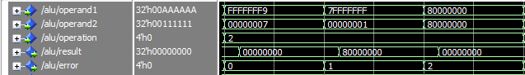

2’s Complement Subtract (normal, overflow, underflow)

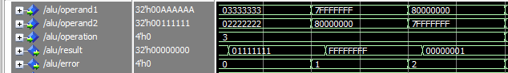

2’s Complement Multiply (normal, overflow, underflow)

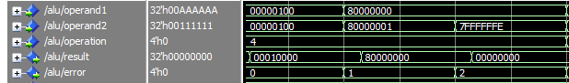

2’s Complement Divide (normal, underflow, divide by zero)

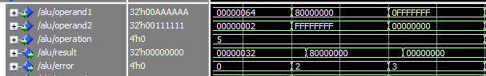

Logical AND (1 AND 1, 0 AND 1, 0 AND 0)

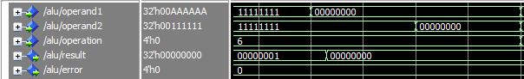

Bitwise AND

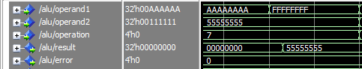

Logical OR (1 OR 1, 0 OR 1)

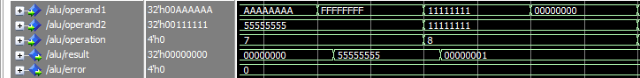

Bitwise OR

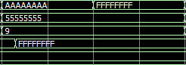

Logical NOT of operand1

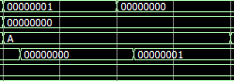

Bitwise NOT of operand1

