CE / CS / SE 3354 · SOFTWARE ENGINEERING · FALL 2026
Project Deliverable P1
Proposal and Requirements — Team Template
Weight 4% · Due Sunday 18 October 2026, 11:59 PM Central · Submit one PDF per team on Canvas
Field | Your entry
Project title | Game Review Aggregator
Team number and section | Team 03, Section 010
Team members (name · net ID) | Terrell Johnson · tkj230000  Mary Demas · dal919457  Umar Shaikh · uas230000  Rohith Rajan · rxr230118  Ethan Nguyen · ekn210003  Chayeol Jung · jcy1205
Repository URL | https://github.com/AgentRachel/game-review-aggregator
Document version | 0.1
Date | 10/17/2026

0 Revision History and Contribution Record
Both tables below are graded. The contribution record carries the individual 20% of this milestone and must be consistent with your repository history.
Version | Date | Author | Summary of change
0.1 | 10/18/2026 | Terrell Johnson, Mary Demas, Umar Shaikh, Rohith Rajan, Ethan Nguyen, Chayeol Jung | Initial baseline for P1

0.1 Individual contribution record
Team member | What this person produced for P1 | Evidence in the repository
Terrell Johnson | Use case and context diagrams, Expanded use cases, traceability matrix | Section 3.4-3.5, repository issues: 5, 19-22
Mary Demas | Elicitation, references, stakeholders, users, constraints, functional requirements, quality requirements, and constraints | Elicitation documentation, repository issues: 4, 6 - 8, 14 - 17
Umar Shaikh | Wrote the scope and purpose, definitions, acronyms and abbreviations | Section 1
Rohith Rajan | Open questions | Section 5
Ethan Nguyen | Open questions | Section 5
Chayeol Jung | Risk | Section 4.3

1 Introduction
1.1 Purpose of this document and of the system

The purpose of this document is to online the requirements, goals, and the functions of the Game Review Aggregator system. It is intended for the development team, the stakeholders, and anyone to review or evaluate the system. This document will serve as a reference throughout the development process to ensure it meets the intended requirements.
The Game Review Aggregator is a website that is designed to help gamers research, discover, and compare video games by bringing reviews from several different sources into one place. Currently, games must visit several other websites to compare ratings and opinions, which is time-consuming and confusing as often times reviews conflict with each other. This system aims to solve this problem by allowing users to search for games, filter results based on their preferences, and view ratings and detailed reviews from available sources on one location.

1.2 Scope

In scope — we will build this | Out of scope — we will not, and why
A website where users can search for video games and view their information | A game purchasing or payment system, since the website is intended for research rather than selling games.
Display available game reviews, ratings, and their original sources | Integration with every review platform, because API restrictions and development time limitations
Allow users to filter games by selected characteristics, such as genre and platform, when the data is available | Advanced personalized recommendation algorithms, because they require additional development and testing
Allow users to compare games and available ratings from different sources | Automatic detection of fake or biased reviews, because accurately identifying them would require more complex methods
Display review details, including written explanations and publication dates when available | Steam account login and friend-based review prioritization, because their necessity and technical feasibility have not been confirmed

These features were excluded to make the project manageable within the course timeline and allow the development team to focus on the core functionality of the website. More advanced features could be considered in future versions once the basic system is out.

1.3 Definitions, acronyms and abbreviations

Term or abbreviation | Meaning as used in this project
Game Review Aggregator | A website that collects and displays video game reviews and ratings from multiple sources in one location
API (Application Programming Interface) | A way for the website to retrieve game information and reviews from external platforms such as Steam
Aggregate Rating | A combined rating calculated using reviews or scores from multiple sources
Stakeholder | A person or organization that uses, develops, or is affected by the system, such as gamers, developers, or Steam
Review Source | The original platform or website where a game review or rating was published
Filtering | Narrowing game search results based on characteristics such as genre or platform
Steam | A digital gaming platform that may provide game reviews and information through its supported API
UI (User interface) | The visual parts of the website that users interact with, including search bars, filters, and review pages

1.4 References

[R1] Valve Corporation, Steamworks Web API Overview. Steamworks Web API Documentation
[R2] Valve Corporation, Steam User Reviews API. Steam User Reviews API Documentation
[R3] Interview transcript in repository. docs\interviews\Interview_1_Gamer.pdf
[R3] Interview notes in repository. docs\interviews\Interview_2_Gamer.pdf

2 Overall Description
2.1 Product perspective and context

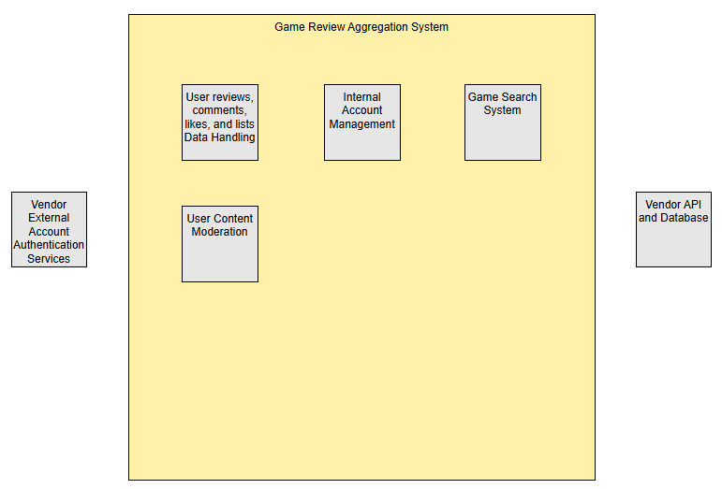
The Game Review Aggregation system is only responsible for the handling of internal data, mainly the data tied to individual user accounts such as reviews, likes, and lists, as well as the account information. If users want to link external accounts from vendors like Steam or Roblox, that functionality wouldn’t fall under our system responsibility since that would require external authentication services. Furthermore, game metadata supplied by databases and APIs from vendors such as Steam would allow us to provide the information we need for our game search system. However, this ultimately means that we are dependent and not responsible for the data we are supplied with. Lastly, account management and user content moderation are within the bounds of our system responsibility since these systems operate strictly on our data and would rely on no third-party providers.

2.2 Stakeholders and how you reached them

Stakeholder | Role in relation to the system | What they need from it | How you learned this
Gamers researching games (represented by interview participants) | Primary users who use the website to research games before deciding what to play or purchase. | Reliable reviews, useful ratings, information about game difficulty and quality, and help deciding whether a game suits their preferences. | Interviews with two gamers (R1 and R2). Their gaming experiences and preferences informed the initial requirements.
Casual and dedicated game reviewers | Users who contribute written reviews and ratings. | An easy way to submit reviews and ratings that other gamers can read. | Initially assumed based on the proposed user-review functionality; needs confirmation through additional elicitation.
Website moderators | Responsible for reviewing reported or inappropriate content, if moderation is included. | Tools to identify and remove reviews that violate the website's rules. | Initially assumed based on the possibility of user-submitted reviews; moderator needs have not yet been directly elicited.
External game and review platforms (e.g., Steam) | Potential providers of game information or existing reviews if external data is incorporated. | Appropriate use of their information and compliance with applicable access restrictions and terms. | Identified during project planning. Specific platform requirements must be researched if external data is used.
Website administrators and development team | Responsible for maintaining the website and its data. | A manageable system that can be maintained, updated, and operated within the team's available resources. | Assumed based on the team's responsibility for developing and maintaining the project.

2.3 User characteristics

Gamers researching games: These users visit the website to learn about games before deciding whether to play or purchase them. They may have different levels of gaming experience and may not be familiar with every game's mechanics, difficulty, or genre. They need clear game information, understandable ratings, and reviews that help them make informed decisions.
Game reviewers: These users submit written reviews and ratings based on their experiences with games. They may have different levels of writing experience and familiarity with review websites. The system should provide a straightforward review submission process with clear instructions and understandable rating options.
Website moderators (if included in the project scope): These users are responsible for managing user-submitted content and ensuring reviews follow the website's rules. They may have varying levels of technical experience, so moderation functions should be clearly labeled and easy to use.

2.4 Constraints

We must comply with the deliverable requirements, submission format, and deadlines specified for SE 3354. We must maintain the project's source code and development history in the team's designated version-control repository. We must comply with the applicable terms of service and technical requirements of any external platform from which we retrieve data. If we use the Steam Web API (R1), we must comply with its applicable access requirements and restrictions. We must not depend on access to private or restricted third-party data unless we have the necessary authorization. We must comply with applicable data usage and attribution requirements for external platforms. We must protect user privacy and comply with applicable privacy requirements if we collect personal information. We must use review sources that provide an accessible and permitted method of obtaining their data. We must use hosting and database services available within our team's budget and resources.

2.5 Assumptions and dependencies

# | Assumption or dependency | What breaks if it does not hold
A1 | Availability of game metadata from official vendors (Dependency) | Wouldn’t be able to use official vendor APIs if they don’t provide public metadata. Would have to use third party databases
A2 | Vendors supporting account linking (Dependency) | Wouldn’t be able to support external account linking if not supported
A3 | Social actions for users, such as creating lists and liking lists from other users (Assumption) | If list features aren’t used for social or game discoverability purposes, then they’d be added for no reason. While interviews haven’t explicitly shown a need for these features, popular review websites such as Letterboxd or MyAnimeList include these features, so we are assuming they’d be useful for our system as well.

2.6 Feasibility summary

Feasibility gate | Verdict | Evidence behind the verdict
Technical | Feasible | Steam documents multiple endpoints such as “IUserReviewsService.GetAppReviews” that would allow us to collect reviews using official steam API. Furthermore, multiple independent third-party database sources (SteamDB, itchDB, and Rolimon’s) that would allow us to gather game metadata for search functionality. Lastly, comparable systems such as Letterboxd are already in production, which shows that our system is technically feasible
Operational | Feasible | Our system would require little to no operation or maintenance after deployment, due to the website and user workflow being small, straightforward, and simple. Furthermore, interviews (R1 and R2) show that there’s a need for this type of system, which suggests that it will be used after deployment
Schedule | A narrow initial version is feasible | Given a little less than two months, it would be more feasible if the team prioritized one supported data source, core search/display functionality, and a simple review/rating system.
Economic / resource | Feasible | The cost of hosting a website is around $2-15/month which is within budget. Database services such as Supabase and MongoDB have free tiers which would satisfy the needs for our simple website.

3 Specific Requirements

3.1 Functional requirements

ID | Requirement — one “shall” sentence | Priority | Source | Acceptance criterion
FR-01 | The system shall allow users to search for games by title. | MUST | Gamer interviews | A tester searches for an existing game and sees matching results.
FR-02 | The system shall display an individual game's information, including its title and available review information. | MUST | Gamer interviews | A tester selects a game and sees its title and available review information.
FR-03 | The system shall display game reviews submitted by users. | MUST | Gamer interviews | A tester opens a game page and can read its submitted reviews.
FR-04 | The system shall allow registered users to submit a review for a game. | MUST | Gamer interviews | A registered tester submits a review, and it appears on the appropriate game page.
FR-05 | The system shall allow users to assign a rating to a game when submitting a review. | MUST | Gamer interviews | A tester submits a review with a rating, and the rating is displayed correctly.
FR-06 | The system shall display an aggregate rating calculated from available game ratings. | SHOULD | Project goal; confirm with team | A tester verifies that the displayed aggregate matches the ratings used in the calculation.
FR-07 | The system shall allow users to sort available reviews by a supported criterion. | COULD | Proposed feature; confirm with team | A tester selects a sorting option and sees reviews in the selected order.
FR-08 | The system shall allow designated moderators to remove reviews that violate the review rules. | SHOULD | Proposed moderator stakeholder; confirm with team | A moderator removes a review, and it no longer appears among published reviews.
FR-09 | The system shall allow users to report and flag content | SHOULD | Proposed moderator stakeholder | A tester verifies that there are options to report user content such as reviews, comments, and lists. After reporting, flagged content should be visible for moderators

3.2 Quality requirements
ID | Requirement — threshold, condition, and measurement | Priority | Source | How it will be verified
QR-01 | Under normal test conditions with up to 20 simultaneous users, at least 95% of game searches shall return results within 3 seconds, measured through 100 test searches. | SHOULD | Proposed performance target | Run 100 searches and record their response times.
QR-02 | The system shall display its main pages correctly at viewport widths of 360 pixels and 1366 pixels, verified by testing each page at both widths. | MUST | Proposed usability requirement | Open each main page at both viewport widths and check for clipped or overlapping content.
QR-03 | The system shall prevent users who are not authorized moderators from accessing moderator-only actions in 100% of the tested unauthorized-access attempts. | MUST | Proposed security requirement | Attempt moderator actions using an ordinary user account and an unauthenticated session.
QR-04 | For a test set of 20 valid reviews, the system shall display all 20 reviews correctly after they are submitted and the relevant page is reloaded. | MUST | Proposed reliability requirement | Submit 20 reviews, reload the relevant page, and confirm that all reviews remain available.

3.3 Constraint requirements
ID | Constraint — one sentence | Source | Why it cannot be negotiated
CON-01 | The system shall comply with the applicable terms and access restrictions of any external platform from which it retrieves game or review data. | Official documentation and terms of each platform used, such as Steamworks documentation [R1] | The team cannot disregard the restrictions imposed by external data providers.
CON-02 | The system shall not access private or restricted third-party game or review data without the authorization required by the data provider. | Official documentation and access policies of each platform used [R1] | The team cannot assume permission to access restricted data.

3.4 Initial use cases
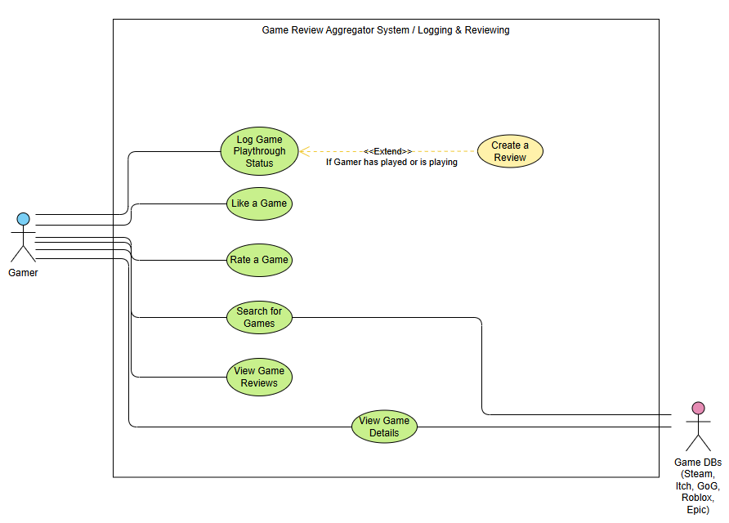
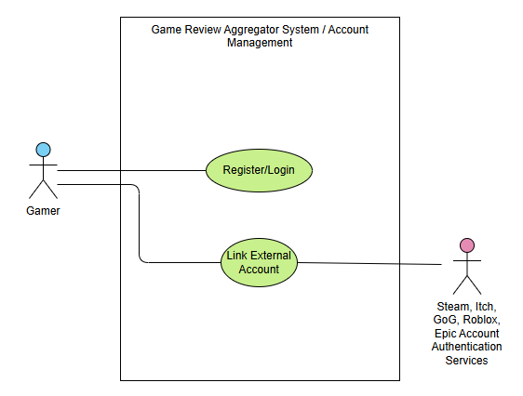
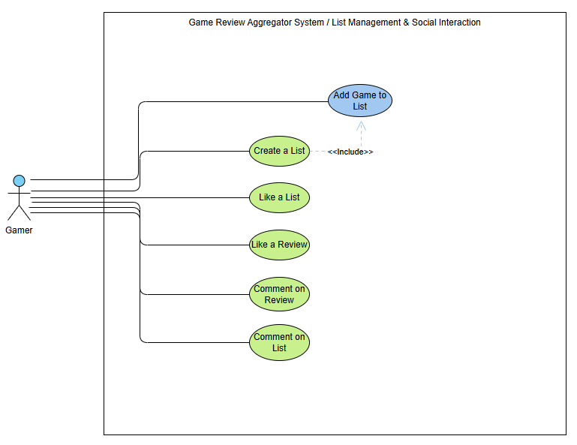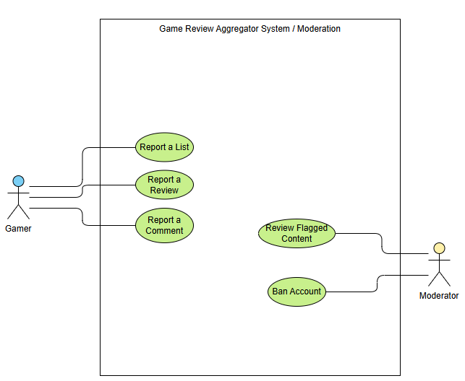

Expanded use case
Field | Content
Identifier and name | UC-05 Search for Games
Primary actor | Gamer
Supporting actors | Game DBs from Vendors
Preconditions — what must be true before it starts | The Website is available and search source is accessible
Trigger — what starts it | Gamer enters a title or term in the search box
Main success scenario — numbered steps | 1. Gamer enters a title or search term  2. Game Review Aggregator System searches for the game records  3. System displays matching results  4. Gamer selects a game
Alternative and exception flows | 1. Gamer enters a title or search term  2. System displays no matching results
Postconditions — what is true when it succeeds | The Gamer can see game page information based on what they search for
Requirements realized | FR-01
Expanded use case
Field | Content
Identifier and name | UC-02 Create a Review
Primary actor | Gamer
Supporting actors | Game DBs from Vendors
Preconditions — what must be true before it starts | The Gamer must log the game playthrough status as either playing or played.
Trigger — what starts it | Gamer writes text into the “Add a review” box and then presses save/continue
Main success scenario — numbered steps | 1. Gamer pressed the “Log” button  2. Searches for the game they want to review  3. Selects the game they want to review  4. Sets playthrough status as “Played” or “Playing”  5. Writes something into the “Add a review” box  6. Presses the “save” button
Alternative and exception flows | 1. Gamer is on a game’s page  2. Gamer presses the “Log/Review” button  3. Sets playthrough status as “Played” or “Playing”  4. Writes something into the “Add a review” box  5. Presses the “save” button
Postconditions — what is true when it succeeds | Gamer has a review posted that they and other Gamers can view
Requirements realized | FR-04

3.5 Requirements to use case traceability

Requirement ID | Use case(s) that realise it | If blank — why, and what you will do
FR-01 | UC-05 Search for Games
FR-02 | UC-06 View Game Reviews  UC-07 View Game Details
FR-03 | UC-06 View Game Reviews
FR-04 | UC-02 Create a Review
FR-05 | UC-04 Rate a Game
FR-06 | UC-06 View Game Reviews  UC-07 View Game Details
FR-07 | UC-06 View Game Reviews
FR-08 | UC-19 Review Flagged Content
FR-09 | UC-16 Report a List  UC-17 Report a Review  UC-18 Report a Comment

The matrix revealed that our core requirements have use cases attached to them, meaning that our use cases all trace back to requirements that we collected through elicitation. This means that our use case features were specifically asked for by stakeholders. However, there are use cases that we proposed that don’t trace back to any requirements, which is a sign of scope creep. We will do further elicitation to determine whether these use cases are

4 Project Plan
4.1 Team roles and working agreement
Team member | Role for P1 to P2 | How the team makes a decision when it disagrees
Terrell Johnson | Revise use cases, perform further elicitation | Gather everyone’s opinion, find a common ground and compromise
Mary Demas | Structure of repository | Agree on organization, issue, and pushes in the repository before major restructuring
Umar Shaikh | Handling APIs/Back-end capabilities | Communicate with the relevant owners with research and information to determine the best course of action
Rohith Rajan | Improve requirements/Revise traceability | Contact and communicate with the associated owner and decide on a solution
Ethan Nguyen | Handling open questions | Asking internal questions and communicating with the team to come to a consensus
Chayeol Jung | Working on front-end capabilities/Revising risks | Communicate with the relevant owners with research and information to determine the best course of action

4.2 Plan to P2
Date | What will be finished | Owner
10/30 | Research on the game APIs and rate limiting | Umar Shaikh
10/30 | Handling and solving existing open questions | Ethan Nguyen
10/30 | Revise requirements and confirm traceability | Rohith Rajan
10/30 | Go over use cases, perform XP spike for technical feasibility | Terrell Johnson
10/30 | Cleaning and revising the repository | Mary Demas

4.3 Risks
# | Risk | Likelihood | Impact | Mitigation — action and owner
R1 | Review Bombing & Spam | Low | Coordinated malicious reviews or bot spam will distort game ratings, destroying trust for gamers researching titles. | Implement rate limiting, captcha for review submissions, and automated keyword flagging to quarantine suspicious reviews before publication.
R2 | Traffic Spikes on Release Days | Low | Massive influxes of users checking reviews for highly anticipated AAA game releases could overload servers, causing system timeouts and violating performance quality requirements. | Design the architecture for horizontal scaling and cache static game information/average ratings to reduce database load during peak times.
R3 | Moderator Bottlenecks | Low | A high volume of user submissions could overwhelm the moderation team, leading to a backlog of unpublished reviews or missed rule violations. | Build efficient bulk-moderation tools, prioritize flagged content, and implement a tiered trust system where veteran reviewers bypass manual approval.
R4 | Reviewer Abandonment | Low | If the review submission process is too complex or lacks clear instructions, reviewers will abandon drafts, resulting in a lack of fresh content. | Conduct usability testing on the submission form early in development to ensure rating options and text fields are straightforward for non-technical writers.
R5 | Moderation Scope Creep | Medium | Over-engineering the moderator dashboard with complex features could delay the core functionality needed for P1 delivery. | Strictly limit the initial moderation tools to basic approve, reject, and flag functions, explicitly defining what is excluded from the current scope.

4.4 Repository and tooling
Repository URL: https://github.com/AgentRachel/game-review-aggregator
Issues are used to log individual work. Team members shall assign themselves an issue and close it upon completion. All team members have access to the GitHub repository.

4.5 Declaration of AI tool use

Tool | What it was used for | Who used it | How the output was checked
ChatGPT | Converting findings into formal requirements of documentation and formatting content to match the P1 template. | Mary Demas | Reviewed against the resources listed in 1.4

5 Open Questions

# | The question | Who can answer it | Needed by | What you assumed in the meantime
Q1 | How would a new gaming vendor enter the system | Rohith Rajan | Gamer and vendors | No new major vendors would try to join the system because existing ones are extremely dominant in the market
Q2 | How would a vendor leave the system | Rohith Rajan | Vendors | A vendor just wouldn't want to leave the system
Q3 | How to differentiate and handle bad actors leaving contradictory reviews | Rohith Rajan | Gamers | Gamers leaving reviews would generally be accurate and would not need to be managed

6 Baseline Declaration

We confirm that the requirements in section 3 represent our agreed baseline as of the submission date, and that every team member has read this document in full.
Team member | Signature or typed name | Date
Terrell Johnson | Terrell Johnson | 10/18/2026
Mary Demas | Mary Demas | 10/18/2026
Umar Shaikh | Umar Shaikh | 10/17/2026
Rohith Rajan | Rohith Rajan | 10/18/2026
Ethan Nguyen | Ethan Nguyen | 10/17/2026
Chayeol Jung | Chayeol Jung | 10/18/2026

