RAVEN WEBSITE

1. SOCIAL MEDIA

Please link the following to

a. FACEBOOK: <http://www.facebook.com/ravenmnl>

b. INSTAGRAM: <http:///www.instagram.com/ravenmnl>

c. TWItter: <http://www.twitter.com/ravenmnl>

2. PLAN YOUR EVENT PAGE

Please have this ready for download on the links.

a. interiors

b. floor plan

c. sales kit

3. EVENTS PAGE

see attached file for layout.

Things to remember upon execution.

1. Kindly make a process that we can upload our event photos ourselves.

2. Each album can upload 16 photos.

3. We can choose our own cover photo for the album.

4. We can link the Facebook page to the the “more photos here”

5. We can write a short description about the event.

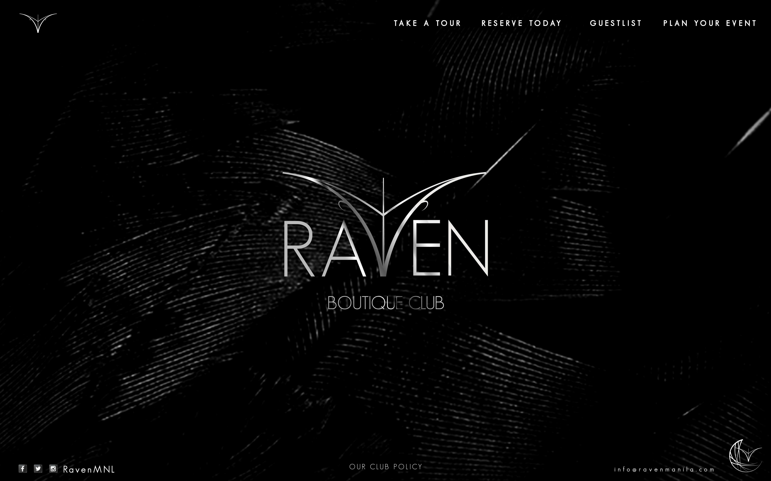

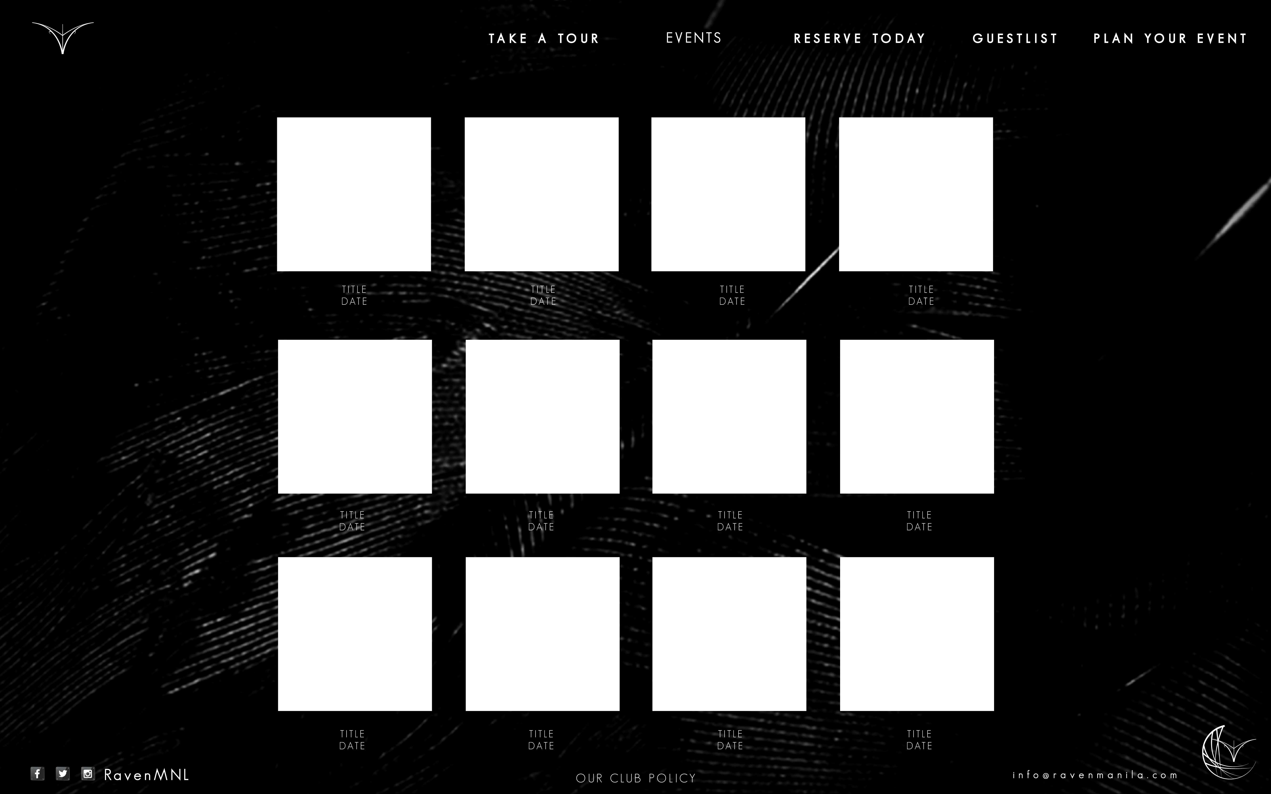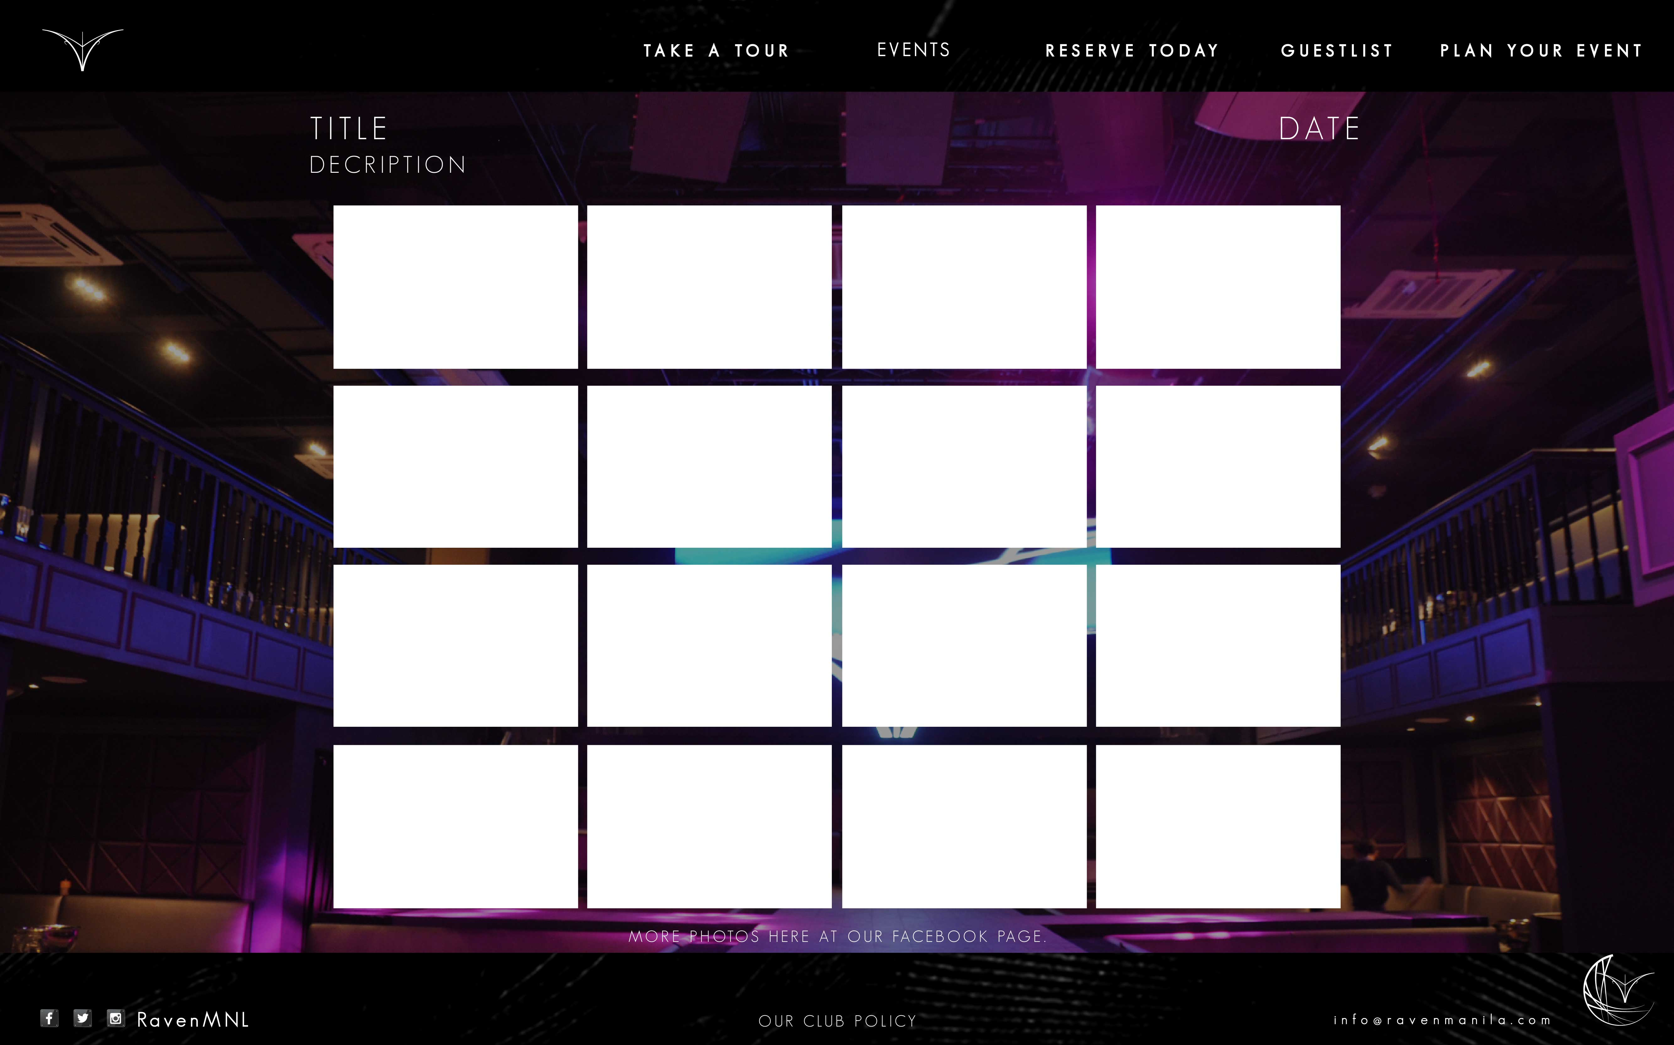

4. Let’s put a disclaimer for Raven Boutique Club’s Policies.

Club Policies:

RAVEN BOUTIQUE CLUB invites you to maintain our standards by dressing smartly and appropriately. NO STYLE, NO ENTRY. Guests who are 20 years old and below are not inside. FIREARMS, DRUGS AND SLRS without media pass are not allowed inside. The establishment reserves the right to refuse entry to those who do not comply or disregard our club policies.