CS3025301:Software Engineering


Design Document for [Project Name]

Version 0.0: [Date published]
Team: Team's name / number]
Team members: [Team members' names]

Contents

1 Introduction 2
2 Design Considerations 2
2.1 Assumptions 2
2.2 Constraints 2
2.3 System Environment 2
3 Architectural (High-Level) Design 2
3.1 Overview 2
3.2 Rationale 3
3.3 Conceptual (or Logical) View 3
4 Low Level Design 3
4.1 Class Diagram 3
4.2 Sequence Diagram 3
4.3 Activity Diagram 3
4.4 State Diagram 3
5 User Interface Design 3

IMPORTANT:
The paragraphs written in the “Comment” style are for the benefit of the person writing the document and should be removed before the document is finalized.
Also, don’t forget to update the Table of contents before submission. (Right Click -> Update Field)

Introduction
The introduction section provides context for the project

Provide a brief high-level description of system structure, functionality, interactions with external systems, system issues, etc.

Design Considerations
These subsections describe issues that need to be addressed or resolved prior to or while completing the design as well as issues that may influence the design process.

。

Assumptions

Describe any assumption, background, or dependencies of the software, its use, the operational environment, or significant project issues. These are things that you are assuming to be true and that directly affect the design
開發平台：MacOS,Window10
開發軟件：Eclipse
要安装JAVA所需的环境如JDK，JRE等。

Constraints

Describe any constraints on the system that have a significant impact on the design of the system. (e.g., technology constraints, performance requirements, end user characteristics) These are things the customer has told you that directly influence the design (e.g., the Database must be an open-source, freely available DBMS).
首先這是一款遊戲，所以我们需要这款游戏数据的精准度：在玩家游戏中方块会随着玩家的操作而移动。
流畅性： 这是一款比较简单操作的游戏要求能够快速的开始游戏，游戏过程中也具有一定的流畅性。
显示需求：当方块填满一行时可以消行，剩余方块向下移动并且统计分数。整个游戏的界面大致分为两个部分：左边是游戏区，显示玩家的操作情况，右边显示当前游戏的分数以及暂停，结束游戏等按钮。

System Environment

Describe the hardware and software that the system must operate in and interact with.
運行一款遊戲必須有軟件以及硬件的支持，比如說輸出以及輸入設備，如屏幕,鼠標以及鍵盤，軟件有开发程序的环境需，如JDK，還有運行程序的軟件Eclipse。

Architectural (High-Level) Design

The architecture provides the top-level design view of a system and provides a basis for more detailed design work. These subsections describe the top-level components of the system you are building and their relationships.
In defining your architectural design, you can follow one or more of the architecture patterns seen in class (Model-View-Control, Layered architecture, Repository, Client-Server, Pipe and Filter) or pick a different one if none of those is appropriate for your system.

Overview

This section provides a high level overview of the structural and functional decomposition of the system. The section should list the different components and concisely discuss the major responsibilities and roles such components must play.
根据分析俄罗斯方块这款游戏可以大致分为这几个模块：游戏模块，游戏控制器模块，游戏逻辑模块，数据显示模块，分数保存模块。
游戏控制器模块：用来控制生成的方块下落，旋转以及左右移动。
游戏逻辑模块：生成方块的算式，当方块填满一行或多行时自动消除，当方块叠加到顶部时游戏游戏结束。
数据显示模块：用来显示分数保存模块的数据。
分数保存模块：计算游戏逻辑模块消除的行数并将行数转换成分数保存。

Rationale

屏幕上有一个X列Y行的区域，计算机将自动生成7种不同形状的方块并出现在区域的最顶端，每过一个固定的时间向下移动一格，每种方块都可以旋转角度玩家可以通过上下左右来控制方块的移动和旋转，为此我们需要游戏控制器模块和游戏逻辑模块。
在这款游戏的右侧显示区将显示游戏当前的分数，每当玩家成功消除一行时，将自动获取一定的分数，右侧显示分数也随着玩家的操作动态更新，当方块填满到顶部时游戏结束，为此我们需要数据显示模块和分数保存模块。

Conceptual (or Logical) View

This section should provide and describe a diagram that shows the various components and how they are connected. The conceptual view shows the logical/functional components of the system, where each component represents a cluster of related functionality. For UML, this would typically be a component diagram or a package diagram.
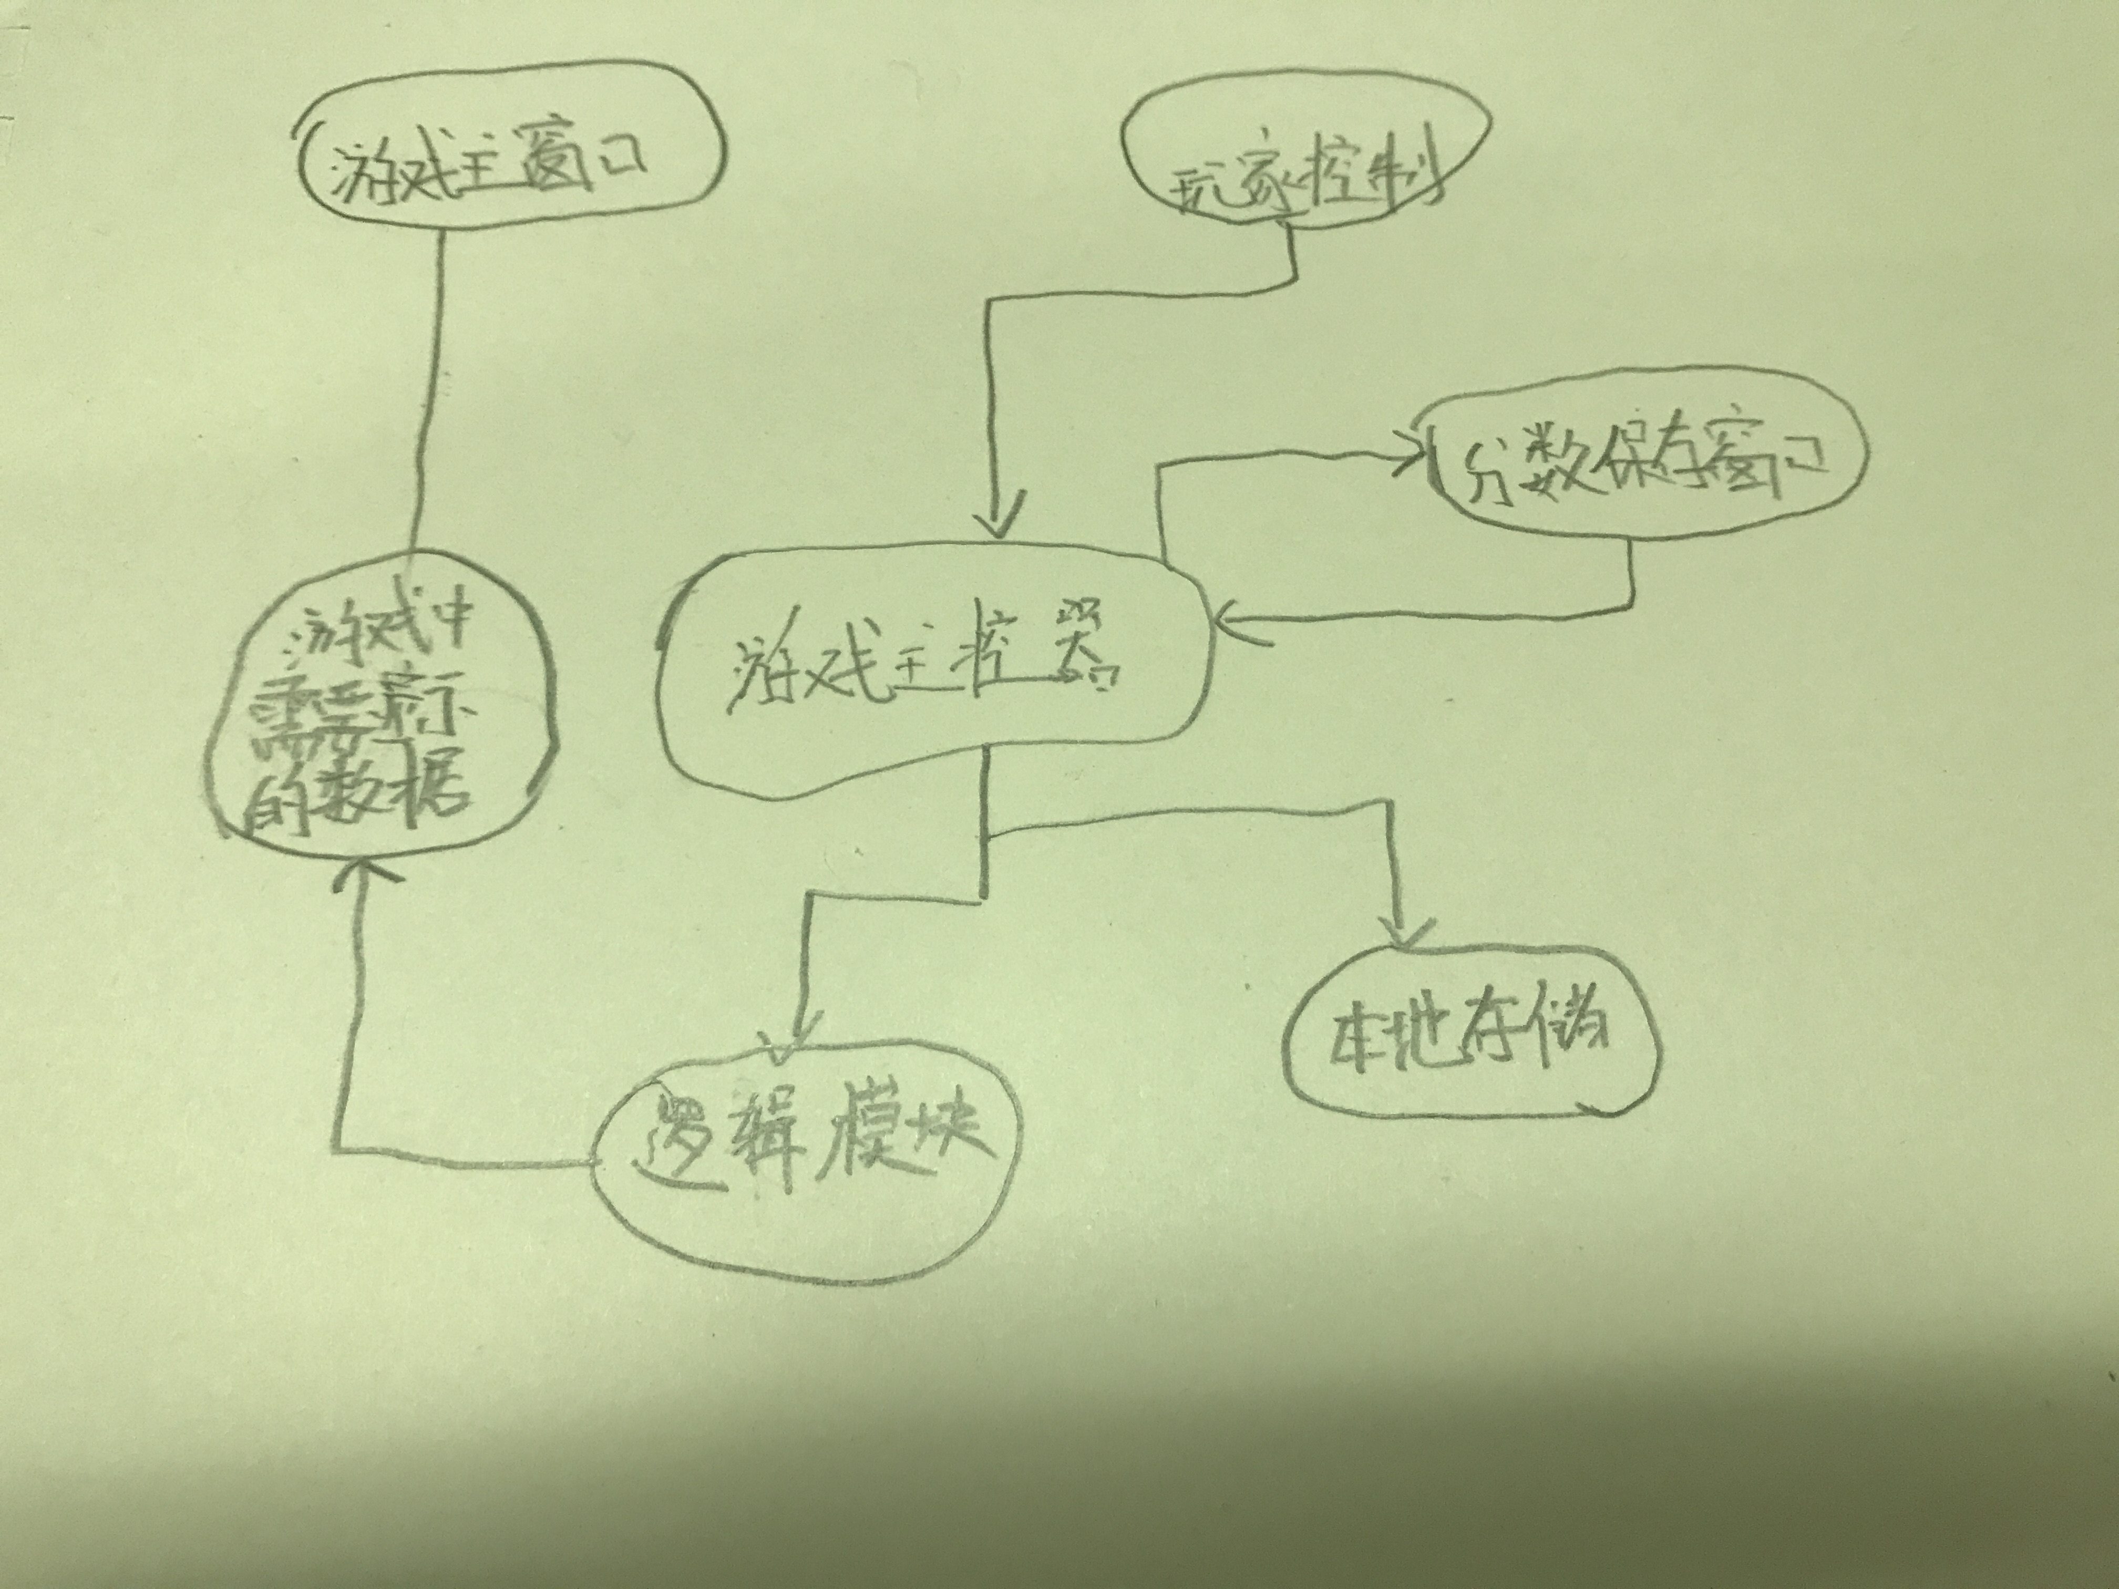

Low Level Design
This section provides the low-level design for each of the system components identified in the previous section. For your component, you should provide details in the following UML diagrams to show its internal structure.

Class Diagram
In the case of an OO design, the internal structure of a software component would typically be expressed as an UML class diagram that represents the static class structure for the component. Along with the system classes, you need to show their attributes and relationship between the classes (Association, Aggregation, Generalization, Dependency, Multiplicity etc.)

Sequence Diagram
This diagram shows details of how objects in your software component interact with each other and in what order.
If needed, you can show additional diagrams like activity & state diagrams.
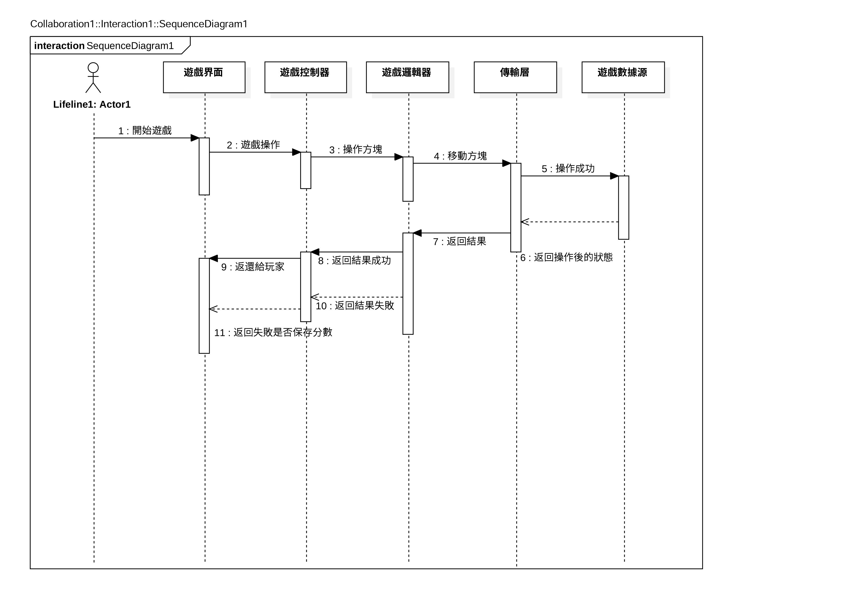

Activity Diagram

State Diagram

User Interface Design
Use this section to list down your screen mockups showing the placement of the different visual elements on the screen.

