
Department of Electrical & Computer Engineering

Power Systems Analysis

PROJECT 2
Voltage & Angle Stability

DUE: Monday, December 2, 2013, 11:59PM

Prof. Claudio Cañizares
For the 14-bus IEEE benchmark system depicted bellow, and using the latest version of PSAT and the corresponding data provide at the course website:

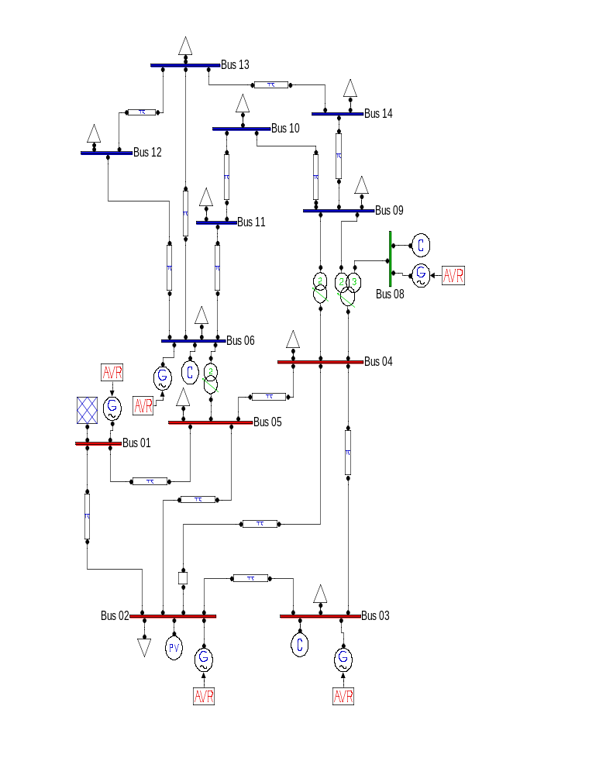

- Obtain and present the PV curve at Bus 14 by running a continuation power flow (CPF) using the base load and generation levels as the direction vector for the base system and for the system with Line 2-4 tripped, respectively. Make sure that you run PSAT using the following settings:
  - General Settings: Discard Dynamic Comp.; Use Distributed Slack Bus; Check PV reactive limits.
  - CPF Settings: Qg limit controls; Initial Loading Param. = 1; Step Size Control = 0.1; uncheck Single Slack Bus.

- Compute and present the eigenvalues for the “upper” sides of the PV curves for the base case and the contingency case, and provide the loading value at which a Hopf bifurcation appears in both cases. Make sure of using the following settings in PSAT:
    - Set Freq. Base to 60 Hz.
    - In General Settings uncheck Discard Dynamic Comp.
    - The program computes the eigenvalues for one loading condition at a time, so the load has to be increased “manually”, as the program does not do this automatically. The provided file Base_14bus_lambda.m will facilitate these calculations by varying the parameter lambda.

- For a 30% loading increase (λ = 1.3), simulate in the time domain a Line 2-4 trip at t = 1s, and demonstrate through time plots that the system becomes unstable due to the existence of a Hopf bifurcation. Make sure that a PQ load model is used to run the simulations.

- Demonstrate through eigenvalue analysis and time domain simulations that the system instability associated with the trip of line 2-4 for λ = 1.3 can be removed by adding the following PSS to the generator at Bus 1 (PSAT type 2, check the PSAT user guide for details on how to introduce the PSS in the system):
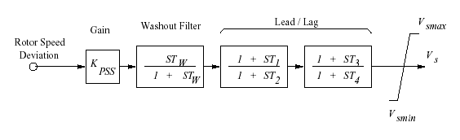
T_{W} [s] | T₁ | T₂ | T₃ | T₄ | V_{smax} | V_{smin}
15 | 0.3 | 0.02 | 0.3 | 0.02 | 0.1 | -0.1

Determine the gain K_{PSS} by trial-and-error, starting with a value of 1, that yields a minimum 9% damping ratio for the system after the contingency. The damping ratio ζ for an eigenvalue μ = a + jb is defined as:
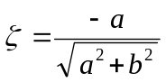
Provide hardcopies of the PSAT data used to obtain the results, and a table of K_{PSS} versus damping ratio values to substantiate your answer.

