1.3 – 0.12 – 0.008 – 0-052 - 5 días

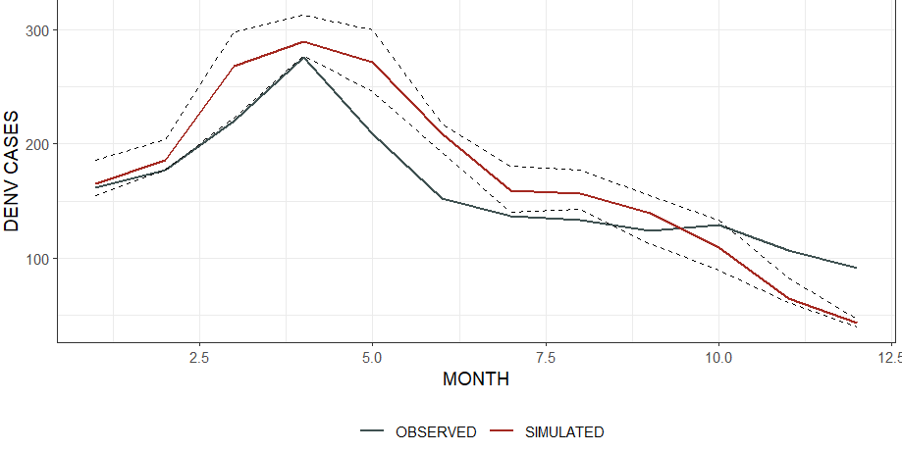

1.5 – 0.12 – 0.008 – 0-052 - 5 días

1.3 – 0.11 – 0.008 – 0-052 - 5 días

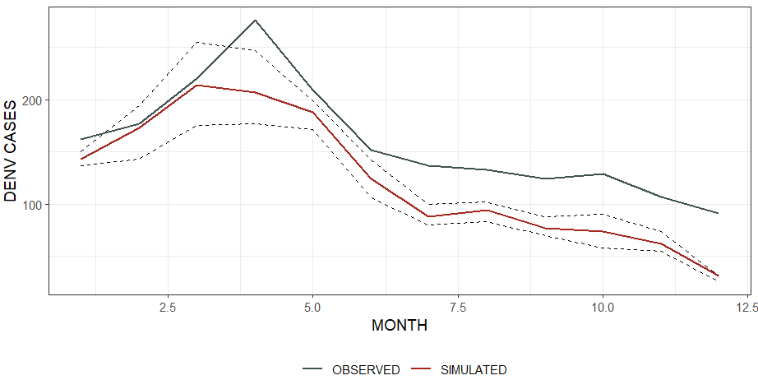

1.3 – 0.11 – 0.0072 – 0.0052 - 5 días (no es)

1.3 – 0.11 – 0.0065 – 0.0052 - 5 días? El tercero

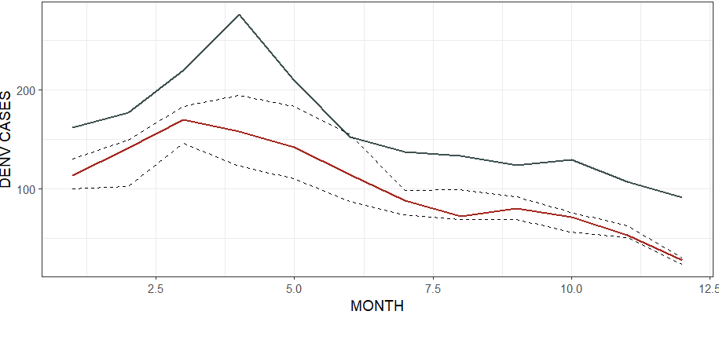

1.3 – 0.11 – 0.0065 – 0.0057 - 5 días

1.3 – 0.1 – 0.008 – 0.0052 – 5 días

1 - 1.5 – 0.1 – 0.008 – 0.0052 – 5 días

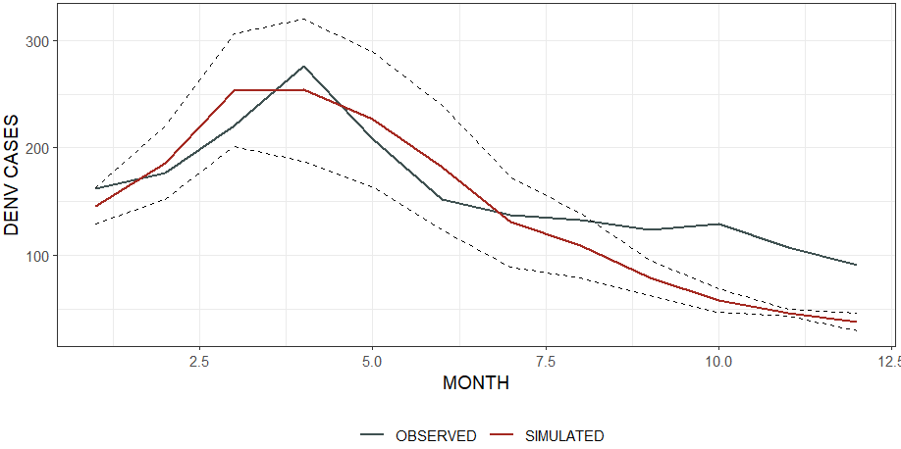

2 - 1.3 – 0.1 – 0.0072 – 0.0052 – 5 días

3 - 1.3 – 0.1 – 0.0096 – 0.0062 – 5 días

3 - 1.3 – 0.11 – 0.0096 – 0.0062 – 5 días

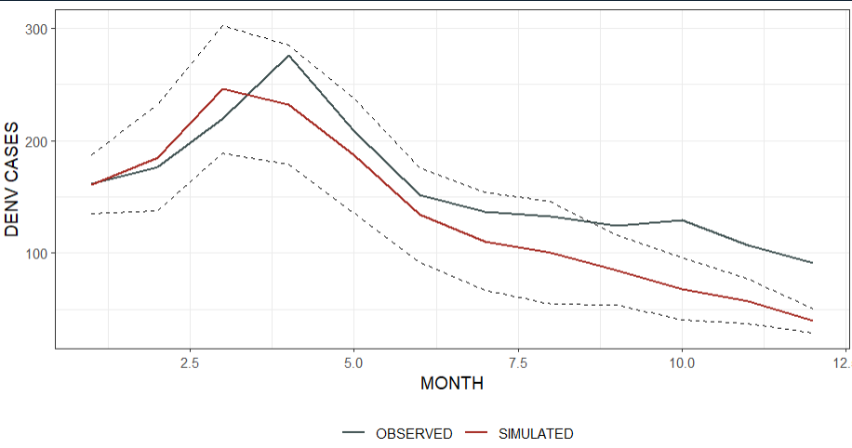

2 – 1.5 – 0.11 – 0.0072 – 0.0052 – 5 días

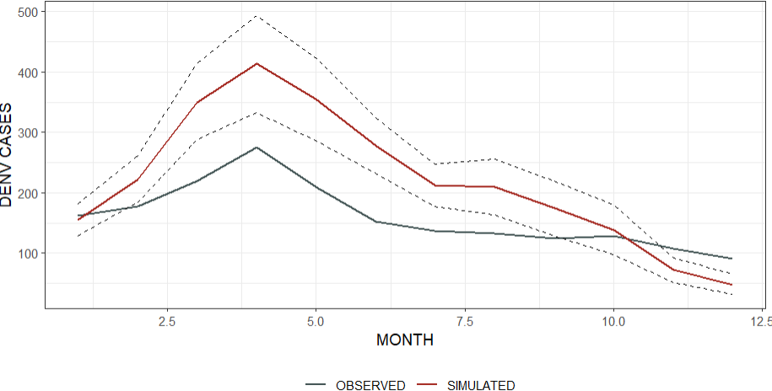

1 – 1.5 – 0.1 – 0.072 – 0.0052 – 5 días

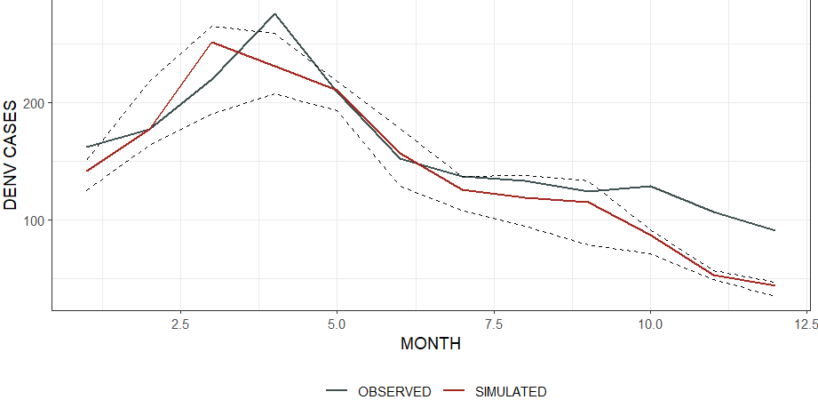

El que creia pero no

1 – 1.3 – 0.11 – 0.0065 – 0.0065 – 5 días

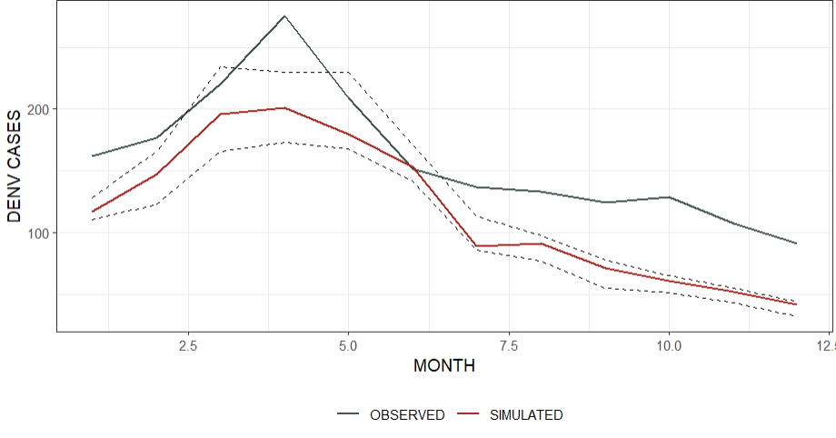

2 – 1.3 – 0.13 – 0.0072 – 0.0052 – 5 dias

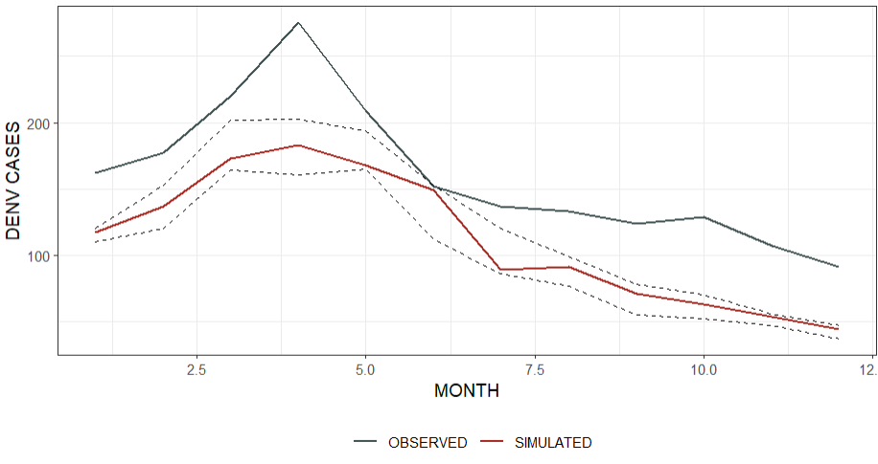

3 – 1.3 – 0.011 – 0.008 – 0.0052 – 5 dias - -5 a 5 en mov

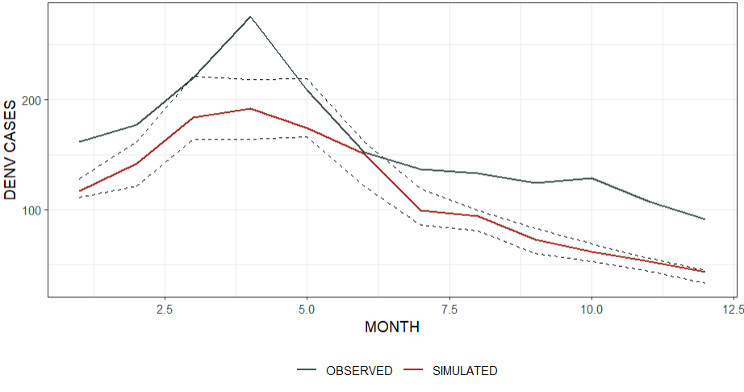

1 – 1.3 – 0.11 – 0.008 – 0.0052 – 5 dias - -50 min

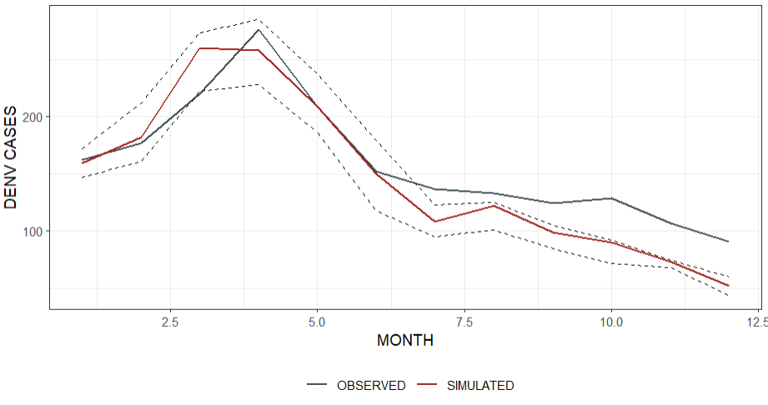

1 – 1.3 – 0.11 – 0.0072 – 0.0052 – 5 dias - -50 min

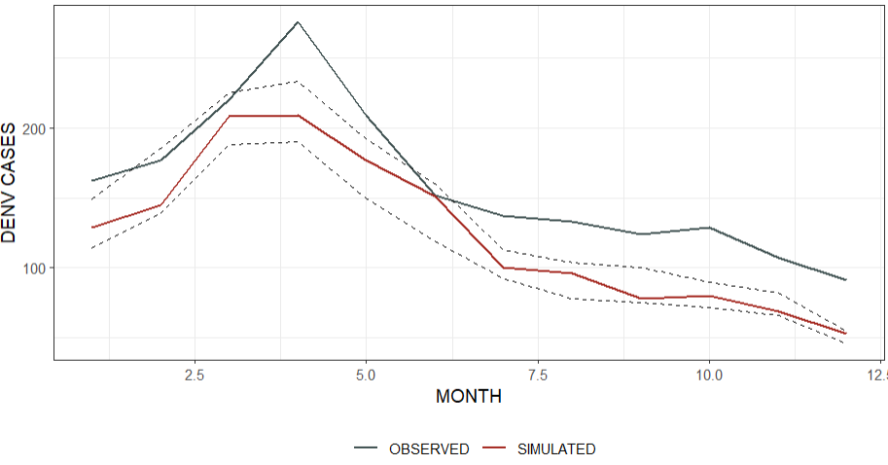

3 – 1.3 – 0.11 – 0.065 – 0.0052 – 5 dias - -50 min (recordar 1 cero de mas)

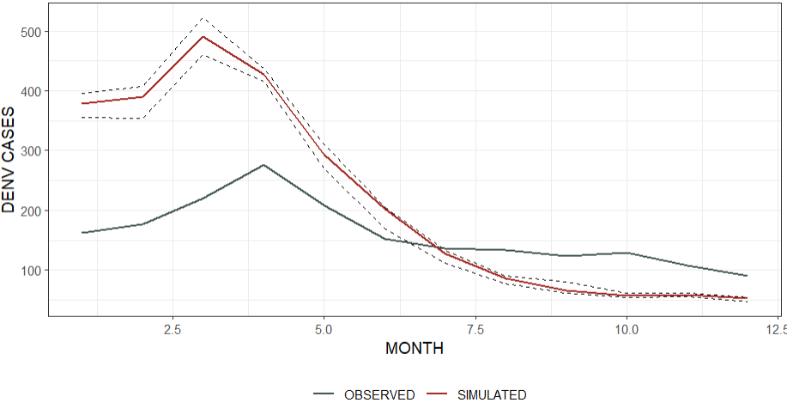

3 – 1.3 – 0.11 – 0.01 – 0.0052 – 5 dias - -50 min (recordar 1 cero de mas)

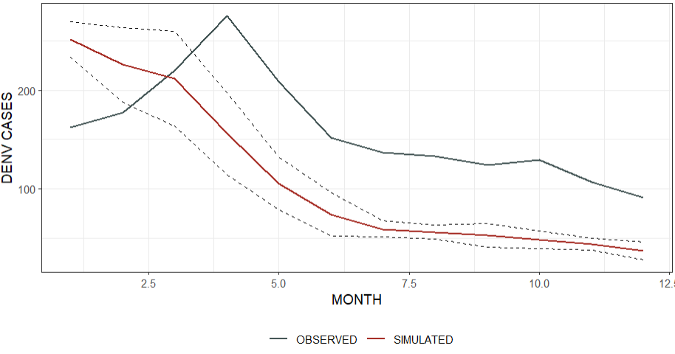

2 - 1.3 – 0.11 – 0.008 – 0.0052 – 5 dias - -50 min – con random que había antes en donde estaba antes jaja

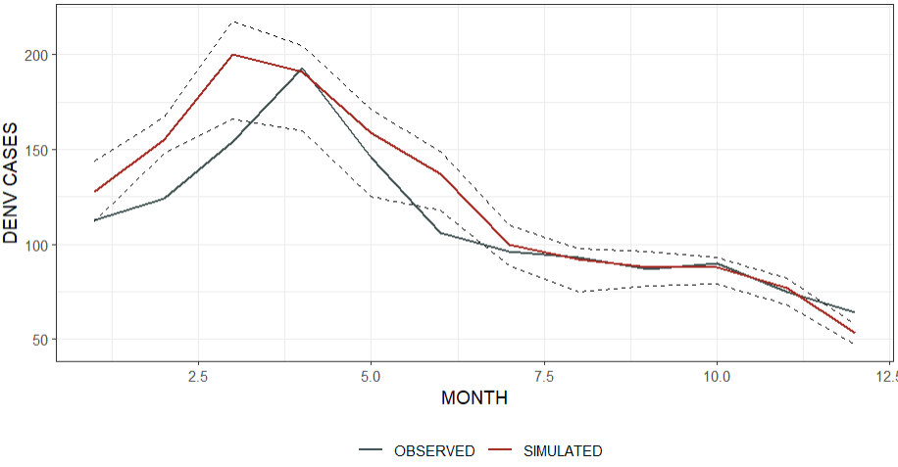

3 - 1.3 – 0.11 – 0.025 – 0.0052 – 5 dias – 50 min

4 – 1.3 – 0.11 – 0.008 – 0.0052 – 5 dias – 50 min – igual que el que estaba en el 1

2 – 1.3 – 0.13 – 0.0072 – 0.0052 – 6 dias – 50 min

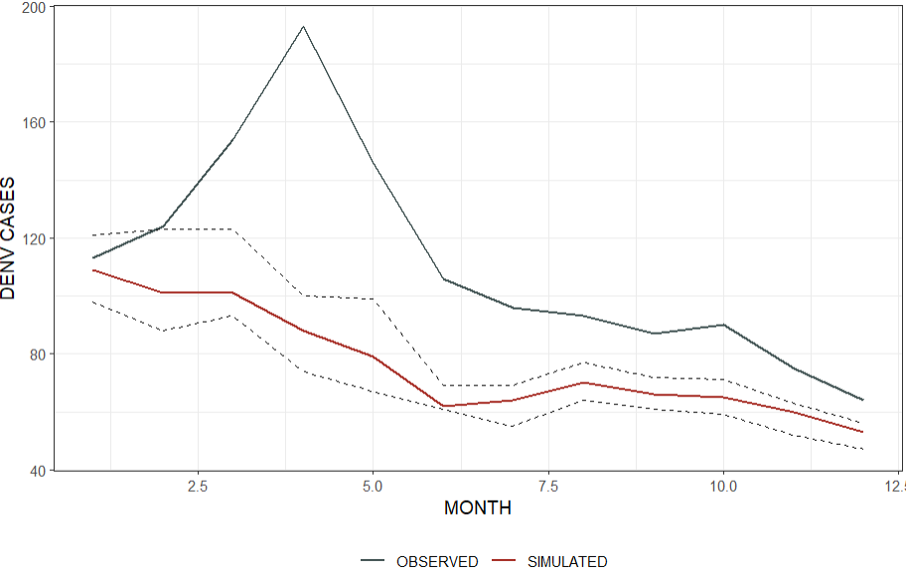

1 – 1.3 – 0.11 – 0.008 – 0.0052 – 5 dias – 50 min +2 – 1.3 – 0.11 – 0.008 – 0.0052 – 5 dias – 50 min

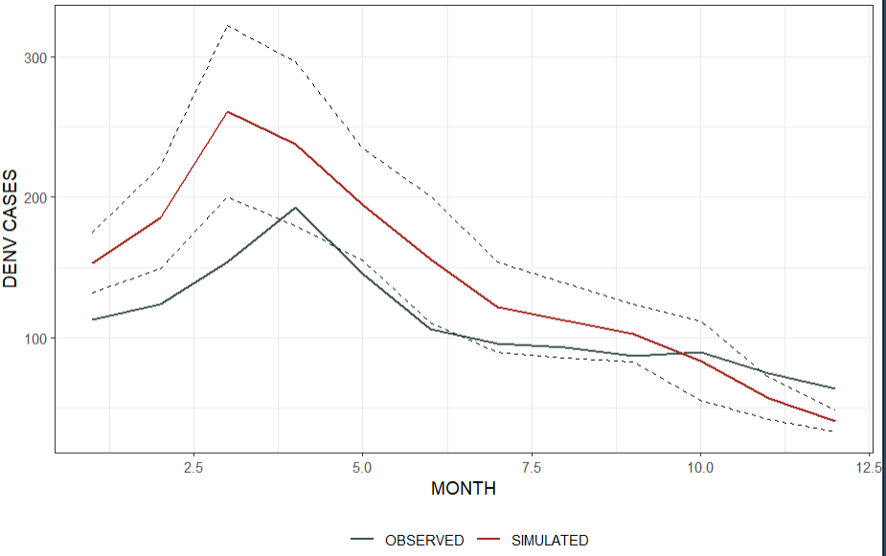

3 – 1.3 – 0.1 – 0.025 – 0.0052 – 5 dias – 50 min

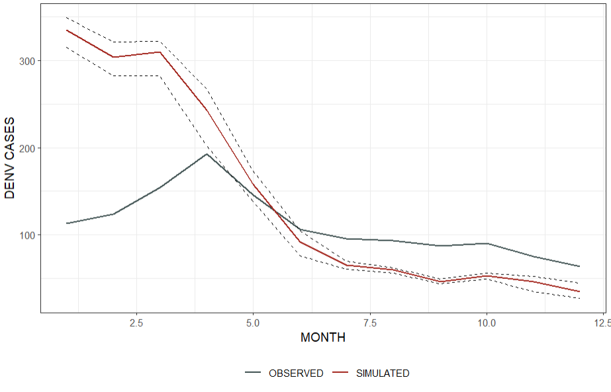

4 – 1.3 – 0.11 – 0.008 – 0.0052 – 5 dias – 50 min -2,2

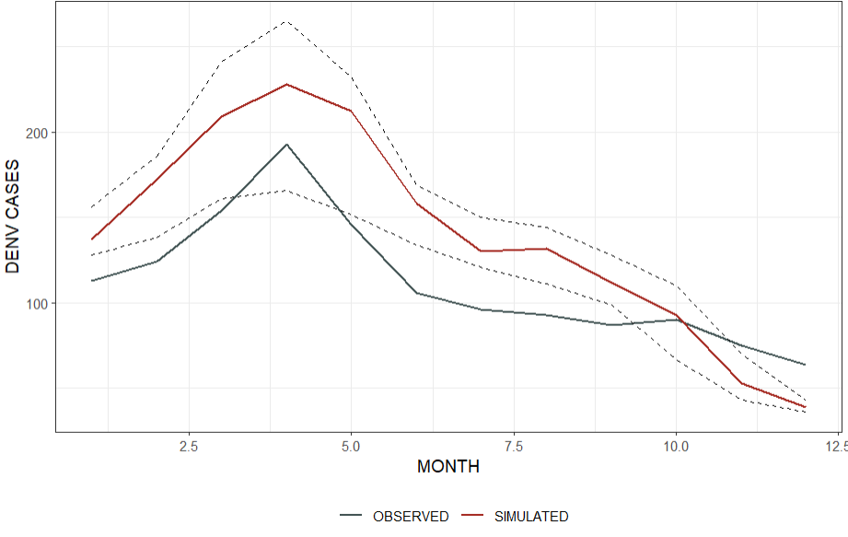

3 – 0.7 – 0.11 – 0.025 – 0.0052 – 6 días – 50 min - -4,4 (pésimo, salió mal, ignorar esos parámetros viejos)

4 – 1.3 – 0.11 – 0.008 – 0.0052 – 5 dias – 50 min -3,3

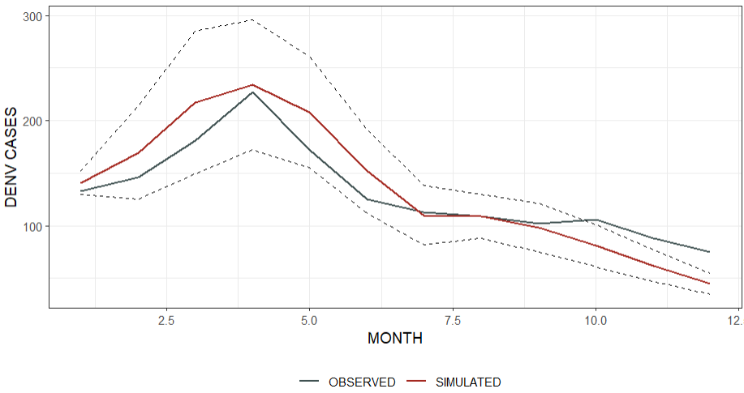

2 – 1.3 – 0.115 – 0.0072 – 0.0052 – 5 dias – 50 min

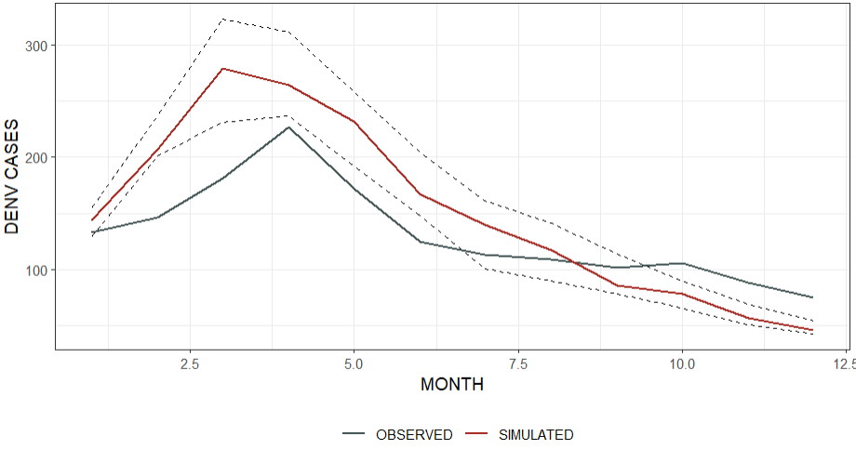

3 – 1.3 – 0.11 – 0.008 – 0.0052 – 6 días – 50 min - -4,4 – 0.7br

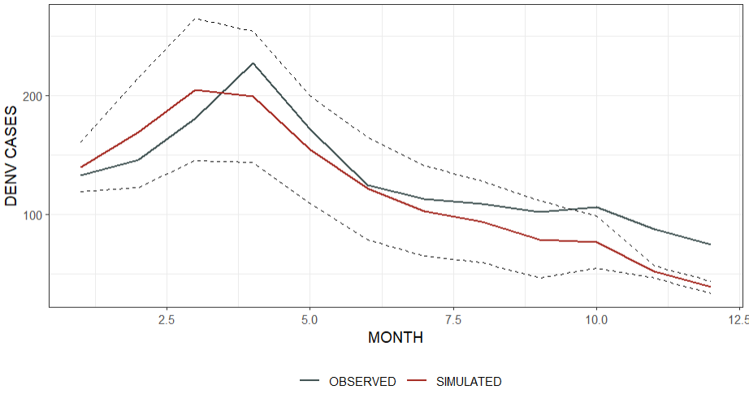

Siguiente intento

3 - 1.3 – 0.11 – 0.008 – 0.005 – 5 dias – 50min(estandar) -3,3 & 0.7br

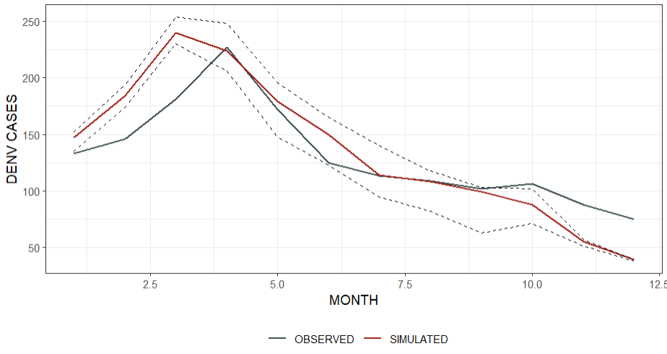

4 – 1.3 – 0.11 – 0.008 – 0.0052 – 5 dias – 50 min -3,3

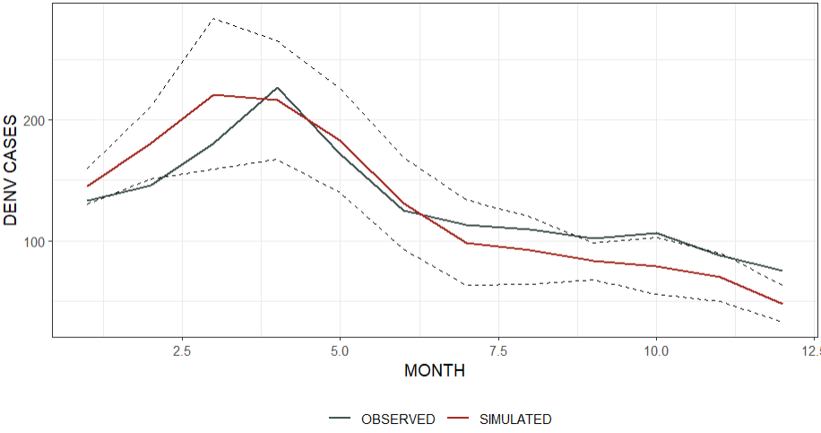

3 – 1.3 – 0.11 – 0.008 – 0.0052 – 6 dias – 50 min -3,3

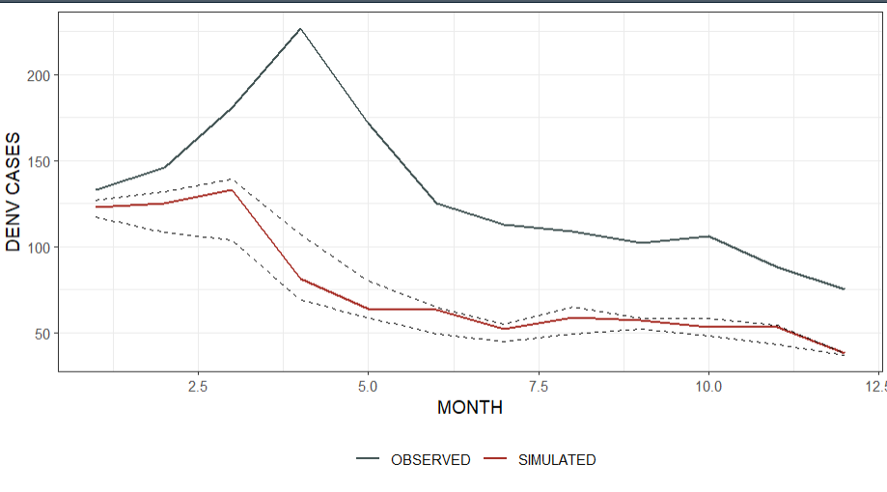

2 – 1.3 – 0.11 – 0.008 – 0.0052 – 5 dias – 50 min - -3,3

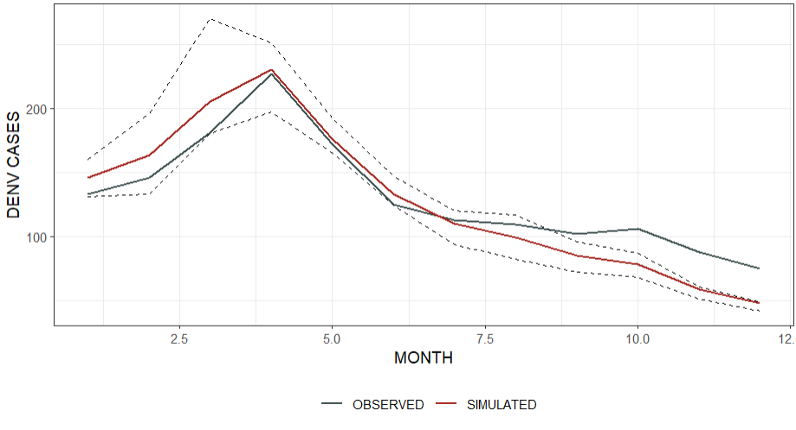

NO SE creo que 1 - 1.3 – 0.11 – 0.0072 – 0.005 – 6 dias – 50min(estandar)

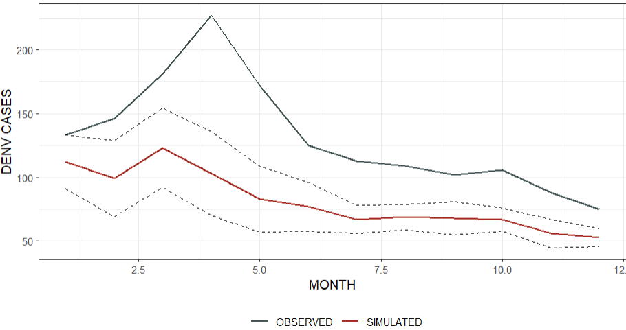

4 - 1.3 – 0.11 – 0.03 – 0.005 – 6 dias

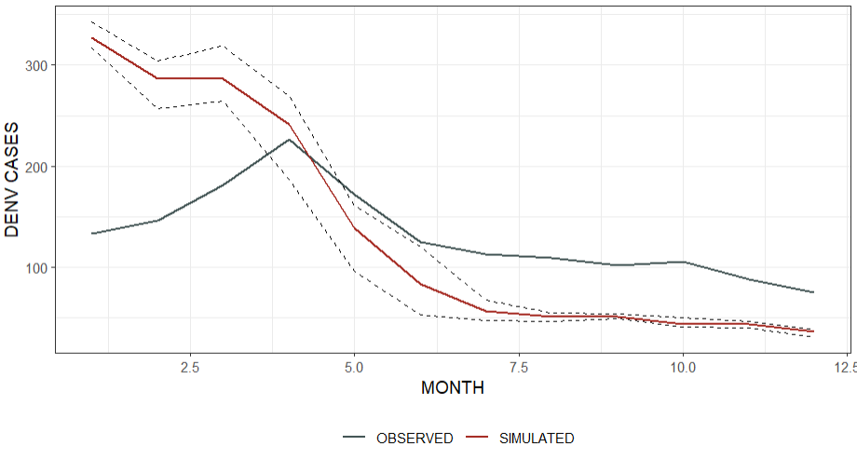

3 - 1.3 – 0.11 – 0.1 – 0.005 – 6 dias – 50min(estandar)

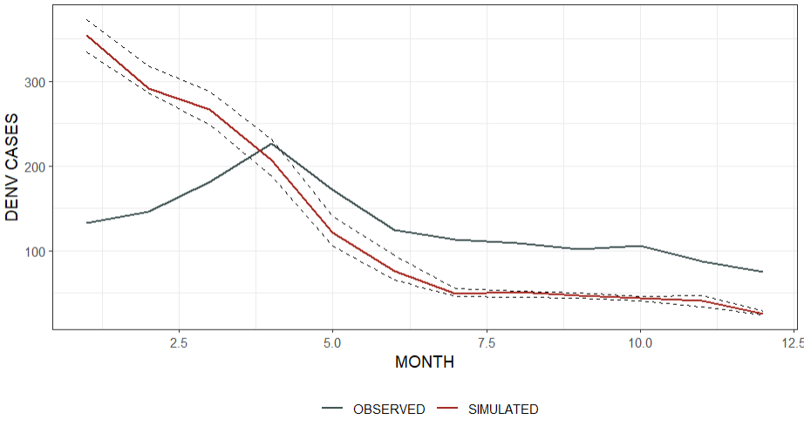

2 – 1.3 – 0.11 – 0.008 – 0.009 – 6 dias – 50 min - -3,3

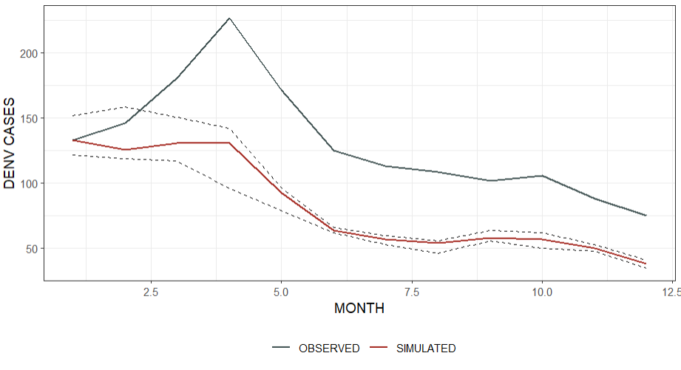

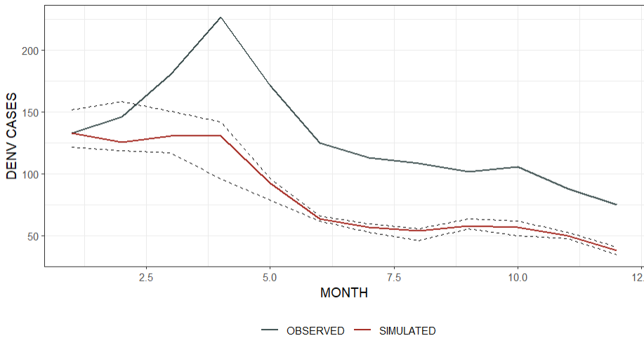

1 - 1.3 – 0.11 – 0.0072 – 0.0072 – 6 dias

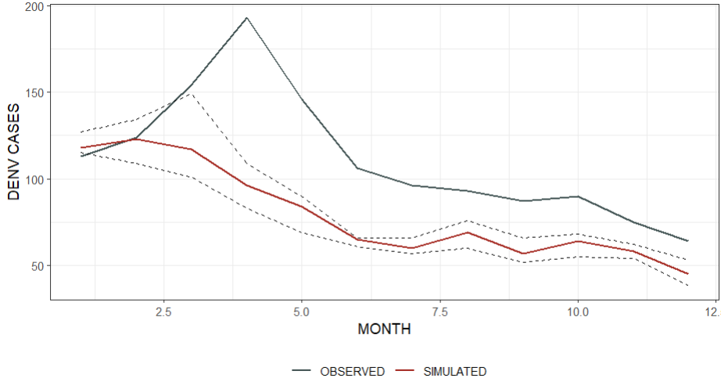

2 - 1.3 – 0.11 – 0.0072 – 0.015 – 6 dias

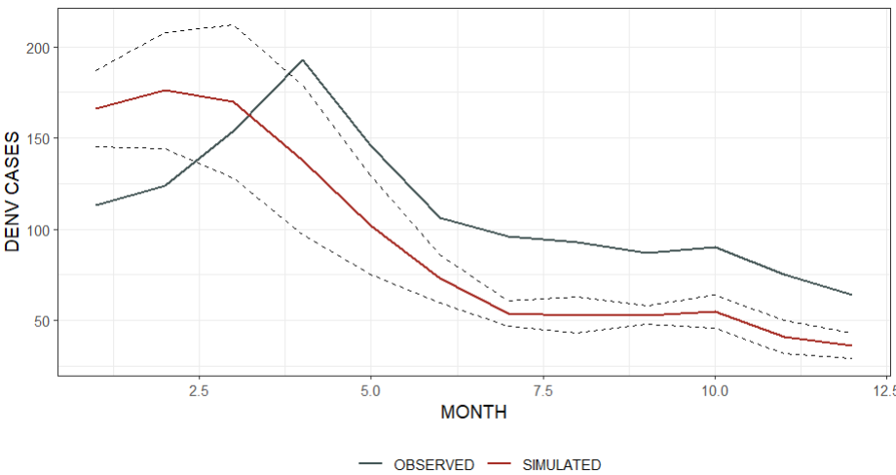

3 - 1.3 – 0.11 – 0.008 – 0.0052 – 5 dias

4 - 1.3 – 0.11 – 0.007 – 0.0052 – 5 dias

,mn b

4 - 1.3 – 0.11 – 0.007 – 0.0052 – 5 dias (20)

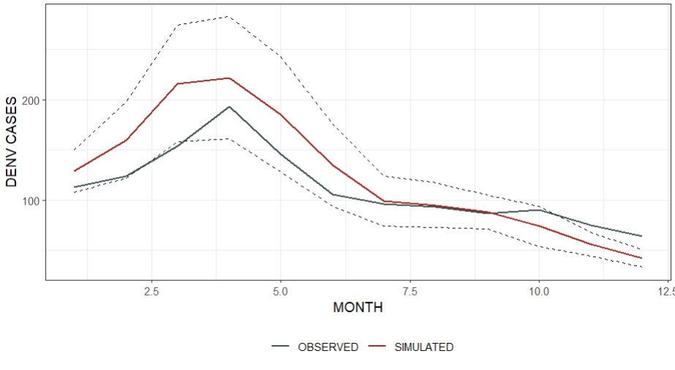

3 - 1.3 – 0.11 – 0.007 – 0.0052 – 4 dias

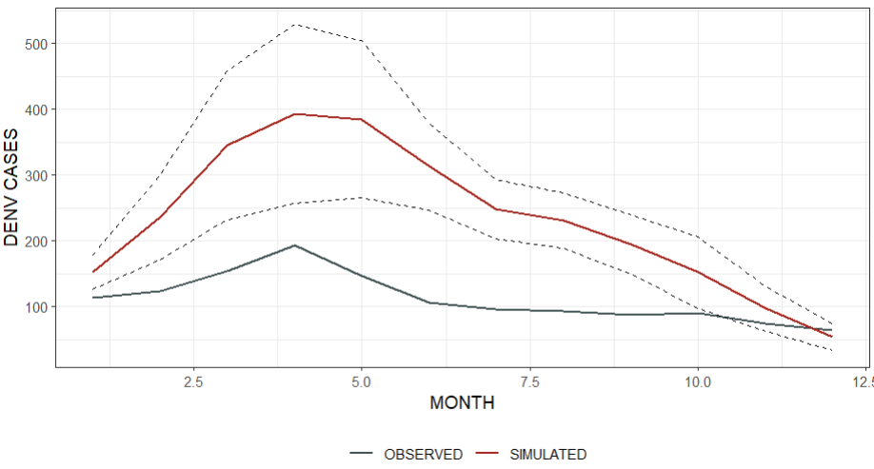

2 - 1.3 – 0.11 – 0.007 – 0.006 – 5 dias

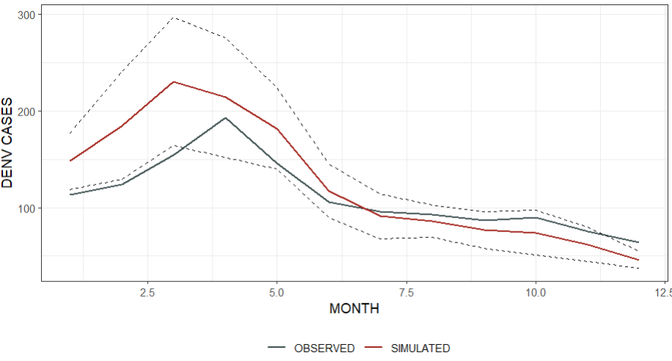

2 - 1.3 – 0.11 – 0.007 – 0.006 – 5 dias - cambiando death rate (0.037, 0.02, 0.01) con el temp90 – Todo mal peeero es arreglable

3 – 0.73 – 0.11 – 0.007 – 0.00026 – 5 dias (mismos iniciales originales [antes había quedado mal el inicial de personas]) – no está mal

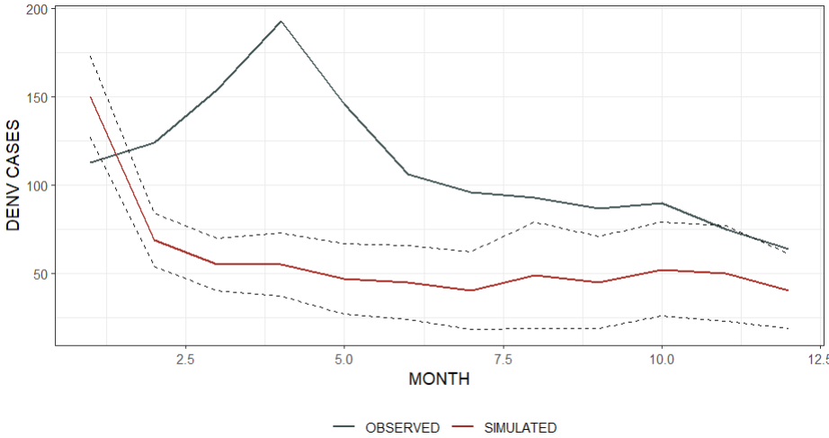

int - 1.3 – 0.11 – 0.007 – 0.006 – 5 dias – interventions (same coeff & 0.7, 0.6, 0.8)

3 – 0.73 – 0.11 – 0.007 – 0.00026 – 6 días -3,3 & cambiando un poco BR

2 - 1.3 – 0.11 – 0.006 – 0.01 – 5 dias - -3,3