

Version 4.0.0

User Manual

Cologne, Germany – 2024 www.rocket-propulsion.com

Table of Contents

Introduction 6
Key Features 6
Calculation Methodology 6
Technical Specifications 6
RPA editions 7
System requirements 7
Microsoft Windows 7
Apple Mac 7
Linux 7
Installation on Microsoft Windows 7
Installation on Linux 7
Running RPA 8
Using Graphical User Interface 8
Using Scripting utility 9
Configuration Files 10
Create a Configuration File 10
Load a Configuration File 10
Save the Current Analysis 10
Save As Another File 10
Recent Files 10
Example Configuration Files 11
Migrating Configuration Files 11
Engine Definition 11
Nozzle Flow Model 14
Nozzle conditions 14
Delivered performance 16
Ambient conditions 17
Throttle settings 17
Thrust Chamber Size 18
Thrust Chamber Sizing 18
Combustion Chamber Geometry 19
Nozzle Geometry 19
Thermal Analysis 20
Cooling segments 21
Radiation Cooling 22
Regenerative Cooling 22
Coolant definition 23
Coaxial Shell Jacket Design 24
Tubular Wall Jacket Design 25
Channel Wall Jacket Design 26
Film Cooling 28
Thrust chamber with multiple cooling segments 28
Thermal Barrier Coating Layer 29
Starting Analysis 29
Results 30
Thermodynamics 30
Combustion products 32
Performance 33
Altitude performance 35
Throttled performance 37
Nested Analysis 38
Propellant Analysis 40
Thrust chamber size 42
Thermal Analysis 44
Propellant Feed System (Cycle Analysis) 45
Thermodynamic Database Editor 46
Preferences 49
Input and Output Units 50
Scripting API 52
API Reference 52
Generic built-In Functions / Objects 52
Object File 54
Object ConfigFile 55
Object Units 57
Object Database 60
Object Species 60
Object Mixture 62
Object Propellant 64
Object Equilibrium 65
Object Derivatives 69
Object Product 71
Object Combustor 73
Object Chamber 75
Object ChamberStationConditions 78
Object TheoreticalPerformance 82
Object TheoreticalThrottlingPerformance 84
Object ChamberDesign 86
Object NozzleDesign 87
Object DXF 88
Object HeatTransferAnalysis 88
Object PropulsionAnalysis 88
Object AltitudePerformance 89
Object PropellantConfiguration 90
Object ChamberConfiguration 91
Object ChamberDesignConfiguration 93
Object NozzleDesignConfiguration 94
Object ChamberDesignResults 95
Object NozzleDesignResults 96
Object HeatTransferConfiguration 97
Object FilmCoolingSlot 98
Object WallCoolingSegment 98
Object HeatTransferAnalysisResults 102
Object Units 102
Object HeatTransferStation 102
Object WallCooling 103
Attachments 104
Equivalence Ratio calculation 104
Oxygen Balance calculation 105

Introduction
Rocket Propulsion Analysis (RPA) is a versatile and user-friendly multi-platform tool designed for predicting the performance of rocket engines. It features an intuitive graphical user interface (GUI) that conveniently groups input parameters and analysis results, making it accessible for both novice and experienced users.

Key Features

- Intuitive GUI: The user interface is designed for ease of use, facilitating straightforward input and clear display of results.

- Comprehensive Chemical Species Library: RPA utilizes an expandable chemical species library based on the NASA Glenn thermodynamic database. This includes data for a wide range of fuels and oxidizers such as liquid hydrogen, liquid oxygen, kerosene, hydrogen peroxide, and MMH.

- Customizable Propellant Components: Users can define new propellant components or import components from PROPEP or CEA2 species databases using the embedded species editor.

- Performance Prediction: By providing essential engine parameters such as combustion chamber pressure, propellant components, and nozzle parameters, RPA calculates the chemical equilibrium composition of combustion products, determines their thermodynamic properties, and predicts theoretical rocket performance.

- Design Applications: The results can be utilized in designing combustion chambers, gas generators, and preburners for liquid propellant rocket engines.

Calculation Methodology

RPA employs a robust and industry-accepted Gibbs free energy minimization approach to:
- Determine combustion composition
- Analyze nozzle flows with shifting and frozen chemical equilibrium
- Calculate engine performance for both finite- and infinite-area combustion chambers

Technical Specifications

RPA is written in C++ programming language using libraries: Qt 6, Qwt, Google protobuf, cryptopp.

The program is developed and distributed by RP Software+Engineering UG. The development team can be contacted by email: contact@propulsion-analysis.com

RPA editions

Starting with version 4, RPA is distributed in only one edition (formerly known as Standard Edition).

System requirements

Microsoft Windows
Operating Systems:
- Windows 11, Windows 10, Windows XP (64-bit Editions).

Any computer that runs with the mentioned operating systems.

Apple Mac
- Not supported

Linux
RPA will not run without the following libraries:
- Qt 6.0 or higher

Installation on Microsoft Windows
RPA for Microsoft Windows is distributed as a compressed bundle (ZIP) for x86-64 architecture.
RPA for Windows depends on Qt 6 and MS VC++ 2019 run-time libraries. If computer does not have it installed, the bundle that includes all required components should be used for installation.
Installation steps:
- Extract files from the compressed bundle (ZIP) into selected directory
- Start the program by executing the command RPA.exe

The user does not need administrator privileges for installing the software. To uninstall the application, remove the RPA installation directory.

Installation on Linux
RPA for Linux is distributed as a compressed bundle (TAR.GZ) for x86-64 architecture.

RPA for Linux depends on Qt 6 run-time libraries. To install the program
- Extract files from the compressed bundle (TAR.GZ) into selected directory
- Start the program by executing the shell script RPA.exe

The user does not need administrator privileges for installing the software to the HOME directory.
To uninstall the application, remove the RPA installation directory.

Running RPA

Using Graphical User Interface
After launching RPA by starting the program RPA.exe, the main window will appear. The main window includes a menu bar, toolbar, and working area designed for ease of use and efficient navigation.
Working area consists of several screens which conveniently group the input parameters and analysis results. The desired screen can be activated by clicking the corresponding button on the list located on the left side of the main window. The user can resize the list and working area by dragging the vertical bar between them to the right or left. This allows the user to enlarge the list and narrow the working area, or vice versa, according to preference.

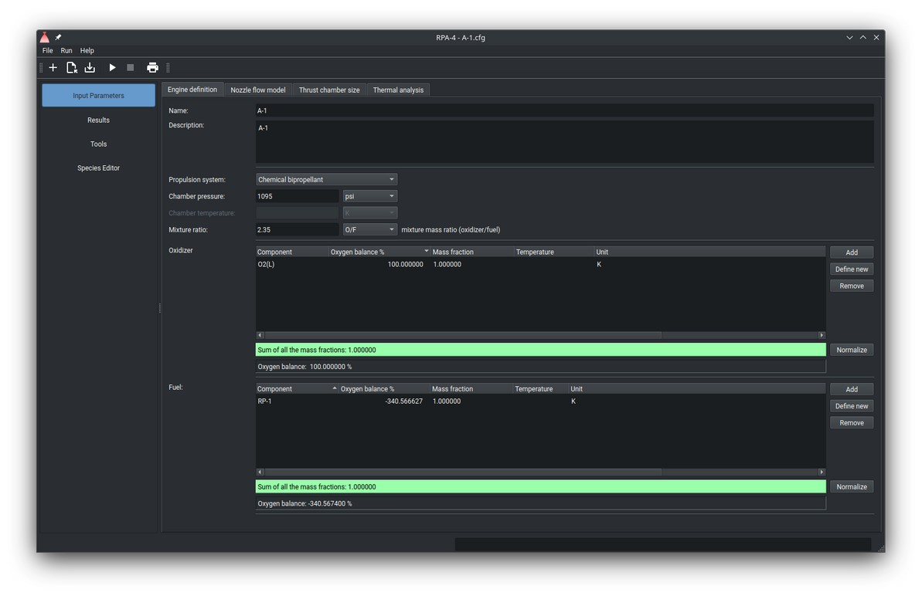
Main window

Using Scripting utility
The scripting utility of RPA allows users to execute custom problems and initiate analyses from the command line.
It supports both interactive and batch modes, providing flexibility for different use cases.
- Interactive Mode: Allows users to interact with the program, input commands, and receive immediate feedback.
- Batch Mode: Enables users to execute a series of commands automatically, ideal for running pre-defined scripts or multiple analyses without manual intervention.
To start the scripting utility, open a command line interface, navigate to RPA installation directory, and type the following command:
RPA-Script.exe
When executed without these arguments --input or --stream, the scripting utility is started in the interactive mode, displaying the prompt rpa>, inviting the user to type valid commands.
Type the command "exit" to stop the utility running in the interactive mode. See Scripting Built-In Commands and Scripting API Reference to get more information about available commands.
To start the scripting utility in the batch mode, use the command-line arguments --input or
--stream to specify the code to be executed in the batch mode. After completion, the scripting utility prints out the results in the console window, writes the log file (if applicable), and exits.
See Scripting API Reference to get more information JavaScript API used to create the batch scripts.
The available command-line arguments are shown below:

Option | Value | Description
-h or --help |  | Display help
-v or --version |  | Display version information
--std_thermo | FILE | Path to standard thermodynamic database file. Default is resources/thermo.inp
-t or --usr_thermo | FILE | Path to user-defined thermodynamics database file. Default is resources/usr_thermo.inp
--std_properties | FILE | Path to properties database file. Default is resources/properties.inp
-p or --usr_properties | FILE | Path to user-defined properties database file. Default is resources/properties.inp
--std_transport | FILE | Path to transport properties database file. Default is resources/trans.inp
--input | FILE | Path to script file to be executed

Option | Value | Description
--debug |  | Print out debug log to console. Can be useful for troubleshooting
--stream |  | Execute script code from input stream

Configuration Files
The input data for analysis problems is stored in the configuration files with extension .cfg. The configuration file has a JSON format, that can be viewed/edited in any ASCII text editor.

Create a Configuration File
- Click File and then New in the menu bar, or
- Click the New icon on the toolbar.

Load a Configuration File
- Click File and then Open in the menu bar, or
- Click the Open icon on the toolbar.
- Select the file you wish to open.
If another configuration file is already open, or a new one has been created, a dialog window will appear to confirm the opening of another configuration file.

Save the Current Analysis
- Click File and then Save in the menu bar.
- If the current analysis problem is new, you will be prompted to specify a file name or select an existing file to overwrite. Otherwise, the data will be saved to the previously opened file.

Save As Another File
- Click File and then Save As... in the menu bar.

Recent Files
- The last 15 used files are listed at the bottom of the File menu in the menu bar for quick access.
- The most recently used configuration file is automatically opened when the program starts.

Example Configuration Files
- The program includes several example configuration files located in the directory
examples inside the installation directory.

Migrating Configuration Files
Configuration files created for earlier versions of RPA are not compatible with the JSON format used in RPA 4. To convert these configuration files, use the provided script examples/scripting/migrate_cfg.js with two arguments:
Input file path: Path to the old configuration file.
Output file path: Path where the new JSON configuration file will be saved. Example usage:
RPA-Script.exe --input ./examples/scripting/migrate_cfg.js old_config.cfg new_config.cfg

Engine Definition
The screen Engine Definition is used to define the parameters:
- Case name and description
- Propellant specification
  - Propulsion system:
    - Chemical bipropellant propulsion,
    - Chemical monopropellant propulsion, or
    - Thermal propulsion
  - Propellant composition

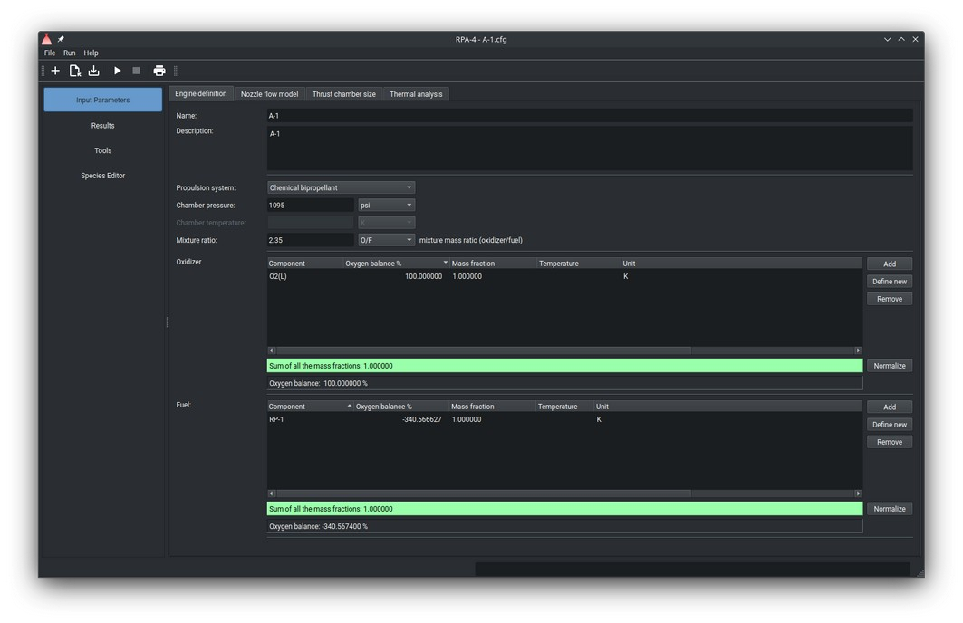

Engine Definition screen

For bipropellant systems, the lists for both Oxidizer and Fuel are enabled, as well as the fields for specifying a mixture ratio. The mixture ratio can be specified in one of two ways:
O/F ratio: The ratio of oxidizer flow rate to fuel flow rate.
Oxidizer excess coefficient: The ratio of the desired O/F to the stoichiometric O/F.
The "optimum" type of mixture ratio can be used to optimize the mixture ratio for maximum specific impulse. The obtained optimum O/F ratio will be displayed on the Results/Thermodynamics screen.
For monopropellant systems, only the list of Propellant components is enabled. The Fuel list and the fields for specifying the mixture ratio are disabled.
Note: For the thermodynamic analysis, the only difference between a bipropellant system and a monopropellant system (that contains more than one species) is how the mixture composition is defined. Any bipropellant system (as well as three- or more propellant systems) can be defined as a monopropellant system by specifying the proper mass fraction for each component on the list.
For example, the following "monopropellant" configuration is equivalent to the bipropellant one with O/F=0.7245/0.2755=2.63:
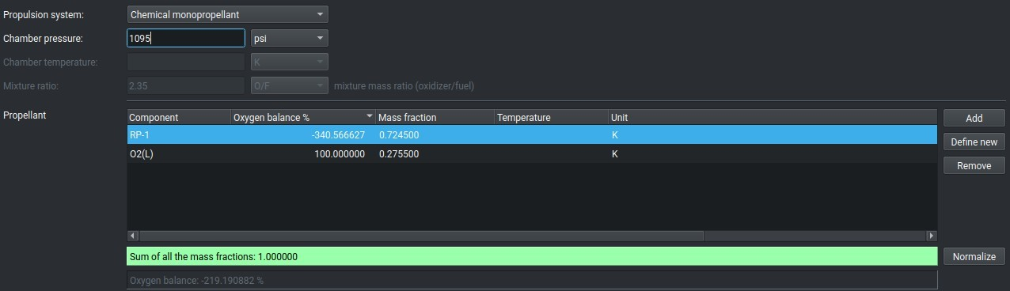

Each component list (Oxidizer and Fuel, or Propellant) may contain one or more species, displayed on the single row. To add species to the list, click the button Add on the right side of the corresponding list.
After clicking the button Add, the dialog window "Components" appears.
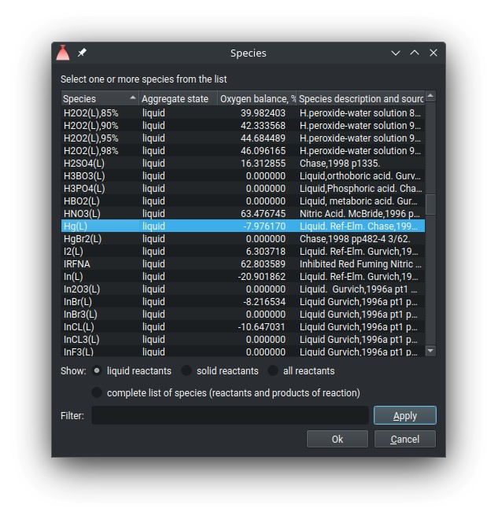
The user can filter the list in the dialog window using a filter pattern. The filter pattern is applied to columns “Species” and “Species description and source data references”.
Mark the check box "complete list of species (reactants and products of reaction)" to see all species, including atomized and/or ionized products of the reaction. Leave it unmarked to see only possible propellant components.

To add species:
Select one or more species from the list. Click the button OK.

To cancel:
Click the button Cancel to leave without adding any species.

To remove species:
Click the button Remove to delete the selected species from the list.

To add new species:
Click the button Define new.
Each component on the list features four parameters:

- Component name
- Oxygen balance
- Mass fraction
- Temperature of the component

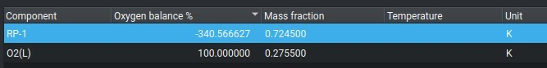

The parameter Mass fraction is required. To modify the value, double click the corresponding cell of the row.
When composing a multi-component mixture, ensure that the sum of all the mass fractions of components on the same list equals 1. Each list includes an automatic mass fraction checker, which displays the current sum at the list footer. If the sum is correct, the footer's background color is light-green; if incorrect, the color is light-red:

The initial temperature of the component can be specified in the column “Temperature”. This is an optional parameter; if not specified, the default standard temperature will be assigned automatically. To add/modify the value or unit, double click the corresponding cell of the row.

Nozzle Flow Model
The code can either calculate the combustion parameters in the combustion chamber, or perform the complete engine performance analysis, analyzing the nozzle flow, performing the thrust chamber sizing and thermal analysis.
Clear the check box "Nozzle conditions", in order to perform combustion analysis only, or mark it to perform the nozzle flow analysis followed by thrust chamber sizing and thermal analysis (if configured):
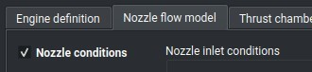

Nozzle conditions
To solve the nozzle flow problem, define at least one of the nozzle exit conditions by specifying one of the following three parameters:

- Nozzle exit pressure
- Nozzle expansion area ratio
- Nozzle expansion pressure ratio
.
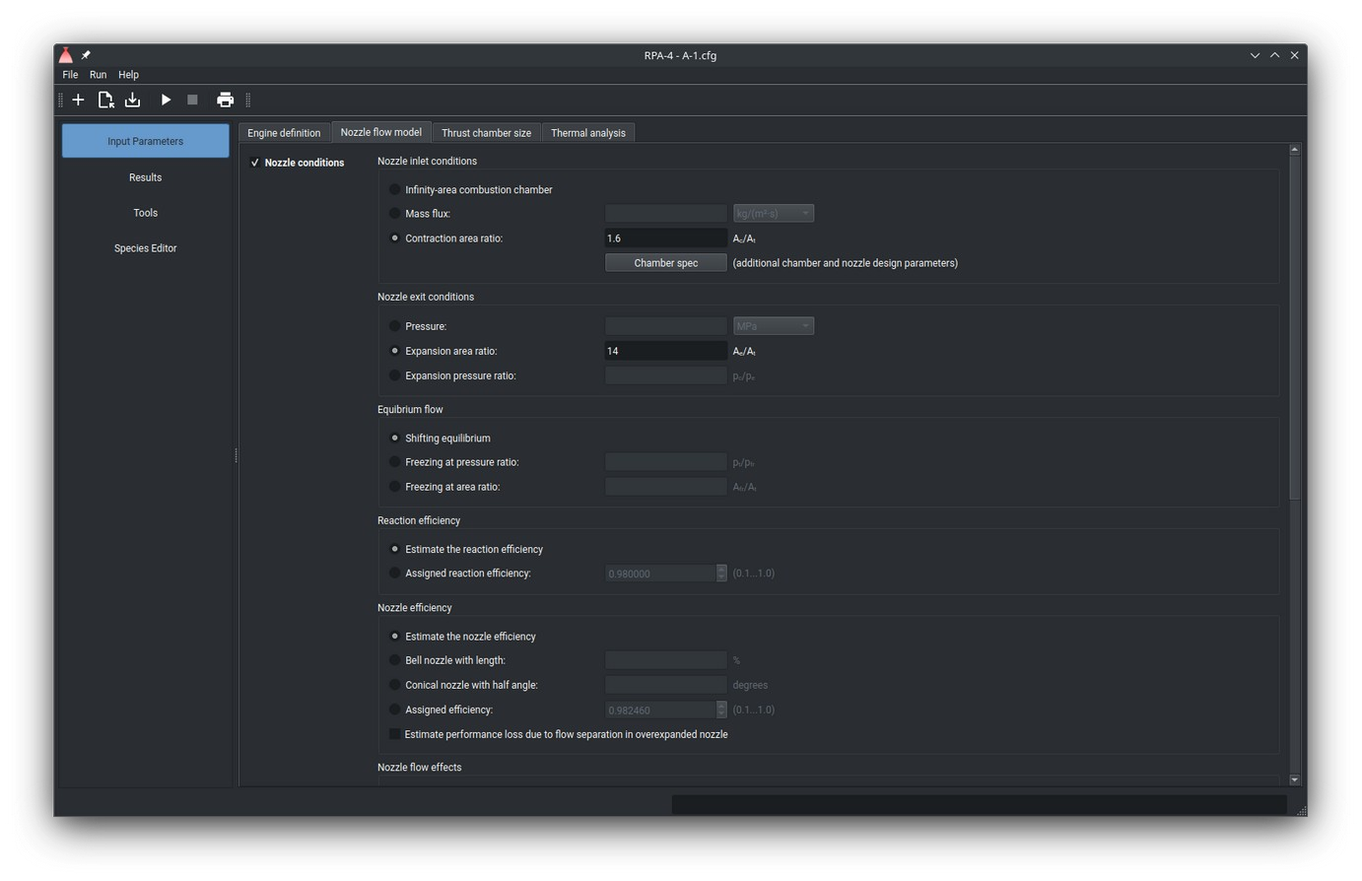
Nozzle conditions

The code can calculate the performance for a combustion chambers with fixed or infinite cross section area. The default model assumes the infinite cross section area of the chamber. To switch to the fixed-area model, mark the check box "Nozzle inlet conditions", and then specify the chamber contraction area ratio ( Ac/At ) or mass flux ( m_dot/Ac ) in the combustion chamber.
If the nozzle inlet and exit conditions are specified, they are also used for thrust chamber sizing, along with additional parameters provided on the screen Thrust chamber size.
The code can calculate the performance for the shifting and frozen chemical equilibrium in the nozzle. The default model assumes the shifting chemical equilibrium in the whole nozzle. To switch to the frozen chemical equilibrium model, mark one of the two check boxes
- Freezing at pressure ratio
- Freezing at area ratio
and then specify the value for selected condition. The frozen chemical equilibrium model will be applied to all nozzle stations downstream of the specified conditions: expansion pressure ratio or expansion area ratio.

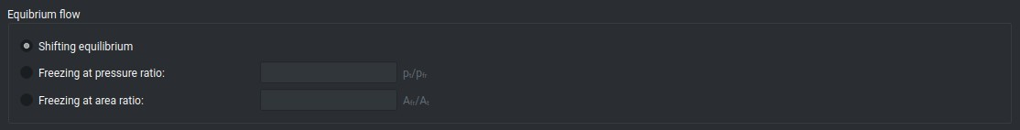

By default, the code calculates the parameters at following nozzle stations:
- nozzle inlet
- nozzle throat
- nozzle exit
Additional nozzle stations can be added by pressing the button Add on the right side of the list “Nozzle stations”, and defining the conditions by double-clicking the corresponding cells of the row:
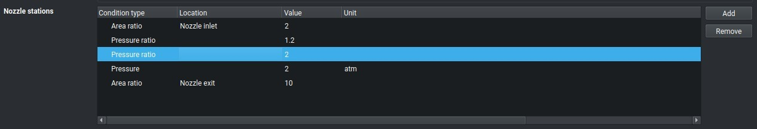

Delivered performance
The code calculates both theoretical and estimated delivered engine performance. The user can define Reaction efficiency and Nozzle efficiency.
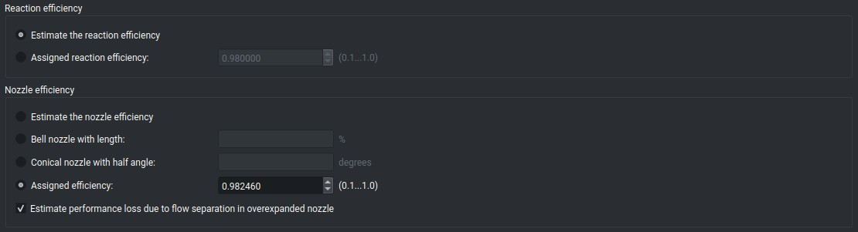

Reaction and nozzle efficiency

The code can assess effects of multiphase flow and ionization:

Switch off the flag Multiphase flow and phase transition in order to suppress the calculation of multiphase flow effects. Note that for the most of solid propellant problems this flag should be switched on.
Switch off the flag Ionization effects in order to to suppress the calculation of species ionization effects.

Ambient conditions
By default, the code calculates the performance of the thrust chamber at the following ambient conditions specified by ambient pressure (pa):
- Sea level (SL) conditions (pa=1 atm, or 14.7 psi)
- Optimum nozzle expansion (pe=pa)
- Vacuum conditions (pa=0)
To calculate the performance at the additional ambient conditions, the user can specify
- fixed ambient pressure
- range of ambient pressures given as high and low range values as well as number of steps between.
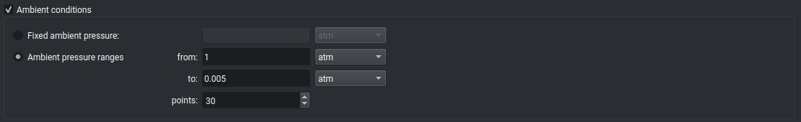
Ambient conditions

Throttle settings
By default, the code calculates the performance of the thrust chamber assuming the propellant flow rate does correspond to the nominal thrust.
To calculate the performance at the additional throttling values, the user can specify
- fixed throttle value
- range of throttle values given as high and low range values.


Throttle settings
The throttling value is a ratio of the propellant flow rate at desired throttling setting to the flow rate at the nominal thrust. Throttling value for the nominal trust R=1.0

Thrust Chamber Size

Thrust Chamber Sizing

The code can estimate the size of the combustion chamber and nozzle matching one of the following design criteria:
- Nominal thrust at a certain ambient pressure
- Nominal mass flow rate
- Nozzle throat diameter
The input of parameters on the screen is only enabled if the flags "Thrust chamber size" is switched on:
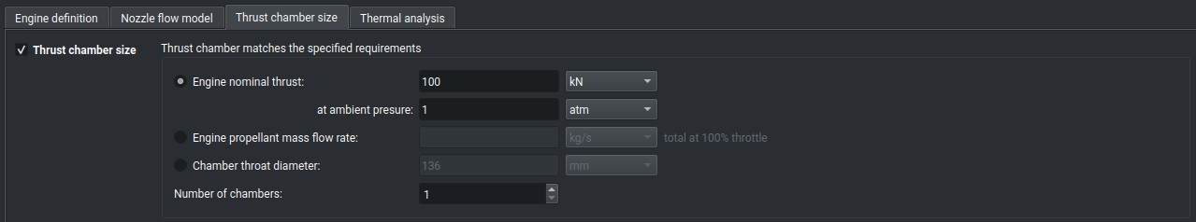

Chamber and nozzle sizing parameters

If the specified number of chambers is greater than 1, the given thrust is a total engine thrust, and the given mass flow rate is a total mass flow rate. The thrust or mass flow rate of a single thrust chamber is obtained by dividing the design parameter value by the number of chambers.
If the ambient pressure is not specified, it is assumed that the engine nominally operates in vacuum condition (pa=0).

Combustion Chamber Geometry
Set of parameters is used to specify the size of a caylindrical combustion chamber from the injector plate to the nozzle throat.
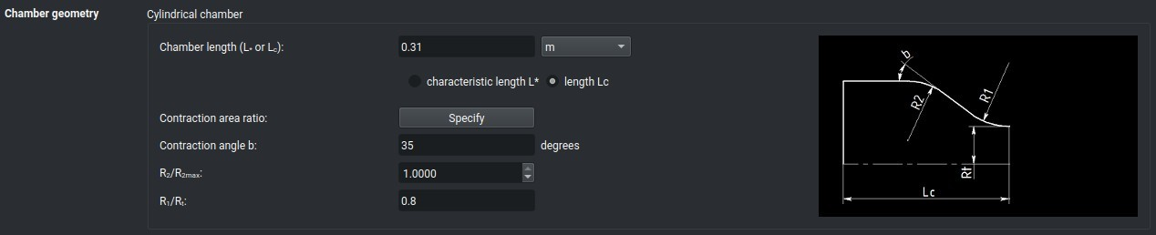

Chamber geometry parameters
A simplified drawing with labeled dimensions on the right side helps to identify the meaning of parameters.

Nozzle Geometry
Set of parameters is used to specify the size of a cylindrical nozzle from the nozzle throat to the nozzle exit.
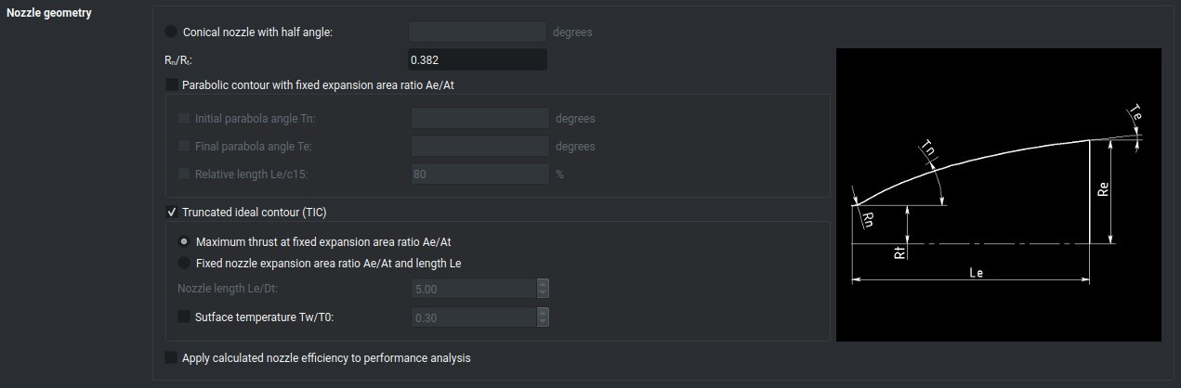
Chamber geometry parameters

Available options to design the nozzle shape include:
- Conical nozzle contour
- Parabolic nozzle contour
- Truncated ideal contour (TIC) calculated by axisymmetric method of characteristics (MOC)
A simplified drawing with labeled dimensions on the right side helps to identify the meaning of parameters.

Thermal Analysis
On the screen Heat Transfer Parameters the user can define heat transfer parameters used to calculate the heat transfer rate distribution in the thrust chamber.
The input of parameters on the screen is only enabled if the flags "Heat Transfer" is switched on.
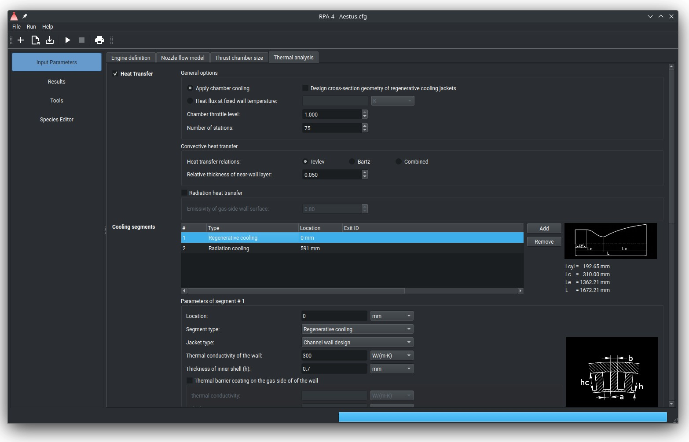
Heat transfer parameters
Option “Apply chamber cooling” triggers the estimation of the temperature and heat flux distribution by applying the specified cooling.
Option “Heat flux at fixed wall temperature” triggers the estimation of the heat flux distribution at a specified constant temperature of the gas-side wall surface.
The parameter “Chamber throttle level” defines the throttling level of the engine. This parameter affects the conditions in the combustion chamber and the mass flow rate through the cooling jackets.
The parameter “Number of stations” defines the number of stations evenly distributed along the thrust chamber. The program automatically inserts stations at the nozzle inlet, nozzle throat, location of film cooling slots, and location of cooling section begin/end.
The program offers two methods for calculating gas-side convective heat transfer rates:

- Ievlev approach.
- Bartz approach.
The user can choose between these two methods or a combined approach, which calculates the resulting heat transfer rate as the average value from the Ievlev and Bartz methods.
The program can perform thermal analysis by calculating heat flux either as convective heat transfer only or by summing the contributions of both convective and radiation heat transfers. For the latter, the user must specify a radiation emissivity coefficient for the wall's inner surface.

Cooling segments
The table Cooling segments contains the list of cooling segments. By clicking the row, the parameters of corresponding cooling segment are displayed below the table, available for modification.
On the right side of the table, the sketch of the thrust chamber with labeled dimensions is displayed to make the definition of cooling segments easier. Note that the dimensions are only available after the first run of the program with enabled thrust chamber sizing parameters.
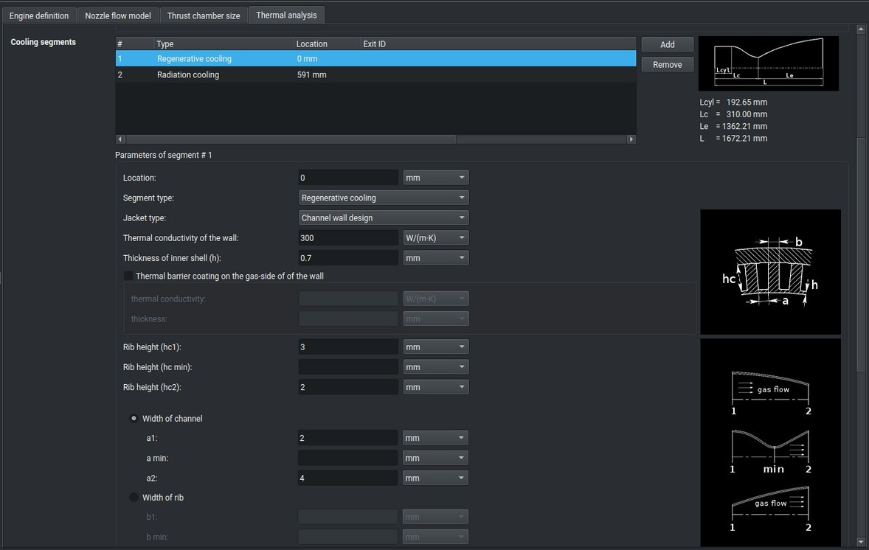
Cooling segments

The user can add new segment pressing the button Add, or delete existing segment pressing the button Remove or keyboard key “Del”.
Note: new cooling segment is always created with type “Radiation cooling”. The user can change the type of the segment by clicking the created segment and changing the type in the parameters area below the table.
To view all parameters assigned to of the existing cooling segment, or to change the type of the segment or modify its parameters, click the segment on the list. All parameters of the segment will be displayed in the parameters area below the table.

The order number of the currently edited segment is displayed at the top of the parameter area.
When the parameters are modified, they are assigned to the selected segment automatically.
The user has to define the location of the each cooling segment or film cooling slot, specifying the distance from the injector plate to the beginning of the segment, or location of the film slot. The length of the cooling segment is defined implicitly by specifying the location of the next cooling segment. If the next segment is not defined, the end of the segment is defined by the nozzle exit.
The program supports 3 types of chamber cooling:
- radiation cooling
- regenerative cooling
- film cooling.

Radiation Cooling
A radiation-cooled chamber transmits the heat from the outer surface of the chamber or nozzle. Radiation cooling is typically used for small thrust chambers made of a high- temperature material, or in low-heat flux regions, such as a nozzle extension.
Configuration of the radiation-cooled section includes the following parameters:

• | location of the section | required
• | wall thickness and thermal conductivity | required
• | thermal barrier coating layer thickness and thermal conductivity (see also Thermal Barrier Coating Layer) | optional
• | radiation emissivity coefficient of the wall outer surface | required
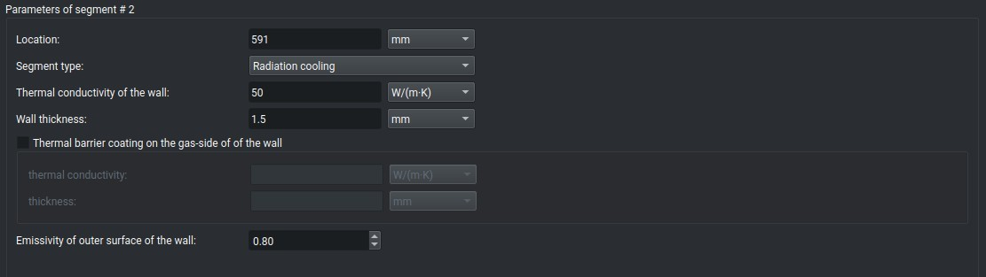
Radiation cooling parameters

The radiation-cooled segment can be combined with a film cooling.

Regenerative Cooling
Regenerative cooling is the most widely used method for cooling a thrust chamber. This

method involves flowing high-velocity coolant over the back side of the chamber's hot gas wall to convectively cool the hot liner. The coolant, after absorbing heat from cooling the liner, is typically discharged into the injector and utilized as a propellant.
Configuration of the regenerative cooling segment includes the following parameters:
- location of the section required
- type of design required
- outlet/exit ID required if the exit from
the segment is hydraulically connected with the input of another regenerative cooling segment
- wall thickness and thermal conductivity required

- thermal barrier coating layer thickness and thermal conductivity (see also Thermal Barrier Coating Layer)
- coolant definition:
component/s, initial temperature and pressure, relative mass flow rate
or
connection with exit of another regenerative cooling segment, specified by its ID
optional required

- flag of opposite flow direction optional
- flag of two-pass coolant flow optional
- wall roughness height / step optional
The regenerative-cooled segment can be combined with a film cooling. The program supports following types of regenerative cooling design:
  - coaxial shell jacket design
  - tubular wall jacket design
  - channel wall jacket design.

Coolant definition
The list of the coolant components contains one or more species. To add species to the list, click the button Add at the bottom of the corresponding list. To remove the selected species from the list, click the button Remove.

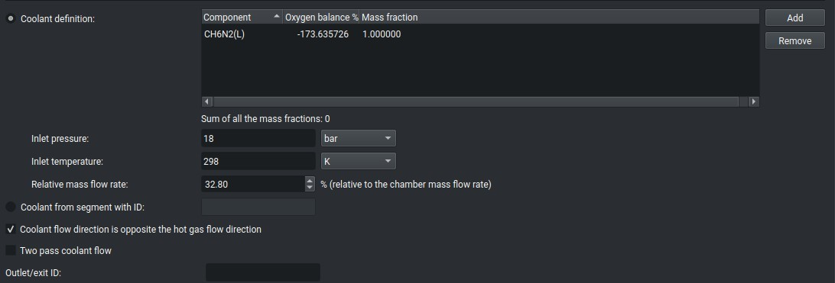

Note: only use the components available in the configuration files properties.inp or usr_properties.inp, because the extended NASA database does not include all required properties such as viscosity, thermal conductivity, density, temperature of vaporization/decomposition and heat of vaporization of liquid components.
Alternatively, the user can configure the connection between the inlet of the current segment with the exit of another segment by specifying its ID. In this case, the coolant components and mass flow rate will be the same as those defined for the first segment. The initial temperature and pressure for the current segment will be equal to the temperature and pressure at the exit of the first segment, as calculated during the thermal analysis.

Coaxial Shell Jacket Design
Design-specific configuration of the segment includes the following parameters:

• | distance between inner and outer walls | Required

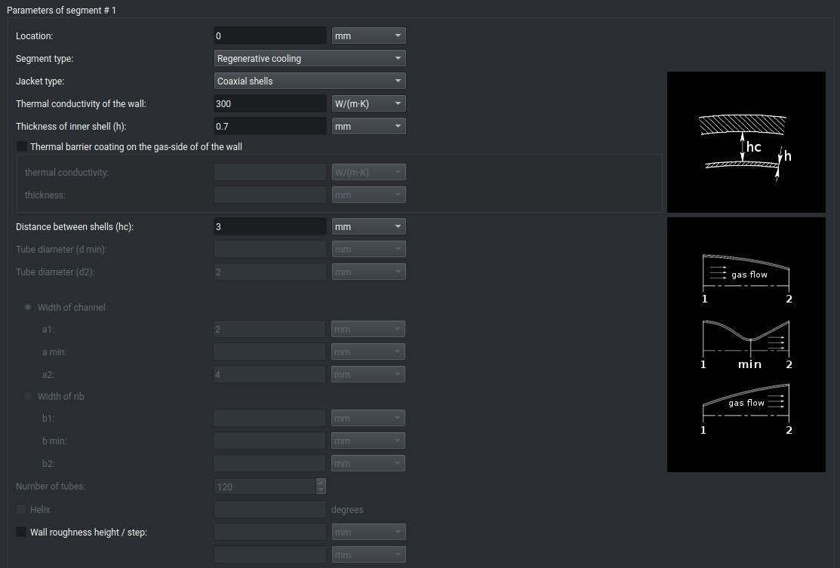
Coaxial shell jacket parameters

The program supports segments with a constant distance between the walls. To simulate a chamber with a variable inter-wall distance, define multiple segments, each with a different inter-wall distance.
Typical issues with configuration:
  - too small inter-wall distance, or too large coolant mass flow rate leads to a high pressure drop; the message "Negative pressure drop" appears;
  - due to too large inter-wall distance or too small mass flow rate, the program cannot converge the solution.
Possible solution: change one or several relevant parameters.

Tubular Wall Jacket Design
Design-specific configuration of the segment includes the following parameters:

• | diameter of tube “d1”, “d2” at both sides of the segment | required
• | diameter of tube “d min” at minimal diameter of the segment | optional; can be defined if a nozzle throat is located within the current segment
• | tube wall thickness “h” and thermal conductivity | required
• | number of tubes | required
• | flag of helical tube wall jacket design | required

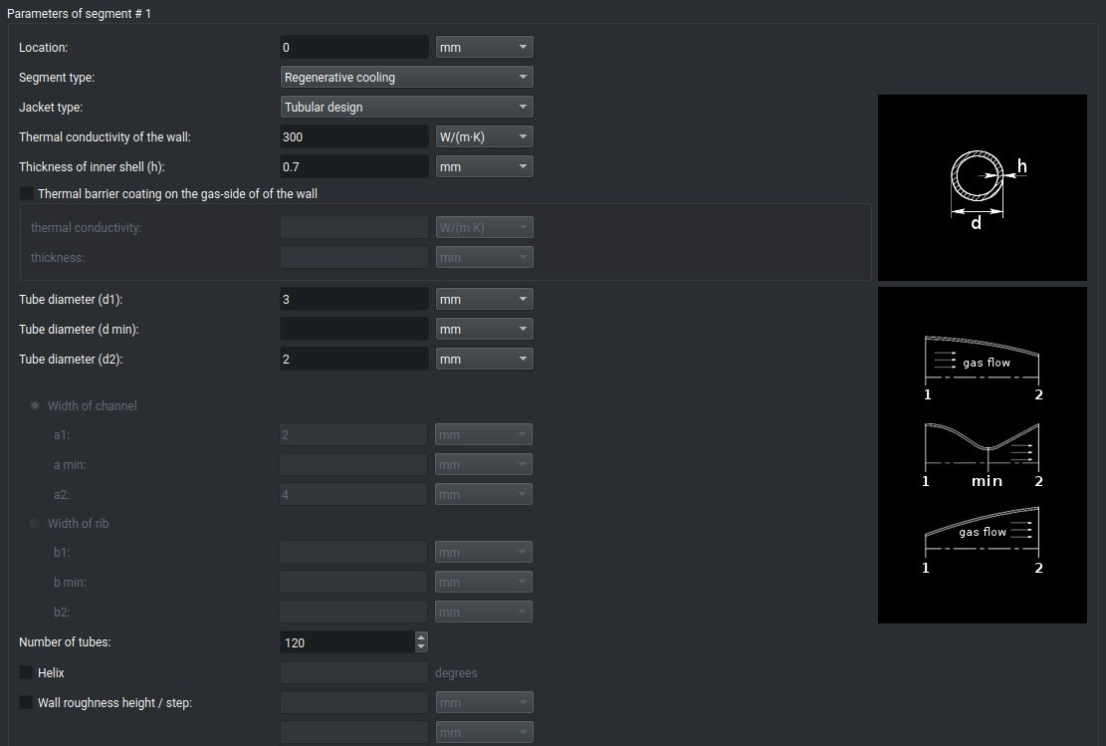
Tube wall jacket parameters

The program supports segments with a constant number and variable diameter of the tubes. To simulate a chamber with a variable number of tubes, define multiple segments, each with different corresponding parameters.
Typical issues with configuration:
  - inappropriate number or diameter of tubes, or too high coolant mass flow rate leads to a high pressure drop; the message "Negative pressure drop" appears;
  - due to inappropriate number or diameter of tubes, or too small mass flow rate the program cannot converge the solution.
Possible solution: change one or several relevant parameters, or replace the single cooling segment with two or more segments with optimum parameters.

Channel Wall Jacket Design
Design-specific configuration of the segment includes the following parameters:

• | height of ribs “hc1”, “hc2” at both sides of the segment | required
• | height of ribs “hc min” at minimal diameter of the segment | optional; can be defined if a nozzle throat is located within the current segment
• | width of channels “a1”, “a2” at both sides of the segment | required
• | width of channels “a min” at minimal diameter of the segment | optional; can be defined if a nozzle throat is

- number of channels “n” or
width of ribs “b1”, “b2” at both sides of the segment
located within the current segment
required

- width of ribs “b min” at minimal diameter of the segment optional; can be defined
if a nozzle throat is located within the current segment
- helix angle optional
Note: index "1" corresponds to the parameters at the section end which is closer to injector plate; index "2" corresponds to the parameters at the section end which is closer to nozzle exit.
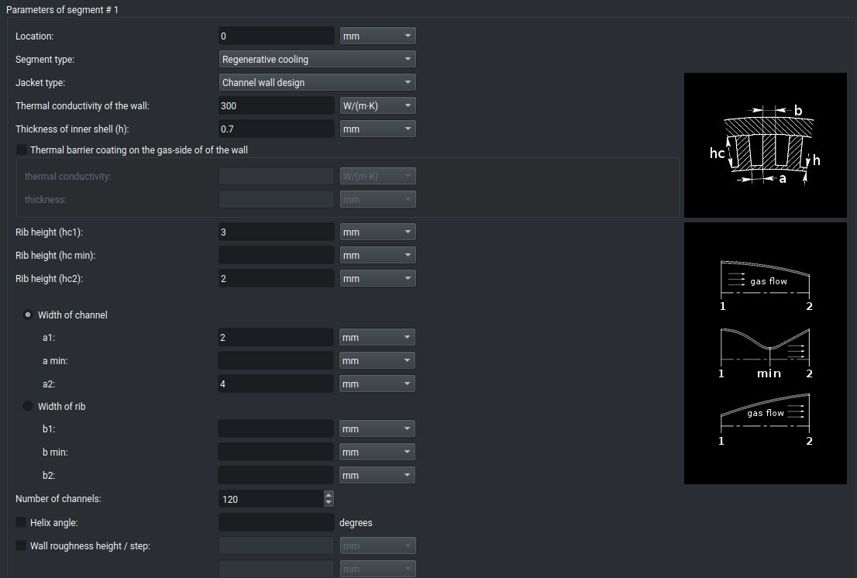
Channel wall jacket parameters

The program supports segments with a constant number of channels, and helix angle. To simulate a chamber with a variable number of channels and/or angle, define multiple segments, each with different corresponding parameters.
Typical issues with configuration:
- inappropriate geometry and/or number of channels, or too high coolant mass flow rate leads to a high pressure drop; the message "Negative pressure drop" appears;
- due to inappropriate geometry and/or number of channels, or too small mass flow rate

the program cannot converge the solution.
Possible solution: change one or several relevant parameters or replace the single cooling segment with two or more segments with optimum parameters.

Film Cooling
Film cooling provides protection from an excessive heat by introducing a thin film of the coolant through orifices around the injector periphery or in the chamber wall. This method is typically used in a high heat flux regions in combination with regenerative or radiation cooling.
Configuration of the film cooling includes the following parameters:
- location (the distance from the injector plate) required

- coolant definition: component/s, initial temperature,
relative mass flow rate
required

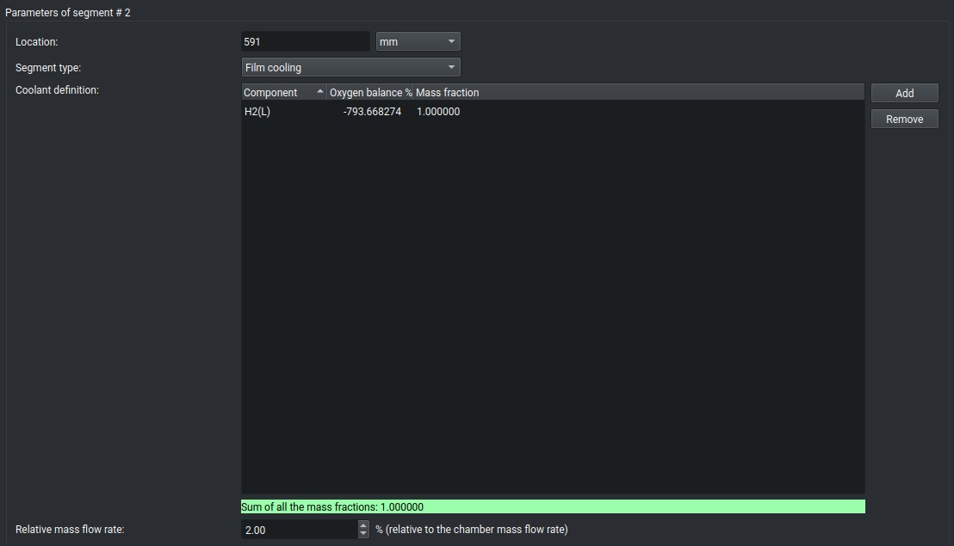
Film cooling parameters

Both liquid and gaseous species can be used as a film coolants.

Thrust chamber with multiple cooling segments
For one chamber, multiple cooling segments can be defined
  - to combine different types of cooling (e.g. regeneratively cooled combustion chamber + radiation cooled nozzle extension + one or more film cooling);
  - to optimize parameters along the chamber (e.g. number of tubes/channels, tube/channel geometry etc).

Thermal Barrier Coating Layer
The thermal barrier coating (TBC) is used to reduce the temperature gradient across the chamber wall.
The functional principle of a TBC, illustrated in figure below, is to increase the hot gas side wall temperature T_{wg}. This is achieved by applying a ceramic top layer (e.g. Y2O3-stabilized ZrO2, PYSZ) onto the wall base material. The PYSZ ceramic offers a thermal conductivity λ of about 1.5 W/(m K). In order to prevent a coating overheat (>1500 K) coating thicknesses of less than 0.1 mm are required. These high hot gas side wall temperatures compared to the maximum temperatures of the uncoated wall lead to the remarkable reduction in heat flux.
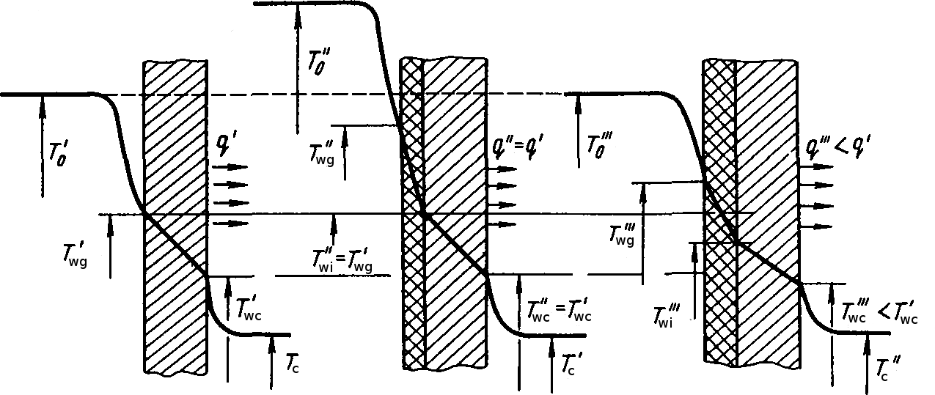
Functional principle of a TBC

With such a protective layer, the application range of existing regenerative or radiation cooling thrust chambers can be enlarged towards higher combustion chamber pressures or an increased thrust chamber life.
In general a TBC acts as an insulator to the inner liner, reducing the wall heat flux into the wall base material.
To analyze the thermal state of the thrust chambers with TBC consisting of several layers with known thicknesses δ1, δ2,... , δN and thermal conductivities λ1, λ2, ... , λN , the effective thermal conductivity λ of the TBC with the thickness ð1+ð 2+...+ð N can be calculated using the following relation:
ð 1+ð2+... ð N
λ = ð ð ð
1 + 2 +...+ N
λ1 λ2 λN

Starting Analysis
The analysis is started by clicking menu Run, and then Start analysis in menu bar, or clicking the icon Run on the main toolbar:


After completing the analysis, the program automatically switches to the screen Results. To print out the results, use the item Run in a menu bar, and then item Print results.
To check the analysis log, use the item Run in a menu bar, and then item Show log. The analysis log in ASCII format is also available as a file in the user directory.
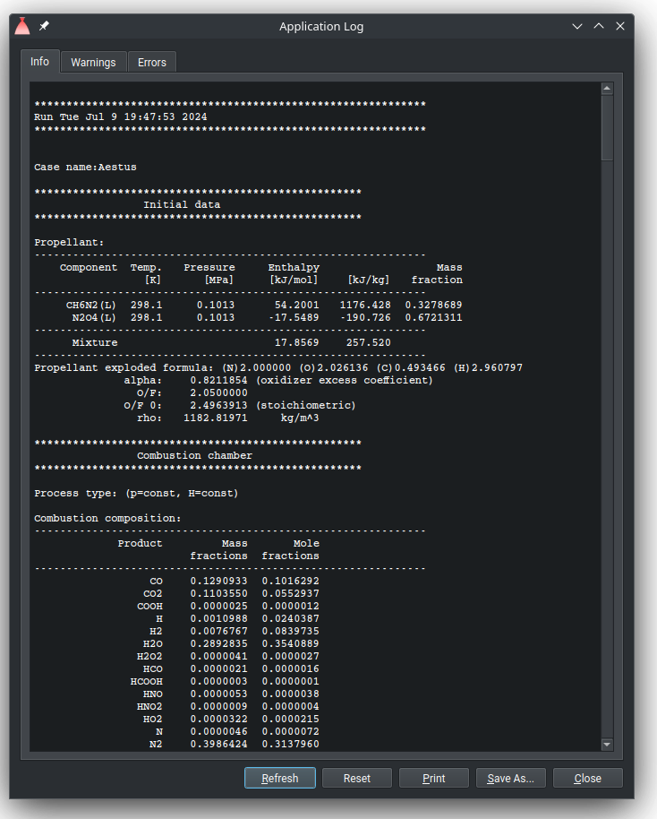
Analysis Log

Results
The screen Results consists of following tabs: Thermodynamics, Combustion products, Performance, Altitude performance, Throttled performance, Thrust chamber size, and Thermal analysis.
To print out the results, use the button Print. To save the results as PDF or HTML file, use the button Save As... Both buttons are placed at the right-bottom corner of the screen.

Thermodynamics
The tab Thermodynamics displays the properties of the propellant and the reaction products

at the chamber stations involved in the analysis.
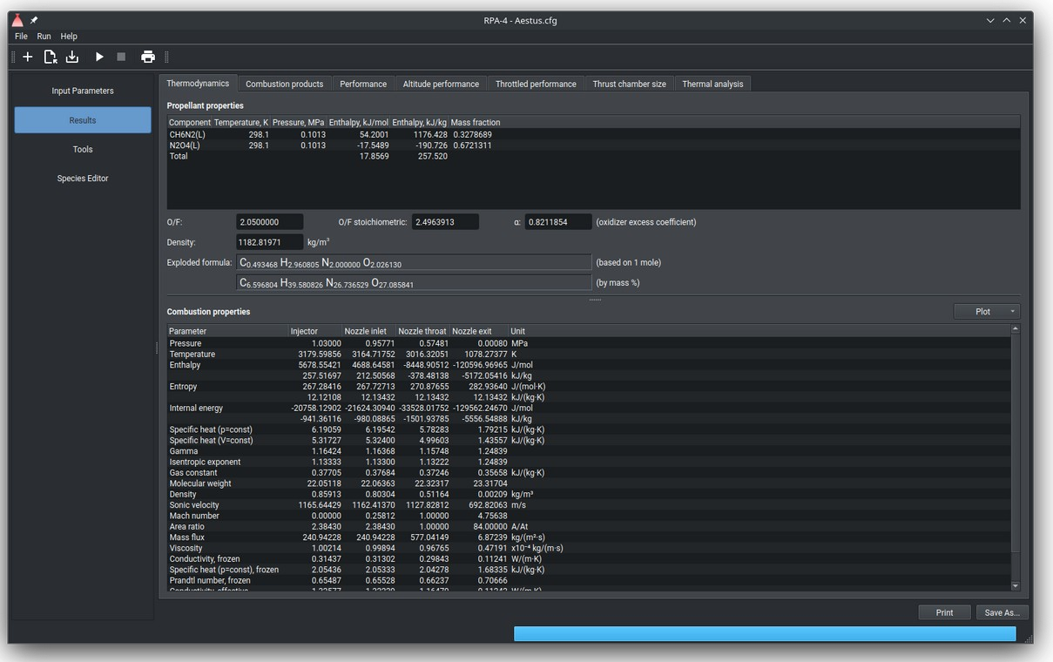
Thermodynamic properties

The following properties of the propellant are available:
- propellant composition with initial parameters of components
- propellant mixture ratio (O/F)
- propellant stoichiometric mixture ratio (O/F),
- oxidizer excess coefficient,
- propellant density (only if density values of all components are available),
- propellant exploded formula.
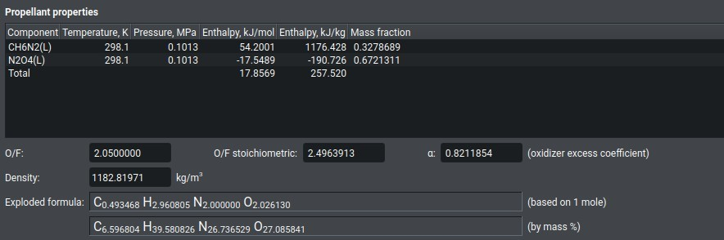
Propellant properties
If the problem is configured to solve the parameters in the combustion chamber (see chapter Nozzle Flow Model), the only available nozzle station is Injector (see figure Injector thermodynamic properties), otherwise the available chamber stations are Injector, Nozzle inlet, Nozzle throat and Nozzle exit as well as additional stations, defined on screen Nozzle Flow Model (see figure Thermodynamic properties above).

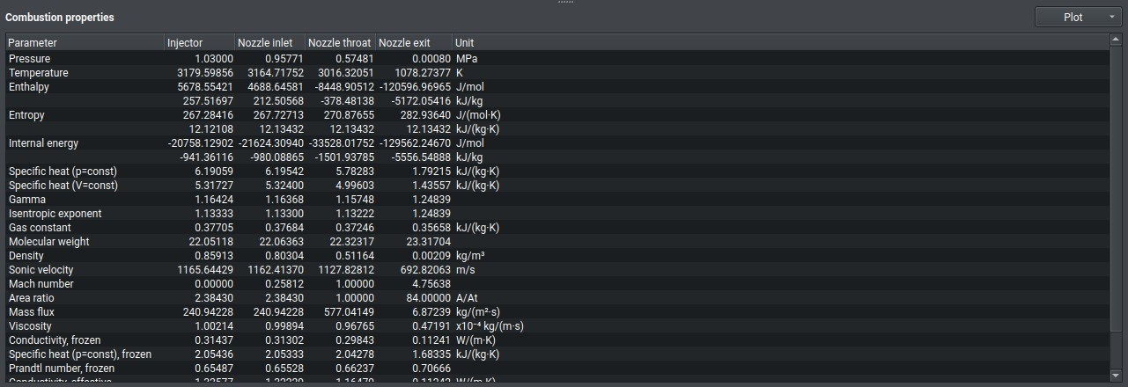
Combustion properties

If the problem is configured to calculate the performance for the combustion chamber with infinite cross section area, the parameters for Nozzle inlet station are identical to that at Injector station.
The thermodynamic parameters are displayed in the current units, defined in the Preferences Dialog.

Combustion products
Screen Combustion products displays the table with products of reaction at each nozzle station.

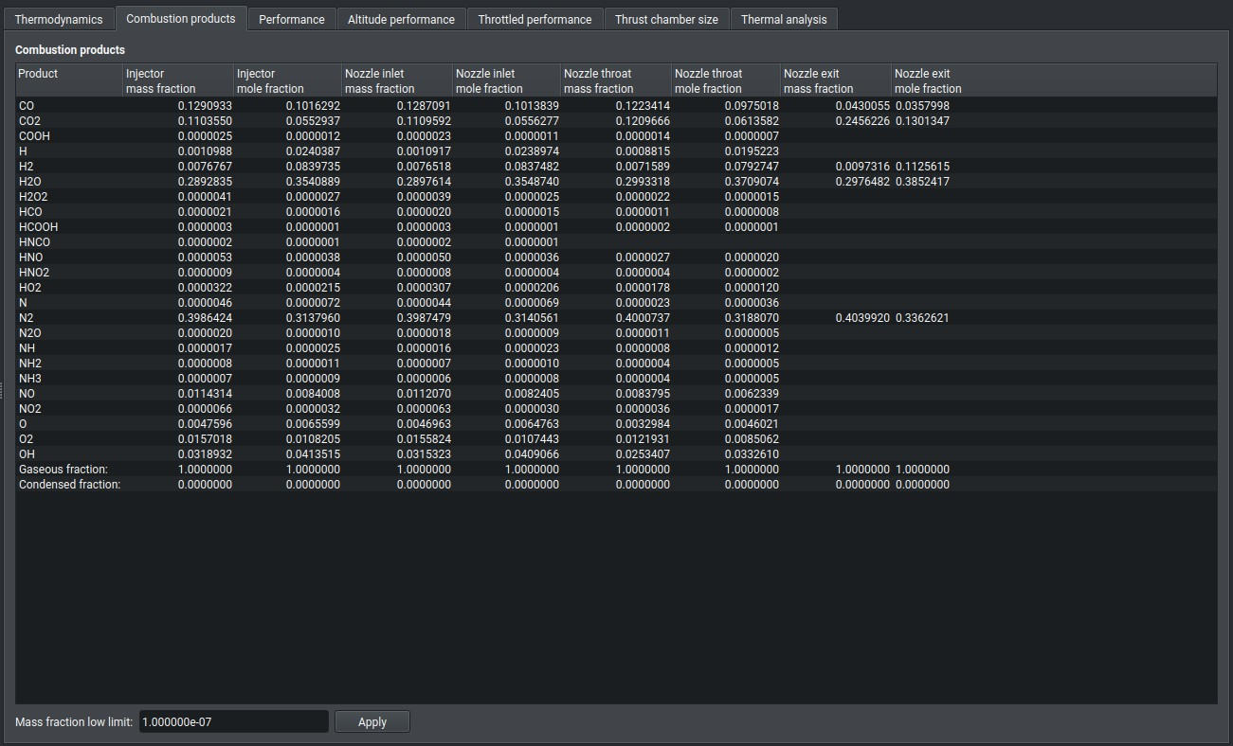
Combustion properties

Performance
The screen Performance displays the theoretical (ideal) performance of the chamber, as well as its estimated delivered performance and the correction factors used to calculate the delivered performance.

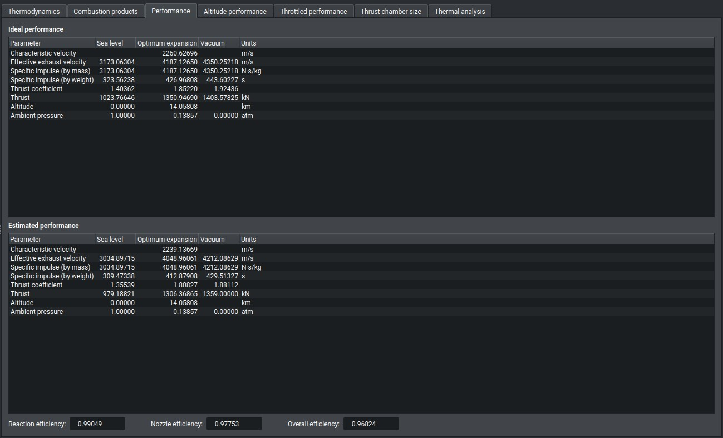
Chamber performance

If the problem is configured to solve the combustion parameters at Injector station (see chapter Nozzle Flow Model), the performance parameters are not available, otherwise the tab displays calculated performance of the chamber at following ambient conditions:
- sea level (SL) conditions (pa=1 atm, or 14.7 psi)
- optimum nozzle expansion (pe=pa)
- vacuum conditions (pa=0).
In case if a flow separation in the nozzle is predicted, the table contains an additional column with the performance at the sea level with respect to the flow separation.

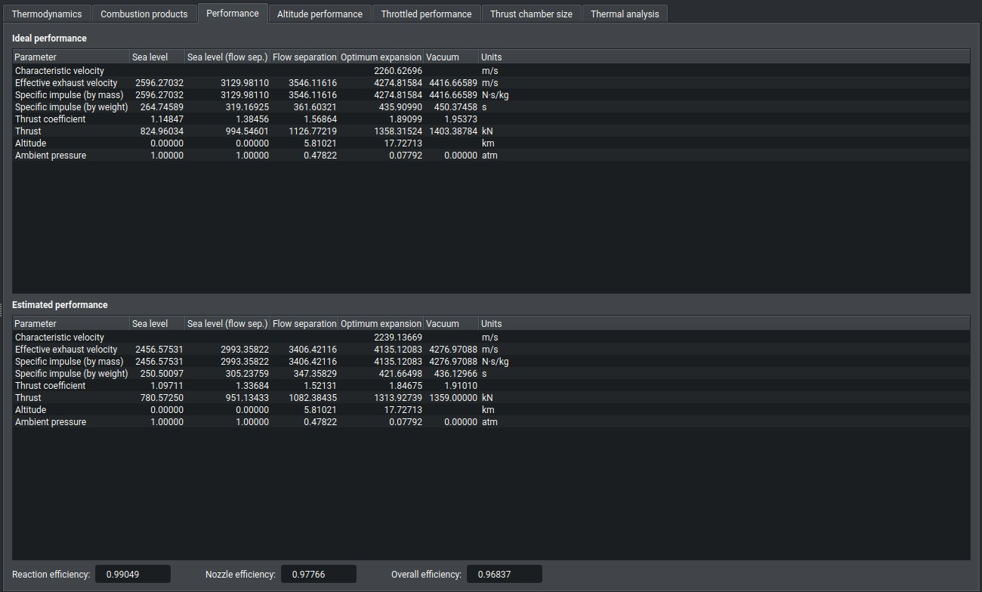
Chamber performance with flow separation

Altitude performance
The tab Altitude performance displays the performance of the thrust chamber at the configured ambient conditions.

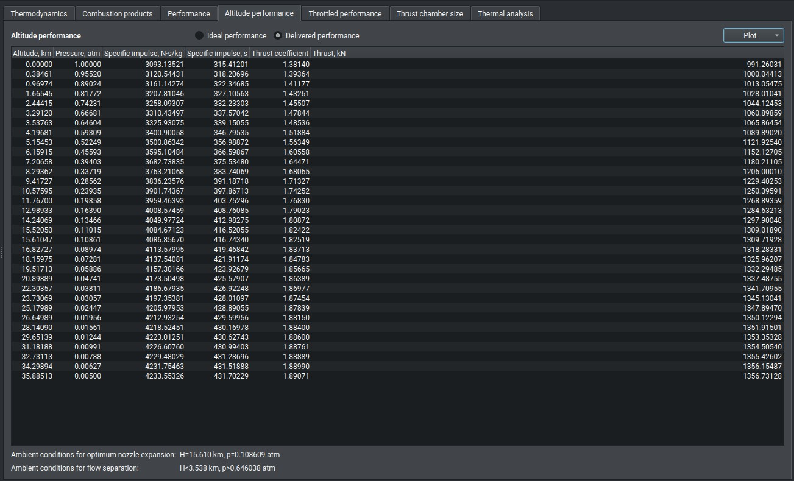
Altitude performance
The code displays the results both for the ideal theoretical performance and the estimated delivered performance.
To plot the diagrams "specific impulse vs. altitude", "thrust coefficients vs. altitude" or "thrust vs. altitude", click the button Plot at the upper-right corner of the tab.

The altitude of an optimum expansion, as well as the altitude of a flow separation (if predicted) are shown on the diagram by corresponding vertical marker line/s.

The performance parameters are displayed in the current units, defined in the Preferences Dialog.

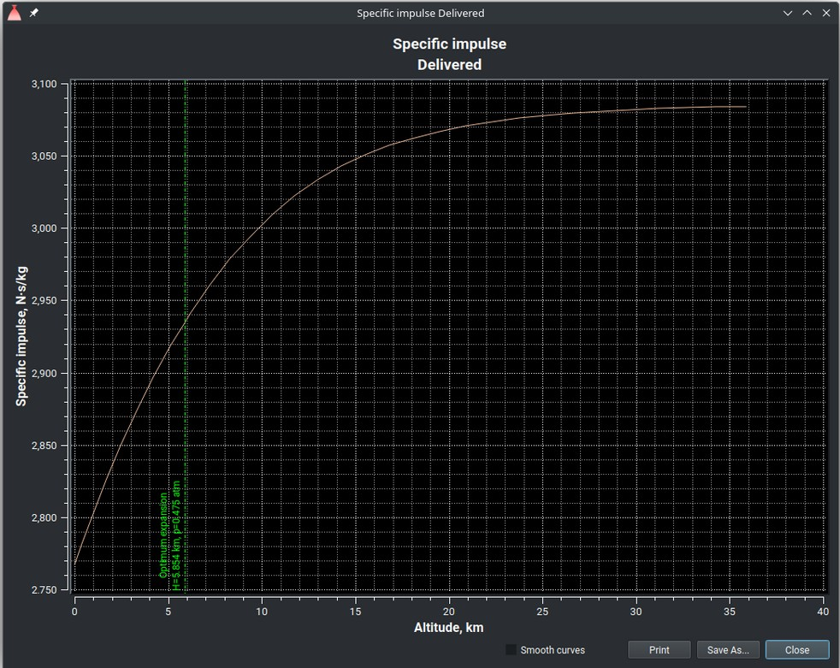  Plot - altitude performance | 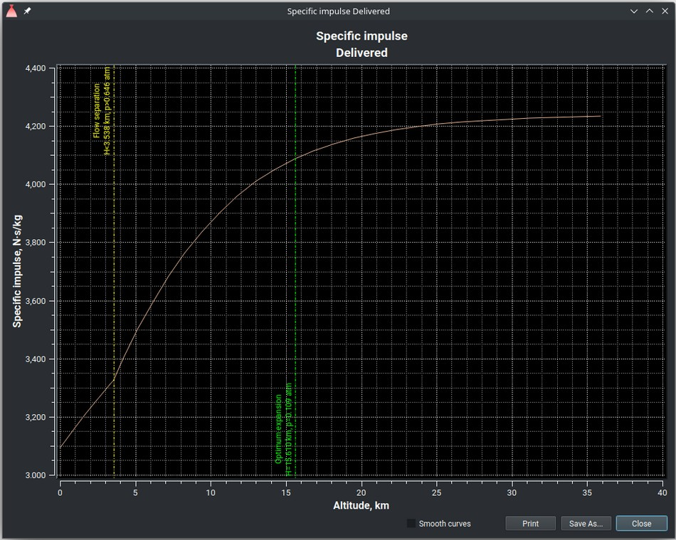  Plot - altitude performance with flow separation

Throttled performance
The tab Throttled performance displays the performance of the thrust chamber at the configured throttling values.
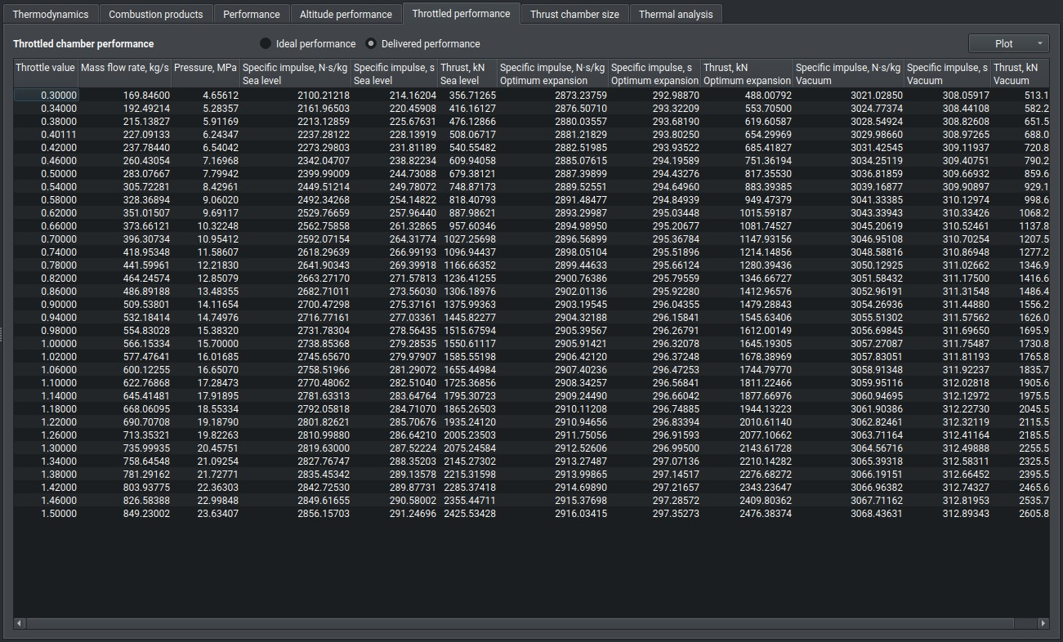
Throttled performance
The code display the results both for the ideal theoretical performance and the estimated

delivered performance.
To plot the diagrams, click the button Plot at the upper-right corner of the tab.
The throttling value with a predicted flow separation is shown on the diagram by vertical marker line.
The performance parameters are displayed in the current units, defined in the Preferences Dialog.
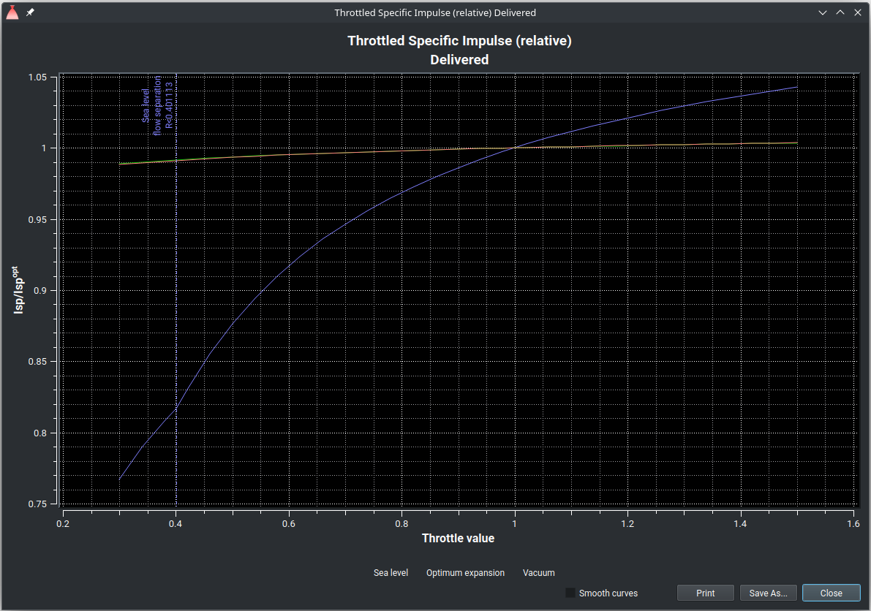
Plot - throttled performance

Nested Analysis
Using the nested analysis, the user can evaluate the performance of the thrust chamber across a range of parameters, with up to four independent variables: component ratio, chamber pressure, nozzle inlet conditions, and nozzle exit conditions.

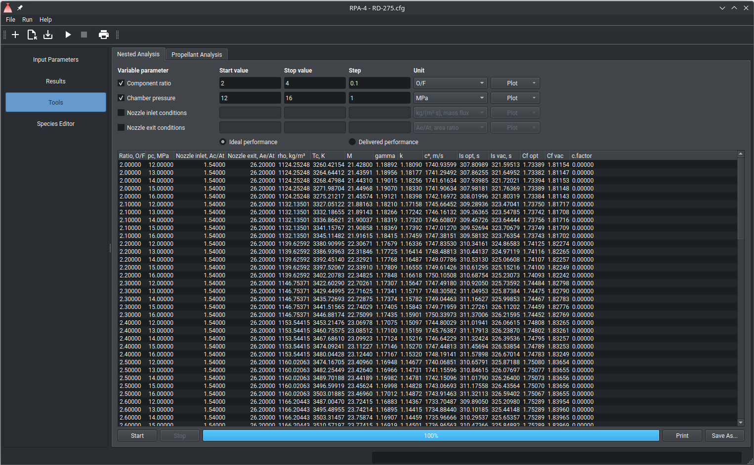
Nested analysis

Nested analysis inherits the initial configuration parameters defined on the screens Engine Definition, Propellant Specification, and Nozzle Flow Model. The user may define up to four variables parameters to replace the corresponding parameters in the initial configuration. To start the nested analysis, click the Start button at the bottom-left corner of the tab.
Note: since the program performs the thermodynamic analysis for each unique combination of variable parameters, using small step size can result in very long execution time.
The code displays the results both for the ideal theoretical performance and the estimated delivered performance.
The program performs thermodynamic analysis for each unique combination of variable parameters, stepping it by defined value, and displaying the results in a table at the bottom of the tab. The progress of the nested analysis is indicated by a progress bar at the bottom of the tab. To stop the running analysis, click the Stop button.
After finishing the nested analysis, the user can plot the diagrams "specific impulse vs. variable parameter", "chamber temperature vs. variable parameter", "characteristic velocity vs. variable parameter" or "thrust coefficient vs. variable parameter" by clicking the button Plot at the right side of the corresponding parameter configuration.

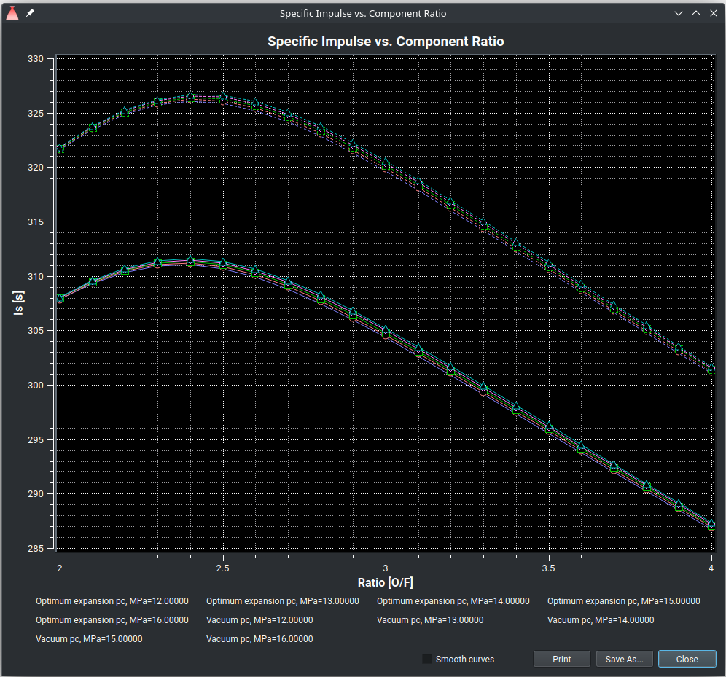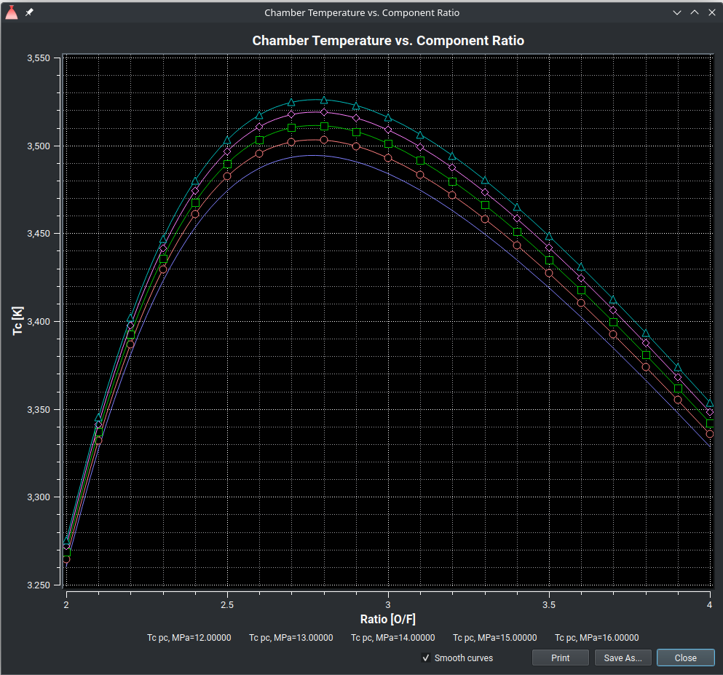
Nested analysis plots

To print out the results of the nested analysis, click the button Print. To save the results as ASCII, HTML, or PDF file, click the button Save As... Both buttons are located at the right- bottom corner of the screen.
The defined parameters of the nested analysis are stored in the INI-file and shared between different configurations for the same user.
The defined parameters are not stored in the current configuration file.

Propellant Analysis
Using the propellant analysis tool, the user can evaluate different propellant compositions by sequentially replacing one component with another.

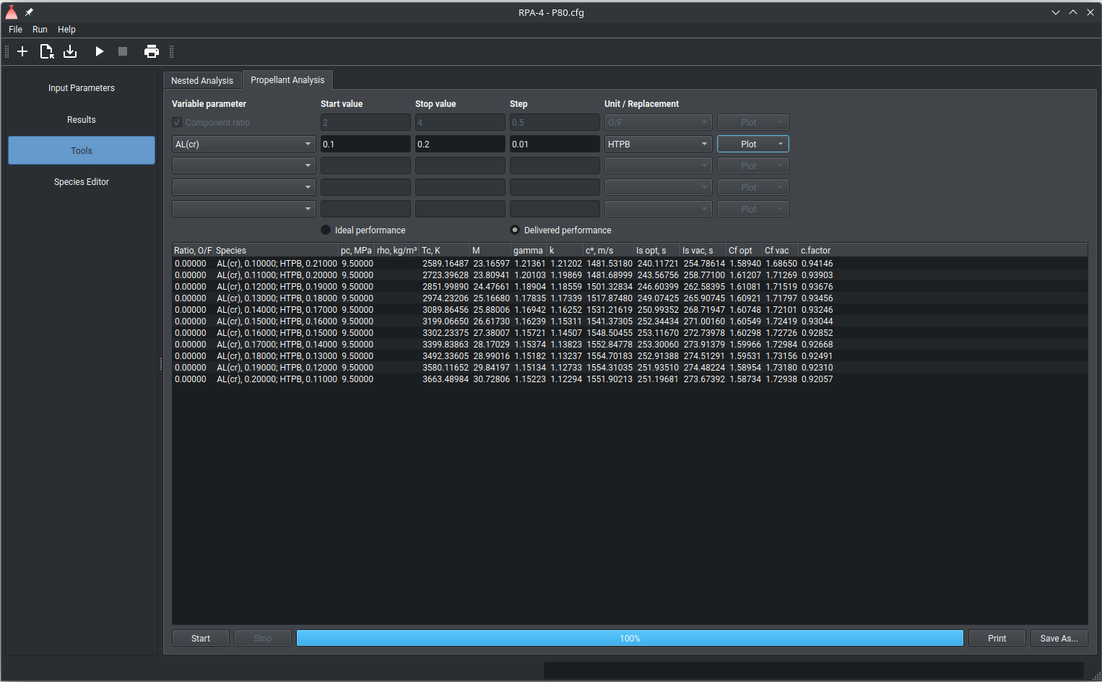
Propellant analysis

Propellant analysis inherits the initial configuration parameters defined on the screens Engine Definition, Propellant Specification, and Nozzle Flow Model. The user can define up to four pairs of components; within each pair, one component replaces the corresponding counterpart component in the initial propellant composition. To start the propellant analysis, click the button Start at the left-bottom corner of the tab.
Note: since the program performs the thermodynamic analysis for each unique combination of variable parameters, using small step size can result in very long execution time.
The code displays the results both for the ideal theoretical performance and the estimated delivered performance.
The program performs thermodynamic analysis for each unique combination of variable parameters, stepping it by defined value, and displaying the results in a table at the bottom of the tab. The progress of the propellant analysis is indicated by a progress bar at the bottom of the tab. To stop the running analysis, click the Stop button.
After finishing the propellant analysis, the user can plot the diagrams "specific impulse vs. variable parameter", "chamber temperature vs. variable parameter", "characteristic velocity vs. variable parameter" or "thrust coefficient vs. variable parameter" by clicking the button Plot at the right side of the corresponding parameter configuration.

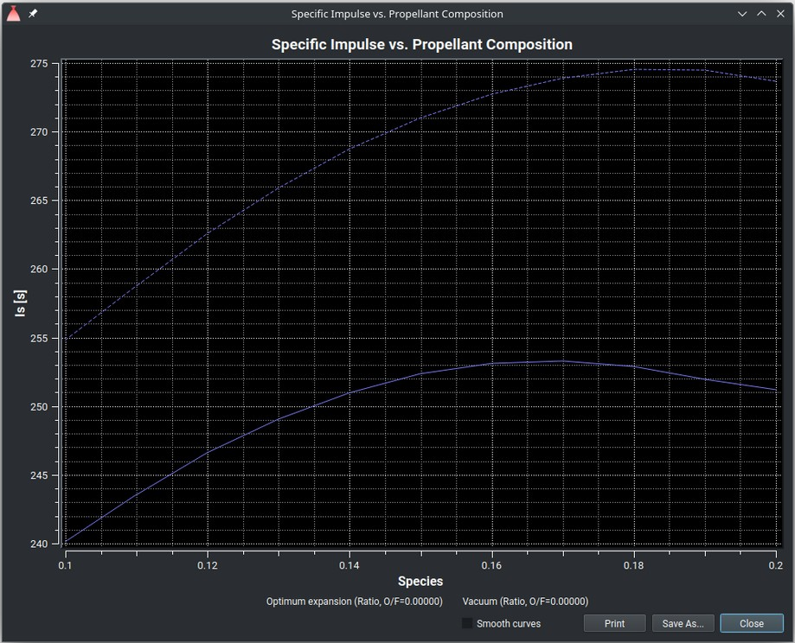
Propellant analysis plot

To print out the results of the nested analysis, click the button Print. To save the results as ASCII, HTML, or PDF file, click the button Save As... Both buttons are located at the right- bottom corner of the screen.
The defined parameters of the nested analysis are stored in the INI-file and shared between different configurations for the same user.
The defined parameters are not stored in the current configuration file.

Thrust chamber size
The tab Size and Geometry displays the calculated size of the thrust chamber.

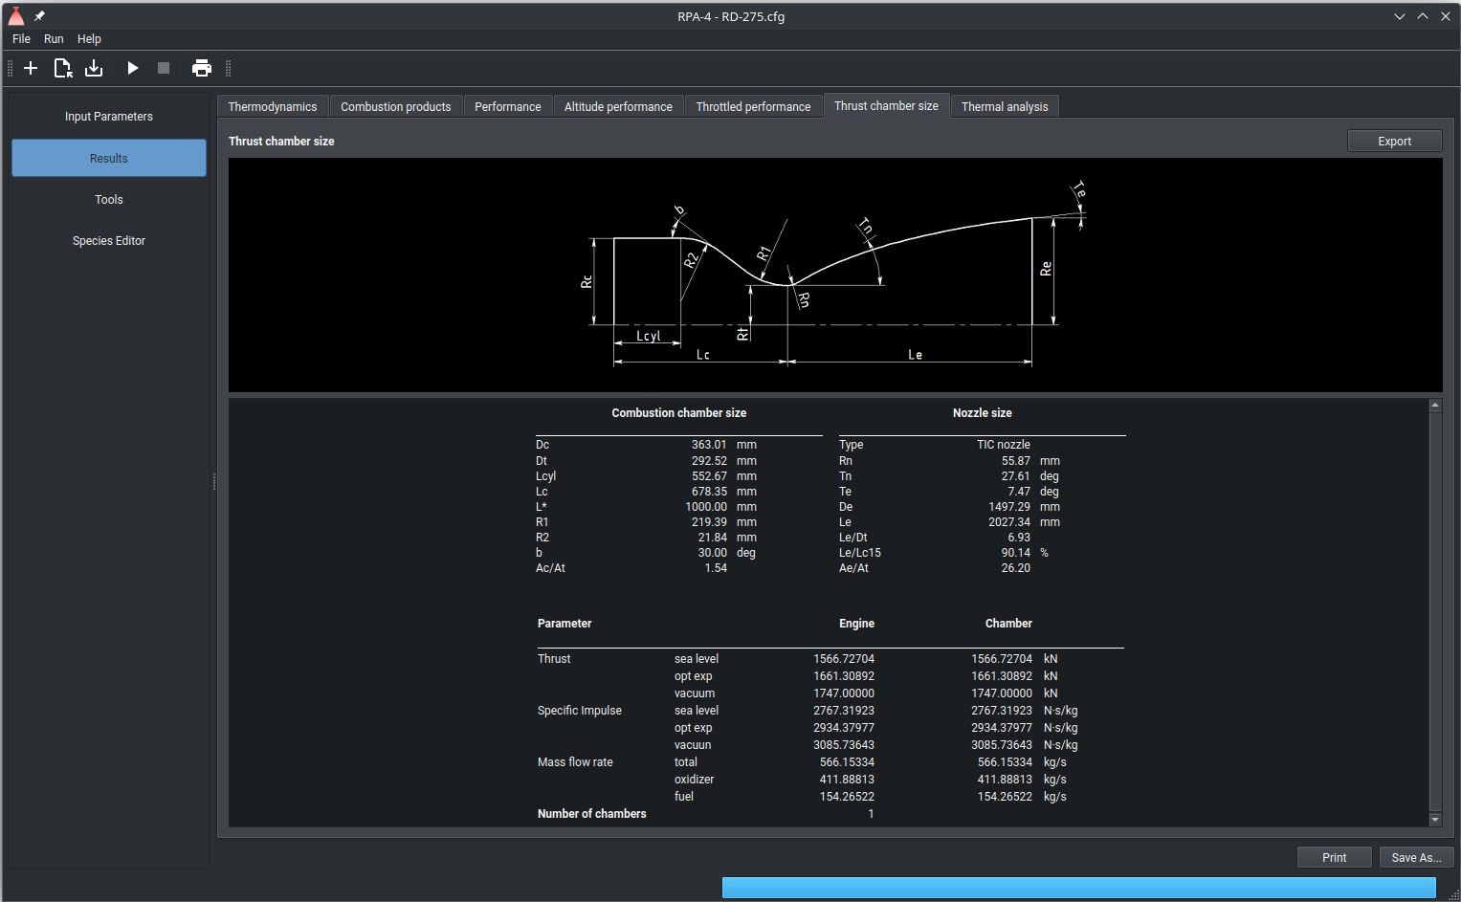
Size and geometry
After the initial program run, the user can use the calculated values for divergence thrust loss and friction thrust loss (from the results of Thermal Analysis) to adjust the nozzle efficiency on the Nozzle Shape and Efficiencies screen.
To save the results as an ASCII file, click the button Save As... To export the contour to the DXF file, click the button Export to DXF at the right-bottom corner of the screen.
When exporting to DXF file, additional export parameters have to be provided:
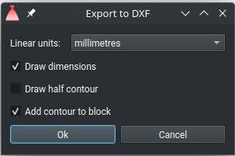
The resulting file can be opened in any CAD software that supports the DXF format.

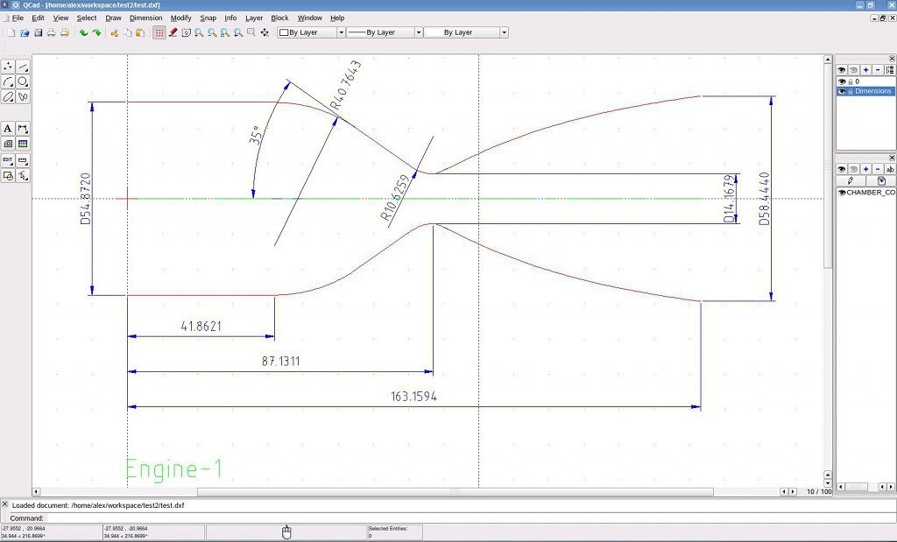
DXF file opened in QCad

Thermal Analysis
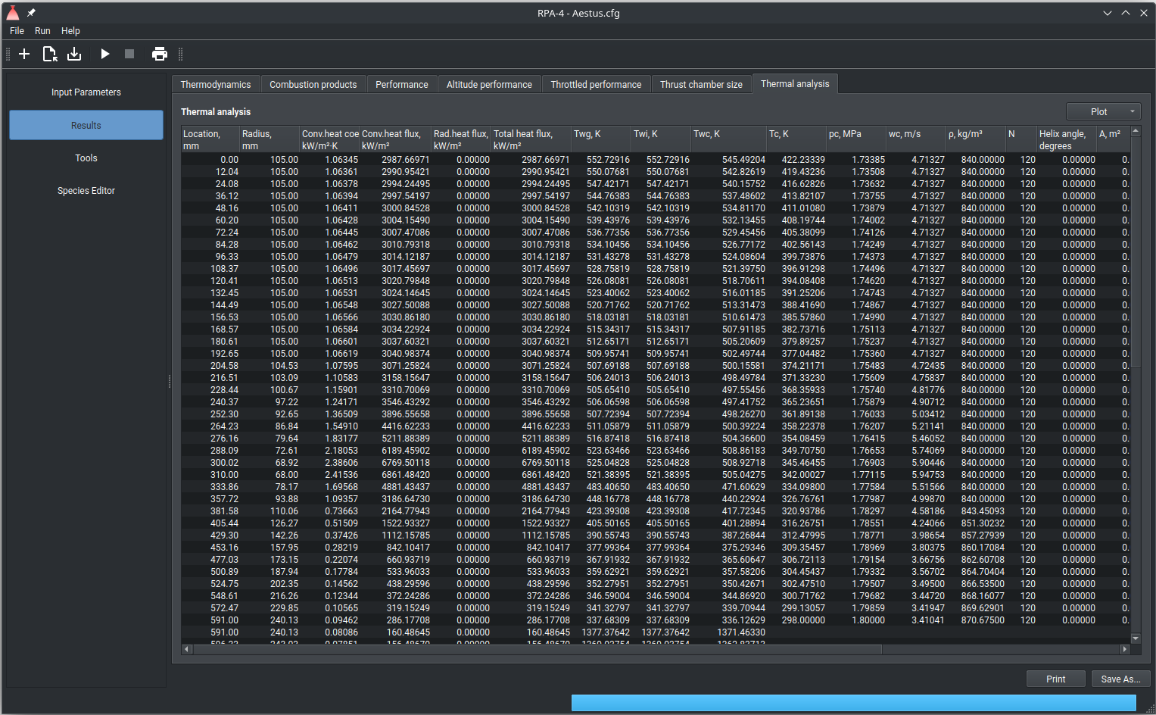
Thermal analysis results

Screen Thermal Analysis displays the results of thermal analysis of thrust chamber in one table.

The thrust chamber geometry is printed out in columns "Location" and "Radius".
The columns “Conv.heat flux”, “Rad.heat flux”, and "Heat flux" display the calculated heat flux: convection heat flux, radiation heat flux, and the sum of convection heat flux and radiation heat flux at the corresponding locations.
The column "T_{wg}" displays the temperature of chamber wall on its hot gas side.
The column "T_{wi}" displays the temperature between the thermal barrier coating layer and chamber wall (if coating is available) or the temperature of chamber wall on its hot gas side (the same as T_{wg}).
The column "T_{wc}" displays the temperature of chamber wall on its cooler side.
The columns "p_{c}", "T_{c}", "wc", and "ρ" display the pressure, temperature, velocity, and density of the coolant correspondingly. The column “N” displays the number of channels or tubes.
The table contains also design parameters for cooling segments.
Using context menu, the content of the complete table or selected rows can be copied into the clipboard.
To save the results as ASCII, HTML, pr PDF file, click the button "Save As..." at the right- bottom corner of the screen.
To plot the diagrams "Heat Flux vs. Location" or "Temperatures vs. Location", click the button Plot at the bottom-right corner of the tab. The location of the nozzle throat is shown on the diagram by corresponding vertical marker line.

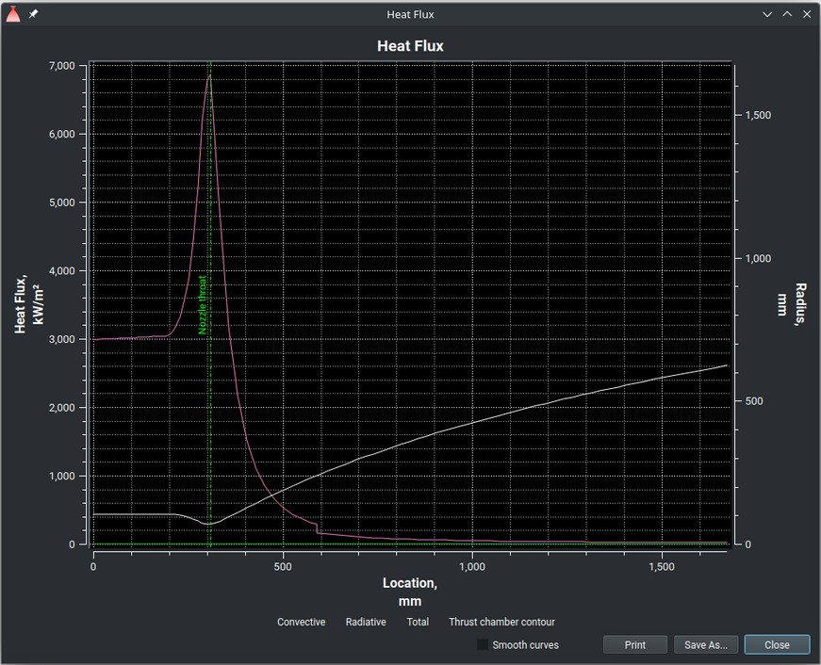  Diagram „Heat flux vs. Location“ | 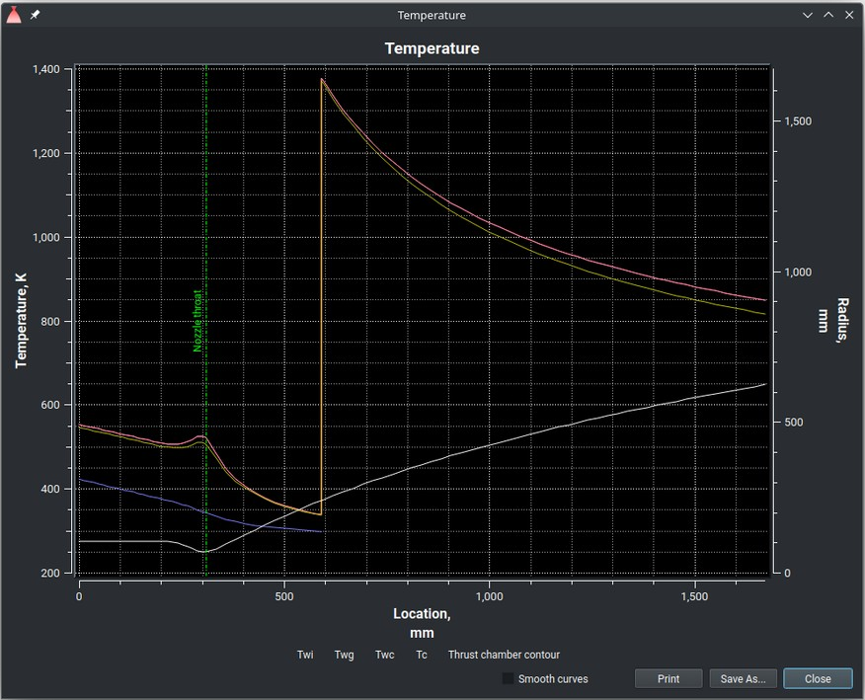  Diagram „Temperatures vs. Location“

All results are displayed in the current units, defined in the Preferences Dialog.

Propellant Feed System (Cycle Analysis)
The version 4.0.0 of the program does not contain the module “Propellant Feed System”.

Thermodynamic Database Editor
The Thermodynamic Database Editor is an integrated species viewer and editor. This tool allows users to easily define new propellant components or import components from PROPEP or CEA2 species databases.
RPA distribution package contains two database files resources/thermo.inp and
resources/properties.inp.
The file resources/thermo.inp contains the thermodynamic properties in format described in the reference documentation available on NASA web site https://www1.grc.nasa.gov/research-and-engineering/ceaweb/.
Users can define custom species and save them in two additional database files resources/usr_thermo.inp and resources/usr_properties.inp. These files are not included in the standard RPA distribution packages and will not be overwritten during program updates.
The tool features a database viewer at the top of the screen and a species editor at the bottom. The views can be resized by dragging the horizontal bar between the viewer and the editor.
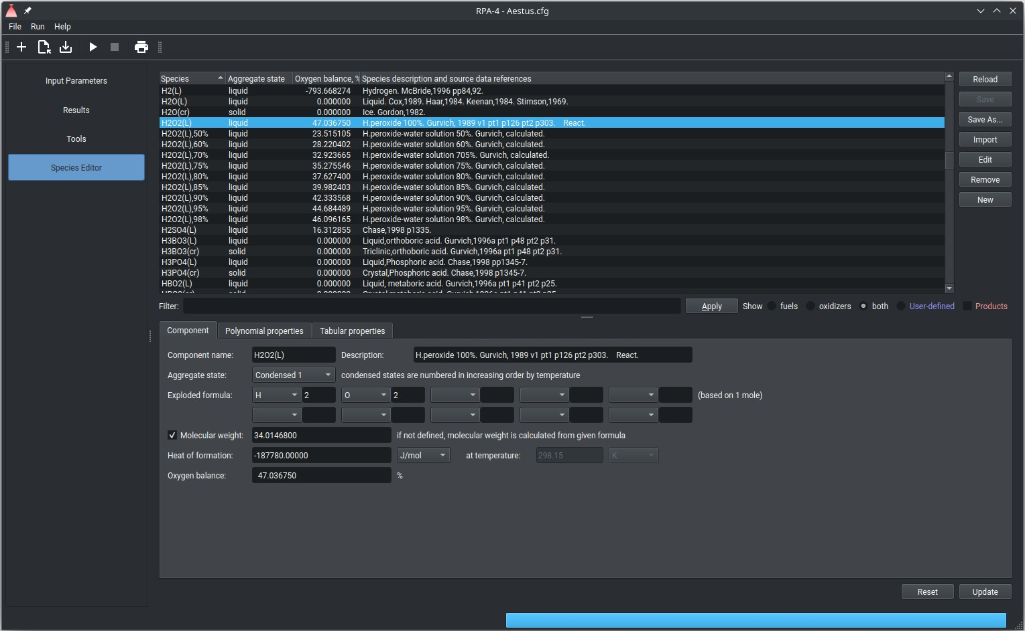
Thermodynamic Database Editor
The viewer includes a species table, filter options, and control buttons. The species table

displays available species according to the filter settings.
- To display only fuels, only oxidizers, or both fuels and oxidizers, select the corresponding radio buttons.
- To view all species, including atomized and/or ionized reaction products, check the All species box. Leave it unchecked to see only possible propellant components
The filter pattern is applied to two columns “Species” and “Species description and source data references”.
The following functions are assigned to control buttons:
- To reload the database from the files, click the button Reload. All changes performed since the database was last time loaded or saved will be lost.
- To save the changes made since the database was last time loaded or saved, click the button Save. The program creates a backup copy of the database files, adding the character "~" to the name of the file.
- To save the current database in specified location, click the button Save As...
- To import the species from external file in CEA2 or PROPEP formats, click the button Import. After successful loading the external database, the program displays the list of available species is the dialog window. Select one or more species to be imported, and click the button OK. All imported species are immediately available for thermodynamic analysis.
- To display the data of the selected species into the species editor, click the button Edit. Alternatively, double click the species on the list to display it in the editor.
- To remove the species from the loaded database, click the button Remove. Note that removed species are immediately unavailable for thermodynamic analysis.
- To reset the editor for creating a new species, click the button New.

Note: all new or updated species are saved into the user-defined database files
resources/usr_thermo.inp and resources/usr_properties.inp.
Note: although the user can import any component from PROPEP species database, do not replace all components already available in CEA2/RPA database: the sources of the data in CEA2 file are NASA Glen thermodynamic database and Gurvich thermodynamic database, both known for their high accuracy.
Note: since PROPEP library does not contain the component's temperature, always check standard temperature and tabular data for imported components.
Note: always check the log (click item Run in main menu, and then Show log; check the tabs "Warnings" and/or "Errors") just after the import from PROPEP library.
The editor consists of three tabs Component, Polynomial properties, and Tabular properties, and the control buttons at the bottom of the editor:

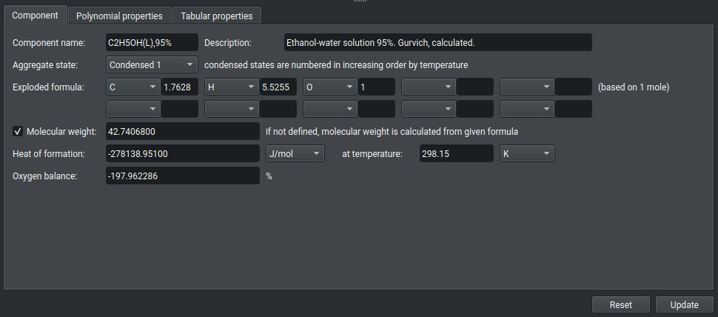
To save changes to existing species or save new species, click the button Update. To reset the species data, click the button Reset.
The tab Component displays information about component, including its aggregate state, chemical formula, molecular weight, heat of formation, and the temperature at which the heat of formation is defined.
The component name serves as the species identifier and must be unique within the database. The suffix "(L)" can be added to the name for liquid components.
The description typically contains the common name of the species and reference information.
The chemical formula is provided as either a molecular formula (if applicable) or an exploded formula, followed by its molecular weight. The heat of formation (enthalpy) can be specified in one of the available units: J/mol, cal/mol, kJ/kg, kcal/kg, Btu/lbm, kcal/lbm.
The heat of formation is followed by the temperature (specified in one of the units: K, R, C, F), at which the heat of formation is defined. Note that if polynomial properties are available, the temperature is always 298.15 K and cannot be changed.
Polynomial properties for the one or more temperature intervals are given by 9 coefficients as described in documentation for CEA2 available on NASA web site https://www1.grc.nasa.gov/research-and-engineering/ceaweb/. Click the button Add to add new temperature interval; click the button Remove to delete selected temperature interval.
Tabular properties for the one or more pressure and temperature intervals are specified by values of specific heat Cp (kJ/mol-K), density rho (kg/m³) and dynamic viscosity mu
(muPa-s) for each unique combination of pressure and temperature. Click the button Add p
to add new pressure interval; click the button Remove p to delete selected pressure interval. Click the button Add T to add new temperature interval; click the button Remove T to delete selected temperature interval.
Note: For the components supplied with thermodynamic properties in the polynomial form, the specification of the specific heat is not required (define "0" instead).
Note: For the gaseous components, the specification of the density is not required. In the database file, the tabular data are formatted as follows:
!p, MPa T, K Cp, kJ/mol-K rho, kg/m3 mu, muPa-s Comp_name 2,3
p1 T1 Cp11 rho11 mu11

p1 | T2 | Cp12 | rho12 | mu12
p1 | T3 | Cp13 | rho13 | mu13
p2 | T1 | Cp21 | rho21 | mu21
p2 | T2 | Cp22 | rho22 | mu22
p2 | T3 | Cp23 | rho23 | mu23
The minimalist data for the component consists of at least two rows:
!p, MPa T, K Cp, kJ/mol-K rho, kg/m3 mu, muPa-s Comp_name 1,2
0.101325 273.15 0.078 823.0
0.101325 373.15 0.078 823.0

This data defines the constant specific heat Cp and constant density rho, and allows to specify the initial temperature in the range 273.15-373.15 K as well as the initial pressure in the range 0...max-required-pressure. Viscosity is not defined and assumed to be equal 0.

Preferences
Dialog window Preferences can be used to set up global configuration parameters. Click the item Help, and then Preferences in main bar to open the window:
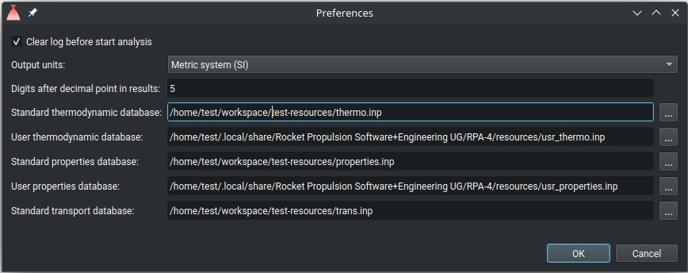
Dialog window "Preferences"

Mark the check box "Clear log before start analysis" to clear the analysis log before each analysis run. Leave it unmarked to accumulate the messages from all runs.
The user can select the default output units for results of analysis by choosing either the
Metric system (SI) or the U.S. Customary system from the list Output units. If selected Metric system (SI), the following units will be used:

Parameter | Unit
Temperature | K (of reaction products)
Temperature | K (of propellant components)
Pressure | MPa
Specific impulse | m/s

Parameter | Unit
Velocity | m/s
Mass flow rate | kg/s
Mass flux | kg/m2-s
Thrust | N, kN
Density | kg/m3
Enthalpy | kJ/kg, J/mol
Entropy, Specific heat, Gas constant | kJ/kg-K, J/mol-K

If selected U.S. Customary system, the following units will be used:

Parameter | Unit
Temperature | F (of reaction products)
Temperature | R (of propellant components)
Pressure | psi
Specific impulse | ft/s
Velocity | ft/s
Mass flow rate | lbm/s
Mass flux | lbm/ft2-s
Thrust | lbf
Density | lbm/ft3
Enthalpy | Btu/lbm, Btu/lb-mol
Entropy, Specific heat, Gas constant | Btu/lbm-R, Btu/lb-mol-R

In order to change the number of digits after decimal points in the result tables, update the field Digits after decimal point in results.
In order to to check for available software updates, click the item Help in the menu bar, and then click Check for Updates.

Input and Output Units
The user can enter the values of input parameters in any supported units, mixing Metric (SI) and U.S. Customary systems. The program automatically converts all entered values to the Metric system, which is a standard internal representation of both input parameters and results of calculation.
The following conversion factors are used to convert values in non-SI units to values in SI

units:

Name | Value | Description
CONST_ATM | 101325.0 | Conversion factor from atm to Pa
CONST_AT | 98066.5 | Conversion factor from at (technical atmosphere) to Pa
CONST_BAR | 100000.0 | Conversion factor from bar to Pa
CONST_PSI | 6894.75729316836 | Conversion factor from psi (pound-force per square inch) to Pa
CONST_T0 | 298.15 K | Temperature 25 C
CONST_R0 | 8.314472 J/(mol·K) | Universal Gas Constant
CONST_G | 9.80665 m/s2
CONST_POUND | 0.45359237 | Conversion factor from lbm (pound mass) to kg
CONST_POUND_FORCE | (CONST_POUND*CONST_G) | Conversion factor from lbf (pound-force) to N (newton)
CONST_FOOT | 0.3048 | Conversion factor from international foot to m
CONST_INCH | 0.0254 | Conversion factor from inch to m
CONST_MILE | (5280.0*CONST_FOOT) | Conversion factor from international mile to m
CONST_LBM_FOOT3 | (CONST_POUND/CONST_FOOT3) | Conversion factor from "lbm/ft3" to "kg/m3
CONST_LBM_INCH3 | (CONST_POUND/CONST_INCH3) | Conversion factor from "lbm/inch3" to "kg/m3"
CONST_MASS_FLUX | (CONST_POUND/CONST_FOOT2) | Conversion factor from "lbm/(ft2·s)" to "kg/(m2·s)"
CONST_LBM_MOLE | (1000.*CONST_LBM) | Conversion factor from lb-mole to mole
CONST_BTU | 1055.05585262 | Conversion factor from Btu to J
CONST_CAL | 4.1868 | Conversion factor from calorie to J
CONST_BTU_LBM | (CONST_BTU/CONST_LBM) | Conversion factor from Btu/lbm to J/kg
CONST_BTU_LBM_MOLE | (CONST_BTU/CONST_LBM_MOLE) | Conversion factor from Btu/lb-mol to J/mol
CONST_BTU_LBM_R | (1000.*CONST_CAL) | Conversion factor from Btu/(lbm·R) to J/(kg·K)
CONST_BTU_LBM_F | CONST_BTU_LBM_R | Conversion factor from Btu/(lbm·F) to J/(kg·K)
CONST_BTU_LBM_MOLE_R | CONST_BTU_LBM_R | Conversion factor from Btu/(lb-mol·R) to J/(mol·K)

The Metric system is also used by default to display the results of calculation. References:
- SP-811. NIST Guide for the Use of the International System of Units (SI).
- Glossary of terms and table of conversion factors used in design of chemical propulsion systems. NASA SP-8126. 1979.
- George P. Sutton, Oscar Biblarz. Rocket Propulsion Elements, 7th Edition (pp.727- 729).
- NASA-STD-3000. Man-Systems Integration Standards. Volume II. Appendix E - Units of Measure and Conversion Factors.

Scripting API
The scripting utility offers bindings to many internal functions of RPA, allowing users to program and run the following tasks:
- Load, manipulate and write configuration files
- Search the thermodynamic database by species name
- Retrieve thermodynamic properties of species
- Prepare mono- bi- and multi-propellant compositions
- Run typical combustion problems (p,H)=const, (p,S)=const, (p,T)=const
- Run typical rocket propulsion problems
- Utilize all the features listed above in a custom JavaScript program The scripting utility can be started in either interactive mode or batch mode.
The scripting utility supports JavaScript (ECMAScript) language as defined in standard ECMA-262.

API Reference
Besides standard ECMA-262 API, RPA Scripting Utility provides the domain-specific API.

Generic built-In Functions / Objects

Function / Object | Description
args | JavaScript array containing command-line arguments for the script started in batch mode (using option “--input”). Empty if no arguments specified in the command line.
load(path_to_script) | Load external script defined by it's path. Example:  load("resources/scripts/config.js");

Function / Object | Description
print(parameter) | Print out the parameter in console and log file. Examples:  print("Starting analysis...");  print("Is_v=" + pr.getNozzleExitSection().getIs_v().toPrecision(7));
sprintf(format,  parameters) | The function is a limited JavaScript implementation of sprintf, originated from the C programming language.  Function returns the string with passed arguments formatted by the usual sprintf conventions.  Possible format values:  %% – returns a percent sign  %b – binary number  %c – the character according to the ASCII value  %d – signed decimal number  %f – floating-point number  %o – octal number  %s – string  %x – hexadecimal number (lowercase letters)  %X – hexadecimal number (uppercase letters)  Additional format values, placed between the % and the letter (example %.2f):  + – forces both + and - in front of numbers. By default, only negative numbers are marked  - – left-justifies the variable value  0 – zero will be used for padding the results to the right string size [0-9] – specifies the minimum width held of to the variable value  .[0-9] – specifies the number of decimal digits or maximum string  length Example:  var s = sprintf("Isp (vac)=%8.4f Isp (SL)=%8.4f s\n", Is_v, Is_SL);
printf(format,  parameters) | The function is a limited Javascript implementation of printf, originated from the C programming language.  Function prints out in console and log file the passed arguments formatted by the usual printf conventions.  Possible format values: see description of function sprintf. Example:  printf("Isp (vac)=%8.4f Isp (SL)=%8.4f s\n", Is_v, Is_SL);
sscanf(format,  parameters) | The function is a limited Javascript implementation of sscanf, originated from the C programming language.  Reads data from "str" and stores them according to parameter "format":  a) into array which is returned as a function result (if no additional arguments

Function / Object | Description
specified),
b) into the locations given by the additional arguments (and returns number of scanned parameters).
Since JavaScript does not support scalar reference variables, any additional arguments to the function will only be allowable here as strings referring to a global variable (which will then be set to the value
found in 'str' corresponding to the appropriate conversion specification in 'format'.

Possible format values:
%% – A % followed by another % matches a single %.
%i – integer
%c – the character according to the ASCII value
%d, %D – signed decimal number (integer)
%u – unsigned decimal number (integer)
%f, %e – floating-point number
%o – octal number (integer)
%s – string
%x, %X – hexadecimal number Examples:
sscanf('Is_v=350.0 s', 'Is_v=%f s');
// returns an array with one element: [350.0]

var Is_v;
sscanf('Is_v=350.0 s', 'Is_v=%f s', 'Is_v');
// returns number of scanned values: 1
// assigns the scanned value 350.0 to variable Is_v

sscanf("Is_v=350.0 s Is_SL=290.0 s", "Is_v=%f s Is_SL=%f s");
// returns an array with two elements: [350.0, 290.0]
exit()  quit() exit quit | Exits from the interactive interpreter.

Object File

Function | Description
File(path_to_file, mode) | Open the file specified by name in given mode.  Supported modes:  "w" – write file, truncate the content if file exists  "wa" – write file, append to existing content if file exists "r" – read file  Example:  var f = File("C:\tmp\results.txt", "w");
print(parameter) | Print out the parameter into the file.

Function | Description
Examples:

var f = File("C:\tmp\results.txt", "w"); f.print("Starting analysis...");
f.print("Is_v=" + pr.getNozzleExitSection().getIs_v().toPrecision(7)); f.close();
printf(format,  parameters) | The function is a limited Javascript implementation of printf, originated from the C programming language.  Function prints out into the file the passed arguments formatted by the usual printf conventions.  Possible format values: see description of function sprintf. Example:  var f = File("C:\tmp\results.txt", "w");  f.printf("Isp (vac)=%8.4f Isp (SL)=%8.4f s\n", Is_v, Is_SL); f.close();
readLine() | The function reads the next available line from the file and returns it as a string. The function returns null if no string is available.  Example:  var f = File("C:\tmp\results.txt", "r"); var s = f.readLine();  f.close();
close() | The function closes the file. Example:  var f = File("C:\tmp\results.txt", "w");  f.printf("Isp (vac)=%8.4f Isp (SL)=%8.4f s\n", Is_v, Is_SL); f.close();

Object ConfigFile
This object represents the configuration file and provides the functions to access different sub-configurations.

Function | Parameters | Description
ConfigFile() | - | Default constructor.  Creates new empty configuration object.  Example:

Function | Parameters | Description
 |  | c = ConfigFile();
ConfigFile(String path) | File path | Constructor.  Creates new empty configuration object and assign the specified file. The assigned file can be loaded with function read().  Example:  c = ConfigFile("examples/test-1.cfg");
read(String path) | File path | Reads the specified file. Example:  c = ConfigFile(); c.read("examples/test-1.cfg");
write(String path) | File path | Writes the configuration into specified file.  Example:  c = ConfigFile(); c.read("examples/test-1.cfg"); c.write("examples/test-2.cfg");
Number getVersion() | - | Returns the version of configuration file.  Example:  c = ConfigFile("examples/test-1.cfg"); print("Version: "+c.getVersion());
getPath() | File path | Assigns the engine name. Example:  c = ConfigFile("examples/test-1.cfg"); print("Path: "+c.getPath();
String toString() | - | Converts the current configuration to string containing JSON representation of the configuration.

Function | Parameters | Description
Example:

c = ConfigFile("examples/test-1.cfg"); raw = JSON.parse(cfg.toString()); raw.engineDefinition.chamberPressure
.value = 10; raw.engineDefinition.chamberPressure
.units = "MPa"; cfg.fromString(JSON.stringify(raw)); print("Problem name: "+c.getName());
String fromString(String) | JSON string representing configuration | Loads the content from the provided string containing JSON representation of the configuration.  Example:  c = ConfigFile("examples/test-1.cfg"); raw = JSON.parse(cfg.toString()); raw.engineDefinition.chamberPressure  .value = 10; raw.engineDefinition.chamberPressure  .units = "MPa"; cfg.fromString(JSON.stringify(raw)); print("Problem name: "+c.getName());

Object Units
The object has no constructor, and cannot be instantiated explicitly. Instead, the Scripting Utility provides the global variable “Units”.

Function | Parameters | Description
double convertPressure(double fromValue, String fromUmit, String toUnit) | Pressure value  pressure unit (one of "Pa", "psi", "atm", "bar", "at", "MPa")  pressure unit (one of "Pa", "psi", "atm", "bar", "at", "MPa") | Converts pressure value from one value to another.  Example:  print(Units.convertPressure(1, "atm", "MPa"));
double convertTemperature(double fromValue, String fromUmit, String toUnit) | Temperature value  temperature unit (one of "K", "F", "C") | Converts temperature value from one value to another.  Example:
 | temperature unit

Function | Parameters | Description
 | (one of "K", "F", "C") | print(Units.convertTemperature(1000, "C", "K"));
double convertMassFlux(double fromValue, String fromUmit, String toUnit) | Mass flux value  Mass flux unit (one of "kg/(m2·s)",  "kg/(m2-s)",  "lbm/(ft2·s)",  "lbm/(ft2-s)") | Converts mass flux value from one value to another.
Mass flux unit (one of "kg/(m2·s)",
"kg/(m2-s)",
"lbm/(ft2·s)",
"lbm/(ft2-s)")
double convertMassFlowrate(double fromValue, String fromUmit, String toUnit) | Mass flow rate value  Mass flow rate unit (one of "kg/s",  "lbm/s") | Converts mass flow rate value from one value to another.
Mass flow rate unit (one of "kg/s",
"lbm/s")
double convertForce(double fromValue, String fromUmit, String toUnit) | Force value  Force unit (one of "kN", "N", "kg",  "lbf") | Converts force value from one value to another.
Force unit (one of "kN", "N", "kg",
"lbf")
double convertLength(double fromValue, String fromUmit, String toUnit) | Length value  Length unit (one of "m", "mm", "in", "ft") | Converts length value from one value to another.
 | Length unit (one of "m", "mm", "in", "ft")
double convertVelocity(double fromValue, String fromUmit, String toUnit) | Velocity value  Velocity unit (one of "m/s", "ft/s", "in/s") | Converts velocity value from one value to another.

Function | Parameters | Description
 | Velocity unit (one of "m/s", "ft/s", "in/s")
double convertRotationalSpeed(double fromValue, String fromUmit, String toUnit) | Rotational speed  value  Rotational speed unit (one of "rad/s", "rpm", "Hz")  Rotational speed unit (one of "rad/s", "rpm", "Hz") | Converts rotational speed value from one value to another.
double convertThermalConductivity(doub le fromValue, String fromUmit, String toUnit) | Thermal conductivity value  Thermal | Converts thermal conductivity value from one value to another.
conductivity unit (one of "W/(m·K)",
"W/(m-K)",
"Btu/(s·in·R)",
"Btu/(s-in-R)",
"Btu/(hr·ft·R)",
"Btu/(hr-ft-R)")
 | Thermal
conductivity unit (one of "W/(m·K)",
"W/(m-K)",
"Btu/(s·in·R)",
"Btu/(s-in-R)",
"Btu/(hr·ft·R)",
"Btu/(hr-ft-R)")
double convertAngle(double fromValue, String fromUmit, String toUnit) | Angle value  Angle unit (one of "rad", "deg") | Converts angle value from one value to another.
 | Angle unit (one of "rad", "deg")
double convertVolumetricMassDensity(do uble fromValue, String fromUmit, String toUnit) | Volumetric mass density value  Volumetric mass | Converts volumetric mass density value from one value to another.
 | density unit (one of "kg/m^3", "g/cm^3", "lbm/in^3",

Function | Parameters | Description
"lbm/ft^3")

Angle unit (one of "kg/m^3", "g/cm^3", "lbm/in^3", "lbm/ft^3")

Object Database
The object represents the species database. The object has no constructor, and cannot be instantiated explicitly. Instead, the Scripting Utility provides the global variable “Database”.

Function | Parameters | Description
Object species(String name) | Name of species | Returns Species object. Example:  print(Database.species("H2O2"));

Object Species
The object represents the species. The object has no constructor, and cannot be instantiated explicitly. The instance of the object can be obtained from objects Database or Mixture.

Function | Parameters | Description
String getName() | - | Returns species name.
String getDescr() | - | Returns species description.
Boolean isReactantOnly() | - | Returns true if species could not be usually used as a propellant component.
Boolean isIon() | - | Returns true if species is ionized.
Number getCharge() | - | Returns the charge of ionized species.
Number getValence() | - | Returns the valency of species.
Boolean isCondensed() | - | Returns true if species is condensed.
Number getCondensed() | - | Returns the number of condensed phase in increased order by temperature.
Number getDHf298_15(String unit) | heat of formation unit (one of "J/mol", "Btu/lb-  mol", "J/kg", "kJ/kg", "Btu/lbm" ) | Returns H0(298.15) - heat of formation at the temperature 298.15 K and pressure 1 bar in desired unit.
Number getDH298_15_0(String unit) | heat of formation unit (one of "J/mol", "Btu/lb- | Returns H0(298.15) – H0(0), if available.

Function | Parameters | Description
 | mol", "J/kg", "kJ/kg", "Btu/lbm" )
Number getT0(String unit) | temperature unit (one of "K", "F", "C") | Returns standard temperature of the species in desired unit.
Number getP0(String unit) | pressure unit (one of "Pa", "psi", "atm", "bar", "at", "MPa") | Returns standard pressure of the species in desired unit.
Number getMinimumT(String unit) | temperature unit (one of "K", "F", "C") | Returns minimum temperature of the species in desired unit.
Number getMaximumT(String unit) | temperature unit (one of "K", "F", "C") | Returns maximum temperature of the species in desired unit.
Number checkT(double t, String unit) | t – temperature  unit - temperature unit (one of "K", "F", "C") | Checks whether the specified temperature is valid. If valid, returns specified temperature. Otherwise throws an exception.
Number getM() |  | Returns molecular weight of species.
Number getR(String unit) | gas constant unit (one of "J/(mol K)", "J/(kg K)",  "kJ/(kg K)",  "Btu/(lb-mol R)",  "Btu/(lbm R)") | Returns gas constant in desired unit (applicable for gaseous species).
Number getCp(Number t, String tunit, String unit) | t - temperatur  tunit - temperature unit (one of "K", "F", "C")  unit - specific heat unit (one of "J/(kg K)", "kJ/(kg  K)", "Btu/(lbm R)") or molar heat capasity unit (one of "J/(mol K)",  "Btu/(lb-mol R)") | Returns specific heat or molar heat capasity at specified temperature and constant pressure in desired unit.
Number getH(Number t, String tunit, String unit) | t - temperatur  tunit - temperature unit (one of "K", "F", "C")  unit - enthalpy | Returns specific or molar enthalpy at specified temperature in desired unit.

Function | Parameters | Description
unit (one of "J/mol", "Btu/lb-
mol", "J/kg",
"kJ/kg", "Btu/lbm")
Number getS(Number t, String tunit, String unit) | t - temperatur  tunit - temperature unit (one of "K", "F", "C")  unit - entropy unit (one of "J/(mol K)", "Btu/(lb-mol  R)", "J/(kg K)",  "kJ/(kg K)",  "Btu/(lbm R)") | Returns specific or molar entropy at specified temperature in desired unit.
Number getG(Number t, String tunit, String unit) | t - temperatur  tunit - temperature unit (one of "K", "F", "C")  unit - Gibbs energy unit (one of "J/mol", "Btu/lb-  mol", "J/kg",  "kJ/kg", "Btu/lbm") | Returns Gibbs energy at specified temperature in desired unit.

Object Mixture
The object represents the mixture ingredients or combustion products. The object can be instantiated using constructor or obtained from other objects.

Function | Parameters | Description
Mixture() | - | Constructor.  Creates an empty mixture.
Object addSpecies(String name, Number r) | name - species name  r - mass fraction of the species in component | Adds species into mixture, assigns specified mass fraction, and returns Species object.
addMixture(Object mixture, Number r) | Mixture - Mixture object  r - mass fraction of the mixture in component | Adds mixture into this mixture object and assigns specified mass fraction.
Number getValence() | - | Returns the resulting valency of mixture.

Function | Parameters | Description
Number getEquivalenceRatio() | - | Returns the equivalence ratio of mixture (for more info see Attachments).
Number getEquivalenceRatio(Array omit) | Java script array of chemical elements to be omitted from calculation of equivalent ratio. | Returns the equivalence ratio of mixture (for more info see Attachments).  Example:  omit = ["CU"]; printf("Equivalence ratio: %8.6f (omitted: %s)\n",  mix.getEquivalenceRatio(omit), omit);
Number getOxygenBalance() | - | Returns the oxygen balance of mixture (for more info see Attachments).
Number getOxygenBalance(Array omit) | Java script array of chemical elements to be omitted from calculation of oxigen balance. | Returns the oxygen balance of mixture (for more info see Attachments).  Example:  omit = ["CU"];  printf("Oxygen balance: %8.6f (omitted: %s)\n", mix.getOxygenBalance(omit), omit);
Array getFormula(String base) | "g" if number of elements in exploded formula have to be based on  100 g of mixture.  Any other string except "g", if number of elements in exploded formula have to be based on  1 mole of mixture. | Returns exploded chemical formula of the mixture as an array of elements.  Each element of the array represents one chemical element (atom) with properties “name” and “n”.
Number getM() | - | Returns molecular weight of mixture.
Number getH(String unit) | enthalpy unit (one of "J/mol" (default), "Btu/lb- mol", "J/kg",  "kJ/kg", "Btu/lbm") | Returns specific or molar enthalpy of mixture in desired unit.
Number getU(String unit) | enthalpy unit (one of "J/mol" (default), "Btu/lb- mol", "J/kg",  "kJ/kg", "Btu/lbm") | Returns specific or molar internal energy of mixture in desired unit.
Number getRho(String unit) | one of "kg/m^3" (default), | Returns volumetric density of mixture in desired unit.

Function | Parameters | Description
 | "g/cm^3", "lbm/ft^3", "lbm/in^3"
setT(Number t, String unit) | t - temperature  unit - temperature unit (one of "K", "F", "C") | Assigns temperature to all species of the mixture.
setP(Number p, String unit) | t - temperature  punit - pressure unit (one of "Pa", "psi", "atm", "bar", "at", "MPa") | Assigns temperature to all species of the mixture.
Number size() | - | Returns number of species included into mixture.
Object getSpecies(Number i) | index | Returns Species object.
Boolean checkFractions() | - | Returns true if mass fractions assigned correctly (i.e. the sum of all mass fraction within each component is equals to 1.0).
Number getFraction(Number i) | index | Returns assigned mass fraction.
setFraction(Number i, Number f) | i - index  f - mass fraction | Assigns mass fraction.
print(String units) | desired units (one of "SI" or "US") | Prints out the information about mixture in desired units.

Object Propellant
The object represents the propellant. The object can be instantiated using constructor or obtained from other objects.

Function | Parameters | Description
Propellant() | - | Constructor.  Creates an empty mixture.
Propellant(Number of_ratio) | of_ratio – propellant components mass ratio (O/F) | Constructor.  Creates an empty mixture with specified O/F ratio.
setRatio(Number r, String type) | r – propellant components ratio  type – type of ratio (one of "O/F", "alpha") | Assigns propellant ratio.

Function | Parameters | Description
Object addOxidizer(String name, Number r) | name - species name  r - mass fraction of the species in component | Adds species into oxidizer mixture, assigns specified mass fraction, and returns Species object.
Object addFuel(String name, Number r) | name - species name  r - mass fraction of the species in component | Adds species into fuel mixture, assigns specified mass fraction, and returns Species object.
Boolean checkFractions(Boolean assign) | Assign – if „true“, the incorrect fractions are fixed to make teh sum=1.0 | Returns true if mass fractions of both oxidizer and fuel mixtures are assigned correctly (i.e. the sum of all mass fraction within each component is equals to 1.0).
Number getM() | - | Returns molecular weight of propellant.
Number getH(String unit) | enthalpy unit (one of "J/mol" (default), "Btu/lb- mol", "J/kg",  "kJ/kg", "Btu/lbm") | Returns specific or molar enthalpy of propellant in desired unit.
Number getU(String unit) | enthalpy unit (one of "J/mol" (default), "Btu/lb- mol", "J/kg",  "kJ/kg", "Btu/lbm") | Returns specific or molar internal energy of propellant in desired unit.
Number getRho(String unit) | one of "kg/m^3" (default), "g/cm^3", "lbm/ft^3", "lbm/in^3" | Returns volumetric density of propellant in desired unit.
Number size(String type) | type – type of component (one of "ox" or "f") | Returns number of species included into component of propellant.
Object getSpecies(String type, Number i) | type – type of component (one of "ox" or "f")  i - index | Returns Species object.
Object getOxidizer() | - | Returns Mixture object.
Object getFuel() | - | Returns Mixture object.

Object Equilibrium

Function | Parameters | Description
Equilibrium(Object p, Boolean multiphase, Boolean ionization) | P - Propellant or Mixture object | Constructor.

Function | Parameters | Description
 | multiphase - multiphase flag  ionization - ionization flag | Creates Reaction object, using specified Propellant or Mixture object. If multi-phase flag is true, phase transitions effects are considered.  If ionization flag is true, ionization effects are considered.
setP(Number p, String p_unit) | p - pressure  p_unit - pressure unit (one of "Pa", "psi", "atm", "bar", "at", "MPa")  T - temperature  T_unit - temperature unit (one of "K", "F", "C") | Assigns pressure of combustion and switches the solving reaction problem to type (p,H)=const. Assigned enthalpy is obtained implicitly from propellant or mixture.
setPT(Number p, String p_unit, Number T, String T_unit) | p - pressure  p_unit - pressure unit (one of "Pa", "psi", "atm", "bar", "at", "MPa")  T - temperature  T_unit - temperature unit (one of "K", "F", "C") | Assigns pressure and temperature of combustion and switches the solving reaction problem to type (p,T)=const.
setPH(Number p, String p_unit, Number H, String H_unit) | p - pressure  p_unit - pressure unit (one of "Pa", "psi", "atm", "bar", "at", "MPa")  H - enthalpy  H_unit - enthalpy unit (one of "J/mol", "Btu/lb-  mol", "kJ/mol") | Assigns combustion pressure and enthalpy of propellant and switches the solving reaction problem to type (p,H)=const.
setPS(Number p, String p_unit, Number S, String S_unit) | p - pressure  p_unit - pressure unit (one of "Pa", "psi", "atm", "bar", "at", "MPa") | Assigns combustion pressure and entropy of propellant and switches the solving reaction problem to type (p,S)=const.

Function | Parameters | Description
S - enropy
S_unit - enropy unit (one of "J/(mol K)",
"Btu/(lb-mol R)",
"kJ/(mol K)")
setV(Number v, String v_unit) | v - specific volume  v_unit - specific volume unit (one of "m^3/kg", "ft^3/lbm") | Assigns combustion specific volume (1/rho) and switches the solving reaction problem to type (v,U)=const. Internal energy is obtained implicitly from propellant or mixture.
setVT(Number v, String v_unit, Number T, String T_unit) | v - specific volume  v_unit - specific volume unit (one of "m^3/kg", "ft^3/lbm") | Assigns specific volume (1/rho) and temperature of combustion and switches the solving reaction problem to type (v,T)=const.
setVU(Number v, String v_unit, Number U, String U_unit) | v - specific volume  v_unit - specific volume unit (one of "m^3/kg", "ft^3/lbm")  U – internal energy  U_unit - internal energy unit (one of "J/mol", "Btu/lb-  mol", "kJ/mol") | Assigns combustion specific volume (1/rho) and internal energy of propellant and switches the solving reaction problem to type (v,U)=const.
setVS(Number v, String v_unit, Number S, String S_unit) | v - specific volume  v_unit - specific volume unit (one of "m^3/kg", "ft^3/lbm")  S - entropy  S_unit - entropy unit (one of "J/(mol K)",  "Btu/(lb-mol R)",  "kJ/(mol K)") | Assigns combustion specific volume (1/rho) and entropy of propellant and switches the solving reaction problem to type (v,S)=const.
Object solve(Boolean startWithCondensed) | startWithCondensed flag; if not specified default | Solves the prepared problem.  In some cases the problem does not converge because condensed species

Function | Parameters | Description
 | value is false. | not included before first iteration. To solve such a problems, set startWithCondensed to true.  On success, returns the object  Derivatives.
reset(Boolean startWithCondensed) | startWithCondensed flag; if not specified default value is false. | Reset the problem before repeating the solving.  In some cases the problem does not converge because condensed species not included before first iteration. To solve such a problems, set startWithCondensed to true.
getP(String unit) | pressure unit (one of "Pa", "psi", "atm", "bar", "at", "MPa") | Returns assigned pressure.
getV(String unit) | specific volume unit (one of "m^3/kg", "ft^3/lbm") | Returns assigned specific volume.
getT(String unit) | temperature unit (one of "K", "F", "C") | Returns the temperature of reaction.
getH(String unit) | enthalpy unit (one of "J/mol", "Btu/lb-mol", "J/kg", "kJ/kg", "Btu/lbm") | Returns specific or molar enthalpy of reaction products.
getU(String unit) | internal energy unit (one of "J/mol", "Btu/lb-  mol", "J/kg",  "kJ/kg", "Btu/lbm") | Returns specific or molar internal energy of reaction products.
getS(String unit) | entropy unit (one of "J/(mol K)",  "Btu/(lb-mol R)",  "J/(kg K)", "kJ/(kg  K)", "Btu/(lbm R)") | Returns specific or molar entropy of reaction products.
Boolean hasCondensedPhase() | - | Returns true if reaction products contains condensed species.
Object getResultingMixture() | - | Returns Mixture object, containing all products of reaction. Note that function Mixture.getSpecies() actually returns Product object.
print(String units) | desired units (one of "SI" or "US") | Prints out the information about problem results.

Object Derivatives
The object represents the thermodynamic derivatives. The object has constructor, but can also be instantiated implicitly from object Equilibrium.

Function | Parameters | Description
Derivatives(Object mixture, Number T, Number p) | mixture - Mixture object  T – temperature in K  p – pressure in Pa | Constructor.  Creates new object Derivatives for given Mixture object.  If temperature and pressure are not specified, the values assigned to mixture are used.
Number getCp(String unit) | specific heat unit (one of "J/(kg K)",  "kJ/(kg K)",  "Btu/(lbm R)") or molar heat  capasity unit (one of "J/(mol K)",  "Btu/(lb-mol R)") | Returns specific heat or molar heat capacity of reaction products at constant pressure in desired unit.
Number getCv(String unit) | specific heat unit (one of "J/(kg K)",  "kJ/(kg K)",  "Btu/(lbm R)") or molar heat  capasity unit (one of "J/(mol K)",  "Btu/(lb-mol R)") | Returns specific heat or molar heat capacity of reaction products at constant volume in desired unit.
Number getR(String unit) | gas constant unit (one of "J/(mol K)", "J/(kg K)",  "kJ/(kg K)",  "Btu/(lb-mol R)",  "Btu/(lbm R)") | Returns gas constant of reaction products in desired unit.
Number getK() | - | Returns isentropic exponent of reaction products.
Number getGamma() | - | Returns specific heat ratio of reaction products.
Number getA(String unit) | velocity unit (one of "m/s" or "ft/s") | Returns velocity of sound in desired unit.
Number getRho(String unit) | density unit (one of "kg/m^3", "g/m^3" or "lbm/ft^3") | Returns density of reaction products in desired unit.
Number getRhoGas(String unit) | density unit (one of "kg/m^3", "g/m^3" or "lbm/ft^3") | Returns density of gaseous reaction products in desired unit.
Number getZ() | - | Returns mass fraction of condensed

Function | Parameters | Description
 |  | reaction products.
Number getM() | - | Returns molecular weight of reaction products.
Number getV(String unit) | unit (one of "x10^-  4 kg/(m s)", "mpoise" or "x10^-4 lb/(ft s)") | Returns viscosity of reacting mixture.
Number getCr(String unit) | unit (one of "W/(m K)", "mW/(cm K)" or  "Btu/(hr ft R)") | Returns equilibrium conductivity of reacting mixture.
Number getCfr(String unit) | unit (one of "x10^-  4 kg/(m s)", "mpoise" or "x10^-4 lb/(ft s)") | Returns frozen conductivity of reacting mixture.
Number getCeql(String unit) | unit (one of "x10^-  4 kg/(m s)", "mpoise" or "x10^-4 lb/(ft s)") | Returns effective conductivity of reacting mixture.
Number getCpr(String unit) | unit (one of "J/(kg K)", "kJ/(kg K)",  "Btu/(lbm R)") or molar heat  capasity unit (one of "J/(mol K)",  "Btu/(lb-mol R)") | Returns equilibrium specific heat of reacting mixture at constant pressure
Number getCpfr(String unit) | unit (one of "J/(kg K)", "kJ/(kg K)",  "Btu/(lbm R)") or molar heat  capasity unit (one of "J/(mol K)",  "Btu/(lb-mol R)") | Returns frozen specific heat of reacting mixture at constant pressure
Number getCpeql(String unit) | unit (one of "J/(kg K)", "kJ/(kg K)",  "Btu/(lbm R)") or molar heat  capacity unit (one of "J/(mol K)",  "Btu/(lb-mol R)") | Returns effective specific heat of reacting mixture at constant pressure
Number getPrr() | - | Returns equilibrium Prandtl number (Pr) of reacting mixture.
Number getPrfr() | - | Returns frozen Prandtl number (Pr) of reacting mixture.
Number getPreql() | - | Returns effective Prandtl number (Pr) of reacting mixture.
print(String units) | desired units (one of "SI" or "US") | Prints out the information derivative properties.

Object Product
The object represents the reaction product. The object has no constructor, and cannot be instantiated explicitly.

Function | Parameters | Description
String getName() | - | Returns species name.
String getDescr() | - | Returns species description.
getN() | - | Returns the mole quantity of the product in reacting mixture.
Number getT(String unit) | temperature unit (one of "K", "F", "C") | Returns temperature of the product in desired unit.
Boolean isReactantOnly() | - | Returns true if species could not be usually used as a propellant component.
Boolean isIon() | - | Returns true if species is ionized.
Number getCharge() | - | Returns the charge of ionized species.
Number getValence() | - | Returns the valency of species.
Boolean isCondensed() | - | Returns true if species is condensed.
Number getCondensed() | - | Returns the number of condensed phase in increased order by temperature.
Number getDHf298_15(String unit) | heat of formation unit (one of "J/mol", "Btu/lb-  mol", "J/kg", "kJ/kg", "Btu/lbm" ) | Returns H0(298.15) - heat of formation at the temperature 298.15 K and pressure 1 bar in desired unit.
Number getDH298_15_0(String unit) | heat of formation unit (one of "J/mol", "Btu/lb-  mol", "J/kg", "kJ/kg", "Btu/lbm" ) | Returns H0(298.15) – H0(0), if available.
Number getT0(String unit) | temperature unit (one of "K", "F", "C") | Returns standard temperature of the species in desired unit.
Number getP0(String unit) | pressure unit (one of "Pa", "psi", "atm", "bar", "at", "MPa") | Returns standard pressure of the species in desired unit.
Number getMinimalT(String unit) | temperature unit (one of "K", "F", "C") | Returns minimum temperature of the species in desired unit.
Number getMaximalT(String unit) | temperature unit (one of "K", "F", | Returns maximum temperature of the species in desired unit.

Function | Parameters | Description
 | "C")
Number checkT(double t, String unit) | t – temperature  unit - temperature unit (one of "K", "F", "C") | Checks whether the specified temperature is valid. If valid, returns specified temperature. Otherwise throws an exception.
Number getM() | - | Returns molecular weight of species.
Number getR(String unit) | gas constant unit (one of "J/(mol K)", "J/(kg K)",  "kJ/(kg K)",  "Btu/(lb-mol R)",  "Btu/(lbm R)") | Returns gas constant in desired unit (applicable for gaseous species).
Number getCp(Number t, String tunit, String unit) | t - temperatur  tunit - temperature unit (one of "K", "F", "C")  unit - specific heat unit (one of "J/(kg K)", "kJ/(kg  K)", "Btu/(lbm R)") or molar heat capasity unit (one of "J/(mol K)",  "Btu/(lb-mol R)") | Returns specific heat or molar heat capacity at specified temperature and constant pressure in desired unit.
Number getH(Number t, String tunit, String unit) | t - temperatur  tunit - temperature unit (one of "K", "F", "C")  unit - enthalpy unit (one of "J/mol", "Btu/lb-  mol", "J/kg",  "kJ/kg", "Btu/lbm") | Returns specific or molar enthalpy at specified temperature in desired unit.
Number getS(Number t, String tunit, String unit) | t - temperatur  tunit - temperature unit (one of "K", "F", "C")  unit - entropy unit (one of "J/(mol K)", "Btu/(lb-mol  R)", "J/(kg K)",  "kJ/(kg K)",  "Btu/(lbm R)") | Returns specific or molar entropy at specified temperature in desired unit.

Function | Parameters | Description
Number getG(Number t, String tunit, String unit) | t - temperatur  tunit - temperature unit (one of "K", "F", "C")  unit - Gibbs energy unit (one of "J/mol", "Btu/lb-  mol", "J/kg",  "kJ/kg", "Btu/lbm") | Returns Gibbs energy at specified temperature in desired unit.

Object Combustor
The object Combustor can be used to solve different combustion problems. It does not applicable to rocket propulsion problems involving nozzle flow and rocket performance.

Function | Parameters | Description
Combustor(Object p, Boolean multiphase, Boolean ionization) | p – Propellant or  Mixture object  multiphase - multiphase flag  ionization - ionization flag | Constructor.  Creates Combustor object using given object Propellant or Mixture.  If multi-phase flag is true, phase transitions effects are considered. If ionization flag is true, ionization effects are considered.
setP(Number p, String unit) | p - pressure  pressure unit (one of "Pa", "psi", "atm", "bar", "at", "MPa") | Assigns combustion chamber pressure. Enthalpy of propellant or mixture is automatically assigned.
setPH(Number p, String p_unit, Number H, String H_unit) | p - pressure  p_unit - pressure unit (one of "Pa", "psi", "atm", "bar", "at", "MPa")  H - enthalpy  H_unit - enthalpy unit (one of "J/mol", "Btu/lb-  mol", "kJ/mol") | Assigns combustion chamber pressure and enthalpy of mixture of ingredients.
setPT(Number p, String p_unit, Number T, String T_unit) | p - pressure  p_unit - pressure unit (one of "Pa", "psi", "atm", "bar", "at", "MPa") | Assigns pressure and temperature of combustion and switches the solving reaction problem to type (p,T)=const.

Function | Parameters | Description
T - temperature

T_unit - temperature unit (one of "K", "F", "C")
setPS(Number p, String p_unit, Number S, String S_unit) | p - pressure  p_unit - pressure unit (one of "Pa", "psi", "atm", "bar", "at", "MPa")  S - enropy  S_unit - enropy unit (one of "J/(mol K)",  "Btu/(lb-mol R)",  "kJ/(mol K)") | Assigns combustion pressure and enropy of propellant and switches the solving reaction problem to type (p,S)=const.
setVT(Number v, String v_unit, Number T, String T_unit) | v - specific volume  v_unit - specific volume unit (one of "m^3/kg", "ft^3/lbm") | Assigns specific volume (1/rho) and temperature of combustion and switches the solving reaction problem to type (v,T)=const.
setVU(Number v, String v_unit, Number U, String U_unit) | v - specific volume  v_unit - specific volume unit (one of "m^3/kg", "ft^3/lbm")  U – internal energy  U_unit - internal energy unit (one of "J/mol", "Btu/lb-  mol", "kJ/mol") | Assigns combustion specific volume (1/rho) and internal energy of propellant and switches the solving reaction problem to type (v,U)=const.
setVS(Number v, String v_unit, Number S, String S_unit) | v - specific volume  v_unit - specific volume unit (one of "m^3/kg", "ft^3/lbm")  S - enropy  S_unit - enropy unit (one of | Assigns combustion specific volume (1/rho) and entropy of propellant and switches the solving reaction problem to type (v,S)=const.

Function | Parameters | Description
"J/(mol K)",
"Btu/(lb-mol R)",
"kJ/(mol K)")
omit(Array species) | species – array of species to be omitted from calculation | Specifies the array of species which should be included into the combustion composition.
solve(Boolean startWithCondensed, Boolean withTransportProperties) | startWithCondensed – true of false  withTransportProper ties – true or false | Solves the chemical equilibrium problem.  In some cases the problem does not converge because condensed species not included before first iteration. To solve such a problems, set startWithCondensed to true.
Object getEquilibrium() | - | Returns object Reaction for solved chemical equilibrium problem.
Object getDerivatives() | - | Returns object Derivatives for solved chemical equilibrium problem.

Object Chamber
The object Chamber can be used to solve rocket propulsion problems including nozzle flow and rocket performance.

Function | Parameters | Description
Chamber(Object p, Number fr_condition, String fr_type, Boolean multiphase, Boolean ionization) | p – Propellant or  Mixture object  fr_condition – condition for freezing chemical equilibrium  fr_type – type of condition (one of "Ar", "pr", or "p")  multiphase - multiphase flag  ionization - ionization flag | Constructor.  Creates Chamber object using given object Propellant or Mixture.  If freezing condition is specified, the model of frozen equilibrium in the nozzle is applied starting with specified value.  If multi-phase flag is true, phase transitions effects are considered.  If ionization flag is true, ionization effects are considered.
setMr(Number mr, String unit) | mr – mass flux value | Assigns combustion chamber mass flux (Mr=m_dot/Ac).
unit – mass flux rate (one of "kg/(m2·s)",
"kg/(m2-s)",

Function | Parameters | Description
"lbm/(ft2·s)",
"lbm/(ft2-s)")
setAcr() | - | Assigns combustion chamber contraction area ratio (Ac/At).
setP(Number p, String unit) | p - pressure  pressure unit (one of "Pa", "psi", "atm", "bar", "at", "MPa") | Assigns combustion chamber pressure. Enthalpy of propellant or mixture is automatically assigned.
setPH(Number p, String p_unit, Number H, String H_unit) | p - pressure  p_unit - pressure unit (one of "Pa", "psi", "atm", "bar", "at", "MPa")  H - enthalpy  H_unit - enthalpy unit (one of "J/mol", "Btu/lb-  mol", "kJ/mol") | Assigns combustion chamber pressure and enthalpy of mixture of ingredients.
setPT(Number p, String p_unit, Number T, String T_unit) | p - pressure  p_unit - pressure unit (one of "Pa", "psi", "atm", "bar", "at", "MPa")  T - temperature  T_unit - temperature unit (one of "K", "F", "C") | Assigns pressure and temperature of combustion and switches the solving reaction problem to type (p,T)=const.
omit(Array species) | species – array of species to be omitted from calculation | Specifies the array of species which should be included into the combustion composition.
assignCorrectionFactors(Number reactionEfficiency, Number divergenceEfficiency, Number frictionEfficiency, Number multiphaseEfficiency) |  | Assigns given correction factors. If not assigned, the code will estimate correction factors using default embedded algorithms.
solve(Boolean startWithCondensed, Boolean withTransportProperties) | startWithCondensed – true of false  withTransportProper ties – true or | Solves the chemical equilibrium problem.  In some cases the problem does not converge because condensed species

Function | Parameters | Description
 | false | not included before first iteration. To solve such a problems, set startWithCondensed to true.
Number getAcr() | - | Returns the combustion chamber contraction area ratio (Ac/At).
Number getMr(String unit) | unit – mass flux rate (one of "kg/(m2·s)",  "kg/(m2-s)",  "lbm/(ft2·s)",  "lbm/(ft2-s)") | Returns the combustion chamber mass flux (Mr=m_dot/Ac).
Number getPc_0(String unit) | unit - pressure unit (one of "Pa", "psi", "atm", "bar", "at", "MPa") | Returns stagnation pressure at nozzle inlet.
Number getSigmaC() | - | Returns coefficient of stagnation pressure loss at nozzle inlet (combustion chamber end).
Number getWc(String unit) | unit – velocity unit (one of "m/s" or "ft/s") | Returns the velocity at nozzle inlet (combustion chamber end).
Number getBetta(String unit) | unit – velocity unit (one of "m/s" or "ft/s") | Returns characteristic velocity (the same as getCstar()).
Number getCstar(String unit) | unit – velocity unit (one of "m/s" or "ft/s") | Returns characteristic velocity (the same as getBetta()).
Object getEquilibrium(String station) | station – one of "inj" or "injector", "inl"  or "inlet", "thr" or "throat" | Returns object Equilibrium for specified chamber station.
Object getDerivatives(String station) | station – one of "inj" or "injector", "inl"  or "inlet", "thr" or "throat" | Returns object Derivatives for specified chamber station.
Boolean isFrozenConditionSet() | - | Returns „true“, if frozen condition is assigned.
Object getEquilibriumStation() | - | Returns object ChamberStationConditions which corresponds to the last station with equilibrium flow.
Object getNozzleStation(Number condition, String type, Boolean superSonic, Boolean startWithCondensed, Boolean | condition – condition value (depends on type) | Returns object ChamberStationConditions for given conditions.

Function | Parameters | Description
withTransportProperties) | type – condition type (one of "Ar", "pr", or "p")  superSonic – „true“ if "Ar" (area ratio) condition correspond to station downstream of nozzle throat.  Applicable only for condition type "Ar"  startWithCondensed – if „true“, the equilibrium will consider condensed species in reaction products in the first iteration; this can be useful for propellants/mixture s containing metals  withTransportProper ties – if „true“, teh results will include transport properties of reaction products

Object ChamberStationConditions

Function | Parameters | Description
Number getAr() | - | Returns the area ratio (A/At) at nozzle station.
Number getPr() | - | Returns the pressure ratio (p/pc) at nozzle station.
Number getP(String unit) | unit - pressure unit (one of "Pa", "psi", "atm", "bar", "at", "MPa") | Returns the pressure at nozzle station.
Number getW(String unit) | unit – velocity unit (one of "m/s" or "ft/s") | Returns the flow velocity at nozzle station.
Number getMach() | - | Returns the Mach number at nozzle station.
Number getMr(String unit) | unit – mass flux rate (one of | Returns the mass flux (Mr=m_dot/Ac) at nozzle station.

Function | Parameters | Description
"kg/(m2·s)",
"kg/(m2-s)",
"lbm/(ft2·s)",
"lbm/(ft2-s)")
Number getIs_v(String unit, bool applyCorrections) | unit – specific impulse unit (one of "s", "m/s" or "ft/s")  applyCorrections – if “true”, returns delivered specific impulse | Returns specific impulse in vacuum as if the nozzle station is a nozzle exit station.  If applyCorrections=”false”, returns ideal value; otherwise returns estimated delivered value.
Number getIs(String unit, bool applyCorrections) | unit – specific impulse unit (one of "s", "m/s" or "ft/s")  applyCorrections – if “true”, returns delivered specific impulse | Returns specific impulse at optimum expansion as if the nozzle station is a nozzle exit station.  If applyCorrections=”false”, returns ideal value; otherwise returns estimated delivered value.
Number getIs_H(Number pH, String phunit, String unit, bool applyCorrections) | pH – ambient pressure value  phunit – ambient pressure unit (one of "Pa", "psi", "atm", "bar", "at", "MPa")  unit – specific impulse unit (one of "s", "m/s" or "ft/s")  applyCorrections – if “true”, returns delivered specific impulse | Returns specific impulse at given ambient pressure as if the nozzle station is a nozzle exit station.  If applyCorrections=”false”, returns ideal value; otherwise returns estimated delivered value.
Number getCf_v(bool applyCorrections) | applyCorrections – if “true”, returns delivered specific impulse | Returns thrust coefficient in vacuum as if the nozzle station is a nozzle exit station.  If applyCorrections=”false”, returns ideal value; otherwise returns estimated delivered value.
Number getCf(bool applyCorrections) | applyCorrections – if “true”, returns delivered specific impulse | Returns thrust coefficient at optimum expansion as if the nozzle station is a nozzle exit station.

Function | Parameters | Description
 |  | If applyCorrections=”false”, returns ideal value; otherwise returns estimated delivered value.
Number getCf_H(Number pH, String phunit, bool applyCorrections) | pH – ambient pressure value  phunit – ambient pressure unit (one of "Pa", "psi", "atm", "bar", "at", "MPa")  applyCorrections – if “true”, returns delivered specific impulse | Returns thrust coefficient at given ambient pressure as if the nozzle station is a nozzle exit station.  If applyCorrections=”false”, returns ideal value; otherwise returns estimated delivered value.
Object getResultingMixture() | – | Returns object Mixture containing objects Product representing the products of reaction.
printResults() | – | Prints the results in console.
Object getEquilibrium() | – | Returns object Equilibrium for nozzle station, or „undefined“ if nozzle station is located downstream of equilibrium freszing station.  Applicable only for station with shifting equilibrium.
Object getDerivatives() | – | Returns object Derivatives for nozzle station, or „undefined“ if nozzle station is located downstream of equilibrium freszing station.
Number getT(String unit) | temperature unit (one of "K", "F", "C") | Returns the temperature of reaction products..  Applicable only for station with frozen equilibrium. For shifting equilibrium stations, see functions getEquilibrium() and getDerivatives().
Number getH(String unit) | enthalpy unit (one of "J/mol", "Btu/lb-mol", "J/kg", "kJ/kg", "Btu/lbm") | Returns specific or molar enthalpy of reaction products.  Applicable only for station with frozen equilibrium. For shifting equilibrium stations, see functions getEquilibrium() and getDerivatives().
Number getS(String unit) | unit - entropy unit (one of "J/(mol K)", "Btu/(lb-mol  R)", "J/(kg K)", | Returns specific or molar entropy of reaction products.  Applicable only for station with frozen

Function | Parameters | Description
 | "kJ/(kg K)",  "Btu/(lbm R)") | equilibrium. For shifting equilibrium stations, see functions getEquilibrium() and getDerivatives().
Number getCp(String unit) | unit - specific heat unit (one of "J/(kg K)", "kJ/(kg  K)", "Btu/(lbm R)") or molar heat capasity unit (one of "J/(mol K)",  "Btu/(lb-mol R)") | Returns specific heat or molar heat capacity of reaction products.  Applicable only for station with frozen equilibrium. For shifting equilibrium stations, see functions getEquilibrium() and getDerivatives().
Number getCv(String unit) | specific heat unit (one of "J/(kg K)",  "kJ/(kg K)",  "Btu/(lbm R)") or molar heat  capasity unit (one of "J/(mol K)",  "Btu/(lb-mol R)") | Returns specific heat or molar heat capacity of reaction products.  Applicable only for station with frozen equilibrium. For shifting equilibrium stations, see functions getEquilibrium() and getDerivatives().
Number getR(String unit) | gas constant unit (one of "J/(mol K)", "J/(kg K)",  "kJ/(kg K)",  "Btu/(lb-mol R)",  "Btu/(lbm R)") | Returns gas constant of reaction products.  Applicable only for station with frozen equilibrium. For shifting equilibrium stations, see functions getEquilibrium() and getDerivatives().
Number getK() | - | Returns isentropic exponent of reaction products.  Applicable only for station with frozen equilibrium. For shifting equilibrium stations, see functions getEquilibrium() and getDerivatives().
Number getA(String unit) | velocity unit (one of "m/s" or "ft/s") | Returns velocity of sound.  Applicable only for station with frozen equilibrium. For shifting equilibrium stations, see functions getEquilibrium() and getDerivatives().
Number getRho(String unit) | density unit (one of "kg/m^3", "g/m^3" or "lbm/ft^3") | Returns density of reaction products.  Applicable only for station with frozen equilibrium. For shifting equilibrium stations, see functions getEquilibrium() and getDerivatives().
Number getM() | - | Returns molecular weight of reaction products.  Applicable only for station with frozen equilibrium. For shifting equilibrium

Function | Parameters | Description
 |  | stations, see functions getEquilibrium() and getDerivatives().

Object TheoreticalPerformance
The object is used to run the performance analysis.

Function | Parameters | Description
TheoreticalPerformance(Object p, Object c) | p – JavaScript object with assigned properties representing PropellantConfigura tion  c – JavaScript object with assigned properties representing ChamberConfiguratio n | Constructor the object  TheoreticalPerformance.
assignCorrectionFactors(Number reactionEfficiency, Number divergenceEfficiency, Number frictionEfficiency, Number multiphaseEfficiency) |  | Assigns given correction factors. If not assigned, the code will estimate correction factors using default embedded algorithms.
solve(Boolean withTransportProperties) | withTransportProper ties – if „true“, calculates transport properties for each nozzel station | Solves the theoretical rocket performance for given configuration.
Boolean isSolved() | - | Returns „true“, if performance problem is already solved.
Boolean isOptimized() | - | Returns „true“, if propellant component ratio (O/F) was optimized.
Object getChamber() | - | If performance problem was solved successfully, returns the reference to the object Chamber.
Object getNozzleExit() | - | If performance problem was solved successfully, returns the reference to the object ChamberStationConditions for nozzle exit.
Object getNozzleStation(Number condition, String type, Boolean supersonic, Boolean checkForFreezing, Boolean withTransportProperties) | condition – condition value (depends on type)  type – condition type (one of "Ar", | Returns object ChamberStationConditions for given conditions.

Function | Parameters | Description
"pr", or "p")

supersonic – „true“ if "Ar" (area ratio) condition correspond to station downstream of nozzle throat.
Applicable only for condition type "Ar"

checkForFreezing – if „true“, check whether equilibrium is frozen at the given conditions

withTransportProper ties – if „true“, the results will include transport properties of reaction products
Number getPaCrit(String punit) | punit – pressure unit (one of "Pa", "psi", "atm", "bar", "at", "MPa") | Returns ambient pressure where flow separation occurs
Object getOverExpansionStation() | - | Returns nozzle station where flow separation occurs for default ambient pressure specified in ChamberSpecification
Object getOverExpansionStation(Number pa, String punit) | pa – ambient pressure  punit – pressure unit (one of "Pa", "psi", "atm", "bar", "at", "MPa") | Returns nozzle station where flow separation occurs for given ambient pressure.
Number getIs_H(Number pa, String punit, Boolean applyCorrections) | pa – ambient pressure value  punit – ambient pressure unit (one of "Pa", "psi", "atm", "bar", "at", "MPa")  unit – specific impulse unit (one of "s", "m/s" or "ft/s") | Returns specific impulse with respect to flow separation at given ambient pressure as if the nozzle station is a nozzle exit station.  If applyCorrections=”false”, returns ideal value; otherwise returns estimated delivered value.

Function | Parameters | Description
 | applyCorrections – if “true”, returns delivered specific impulse
Number getCf_H(Number pa, String punit, bool applyCorrections) | pa – ambient pressure value  punit – ambient pressure unit (one of "Pa", "psi", "atm", "bar", "at", "MPa")  applyCorrections – if “true”, returns delivered specific impulse | Returns thrust coefficient with respect to flow separation at given ambient pressure as if the nozzle station is a nozzle exit station.  If applyCorrections=”false”, returns ideal value; otherwise returns estimated delivered value.

Object TheoreticalThrottlingPerformance
The object is used to run the performance analysis for throttled thrust level. All functions of object TheoreticalPerformance are inherited and can be used from this object as well. The returned results correspond to the specified throttle level.

Function | Parameters | Description
TheoreticalThrottlingPerformanc e(Object nominal, Number r) | nominal – reference to object TheoreticalPerforma nce  r – throttling level | Constructor the object TheoreticalThrottlingPerformance for given nominal thrust and throttling level.
Number getR() | - | Returns throttling level
Object getNominalThrustPerformance() | - | Returns object TheoreticalPerformance for nominal thrust.
assignCorrectionFactors(Number reactionEfficiency, Number divergenceEfficiency, Number frictionEfficiency, Number multiphaseEfficiency) |  | Assignes given correction factors. If not assigned, the code will estimate correction factors using embedded algorithms.
solve(Boolean withTransportProperties) | withTransportProper ties – if „true“, calculates transport properties for each nozzel station | Solves the theoretical rocket performance for given configuration.
Boolean isSolved() | - | Returns „true“, if performance problem

assignCorrectionFactors(Number reactionEfficiency, Number divergenceEfficiency, Number frictionEfficiency, Number multiphaseEfficiency) |  | Assignes given correction factors. If not assigned, the code will estimate correction factors using embedded algorithms.
 |  | is already solved.
Boolean isOptimized() | - | Returns „true“, if propellant component ratio (O/F) was optimized.
Object getChamber() | - | If performance problem was solved successfully, returns the reference to the object Chamber.
Object getNozzleExit() | - | If performance problem was solved successfully, returns the reference to the object ChamberStationConditions for nozzle exit.
Object getNozzleStation(Number condition, String type, Boolean supersonic, Boolean checkForFreezing, Boolean withTransportProperties) | condition – condition value (depends on type)  type – condition type (one of "Ar", "pr", or "p")  supersonic – „true“ if "Ar" (area ratio) condition correspond to station downstream of nozzle throat.  Applicable only for condition type "Ar"  checkForFreezing – if „true“, check whether equilibrium is frozen at the given conditions  withTransportProper ties – if „true“, the results will include transport | Object getNozzleStation(Number condition, String type, Boolean supersonic, Boolean checkForFreezing, Boolean withTransportProperties)
Number getPaCrit(String punit) | punit – pressure unit (one of "Pa", "psi", "atm", "bar", "at", "MPa") | Returns ambient pressure where flow separation occurs
Object getOverExpansionStation() | - | Returns nozzle station where flow separation occurs for default ambient pressure specified in ChamberSpecification
Object | pa – ambient | Returns nozzle station where flow

assignCorrectionFactors(Number reactionEfficiency, Number divergenceEfficiency, Number frictionEfficiency, Number multiphaseEfficiency) |  | Assignes given correction factors. If not assigned, the code will estimate correction factors using embedded algorithms.
getOverExpansionStation(Number pa, String punit) | pressure  punit – pressure unit (one of "Pa", "psi", "atm", "bar", "at", "MPa") | separation occurs for given ambient pressure.
Number getIs_H(Number pa, String punit, Boolean applyCorrections) | pa – ambient pressure value  punit – ambient pressure unit (one of "Pa", "psi", "atm", "bar", "at", "MPa")  unit – specific impulse unit (one of "s", "m/s" or "ft/s")  applyCorrections – if “true”, returns delivered specific impulse | Returns specific impulse with respect to flow separation at given ambient pressure as if the nozzle station is a nozzle exit station.  If applyCorrections=”false”, returns ideal value; otherwise returns estimated delivered value.
Number getCf_H(Number pa, String punit, bool applyCorrections) | pa – ambient pressure value  punit – ambient pressure unit (one of "Pa", "psi", "atm", "bar", "at", "MPa")  applyCorrections – if “true”, returns delivered specific impulse | Returns thrust coefficient with respect to flow separation at given ambient pressure as if the nozzle station is a nozzle exit station.  If applyCorrections=”false”, returns ideal value; otherwise returns estimated delivered value.

Object ChamberDesign
Object ChamberDesign provides functions to specify and calculate combustion chamber geometry. The instance of the object can be obtained from PropulsionAnalysis, or constructed directly.

Function | Parameters | Description
ChamberDesign(Object p, Boolean applyCorrections) | p – reference to JavaScript object ChamberDesignConfig | Constructor the object  ChamberDesign for given

Function | Parameters | Description
 | uration with configuration parameters  applyCorrections – if “true”, apply corrections factors | configuration parameters.
Object getConfiguration() | - | Returns the object ChamberDesignConfiguration with configuration parameters used to construct the object ChamberDesign.
Object getSize(Number contourPoints) | contourPoints – number of contour points | For already calculated design, returns the reference to JavaScript object ChamberDesignResults.  Actual number of points can differ from specified one, and is returned in the object ChamberDesignResults.

Object NozzleDesign

Function | Parameters | Description
NozzleDesign(Object p) | p – reference to JavaScript object NozzleDesignConfigu ration with configuration parameters | Constructor the object NozzleDesign for given configuration parameters.
Object getConfiguration() | - | Returns the object NozzleDesignConfiguration with configuration parameters used to construct the object NozzleDesign.
Object getSize(Boolean startFromLc, Number contourPoints) | startFromLc – if “false”, the location of the first contour point is 0. Otherwise, the location of the first point is “Lc” (combustion chamber length).  contourPoints - number of contour points | For already calculated design, returns the reference to JavaScript object NozzleDesignResults.  Actual number of points can differ from specified one, and is returned in the object NozzleDesignResults.

Object DXF
Object DXF has no constructor, and provides static function to generate DXF file for CAD systems from provides objects ChamberDesign and NozzleDesign.

Function | Parameters | Description
draw(String fileName, String descr, Object chamberDesign, Object nozzleDesign) | fileName – target name to save generated DXF file.  descr – description of DXF file.  chamberDesign – reference to object ChamberDesign.  nozzleDesign – reference to object NozzleDesign. | Generates DXF file.

Object HeatTransferAnalysis

Function | Parameters | Description
HeatTransferAnalysis(Object p) | p – reference to JavaScript object HeatTransferConfigu ration with configuration parameters | Constructor the object HeatTransferAnalysis for given configuration parameters.
Object getConfiguration() | - | Returns the object HeatTransferConfiguration with configuration parameters used to construct the object HeatTransferAnalysis.
Object getResults() | - | Returns JavaScript HeatTransferAnalysisResults object with results.

Object PropulsionAnalysis
Object PropulsionAnalysis is used for top-level configuration and analysis.

Function | Parameters | Description
PropulsionAnalysis(Object cfg, Boolean printResults, Boolean outputMetric) | cfg – reference to object ConfigFile  printResults – if | Constructor the object PropulsionAnalysis for given configuration files.

Function | Parameters | Description
 | „true“, the results are printed out in console after completing the analysis  outputMetric – if  „true“, the results are printed out in SI (metric) units | The analysis is started automatically.
Object getPerformanceAnalysis() | - | Returns object  TheoreticalPerformance
Boolean hasAltitudePerformanceAnalysis(  ) | - | Returns „true“, if altitude performance analysis is completed.
Object getAltitudePerformanceAnalysis(  ) | - | Returns the array of JavaScript objects  AltitudePerformance.
Boolean hasThrottlingPerformanceAnalysi s() | - | Returns „true“ if throttling performance analysis is completed.
Object getThrottlingPerformanceAnalysi s() | - | Returns the array of objects  TheoreticalThrottlingPerformance.
Number getStationsListSize() | -
Object getStation(Number n)
Object getChamberDesign() | -
Object getChamberSize(Number n)
Object getNozzleDesign() | -
Object getNozzleSize(Boolean startFromLc, Number n)
Object getNozzleHeatTransferAnalysis() | -

Object AltitudePerformance
Object AltiturePerformance is a pure JavaScript object with properties and without functions. It used to return the results of altitude performance analysis.

Property | Description
pa | Ambient pressure, Pa
h | Altitude, m
Is | Ideal specific impulse, m/s
Is_overexp | Ideal specific impulse for overexpanded flow, m/s
Cf | Ideal thrust coefficient

Property | Description
Cf_overexp | Ideal thrust coefficient for overexpanded flow
Is_d | Delivered specific impulse, m/s
Is_overexp_d | Delivered specific impulse for overexpanded flow, m/s
Cf_d | Delivered thrust coefficient
Cf_overexp_d | Delivered thrust coefficient for overexpanded flow
delivered | “true” if parameters for delivered performance are provided

Object PropellantConfiguration
Object PropellantConfiguration is a pure JavaScript object with properties and without functions. It is used to prepare the configuration parameters to be passed to constructor of objects TheoreticalPerformance or TheoreticalThrottlingPerformance.

Property | Description
propellant | Reference to object Propellant.
mixture | Reference to object Mixture.  Note the property propellant has priority: if both properties propellant and  mixture are specified, the property mixture will be ignored.
H | Assigned enthalpy of propellant or mixture. Optional property: if missing, the enthalpy is obtained from assigned propellant or mixture.
H_unit | Unit for assigned enthalpy. One of "kJ/mol", "J/mol", or "Btu/lb-mol"
T | Assigned temperature of propellant or mixture. Optonal property: if missing, the standard temperature is assumed.
T_unit | Unit for assigned temperature. One of "K", "F", "C",
optimize | If „true“, the component ratio of propellant (O/F) will be optimized for max specific impulse. Applicable only if property propellant is assigned.
blc_m | Relative mass flow rate (m_blc = m_dot_blc/m_dot_total) of Boundary Layer Coolant (BLC).
blc_propellant | Reference to object Propellant for BLC.
blc_H | Assigned enthalpy of propellant or mixture for BLC. Optional property: if missing, the enthalpy is obtained from assigned propellant or mixture.
blc_H_unit | Unit for assigned enthalpy. One of "kJ/mol", "J/mol", or "Btu/lb-mol"
blc_T | Assigned temperature of propellant or mixture for BLC. Optonal property: if missing, the standard temperature is assumed.
blc_T_unit | Unit for assigned temperature. One of "K", "F", "C",

Examples:

pc = new Object();  pc.propellant = new Propellant(2.6); pc.propellant.addOxidizer("O2(L)", 1.0);  pc.propellant.addFuel("H2(L)", 1.0); | propellant = new Propellant(2.6); propellant.addOxidizer("O2(L)", 1.0);  propellant.addFuel("H2(L)", 1.0);

pc.optimize = false;  cc = new Object(); cc.pc = 1; cc.pc_unit = "MPa" cc.ions = true;  cc.multiphase = false; cc.condensed = false; cc.solveNozzleFlow = true; cc.nozzleInlet_Ar = 2.5;  cc.freezing_Ar = 2;  cc.nozzleExit_Ar = 20;  tp = new TheoreticalPerformance(pc, cc); tp.solve();  tp.printResults(); | pc = {  "propellant":propellant, "optimize":false  };  cc = {  "pc":1,  "pc_unit": "MPa", "ions": true, "multiphase": false, "condensed": false, "solveNozzleFlow": true, "nozzleInlet_Ar": 2.5,  "freezing_Ar": 2, "nozzleExit_Ar":20  };  tp = new TheoreticalPerformance(pc, cc); tp.solve();  tp.printResults();

Object ChamberConfiguration
Object ChamberConfiguration is a pure JavaScript object with properties and without functions. It is used to prepare the configuration parameters to be passed to constructor of objects TheoreticalPerformance or TheoreticalThrottlingPerformance.

Property | Description
pc | Combustion chamber pressure
pc_unit | Pressure unit. One of "Pa", "psi", "atm", "bar", "at", "MPa".
Tc | Assigned combustion chamber temperature. Optional property.
Tc_unit | Temperature unit. One of "K", "F", "C",
ions | If „true“, ionization effects will be considered.
multiphase | If „true“, multi-phase effects will be considered.
condensed | If „true“, condensed phase will be considered during first iteration. Can be useful for propellant/mixture containing metals.
solveNozzleFlow | If „false“, solve combustion problem only without nozzle flow.  If „true“, solve the nozzle flow: nozzle inlet, nozzle throat, and nozzle exit stations.
nozzleInlet_Ar | If provided, solve the nozzle inlet with specified contraction area ratio (Ar=Ac/At).  If neither nozzleInlet_Ar nor nozzleInlet_Mr is provided, solve the nozzle inlet flow for infinity-area combustion chamber.

Property | Description
nozzleInlet_Mr | If provided, solve the nozzle inlet with specified mass flux (Mr=m_dot/Ac).  If neither nozzleInlet_Ar nor nozzleInlet_Mr is provided, solve the nozzle inlet flow for infinity-area combustion chamber.
nozzleInlet_Mr_unit | Mass flux unit. One of "kg/(m2·s)", "kg/(m2-s)", "lbm/(ft2·s)", "lbm/(ft2-s)"
freezing_p | If provided, the model of equilibrium freezing at specified pressure is applied to nozzle flow.
freezing_p_unit | Pressure unit. One of "Pa", "psi", "atm", "bar", "at", "MPa".
freezing_Ar | If provided, the model of equilibrium freezing at specified area ratio (Ar=Afr/At) is applied to nozzle flow.
freezing_pr | If provided, the model of equilibrium freezing at specified pressure ratio (pr=pc/A) is applied to nozzle flow.
nozzleExit_p | If provided, nozzle exit is defined by nozzle exit pressure.
nozzleExit_p_unit | Pressure unit. One of "Pa", "psi", "atm", "bar", "at", "MPa".
nozzleExit_Ar | If provided, nozzle exit is defined by nozzle exit area ratio (Ar=Ae/At).
nozzleExit_pr | If provided, nozzle exit is defined by nozzle exit pressure ratio (pr=pc/pe).
solveOverexpation | If „true“, estimate performance loss due to flow separation in overexpanded flow.
pa | Default ambient pressure used to estimate flow separation.
pa_unit | Ambient pressure unit. One of "Pa", "psi", "atm", "bar", "at", "MPa".

Examples:

pc = new Object();  pc.propellant = new Propellant(2.6); pc.propellant.addOxidizer("O2(L)", 1.0);  pc.propellant.addFuel("H2(L)", 1.0); pc.optimize = false;  cc = new Object(); cc.pc = 1; cc.pc_unit = "MPa" cc.ions = true;  cc.multiphase = false; cc.condensed = false; cc.solveNozzleFlow = true; cc.nozzleInlet_Ar = 2.5;  cc.freezing_Ar = 2;  cc.nozzleExit_Ar = 20;  tp = new TheoreticalPerformance(pc, cc); tp.solve();  tp.printResults(); | propellant = new Propellant(2.6); propellant.addOxidizer("O2(L)", 1.0);  propellant.addFuel("H2(L)", 1.0);  pc = {  "propellant":propellant, "optimize":false  };  cc = {  "pc":1,  "pc_unit": "MPa", "ions": true, "multiphase": false, "condensed": false, "solveNozzleFlow": true, "nozzleInlet_Ar": 2.5,  "freezing_Ar": 2, "nozzleExit_Ar":20  };

tp = new TheoreticalPerformance(pc, cc); tp.solve();
tp.printResults();

Object ChamberDesignConfiguration
Object ChamberDesignConfiguration is a pure JavaScript object with properties and without functions. It is used to prepare the configuration parameters to be passed to constructor of objects ChamberDesign.

Property | Description
performance | Reference to object TheoreticalPerformance.
n | Number of chambers. Optional. Default value “1”.
sizing_type | Type of chamber sizing. Possible values: "THRUST" "TOTAL_MASS_FLOW_RATE" "NOZZLE_THROAT_DIAMETER"
thrust | Thrust value. Used with sizing_type="THRUST".
thrust_unit | Thrust unit. One of "kN", "N", "kg", "lbf"
pa | Ambient pressure for specified thrust value.
pa_unit | Ambient pressure unit. One of "Pa", "psi", "atm", "bar", "at", "MPa".
mdot | Propellant total mass flow rate. Used with sizing_type="TOTAL_MASS_FLOW_RATE"
mdot_unit | Mass flow rate unit. One of "kg/s", "lbm/s".
Dt | Throat diameter. Used with sizing_type="NOZZLE_THROAT_DIAMETER"
Dt_unit | Throat diameter unit. One of "m", "mm", "in", "ft".
length_type | Type of specified chamber length. Possible values: "L_STAR"  "L_C"
Lstar | Value of L*. Used with length_type="L_STAR".
Lstar_unit | Unit of L*. One of "m", "mm", "in", "ft".
Lc | Value of Lc – absolute length of combustion chamber from injector to nozzle throat. Used with length_type="L_C".
Lc_unit | Unit of Lc. One of "m", "mm", "in", "ft".
b | Contraction angle
b_unit | Contraction angle unit. One of "degrees", "radians".
R1_to_Rt | R1/Rt
R1 | The same as R1_to_Rt. Note: R1 is not an absolute value.
R2_to_R2max | R2/R2max
R2 | The same as R2_to_R2max. Note: R2 is an absolute value.

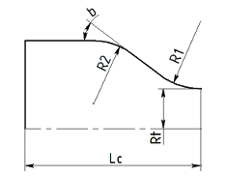
Chamber design configuration parameters

Object NozzleDesignConfiguration
Object NozzleDesignConfiguration is a pure JavaScript object with properties and without functions. It is used to prepare the configuration parameters to be passed to constructor of objects NozzleDesign.

Property | Description
chamberDesign | Reference to object ChamberDesign.
type | Nozzle type. Possible values: "CONICAL"  "PARABOLIC" "MOC"
theta_1 | Nozzle initial half-angle Tn. Used with type="PARABOLIC".
theta_1_unit | Angle unit. One of "degrees", "radians".
theta_e | Nozzle exit half-angle Te. Used with type="CONICAL" or type="PARABOLIC".
theta_e_unit | Angle unit. One of "degrees", "radians".
R1_to_Rt | Rn/Rt
R1 | The same as R1_to_Rt. Note: R1 is not an absolute value.
Le_to_Dt | Relative nozzle length Le/Dt. Optional. Used with type="MOC",  mocType="FIXED_EXIT_AREA_AND_LENGTH".
Le_r | Relative nozzle length Le/Le_con_15 (%). Optional. Used with type="PARABOLIC".
mocType | Type of MOC nozzle. Possible values: "FIXED_EXIT_AREA" "FIXED_EXIT_AREA_AND_LENGTH"
Tw_to_T0 | Average Tw/T0. Used with type="MOC".
Tw_bar | The same as Tw_to_T0.

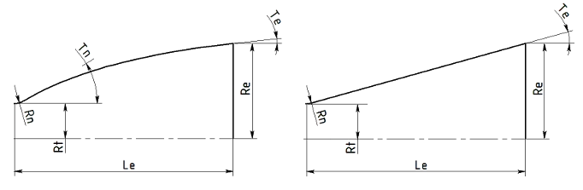

Parabolic and MOC nozzle design configuration parameters
Conical nozzle design configuration parameters

Object ChamberDesignResults
Object ChamberDesignResults is a pure JavaScript object with properties and without functions. It is used to return the results from solved object ChamberDesign.

Property | Description
Ac | Combustion chamber area.
Ac_unit | "m^2"
At | Throat area.
At_unit | "m^2"
Vc | Volume of combustion chamber.
Vc_unit | "m^3"
Sc | Surface area of combustion chamber.
Sc_unit | "m^2"
mdot | Chamber total mass flow rate.
mdot_unit | "kg/s"
F | Chamber thrust.
F_unit | "N"
pa | Ambient pressure for calculated thrust.
pa_unit | "Pa"
Dc | Combustion chamber diameter.
Dc_unit | "m"
Lcyl | Length of cylindrical part of chamber.
Lcyl_unit | "m"
Lstar | L*

Property | Description
Lstar_unit | "m"
b | Nozzle inlet contraction angle.
b_unit | "radians"
R1 | See image “Thrust chamber design result parameters”.
R1_unit | "m"
R2 | See image “Thrust chamber design result parameters”.
R2_unit | "m"
Linlet | Length of nozzle inlet.
Linlet_unit | "m"
Vinlet | Volume of nozzle inlet.
Vinlet_unit | "m^3"
Sinlet | Surface area of nozzle inlet.
Sinlet_unit | "m^2"
Dt | Throat diamater.
Dt_unit | "m"
n | Number of thrust chambers.
contour | Array of contour points. Each element of array is a JavaScript object with properties:  x - axial distance from injector plate r - radius  unit - unit, "m"

Object NozzleDesignResults
Object NozzleDesignResults is a pure JavaScript object with properties and without functions. It is used to return the results from solved object NozzleDesign.

Property | Description
type | Type of nozzle contour. One of "CONICAL", "PARABOLIC", "MOC"
Ar | Nozzle area ratio Ae/At.
At | Nozzle throat area.
At_unit | "m^2"
Ae | Nozzle exit area.
Ae_unit | "m^2"
Dt | Nozzle throat diameter.
Dt_unit | "m"
De | Nozzle exit diameter.
De_unit | "m"

Property | Description
L | Nozzle length.
L_unit | "m"
theta_1 | Nozzle initial half-angle Tn.
theta_1_unit | Tn_unit, "radians".
theta_e | Nozzle exit half-angle Te.
theta_e_unit | "radians"
R1 | Rn, see image “Thrust chamber design result parameters”.
R1_unit | Rn_unit, "m"
contour | Array of contour points. Each element of the array is a JavaScript object with properties:  x - axial location  r - radius  unit - unit, "m"  The value of axial location depends on parameter startFromLc (see function NozzleDesign.getSize()). If “false”, the location of the first contour point is 0. Otherwise, the location of the first point is “Lc” (combustion chamber length).
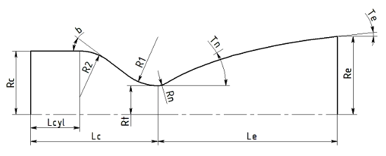

Thrust chamber design result parameters

Object HeatTransferConfiguration
Object HeatTransferConfiguration is a pure JavaScript object with properties and without functions. It is used to prepare the configuration parameters to be passed to constructor of objects HeatTransferAnalysis.

Property | Description
chamberDesign | Reference to object ChamberDesign.
nozzleDesign | Reference to object NozzleDesign.

Property | Description
throttle_value | Thrust chamber throttle value. Optional. Default value is “1.0”.
points | Number of points along the chamber to calculate heat transfer. Optional. Default value is “50”.
applyCooling | If “true”, calculate wall cooling and find steady state wall temperature and heat transfer at each wall point.  Otherwise, estimate heat transfer at fixed wall temperature Twg without applying wall cooling.
Twg | Fixed wall temperature. Used with parameter applyCooling="false".
Twg_unit | Fixed temperature unit. One of "K", "F", "C",
approach | Heat transfer relations. Possible values: "IEVLEV"  "BARTZ" "MIXED"
wallLayer | Relative thickness of near-wall layer. Optional. Default value “0.025”.
withRadiationHeatTransfer | If “true”, estimate radiation heat transfer from combustion products to gas- side wall surface.
eps_w | Emissivity of gas-side wall surface. Optional. Default value is “0.8”.
applyFilmCooling | If “true”, specified film slot configurations will be applied during wall cooling analysis.
designRegenCoolingJackets | If “true”, the code will try to design the geometry of configured regenerative cooling segments.
filmCoolingSlots | Array of film cooling slots. Contains objects FilmCoolingSlot.
wallCoolingSegments | Array of wall cooling segments. Contains objects WallCoolingSegment.

Object FilmCoolingSlot

Property | Description
coolant | Object Mixture to specify the coolant for the film slot.
mdot_bar | Slot relative mass flow rate. The value is relative to the chamber total mass flow rate: mdot_bar = mdot_slot/mdot_total.
location | Slot location: distance from the injector along the longitudinal axis of the chamber.
location_unit | Location unit. One of "m", "mm", "in", "ft".

Object WallCoolingSegment

Property | Description
id | ID of the cooling slot. Any string value which is unique among all other segments.
location | Segment location: distance from the injector along the longitudinal axis of the chamber to the segment end closest to the injector.
location_unit | Location unit. One of "m", "mm", "in", "ft".
h | Thickness of the inner (gas-side) wall, or thickness of the tube wall.
h_unit | Thickness unit. One of "m", "mm", "in", "ft".
lambda | Thermal conductivity of inner (gas-side) wall.
lambda_unit | Thermal conductivity. One of "W/(m K)", "Btu/(s in R)", "Btu/(hr ft R)".
bcH | Thickness of barrier coating on the gas-side of the wall. Optional.
bcH_unit | Thickness unit. One of "m", "mm", "in", "ft".
bcLambda | Thermal conductivity of barrier coating on the gas-side of the wall.
bcLambda_unit | Thermal conductivity. One of "W/(m K)", "Btu/(s in R)", "Btu/(hr ft R)".
type | Possible values: "RADIATION" "COAXIAL" "TUBULAR" "CHANNEL"
eps_w | Emissivity of outer surface of the wall. Used with type="RADIATION". Optional, Default value is “0.8”.
hc | Distance between shells. Used with type="COAXIAL".
hc_unit | Distance unit. One of "m", "mm", "in", "ft".
d1 | Tube diameter (before forming) at segment end closest to the injector (see fig. “Stations of cooling segments”). Used with type="TUBULAR".
d1_unit | Diameter unit. One of "m", "mm", "in", "ft".
d2 | Tube diameter (before forming) at segment end which is most distant from the injector (see fig. “Stations of cooling segments”). Used with type="TUBULAR".
d2_unit | Diameter unit. One of "m", "mm", "in", "ft".
dmin | Tube diameter (before forming) at segment end at the lowest area ratio (see fig. “Stations of cooling segments”). Optional. Used with type="TUBULAR".
dmin_unit | Diameter unit. One of "m", "mm", "in", "ft".
n | Number of tubes or channels. Used with type="TUBULAR" and type="CHANNEL".
helix | If “true”, tubular segment has a helix structure. Optional. Default value is “false”. Used with type="TUBULAR".
hc1 | Rib height at segment end closest to the injector (see fig. “Stations of cooling segments”). Used with type="CHANNEL".
hc1_unit | Height unit. One of "m", "mm", "in", "ft".
hc2 | Rib height at segment end which is most distant from the injector (see fig. “Stations of cooling segments”). Used with type="CHANNEL".

Property | Description
hc2_unit | Height unit. One of "m", "mm", "in", "ft".
hcmin | Rib height at segment end at the lowest area ratio (see fig. “Stations of cooling segments”). Optional. Used with type="CHANNEL".
hcmin_unit | Height unit. One of "m", "mm", "in", "ft".
a1 | Width of channel at segment end closest to the injector (see fig. “Stations of cooling segments”). Used with type="CHANNEL".
a1_unit | Width unit. One of "m", "mm", "in", "ft".
a2 | Width of channel at segment end which is most distant from the injector (see fig. “Stations of cooling segments”). Used with type="CHANNEL".
a2_unit | Width unit. One of "m", "mm", "in", "ft".
amin | Width of channel at segment end at the lowest area ratio (see fig. “Stations of cooling segments”). Optional. Used with type="CHANNEL".
amin_unit | Width unit. One of "m", "mm", "in", "ft". Used with type="CHANNEL".
gamma | Angle between channel passage and the plane perpendicular to symmetry axis of the chamber. Optional. Used with type="CHANNEL".
gamma_unit | Angle unit. One of "degrees", "radians".
b1 | Width of rib at segment end closest to the injector (see fig. “Stations of cooling segments”). Used with type="CHANNEL".
b1_unit | Width unit. One of "m", "mm", "in", "ft".
b2 | Width of rib at segment end which is most distant from the injector (see fig. “Stations of cooling segments”). Used with type="CHANNEL".
b2_unit | Width unit. One of "m", "mm", "in", "ft". Used with type="CHANNEL".
bmin | Width of rib at segment end at the lowest area ratio (see fig. “Stations of cooling segments”). Optional. Used with type="CHANNEL".
bmin_unit | Width unit. One of "m", "mm", "in", "ft".
channel_type | Possible values:  "CONST_CHANNEL_WIDTH" "CONST_RIB_WIDTH"  If channel_type="CONST_CHANNEL_WIDTH", parameters a1, a2, and amin are used, while parameters b1, b2, and bmin are ignored.  If channel_type="CONST_RIB_WIDTH"", parameters b1, b2, and bmin are used, while parameters a1, a2, and amin are ignored.  Used with type="CHANNEL".
lambda_rib | Optional.
lambda_rib_unit | Optional.
inputFrom | Coolant from regenerative cooling segment with specified ID.
coolant | Object Mixture to specify the coolant. Not applicable if inputFrom is specified.
mdot_bar | Relative mass flow rate. The value is relative to the chamber total mass flow rate: mdot_bar = mdot_slot/mdot_total. Not applicable if inputFrom is

Property | Description
 | specified.
coolant_p | Coolant inlet pressure. Not applicable if inputFrom is specified.
coolant_p_unit | Pressure unit. One of "Pa", "psi", "atm", "bar", "at", "MPa".
coolant_T | Coolant inlet temperature. Not applicable if inputFrom is specified.
coolant_T_unit | Temperature unit. One of "K", "F", "C",
oppositeFlow | Optional. Default value is “false”.
twoPass | Optional. Default value is “false”.
roughnessH | Gas-side wall average roughness height. Optional.
roughnessH_unit | Roughness height unit. One of "m", "mm", "in", "ft".
roughnessT | Gas-side wall average roughness step. Optional.
roughnessT_unit | Roughness step unit. One of "m", "mm", "in", "ft".
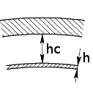
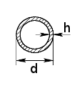
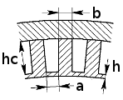

Coaxial shell segment configuration parameters
Tubular segment configuration parameters
Channel segment configuration parameters

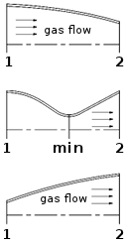
Stations of cooling segments

Object HeatTransferAnalysisResults

Property | Description
approach | Heat transfer relations. Possible values: "IEVLEV"  "BARTZ" "MIXED"
throttle_level | Thrust chamber throttle value.
Tw_bar | Average Tw/T0.
maxPass | MaxPass=2, if at least one regenerative cooling segments configured with two- pass coolant flow. Otherwise, maxPass=1.
units | JavaScript object with units used for values in HeatTransferAnalysisResults.
stations | JavaScript array with stations. Each element of the array is a JavaScript object  HeatTransferStation with parameters for specific station of thrust chamber.

Object Units
Object Units is a pure JavaScript object with units used for values in
HeatTransferAnalysisResults.

Property | Description
dimension | Unit for dimensions (location, diameter, length, width, etc.) Default "m".
area | Unit for area. Default "m^2".
velocity | Unit for velocity. Default is "m/s".
density | Unit for volumetric mass density. Default is "kg/m^3".
temperature | Unit for temperature, Default is "K".
pressure | Unit for pressure. Default is "Pa".
heat_flux | Unit for heat flux. Default is "W/m^2".
convective_heat_coeffi cient | Unit for convective heat transfer coefficient. Default is "W/m^2-K".
alpha | The same as "convective_heat_coefficient"

Object HeatTransferStation
Object HeatTransferStation is a pure JavaScript object with result parameters for specific station of thrust chamber.

Property | Description
x | Axial location.
r | Radius of thrust chamber contour.
q_total | Total heat transfer.
q_rad | Radiation heat transfer.

Property | Description
q_conv | Convective heat transfer.
alpha | Convective heat transfer coefficient.
Twg | Gas-side wall temperature.
cooling | JavaScript array. Each element of the array is a JavaScript object WallCooling  representing parameters of wall cooling.  For regenerative cooling segments configured with two-pass coolant flow, the array contains two elements.  For regenerative cooling segments configured with one-pass coolant flow, as well as for segments with radiation cooling, the array contains one element.

Object WallCooling
Object WallCooling is a pure JavaScript object with parameters for specific wall cooling segment.

Property | Description
id | Segment id.
type | Segment type. Possible values: "radiation" "radiation, film slot" "regen coaxial"  "regen coaxial, film slot" "regen tubular"  "regen tubular 1"  "regen tubular 2" "regen tubular, film slot"  "regen tubular 1, film slot" "regen tubular 2, film slot" "regen channel"  "regen channel 1"  "regen channel 1" "regen channel, film slot"  "regen channel 1, film slot" "regen channel 1, film slot" "failed"
Twi | Temperature on the wall under the thermal barrier coating layer.
Twc | Temperature of the wall on the coolant side.
Tc | Coolant temperature.
pc | Coolant pressure.
wc | Coolant velocity.
rhoc | Coolant volumetric mass density.
A | Coolant passage flow area.
de | Equivalent diameter of the coolant passage.
a, hc | Dimensions of the coolant passage. For coaxial shell: n.a.

Property | Description
 | For tubular cooling jacket: dimensions of deformed tube. For channel cooling jacket: dimensions of channel.
n | Number of tubes or channels.
helix | Angle of tube or channel having helix structure.
h | Thickness of the inner (gas-side) wall, or thickness of the tube wall.
bcH | Thickness of barrier coating on the gas-side of the wall. 0 if not applicable.

Attachments

Equivalence Ratio calculation

vox = ∑[if ( vi ∈0) then(ni vi )]
N
i=1
else0
vrd = ∑[if ( vi >0) then(ni vi )]
N
i=1
else 0

ER = − vox
vrd

where
N - number of chemical elements in chemical formula
i - index of chemical element in chemical formula (1, 2, ...)
n_{i} - number of atoms of chemical element i in chemical formula
v_{i} - valency of chemical element i
v_{ox} - sum of oxidizing valencies in chemical formula
v_{rd} - sum of reducing valencies in chemical formula Examples:
H₂ O (water)  N = 2 ( H , O )  for i = 1 ( H ) :  n₁ = 2  v₁ = 1 (reducing)  for i = 2 ( O ) :  n₂ = 1 | H₂ O₂ (hydrogen peroxide)  N = 2 ( H , O )  for i = 1 ( H ) :  n₁ = 2  v₁ = 1 (reducing)  for i = 2 ( O ) :  n₂ = 2

v₂ = −2 (oxidizing)  v_{ox} = n₂ v₂ = 1×(−2) = −2  v_{rd} = n₁ v₁ = 2×1 = 2  ER = −−2 = 1  2 | v₂ = −2 (oxidizing)  v_{ox} = n₂ v₂ = 2×(−2) = −4  v_{rd} = n₁ v₁ = 2×1 = 2  ER = −−4 = 2  2

Oxygen Balance calculation

b = Mox
N
∑ n v

ox
v
M
ox
i i
i=1

where
M_{ox} = 15.99 - atomic weight of oxygen
v_{ox} = −2 - valency of oxygen
N - number of chemical elements in chemical formula
i - index of chemical element in chemical formula (1, 2, ...)
n_{i} - number of atoms of chemical element i in chemical formula
v_{i} - valency of chemical element i
M - molecular weight of chemical specie Examples:
Na Cl O₄ (Sodium Perchlorate)  N = 3 ( Na , Cl , O )  for i = 1 ( Na ) :  n₁ = 1  v₁ = 1  M₁ = 22.99  for i = 2 ( Cl ) :  n₂ = 1  v₂ = −1  M₂ = 35.45  for i = 3 ( O ) :  n₃ = 4  v₃ = −2  M₃ = 15.99  M = n1 M 1 +n2 M 2 +n3 M 3 =  22.99 + 35.45 + 4×15.99 = 122.4 | Al (Aluminum)  N = 1 ( Al )  for i = 1 ( Al ) :  n₁ = 1  v₁ = 3  M₁ = 26.98  M = n₁ M₁ = 26.98  b = 15.99 (1×3) =  ^{O} −2×26.98  −0.29633×3 = −0.88899

bO =
15.99 (1×1 + 1×(−1) + 4×(−2))=
−2×122.4
−0.13063 (1−1−8) = 0.52255

