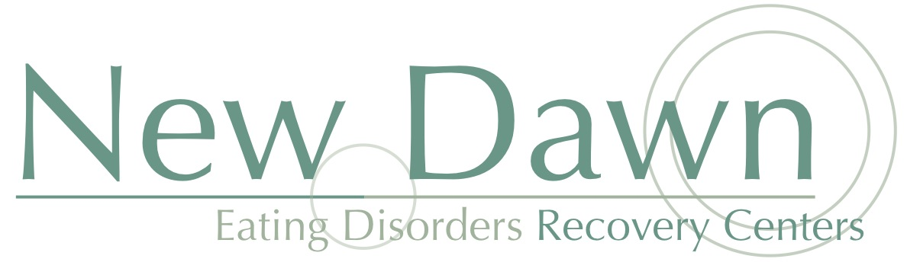

**Modified Maudsley Guidelines for Parents of Teens with Anorexia Nervosa**

**Important Concepts**

1. Your child’s illness means that she cannot be solely responsible for her nutritional health. She will require your active participation in treatment.
2. Anorexia is the deadliest of psychiatric diseases; it’s estimated that up to 15 percent of individuals with anorexia die from complications related to starvation or suicide. However, if anorexia is treated during adolescence in a vigorous way, prognosis vastly improves.
3. There is no single cause of anorexia-genetics, personality type, stressful life events, societal pressures, all can be contributors. It is very important that parents not blame themselves for their child’s illness. Family sessions will help you with process, and lead to important insights that strengthen the family to conquer and defeat the eating disorder.
4. Some parents fear that they will violate their child’s boundaries if they are “hands on” when it comes to monitoring eating behavior. There is a worry even among some providers that the Modified Maudsley will negatively impact a teen’s need for independence and is somehow disrespectful to the teenager. However, as associate professor of psychiatry at the University of Chicago, Dr. Daniel Le Grange explains, “If your child has diabetes and doesn’t check her blood sugar often enough, you would make sure she did. What we’re trying to achieve is taking anorexia away so the child can go on her way unencumbered by the eating disorder. What could be more respectful of adolescent development?” At New Dawn, we will assist each family with re-feeding as well as with how to remain respectful and connected during this process.
5. For individuals with anorexia, eating a “normal diet” is not enough to gain weight. The anorexic body requires greater numbers of calories to gain weight and maintain it. At New Dawn, we will help your daughter as well as the entire family accept that your daughter needs to eat higher calorie foods, more frequent portions, and larger portions than the rest of the family in order to recover from anorexia. It is important that you as parents do not buy into your daughter’s worry that treatment will make her fat. Treatment at New Dawn is geared toward re-establishing a healthy weight not making a person fat.
6. Many parents feel that while they are in the process of performing the Modified Maudsley Method, it takes them back to what it felt like to parent a toddler. Your child with anorexia is dependent on you to eat, just like she was as a baby and toddler. Keep in mind that this “dependency” phase of recovery will be shorter if you are able to stay firm and resolved in helping her with re-feeding.