[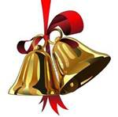](http://www.bing.com/images/search?q=christmas+pictures+clip+art&view=detail&id=B216F26188DF171376793E1161D60473C2B871F2) [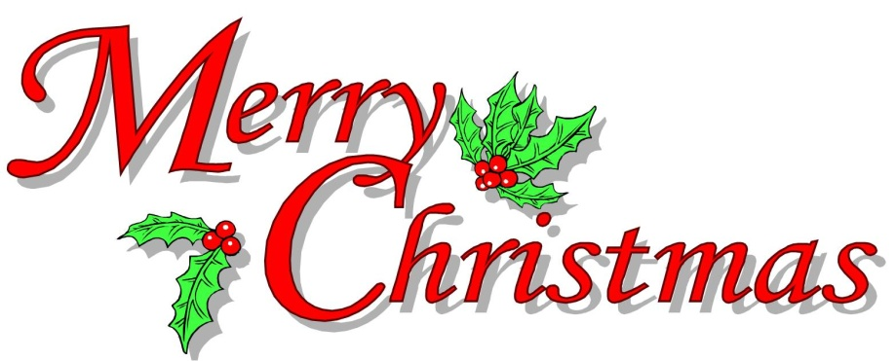](http://2.bp.blogspot.com/_u9BzJnthodc/TRK_fcawXlI/AAAAAAAAA7g/JjBlZrrzsxk/s1600/Merry%2BChristmas%2BClip%2BArt.jpg)

Dear Faculty and Staff

The Administration cordially invites everyone to attend our Christmas Breakfast Extravaganza on Tuesday, December 18th in the Upper Division Library beginning at 8:00am. Please make every effort to join in the food, fellowship and fun.

[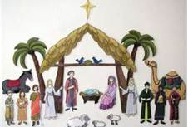](http://www.bing.com/images/search?q=nativity+clip+art&view=detail&id=8F5BDF4F6FDEE004495FCAD027E86F8701E653B6&first=36)