**CTI-110 Final Project – Spring 2021**

You will write a calculating program with the following requirements. Treat this like a final exam. No help from classmates, tutors, boyfriends, girlfriends nor others. Do this all by yourself. Use only your notes, previous programs, the textbook and online resources.

Remember to use all the skills you have learned in this course. That includes but is not limited to: colors, a css file, images, comments, indentation, algorithms, etc.

**Part 1: due Sunday 5/2 @ 11:55pm**You are only responsible for coding the html file and writing PHP algorithms this week.

* Code the ***Lastname*-*calculating.html*** file as described below. Include the IPO and the algorithm in the comments at the top of the file. Your html code should load an image and a css file.
* Use pseudocode to write the algorithm for the PHP file and the functions as described below. Save this in a file called ***Lastname-calculating.txt***. You are only responsible for the algorithms for the PHP files this week. You will do the PHP coding in Part 2.
* Submit the following files for Part 1:
  + Lastname-calculating.html
  + Lastname-calculating.txt
  + Lastname-calculating.css
  + Lastname-calculating.jpg (or png, etc.)

**Part 2: due Sunday 5/9 @ 11:55pm**

* Complete the program by coding ***Lastname*-*calculating.php*** and ***Lastname*-*inc-calc-functions.php***files as described below. Your php code should load an image and a css file.
* Put Part 1 and 2 together and test the completed program by loading the html file through localhost and clicking submit so that the PHP code runs. Be sure to run the program with each of the scores files (see below.)
* Submit the following files for Part 2:
  + Lastname-calculating.html
  + Lastname-calculating.txt
  + Lastname-calculating.css
  + Lastname-calculating.jpg (or png, etc.)
  + Lastname-calculating.php
  + Lastname-inc-calc-functions.php

**Calculating Program:**

1. ***Lastname*-*calculating.html*** –provide a drop-down menu with 3 options (scores1.txt, scores2.txt, and scores3.txt) and 2 buttons (one to submit/calculate, and one to reset). Your form action should be set to call *Lastname*-calculating.php (which you will code in Part 2.) You should also have a submit and reset button. Following is what the basic screen should contain (although yours will be designed to be more appealing with both a photo and color):

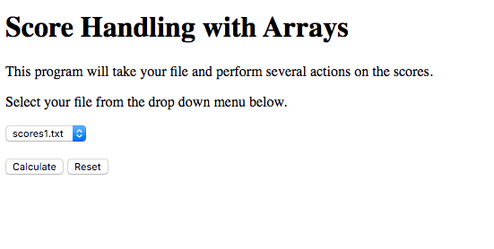

1. ***Lastname*-*inc-calc-functions.php*** – a file that will contain the following 5 functions:  
   **avgArray** – accepts an array as a parameter, uses a FOR loop to get the total of all the scores, and uses the total and the sizeof() functions to calculate average; returns the average, rounded by 2 decimal places

**highestInArray** – accepts an array as a parameter, uses a FOR loop to determine the highest score and returns the result

**lowestInArray -** accepts an array as a parameter, uses a FOR loop to determine the lowest score and returns the result

**numPassingArray –** accepts an array as a parameter, uses a FOR loop to count the number of scores that are greater than or equal to 60 and return the result  
**Do NOT read from the file in these functions. That should only be done in Lastname-calculating.php.**

1. ***Lastname*-calculating.php** – a file that will perform these tasks (use these function names):
   1. Use the PHP include() function to include your ***Lastname-inc-calc-functions.php*** file.
   2. Accept the filename from the html file.
   3. Use a while loop to read in the scores from the file and store them in an array. Close the file.
   4. Call the **avgArray** function, passing it the array. Store the result in a new variable
   5. Call the **highestInArray** function, passing it the array. Store the result in a new variable
   6. Call the **lowestInArray** function, passing it the array. Store the result in a new variable
   7. Call the **numPassingArray** function, passing it the array. Store the result in a new variable
   8. Open a file called output.txt for **appending,** and write all results to that file as follows:  
      scores1.txt:81.58:100:56:32:36   
      where the colon (:) is used as a delimiter and the following format is used:  
      filename:average:highest:lowest:numberPassing:totalNumber  
      (* filename is the name of the user input and totalNumber is the size of the array.)
   9. Also display the results to the screen in a way that is appealing and easy to understand (see the screen below for an example.)
   10. Have a link back to the html file so user can return to choose a different scores file.

When the user clicks the Calculate Button, your screen should contain this information (with color and an image):

