France JRC vs Gaspar Flood Comparison
JRC flood-depth maps, Gaspar CATNAT recognitions, and match results
Report scope | France, JRC flood-depth maps vs Gaspar flood recognitions
Main result folders | data/processed/jrc_gaspar_comparison_flexible_7d and ..._30d
Prepared from | Current processed outputs and JRC source documentation

This document explains what the comparison outputs mean, how the matching logic works, and how to interpret the strict 7-day and flexible 30-day variants.

Executive summary
• The France comparison uses 288 JRC flood events and 3505 Gaspar recognition-period groups derived from 164 CATNAT decree IDs.
• At the department level, the strict 7-day rule matches 125 of 288 JRC events (43.4%), while the flexible 30-day rule matches 171 (59.4%).
• At the commune level, match rates remain much lower: 66 JRC events under the 7-day rule and 80 under the 30-day rule.
• The department-level comparison is easier to interpret than the commune-level comparison because the two sources break the same flood episode into space and time differently.
• The flexible 30-day outputs are the best operational baseline, but event-level Gaspar counts should be read as administrative recognition-period proxies rather than true physical disaster-event IDs.

Data sources used in the comparison
This report documents the processed France comparison between the European Satellite-Derived Flood Depth Maps published by the Joint Research Centre (JRC) and the French Gaspar CATNAT recognition database.

JRC flood-depth maps
Field | Value
Dataset name | European Satellite-Derived Flood Depth Maps
Maintainer | Copernicus Emergency Management Service / JRC catalogue
DOI | 10.2905/0bc96690-b89c-4909-9166-c2c322a20130
Coverage | Europe and surroundings, land only
Time span | 2015-01-01 to 2024-12-31 in the official release
Resolution | 20 m
Projection | Azimuthal equidistant
File format | GeoTIFF, water depth in cm, uint16
Important dummy value | 9999 indicates permanent or seasonal water bodies
Method summary | Flood extents from Copernicus GFM aggregated with terrain topography using FLEXTH to estimate depth and enhance extent
Method reference: Andrea Betterle, Peter Salamon (2024), Water depth estimate and flood extent enhancement for satellite-based inundation maps, Natural Hazards and Earth System Sciences, DOI 10.5194/nhess-24-2817-2024.
Paper takeaway: The NHESS paper explains that FLEXTH expands flood masks into no-data areas using morphology and estimates water depths from terrain elevation along the flood boundary, allowing large-scale unsupervised processing.

Gaspar source used here
- Processed workbook: data/processed/Gaspar_2015_2024.xlsx, sheet Gaspar20152024FloodsClean.
- Risk filter used in preprocessing: Inondations et/ou Coulees de Boue, Inondations Remontee Nappe, and Chocs Mecaniques lies a l'action des Vagues.
- Comparison geography: commune level first, then department level derived from commune INSEE codes.
- Gaspar is an administrative recognition database. It does not provide a ready-made physical flood-event ID comparable to JRC jrc_event_id.

Comparison workflow
- 1. JRC rasters are tabularized to LAU, then harmonized to France INSEE communes in data/processed/france_lau_insee_documentation/events_fr_insee_long.csv.
- 2. Gaspar rows are cleaned, deduplicated, and filtered to flood-related hazards in the preprocessing notebook.
- 3. The strict run matches the same commune or department when both start and end dates are within 7 days.
- 4. The flexible run uses a 30-day window and also accepts cross start/end proximity and expanded interval overlap inside the same 30-day tolerance.
- 5. Department tables are derived from commune INSEE codes; best-match overviews then suggest one strongest Gaspar partner per JRC event.
- 6. unmatched_jrc_events_* tables count unique JRC events with no match at the chosen level, whereas unmatched_jrc_*_events tables count every unmatched commune or department row.

JRC France subset used for this report
Field | Value
Unique JRC events | 288
Canonical commune rows | 64327
Unique communes touched | 9829
Unique departments touched | 90
First start date in France subset | 2015-01-12
Last end date in France subset | 2025-01-06
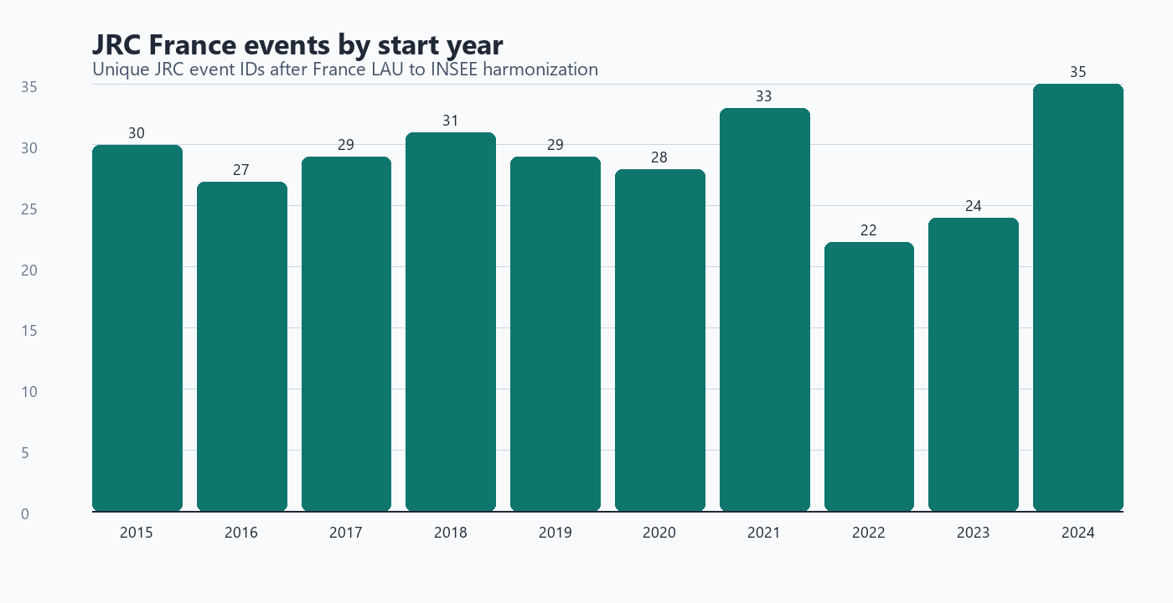
Figure 1. Unique JRC event IDs by start year after France harmonization. The highest count in the current France subset is 2024 (35 starts).

Annual profile of the two sources
Important caveat: JRC counts are unique physical map events. Gaspar counts below are recognition-period proxies built as cod_nat_catnat + start date + end date, so they are not directly equivalent to physical disaster episodes.
Start year | JRC unique events | Gaspar recognition-period groups
2015 | 30 | 201
2016 | 27 | 423
2017 | 29 | 137
2018 | 31 | 634
2019 | 29 | 221
2020 | 28 | 304
2021 | 33 | 429
2022 | 22 | 167
2023 | 24 | 404
2024 | 35 | 585

Match coverage: strict 7-day vs flexible 30-day
How to read this table: “Unique events” counts one event ID per source. “Canonical rows” counts one comparison row per commune-event or department-event record, so row totals are much larger than event totals.
Level / measure | JRC 7d | JRC 30d | Gaspar 7d | Gaspar 30d
Commune / unique events | 66/288 (22.9%) | 80/288 (27.8%) | 499/3505 (14.2%) | 587/3505 (16.7%)
Commune / canonical rows | 2501/64327 (3.9%) | 3080/64327 (4.8%) | 1983/19217 (10.3%) | 2204/19217 (11.5%)
Department / unique events | 125/288 (43.4%) | 171/288 (59.4%) | 1488/3505 (42.5%) | 1886/3505 (53.8%)
Department / canonical rows | 691/2642 (26.2%) | 1002/2642 (37.9%) | 1902/5426 (35.1%) | 2466/5426 (45.4%)
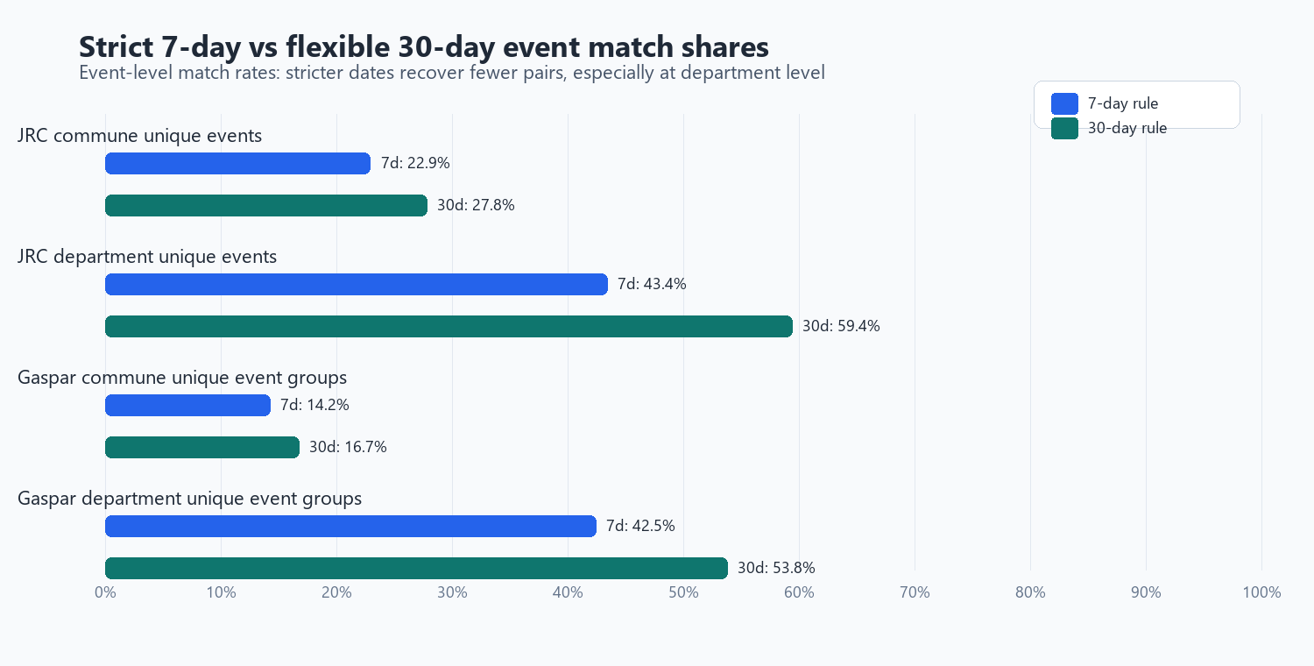
Figure 2. Event-level sensitivity of match rates to the stricter 7-day and more permissive 30-day rules.
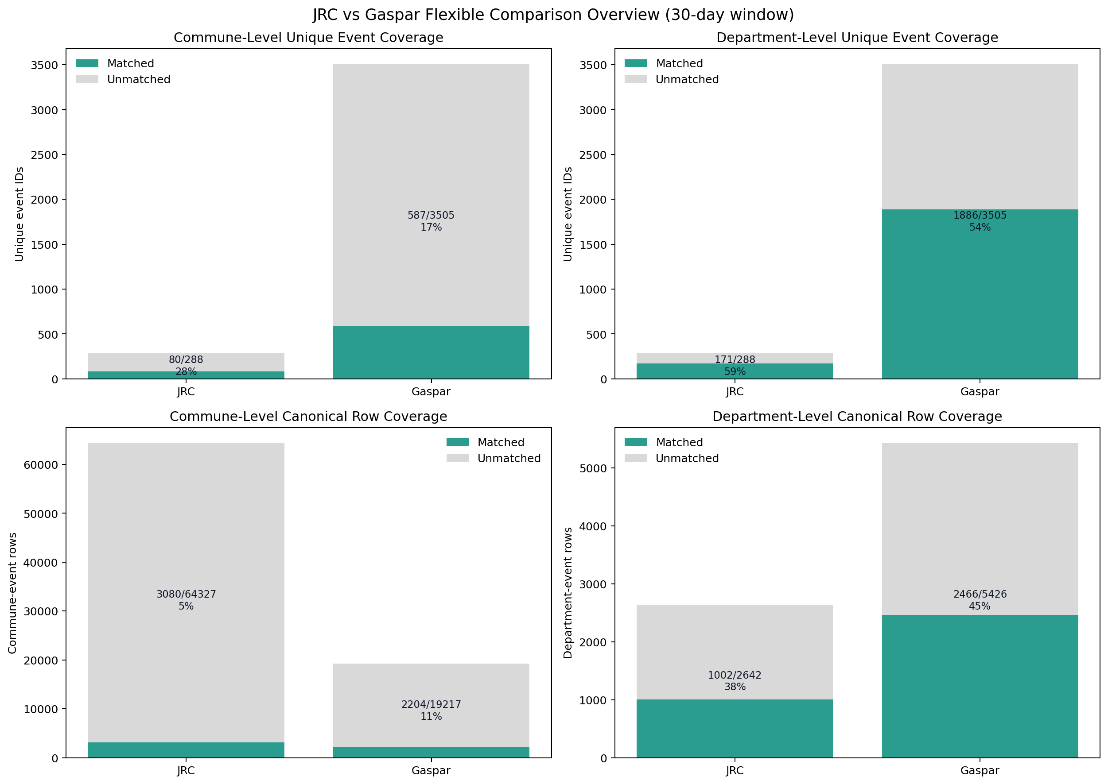
Figure 3. Coverage overview from the 30-day comparison. Unique-event shares and row-level shares tell different stories and should not be mixed.

Interpretation of the 30-day flexible results
- Department-level matching is substantially stronger than commune-level matching. This is expected because JRC event footprints and Gaspar recognitions rarely line up commune by commune.
- The flexible 30-day rule is materially more permissive than the strict 7-day rule. It recovers additional matches when the same flood episode is fragmented differently across the two datasets.
- Most department best-match pairs are 'Gaspar full, JRC partial'. In practice, this means a Gaspar recognition-period group is often fully contained inside a broader JRC event footprint or duration, rather than the other way around.
- Exact same start and end dates are rare. Spatial overlap plus a tolerant time window is doing most of the matching work.
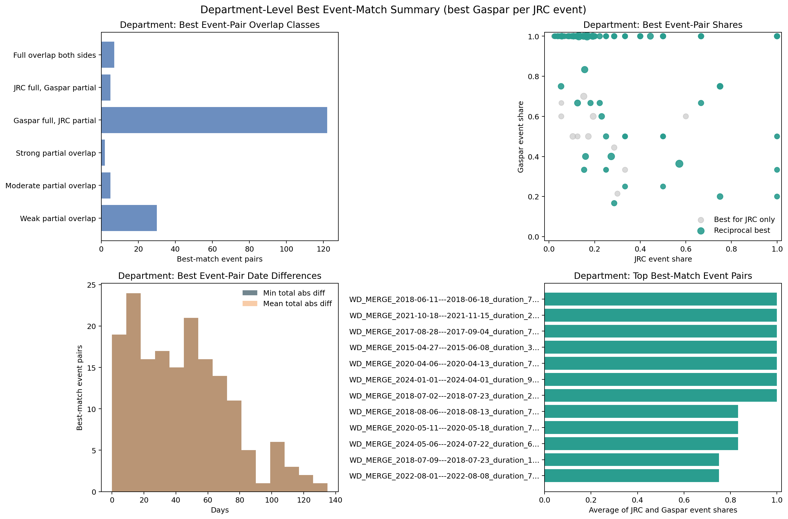
Figure 4. Department-level best event-pair summary for the 30-day run. Most best pairs are Gaspar-full and JRC-partial rather than full overlaps on both sides.

Why event-level counts are asymmetric
- JRC uses physical flood map events. Gaspar uses administrative recognition rows and the current comparison groups them with a proxy key: cod_nat_catnat + start date + end date.
- One JRC event can overlap many Gaspar recognition-period groups, and one Gaspar group can cover only part of a broader JRC event footprint.
- That is why department-level event matching is much stronger than commune-level event matching, and why matched row totals differ from matched unique event totals.
- In the 30-day run, only one best-match pair has exact same start and end dates at commune level, and only one at department level. Exact dates are the exception, not the rule.

Which output files to open first
File | What it is for
comparison_summary.xlsx | Headline counts for each run.
coverage_overview.xlsx | The key distinction between unique events and canonical rows.
best_match_overview_commune.xlsx | One suggested best Gaspar partner per JRC event at commune level.
best_match_overview_department.xlsx | Same idea at department level; usually the best first analytical table.
jrc_gaspar_comparison_flexible.xlsx | Combined workbook for people who prefer one Excel file.
details/ | Raw canonical tables, unmatched rows, and audit tables for debugging.

Limitations and recommended reading of the outputs
- Gaspar is an administrative recognition database, not a satellite event catalogue. In the current comparison code, gaspar_event_uid is a recognition-period proxy built as cod_nat_catnat + start date + end date.
- This means Gaspar 'unique event' counts are best read as recognition-period groups, not as perfectly reconstructed physical flood events.
- The 30-day diagnostics show 164 unique decree IDs but 3505 unique Gaspar recognition-period groups, which illustrates how a single decree can branch into many dated groups.
- Commune-level row match shares are low by construction because both sources partition the same episode differently across space and time. Department-level metrics are more stable for management reporting.
- JRC flood maps cover land only, use 20 m pixels, and encode permanent or seasonal water as dummy value 9999. They are therefore very strong for flood extent and relative timing, but not a direct mirror of compensation or administrative recognition processes.
- Recommended baseline: use the 30-day department-level outputs for the main narrative, keep the 7-day outputs as a stricter sensitivity test, and use commune tables only for local audit or deep dives.

References
- JRC dataset page: https://data.jrc.ec.europa.eu/dataset/0bc96690-b89c-4909-9166-c2c322a20130
- JRC dataset DOI: 10.2905/0bc96690-b89c-4909-9166-c2c322a20130
- JRC storage: https://jeodpp.jrc.ec.europa.eu/ftp/jrc-opendata/CEMS-EFAS/European_Satellite-Derived_Flood_Depth_Maps/
- Andrea Betterle, Peter Salamon (2024), Water depth estimate and flood extent enhancement for satellite-based inundation maps, Natural Hazards and Earth System Sciences, DOI: 10.5194/nhess-24-2817-2024
- Processed Gaspar source used by the comparison scripts: data/processed/Gaspar_2015_2024.xlsx (sheet Gaspar20152024FloodsClean).
- France JRC comparison input used by the scripts: data/processed/france_lau_insee_documentation/events_fr_insee_long.csv.

