France JRC vs Gaspar Flood Comparison
JRC flood-depth maps, Gaspar CATNAT recognitions, and match results
Report scope | France, JRC flood-depth maps vs Gaspar flood recognitions
Main result folders | data/processed/jrc_gaspar_comparison_flexible_7d and ..._30d
Prepared from | Current processed outputs and JRC source documentation

This document explains what the comparison outputs mean, how the matching logic works, and how to interpret the 7-day and 30-day flexible-window variants.

Executive summary
• The France comparison uses 288 JRC flood events and 3505 Gaspar recognition-period groups derived from 164 CATNAT decree IDs.
• At the department level, the 7-day window matches 125 of 288 JRC events (43.4%), while the 30-day window matches 171 (59.4%).
• At the commune level, match rates remain much lower: 66 JRC events under the 7-day rule and 80 under the 30-day rule.
• The department-level comparison is easier to interpret than the commune-level comparison because the two sources break the same flood episode into space and time differently.
• The flexible 30-day outputs are the best operational baseline, but event-level Gaspar counts should be read as administrative recognition-period proxies rather than true physical disaster-event IDs.

Data sources used in the comparison
This report documents the processed France comparison between the European Satellite-Derived Flood Depth Maps published by the Joint Research Centre (JRC) and the French Gaspar CATNAT recognition database.

JRC flood-depth maps
Field | Value
Dataset name | European Satellite-Derived Flood Depth Maps
Maintainer | Copernicus Emergency Management Service / JRC catalogue
DOI | 10.2905/0bc96690-b89c-4909-9166-c2c322a20130
Coverage | Europe and surroundings, land only
Time span | 2015-01-01 to 2024-12-31 in the official release
Resolution | 20 m
Projection | Azimuthal equidistant
File format | GeoTIFF, water depth in cm, uint16
Important dummy value | 9999 indicates permanent or seasonal water bodies
Method summary | Flood extents from Copernicus GFM aggregated with terrain topography using FLEXTH to estimate depth and enhance extent
Method reference: Andrea Betterle, Peter Salamon (2024), Water depth estimate and flood extent enhancement for satellite-based inundation maps, Natural Hazards and Earth System Sciences, DOI 10.5194/nhess-24-2817-2024.
Paper takeaway: The NHESS paper explains that FLEXTH expands flood masks into no-data areas using morphology and estimates water depths from terrain elevation along the flood boundary, allowing large-scale unsupervised processing.

Gaspar source used here
Field | Value
System name | GASPAR: Gestion Assistee des Procedures Administratives relatives aux Risques
Official role | Backbone of the DGPR natural-risk information system, according to Georisques
What the broader database contains | CatNat recognitions plus preventive and regulatory procedures such as PPR, DICRIM, TIM, AZI and others
What we use here | Only the CatNat recognition table, not the full administrative database
Official update note | Georisques says CatNat procedures are updated within 30 days after publication in the Journal Officiel
Open-data access | National, regional, departmental and annual extracts are offered on Georisques; an open-data listing is also published on data.gouv
Licence on data.gouv | Licence Ouverte / Open Licence version 2.0
Observed metadata date | The data.gouv CatNat page accessed for this report showed a last update of 4 March 2026
Official Géorisques documentation describes GASPAR as an administrative risk database rather than a physical flood-event catalogue. This distinction is central for interpreting any comparison with the JRC satellite event set.

What one Gaspar CatNat row means
The official GASPAR data dictionary states that one line in catnat_gaspar.csv corresponds to one recognition concerning one commune, one event period and one risk. Several recognitions can therefore exist for the same commune and the same broad event when different risks or administrative treatments are involved.
Field | Meaning
cod_nat_catnat | Unique recognition code generated by Gaspar
cod_commune / lib_commune | Affected commune code and commune name
num_risque_jo / lib_risque_jo | Risk code and official risk wording in the Journal Officiel
dat_deb / dat_fin | Recognized start and end dates of the event period
dat_pub_arrete | Date of the interministerial order
dat_pub_jo | Date of publication in the Journal Officiel
dat_maj | Date the Gaspar record was last updated
This structure explains why Gaspar does not naturally offer a physical event identifier equivalent to JRC jrc_event_id. In the current comparison scripts we therefore use a practical proxy, gaspar_event_uid = cod_nat_catnat + start date + end date. That is useful for matching, but it is still closer to an administrative recognition-period group than to a fully reconstructed flood episode.

How the CatNat mechanism shapes the data
- Géorisques explains that the CatNat indemnification regime is activated after an interministerial order is published in the Journal Officiel.
- The mayor requests recognition for the commune, and the published order specifies the recognized communes, the period of the event and the nature of the damage.
- Géorisques also notes that insured parties have 30 days after publication in the Journal Officiel to declare the loss to their insurer.
- Because the database follows this recognition workflow, Gaspar dates and event boundaries may legitimately differ from JRC satellite event boundaries.

Gaspar flood subset used in this project
Field | Value
Processed workbook | data/processed/Gaspar_2015_2024.xlsx, sheet Gaspar20152024FloodsClean
Rows in the cleaned flood sheet | 19304
Canonical commune rows after downstream deduplication | 19217
Unique Gaspar recognition-period groups in comparison | 3505
Unique decree IDs in comparison | 164
- Inondations et/ou Coulees de Boue: 18632 rows in the cleaned flood sheet.
- Inondations Remontee Nappe: 389 rows.
- Chocs Mecaniques lies a l'action des Vagues: 283 rows.
- Comparison geography: commune level first, then department level derived from commune INSEE codes.

Comparison workflow
- 1. JRC rasters are tabularized to LAU, then harmonized to France INSEE communes in data/processed/france_lau_insee_documentation/events_fr_insee_long.csv.
- 2. Gaspar rows are cleaned, deduplicated, and filtered to flood-related hazards in the preprocessing notebook.
- 3. Row-level matching is performed with src/compare_france_jrc_gaspar_flexible.py, using the same logic with two tolerance windows: 7 days and 30 days.
- 4. A commune-level or department-level row match requires the same geographic unit and at least one of the following conditions to hold, where w is the chosen window (7 or 30 days): (a) |JRC_start - Gaspar_start| <= w and |JRC_end - Gaspar_end| <= w; (b) |JRC_start - Gaspar_end| <= w and |Gaspar_start - JRC_end| <= w; (c) JRC_start <= Gaspar_end + w and Gaspar_start <= JRC_end + w.
- 5. Event-level summaries are then aggregated from these row-level matches. An event is counted as matched if at least one commune or department row matches, while matched_communes, matched_departments, jrc_match_share, and gaspar_match_share show whether the overlap is weak or strong.
- 6. unmatched_jrc_events_* tables count unique JRC events with no match at the chosen level, whereas unmatched_jrc_*_events tables count every unmatched commune or department row.

JRC France subset used for this report
Field | Value
Unique JRC events | 288
Canonical commune rows | 64327
Unique communes touched | 9829
Unique departments touched | 90
First start date in France subset | 2015-01-12
Last end date in France subset | 2025-01-06
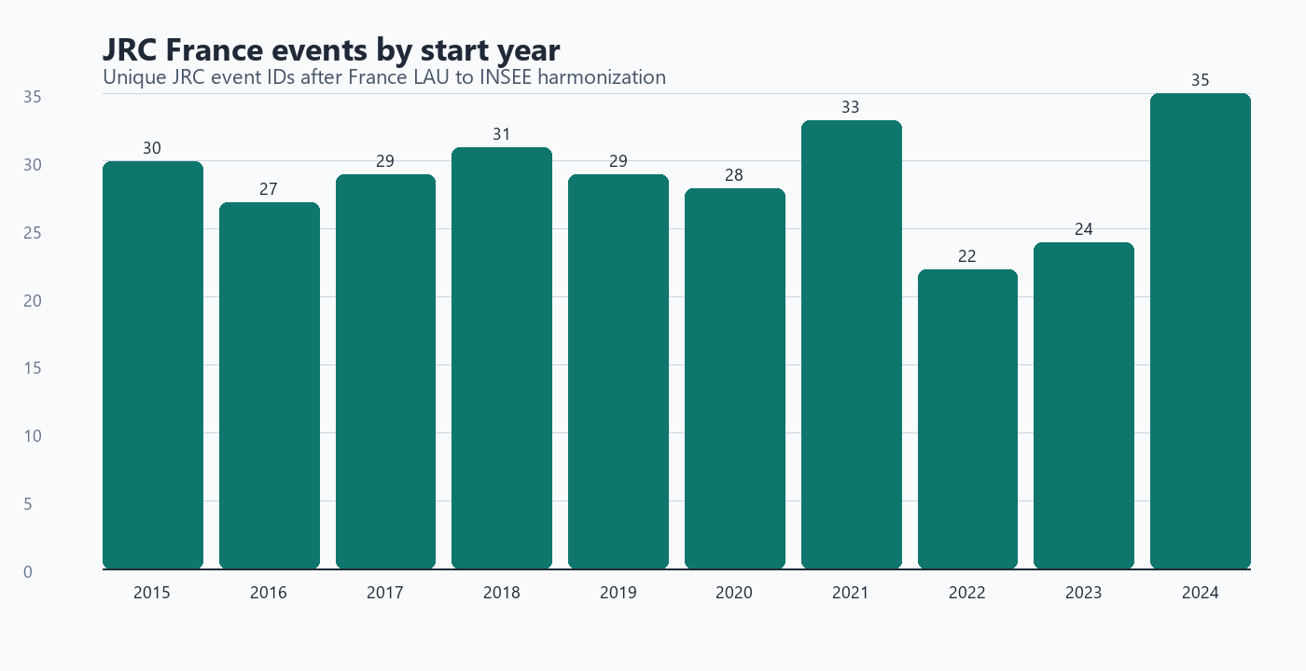
Figure 1. Unique JRC event IDs by start year after France harmonization. The highest count in the current France subset is 2024 (35 starts).

Annual profile of the two sources
Important caveat: JRC counts are unique physical map events. Gaspar counts below are recognition-period proxies built as cod_nat_catnat + start date + end date, so they are not directly equivalent to physical disaster episodes.
Start year | JRC unique events | Gaspar recognition-period groups
2015 | 30 | 201
2016 | 27 | 423
2017 | 29 | 137
2018 | 31 | 634
2019 | 29 | 221
2020 | 28 | 304
2021 | 33 | 429
2022 | 22 | 167
2023 | 24 | 404
2024 | 35 | 585

Match coverage: 7-day vs 30-day windows
How to read this table: “Unique events” counts one event ID per source. “Canonical rows” counts one comparison row per commune-event or department-event record, so row totals are much larger than event totals.
Level / measure | JRC 7d | JRC 30d | Gaspar 7d | Gaspar 30d
Commune / unique events | 66/288 (22.9%) | 80/288 (27.8%) | 499/3505 (14.2%) | 587/3505 (16.7%)
Commune / canonical rows | 2501/64327 (3.9%) | 3080/64327 (4.8%) | 1983/19217 (10.3%) | 2204/19217 (11.5%)
Department / unique events | 125/288 (43.4%) | 171/288 (59.4%) | 1488/3505 (42.5%) | 1886/3505 (53.8%)
Department / canonical rows | 691/2642 (26.2%) | 1002/2642 (37.9%) | 1902/5426 (35.1%) | 2466/5426 (45.4%)
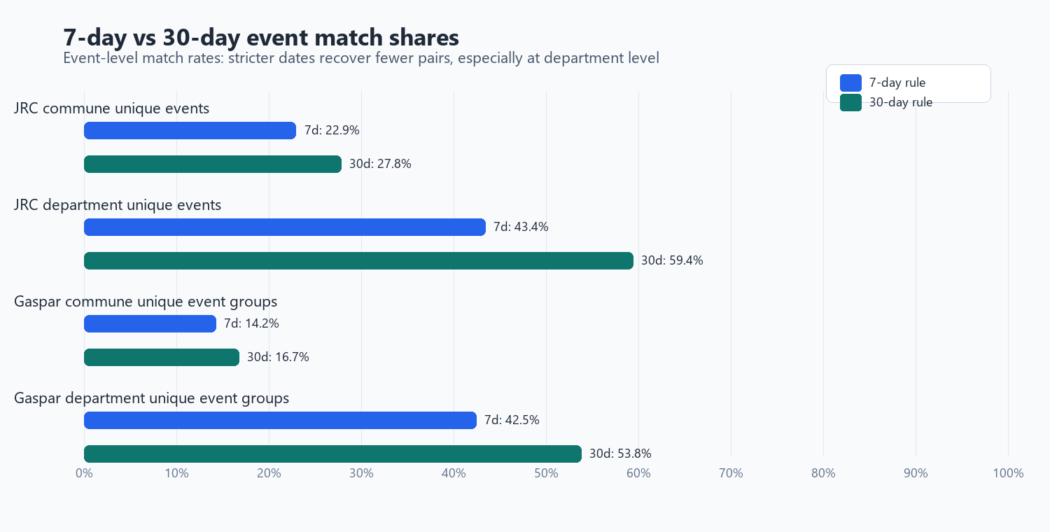
Figure 2. Event-level sensitivity of match rates to the 7-day and 30-day matching windows.
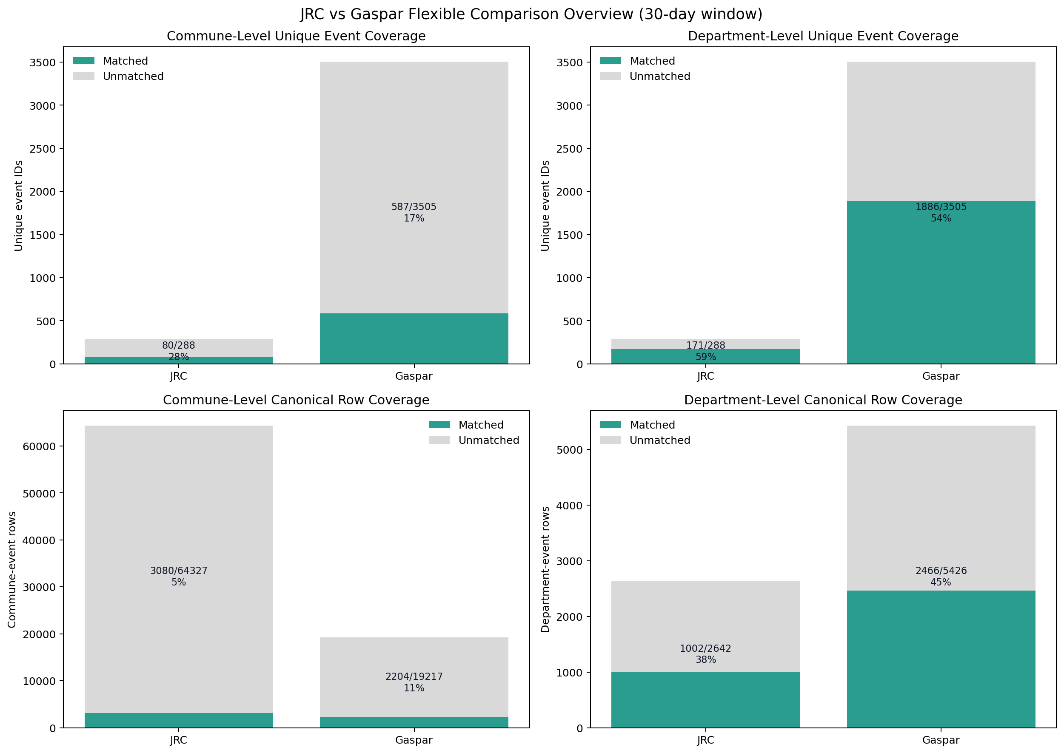
Figure 3. Coverage overview from the 30-day comparison. Unique-event shares and row-level shares tell different stories and should not be mixed.

Interpretation of the 30-day flexible results
- Department-level matching is substantially stronger than commune-level matching. This is expected because JRC event footprints and Gaspar recognitions rarely line up commune by commune.
- The 30-day window is materially more permissive than the 7-day window. It recovers additional matches when the same flood episode is fragmented differently across the two datasets.
- Most department best-match pairs are 'Gaspar full, JRC partial'. In practice, this means a Gaspar recognition-period group is often fully contained inside a broader JRC event footprint or duration, rather than the other way around.
- Exact same start and end dates are rare. Spatial overlap plus a tolerant time window is doing most of the matching work.
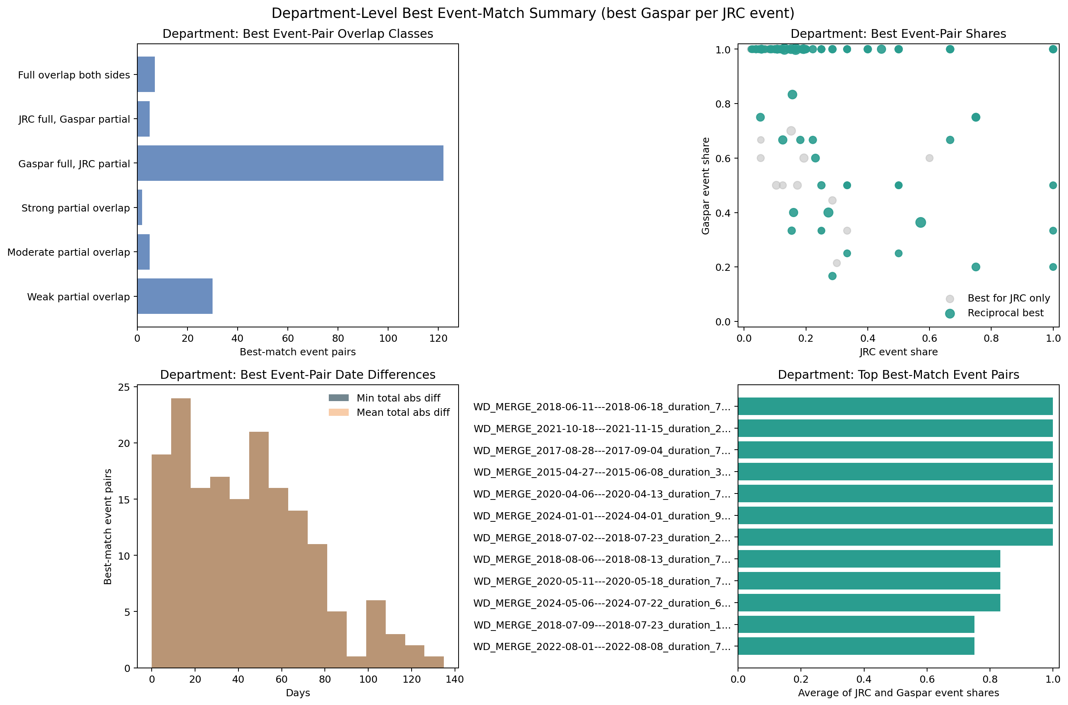
Figure 4. Department-level best event-pair summary for the 30-day run. Most best pairs are Gaspar-full and JRC-partial rather than full overlaps on both sides.

Why event-level counts are asymmetric
- JRC uses physical flood map events. Gaspar uses administrative recognition rows and the current comparison groups them with a proxy key: cod_nat_catnat + start date + end date.
- One JRC event can overlap many Gaspar recognition-period groups, and one Gaspar group can cover only part of a broader JRC event footprint.
- That is why department-level event matching is much stronger than commune-level event matching, and why matched row totals differ from matched unique event totals.
- In the 30-day run, only one best-match pair has exact same start and end dates at commune level, and only one at department level. Exact dates are the exception, not the rule.

Which output files to open first
File | What it is for
comparison_summary.xlsx | Headline counts for each run.
coverage_overview.xlsx | The key distinction between unique events and canonical rows.
best_match_overview_commune.xlsx | One suggested best Gaspar partner per JRC event at commune level.
best_match_overview_department.xlsx | Same idea at department level; usually the best first analytical table.
jrc_gaspar_comparison_flexible.xlsx | Combined workbook for people who prefer one Excel file.
details/ | Raw canonical tables, unmatched rows, and audit tables for debugging.

Limitations and recommended reading of the outputs
- Gaspar is an administrative recognition database, not a satellite event catalogue. In the current comparison code, gaspar_event_uid is a recognition-period proxy built as cod_nat_catnat + start date + end date.
- This means Gaspar 'unique event' counts are best read as recognition-period groups, not as perfectly reconstructed physical flood events.
- The 30-day diagnostics show 164 unique decree IDs but 3505 unique Gaspar recognition-period groups, which illustrates how a single decree can branch into many dated groups.
- Commune-level row match shares are low by construction because both sources partition the same episode differently across space and time. Department-level metrics are more stable for management reporting.
- JRC flood maps cover land only, use 20 m pixels, and encode permanent or seasonal water as dummy value 9999. They are therefore very strong for flood extent and relative timing, but not a direct mirror of compensation or administrative recognition processes.
- Recommended baseline: use the 30-day department-level outputs for the main narrative, keep the 7-day outputs as a narrower-window sensitivity test, and use commune tables only for local audit or deep dives.

References
- JRC dataset page: https://data.jrc.ec.europa.eu/dataset/0bc96690-b89c-4909-9166-c2c322a20130
- JRC dataset DOI: 10.2905/0bc96690-b89c-4909-9166-c2c322a20130
- JRC storage: https://jeodpp.jrc.ec.europa.eu/ftp/jrc-opendata/CEMS-EFAS/European_Satellite-Derived_Flood_Depth_Maps/
- GASPAR glossary page: https://www.georisques.gouv.fr/gaspar
- GASPAR administrative-procedures download page: https://www.georisques.gouv.fr/donnees/bases-de-donnees/procedures-administratives-relatives-aux-risques
- GASPAR official data dictionary PDF: https://www.georisques.gouv.fr/sites/default/files/Georisques_DictionnaireDonneesGaspar_1.0.pdf
- GASPAR CatNat open-data listing: https://www.data.gouv.fr/datasets/risques-arretes-catastrophes-naturelles
- Géorisques explanation of the CatNat indemnification mechanism: https://georisques.gouv.fr/le-dispositif-dindemnisation-des-catastrophes-naturelles
- Andrea Betterle, Peter Salamon (2024), Water depth estimate and flood extent enhancement for satellite-based inundation maps, Natural Hazards and Earth System Sciences, DOI: 10.5194/nhess-24-2817-2024
- Processed Gaspar source used by the comparison scripts: data/processed/Gaspar_2015_2024.xlsx (sheet Gaspar20152024FloodsClean).
- France JRC comparison input used by the scripts: data/processed/france_lau_insee_documentation/events_fr_insee_long.csv.

