France JRC vs Gaspar Flood Comparison
Full analysis report: commune and department results, 2015-2024 horizon audit, July 2021 case study, and app interpretation

Prepared on | 2026-06-11
Scope | France, processed JRC-Gaspar comparison outputs covering 2015-2024.
Main purpose | Consolidate the national comparison, the commune-versus-department reading, the horizon audit, the July 2021 mismatch note, and the app interpretation in one Word report.
Recommended baseline | Use the 30-day department-level outputs for the main narrative, and use commune-level outputs plus the app for diagnosis and manual review.

This report synthesizes the existing local analyses already present in the repository. It does not introduce a new matching algorithm; it explains and consolidates the results we already produced.

Executive summary
• The France comparison uses 288 unique JRC events and 3,505 Gaspar recognition-period groups derived from 164 decree IDs.
• Commune-level event matching remains low even under the 30-day rule: 27.8% for JRC and 16.7% for Gaspar.
• Department-level event matching is much higher: 59.4% for JRC and 53.8% for Gaspar in the 30-day run.
• The horizon audit shows that this mismatch is structural across several flood families from 2016 to 2024 rather than an isolated one-off case.
• The July 2021 evidence note found support for both Gaspar-only clusters and JRC-only clusters, which means the disagreement is not just noise on one side.
• The Streamlit app turns those statistics into a map-based validation workflow that can be used for manual interpretation and QA.

Report scope and source pack
This document is a consolidation report. It brings together the earlier national comparison outputs, the commune-activity app logic, the 2015-2024 horizon audit, and the July 2021 external-evidence note.
Repository artifact | Role in this report
data/processed/jrc_gaspar_comparison_flexible_7d | Strict-window comparison outputs used for the narrower sensitivity check.
data/processed/jrc_gaspar_comparison_flexible_30d | Flexible-window comparison outputs used for the main operational reading.
docs/gaspar_jrc_match_audit_en.md | National match statistics plus mapped manual checks for selected periods.
docs/gaspar_jrc_horizon_audit_en.md | 2015-2024 region-quarter mismatch ranking and extended manual review.
docs/july_2021_gaspar_jrc_mismatch_evidence_report.md | External-evidence note used to interpret the July 2021 mismatch.
docs/france_commune_activity_app_deep_guide.md | Functional explanation of the Streamlit commune-activity comparison app.

- The national comparison sections use the processed 7-day and 30-day output folders directly.
- The horizon section uses the saved region-quarter ranking and its mapped examples.
- The July 2021 section uses the earlier external-evidence note as an interpretation layer on top of the local comparison.
- The app section explains how the same commune-activity logic can be used interactively for validation and manual QA.

Data and matching logic
The comparison is between two very different source families: JRC flood-depth events derived from satellite-based products, and Gaspar catastrophe-naturelle recognition rows that follow an administrative process. That source asymmetry is the central reason the outputs require careful interpretation.

JRC flood-depth source
Field | Value
Dataset name | European Satellite-Derived Flood Depth Maps
Institutional source | Copernicus Emergency Management Service / Joint Research Centre
Coverage | Europe and surroundings, land only
Time span used in the local France subset | 2015-01-01 to 2024-12-31
Raster meaning | Water depth in centimetres on 20 m pixels
Important dummy code | 9999 marks permanent or seasonal water bodies
Analytical role here | Physical flood-footprint event source

Gaspar source used in this project
Field | Value
System | GASPAR: administrative risk-procedure information system
Subset used here | Processed CatNat flood-related rows only
Processed workbook | data/processed/Gaspar_2015_2024.xlsx (sheet Gaspar20152024FloodsClean)
Rows in cleaned flood sheet | 19,304
Canonical commune rows used downstream | 19,217
Unique decree IDs in comparison | 164
Unique Gaspar event groups in comparison | 3,505
Analytical role here | Administrative recognition-period event proxy
One Gaspar row is not the same thing as one physical flood event. For the comparison scripts, the practical event key is gaspar_event_uid = cod_nat_catnat + start date + end date. That makes matching possible, but it still represents an administrative recognition-period grouping rather than a natural disaster episode reconstructed from first principles.
- Inondations et/ou Coulées de Boue rows in the cleaned sheet: 18,632.
- Inondations Remontée Nappe rows in the cleaned sheet: 389.
- Chocs Mécaniques liés à l'action des Vagues rows in the cleaned sheet: 283.
- The comparison geography starts at commune level and also produces department-level rollups derived from commune codes.

How the matching works
- JRC rasters are first tabularized to LAU and then harmonized to current French INSEE communes.
- Gaspar rows are cleaned, deduplicated, filtered to flood-related risks, and resolved to current communes where possible.
- The flexible comparison is then run at commune level and at department level.
- The direct rule keeps pairs whose start dates are within the chosen window and whose end dates are also within that window.
- The broader rules also keep pairs when opposite endpoints are close or when the two periods overlap once the same date window is applied to both sides.
- The repository already contains both a 7-day run and a 30-day run, which lets us compare a stricter and a more permissive interpretation.

National comparison results
The headline result is stable across the project outputs: commune-level event matching is low, but department-level matching is materially higher. That pattern strongly suggests that the two sources often describe related flood episodes with different commune footprints and timing slices rather than having no overlap at all.
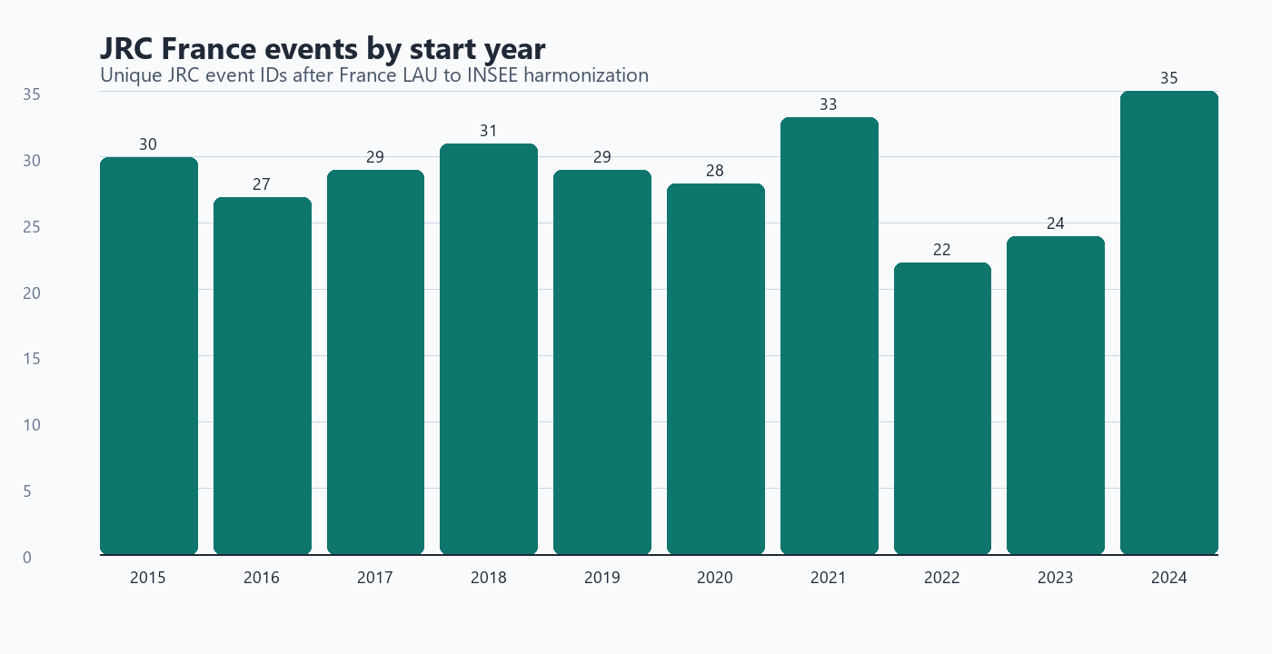
Figure 1. Unique JRC event starts by year in the France harmonized subset.

Match coverage: 7-day vs 30-day windows
How to read this table: “Unique events” counts one event ID per source. “Canonical rows” counts one comparison row per commune-event or department-event record, so row totals are much larger than event totals.
Level / measure | JRC 7d | JRC 30d | Gaspar 7d | Gaspar 30d
Commune / unique events | 66/288 (22.9%) | 80/288 (27.8%) | 499/3505 (14.2%) | 587/3505 (16.7%)
Commune / canonical rows | 2501/64327 (3.9%) | 3080/64327 (4.8%) | 1983/19217 (10.3%) | 2204/19217 (11.5%)
Department / unique events | 125/288 (43.4%) | 171/288 (59.4%) | 1488/3505 (42.5%) | 1886/3505 (53.8%)
Department / canonical rows | 691/2642 (26.2%) | 1002/2642 (37.9%) | 1902/5426 (35.1%) | 2466/5426 (45.4%)

Window | JRC commune | JRC department | JRC uplift | Gaspar commune | Gaspar department | Gaspar uplift
7 days | 22.9% | 43.4% | 20.5 pp | 14.2% | 42.5% | 28.2 pp
30 days | 27.8% | 59.4% | 31.6 pp | 16.7% | 53.8% | 37.1 pp
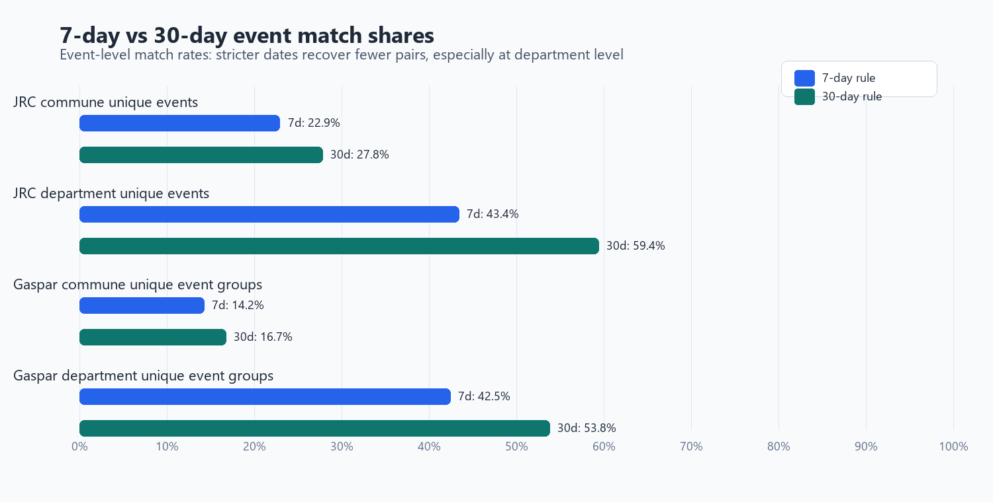
Figure 2. Event-match shares under the stricter 7-day rule and the more permissive 30-day rule.
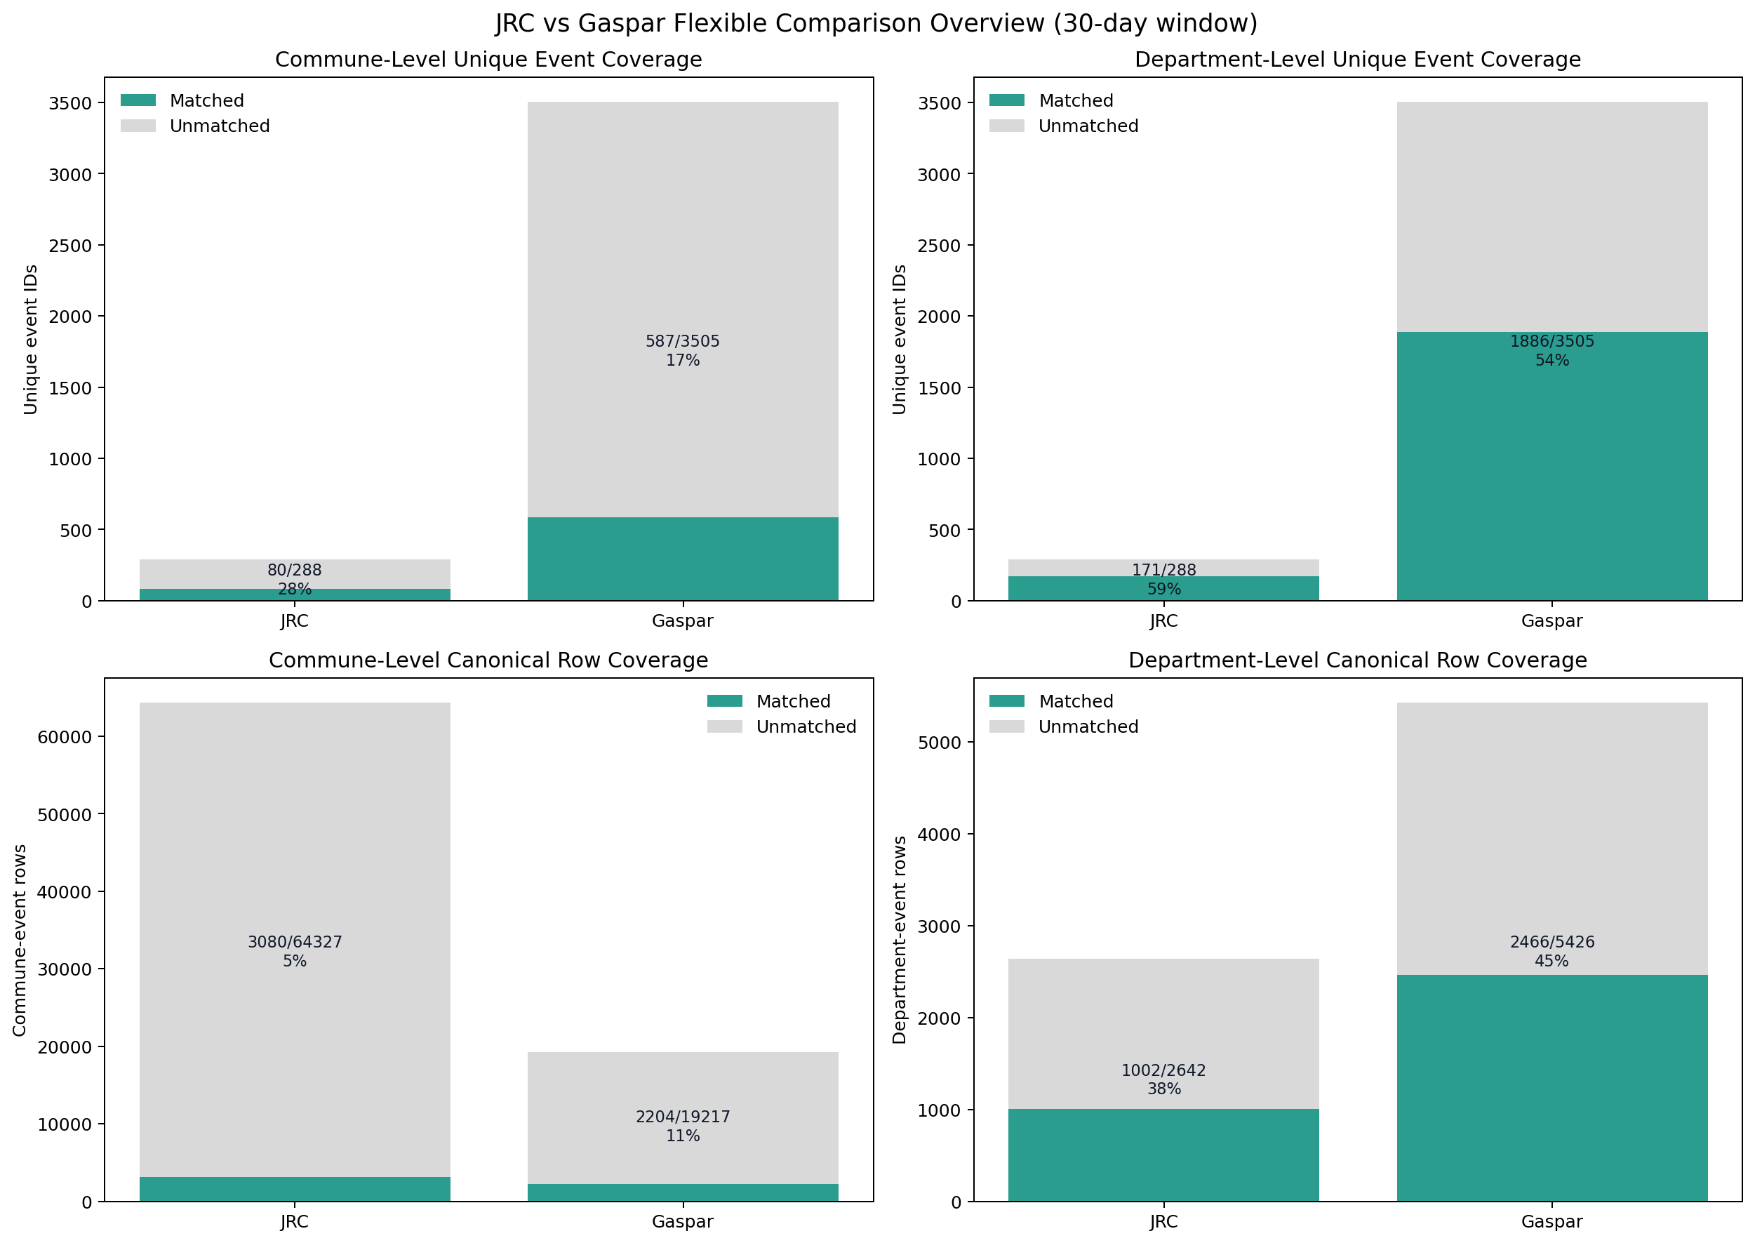
Figure 3. 30-day comparison overview. The event-level and row-level views tell different stories and should be read separately.
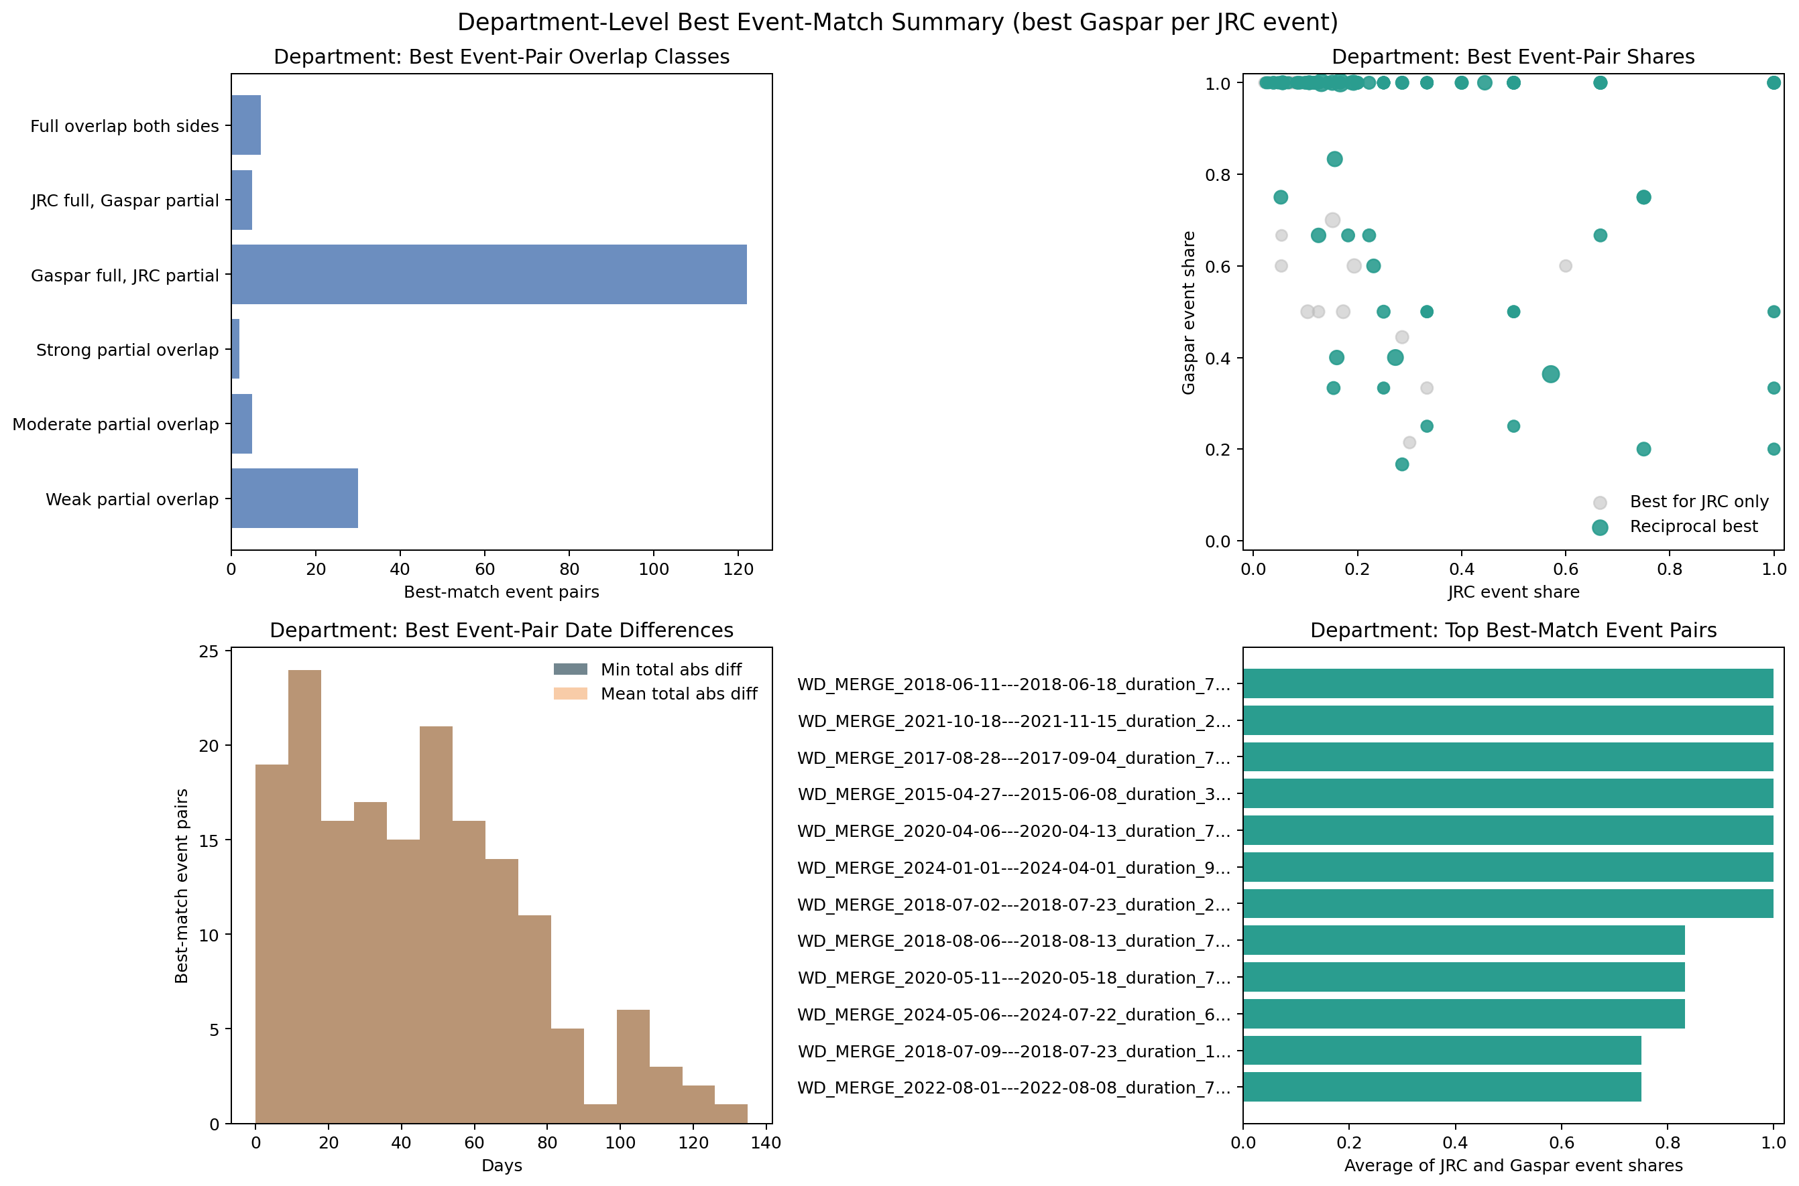
Figure 4. 30-day department-level best event-pair summary. Gaspar-full / JRC-partial pairs dominate the best-match picture.
- At commune level, the 30-day run matches 80 of 288 JRC events (27.8%) and 587 of 3,505 Gaspar event groups (16.7%).
- At department level, the same 30-day run rises to 171 matched JRC events (59.4%) and 1,886 matched Gaspar event groups (53.8%).
- The uplift from commune to department is +31.6 pp for JRC and +37.1 pp for Gaspar in the 30-day run.
- Gaspar expands from 164 decree IDs to 3,505 recognition-period groups in the comparison logic, or about 21.4 groups per decree on average. The saved diagnostics also show one decree branching into as many as 85 distinct date pairs.
- This asymmetry is why department-level matching is a better narrative baseline, while commune-level mismatches are better treated as signals that deserve diagnosis rather than as automatic source errors.

What the Streamlit app adds
The repository now includes a Streamlit commune-activity app that turns the comparison into a practical manual-QA workflow. The app does not compare rasters live on the map. Instead, it shows which current communes are active in Gaspar, JRC, or both for a chosen period.
- Switch between Gaspar, JRC, and direct comparison modes on the same France commune map.
- Filter by exact date, month, year, quarter, or custom interval.
- Inspect active communes, filtered source rows, matched rows, and unresolved Gaspar rows.
- Download the current commune table as CSV and the current rendered map as HTML.
- Overlay department boundaries while keeping the fill layer at current-commune resolution.

- The app is a temporal commune-activity viewer, not a raw raster viewer.
- Gaspar rows are resolved to current INSEE communes before they contribute to the map.
- JRC rows are already close to map-ready once the France LAU to INSEE harmonization has been run.
- Comparison mode is the fastest way to see both-active, Gaspar-only, and JRC-only communes for one period.
This matters for interpretation. The app is where the July 2021 and horizon-audit examples become visually understandable: the user can move from national counts to one date range, one region, and one cluster of communes without changing the underlying reconciliation logic.

2015-2024 horizon audit
The horizon audit extends the analysis beyond the original national summary by ranking every region-quarter from 2015-Q1 to 2024-Q4 with the same commune-activity logic used in the app. The ranking therefore measures period-overlap mismatch, not event-pair matching in the flexible comparison script.
Period | Region | Active | Both | Gaspar only | JRC only | Mismatch | Overlap
2018-Q1 | Grand Est | 1,432 | 120 | 48 | 1,264 | 1,312 | 8.4%
2024-Q1 | Grand Est | 1,255 | 8 | 23 | 1,224 | 1,247 | 0.6%
2018-Q1 | Bourgogne-Franche-Comte | 1,247 | 120 | 64 | 1,063 | 1,127 | 9.6%
2020-Q1 | Grand Est | 1,109 | 6 | 5 | 1,098 | 1,103 | 0.5%
2021-Q1 | Grand Est | 1,101 | 0 | 0 | 1,101 | 1,101 | 0.0%
2024-Q2 | Grand Est | 1,190 | 110 | 348 | 732 | 1,080 | 9.2%
2019-Q4 | Grand Est | 994 | 0 | 0 | 994 | 994 | 0.0%
2020-Q2 | Grand Est | 956 | 1 | 8 | 947 | 955 | 0.1%
2023-Q4 | Grand Est | 882 | 3 | 15 | 864 | 879 | 0.3%
2024-Q1 | Occitanie | 868 | 1 | 10 | 857 | 867 | 0.1%

- The largest mismatch quarters are not confined to one year. They span 2016, 2018, 2021, and 2024.
- The strongest high-activity Gaspar-dominant quarter is Centre-Val de Loire, 2016-Q2.
- The strongest JRC-dominant quarters cluster around Grand Est and Bourgogne-Franche-Comte in early 2018, with additional very large recent quarters in 2024.
- This means the low match rate is not a single-event anomaly. It recurs across different hydrologic settings and different parts of the source horizon.
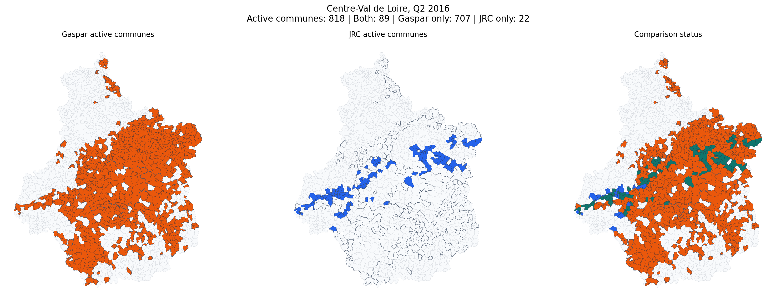
Figure 5. Centre-Val de Loire, Q2 2016. This is the strongest high-activity Gaspar-dominant quarter in the saved horizon audit.
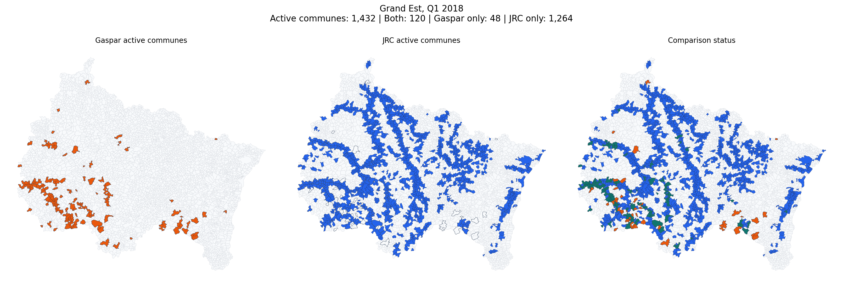
Figure 6. Grand Est, Q1 2018. This is the largest saved region-quarter mismatch and is strongly JRC-dominant.
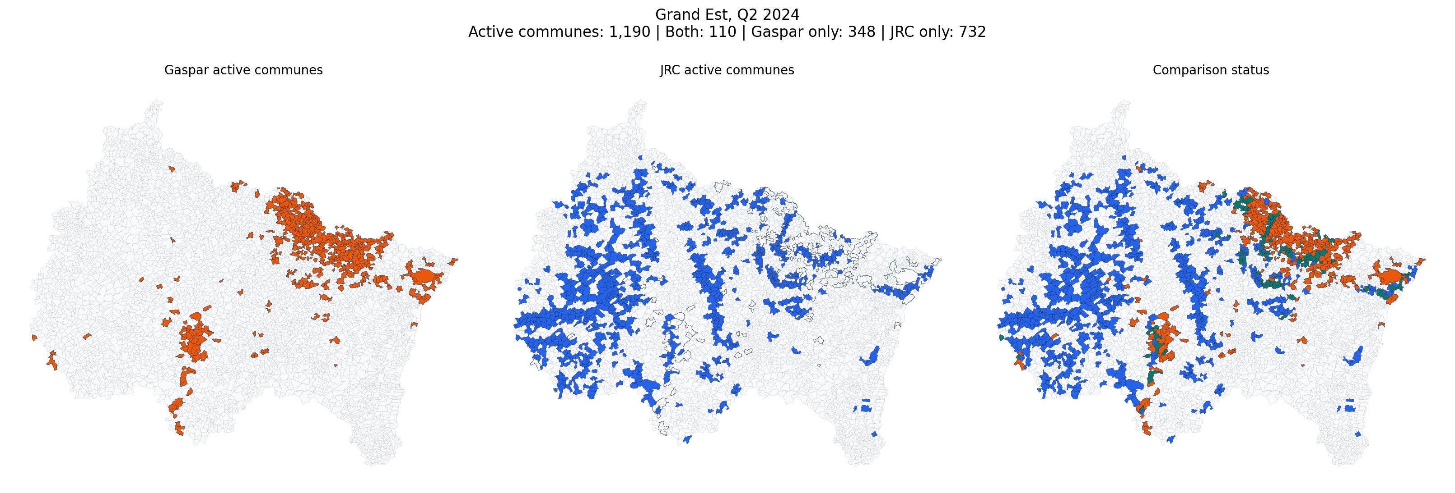
Figure 7. Grand Est, Q2 2024. This recent quarter shows large disagreement in both directions near the end of the source horizon.

July 2021 case study
The July 2021 mismatch was already audited in a separate external-evidence note. That note matters because it tests a key question: are the largest Gaspar-only and JRC-only clusters just noise, or do they correspond to real flood evidence on the ground?
Monthly app snapshot | Both active | Gaspar only | JRC only
July 2021 (app filter: Year 2021 -> Month 07) | 133 | 363 | 1,175

- The mismatch is material in both directions: there are many Gaspar-only communes and many more JRC-only communes in the month-level app snapshot.
- The earlier evidence note found supporting public evidence on both sides, which means the mismatch should not be read as an automatic false-positive problem for one source only.
- The most useful interpretation is that Gaspar and JRC capture related but non-identical aspects of the same flood family: administrative recognition versus mapped inundation footprint.

Grand Est, 2021-Q3
Saved quarter-level counts for this case: active communes 829, both 95, Gaspar only 202, JRC only 532, overlap share 11.5%.
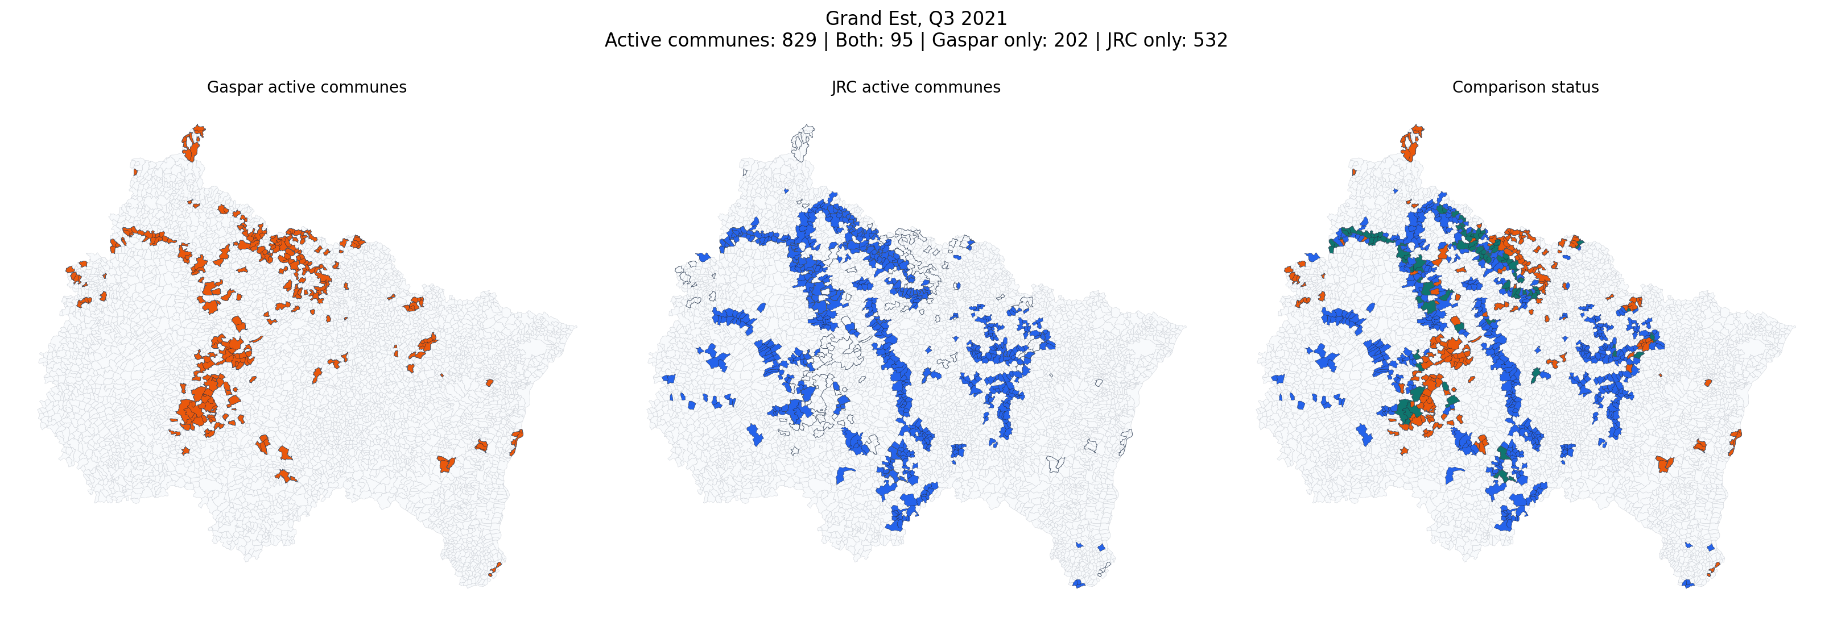
Figure 8. Grand Est, Q3 2021. The overlap exists, but the two source-specific clusters are much larger than the shared zone.

Bourgogne-Franche-Comte, 2021-Q3
Saved quarter-level counts for this case: active communes 508, both 22, Gaspar only 69, JRC only 417, overlap share 4.3%.
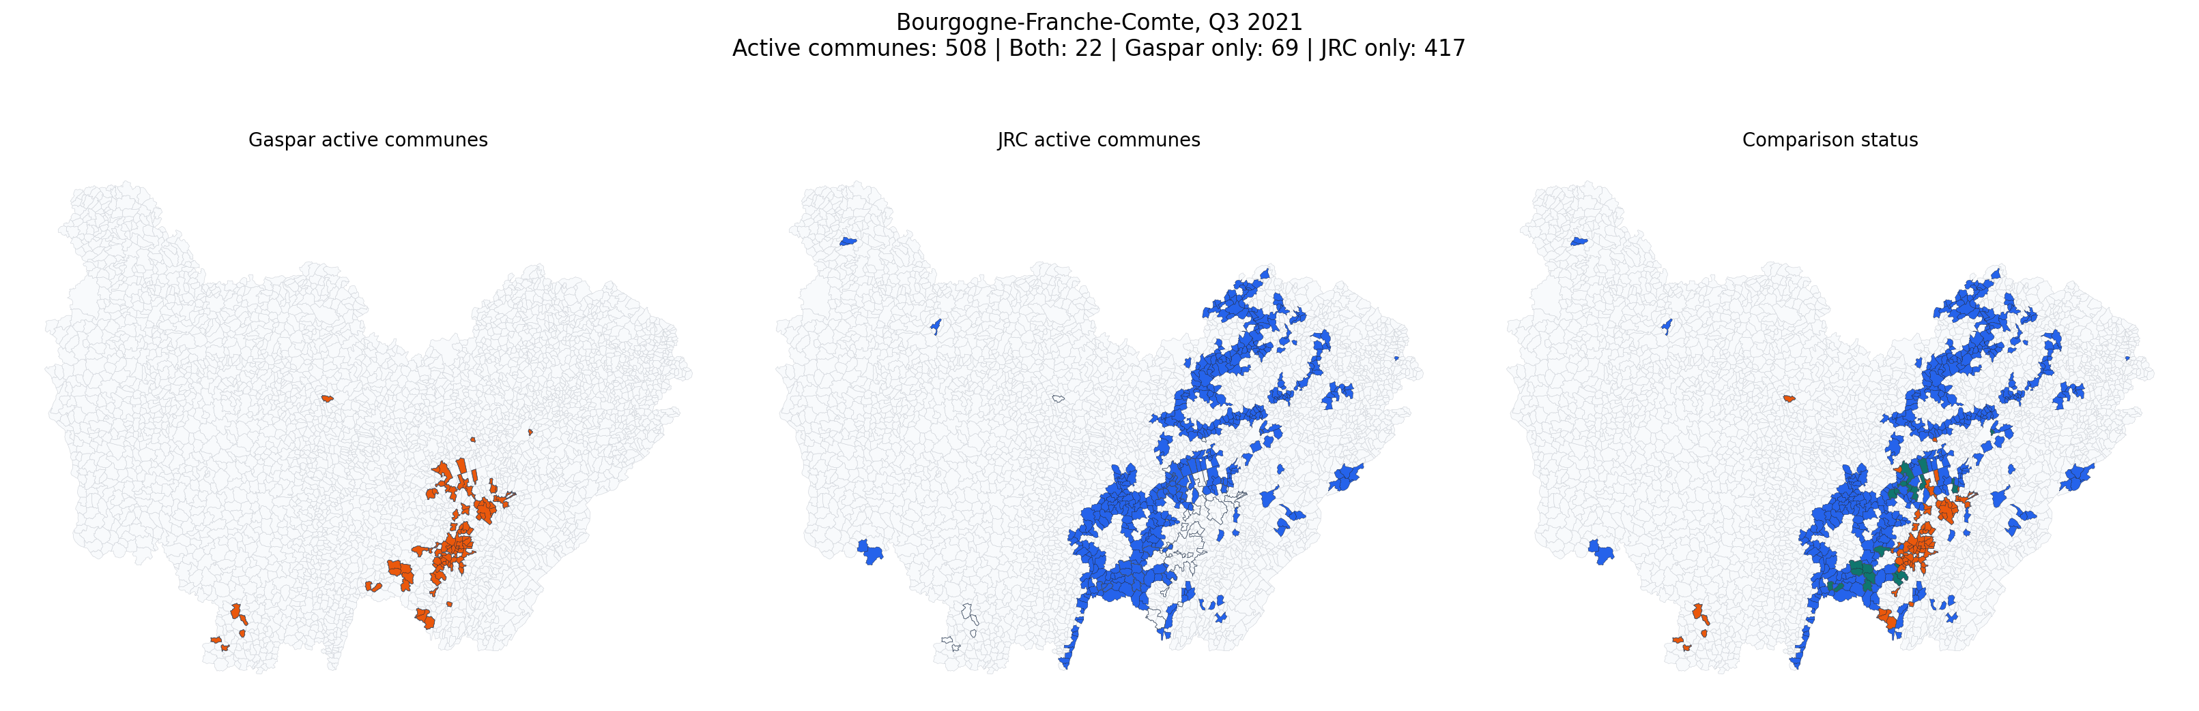
Figure 9. Bourgogne-Franche-Comte, Q3 2021. JRC spreads across a much wider corridor, while Gaspar still preserves real supported pockets.

Evidence-supported July 2021 clusters
Cluster | Side | Evidence strength | Reading
Jura (39): Arbois / Lons-le-Saunier / Bletterans | Gaspar only | Strong | The earlier note found local reporting, an official basin report, and a CatNat decree that all support real flood impacts.
Meuse (55): Bar-le-Duc / Behonne | Gaspar only | Strong | The earlier note found local reporting, prefecture material, and CatNat recognition for 13-15 July 2021 floods.
Seine-et-Marne (77): Claye-Souilly | Gaspar only | Moderate to strong | The earlier note found clear local media evidence of flooded communes and emergency interventions.
Haute-Saone (70): Autet and nearby communes | JRC only | Moderate | The earlier note found local flood cleanup reporting and department-level vigilance evidence.
Ardennes (08): Asfeld / Sedan sector | JRC only | Moderate to strong | The earlier note found local reporting on pumping operations, continuing flood conditions, and vigilance context.
Aisne / Ardennes floodplain: Savigny-sur-Aisne / Vieux-les-Asfeld | JRC only | Strong | The earlier note found site-level flood-mark evidence on the official reperes de crues platform.
Saone-et-Loire (71): Louhans / Seille corridor | JRC only | Moderate to strong | The earlier note found both government return-experience material and local reporting on flood impacts.

- Gaspar-only does not automatically mean false positive. The earlier note found strong support in Jura and Meuse, and additional support in Seine-et-Marne.
- JRC-only does not automatically mean false positive either. The earlier note found support in Haute-Saone, Ardennes, the Aisne-Ardennes floodplain sector, and Saone-et-Loire.
- The July 2021 case therefore behaves like a real source disagreement rather than a simple cleaning failure.

Overall interpretation
- The commune-level match rate is genuinely low in the saved outputs, even after moving from a 7-day to a 30-day window.
- The department-level uplift is too large to ignore. It is the clearest sign that commune allocation and timing fragmentation drive much of the mismatch.
- Gaspar event counts must be read as administrative recognition-period groups, not as clean physical event IDs.
- The horizon audit shows that the mismatch is structural across several major flood families, not confined to one famous month or one region.
- The July 2021 case study shows that both Gaspar-only and JRC-only clusters can still correspond to real flood evidence.
- Operationally, the strongest workflow is to use the 30-day department-level outputs for the main narrative, and then use commune-level diagnostics plus the app when a specific event family needs manual review.

Local reading path after this report
- Read the 30-day comparison directory first when you want the main national story.
- Use the 7-day directory as a stricter sensitivity check rather than as the default benchmark.
- Use the app when you need to understand where a mismatch sits geographically and which communes drive it.
- Use the horizon and July notes when you need manual, human-readable interpretation rather than raw tables.

Which output files to open first
File | What it is for
comparison_summary.xlsx | Headline counts for each run.
coverage_overview.xlsx | The key distinction between unique events and canonical rows.
best_match_overview_commune.xlsx | One suggested best Gaspar partner per JRC event at commune level.
best_match_overview_department.xlsx | Same idea at department level; usually the best first analytical table.
jrc_gaspar_comparison_flexible.xlsx | Combined workbook for people who prefer one Excel file.
details/ | Raw canonical tables, unmatched rows, and audit tables for debugging.

Limitations and recommended reading of the outputs
- Gaspar is an administrative recognition database, not a satellite event catalogue. In the current comparison code, gaspar_event_uid is a recognition-period proxy built as cod_nat_catnat + start date + end date.
- This means Gaspar 'unique event' counts are best read as recognition-period groups, not as perfectly reconstructed physical flood events.
- The 30-day diagnostics show 164 unique decree IDs but 3505 unique Gaspar recognition-period groups, which illustrates how a single decree can branch into many dated groups.
- Commune-level row match shares are low by construction because both sources partition the same episode differently across space and time. Department-level metrics are more stable for management reporting.
- JRC flood maps cover land only, use 20 m pixels, and encode permanent or seasonal water as dummy value 9999. They are therefore very strong for flood extent and relative timing, but not a direct mirror of compensation or administrative recognition processes.
- Recommended baseline: use the 30-day department-level outputs for the main narrative, keep the 7-day outputs as a narrower-window sensitivity test, and use commune tables only for local audit or deep dives.

References and project artifacts
Selected external references used across the earlier notes and the comparison documentation:
- JRC dataset DOI: 10.2905/0bc96690-b89c-4909-9166-c2c322a20130
- JRC dataset page: https://data.jrc.ec.europa.eu/dataset/0bc96690-b89c-4909-9166-c2c322a20130
- GASPAR glossary page: https://www.georisques.gouv.fr/gaspar
- GASPAR official data dictionary PDF: https://www.georisques.gouv.fr/sites/default/files/Georisques_DictionnaireDonneesGaspar_1.0.pdf
- GASPAR CatNat open-data listing: https://www.data.gouv.fr/datasets/risques-arretes-catastrophes-naturelles
- July 2021 official CatNat decree: https://www.legifrance.gouv.fr/jorf/id/JORFSCTA000043879099
- Centre-Val de Loire prefecture floods page: https://www.prefectures-regions.gouv.fr/centre-val-de-loire/Actualites/Principales/Inondations-en-region-Centre-Val-de-Loire
- Government return-experience report on the 2021 floods: https://www.economie.gouv.fr/cge/retour-inondations2021

