JRC Flood Source Comparison: France vs Italy
Rigorous source-level study from the processed JRC flood-depth tables, with national and regional comparisons and a point-matching interpretation note.
Prepared on | 2026-06-19
Primary scope | Country-level and regional comparison of the processed JRC flood-depth source for France and Italy.
Archive horizon | JRC raster inventory stored in data/JRC_flood_depth_maps with processed outputs covering 2015-2024.
Main source tables | events_lau_long.parquet, events_nuts2.csv, nuts3_event_coverage.csv, lau_nuts_lookup.csv.
Key caveat | The repository T20 workbook is France-only, so the report explains source asymmetry rather than claiming a symmetric point portfolio test.
This report compares the JRC source coverage itself. It does not claim a symmetric France-vs-Italy point study, because the repository T20 workbook is France-only.

Executive Summary
- France is touched by 288 unique JRC events in the 2015-2024 archive, versus 155 for Italy.
- France averages 28.8 events per year and Italy 15.5; the source is materially denser on the French side.
- The cumulative flooded footprint summed across country-event intersections is 30,684 km2 for France versus 3,208 km2 for Italy.
- Regional reach is broad in both countries: JRC touches 89.1% of French NUTS3 regions and 86.0% of Italian NUTS3 regions.
- Italy is not missing regional coverage; instead it is more concentrated. The top 10 Italian NUTS3 regions account for 66.5% of cumulative flooded area, versus 59.0% in France.
- Only 29 event IDs touch both countries, so most of the comparison reflects country-specific flood histories rather than the same transnational events.

Methodology And Scope
This study uses the processed JRC source products already present in the repository: `data/processed/_outputs_eurostat_full/events_lau_long.parquet`, `events_nuts2.csv`, `nuts3_event_coverage.csv`, and `lau_nuts_lookup.csv`.
The comparison is source-level and country-symmetric only on the JRC branch. France and Italy use the same JRC event archive and the same Eurostat LAU/NUTS harmonization, but their fallback screening branches differ in the point workflows: France uses Gaspar plus TRI/riparian, whereas Italy uses HANZE plus high-hazard TRI.
- Unit of comparison for national totals: one country-event intersection, aggregated from the event x LAU table.
- Regional footprint: unique event IDs, cumulative flooded area, and regional coverage shares at NUTS1/NUTS2/NUTS3.
- Time horizon: the checked-in JRC archive spans 2015 through 2024, with some events ending in early January 2025.
- Interpretation rule: larger event counts and more repeated regional hits increase the chance that a point screening workflow finds a local or nearby flood match.

T20 Point-Level Limitation
Scope item | Value
Rows in repository T20 workbook | 49
Rows mapped to France | 44
Rows mapped to Italy | 0
Rows unmatched to a LAU | 5
Source: data/processed/T20_Anonymised.xlsx plus a fresh LAU spatial join performed for this report.
- The checked-in T20 workbook contains 49 rows.
- All matched coordinates map to France; no checked-in T20 coordinate maps to Italy.
- Five rows stay unmatched to a Eurostat LAU and therefore cannot support country-level interpretation.
- A symmetric France-vs-Italy point comparison therefore requires an Italy point file or saved Italy point-run workbook that is not present in the repository.

National Comparison
Metric | France | Italy
Unique JRC events touching the country | 288 | 155
Average events per year (2015-2024) | 28.8 | 15.5
Cumulative country-event flooded area (km2) | 30,684 | 3,208
Median flooded area per country-event (km2) | 5.3 | 4.0
Median LAUs hit per country-event | 31.0 | 17.0
Median NUTS3 hit per country-event | 4.0 | 5.0
NUTS3 coverage share | 89.1% | 86.0%
Median event count per hit NUTS3 | 29.5 | 7.0
Top 10 NUTS3 share of cumulative area | 59.0% | 66.5%
Sources: data/processed/_outputs_eurostat_full/events_lau_long.parquet, nuts3_event_coverage.csv, and lau_nuts_lookup.csv.
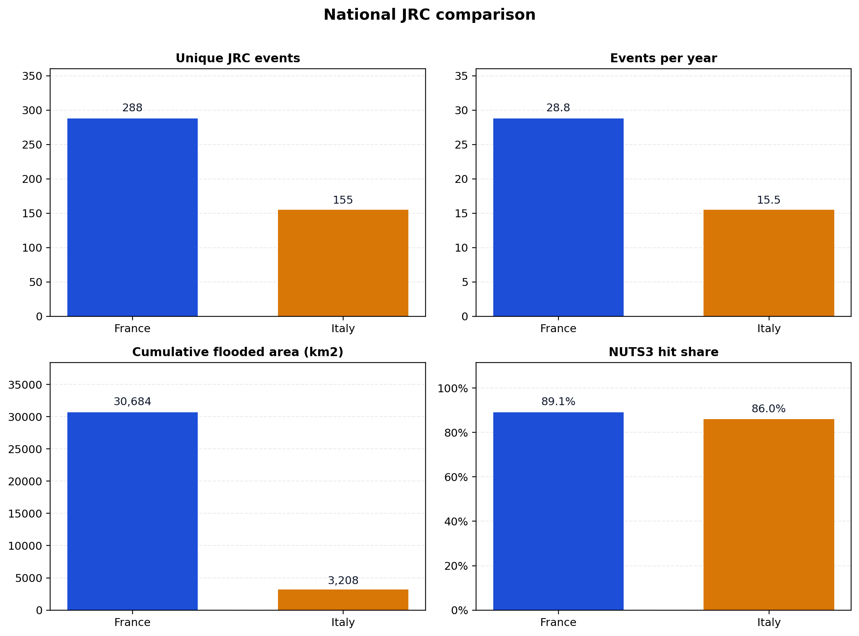
Figure 1. France exceeds Italy on event count, annual event rate, and cumulative flooded footprint, while both retain broad NUTS3 coverage.
France records 259 country-specific event IDs that never touch Italy, while Italy records 126. The shared set is only 29 events, so the observed gap is mostly structural rather than an artifact of shared storms.
A particularly important point for downstream point matching is recurrence: the median hit French NUTS3 region sees 29.5 JRC events over the archive, versus 7.0 in Italy.
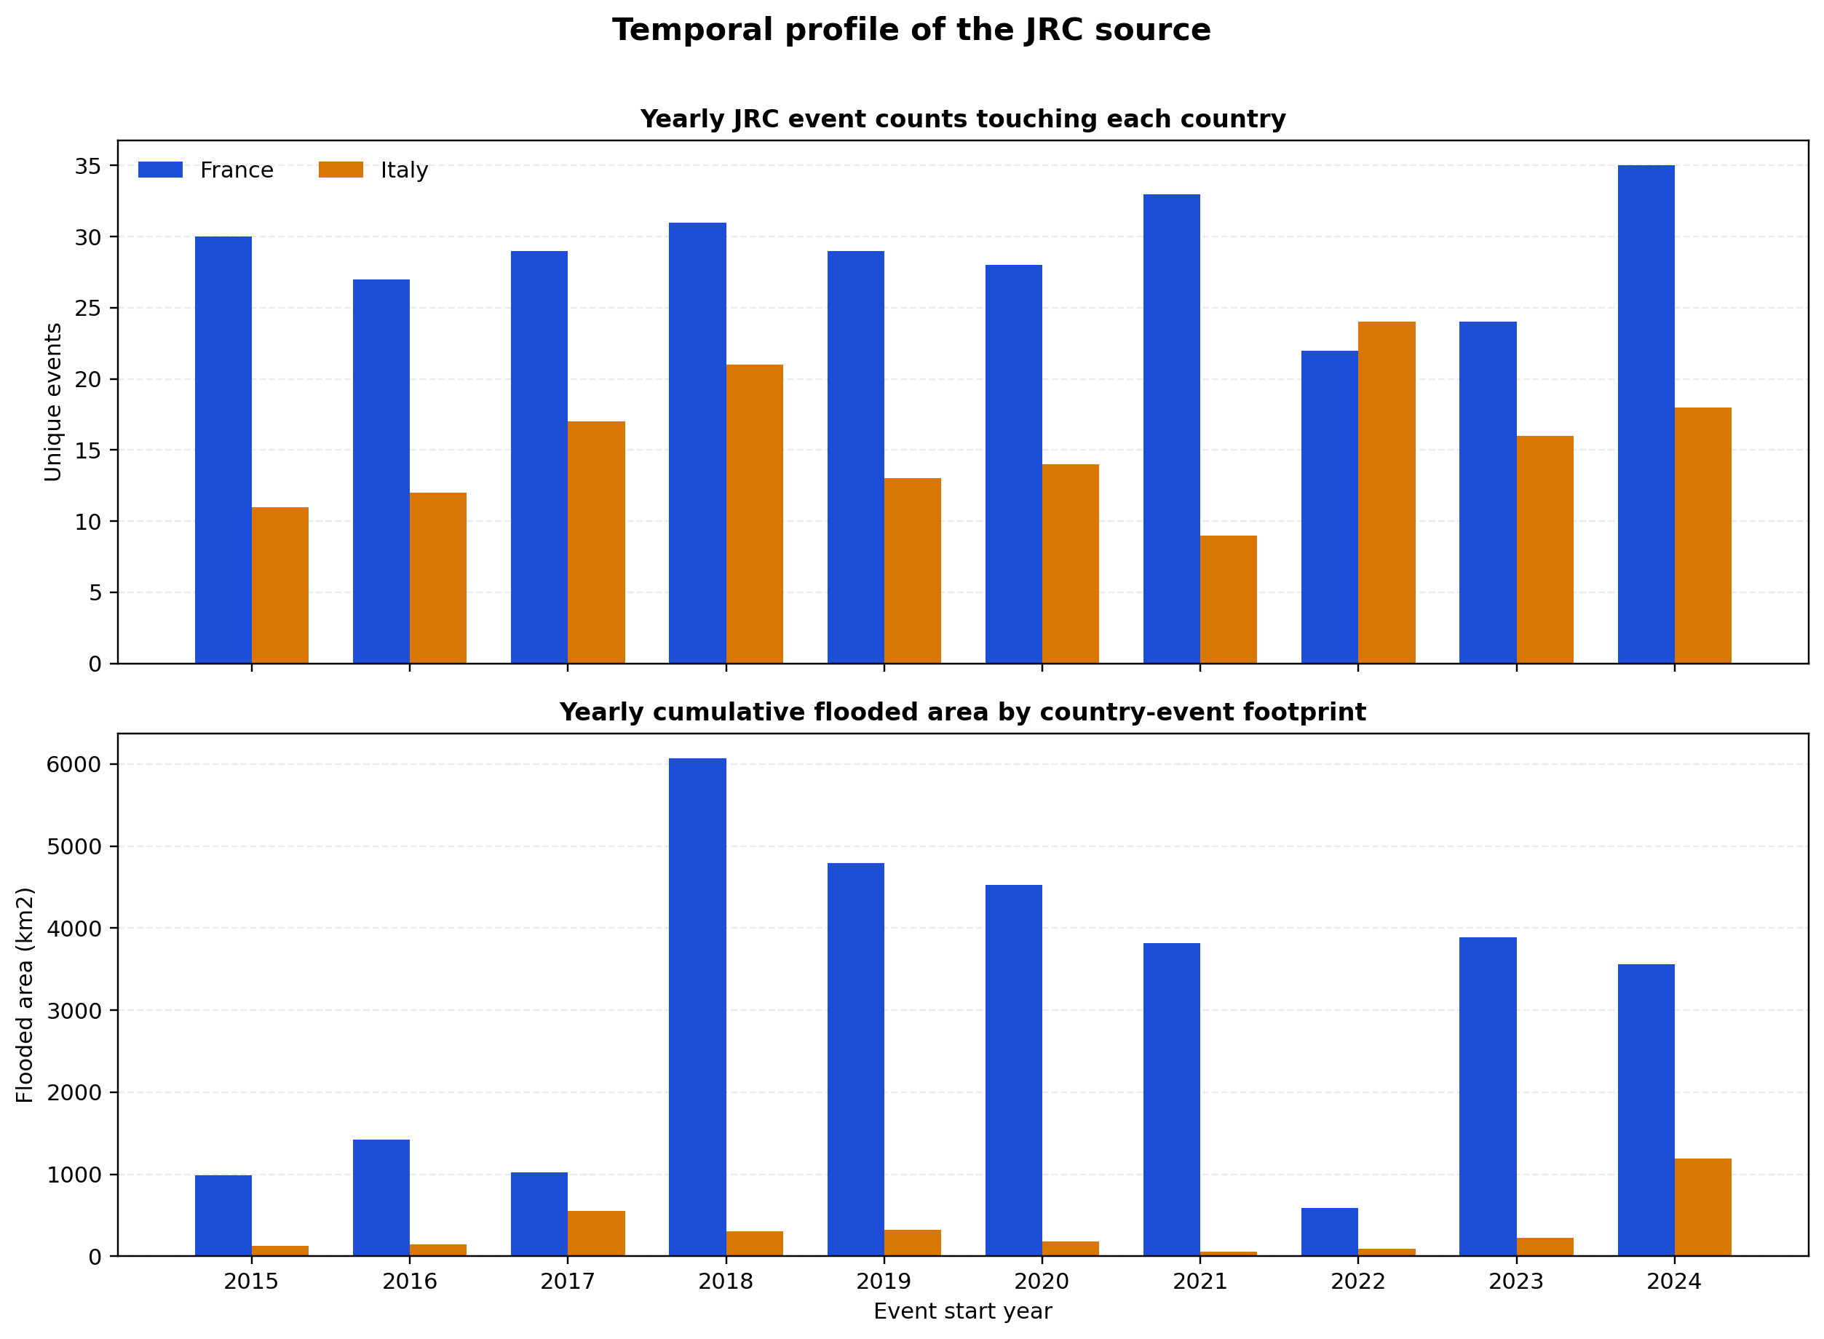
Figure 2. France stays above Italy in yearly event count throughout the archive and shows much larger high-water years in 2018, 2020, 2021, 2023, and 2024.

Regional Structure
Regional coverage is broad in both countries, but the shape differs. Italy reaches all checked NUTS1 and NUTS2 regions, yet the source is more concentrated in the Po basin and Emilia-Romagna corridor. France combines high recurrence in the west and Brittany with very large cumulative footprints in Pays de la Loire, Grand Est, Bourgogne-Franche-Comte, and Normandie.

NUTS1 leaders
Country | NUTS1 region | Events | Area km2 | NUTS3 hit
France | Grand Est | 64 | 7,914 | 10
France | Pays de la Loire | 111 | 5,477 | 5
France | Bourgogne-Franche-Comté | 60 | 4,660 | 8
France | Normandie | 63 | 4,055 | 5
France | Nouvelle-Aquitaine | 82 | 3,595 | 12
Italy | Nord-Ovest | 59 | 1,399 | 21
Italy | Nord-Est | 81 | 1,381 | 21
Italy | Centro (IT) | 33 | 225 | 20
Italy | Sud | 39 | 142 | 20
Italy | Isole | 14 | 60 | 10
Top 5 NUTS1 regions per country ranked by cumulative flooded area.

NUTS2 leaders
Country | NUTS2 region | Events | Area km2 | Max depth cm
France | Pays de la Loire | 111 | 5,477 | 3,098
France | Champagne-Ardenne | 50 | 4,111 | 2,659
France | Basse-Normandie | 59 | 3,916 | 1,801
France | Lorraine | 52 | 3,363 | 2,503
France | Bourgogne | 51 | 3,137 | 2,280
Italy | Emilia-Romagna | 70 | 1,008 | 1,980
Italy | Lombardia | 57 | 786 | 6,686
Italy | Piemonte | 35 | 592 | 14,868
Italy | Veneto | 61 | 283 | 4,645
Italy | Toscana | 21 | 121 | 1,717
Top 5 NUTS2 regions per country ranked by cumulative flooded area.
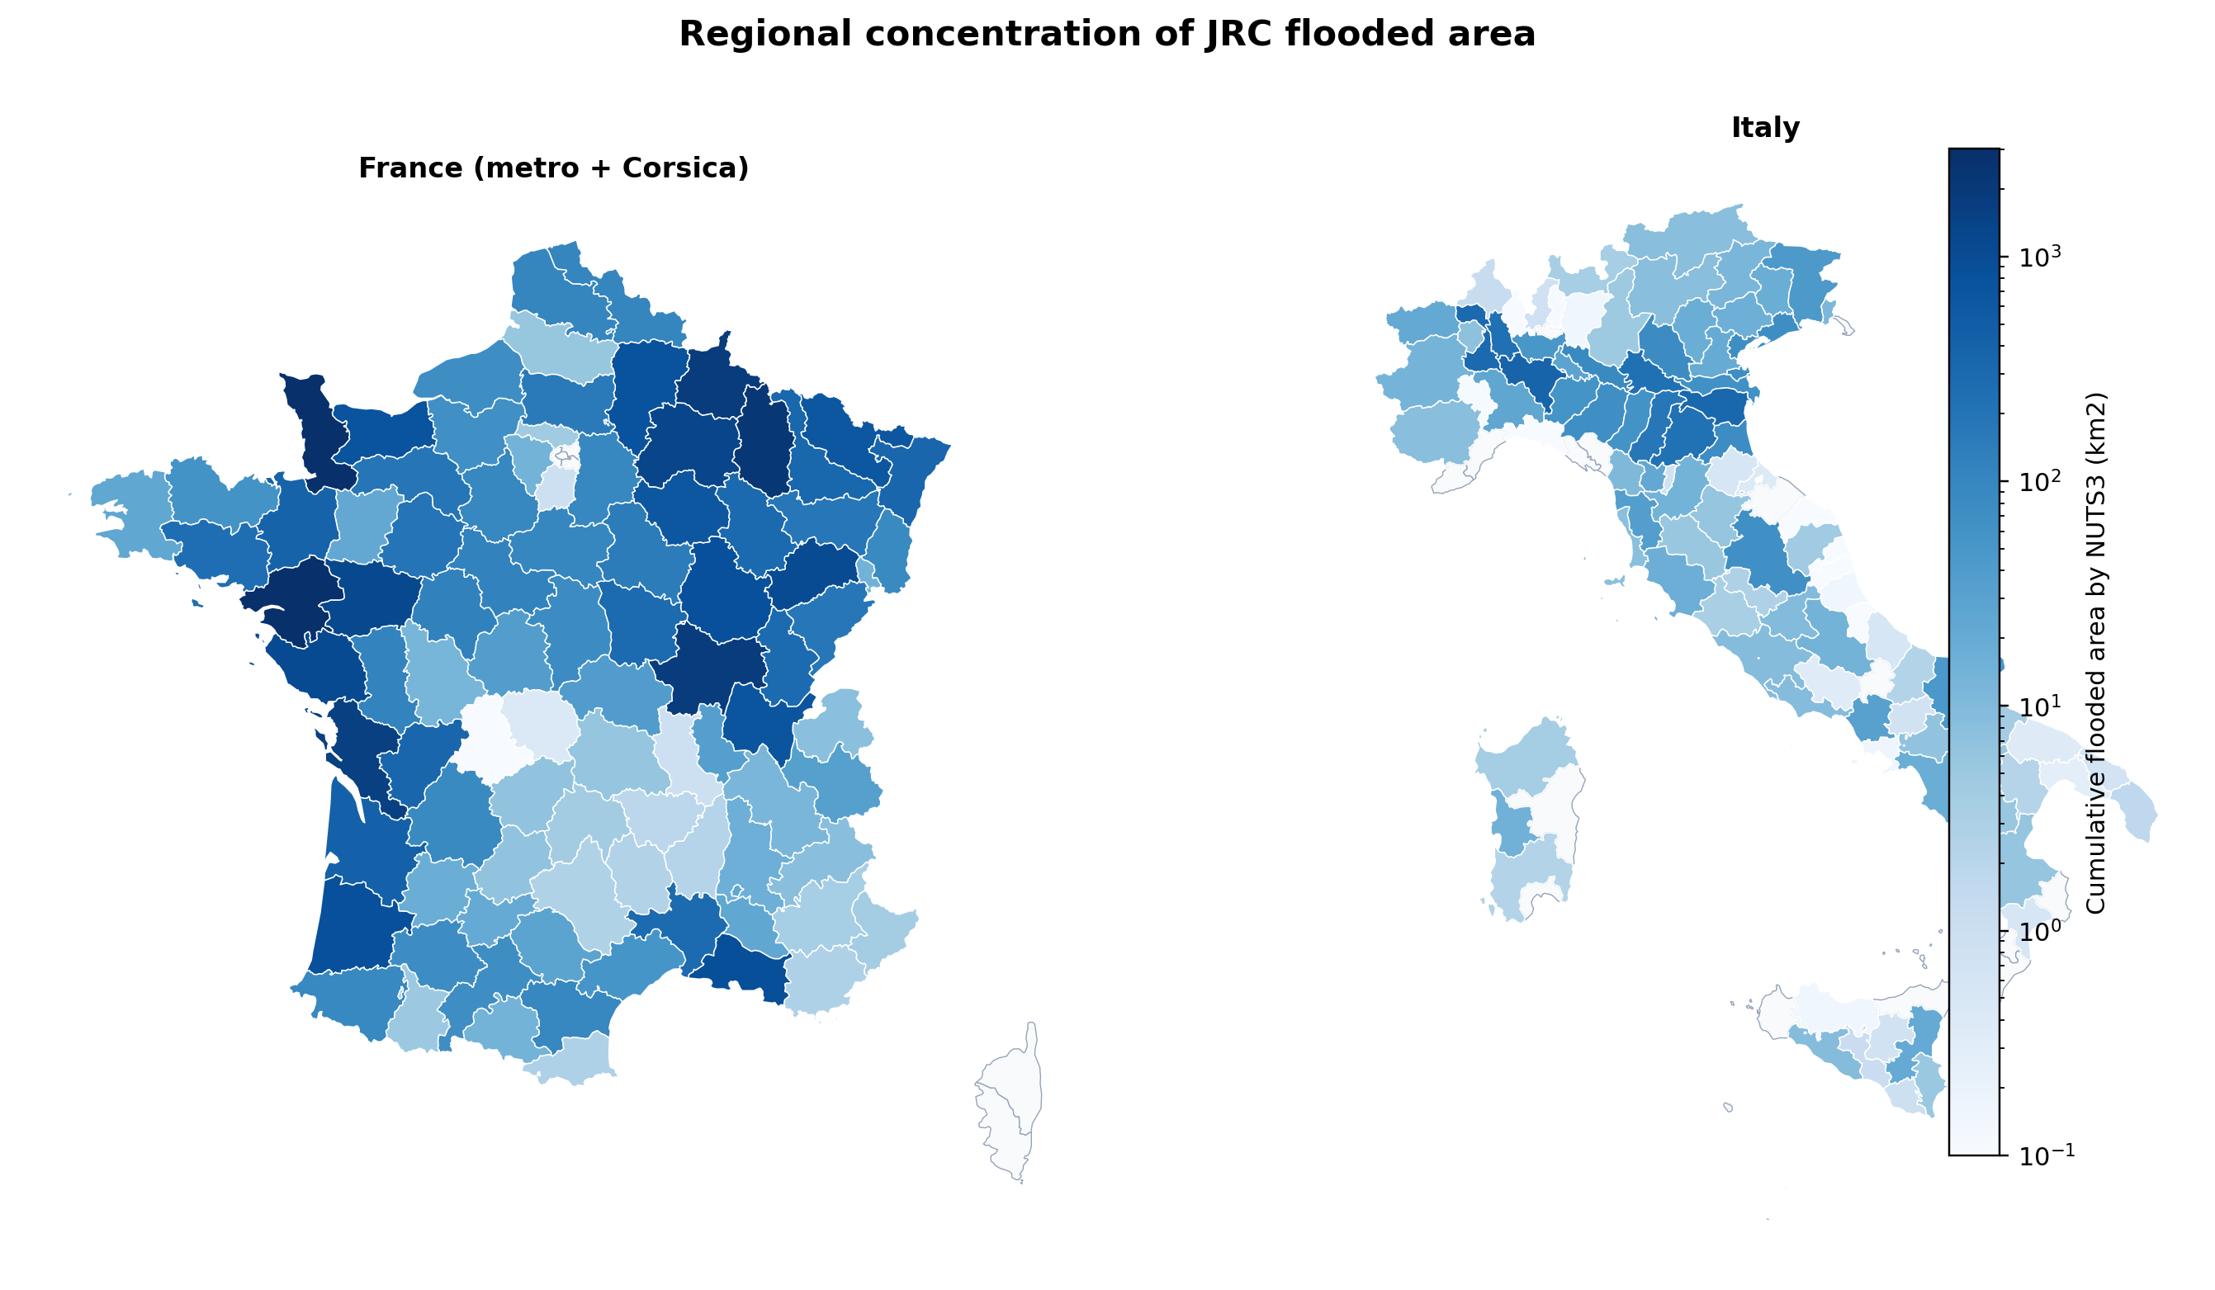
Figure 3. JRC flooded area is broadly distributed in both countries, but Italian intensity is visibly concentrated in the north and north-east.

NUTS3 leaders by flooded area
Country | NUTS3 region | Events | Area km2
France | Loire-Atlantique | 92 | 3,024
France | Manche | 55 | 2,968
France | Meuse | 50 | 2,195
France | Saône-et-Loire | 43 | 1,852
France | Ardennes | 39 | 1,843
Italy | Pavia | 33 | 377
Italy | Ferrara | 47 | 342
Italy | Vercelli | 26 | 306
Italy | Mantova | 37 | 235
Italy | Novara | 25 | 229
Top 5 NUTS3 regions per country ranked by cumulative flooded area.
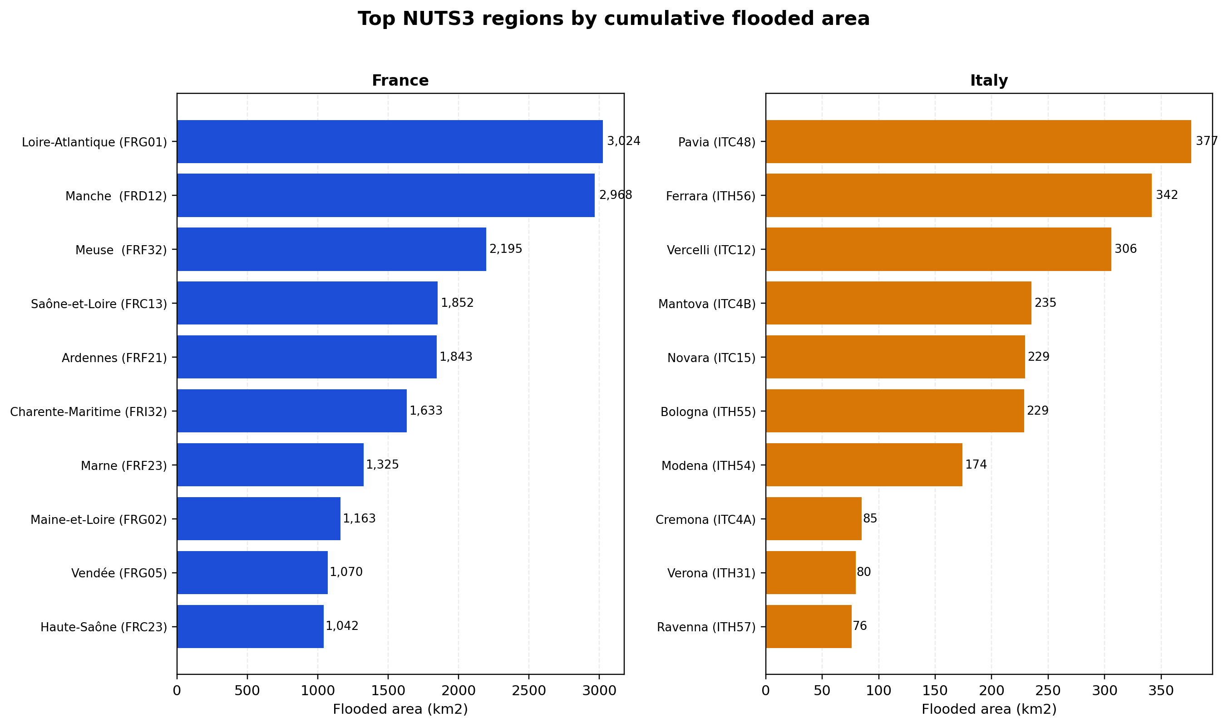
Figure 4. France's largest flooded-area regions are mostly in the west and north-east; Italy's are concentrated in Pavia, Ferrara, Vercelli, Mantova, and Novara/Bologna.
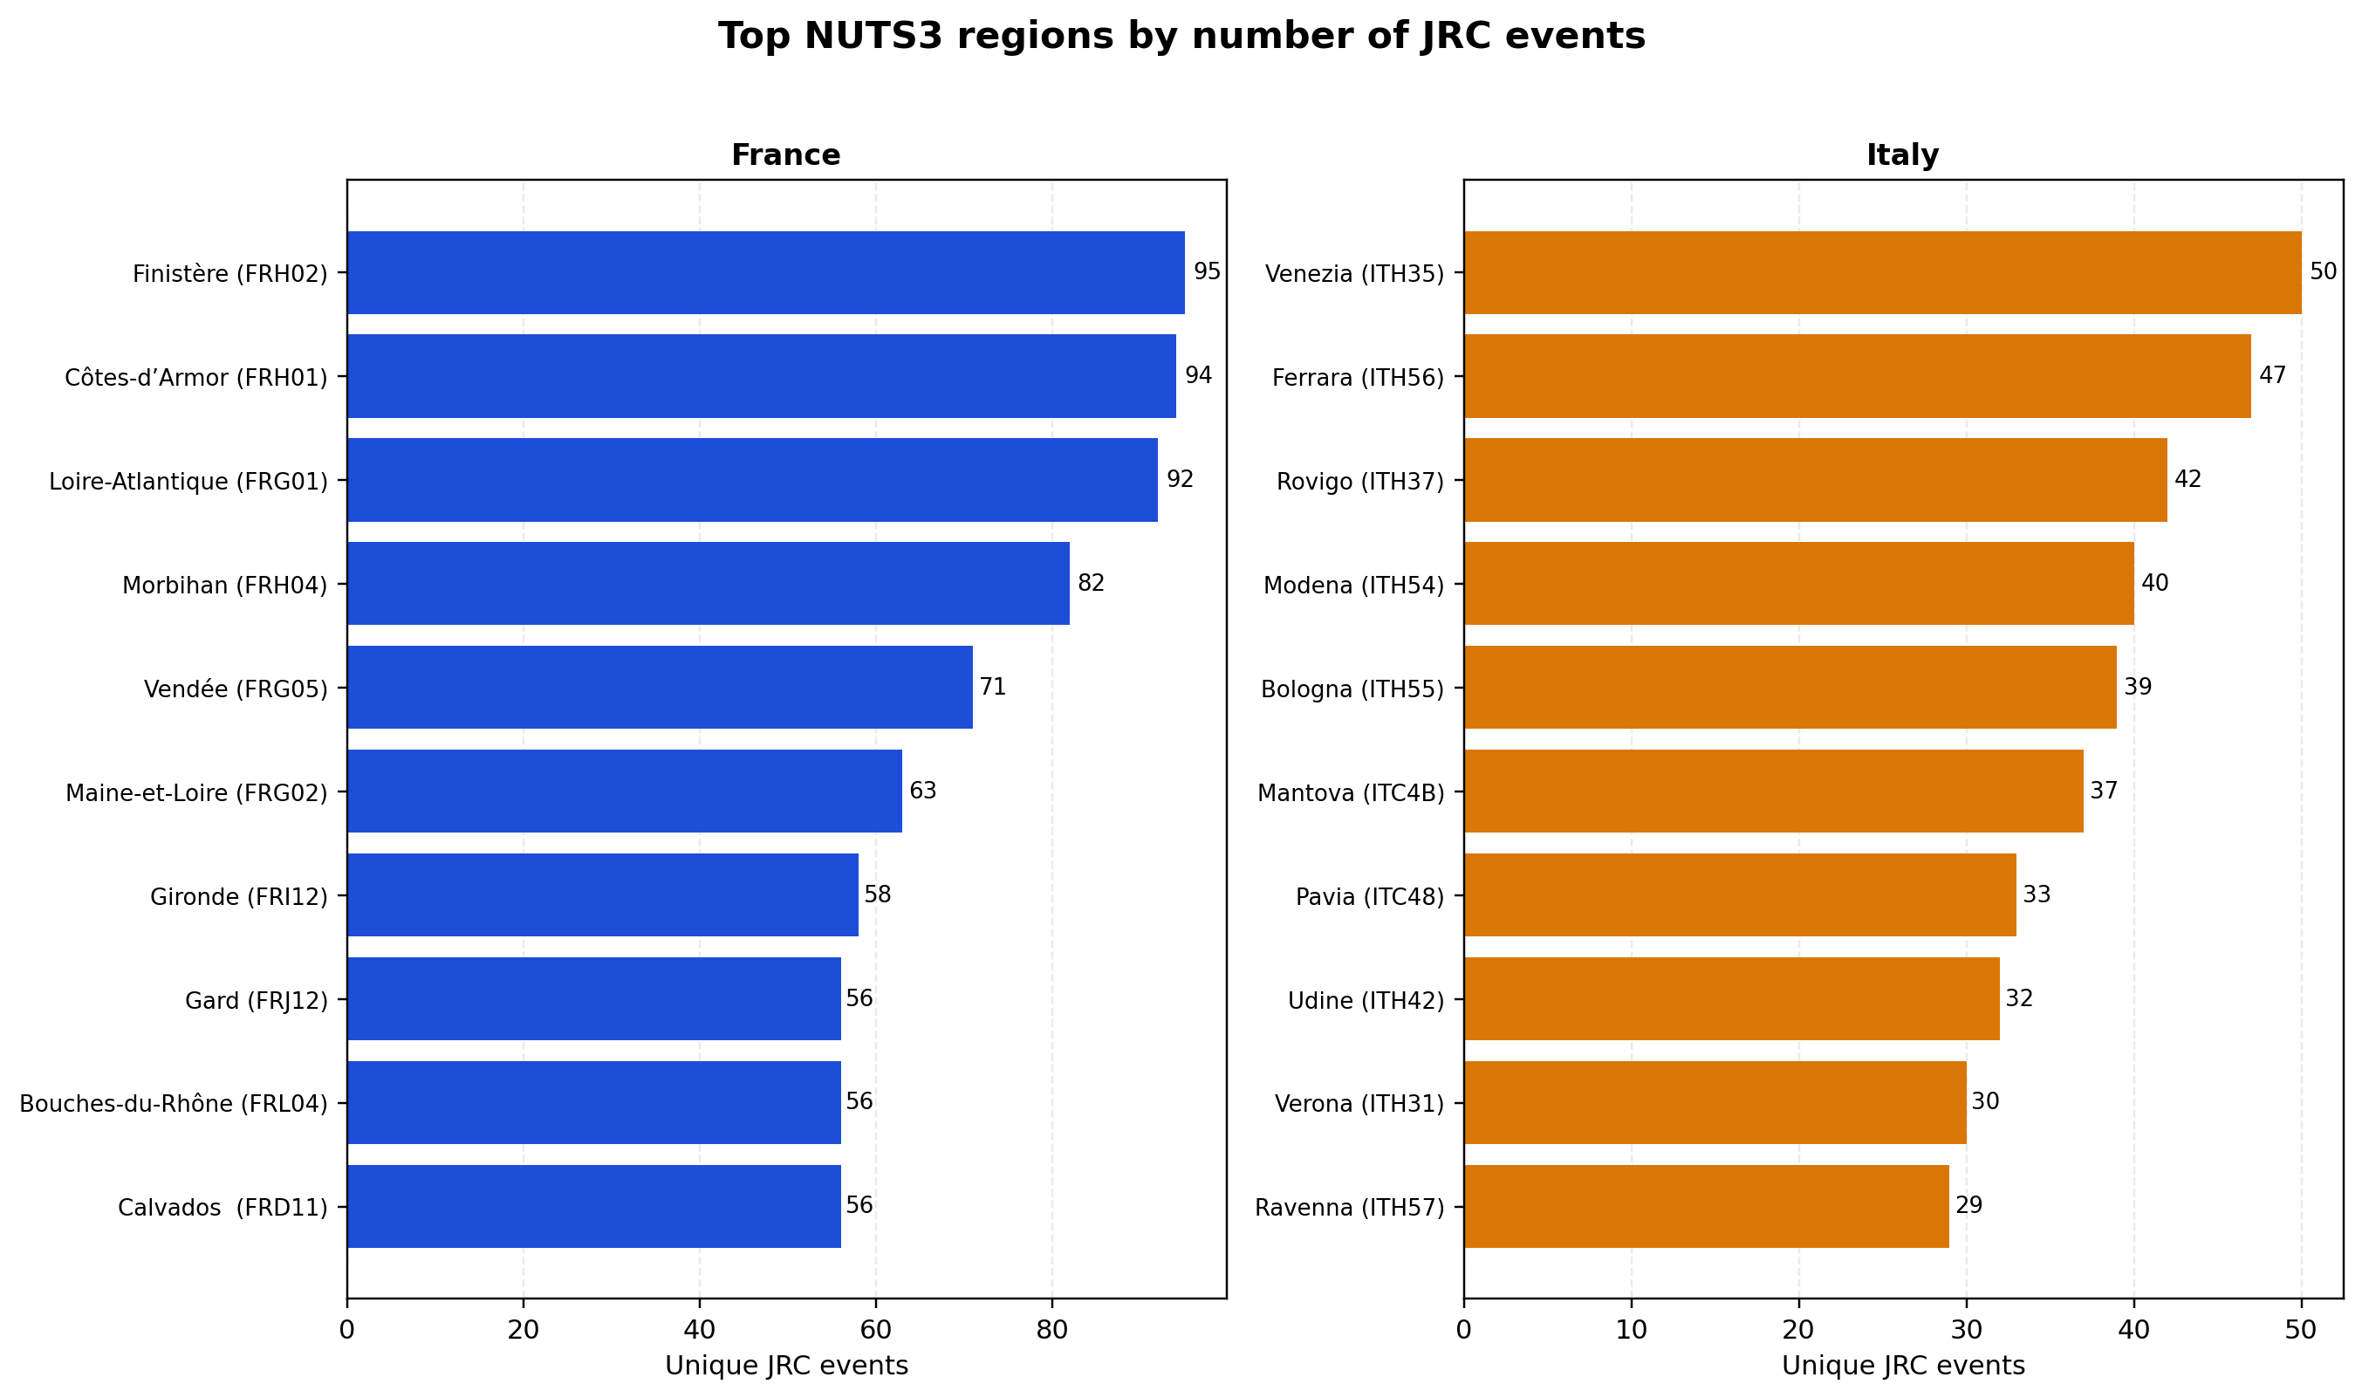
Figure 5. Event recurrence is much higher across many French regions, while Italian recurrence peaks in Veneto and Emilia-Romagna but drops quickly outside those corridors.

Interpretation For Point Matching
- If France and Italy had comparable point portfolios and identical date windows, France would still start with a stronger match opportunity set: 288 versus 155 total JRC events.
- The difference is amplified by footprint intensity: France accumulates roughly 30,684 km2 of country-event flooded area versus 3,208 km2 for Italy.
- Italy still has broad regional reach, with 100.0% NUTS2 coverage and 86.0% NUTS3 coverage, so the problem is not absent Italian source coverage.
- The more likely explanation is concentration: the top 10 Italian NUTS3 regions hold 66.5% of cumulative flooded area, whereas France is both denser and more geographically diversified.
- For strict point-screening comparisons, only the JRC branch is directly comparable between countries. Gaspar and HANZE/TRI fallback outputs should be interpreted separately.

Limitations
- The T20 workbook stored in the repository is France-only, so this report cannot validate a France-vs-Italy point-hit claim from T20 itself.
- Cumulative flooded area sums country-event intersections over time. It is an intensity indicator, not a unique physical area of land flooded once.
- JRC event presence is not the same thing as insured loss severity, asset vulnerability, or obligor exposure.
- Country labels in the processed tables are harmonized from Eurostat LAU/NUTS joins; remaining boundary or naming artifacts can still affect marginal rows.

Appendix: Unhit Regions And Largest Events
France has 11 unhit NUTS3 regions in the checked archive, mostly Paris/inner Ile-de-France, Corsica, and overseas territories. Italy has 15 unhit NUTS3 regions, concentrated in Liguria, Calabria, Sardegna, and parts of Sicilia/Marche/Toscana.
Country | Start | End | Days | Area km2 | LAUs hit | NUTS3 hit
France | 2018-01-15 | 2018-02-05 | 21 | 2,128 | 3,695 | 60
France | 2021-01-11 | 2021-02-15 | 35 | 2,075 | 3,265 | 56
France | 2020-02-24 | 2020-04-06 | 35 | 1,685 | 2,997 | 57
France | 2018-01-01 | 2018-01-29 | 28 | 1,440 | 2,333 | 31
Italy | 2024-05-13 | 2024-07-01 | 49 | 672 | 503 | 32
Italy | 2017-01-16 | 2017-01-23 | 7 | 500 | 167 | 13
Italy | 2024-03-25 | 2024-05-27 | 49 | 266 | 258 | 17
Italy | 2019-11-04 | 2020-01-06 | 56 | 225 | 399 | 47

