Jamal Eddine Damir

Assignement 1.2: GitHub Repository Setup

05/27/2022

GitHub Repository: <https://github.com/jdam05/web-231>

GitHub Repository Screenshots:

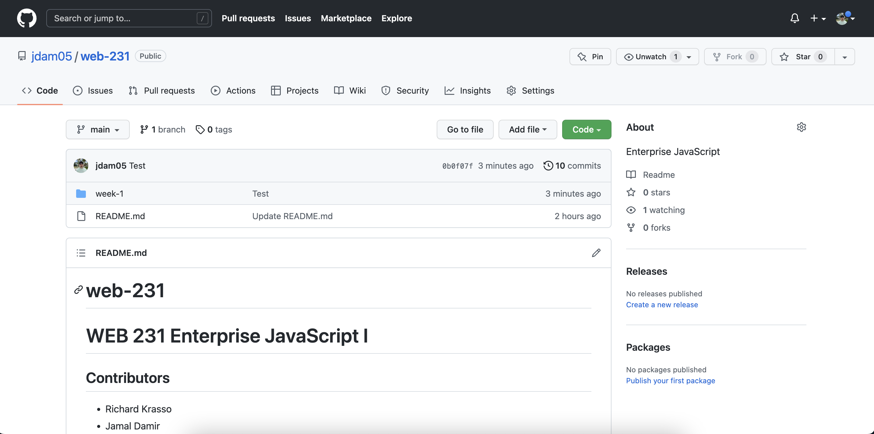

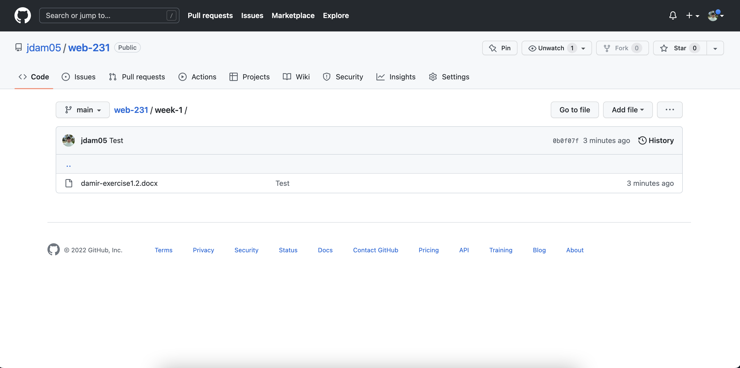

Locally Directory Screenshots:

