Jamal Eddine Damir

November 19, 2022

WEB335

Assignment 5.1 – Projections

* Query to add new user:

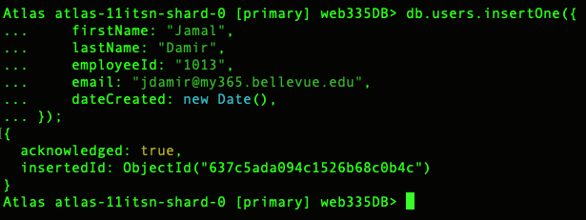

* Query to update email:

* Displaying updated user email:

* Listing all the document with specific field only:

