fJamal Eddine Damir

November 22, 2022

WEB335

Assignment 6.2 - Aggregate Queries

* Showing list of documents in the houses collection:

* Showing a list of documents in the students’ collection:

* Adding a document to the students’ collection:

* Showing that a new document has been added to the students’ collection:

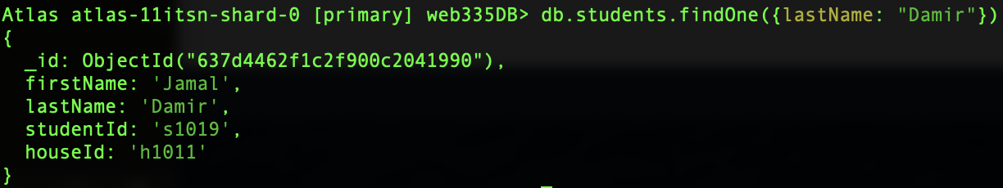

* Deleting the newly added document from the student’s collection:



* Showing students by house:

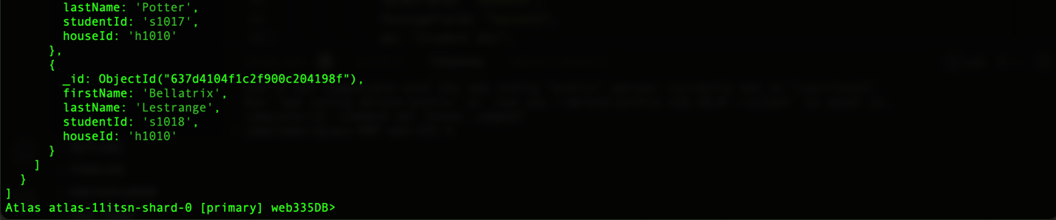

* Showing students at house Gryffindor:

* Showing a list of students with Eagle mascot:

