Do not memorize without understanding first!

**You Should Know ... Basic Operations**(+,−**,** ×,÷)

Properties of Addition:

* Associative (parentheses don’t matter):
  + Example:

You get the same answer no matter what parentheses:

Or

* Commutative (order doesn’t matter):

Properties of Subtraction:

* Multiplying times a negative, and subtracting, are the same thing!
* Not Associative (parentheses do matter!):
* Not Commutative (order does matter!):

Properties of Multiplication:

* Associative (parentheses don’t matter):
* Commutative (order doesn’t matter):
* Multiplication distributes over addition:
* Multiply two sums using FOIL method:

* Squaring means multiply times itself:
* Difference of squares factors like so:

Properties of Division:

* Dividing by a negative, and multiplying by a negative ARE EQUIVALENT:
* More next page (see Fractions).

**Examples using Basic Operations**(+,−**,** ×,÷)

Examples of Addition:

Examples of Subtraction:

is not equal to

is not equal to

Examples of Multiplication:

* Associative (parentheses don’t matter):
* Commutative (order doesn’t matter):
* Multiplication distributes over addition:
* Multiply two sums using FOIL method:

* Squaring means multiply times itself:
* Difference of squares factors like so:

Examples of Division:

* Dividing by a negative, and multiplying by a negative ARE EQUIVALENT:
* More next page (see Fractions).

**You Should Know ... Fractions**

Dealing with Constants: Any constant can be made into a fraction by inserting “over one”.

Multiplying:  *Multiply numerators, multiply denominators.*

Therefore...

* A constant C multiplied goes in the numerator:

Dividing: *Flip the bottom fraction, then multiply*.

Therefore...

* A constant C divided goes in the denominator:

Adding:  *Need a common denominator!*

* **#1:** These fractions have a common denominator:
* **#2:** These fractions have different denominators:

**You Should Know ... Exponents**

Do not memorize without understanding!

*Understand first,* THEN *memorize!*

**FACTS**

To multiply/divide with common base x:

add/subtract exponents.

and

To multiply/divide with common exponent a:

use parentheses.

and

Raising an exponent to an exponent: multiply exponents.

Roots are fractional exponents:

* ... etc.

Move exponents between denominator and numerator by negating the exponent:

* ... etc.

Combine fraction rules and exponents rules carefully:

* ... etc.

Anything to the zero power is one:

If no exponent then assume exponent one:

Examples where you **cannot simplify**:

* cannot combine different powers added

(( ))

* cannot separate terms added in denominator

(( ))

* cannot distribute roots over addition

(( ))

**TRUE OR FALSE**

1. __________
2. cannot be simplified __________
3. cannot be simplified __________
4. __________
5. __________
6. __________
7. __________

**EXAMPLES**

**Example A.** Fully simplify:

*Hint: Recall the rules for multiplying fractions!*

**Example B.** Fully simplify:

**Example C.** Fully simplify:

**You Should Know ... LINES**

Do not memorize without understanding!

*Understand first,* THEN *memorize!*

**GENERAL CONCEPTS**

Zeros / x-intercepts

* An x-value satisfying
* Set and solve for .

y-intercepts

* The y-value of
* Set and solve for y.

**LINES**

Equations

* Slope-y-intercept format:
* Point-slope format:

Symbols

* is the slope of the line
* is a point on the line
* is the y-intercept point

Special Cases

* For *positive slope* () the line goes UP
* For *negative slope* ( the line goes DOWN
* is a *horizontal line* with slope
* is a *vertical line* with infinite slope
* Lines with the same slope are *parallel*
* Lines with the same slope and y-intercept *overlap*
* Lines with slopes and are *perpendicular*

How to Draw a *Rough* Sketch *Quickly & Efficiently*

* Find two points on the line.
* Connect the two points with a line.
* Double check the slope roughly goes the correct way. ***DO NOT draw every single tick mark!***

**EXAMPLES**

**Demo Example.**

* is a point on the line
* is the y-intercept point
* The slope is
* If x goes up by 1 then y goes down by 36.
* Sketch the line :

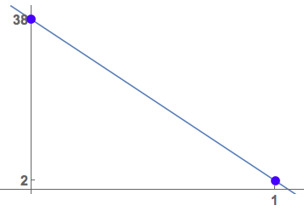

**Example A.**

* is a point on the line
* is the y-intercept point
* If x goes up by ________ , y goes __________ by ________.
* Sketch the line :

**Example B.**

* is the y-intercept point
* is the x-intercept point
* If x goes up by ________ , y goes __________ by ________.
* Sketch the line:

**Example C.**  Complete the sentences.

* For slope-intercept format it is easiest to find the _____-intercept and the ______-intercept.
* For point-slope format it is easiest to find the point ( ______ , ______ ) and the ______-intercept.
* is perpendicular to +8.
* ______ = 5 is a vertical line
* ______ = -37 is a horizontal line
* The line that goes through and is parallel to is ______________________________.
* The line that goes through and is perpendicular is

______________________________.**You Should Know ... QUADRATICS**

Do not memorize without understanding!

*Understand first,* THEN *memorize!*

**GENERAL CONCEPTS**

Shifting rules (assuming )

* shifts c-units right
* shifts c-units left
* shifts c-units up
* shifts c-units down

Reflecting rules

* flips left-to-right, about the y-axis
* flips up-down, about the x-axis

**A QUADRATIC IS A PARABOLA**

Equations

* Standard format:
* Completed Square format:

Symbols

* is the vertex of the parabola
* is the y-intercept of the parabola
* is the x-value of the vertex
* is the y-value of the vertex

Special Cases

* For the parabola curves UP
* For the parabola curves DOWN
* To find the x-intercepts (a.k.a. zeros) set and solve for x:
  + If are nice, factor, set each factor to zero, then solve for x.
  + If are not nice, use the quadratic formula to solve for x:

How to Draw a *Rough* Sketch *Quickly & Efficiently*

* Determine the vertex .
* Decide if the parabola curves UP or DOWN.
* Quickly sketch. ***DO NOT draw every tick mark!***

**You Should Know ... OTHER BASIC FUNCTIONS**

Do not memorize without understanding!

*Understand first,* THEN *memorize!*

**GENERAL CONCEPTS**

Properties of Functions

* x-intercepts, y-intercepts, shifting and reflecting rules (see previous pages)
* Domain is the set of *allowed* x-values
* Range is the set of all *output* y-values

**OTHER BASIC FUNCTIONS**

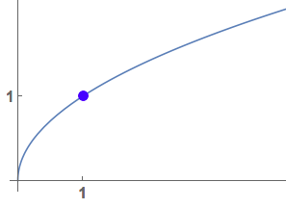

**Any Even Root**

n is even integer

Domain

Range

* Example: Square root .
* Example: Sixth root

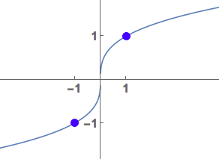**Any Odd Root**

n is odd integer

Domain

Range

* Example: Cube root .
* Example: Seventh root

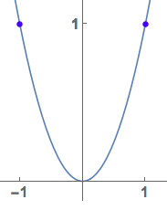

**Any Even Power Monomial**

p is even integer

Domain

Range

Examples: ,

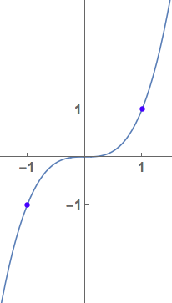

**Odd Power Monomial**

p is odd integer

Domain

Range

Examples: ,

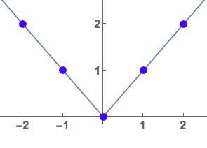**Absolute Value**

Domain

Range

Writing absolute value in piecewise format:

**EXAMPLES**

**Demo Example.**

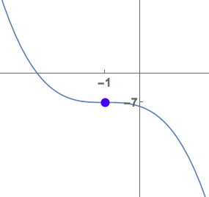The function is

an odd power,

flipped upside down

(due to minus sign in front),

shifted 1 unit left

and 7 units down.

Domain

Range

**Demo Example.**

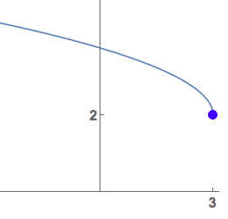To see shift/reflection

must factor out minus

therefore square root

is shifted right 3 units,

up 2 units, and reflected

left-to-right due to minus.

Domain

Range

**Demo Example.**

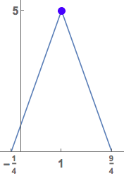This is a vee-shape

with slope 4

flipped upside down

(due to minus)

then shifted right 1 unit

and up 5 units.

Domain

Range

Write in piecewise format:

**Example A.** Draw rough sketch, and state domain/range.

**Example B.**  Draw rough sketch, and state domain/range.

**Example C.** Draw rough sketch, and state domain/range.

Write the function in piecewise format too.

**Example D.** Draw rough sketch, and state domain/range.

**You Should Know ... CIRCLES**

Do not memorize without understanding!

*Understand first,* THEN *memorize!*

**GENERAL CONCEPTS**

Distance between and is ...

**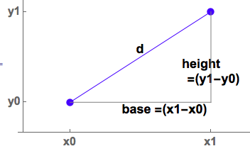***Why?* Make a triangle and use Pythagorean Theorem:

**CIRCLES**

Equations

* Standard format:
* General format:

Symbols

* is the radius of the circle
* is the center of the circle
* are constants

Special Cases

* , a circle radius r centered at origin
* is the top half of a circle of radius r centered at origin
* is the bottom half of a circle of radius r centered at origin

How to Draw a *Rough* Sketch *Quickly & Efficiently*

* Identify center and radius.
* From the center of the circle go up, down, left, and right the radius-length and mark 4 dots.
* Roughly connect the dots creating the circle.

**EXAMPLES**

**Demo Example.** Write circle in standard format. (How? COMPLETE THE SQUARE).

* Use the VERTEX FORMULA from previous page!

The x-part is .

,

.

Therefore .

* Now complete the square for the y-part.

.

.

Therefore .

Put It Together:

Therefore ...

Standard Format is: .

**Demo Example Continued.** Therefore ...

* The center is .
* The radius is

**Example A.** Write the circle in standard format. State the center and radius. Then draw and label the circle.

**Example B.** Draw a rough sketch of .

**Example C.** Draw a rough sketch of .

**You Should Know ... TRIGONOMETRY**

Do not memorize without understanding!

*Understand first,* THEN *memorize!*

**RADIANS V. DEGREES**

Facts: and .

**Example A.**

_________, _________, _________

**SOHCAHTOA**

**Example B.** What does it mean?

_________, _________, __________

**OTHER FACTS**

and

**Example C.** Complete the other functions:

_________ and _________

**SPECIAL TRIANGLE: --right**

**Example D.** Draw the triangle.

*Hint: The sides are*  .

**SPECIAL TRIANGLE: --right**

**Example E.** Draw the triangle.

*Hint1: The sides are* .

*Hint2: The smallest side is opposite the smallest angle.*

**SPECIAL VALUES**

**Example F.**

* __________
* __________
* __________
* __________

**SINE FUNCTION FACTS**

* Sine has period .
* Sine is odd: .

**Example G1.** Draw at least one cycle of the function. Label at least two points on each of the x,y axes.

**Example G2.** State the domain and the range.

**Example G3.** Use the graph to find these special values.

* __________
* __________
* __________
* __________

**COSINE FUNCTION FACTS**

* Cosine has period .
* Cosine is even: .

**Example H1.** Draw at least one cycle of the function. Label at least two points on each of the x,y axes.

**Example H2.** State the domain and the range.

**Example H3.** Use the graph to find these special values.

* __________
* __________
* __________
* __________

**MORE SPECIAL VALUES**

**Example I.**  *Hint: Recall that dividing by zero is undefined.*

* __________
* __________
* __________
* __________

**You Should Know ... EXP & LOG FUNCTIONS**

Do not memorize without understanding!

*Understand first,* THEN *memorize!*

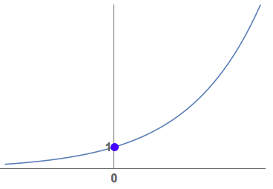**EXPONENTIALS:**

**With base a > 1**

the graph is increasing.

Domain

Range

Horizontal Asymptote:

* Examples: , , , , etc.

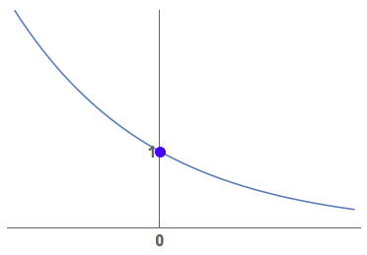

**With base 0 < a < 1**

the graph is decreasing.

Domain

Range

Horizontal Asymptote:

* Examples: , etc.

**Additional Facts**

* therefore all graphs above go thru .

**LOGARITHMS:**

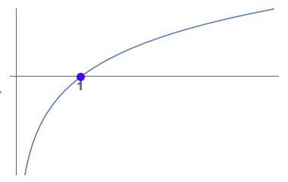**With base a > 1**

the graph is increasing.

Domain

Range

Vertical Asymptote:

* Examples: etc.
* Note: means
* Note: means .

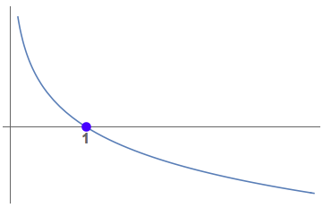

**With base 0 < a < 1**

the graph is decreasing.

Domain

Range

Vertical Asymptote:

* Examples: etc.

**Additional Facts**

* therefore all logs above go thru .

**EXP and LOG ARE INVERSES**

Fact: (log composed with exp cancels)

Fact: (exp composed with log cancels)

**TRUE OR FALSE**

1. __________
2. __________
3. __________
4. __________
5. __________

**EXAMPLES**

**Example A.** Expand using log rules:

**Example B.** Condense into a single log expression:

**Example C.**  Simplify:

**Example D.**  Draw and on the same set of axes. *Hint1: Remember shift rules.*

*Hint2: Start by shifting known points / asymptotes.*

**You Should Know ... DERIVATIVES**

Do not memorize without understanding!

*Understand first,* THEN *memorize!*

**RULES**

Multiplied constants are “pulled out”

Linearity

Product Rule

Quotient Rule

Chain Rule

“Times-a rule” ( is a constant)

**FACTS**

Derivative of a constant is zero

Derivative of a linear function is constant

Power rule

Derivative of is itself

Derivative of is

General exponential derivative rule

General logarithm derivative rule

**Derivatives of trig functions:**

)

**Derivatives of inverse trig functions:**

**EXAMPLES**

**Demo Example.** *Note: Wise algebra can make it easier!*

)

)

**Example A.** Find the derivative:

=

**Example B.** Find the derivative. *Hint: Simplify first, and DO NOT use the quotient rule!*

=

**Example C.** Find the derivative.

=

**Example D.** Suppose an object is moving with velocity

Find the acceleration.

**Example C.** Choose among the following words/phrases in order to complete the sentences below: “positive”, or “negative”, or “moving left”, or “moving right”, or “increasing”, or “decreasing”.

* If is _____________________

then is _____________________.

* If is _____________________

then is _____________________.

* If velocity is _____________________

then the object is _____________________.

* If velocity is _____________________

then the object is _____________________.

* If acceleration is _____________________

then the velocity is _____________________.

* If acceleration is _____________________

then the velocity is _____________________.

**You Should Know ... ANTIDERIVATIVES**

Do not memorize without understanding!

*Understand first,* THEN *memorize!*

**NOTATION/TERMINOLOGY**

* If then .
  + Therefore is antiderivative of .
* If then .
  + Therefore is antiderivative of .

**RULES**

Multiplied constants “pull out”

Linearity

“The -rule” ( is a constant)

Substitution()

Integration by parts (IBP)

**EXAMPLES with Linearity & - Rule**

**Demo Example.** *Note: Wise algebra is essential!*

**Example A.** Find the antiderivative:

=

**EXAMPLES: Substitution**

**Demo Example.**

Set therefore .

Therefore

=+C

**Example B.** Find the antiderivative:

=

**Example C.** Find the antiderivative:

=

**EXAMPLES: IBP**

**Demo Example.**

Set and .

Therefore and .

Using the IBP formula:

Now integrate tangent by using its definition

Use substitution with *Write it out!!*

Final answer: .

**Example D.** Find the antiderivative:

=

**Example E.** Find the antiderivative (use IBP twice):

=

Complete this sentence:

“This review packet was ____________________”.

|  |  |
| --- | --- |
| **If you answered...** | **Here is your advice...** |
| VERY DIFFICULT / IMPOSSIBLE | You may have been placed in the wrong class. Speak to the Prof. in office hours, after/before class, or schedule an appointment. See you then! |
| DIFFICULT BUT DOABLE | Seek tutoring or get help from the Prof. in office hours, after/before class, or schedule an appointment **2-3 times a week**. See you then! |
| HARD BUT GOOD REVIEW | Seek tutoring or get help from the Prof. in office hours, after/before class, or schedule an appointment **1-2 times a week**. See you then! |
| EASY PEASY | Seek tutoring or get help from the Prof. in office hours, after/before class, or schedule an appointment **as needed**. See you then! |
| TIME CONSUMING | Yes, this class *will be* time consuming.  You should expect it!  Ask questions, be engaged, and enjoy the math! |

**Failing student mentality:**

“I am too busy for tutoring.”

“Tutoring is for failing students, not for me.”

“I am worried about how I will look when I ask for help.”

**Succeeding student mentality:**

“Tutoring helps me learn and succeed.”

“Asking questions is the quickest way to clear things up.”

“Talking with peers/tutors/Prof. helps me understand math from different perspectives.”