# The Association between Mars Crater Distance from Equator and Crater Diameter and Depth

### Jerry D'Antonio, Akron, Ohio, U.S.A.

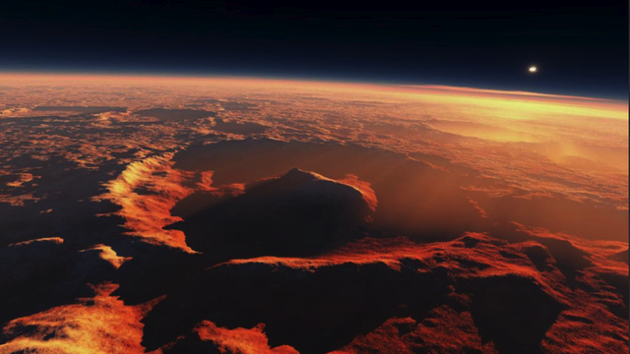

## Introduction

Mars craters come in all shapes and sizes. They also exhibit a wide array of characteristics. Reason would indicate that the diameter of a crater and its depth would be positively related--bigger craters should be deeper--but little is known about the size of a crater in relationship to its other characteristics. It is possible that other factors, such as distance of a crater from the equator, may be related to its size.

## Research Questions

1. Is crater depth associated with its diameter.
2. Is crater diameter associated with its position relative to the equator.
3. Is crater depth associated with its position relative to the equator.

## Methods

#### Sample

* All craters on Mars (378,540) with diameters greater than or equal to 1 km. as compiled by Stuart Robbins.
* Dr. Robbins compiled the Mars global crater database while pursuing his Ph.D. in Geophysics from the University of Colorado.
* The Mars global database was published as part of Dr. Robbins' thesis Planetary "Surface Properties, Cratering Physics, and the Volcanic History of Mars from a New Global Martian Crater Database" in 2011.

#### Measures

* Crater latitude was calculated from a best-fit derived center and was measured in decimal degrees North.
* Diameter was measured in kilometers from the derived center to the rim vertices.
* Depth was measured in kilometers from the crater rim to the lowest elevation of the crater floor.
* For some calculations craters were separated into groups representing ten-degree "bands" of latitude.
* For some calculation crater latitude was rounded down to the nearest whole degree latitude.

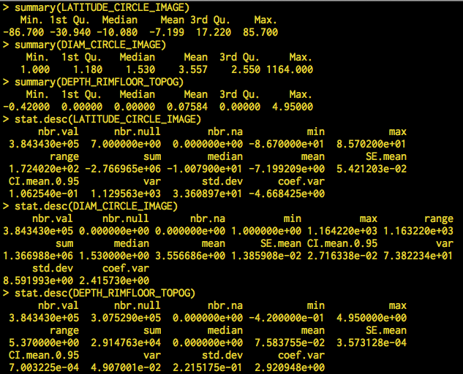

Figure : Summary statistics for crater latitude (LATITUDE_CIRCLE_IMAGE), diameter (DIAM_CIRCLE_IMAGE), and depth (DEPTH_RIMFLOOR_TOPOG) calculated with R (functions summary and stat.desc).

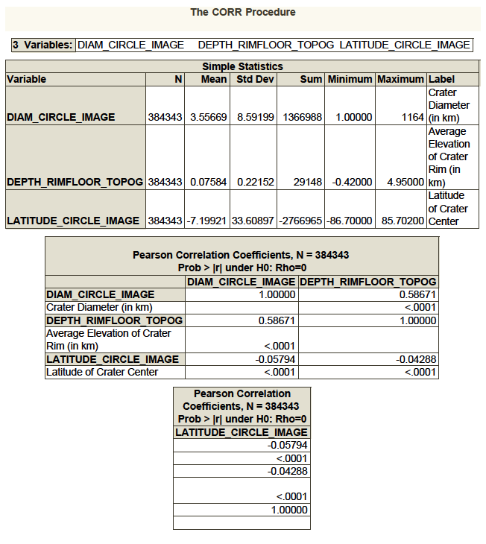

Figure : Correlation of crater latitude (LATITUDE_CIRCLE_IMAGE), diameter (DIAM_CIRCLE_IMAGE), and depth (DEPTH_RIMFLOOR_TOPOG). Proc Correlation procedure. Interpret Pearson Correlation Coefficients.

## Results

#### Univariate

* The average crater diameter is 3.56 km. (s.d. 8.59)
* The average crater depth is 0.0758 km. (s.d. 0.2215)
* The average crater latitude is 7.20 degrees South (s.d. 3.36) showing a slight skew toward the Southern hemisphere.

#### Bivariate

* As expected, analysis showed a positive correlation between crater diameter and depth (corr. 0.58671, p < 0.0001), suggesting that 34.4% of the depth variance can be explained by diameter. That is, bigger craters tend to be deeper craters.
* There is a minimal but significant negative correlation between crater latitude and diameter (corr. -0.05794 p < 0.0001). That is, craters tend to be slightly wider as they get nearer to the equator.
* There is a minimal but significant negative correlation between crater latitude and depth (corr. -0.04288 p < 0.0001). That is, craters tend to be slightly deeper as they get nearer to the equator.

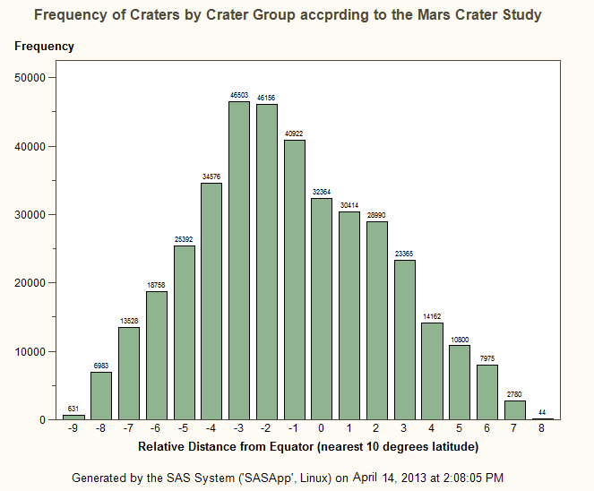

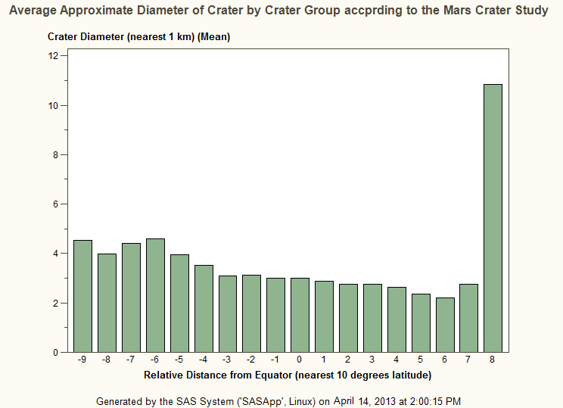

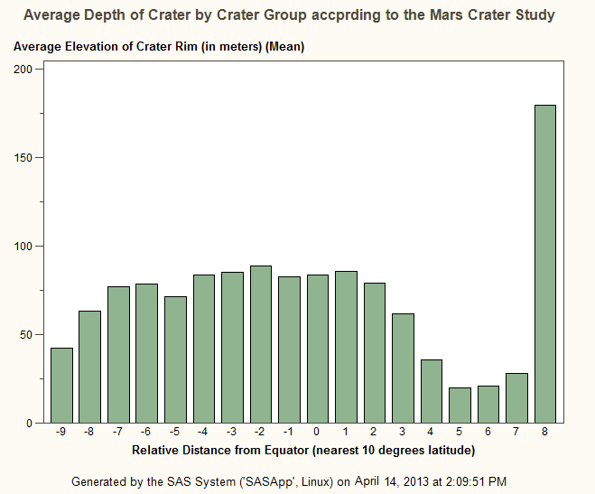

## Discussion

#### What might the results mean?

* The distance of a crater from the Mars equator seems to have a small but measurable relationship to its diameter and depth.

#### Strength

* Results are based on a comprehensive and statistically complete study of over 380,000 Mars craters.

#### Limitations

* Crater diameter and depth had to be calculated based upon a number of factors related to the crater rim. Although mathematically consistent, these values are approximations. The small correlations found in this study could be the result of measuring errors.

#### Recommended Future Research

* Further research is needed to determine whether relationships exist between any other characteristics of Mars craters.

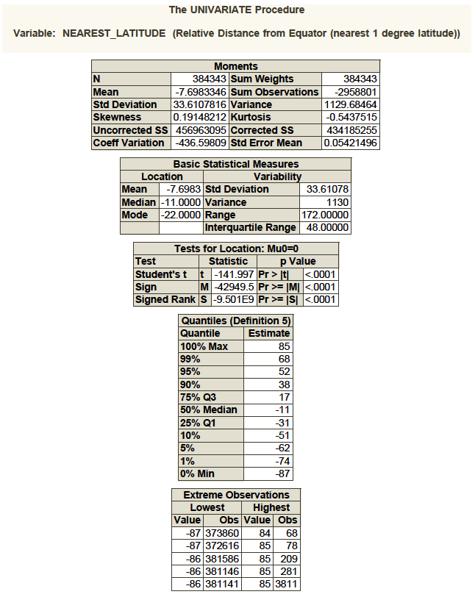

Figure : Mean crater latitude (rounded down to nearest whole degree) and standard deviation (quantitative, ordered variable). Variable named NEAREST_LATITUDE. Proc Univariate Procedure.

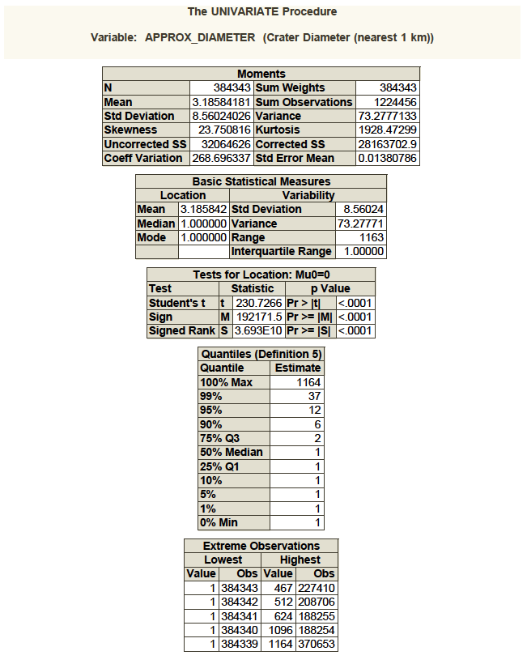

Figure : Mean crater diameter (rounded down to nearest whole kilometer) and standard deviation (quantitative, ordered variable). Variable named APPROX_DIAMETER. Proc Univariate procedure.

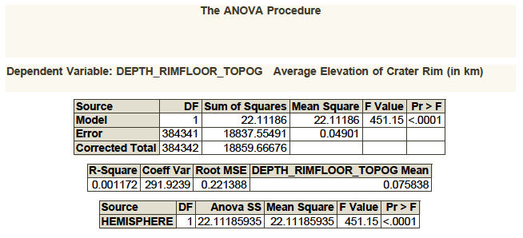

Figure : Relationship of crater hemisphere (categorical variable) and crater depth (quantitative variable). Proc ANOVA procedure. Interpret columns F Value and P Value(451.15, 0.0001).

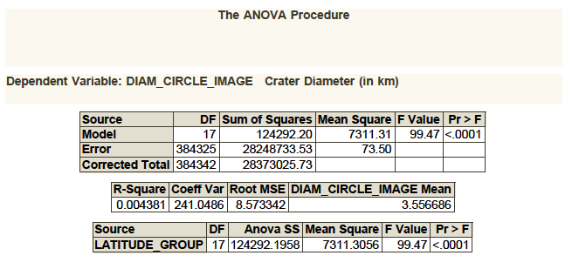

Figure : Relationship of crater latitude group (categorical variable) and crater diameter (quantitative variable). Proc ANOVA procedure. Interpret columns F Value and P Value(99.47, 0.0001).

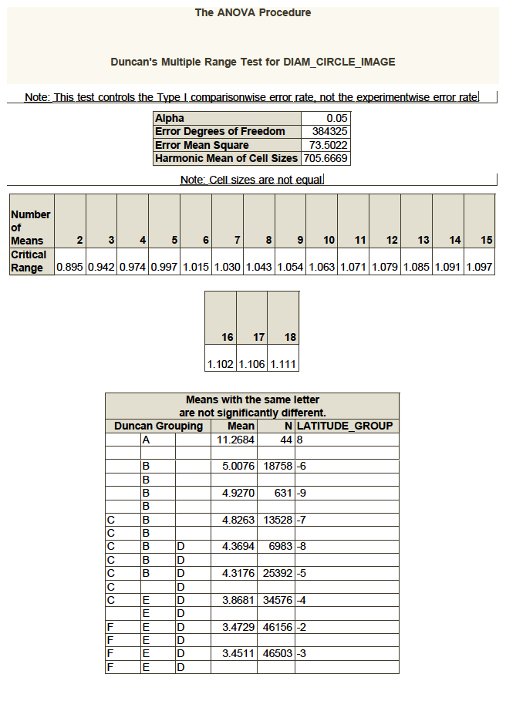

Figure : Relationship of crater diameter (quantitative variable), crater depth (quantitative variable), and latitude group (categorical variable). Proc ANOVA procedure with Duncan's multiple range test. Interpret column Duncan Grouping. (1 of 2)

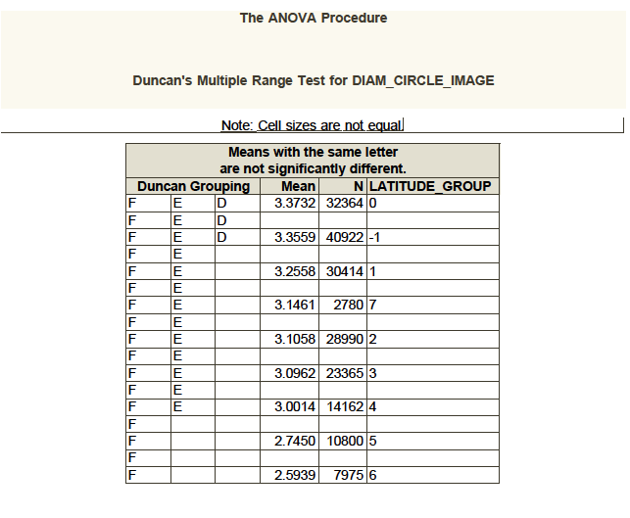

Figure : Relationship of crater diameter (quantitative variable), crater depth (quantitative variable), and latitude group (categorical variable). Proc ANOVA procedure with Duncan's multiple range test. Interpret column Duncan Grouping. (2 of 2)

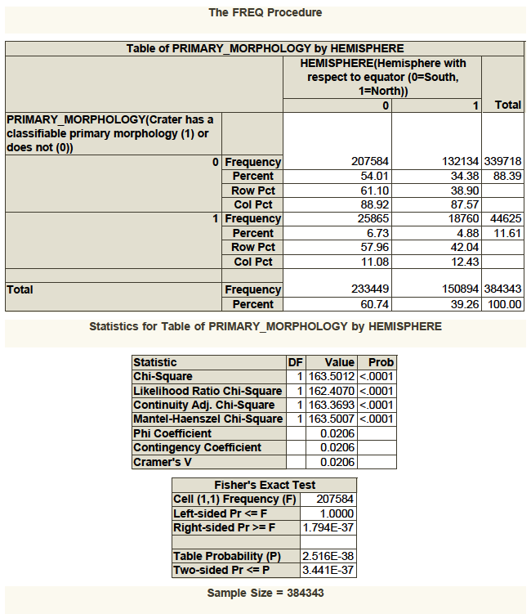

Figure : Relationship of crater diameter (quantitative variable), crater depth (quantitative variable), and latitude group (categorical variable). Proc ANOVA procedure with Duncan's multiple range test. Interpret column Duncan Grouping. (2 of 2)