Jordan Dardar
CSD430 Server Side Development
Module 9.2
7/20/2026

Screenshot 1 – Module 9 Home Page
Show index.jsp running in the browser with the create form, navigation links, and the current student records table.
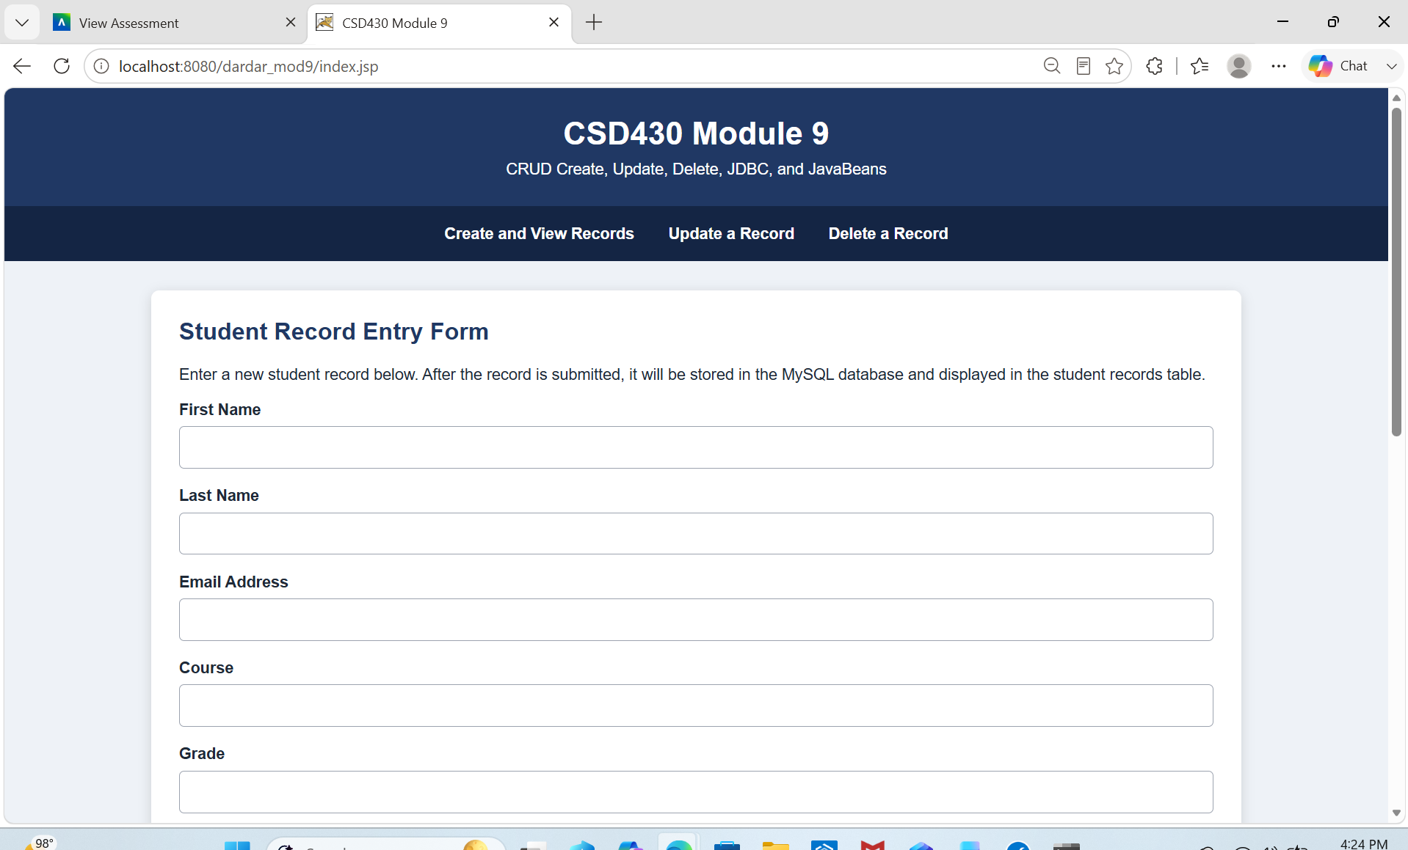

Screenshot 2 – Delete Page Before Deletion
Show deleteStudent.jsp with the primary-key dropdown and all current records displayed in the HTML table.
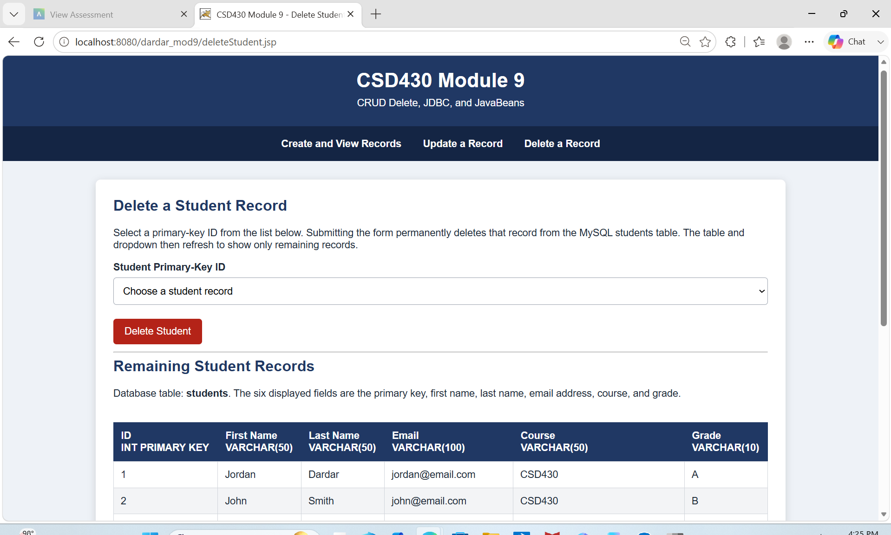

Screenshot 3 – Successful Record Deletion
Select a student ID, delete it, and show the green success message and refreshed table.
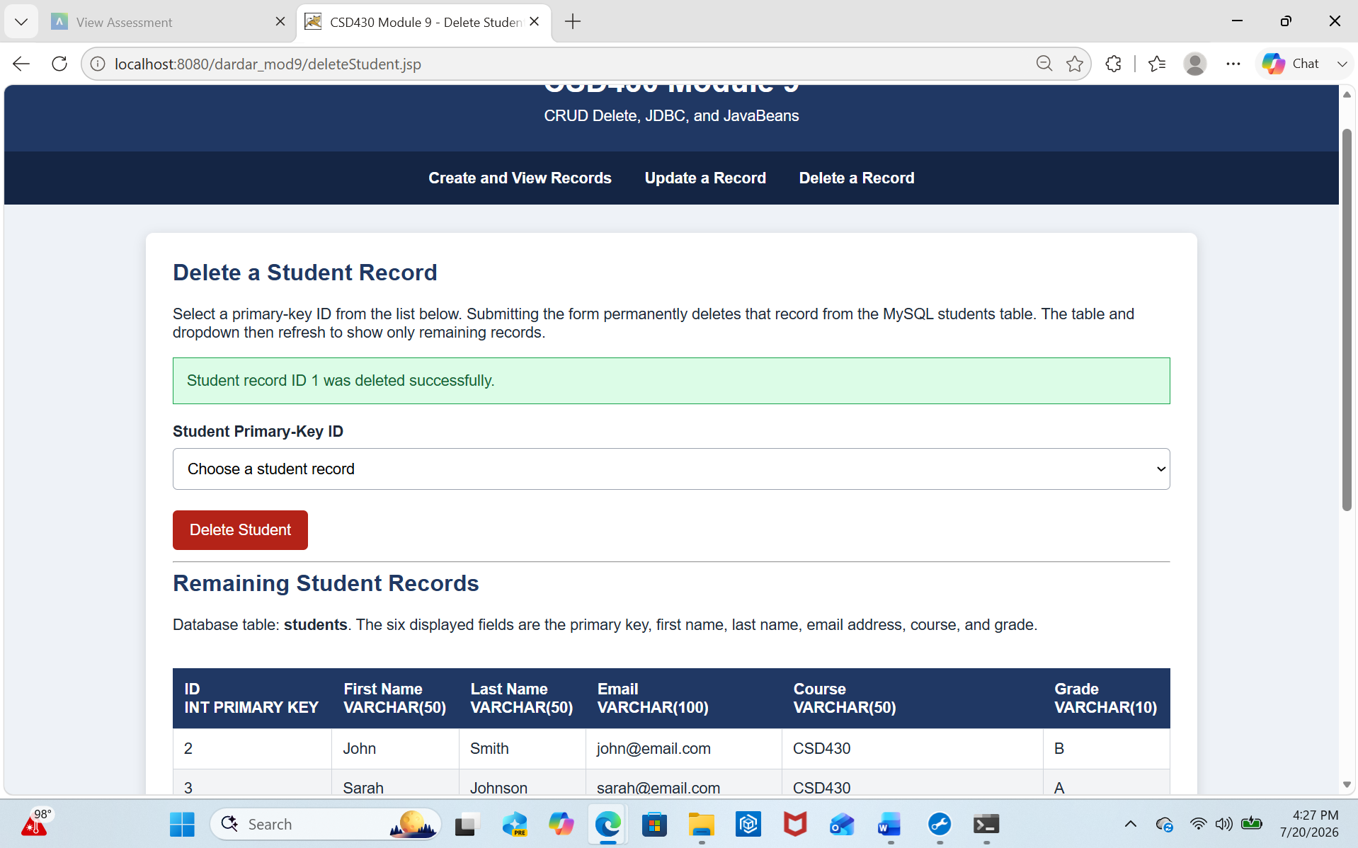

Screenshot 4 – Database Verification
Show MySQL Command Line after running USE csd430; and SELECT * FROM students; to prove the selected record was removed.
