Jordan Dardar
November 03, 2025

Assignment: Data Models
This document compares relational and non-relational database structures and models three business rules using both relational ERD diagrams and example NoSQL document structures. The three rules are: (1) a PERSON owns many CARS (one-to-many), (2) an EMPLOYEE learns many SKILLS and a SKILL can be learned by many EMPLOYEES (many-to-many), and (3) an EMPLOYEE manages exactly one RESTAURANT and each RESTAURANT has exactly one EMPLOYEE manager (one-to-one).

Relational vs. Non‑Relational: Concise Comparison
Aspect | Relational (SQL) | Non‑Relational (NoSQL)
Data model | Relational tables, rows, columns with predefined schema. | Flexible JSON-like documents; schema can evolve.
Relationships | Normalized using keys and joins (1:N, M:N via junction tables). | References or embedded subdocuments; joins avoided or done at app level.
Transactions | ACID by default. | Often BASE/partition-tolerant; ACID available in some engines or within a shard.
Scaling | Vertical or sharded with care. | Horizontal/partition-first design.
Best for | Strong consistency, structured data, complex joins. | High write/read scale, varied schema, event/log data.

One‑to‑Many: PERSON owns CAR (Relational ERD)
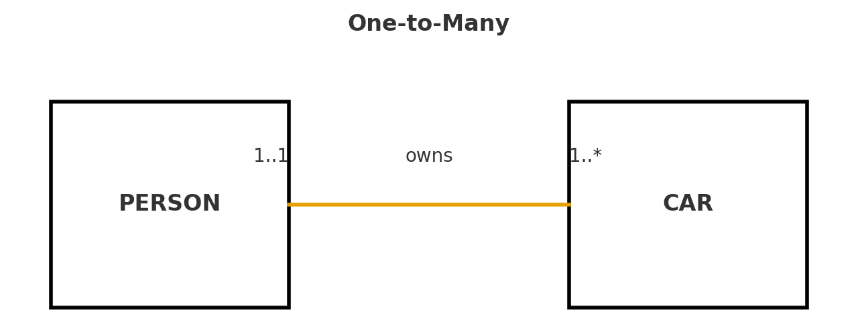
Relational design: PERSON( person_id PK, name, … ), CAR( car_id PK, person_id FK → PERSON, vin, make, model, year, color ).

NoSQL Document Structure (Embedded Collection)
Key idea: store a person's cars inside the PERSON document as an array of car subdocuments.
{
"_id": "user_1001",
"name": "Jordan Dardar",
"email": "jordan@example.com",
"cars": [
{
"vin": "1HGCM82633A004352",
"year": 2018,
"make": "Toyota",
"model": "Camry",
"color": "Silver"
},
{
"vin": "1N4AL11D75N467892",
"year": 2021,
"make": "Tesla",
"model": "Model 3",
"color": "Blue"
}
]
}

Many‑to‑Many: EMPLOYEE learns SKILL (Relational ERD)
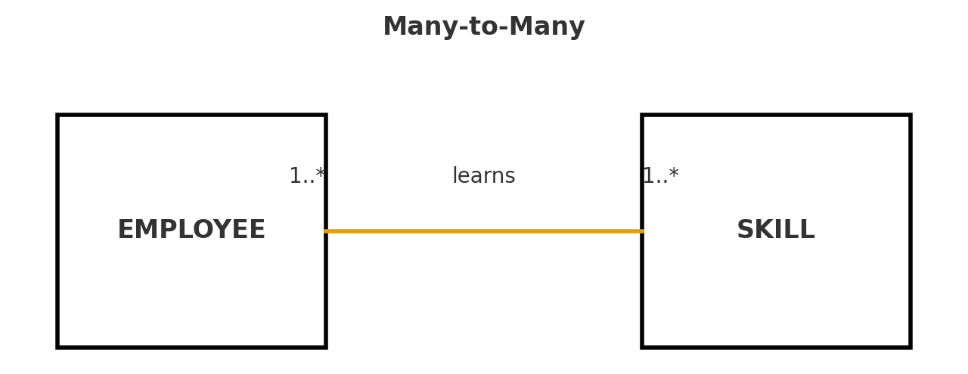
Relational design uses a junction table:
EMPLOYEE(emp_id PK, name, title, …)
SKILL(skill_id PK, name, category, …)
EMPLOYEE_SKILL(emp_id FK → EMPLOYEE, skill_id FK → SKILL, level, acquired_on, PRIMARY KEY(emp_id, skill_id))

NoSQL Options for Many‑to‑Many
Option A – Embed skill references in EMPLOYEE (simple and read‑optimized per employee):
{
"_id": "emp_2001",
"name": "Ava Carter",
"title": "Software Engineer",
"skills": [
{"skill_id": "skill_sql", "level": "advanced"},
{"skill_id": "skill_python", "level": "advanced"},
{"skill_id": "skill_docker", "level": "intermediate"}
]
}
Option B – Keep a small SKILLS collection and (if needed) a linking collection to support reverse lookups and constraints:
[
{"_id": "skill_sql", "name": "SQL", "category": "Data"},
{"_id": "skill_python", "name": "Python", "category": "Programming"},
{"_id": "skill_docker", "name": "Docker", "category": "DevOps"}
]
[
{"_id": "link_1", "employee_id": "emp_2001", "skill_id": "skill_sql"},
{"_id": "link_2", "employee_id": "emp_2001", "skill_id": "skill_python"},
{"_id": "link_3", "employee_id": "emp_2002", "skill_id": "skill_sql"}
]

One‑to‑One: EMPLOYEE manages RESTAURANT (Relational ERD)
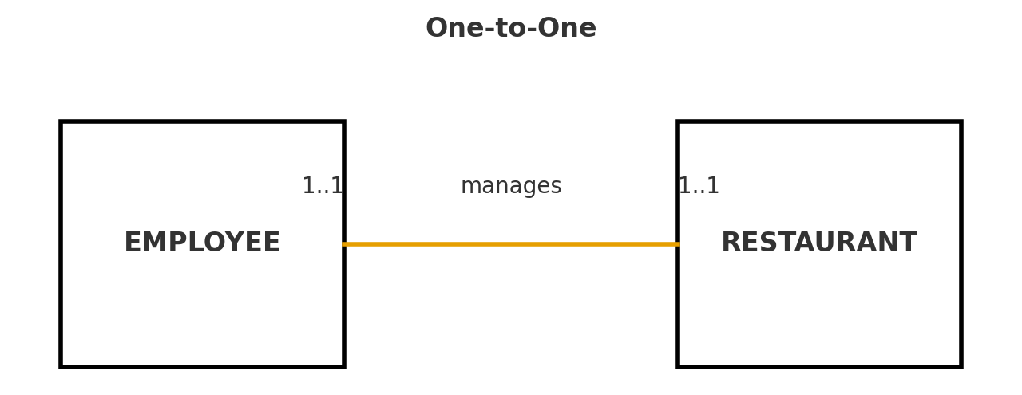
Relational design (one‑to‑one via unique foreign key):
EMPLOYEE(emp_id PK, …, UNIQUE(manages_restaurant_id))
RESTAURANT(rest_id PK, …, manager_emp_id UNIQUE FK → EMPLOYEE)

NoSQL Options for One‑to‑One
Option A – Reference keys on each side (mutual references for clarity):
{
"_id": "emp_mngr_3001",
"name": "Liam Nguyen",
"manages_restaurant_id": "rest_9001"
}
{
"_id": "rest_9001",
"name": "Bentonville Bistro",
"address": {
"street": "123 Main St",
"city": "Bentonville",
"state": "AR",
"zip": "72712"
},
"manager_employee_id": "emp_mngr_3001"
}
Option B – Embed the RESTAURANT inside the EMPLOYEE when the pair is tightly coupled:
{
"_id": "emp_mngr_3002",
"name": "Sophia Martinez",
"restaurant": {
"_id": "rest_9002",
"name": "Ozark Grill",
"address": {
"street": "987 Elm St",
"city": "Rogers",
"state": "AR",
"zip": "72756"
}
}
}
Apa: Fowler, M., & Sadalage, P. J. (2012). NoSQL distilled: A brief guide to the emerging world of polyglot persistence. Addison-Wesley.
Elmasri, R., & Navathe, S. B. (2016). Fundamentals of database systems (7th ed.). Pearson Education.
Coronel, C., & Morris, S. (2019). Database systems: Design, implementation, and management (13th ed.). Cengage Learning.
MongoDB, Inc. (2024). Data modeling concepts. MongoDB Documentation. https://www.mongodb.com/docs/manual/core/data-modeling-introduction/

