Jordan Dardar
Advanced Python
Module 9.2

Astronauts API Tutorial (astros_api.py)

For the first part of this assignment, I followed the API tutorial from the reading list using the OpenNotify astronauts API (http://api.open-notify.org/astros.json). I wrote a Python program called astros_api.py that uses the requests library to connect to the API.

First, the program tests the connection by printing the HTTP status code. A status code of 200 means the request was successful. Next, the program prints the raw JSON response text exactly as it comes from the server. Finally, I convert the JSON response into a Python dictionary and print formatted output that shows how many people are currently in space and lists each astronaut’s name and their spacecraft.
Astronauts API Tutorial – astros_api.py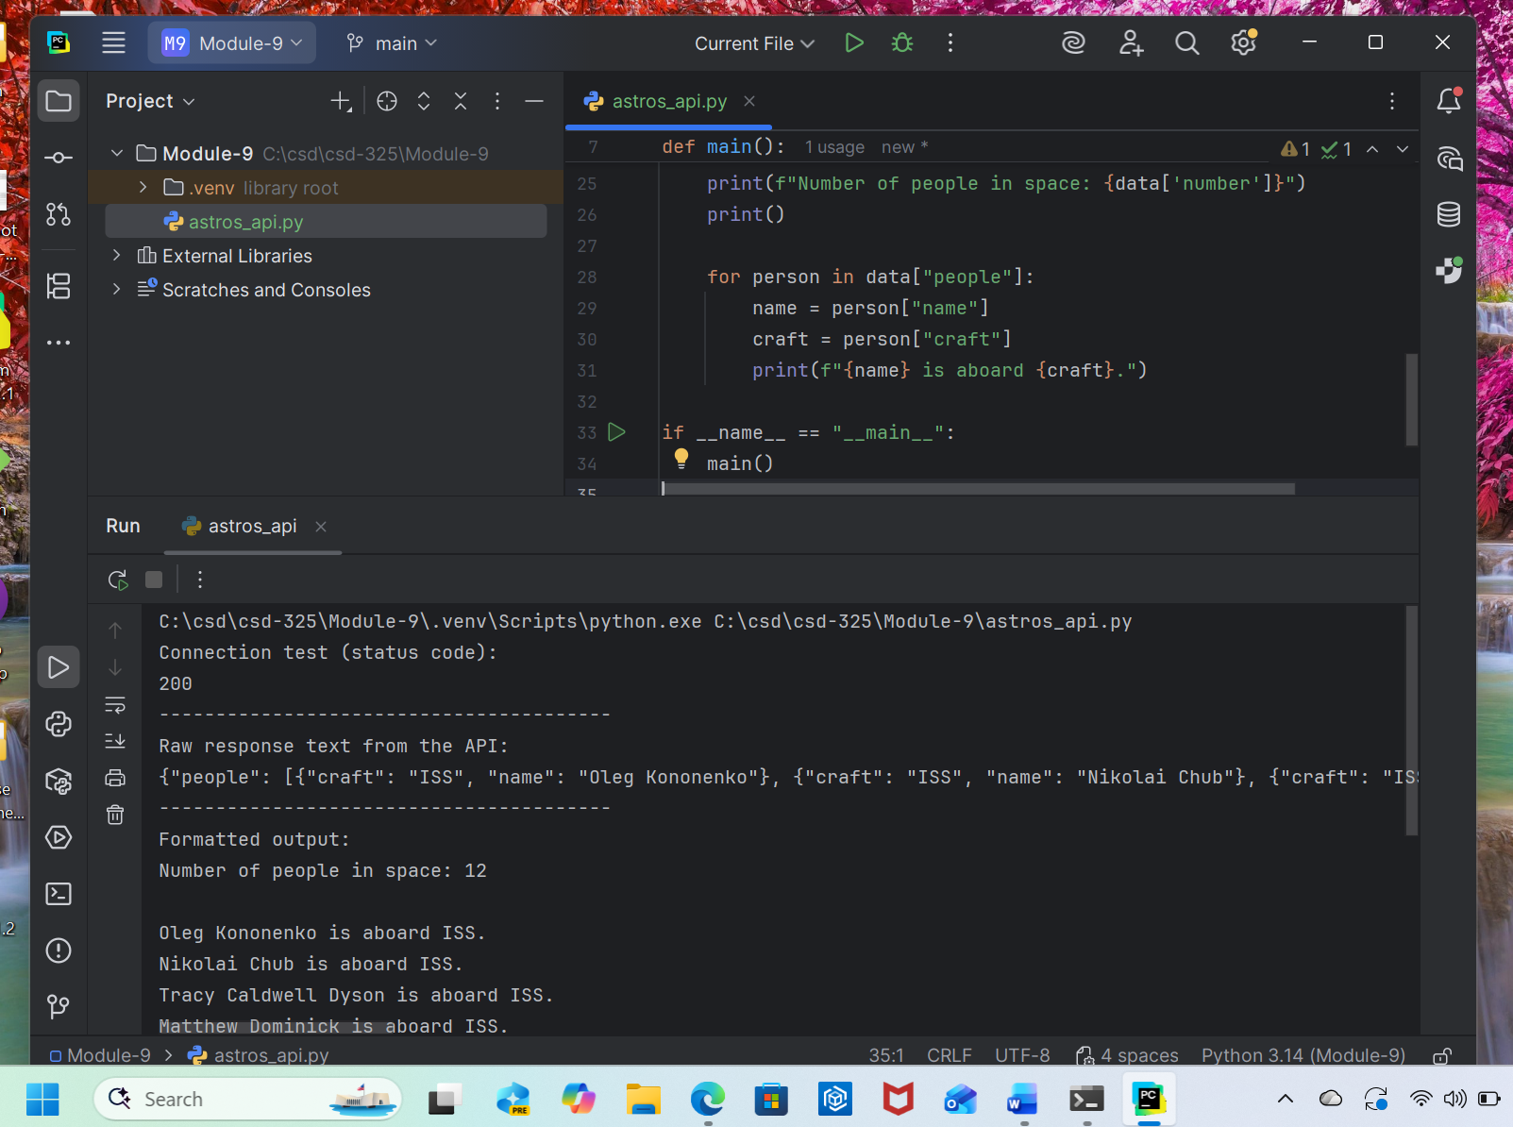 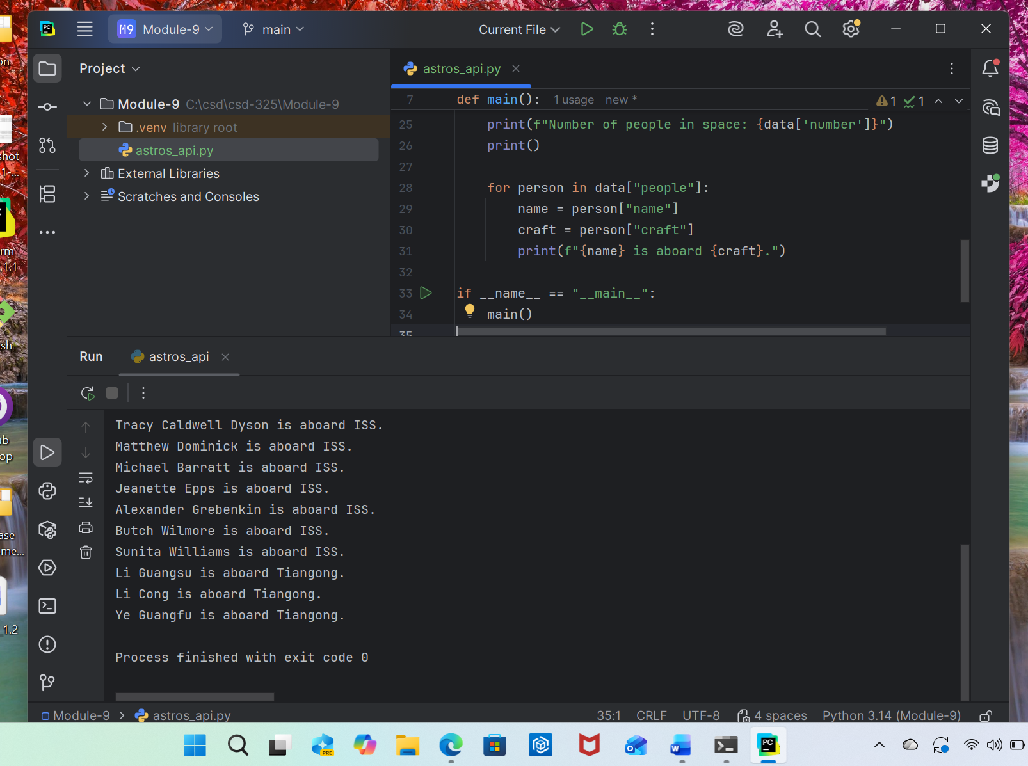
Custom API Program – Dog API (dog_api.py)
Custom API Program – Dog API (dog_api.py)
dog.ceo/api/breeds/image/random

For the second part of this assignment, I used the Dog API (https://dog.ceo/api/breeds/image/random), which returns a random dog image in JSON format. I created a Python program called dog_api.py that connects to this API using the requests library.
The program first tests the connection and prints the HTTP status code. Then it prints the raw JSON response exactly as it is returned from the API. After that, the program converts the JSON into a Python dictionary and prints formatted output that displays the API status and a clickable URL to a random dog image. This demonstrates how to retrieve, inspect, and format data from a public API.

