Module 5.2 Assignment: Forest Fire Simulation – Flowchart
Jordan Dardar
Advanced Python
Module 5.2 – Forest Fire Simulation Flowchart

This document shows flowcharts for the forest fire simulation program (forestfiresim.py). The first flowchart gives an overview of the program’s main control flow. The second flowchart zooms in on the rules used to update each grid cell during one simulation step.
Overall Program Flow
The overall flowchart summarizes what happens when the program starts, how the forest is initialized, and how the main simulation loop repeatedly displays the forest, updates every cell based on the tree, fire, and empty-space rules, and pauses between frames.
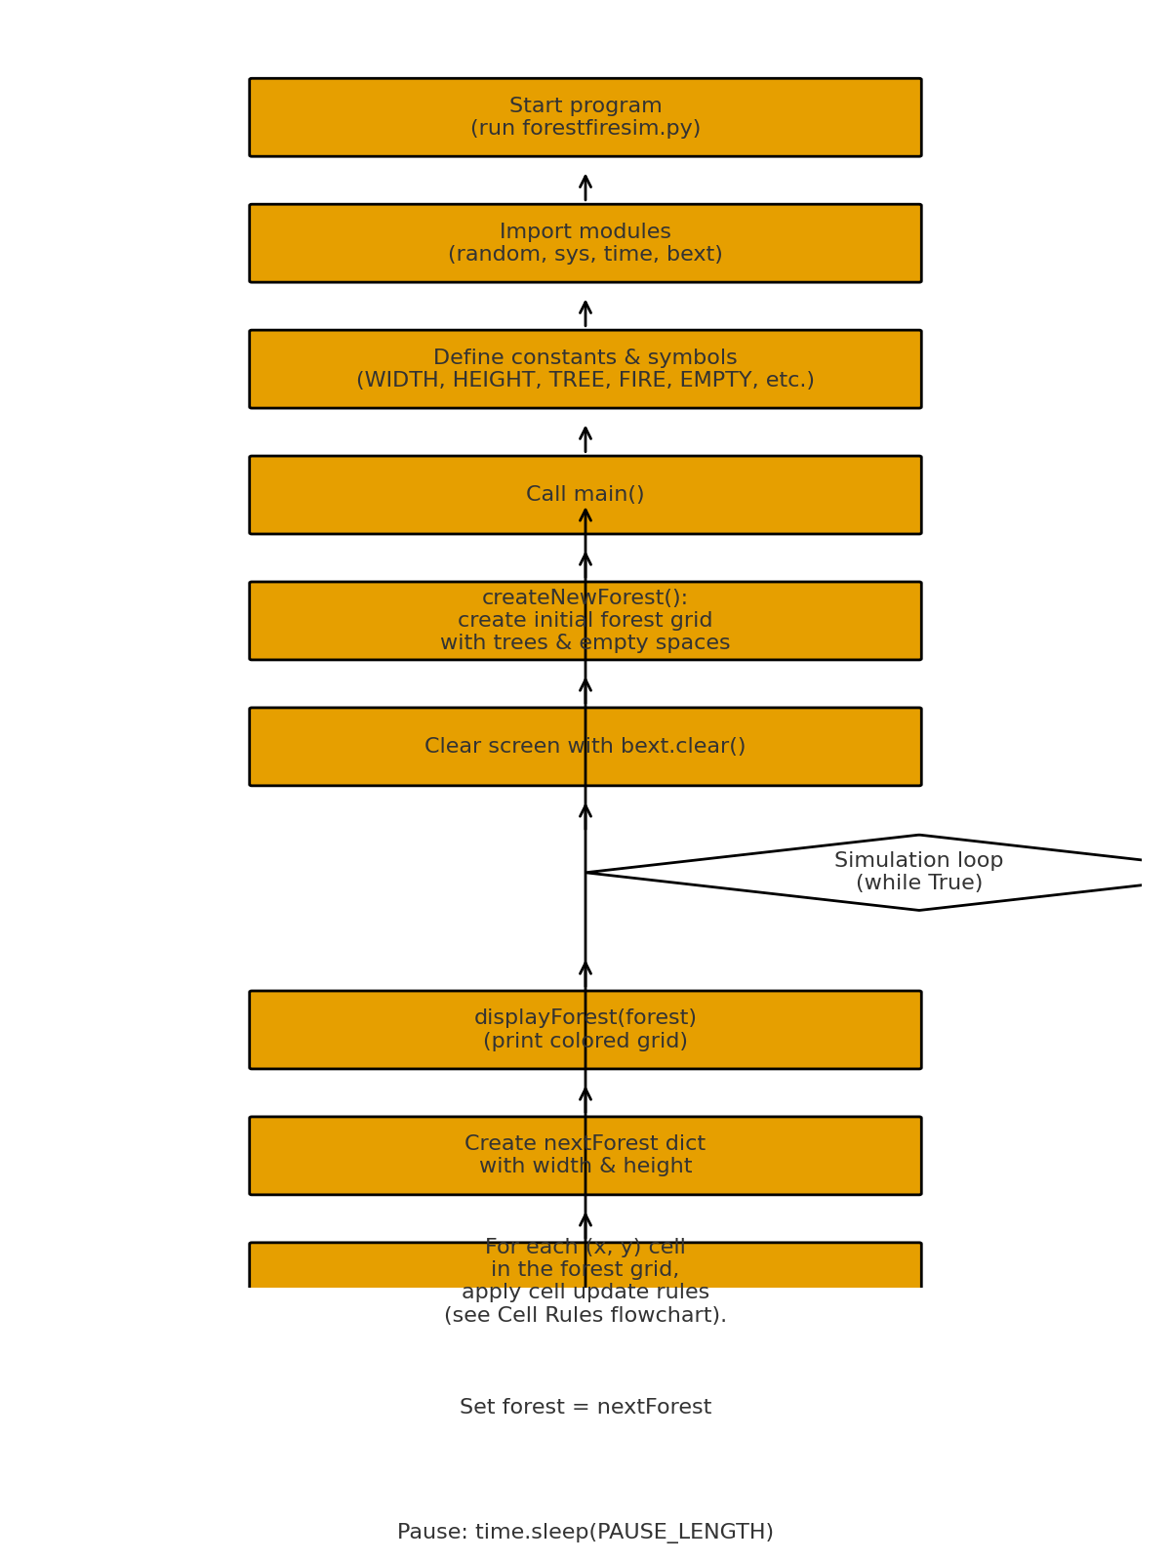
Figure 1. Overall flow of the forest fire simulation program.

Cell Update Rules
This flowchart shows the decision-making process for a single cell (x, y) in the forest grid. For each step of the simulation, the program:
1. Checks whether the cell was already updated in nextForest.
2. Decides whether an empty space grows a new tree.
3. Decides whether a tree is struck by lightning and catches fire.
4. Spreads fire from burning trees to neighboring trees and then turns burned trees into empty spaces.
5. Copies any remaining cells directly into the next forest state.
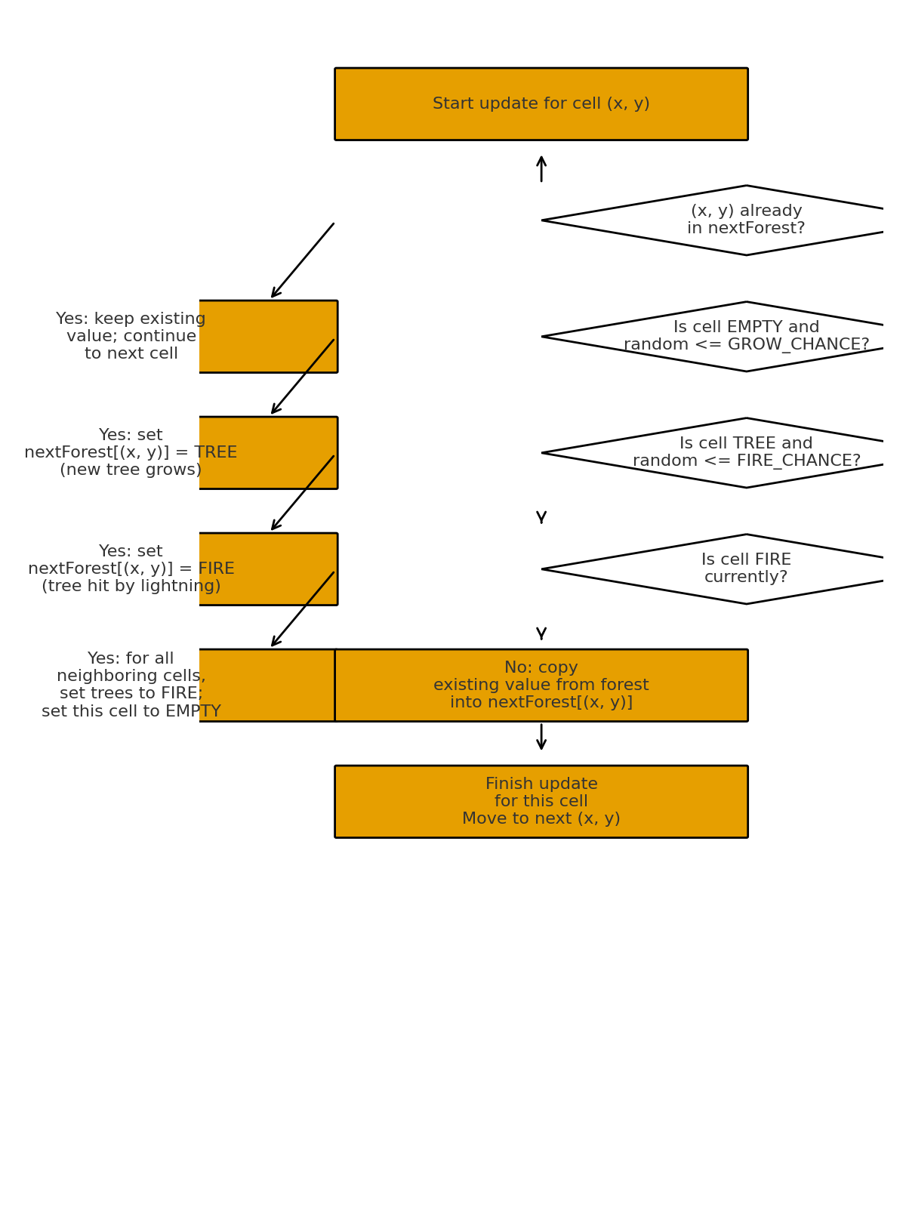
Figure 2. Decision rules for updating a single cell in the forest.

Notes
• The simulation continues to run in an infinite loop until the user presses Ctrl-C in the command-line window.
• The appearance of the forest changes over time because random numbers are used both for tree growth and for lightning strikes that start fires.
• The GROW_CHANCE and FIRE_CHANCE constants control how quickly trees grow and how often fires start.

