Jordan Dardar
Module 2.2
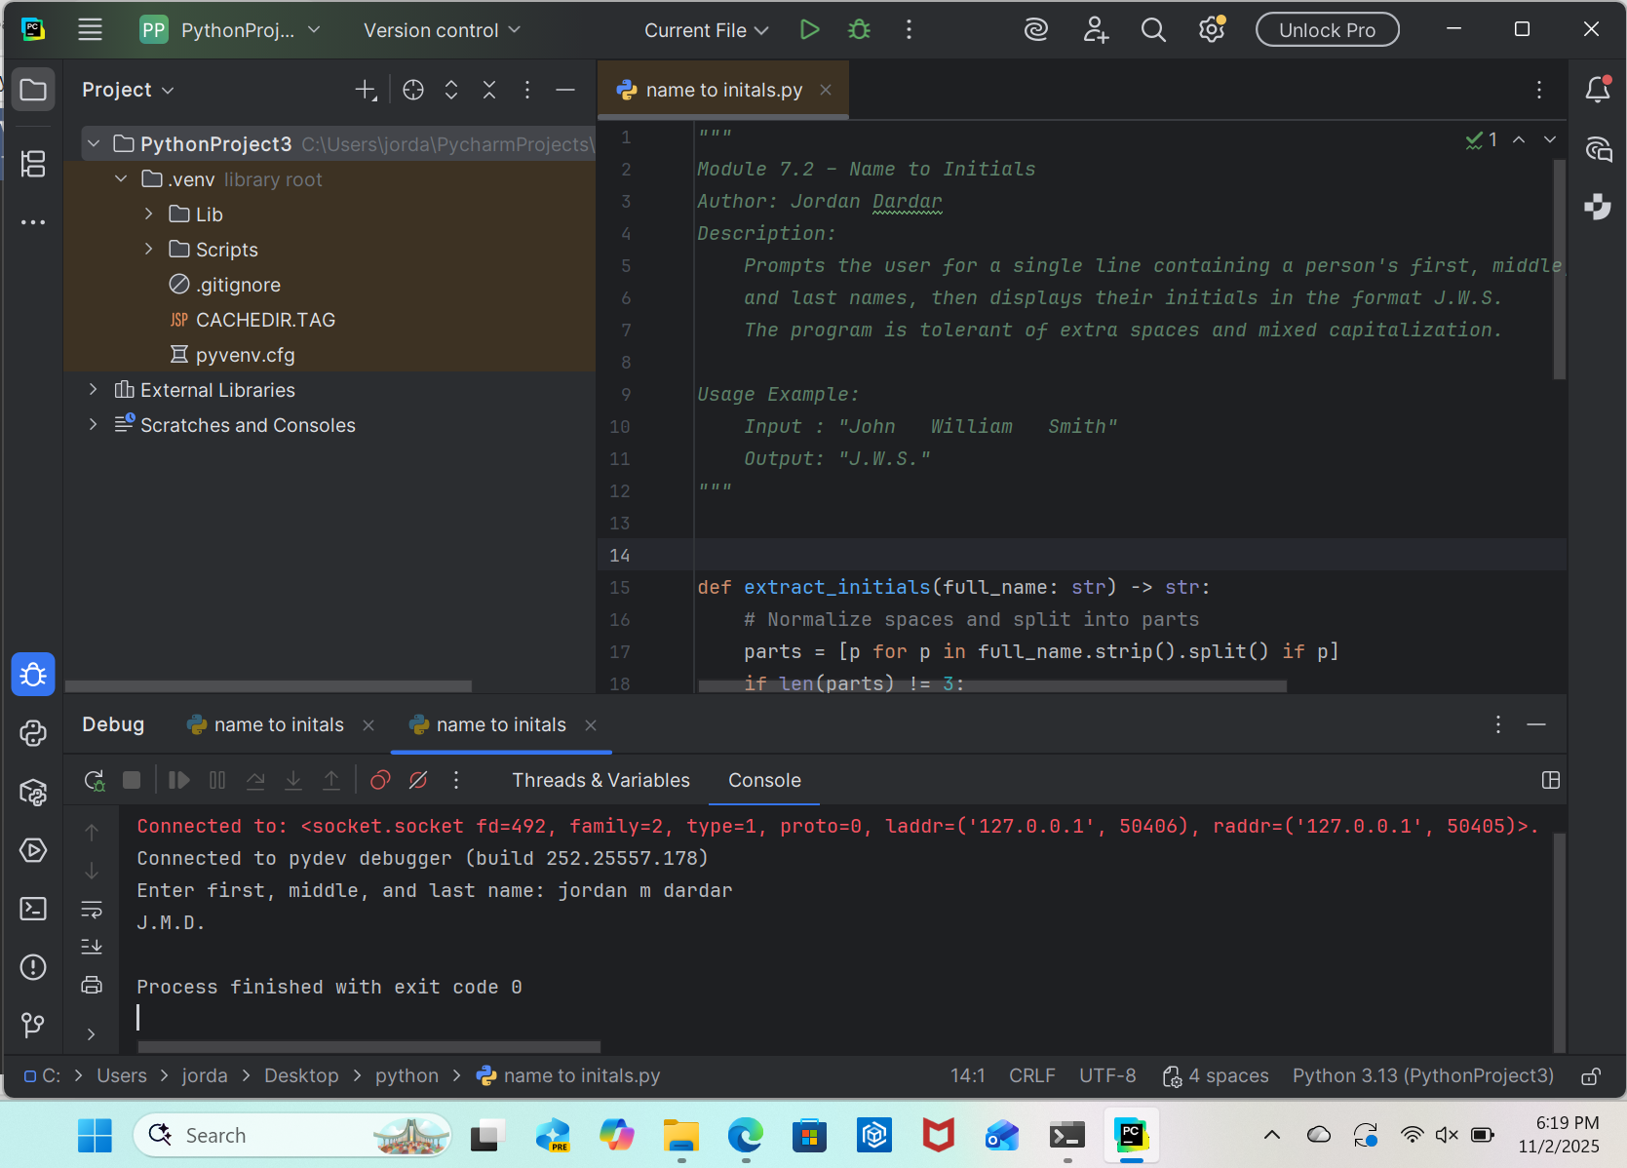
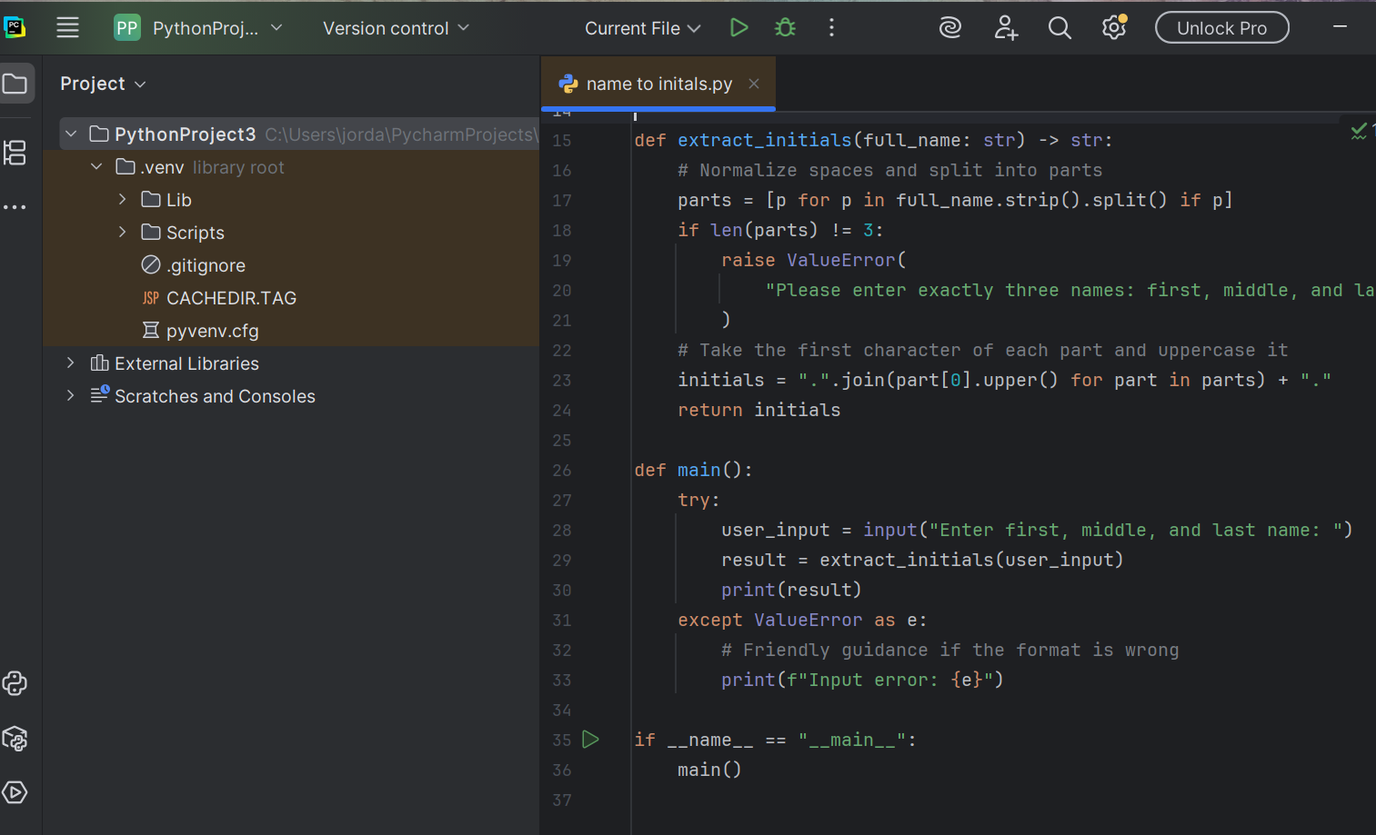
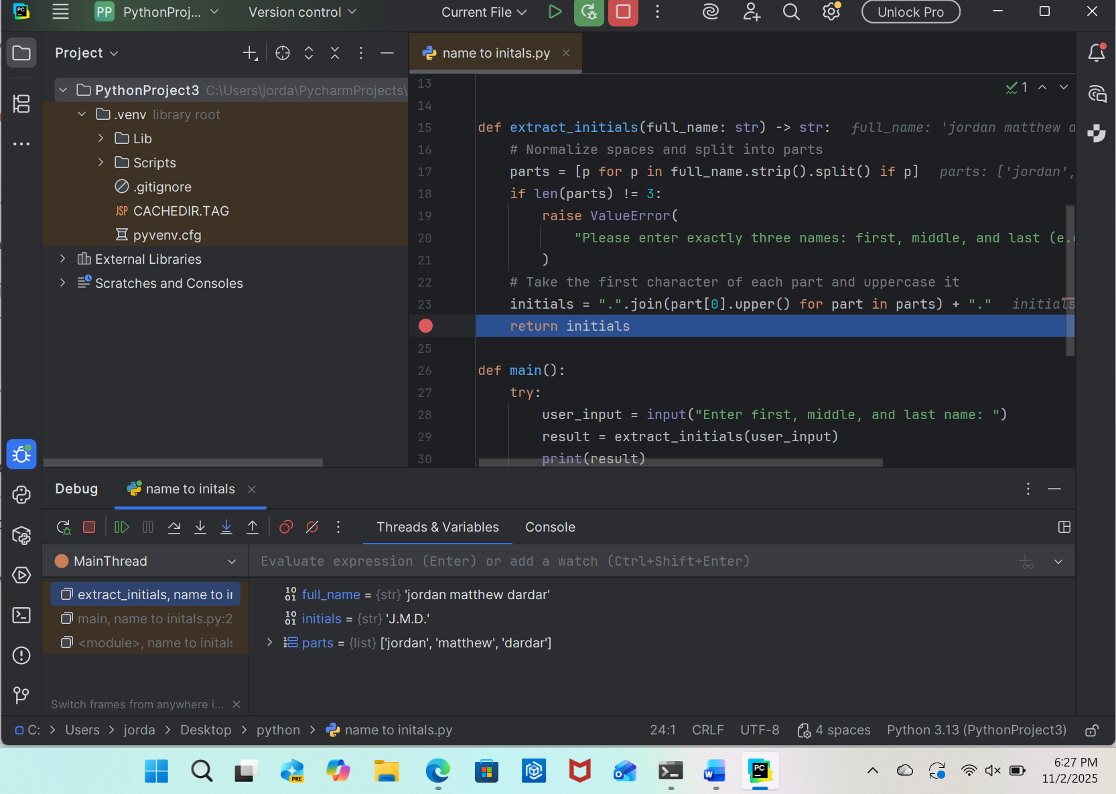
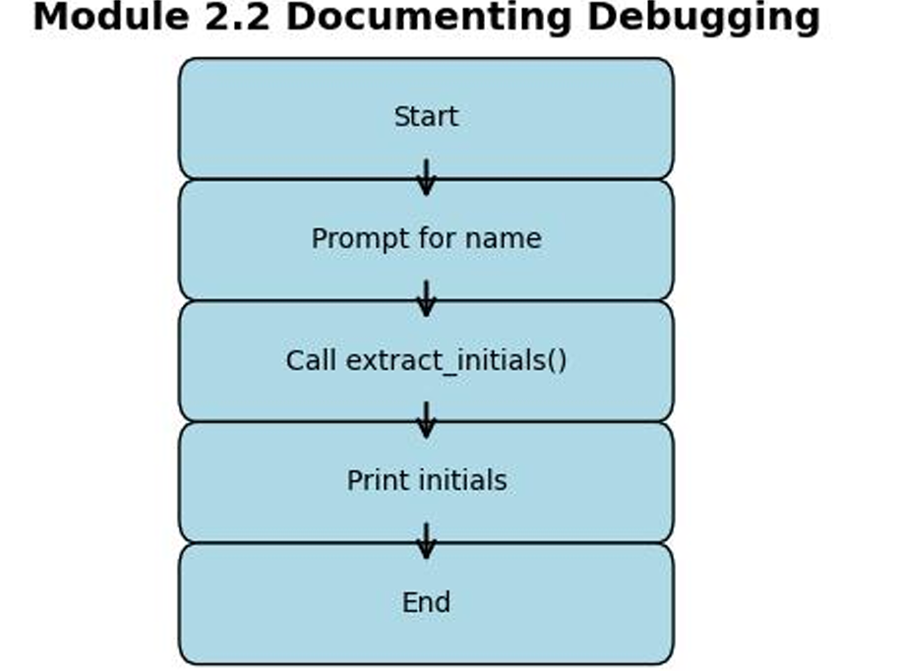This flowchart models the programs used for this assignment. It shows the sequence of operations: start the program, prompt for a full name, call the function to extract initials, display the initials, and end the program.
