Jordan Dardar
CSD-340
Module 5.1
Web Development with HTML

Front-End Style Guide:

Color Palette
- Primary: #2F6F6D (teal – calm, coastal)
- Secondary: #F2E8CF (soft cream)
- Accent: #D4A373 (warm sand)
- Background: #FFFFFF
- Text: #333333
Typography
- Headings: Georgia, serif
- Body text: Arial, sans-serif
UI Elements
- Buttons: Rounded corners, teal background, white text, subtle hover darkening
- Links: Teal text, underline on hover only
- Cards: Light cream background, soft shadow, generous padding
- Spacing: Open layout with plenty of white space for readability

Wireframes: 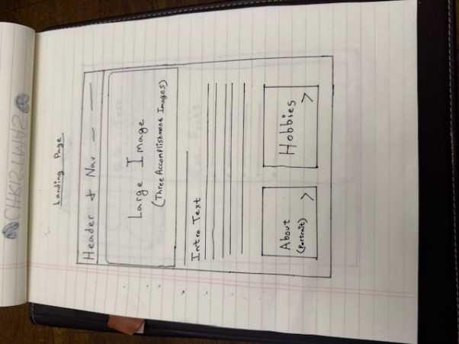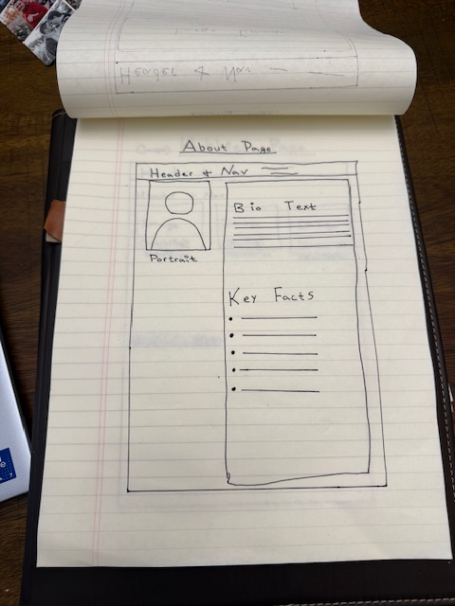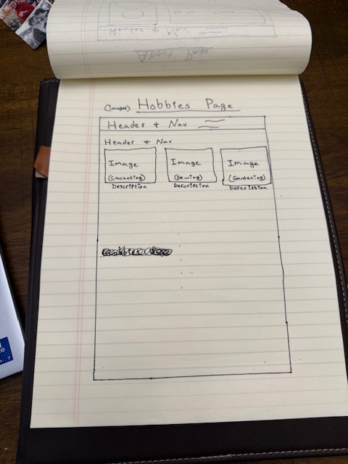

Interview with Janet(my grandmother):

1. Where were you born and raised?
I was born on August 12, 1944, and raised in Houma, Louisiana in a close-knit family where community and hard work were very important.

2. What are some of your favorite hobbies?
I love crocheting and sewing because they allow me to be creative and relax. Gardening is also very important to me, and I enjoy growing flowers and vegetables. Traveling with my husband is another favorite pastime.

3. How did you first get into crocheting and sewing?
I learned from family members when I was younger, and it stuck with me throughout my life.

4. What do you enjoy most about gardening?
I enjoy watching things grow and taking care of something from start to finish.

5. What places have you enjoyed traveling to the most?
Anywhere near the ocean has always been special, especially now that we live near the beach.
6. What accomplishment are you most proud of?
Raising a family and maintaining a loving marriage are my greatest accomplishments.

7. What values are most important to you?
Patience, kindness, and doing things with care.

8. What motivates you to stay active and creative?
Staying busy keeps my mind sharp and brings me joy.

9. What advice would you give your grandchildren?
Take your time, learn useful skills, and appreciate the people around you.

10. What does a perfect day look like to you?
Spending time with family, working on a project, and ending the day near the water.

About Janet(my grandmother):

My grandmother Janet was born on August 12th, 1944, and has lived a life centered around family, creativity, and patience. She currently lives in Panama City Beach, Florida, where the relaxed coastal lifestyle fits her personality perfectly. My grandmother has always believed in staying busy and finding joy in simple, meaningful activities.

One of my grandmother’s greatest passions is crocheting and sewing. These hobbies allow her to create useful and decorative items while also giving her a sense of calm and focus. Over the years, she has made countless handmade pieces for family members, each one reflecting the care and attention she puts into her work. Gardening is another important part of her daily life. She enjoys tending to plants and watching them grow, which mirrors her patient and nurturing nature.

Traveling with her husband(gramps) is another hobby that brings her great happiness. Whether it’s a short trip or a longer journey, my grandmother enjoys exploring new places while creating memories together. Living near the beach has given her the opportunity to enjoy peaceful scenery and a slower pace of life.

Janet is most proud of her family and the life she has built through dedication and love. Her values of kindness, patience, and creativity continue to influence those around her. Through her hobbies and lifestyle, Janet shows that fulfillment often comes from consistency, care, and appreciating the small moments.

Image List:

Hobby Images: 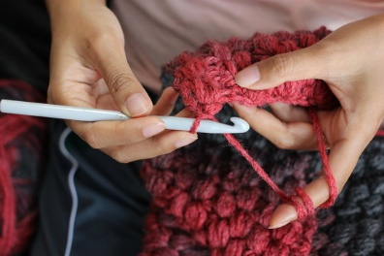 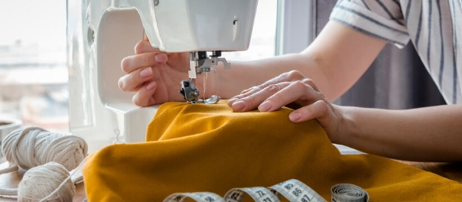
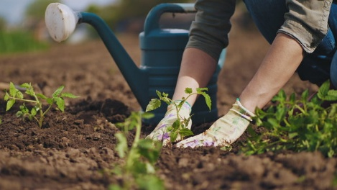

Accomplishment Images:


Portrait: 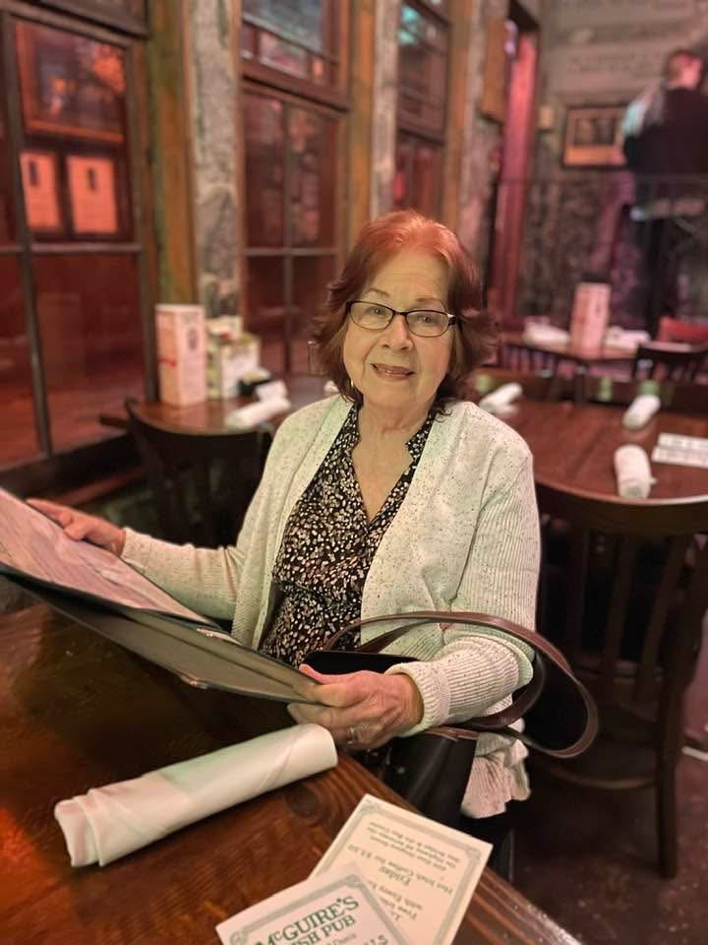

Intro Text/Landing Page: This website is a biographical site that tells the story of someone important to me, my grandmother. The focus of this site is Janet, who was born on August 12th, 1944, and currently lives in Panama City Beach, Florida. This site highlights her background, interests, and hobbies, including crocheting, sewing, gardening, and traveling with her husband. The purpose of this site is to share her story in a clear and respectful way while applying design principles learned throughout the course.

