Project: | To Do Application
Course: | CSD 380 - DevOps
Description: | Functional test plan to the ToDo Web Application.
Date: | Due On: June 25th, 2026
To complete the test case plan, fill out the information for Project, Course, Description and Date in the header below.
.
TABLE OF CONTENTS
Website Accessibility via Standard URL 2
Create a New Todo Task Item 3
View the List of Todo Task Items 4
Delete a Todo Task Item 5
Prevent Submission of Empty Task Form 6

For each test, the developer should provide a test description, a test objective, the developer’s name, and the date. For each step, fill out the actions to be taken, describe the expected results, and indicate yes or no for each step depending upon the result. The peer tester should provide their name, the date tested, indicate yes or no for each step based on the result, and include a screenshot (thumbnail) of the result.

Test 1 | Website Accessibility via Standard URL
 | Test Objective: Verifies that users can access the Todo application through the standard URL (Req #10) | Developer: Robert Breutzmann  Date tested: 2026/06/24 | Peer tester: Jordan Dardar  Date tested: 2026/06/24
Step | Action | Expected results: | Developer pass/fail | Tester pass/fail  + Screenshot
1 | Open a web browser and navigate to https://buwebdev.github.io/todo/ | The browser loads the Todo application landing page without any errors or HTTP error codes | Yes | Yes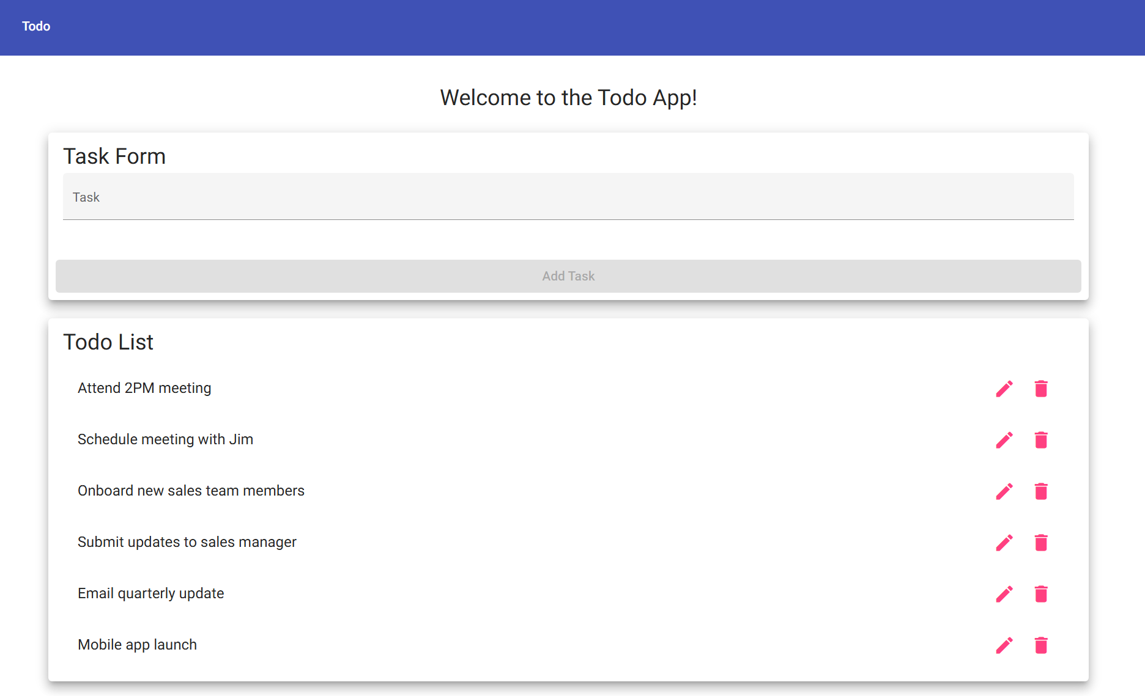
2 | Observe the page title and heading displayed in the browser | The page displays the Todo application with its title and task list visible | Yes | Yes
3 | Click the browser Refresh button or press F5 to reload the page | The page reloads correctly and the Todo application displays as expected with no loss of content | Yes | Yes
4 | Open a second browser tab and navigate to https://buwebdev.github.io/todo/ | The Todo application loads successfully in the second tab, confirming multi-tab accessibility | Yes | Yes
5 | Check the browser address bar to confirm the full URL is correctly displayed | The URL shown in the address bar matches https://buwebdev.github.io/todo/ exactly | Yes | Yes
Comments | The Todo application successfully loads via the standard URL defined in Req #10. The page renders without errors on both initial load and refresh, confirming stable accessibility. The test also confirms that the application supports multiple simultaneous browser tab sessions without conflict.

Test 2 | Create a New Todo Task Item
 | Test Objective: Verifies that users can successfully create a new todo task item (Req #2) | Developer: Robert Breutzmann  Date tested: 2026/06/24 | Peer tester: Jordan Dardar  Date tested: 2026/06/24
Step | Action | Expected results: | Developer pass/fail | Tester pass/fail
1 | Navigate to https://buwebdev.github.io/todo/ and locate the new task input field | The input field for entering a new todo task item is visible and interactive on the landing page | Yes | Yes
2 | Type a task description such as 'Buy groceries' into the input field | The text is entered and displayed correctly in the input field without any formatting issues | Yes | Yes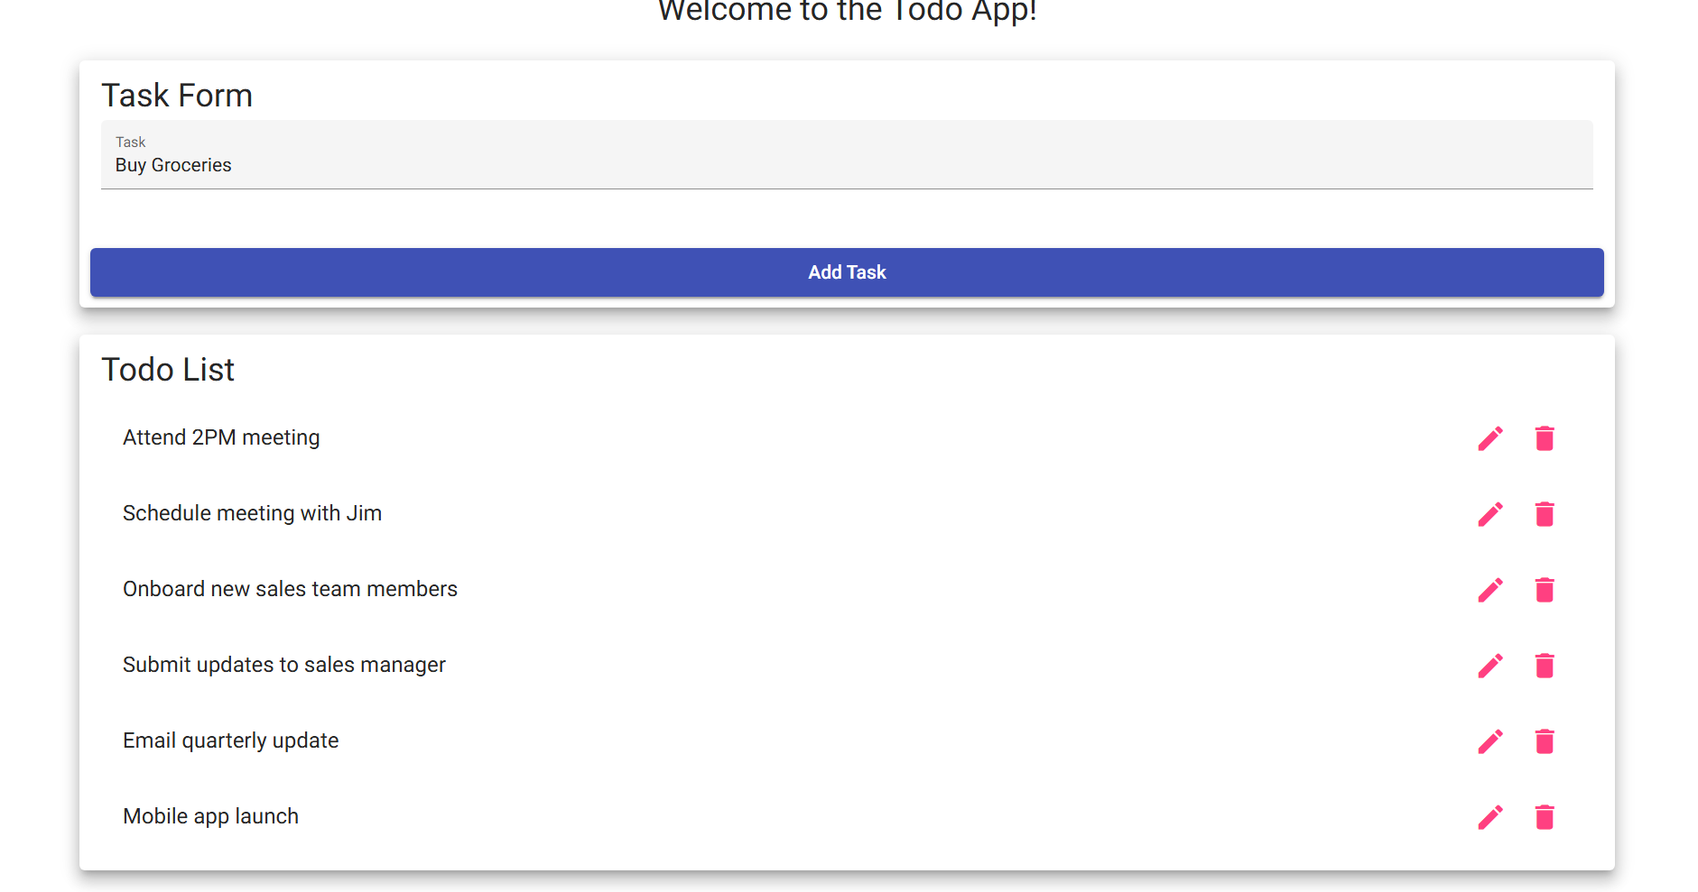
3 | Click the submit or add button to create the new task item | The task 'Buy groceries' appears in the todo list below the input field | Yes | Yes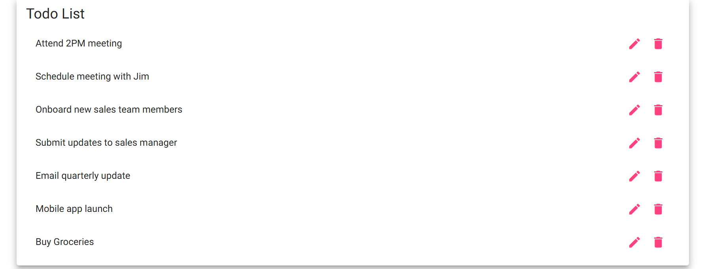
4 | Confirm the new task is displayed in the task list | The newly created task is visible in the list with the correct text that was entered | Yes | Yes
5 | Create a second task by typing 'Schedule dentist appointment' and submitting | Both tasks appear in the todo list, confirming that multiple items can be created successfully | Yes | Yes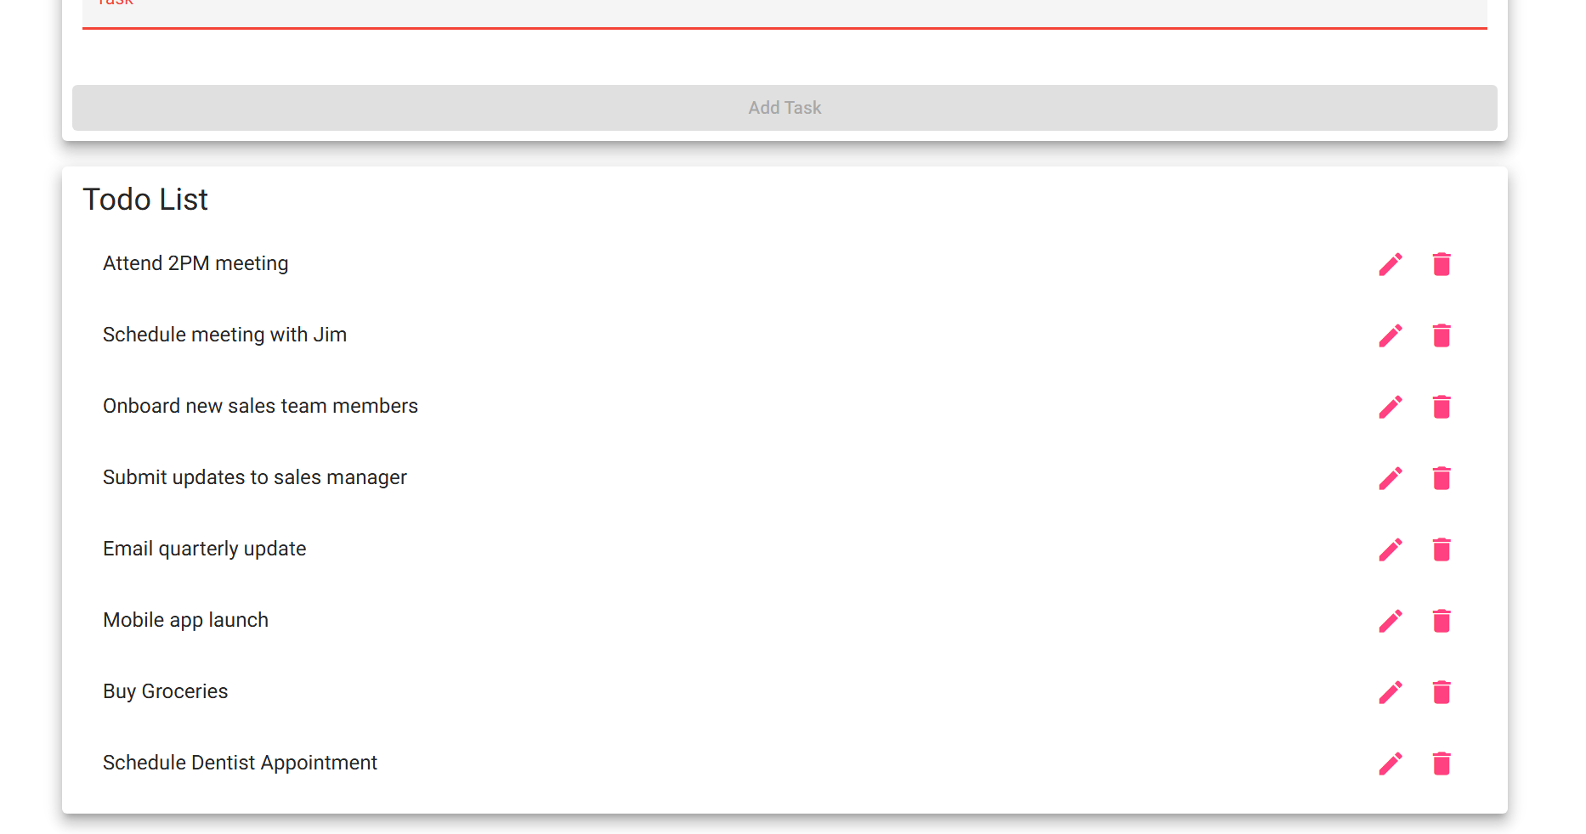
Comments | The create task functionality performed as expected per Req #2. New tasks were added to the list immediately after submission and retained their text accurately. The application handled multiple sequential task creations without any degradation in performance or display errors.

Test 3 | View the List of Todo Task Items
 | Test Objective: Verifies that the application displays the full list of existing todo task items (Req #1) | Developer: Robert Breutzmann  Date tested: 2026/06/24 | Peer tester: Jordan Dardar  Date tested: 2026/06/24
Step | Action | Expected results: | Developer pass/fail | Tester pass/fail
1 | Navigate to https://buwebdev.github.io/todo/ and add at least three tasks to the list | Three or more todo task items are successfully created and visible on the page | Yes | Yes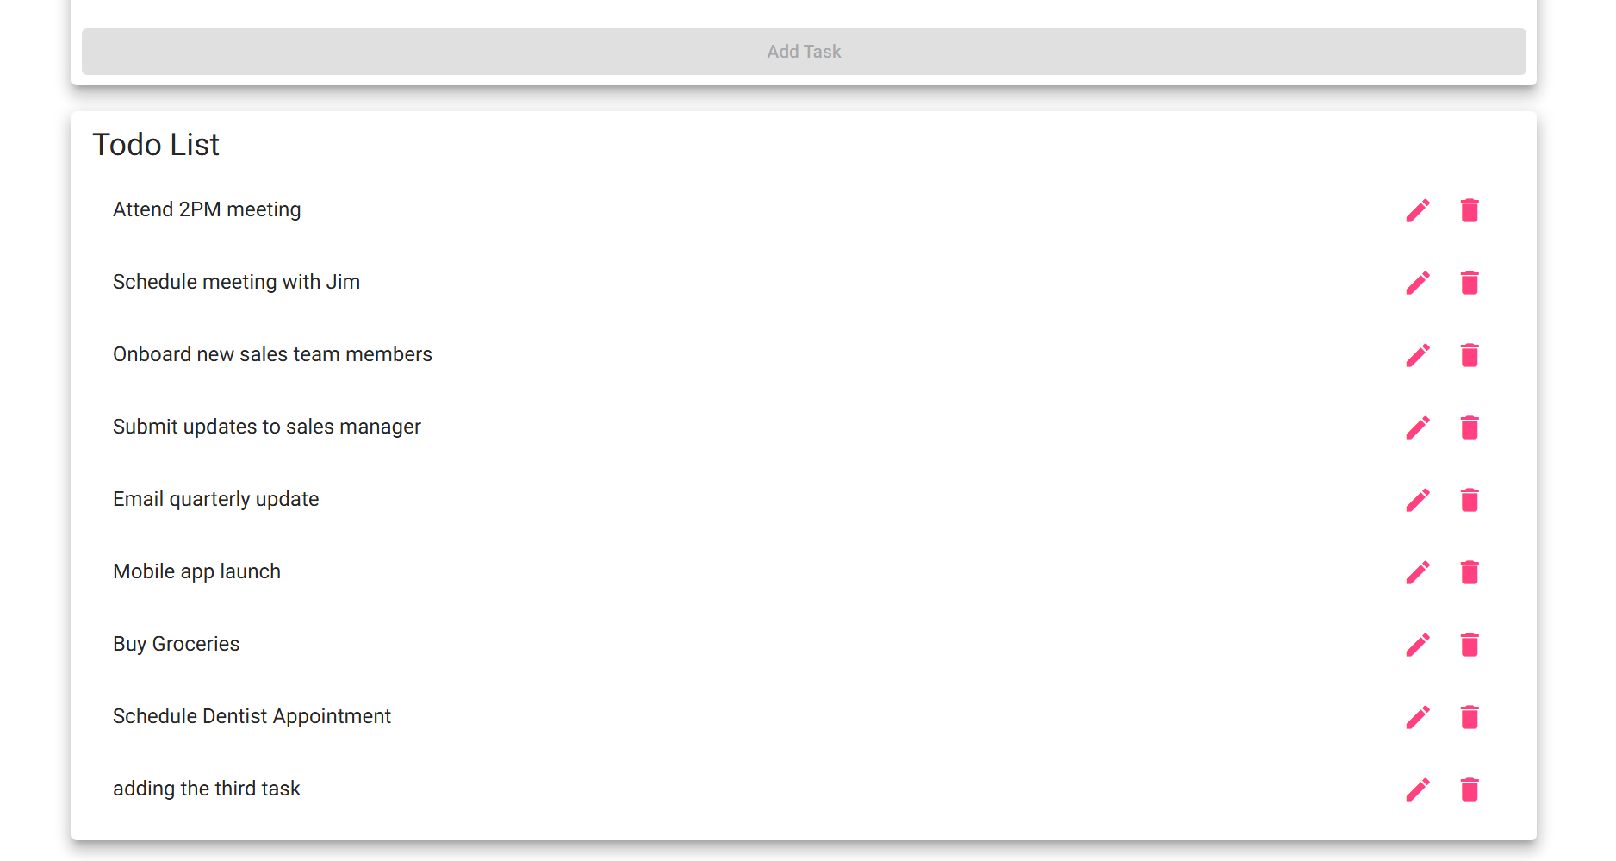
2 | Observe the todo list section of the landing page | All created todo task items are displayed in the list in the order they were added | Yes | Yes
3 | Scroll through the task list to confirm all items are visible | All task items appear in the list without any items missing or hidden from view | Yes | Yes
4 | Refresh the page and observe whether the task list is still visible | The page refreshes and the task list displays the existing tasks without data loss | No | No
5 | Verify the task list area is clearly separated and readable from other UI elements | The task list is visually distinct, properly formatted, and easy to read on the page | Yes | Yes
Comments | The view task list feature meets the requirements described in Req #1. All created tasks appeared correctly in the list both. A page refresh wiped the memory of the ToDo list. The task list is clearly presented and distinguishable from other page elements, providing a clear and usable interface for managing todo items.

Test 4 | Delete a Todo Task Item
 | Test Objective: Verifies that users can successfully delete an existing todo task item from the list (Req #4) | Developer: Robert Breutzmann  Date tested: 2026/06/24 | Peer tester: Jordan Dardar  Date tested: 2026/06/24
Step | Action | Expected results: | Developer pass/fail | Tester pass/fail
1 | Navigate to https://buwebdev.github.io/todo/ and create two task items: 'Call bank' and 'Walk dog' | Both tasks appear in the todo list and are visible on the page | Yes | Yes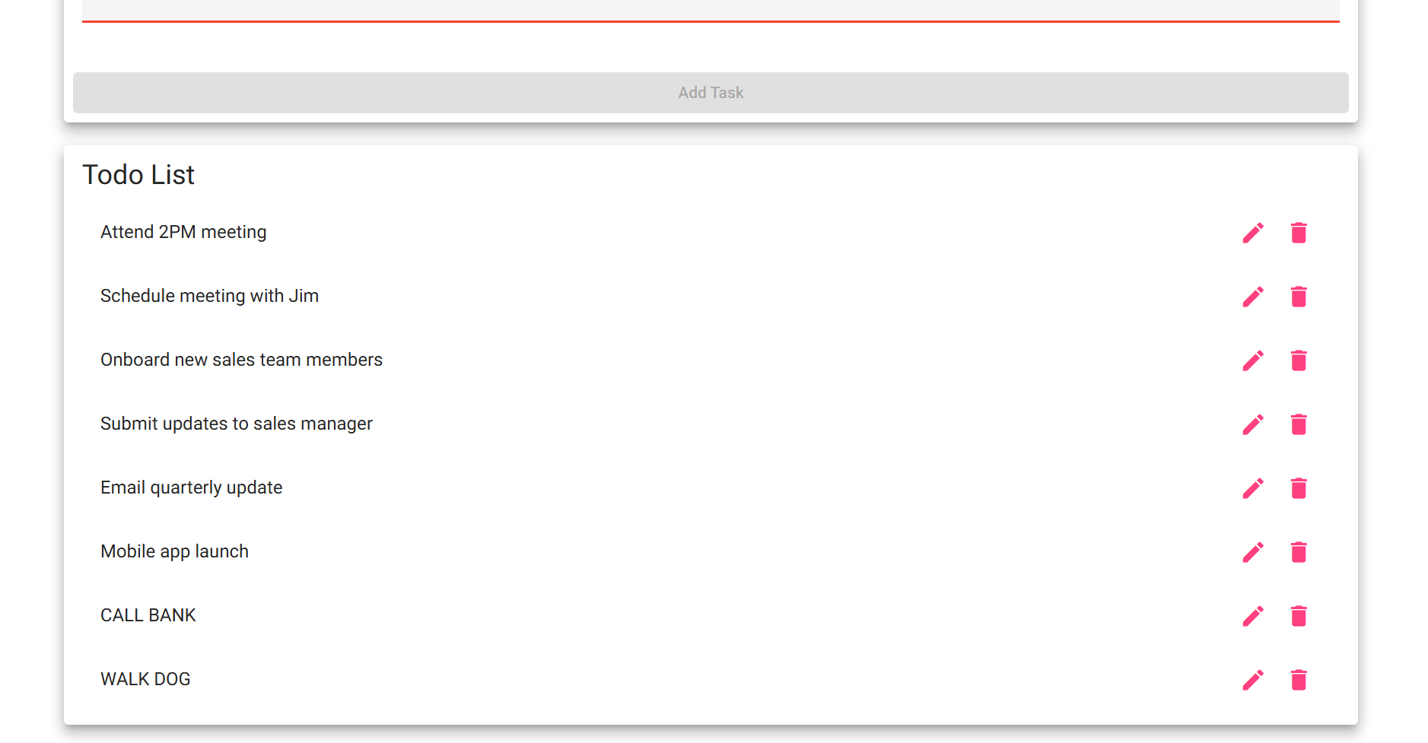
2 | Locate the delete control (button or icon) next to the 'Call bank' task item | A delete control is visible and accessible next to each task item in the list | Yes | Yes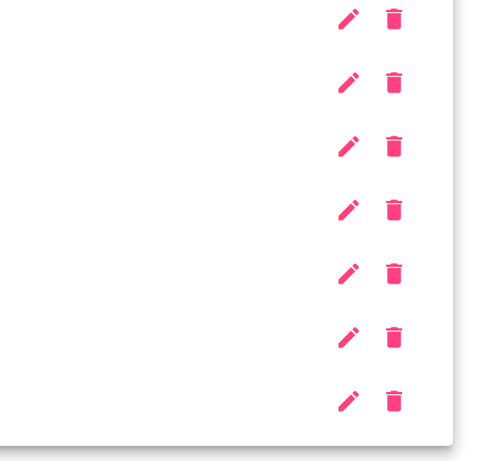
3 | Click the delete control for the 'Call bank' task | The 'Call bank' task is immediately removed from the todo list | Yes | Yes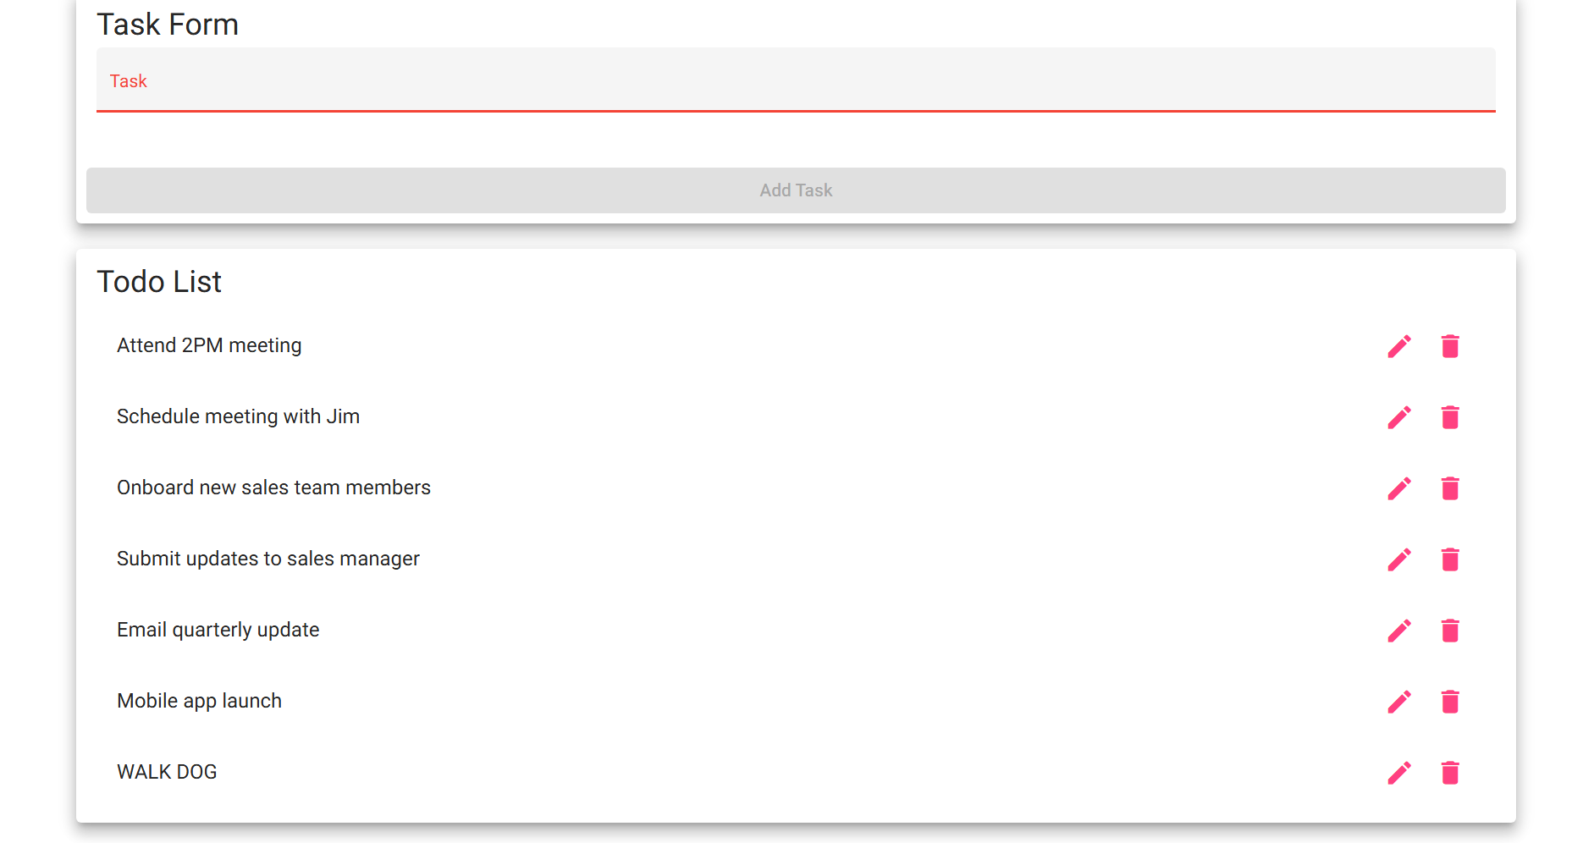
4 | Confirm that the 'Walk dog' task remains in the list after deleting 'Call bank' | Only 'Walk dog' remains in the list, confirming that only the targeted task was deleted | Yes | Yes
5 | Click the delete control for the 'Walk dog' task to remove the remaining item | The 'Walk dog' task is removed and the task list is now empty | Yes | Yes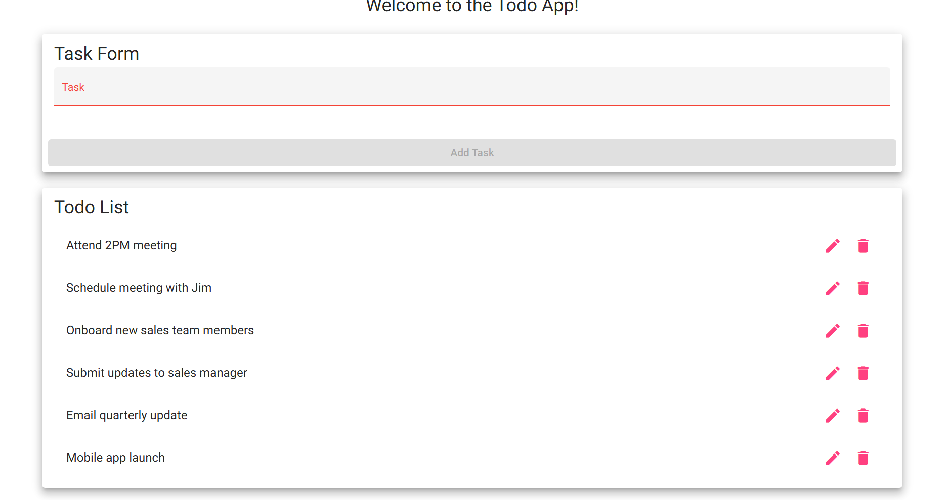
Comments | The delete functionality performed correctly per Req #4. Individual tasks were removed as expected without affecting other items in the list. The application correctly updated the task list in real-time after each deletion, and the final state showed an empty list when all tasks had been removed.

Test 5 | Prevent Submission of Empty Task Form
 | Test Objective: Verifies that the application prevents users from submitting an empty task creation form (Req #6) | Developer: Robert Breutzmann  Date tested: 2026/06/24 | Peer tester: Jordan Dardar  Date tested: 2026/06/24
Step | Action | Expected results: | Developer pass/fail | Tester pass/fail
1 | Navigate to https://buwebdev.github.io/todo/ and locate the new task input field | The task input field is visible and empty on the landing page | Yes | Yes
2 | Leave the task input field blank and click the submit or add button | The application does not create a new task; a warning is shown or the form submission is blocked | Yes | Yes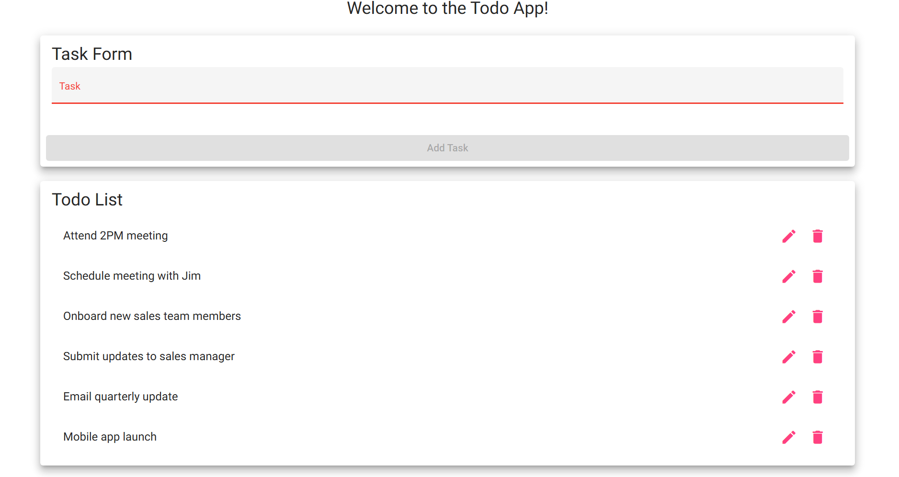
3 | Confirm that no blank or empty task item is added to the todo list | The task list does not contain any blank or empty entry after the failed submission attempt | Yes | Yes
4 | Type only spaces into the input field and attempt to submit the form | The application rejects the submission and no whitespace-only task is added to the list | No | No
5 | Enter valid text such as 'Pick up laundry' into the input field and submit | The application accepts the valid entry and the task 'Pick up laundry' appears in the task list | Yes | Yes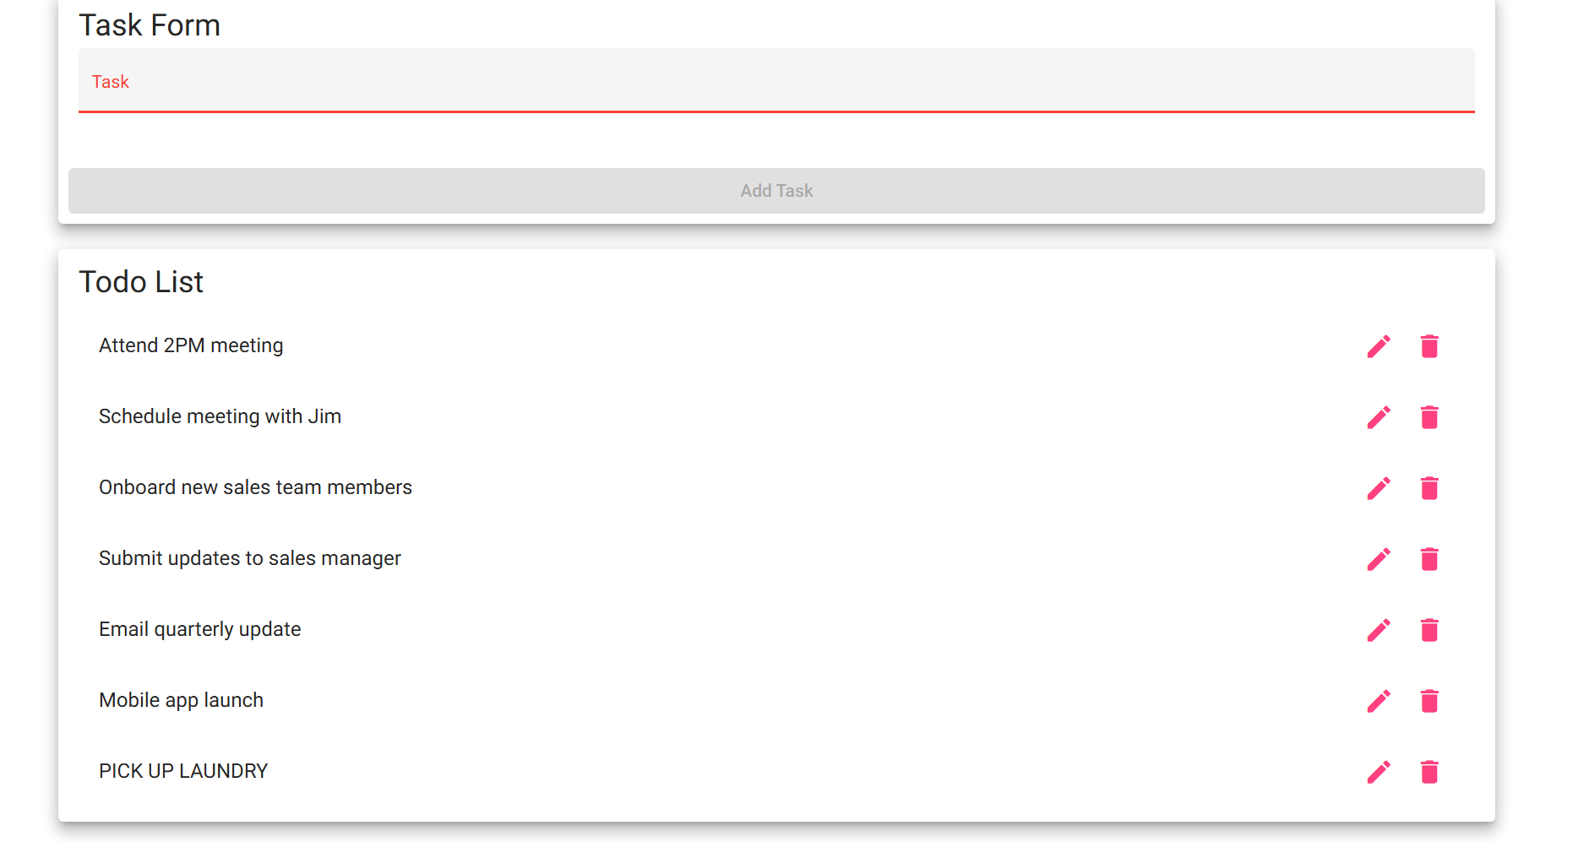
Comments | The form validation for empty task submission functions correctly as specified in Req #6. The application prevented blank submissions and 3 or fewer white spaces from being added to the task list. When a entry of four or more whitespaces is entered, the application allows you to enter an item into the Todo list of 4+ white spaces only. When a valid task was entered, it was accepted and displayed normally, confirming that validation does not block legitimate input.

