Project: Todo Project | Name: Matthew Rozendaal
Course: CSD380 | Assignment: Mod 4.2
Description: Todo is a business application focused on the monitoring of task items. Users of this system are able to create, update, and delete items from their “Todo List.” Views have been created to support most major devices and web browsers.
Date: 2026/06/12
To complete the test case plan, fill out the information for Project, Course, Description and Date in the header below.
.
TABLE OF CONTENTS
Landing Page Inputs 2
Edit existing Task 3
Delete Existing task 3
Create new ToDo Item 4
Make sure is screen size responsive 4

Test 1 | Landing Page Inputs
 | Test Objective: Verify Landing Page contains needed inputs | Developer: Matthew Rozendaal  Date tested: 2026/06/12 | Peer tester: Jordan Dardar  Date tested: 2026/06/23
Step | Action | Expected results: | Developer pass/fail | Tester pass/fail  + Screenshot
1 | Visit https://buwebdev.github.io/todo/ | That the page loads | Yes | Yes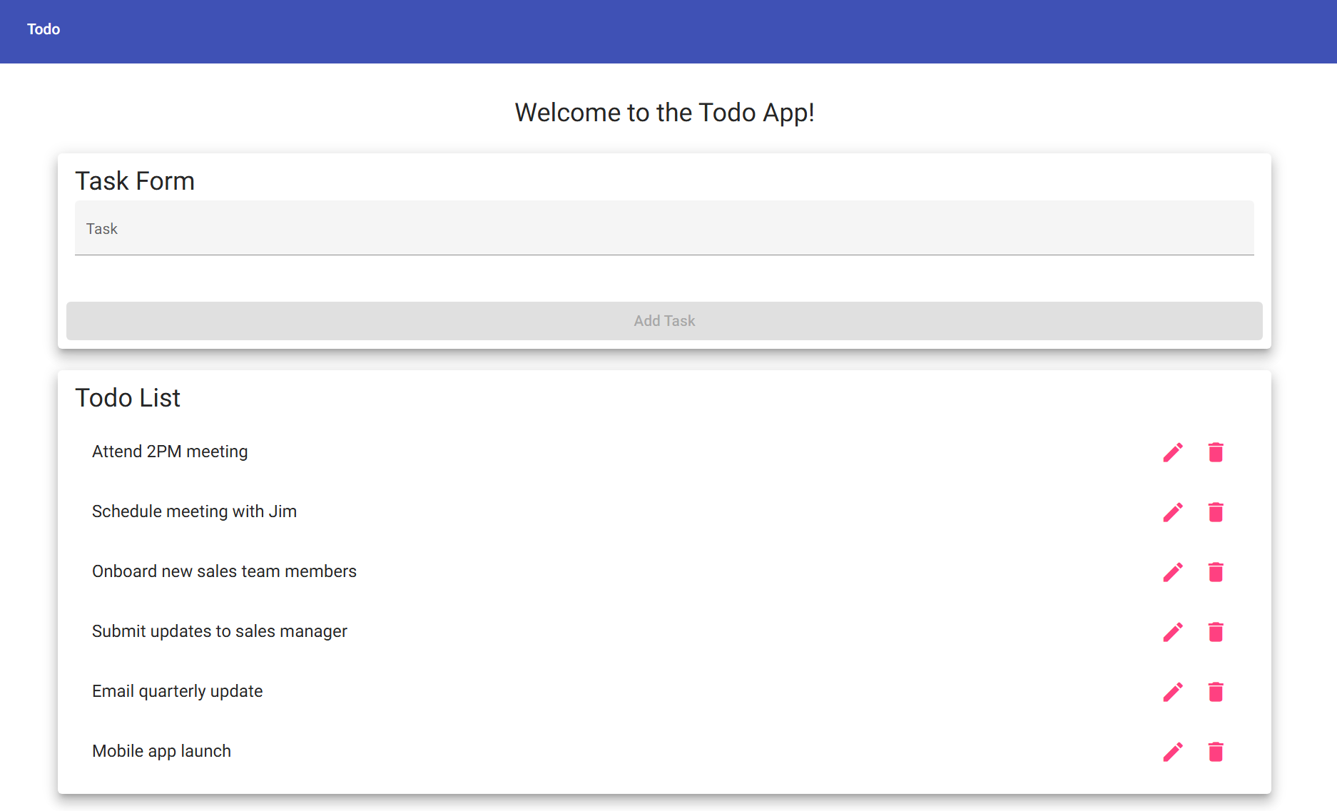
2 | Confirm there is a task input form | The input form should closely mimic the prototype | Yes | Yes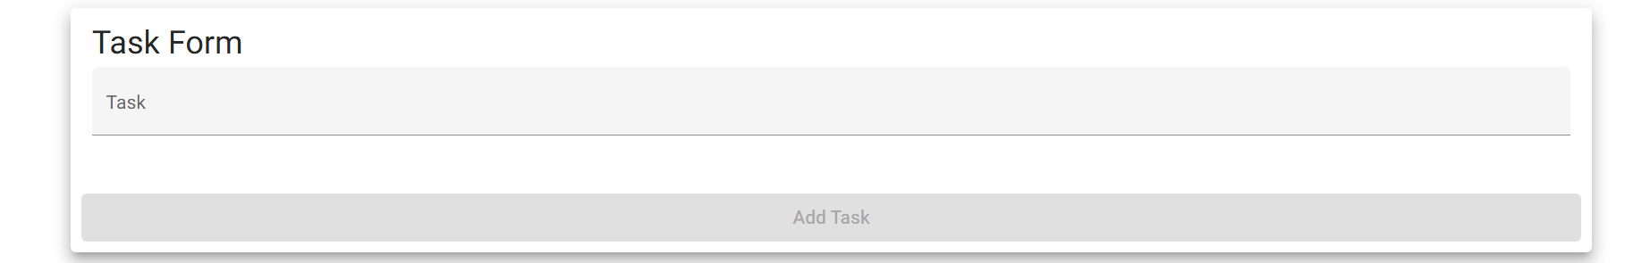
3 | Confirm there is a ToDo list below task input | The ToDoList should mimic the prototype | Yes | Yes
Comments | Website loads with no issue and appears functional
For each test, the developer should: provide a test description, a test objective, the developer name and date tested. For each step, fill out the actions to be taken and describe the expected results, and indicate yes or no for each step depending upon the result. The peer tester should provide their name, date tested, indicate yes or no for each step depending upon the result, and a screenshot (thumbnail) of the result.

Test 2 | Edit existing Task
 | Test Objective:  Should edit an existing task and be able to save it | Developer: Matthew Rozendaal  Date tested: 2026/06/12 | Peer tester: Jordan Dardar  Date tested: 2026/06/23
Step | Action | Expected results: | Developer pass/fail | Tester pass/fail  + Screenshot
1 | Visit https://buwebdev.github.io/todo/ | That the page loads | Yes | Yes
2 | In the Todo List, click the edit button for an existing item | An edit form should pop up | Yes | Yes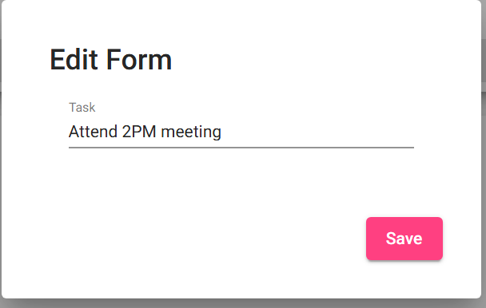
3 | Edit the value | The value in the pop up should allow you to edit it | Yes | Yes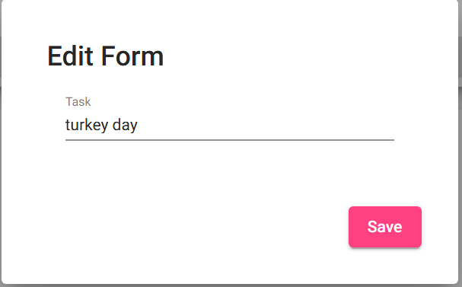
4 | Click Save | The form should close and the edited value should show in the list | Yes | Yes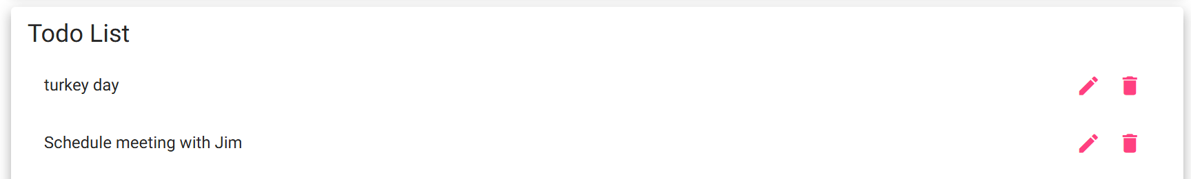
Comments

Test 3 | Delete Existing task
 | Test Objective:  Should be able to delete a task | Developer: Matthew Rozendaal  Date tested: 2026/06/12 | Peer tester: Jordan Dardar  Date tested: 2026/06/23
Step | Action | Expected results: | Developer pass/fail | Tester pass/fail
1 | Visit https://buwebdev.github.io/todo/ | That the page loads | Yes | Yes
2 | In the Todo List, click the delete button (Trash can) for one of the items on the list | The item should disappear from the UI | Yes | Yes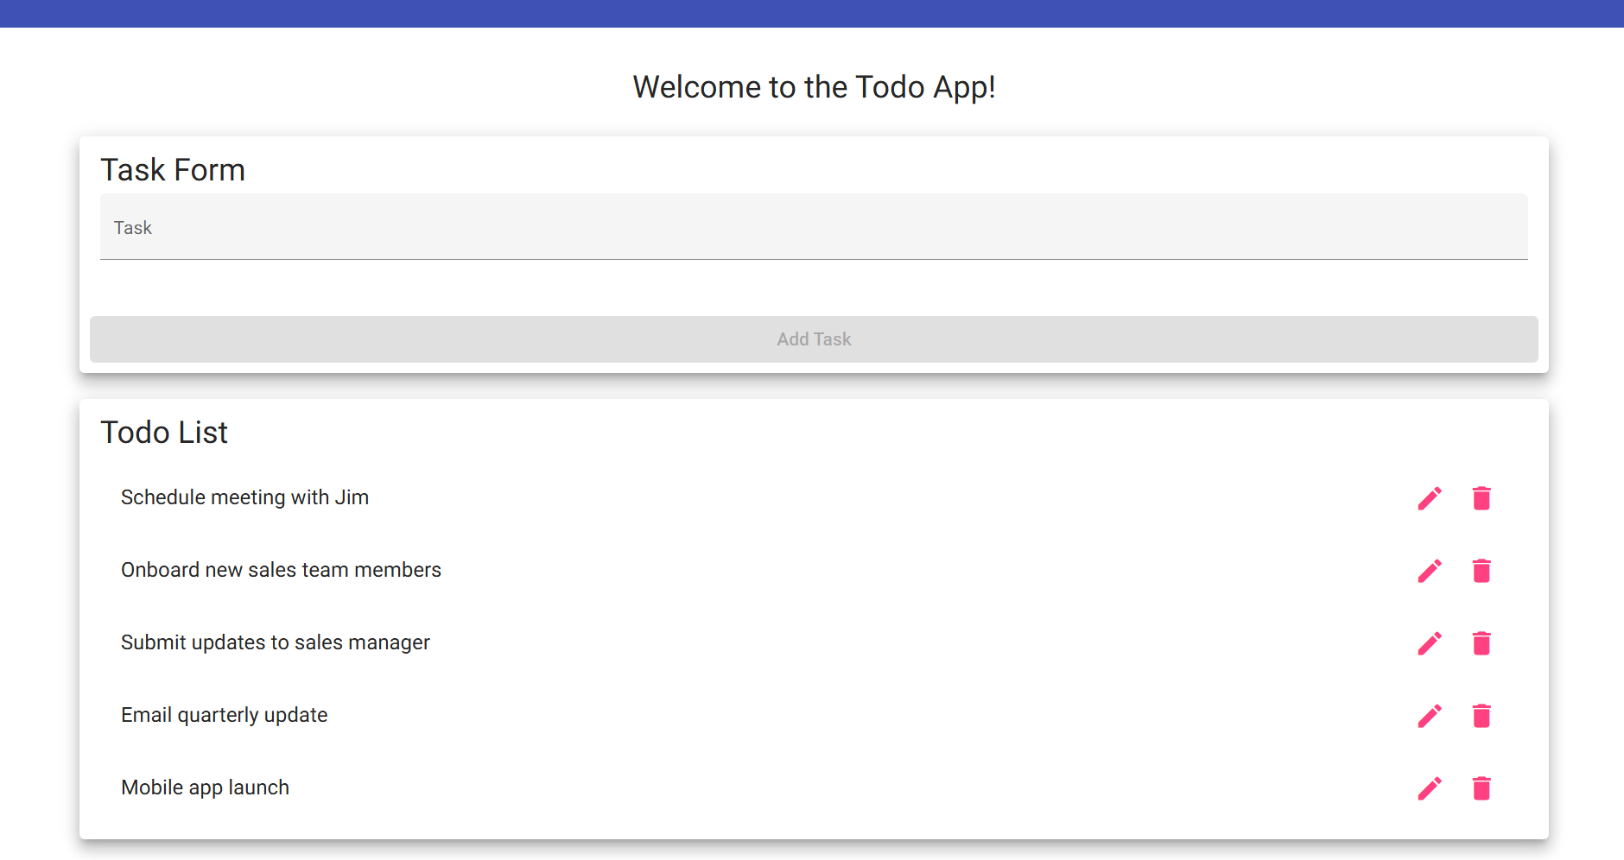
Comments | While the ability to delete works perfectly, we may want to have a pop up to confirm the users action. Especially with the edit button so close.

Test 4 | Create new ToDo Item
 | Test Objective:  Create a new ToDo item in the UI | Developer: Matthew Rozendaal  Date tested: 2026/06/12 | Peer tester: Jordan Dardar  Date tested: 2026/06/23
Step | Action | Expected results: | Developer pass/fail | Tester pass/fail
1 | Visit https://buwebdev.github.io/todo/ | That the page loads | Yes | Yes
2 | Enter “New Task” into Task Form | The Add Task Button should become available | Yes | Yes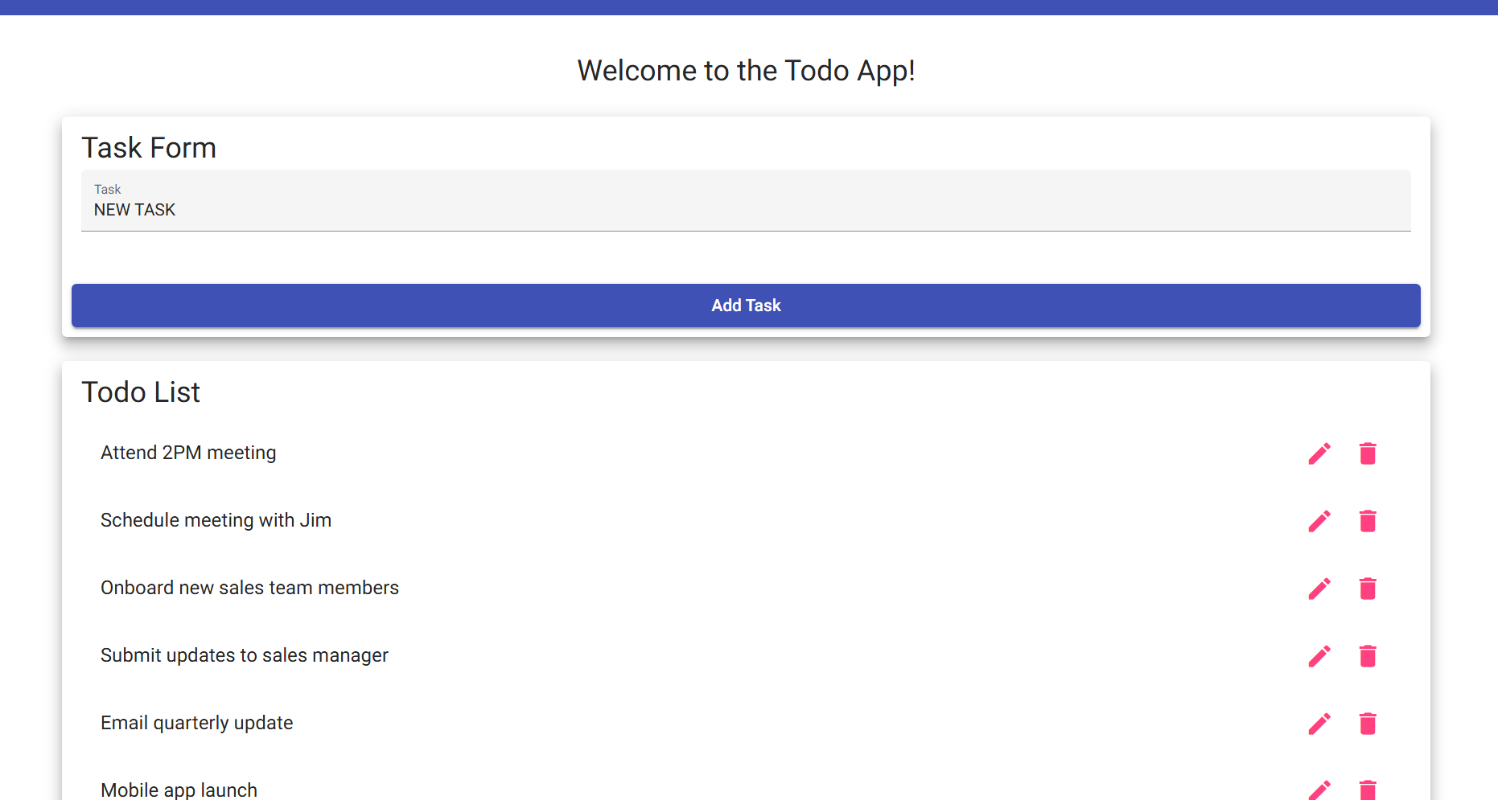
3 | Click “Add Task” | A new task in the Todo List with “New Task” as the name | Yes | Yes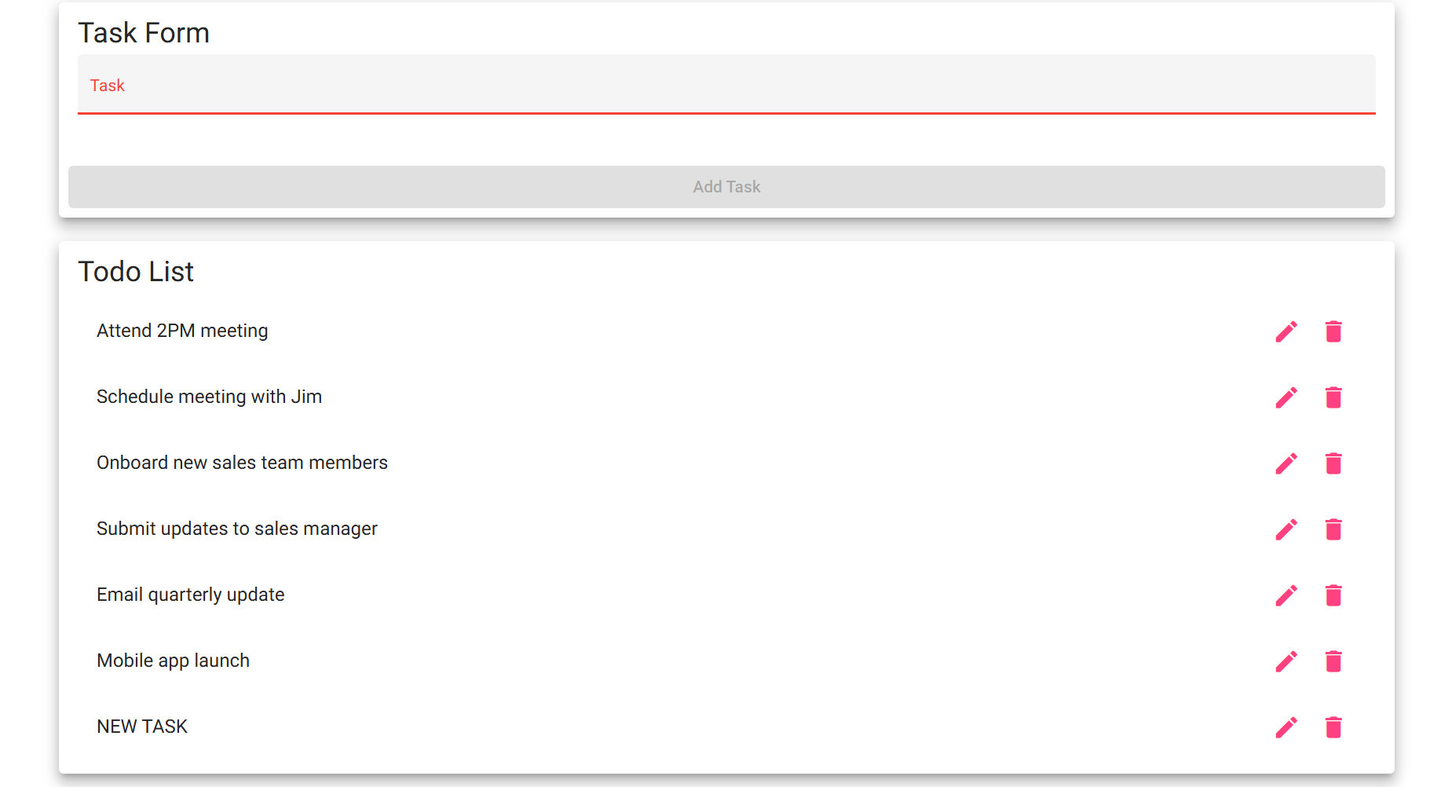
Comments | While the button to add a task works well, users may want to add multiple without needing to click with mouse. If the Add Task is enabled, allowing the task to be added by clicking “enter” on the keyboard would be ideal

Test 5 | Make sure is screen size responsive
 | Test Objective:  Make sure elements on page react to different screen dimensions | Developer:  Date tested: <yyyy/mm/dd> | Peer tester: Jordan Dardar  Date tested: 2026/06/23
Step | Action | Expected results: | Developer pass/fail | Tester pass/fail
1 | Visit https://buwebdev.github.io/todo/ | That the page loads | Yes | Yes
2 | Right click and choose inspect | A developer panel should show up | Yes | Yes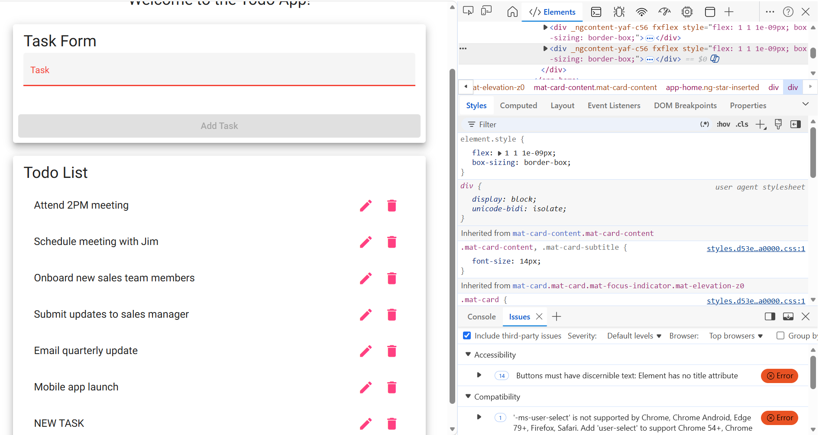
3 | Enable device emulation | The web page should change in size and the developer console should give you ability to change the dimensions of the website. | Yes | Yes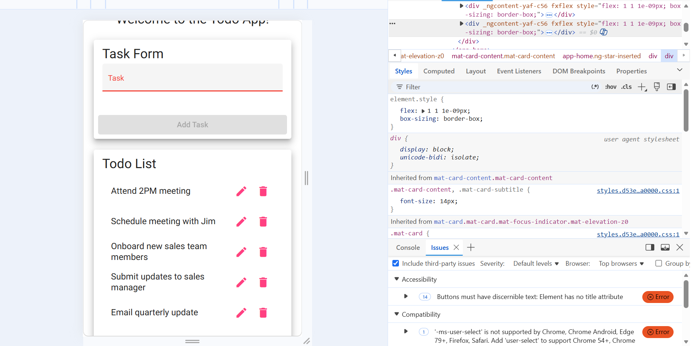
4 | Change the size of the view of the web site to bigger sizes | The web page items should contract when dimensions are smaller and expand when dimensions are bigger. | Yes | Yes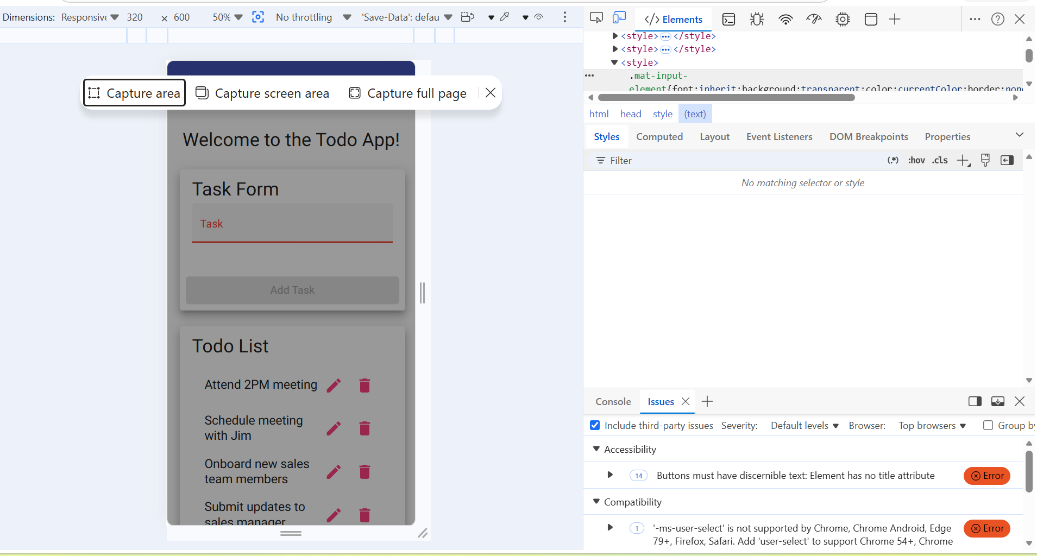
Comments

